ICBC Group Single Financial Institution
Transaction Proposal
Transaction Summary
Name of Customer | JSC National Bank for Foreign Economic Activity of the Republic of Uzbekistan ("NBU") | Total Assets (Dec 2025) | UZS 144.7 trillion (~USD 11.9 billion)
Top Shareholder | Ministry of Economy and Finance of the Republic of Uzbekistan | Total Equity (Dec 2025) | UZS 19.97 trillion (~USD 1.64 billion)
Ultimate Shareholder | Government of the Republic of Uzbekistan (100% state-owned) | Country of Incorporation | Republic of Uzbekistan
Credit Rating & Outlook | Moody's Ba3/Stable; S&P BB-/Stable; Fitch BB/Stable | Auditor | Deloitte & Touche
NBU has mandated Mashreqbank psc ("Mashreq") and Bank of China (Dubai) Branch ("BOC Dubai"), together the Initial Mandated Lead Arrangers and Bookrunners (the "IMLABs"), to arrange and coordinate the syndication of a CNH-denominated senior unsecured term loan facility of up to CNH 2.0 billion (the "Facility"), launching at CNH 1.0 billion with a green-shoe option. The Facility has a three-year tenor, carries a fixed interest rate of 3.8% per annum and a 0.6% flat upfront fee, and is being documented on LMA terms.
ICBC Almaty Branch is the client management branch for NBU, and hence it is in charge of applying for the internal credit rating, the total credit limit of 350 million CNH for NBU and the loan business credit review on their side. Upon approval, ICBC DIFC will apply for the credit limit utilization of 100 million CNH. It is under Kazakhstan law that ICBC Almaty Branch may sign the commitment letter only on its own behalf and cannot extend its commitment to other ICBC branches. The ICBC Group's internal syndication therefore totals CNH 300 million, with each of the three entities committing CNH 100 million — ICBC Almaty Branch CNH 100 million (signing on its own behalf as a Face Lender), ICBC (DIFC Branch) CNH 100 million and ICBC (Asia) CNH 100 million fronted by ICBC (DIFC Branch). Externally, ICBC Almaty Branch and ICBC (DIFC Branch) act as the Face Lenders, signing CNH 100 million and CNH 200 million respectively, with ICBC (DIFC Branch) fronting ICBC (Asia)'s CNH 100 million under a risk participation agreement.
FID hereby applies for approval to undertake the 100 million CNH loan business under the Facility, with ICBC (DIFC Branch) participating as a Face Lender, signing CNH 200 million externally — comprising its own CNH 100 million commitment and a further CNH 100 million committed by ICBC (Asia). At the same time, ICBC (Asia) will sign a risk participation agreement with ICBC (DIFC Branch) in respect of its CNH 100 million share. Separately, ICBC Almaty Branch is applying, as a Face Lender, for a CNH 100 million syndicated loan transaction signed on its own behalf within their branch.
NBU is registered in the Republic of Uzbekistan, which falls outside the Dubai (DIFC) Branch’s normal credit jurisdiction. As explained above, the transaction nonetheless qualifies under the Bank’s policy on locally-arranged syndications, given that the syndication is led by Mashreq, a UAE local bank. We therefore apply for this loan from the Dubai (DIFC) Branch as a self-operated business.
Bank of China (Dubai) Branch, as coordinator, is expected to commit CNH 500 million (understood to have been approved within Bank of China (Dubai)); accordingly, no single ICBC lender will be the largest lender in the syndicate. To our knowledge, no other Chinese bank will participate in the syndication.
The principal facility terms are summarised below; this is a summary only and the executed term sheet and Facility Agreement prevail.
Item | Detail (per term sheet)
Borrower | Joint-stock Company "National Bank for Foreign Economic Activity of the Republic of Uzbekistan"
Coordinators / IMLABs | Mashreqbank psc ("Mashreq") and Bank of China (Dubai) Branch ("BOC Dubai"), together the Initial Mandated Lead Arrangers and Bookrunners
Facility Agent | To be confirmed
Lenders | A pool of banks selected by the IMLABs; ICBC (DIFC Branch) proposed to participate as a lender
Facility Type | Term Loan Facility; senior unsecured; documented on LMA-recommended form
Amount | Up to CNH 2.0 billion (launching at CNH 1.0 billion)
Green-shoe Option | If oversubscribed, the Facility may be increased by up to a further CNH 2.0 billion by mutual agreement
Purpose | General corporate purposes
Tenor / Maturity | 36 months from the First Utilisation Date; Borrower option to request a 1-year extension, at each lender's discretion (request >= 60 days before maturity)
Availability Period | 30 days from signing (extendable); no commitment fee for the first 30 days, thereafter a commitment fee of 20% of the applicable interest on the undrawn amount
Drawdown / Repayment | Single drawdown in one lump sum on 5 business days' notice; bullet repayment of principal plus accrued interest at maturity; undrawn amounts cancelled
Fixed Interest | 3.8% per annum
Upfront Fee | 0.6% flat, calculated on the total facility amount
Interest Periods / Day count | 6 months (or as mutually agreed); actual/360
Default Interest | 2% per annum above the applicable rate
Voluntary Prepayment | In whole or part on 5 business days' notice (minimum CNH 70 million / USD 10 million), with accrued interest and breakage costs; prepaid amounts may not be redrawn
Financial Covenants | Minimum CAR the higher of 13% or the CBU-prescribed minimum (Borrower standalone); NPL ratio not exceeding 7% (see Section 7)
Governing Law / Jurisdiction | English law; courts of England (exclusive, with an enforcement carve-out)
Financial Covenants | 1. Capital Adequacy Ratio (to apply to the Borrower on a standalone basis):  Minimum Capital Adequacy Ratio to be the higher of 13% or the minimum  ratio prescribed by the Central Bank of Uzbekistan from time to time; and  2. Non-Performing Loans  The Borrower shall ensure that at all times it maintains a ratio (expressed as a  percentage) of non-performing loans to total loans and advances of not more  than 7%.
ICBC (DIFC Branch)'s own commitment is proposed at CNH 100 million (signing CNH 200 million externally as a Face Lender, inclusive of the CNH 100 million fronted for ICBC (Asia) under a risk participation agreement), subject to RMD approval, and is within the maximum supportable limit assessed in Section 6 (USD 51.4 million). The economics of the proposed participation are set out in Section 8 (Cost-Income Analysis), and the credit terms, financial covenants and risk mitigants in Section 7. The Facility is senior unsecured and, in the base case, is not supported by any third-party guarantee, standby letter of credit (SBLC) or dedicated security package; credit risk is mitigated through NBU's quasi-sovereign status and the covenant and monitoring package described in Section 7 (see Sections 7.2 and 7.3). The Facility includes binding financial covenants - a minimum Capital Adequacy Ratio of the higher of 13% or the CBU-prescribed minimum, and an NPL ratio not exceeding 7% - together with the customary LMA mandatory-prepayment triggers (including a two-notch downgrade of the sovereign or the Borrower, change of control, and sanctions events).
Part 1. Overall Evaluation of Customer
1.1 Key Information List of Customer
Name of Customer | JSC National Bank for Foreign Economic Activity of the Republic of Uzbekistan ("NBU") | Total Assets (Dec 2025) | UZS 144.7 trillion (~USD 11.9 billion)
Top Shareholder | Ministry of Economy and Finance of the Republic of Uzbekistan | Total Equity (Dec 2025) | UZS 19.97 trillion (~USD 1.64 billion)
Ultimate Shareholder | Government of the Republic of Uzbekistan (100% state-owned) | Country of Incorporation | Republic of Uzbekistan
Credit Ratings | Moody's: Ba3/Stable | S&P: BB-/Stable | Fitch: BB/Stable | Auditor | Deloitte & Touche
USD/UZS = 12,150 (as of April 2026)
JSC National Bank for Foreign Economic Activity of the Republic of Uzbekistan ("NBU") is a joint-stock company established by Presidential Decree in September 1991. The bank is headquartered at 101 Amir Temur Avenue, Tashkent, Uzbekistan. NBU is 100% state-owned, with the Ministry of Economy and Finance of the Republic of Uzbekistan and the Fund for Reconstruction and Development of the Republic of Uzbekistan as its principal shareholders.
Shareholder structure (as at 31 December 2025)
Shareholder | Ordinary registered shares | Par value (UZS bn) | Holding
Fund for Reconstruction and Development of the Republic of Uzbekistan (UFRD) | 10,990,718,050 | 10,990.7 | 61.86%
Ministry of Economy and Finance of the Republic of Uzbekistan | 6,776,397,120 | 6,776.4 | 38.14%
Total (100% state-owned) | 17,767,115,170 | 17,767.1 | 100.00%
All shares are ordinary registered shares with a par value of UZS 1,000; NBU is 100% state-owned. The share register reconciles to the bank’s authorized capital of UZS 17,767.1 billion at 31 December 2025. Source: NBU investor disclosures (nbu.uz).
NBU is the largest bank in Uzbekistan by total assets, accounting for approximately 16% of total banking sector assets as of end-2025. It is the international flagship of the Uzbekistan banking system, often described as the "visiting card" of the country in international financial markets. The bank combines the functions of a project finance bank, universal commercial bank, investment bank, and savings institution, playing a central role in financing large investment projects and supporting foreign economic activity.
NBU operates through a nationwide network of 96 branches and representative offices across all regions of Uzbekistan, as well as international correspondent banking relationships with over 500 banks globally. The bank's primary strategic objectives include:
- Active lending to large investment projects in priority sectors of the economy through foreign credit lines and international capital market resources
- Servicing foreign trade operations of domestic enterprises at international standards, including letters of credit, guarantees, factoring and documentary operations
- Retail and SME banking services, including mortgage lending, car loans, salary projects and digital banking via the Milliy Mobile App
- Development of capital market and investment banking activities, including underwriting and Eurobond issuances
- Attracting foreign investments and advanced technologies to the Uzbek economy through long-term international borrowings
In July 2025, NBU successfully priced a dual-tranche Eurobond consisting of a USD 300 million, 5-year senior bond at 7.2% coupon and a UZS 1.5 trillion, 3-year local-currency bond at 17.95% coupon — the latter settled in USD. Both tranches attracted strong investor demand, with order books significantly oversubscribed.
1.2 Shareholders
NBU is 100% state-owned. Following its 2019 transformation from a unitary enterprise into a joint-stock company (Presidential Resolution PP-4540 of 30 November 2019), the bank is held by two arms of the Government of the Republic of Uzbekistan: the Fund for Reconstruction and Development of the Republic of Uzbekistan (UFRD), which holds 61.86%, and the Ministry of Economy and Finance of the Republic of Uzbekistan, which holds 38.14% (see the shareholder table in Section 1.1). The ultimate shareholder is therefore the Republic of Uzbekistan, and the bank is treated by the rating agencies as a quasi-sovereign entity.
State ownership is central to the credit. The government has provided recurring capital support through subscriptions to NBU’s authorized capital, which rose to UZS 17,767.1 billion at 31 December 2025; the share register reconciles directly to this figure. This pattern of capital injections, together with NBU’s systemic importance and policy role, underpins the agencies’ assessment of a very high probability of extraordinary state support.
As part of Uzbekistan’s banking-sector reform programme, NBU is among the state-owned institutions potentially subject to future partial privatisation through an IPO or strategic-investor process. Any reduction in state ownership below a controlling stake, or a change of control, would be a covenant review event under the proposed terms (see Section 7.2), given that quasi-sovereign support is core to the credit profile.
1.3 Subsidiary List
NBU heads a banking group and prepares consolidated IFRS financial statements. Non-controlling interests were only UZS 103.4 billion at 30 June 2025 (approximately 0.5% of total equity), indicating that the consolidated subsidiaries are predominantly wholly-owned and that the bank itself accounts for substantially all group assets. NBU’s strategic equity participations and industrial holdings are held and managed through its asset-management arm, NBU Invest Group. The principal subsidiaries and associated undertakings identified from public disclosures are summarised below.
Entity | Principal activity | NBU stake | Notes / basis
NBU Invest Group LLC | Asset management; holding vehicle for NBU’s strategic equity and industrial portfolio | 100%* | Manages stakes in priority sectors (textiles, construction materials, agriculture, etc.)
Uzbek Leasing International A.O. (ULI) | SME and equipment leasing | 45.5% | Associate; co-shareholders Uzbek-Oman Investment Co. (44.1%) and Maybank (10.4%) (IFC, 2022)
Strategic equity / industrial holdings | Equity participations in priority economic sectors | Various | Held and managed via NBU Invest Group; consolidated where controlled
* Ownership stakes marked with an asterisk, and the complete list of consolidated subsidiaries, are to be confirmed from the notes to NBU’s IFRS consolidated financial statements (provided as an attachment per Section 2.1). NBU has also historically held a banking subsidiary in Russia (Asia Invest Bank, Moscow); its current status should be confirmed. Sources: NBU Invest Group (nbuig.uz); IFC project disclosure (Uzbek Leasing International, 2022); NBU interim IFRS financial statements, 30 June 2025.
1.4 Client Management and Transaction Structure
ICBC Almaty Branch is the client management branch for NBU and holds primary relationship responsibility for the Bank within the ICBC group. The client’s internal rating status is currently pending final approval, with the internal rating expected to be sA+, valid for one year. The total approved credit limit for NBU is also pending approval, at CNH 300 million in aggregate, to be committed across three ICBC entities — ICBC Almaty Branch, ICBC (Asia) and ICBC (Dubai) each committing CNH 100 million. Externally, ICBC Almaty Branch and ICBC (Dubai) act as the Face Lenders, signing CNH 100 million and CNH 200 million respectively, the latter inclusive of ICBC (Asia)’s CNH 100 million fronted under a risk participation agreement. As client management branch, ICBC Almaty Branch is responsible for applying for the internal credit rating, the total credit limit and the loan business credit review. The credit-limit details relevant to this transaction are summarised below.
Item | Detail
Client management branch | ICBC Almaty Branch is the client management branch for NBU.
Internal rating (status) | sA+; valid for one year.
Total approved credit limit (pending) | CNH 300 million in aggregate — ICBC Almaty Branch CNH 100 million, ICBC (Asia) CNH 100 million and ICBC (Dubai) CNH 100 million (ICBC (Dubai) signing CNH 200 million externally as Face Lender, inclusive of ICBC (Asia)’s CNH 100 million fronted under a risk participation agreement).
Relevant credit-limit section | Intra-banking (inter-bank) credit.
Validity period of the current credit limit | 1 year.
Current available credit limit | Nil (CNH 0).
Sufficient limit available for the proposed syndication | Yes, upon approval.
Restrictions or conditions in the latest credit-limit approval relevant to this transaction | Not expected.

Part 2. Evaluation and Financial Position
2.1 Financial Situation
The Group’s external auditor for its IFRS consolidated financial statements is Deloitte & Touche. The audited IFRS consolidated financial statements for FY2024 have been published; the most recent IFRS financial information available is the reviewed (not audited) interim condensed consolidated financial statements for the six months ended 30 June 2025 (“2025 1H”), on which Deloitte & Touche issued a limited-assurance review conclusion (i.e. a review, not an audit). The FY2025 IFRS audit is pending as of the report date. Accordingly, the financial position below is presented on the 2025 1H reviewed IFRS basis, with the 31 December 2024 and 31 December 2023 (balance sheet) and six-months-to-30-June-2024 and full-year FY2023 (income statement) comparatives shown for reference. The 31 December 2023 and FY2023 comparatives are drawn from the audited IFRS consolidated financial statements for the year ended 31 December 2023. No year-on-year percentage change is presented, because a six-month interim period is not directly comparable with a full prior year. The complete reviewed interim IFRS financial statements for 2025 1H are provided as a separate attachment and prevail over the summary below. Figures are in UZS millions unless noted.
Interim IFRS Financial Statements (Reviewed, H1 2025)
The following primary financial statements are extracted from NBU's interim condensed consolidated financial statements for the six months ended 30 June 2025, prepared under IFRS and reviewed (not audited) by Deloitte & Touche, which issued a limited-assurance review conclusion. The complete statements, including the accompanying notes and the independent auditor's review report, are provided as a separate attachment and prevail over this summary. Figures are in UZS millions. Certain captions have been grouped for presentation; "Other assets", "Other liabilities" and "Other reserves and retained earnings" aggregate the remaining balance-sheet captions.
Interim Condensed Consolidated Statement of Financial Position (30 June 2025)
UZS millions | 30 Jun 2025 | 31 Dec 2024 | 31 Dec 2023
ASSETS
Cash and cash equivalents | 27,829,851 | 18,422,741 | 14,377,483
Due from credit institutions | 3,686,146 | 3,565,128 | 6,943,790
Loans to customers | 104,338,981 | 102,570,837 | 94,783,232
Investment securities | 3,855,223 | 7,441,674 | 7,140,848
Other assets | 5,723,580 | 4,803,008 | 3,244,053
Total assets | 145,433,781 | 136,803,388 | 126,489,406
LIABILITIES
Due to the Central Bank | 579,182 | 982,953 | 1,045,549
Due to credit institutions | 11,037,957 | 8,241,262 | 11,497,362
Due to customers | 47,255,264 | 38,582,800 | 33,968,762
Other borrowed funds | 54,072,274 | 57,250,426 | 55,467,518
Debt securities issued | 8,832,937 | 9,353,170 | 3,655,270
Subordinated loans | 1,743,745 | 1,805,129 | 1,783,232
Other liabilities | 814,937 | 541,428 | 585,306
Total liabilities | 124,336,296 | 116,757,168 | 108,002,999
EQUITY
Share capital | 16,697,180 | 15,994,554 | 15,476,078
Other reserves and retained earnings | 4,296,910 | 3,977,294 | 2,966,932
Equity attributable to shareholders of the Bank | 20,994,090 | 19,971,848 | 18,443,010
Non-controlling interests | 103,395 | 74,372 | 43,397
Total equity | 21,097,485 | 20,046,220 | 18,486,407
Interim Condensed Consolidated Statement of Profit or Loss (6 months to 30 June 2025)
UZS millions | 6m to 30 Jun 2025 | 6m to 30 Jun 2024 | FY2023*
Interest income | 6,717,985 | 5,950,284 | 10,606,305
Interest expense | (3,459,154) | (2,943,035) | (5,069,070)
Net interest income | 3,258,831 | 3,007,249 | 5,537,235
Credit loss expense on financial assets | (667,995) | (599,946) | (1,754,147)
Fee and commission income | 559,307 | 448,432 | 813,879
Net gains from foreign exchange | 888,348 | 607,247 | 1,027,812
Personnel and other operating expenses | (1,362,845) | (1,177,646) | (2,059,537)
Other operating expenses, net | (511,941) | (352,508) | (513,157)
Profit before tax | 2,163,705 | 1,932,828 | 3,052,085
Income tax expense | (510,584) | (418,169) | (736,642)
Profit for the period | 1,653,121 | 1,514,659 | 2,315,443
Attributable to shareholders of the Bank | 1,628,772 | 1,500,143 | 2,296,771
Non-controlling interests | 24,349 | 14,516 | 18,672
Source: NBU interim condensed consolidated financial statements for the six months ended 30 June 2025 (reviewed by Deloitte & Touche), and the audited IFRS consolidated financial statements for the year ended 31 December 2023. Certain captions have been grouped for presentation; the attached full statements and notes prevail. *The FY2023 column reflects audited full-year IFRS results and is shown for reference only; it covers a twelve-month period and is therefore not directly comparable with the six-month interim columns. The FY2023 “Net gains from foreign exchange” line aggregates dealing and translation results, and “Other operating expenses, net” aggregates the remaining non-interest income and expense captions, consistent with the interim presentation.
2.2 Financial Performance in 2025
The discussion below analyses NBU’s financial performance and position for the first half of 2025, organised into three parts — Asset Analysis, Liability Analysis and Income Analysis — on the same reviewed IFRS interim basis as Section 2.1 (the six months ended 30 June 2025, reviewed by Deloitte & Touche). Balance-sheet movements are measured over the half-year against 31 December 2024, and income-statement movements against the six months ended 30 June 2024; net-income and return measures are also shown on an annualised basis (six-month result × 2) where indicated, to give a full-year-equivalent view. These figures reconcile to Section 2.1 and will be superseded by NBU’s audited FY2025 IFRS financial statements when published. Source: NBU interim condensed consolidated financial statements for the six months ended 30 June 2025 (reviewed by Deloitte & Touche).
Asset Analysis
Total assets grew 6.3% over the half-year to UZS 145.4 trillion (~USD 11.9 billion) at 30 June 2025, from UZS 136.8 trillion at 31 December 2024, consolidating NBU’s position as Uzbekistan’s largest bank with approximately 16% system market share. The growth was driven primarily by a build-up of liquid assets alongside continued, more measured, loan growth.
Loans to customers (net) rose 1.7% over the half-year to UZS 104.3 trillion at 30 June 2025, from UZS 102.6 trillion at 31 December 2024, reflecting a more measured pace of credit extension amid elevated provisioning levels; net loans remained the Bank’s largest asset class at roughly two-thirds of interest-earning assets.
Liquidity was built up materially over the half-year: cash and cash equivalents increased 51.1% to UZS 27.8 trillion (from UZS 18.4 trillion at 31 December 2024) and amounts due from credit institutions rose 3.4% to UZS 3.7 trillion, reflecting deployment into higher-yielding short-term and interbank assets consistent with the Bank’s active treasury management.
The investment-securities portfolio was reduced by 48.2% over the half-year to UZS 3.9 trillion (from UZS 7.4 trillion at 31 December 2024), as maturing government bonds and notes were redeployed into cash and interbank placements.
On asset quality, NBU’s regulatory NPL ratio of approximately 2.8% (CBU, NBU-specific) sits below the banking-sector average of 4.1% (December 2025), consistent with the Bank’s position as the state-owned flagship institution. On an IFRS basis, Stage 3 (credit-impaired) loans were approximately 4.2% of gross loans at 30 June 2025, while the loan-loss provision coverage ratio (total provisions to gross loans) was approximately 5.6% on a statutory basis and is not an NPL ratio; the IMF has noted that IFRS Stage 3 ratios in Uzbekistan typically run at roughly twice the regulatory NPL ratio. NBU’s capitalisation is solid: total equity was UZS 21.1 trillion at 30 June 2025, equivalent to a capital-to-assets ratio of approximately 14.5%, and Fitch has estimated the Bank’s Fitch Core Capital ratio above 20% for 2024-2025. NBU’s estimated bank-level regulatory CAR (~18.2%) and Tier 1 ratio (~16.9%) at 30 June 2025 are set out in Section 2.4.
A notable feature of the period is that asset growth outpaced earnings growth, so profitability per unit of assets declined: net profit rose only 9.1% year on year (to UZS 1,653.1 billion in 1H 2025) while the balance sheet expanded more quickly, taking the return on assets from approximately 1.4% in 2023 and 1.3% in 2024 to approximately 1.1% on a six-month basis in 1H 2025. This largely reflects the composition of the growth: the expansion was concentrated in low-yielding liquid assets — cash and cash equivalents rose 51.1% while net loans grew only 1.7% — so the asset base grew without a commensurate rise in interest income, and the net interest margin was squeezed as interest expense increased 17.5% year on year against a 12.9% rise in interest income amid rapid, higher-cost deposit growth, holding net interest income growth to 8.4%.
Higher operating expenses (+15.7%), provisioning (+11.3%) and a 22.1% increase in income tax then absorbed much of the pre-tax gain (profit before tax rose 11.9%). The pattern is also structural: as the state flagship, NBU carries a large book of lower-margin, state-directed project finance to government-related entities, which keeps its return on assets below the ~2.2% sector average and makes balance-sheet growth inherently volume-driven and dilutive to returns; part of the 1H 2025 profit was, moreover, carried by more volatile foreign-exchange gains (+46.3%) and fee income (+24.7%) rather than core lending spread income.
Liability Analysis
Total customer deposits (amounts due to customers) increased 22.5% over the half-year to UZS 47.3 trillion at 30 June 2025, from UZS 38.6 trillion at 31 December 2024, demonstrating robust franchise strength and a continued, strategic deepening of the retail and corporate funding base as a lower-cost alternative to foreign wholesale borrowings.
Conversely, wholesale funding was trimmed over the half-year: other borrowed funds (largely foreign-lender facilities) declined 5.6% to UZS 54.1 trillion and debt securities issued fell 5.6% to UZS 8.8 trillion, while amounts due to credit institutions rose 33.9% to UZS 11.0 trillion. The shift toward domestic deposits reduced reliance on foreign borrowings.
The Bank maintained a strong capital base, with total equity rising 5.2% over the half-year to UZS 21.1 trillion at 30 June 2025 (from UZS 20.0 trillion at 31 December 2024), supported by retained earnings; share capital stood at UZS 16.7 trillion, reflecting prior government capital injections.
Income Analysis
Net profit for the six months ended 30 June 2025 was UZS 1,653.1 billion (~USD 136 million), up 9.1% year on year from UZS 1,514.7 billion in the first half of 2024; on an annualised basis (six-month result × 2) this is equivalent to approximately UZS 3,306 billion (~USD 272 million), driven by higher net interest income and strong growth in fee and foreign-exchange income, partly offset by higher operating and provisioning costs.
Net interest income increased 8.4% year on year to UZS 3,258.8 billion for the six months (annualised, approximately UZS 6,517.7 billion), as a 12.9% rise in interest income outpaced a 17.5% increase in interest expense from higher funding balances; the net interest margin was approximately 4.5%.
Non-interest income grew strongly: fee and commission income rose 24.7% year on year to UZS 559.3 billion and net foreign-exchange gains increased 46.3% to UZS 888.3 billion in the first half of 2025, reflecting higher transaction volumes and trade-related activity.
Personnel and other operating expenses rose 15.7% year on year to UZS 1,362.8 billion, driven by higher staff costs and continued IT and infrastructure investment; the cost-to-income ratio nonetheless remained low at approximately 29%. The credit-loss expense increased 11.3% to UZS 668.0 billion and profit before tax rose 11.9% to UZS 2,163.7 billion.
Profitability was solid. On a six-month (non-annualised) basis the return on assets was approximately 1.1%, consistent with the 2025 1H figure in Section 2.4; annualised (six-month result × 2), this equates to a return on assets of approximately 2.3% and a return on equity of approximately 15.7%, consistent with the annualised peer comparison in Section 2.5. The annualised returns reflect the strong first-half run-rate and are presented for full-year-equivalent comparability.

2.3 Financial Performance in 2024
In FY2024, NBU delivered a net profit of UZS 1,722.2 billion, a marginal 0.3% increase from UZS 1,716.5 billion in FY2023. Total assets grew 6.0% to UZS 135,090 billion, driven primarily by modest growth in the loan portfolio (+8.8% gross), expansion in securities holdings and higher interbank placements. Net interest income before provisions remained broadly stable at UZS 5,375.4 billion. Non-interest income grew modestly (+2.0%) to UZS 7,420.7 billion. Operating expenses rose 21.1%, reflecting staff, IT and infrastructure investment. Total customer deposits grew from UZS 32,920 billion to UZS 36,839 billion (+11.9%), improving the funding mix.
2.4 KPIs Summary
The table below summarises NBU’s key performance indicators for 2023, 2024 and 2025 1H. The summary has been extended to incorporate the asset-quality and regulatory-capital metrics (NPL, capital adequacy and Tier 1) that were previously presented separately, so that profitability, scale, capital and asset quality can be read together. Balance-sheet items are in UZS trillion unless stated; 2023 and 2024 are full-year statutory figures, while 2025 1H reflects the six-month interim IFRS results as at 30 June 2025 (interim profit and income figures are six-month and are not annualised).
Item | 2023 | 2024 | 2025 1H
Profitability
Net Profit (UZS Billion) | 1,716.5 | 1,722.2 | 1,653.1
Net Profit (USD Million, approx.) | ~151 | ~143 | ~136
Net Interest Income (UZS Billion) | 5,354.7 | 5,375.4 | 3,258.8
Cost-to-Income Ratio | ~31% | ~35% | ~29%
Return on Assets (ROA, approx.) | ~1.4% | ~1.3% | ~1.1%
Return on Equity (ROE, approx.) | ~9.6% | ~9.1% | ~9.6%†
Scale
Total Assets (UZS Trillion) | 127.5 | 135.1 | 145.4
Total Loans Net (UZS Trillion) | 92.4 | 100.5 | 104.3
Total Deposits (UZS Trillion) | 32.9 | 36.8 | 47.3
Capital & Asset Quality
Total Equity (UZS Trillion) | 17.8 | 18.9 | 21.1
Authorized Capital (UZS Trillion) | 15.5 | 16.3 | 16.7
Total Capital Adequacy Ratio (CAR) | 18.0% | 17.5% | 18.2%
Tier 1 Capital Ratio | 16.5% | 16.0% | 16.9%
NPL ratio — IFRS Stage 3 / gross loans | n.a. | 4.2% | 4.2%
NPL ratio — regulatory (CBU, memo) | 3.8% | 4.0% | 2.8%
Ratings
Moody’s | Ba3/Stable | Ba3/Stable | Ba3/Stable
Fitch | BB-/Stable | BB-/Stable | BB/Stable
S&P | BB/Stable | BB-/Stable | BB-/Stable
2023 and 2024 are full-year statutory figures; 2025 1H reflects the six-month interim IFRS results as at 30 June 2025. Net profit, net profit (USD) and net interest income for 2025 1H are six-month figures and are not annualised. † 2025 1H ROE is shown on an FY2025 statutory basis, as the six-month interim profit is not annualised, so a like-for-like half-year ROE is not directly comparable. n.a. = not separately available for the period. CAR, Tier 1 and NPL are NBU-specific (FID estimates / CBU and IFRS bases; see the detailed table below). Data source: Central Bank of Uzbekistan (1 January 2026 publication) and 2025 1H financial statements.
For 2024 NPL calculation (All figures in UZS million) :

Step 1 — Sum Stage 3 gross loans across all customer categories:
Category | Stage 3
Private companies | 3,484,783
State companies | 414,123
State or local authorities | 524,479
Gross investment in finance lease | —
Non-banking financial institutions | 157
Loans to individuals | 214,163
Total Stage 3 (NPL) | 4,637,705
Step 2 — Total gross loans to customers: 86,974,958 (St1) + 19,893,046 (St2) + 4,637,705 (St3) = 111,505,709 N
Step 3 — NPL= 4,637,705/111,505,709 = 0.04159 = 4.16%

For 2025 1H NPL calculation (All figures in UZS million) :
Step 1 — Sum Stage 3 gross loans across all customer categories:
Category | Stage 3
Private companies | 4,139,231
State companies | 352,920
State or local authorities | —
Gross investment in finance lease | —
Non-banking financial institutions | 157
Loans to individuals | 290,522
Total Stage 3 (NPL) | 4,782,830
Step 2 — Total gross loans to customers: 87,660,440 (St1) + 21,495,972 (St2) + 4,782,830 (St3) = 113,939,242
Step 3 — NPL=4,782,830/113,939,242 = 0.04198 = 4.20%

We noticed that ICBC Almaty Branch has made a NPL calculation at 4.3%，which is slightly different from our 4.2% for 2025 1H. We have reached out to ICBC Almaty Branch but have not received any feedback yet on how they calculated the NPL ratio as of the time we completed our report.
NPL discrepancy explanation: NBU’s regulatory NPL ratio reported to the CBU (approximately 2.8% as of 1 January 2026) is materially lower than the IFRS Stage 3 ratio computed above (4.2% at 1H 2025) because the two use different definitions. The regulatory measure is rules-based, driven mainly by loans overdue 90+ days and the CBU classification buckets, and the local framework allows banks to defer recognition (for example by treating restructured exposures as “substandard” rather than non-performing); IFRS 9 Stage 3 is broader, capturing forborne and qualitatively credit-impaired loans that are not yet 90 days past due. The IMF has observed that in Uzbekistan IFRS Stage 3 ratios typically run at roughly twice the regulatory NPL, consistent with the 4.2% versus ~2.8% gap here. This basis difference also drives the Section 2.5 peer comparison: NBU is shown there on the more conservative IFRS Stage 3 basis (4.2%), whereas on the consistent CBU regulatory basis published in the CBU’s monthly statistics for June 2025, NBU’s NPL was approximately 2.9% — below SQB’s approximately 3.7% and the sector average of approximately 3.8%. The minor difference between our 4.2% Stage 3 figure and ICBC Almaty Branch’s 4.3% is within rounding/classification tolerance and is being reconciled with the branch.

Extended KPI chart — NBU vs peers (key ratios)
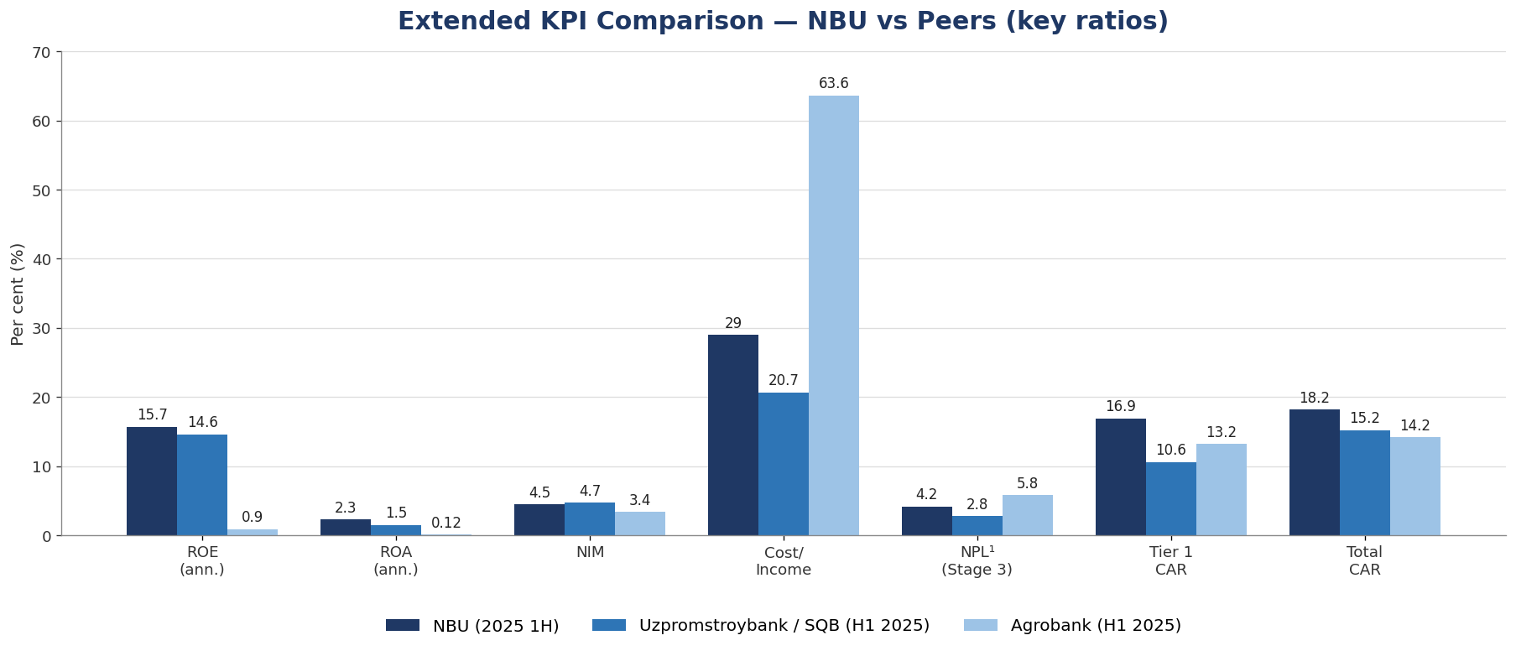
Extended KPI comparison across NBU and its two largest domestic peers (Uzpromstroybank/SQB and Agrobank) on key profitability, asset-quality and capital ratios — the asset-quality (NPL) and capital (CAR) metrics that were not previously charted are now included. ¹ NBU NPL is shown on the IFRS Stage 3 / gross-loans basis (4.2%); NBU’s regulatory NPL is 2.8% and the 5.6% sometimes cited is the provision-to-gross-loans coverage ratio (not an NPL ratio). All three banks are shown on a 2025 1H basis as at 30 June 2025; NBU’s ROE, ROA and NIM are annualised from the six-month interim IFRS results. FX uniform at USD/UZS = 12,150. The full peer breakdown is in Section 2.5. Source: attached Peer Comparison KPI workbook.
Over 2023-2024 NBU sustained steady balance-sheet growth, with total assets rising from UZS 127.5 trillion to UZS 135.1 trillion and net profit broadly stable at around UZS 1.7 trillion per year. The 2025 1H interim results show total assets of UZS 145.4 trillion, net loans of UZS 104.3 trillion and customer deposits of UZS 47.3 trillion as at 30 June 2025, with a six-month net profit of UZS 1,653.1 billion and net interest income of UZS 3,258.8 billion - a strong half-year run-rate. Equity reached UZS 21.1 trillion and external ratings were unchanged at Moody’s Ba3/Stable, S&P BB-/Stable and Fitch BB/Stable.
2.5 Peer Comparison
The table below benchmarks NBU against the two next-largest banks in Uzbekistan — Uzpromstroybank (SQB) and Agrobank — and the two largest banks in Kazakhstan — Halyk Bank (Halyk Savings Bank of Kazakhstan) and Kaspi.kz — across the same extended set of key performance indicators used in Section 2.4 (profitability, asset quality, capital adequacy, liquidity, scale and ratings). To make the comparison meaningful, all five banks are shown on a consistent 2025 1H basis as at 30 June 2025, using uniform exchange rates of USD/UZS = 12,150 and USD/KZT = 519.73 (period-end). Net profit and net interest income are stated for the six-month period; in line with the agreed basis, only the return ratios (ROE and ROA) are annualised (six-month result × 2) so that half-year earnings can be compared on a full-year-equivalent basis, while NIM is each bank’s published period margin. Monetary KPIs are in USD million unless stated; ratios are in per cent. Halyk and Kaspi are materially larger than the Uzbek banks and are included to position NBU against the leading Central Asian banking franchises; Kaspi.kz reports as a diversified payments and fintech group and does not disclose several bank-prudential ratios, which are accordingly marked n.a.
Indicator | NBU (2025 1H) | SQB (2025 1H) | Agrobank (2025 1H) | Halyk (2025 1H) | Kaspi.kz (2025 1H)
Profitability
Net Profit - reported period (USD M) | 136.1 | 58.5 | 4.7 | ~1,017 | ~987
Net Interest Income - reported (USD M) | 268.2 | 220 | n.a.² | ~1,280 | n.a.³
Net Interest Margin (NIM) | ~4.5% | 4.7% | 3.4% | 7.2% | n.a.³
Cost-to-Income Ratio (CIR) | ~29% | 20.7% | 63.6% | 17.2% | n.a.³
Return on Equity (ROE, ann.) | 15.7% | 14.6% | 0.9% | ~32% | n.a.³
Return on Assets (ROA, ann.) | 2.3% | 1.5% | 0.12% | ~5.3% | n.a.³
Asset Quality
NPL ratio (Stage 3 / gross loans) | 4.2%¹ | 2.8% | 5.8% | 6.6% | 5.7%
NPL provision coverage (ECL / Stage 3) | ~100% | 119.6% | 53.8% | n.a. | n.a.³
Capital Adequacy
Tier 1 Capital Ratio | 16.9% | 10.6% | 13.2% | ~19% | n.a.³
Total Capital Adequacy Ratio (CAR) | 18.2% | 15.2% | 14.2% | ~18.5% | n.a.³
Leverage Ratio (Tier 1 / assets) | 13.8% | 13.5% | 14.0% | n.a. | n.a.
Regulatory minimum CAR (memo) | 13% | 13% | 13% | 12% | 12%
Liquidity
Liquidity Coverage Ratio (LCR)* | ~195% | 86% | 78% | n.a. | n.a.
Net Stable Funding Ratio (NSFR)* | 115% | 97% | 96% | n.a. | n.a.
Loan-to-Deposit Ratio (LDR) | 221% | 256% | 323% | ~86% | ~95%
Scale (USD Million)
Total Assets | 11,970 | 7,800 | 7,937 | ~37,700 | ~19,300
Net Loan Portfolio | 8,588 | 5,766 | 6,648 | ~22,900 | ~12,300
Customer Deposits | 3,889 | 2,258 | 2,058 | ~26,000 | ~12,900
Total Equity | 1,736 | ~960 | 1,096 | ~6,000 | ~3,900
Loan Portfolio Growth (period) | +1.7% | +5.4% | +21.9% | +2.4% | +11.0%
Credit Ratings
Moody’s | Ba3/Stable | Ba3/Stable | Ba3/Positive | Baa1/Stable | Baa3/Stable
Fitch | BB/Stable | BB-/Stable | BB/Stable | BBB-/Stable | BBB-/Stable
S&P | BB/Stable | BB-/Stable | — | BBB-/Stable | —
LCR adjustment and calculation method: On asset quality, the NBU NPL of 4.2% in the table above is on the IFRS Stage 3 basis for comparability with the Kazakh peers; on the consistent CBU regulatory basis (June 2025) NBU’s NPL was ~2.9%, below SQB’s ~3.7% and the sector ~3.8% (see the NPL discrepancy explanation in Section 2.4). On liquidity, NBU’s LCR has been revised from ~520% to approximately 195%. The earlier figure was a contractual maturity-gap proxy (all liquid assets against only the outflows contractually due within 30 days), which overstates the ratio. The revised figure is a stressed Basel III estimate computed from NBU’s 1H 2025 IFRS balance sheet: high-quality liquid assets (HQLA — cash, balances with the CBU and government securities, ~UZS 26 trillion) divided by stressed net 30-day cash outflows (~UZS 13 trillion), applying standard run-off assumptions (a blended ~25% deposit run-off, ~30% of interbank funding maturing within 30 days, ~2% of long-term foreign borrowings, with inflows capped at 75% of outflows). This gives an LCR of approximately 195% at 30 June 2025 (and ~215% at 31 December 2024), consistent with the CBU’s published banking-sector LCR of 194% at end-2024 and well above the 100% minimum. NBU does not separately disclose its regulatory LCR, so this remains an FID estimate to be confirmed against the bank’s CBU prudential returns; the result is sensitive to the run-off assumptions.
Sources: Central Bank of Uzbekistan, as reported by national financial media, and the banks’ financial statements. ”n.a.” indicates the line was not separately reported in the sourced disclosures. Bank-level regulatory NPL ratios other than NBU’s are not uniformly published by the CBU; the banking-sector average NPL was 4.1% (December 2025). Where required, bank-level figures should be updated to the 1 January 2026 CBU returns.

Part 3. Risk Analysis
3.1 Macro Business Environment
Uzbekistan's economy continued to demonstrate robust growth momentum in 2025. The IMF projects real GDP growth of approximately 5.8% for 2025 and 5.5% for 2026, supported by fiscal stimulus, strong private consumption, continued structural reforms, and favorable commodity dynamics. Uzbekistan is among the fastest-growing economies in Central Asia, underpinned by an active reform agenda under President Shavkat Mirziyoyev, including privatization, trade liberalization, financial sector development, and FDI attraction.
The reform programme has yielded tangible results: foreign direct investment inflows have increased markedly, the country has attracted multilateral financing from the World Bank, ADB, AIIB, and EBRD, and the banking sector has been substantially liberalized. Population growth, urbanization, and a young demographic profile provide structural tailwinds to consumer lending, mortgage markets, and retail deposits.
Inflation moderated to approximately 8–9% in 2025 (down from double digits in prior years), and the Central Bank of Uzbekistan (CBU) has been cautiously reducing its policy rate toward 13.5% in late 2025 — a favorable trend for bank NIM management. The UZS has experienced moderate depreciation against the USD (approximately 5–8% annually), consistent with prevailing inflation differentials, and the CBU has maintained a managed float regime with adequate FX reserves.
3.2 Country Risk
As substantially all of NBU’s assets, operations and customers are located in the Republic of Uzbekistan, the Bank’s credit profile is closely tied to Uzbek country risk. Uzbekistan is an emerging market that continues to display the economic, political, legal and regulatory characteristics of a transition economy, including evolving legislation, tax and regulatory frameworks that are subject to varying interpretation, and a developing institutional environment. The sovereign is now rated in the ‘BB’ category by all three major agencies (Moody’s Ba3, S&P BB, Fitch BB), and NBU’s ratings are aligned with the sovereign, so any change in the sovereign rating or outlook would flow directly through to the Bank. On 21 November 2025, S&P Global Ratings raised its long-term foreign- and local-currency sovereign credit ratings on Uzbekistan to ‘BB’ from ‘BB-’, with a stable outlook, affirmed the ‘B’ short-term ratings, and revised its transfer and convertibility assessment to ‘BB+’ from ‘BB-’. S&P attributed the upgrade primarily to sustained improvements in Uzbekistan’s macroeconomic policymaking in recent years — including ongoing energy-sector and tariff reforms, improvements in transparency, and the government’s focus on delivering a range of investment projects — together with a materially strengthened external position.
The economy remains sensitive to external conditions. Uzbekistan is a significant producer and exporter of gold, with gold and other metals accounting for about 40% of exports, so government revenues and the external accounts are exposed to swings in the gold price and other commodities. Record gold prices have nonetheless bolstered the country’s external position, with central bank international reserves more than doubling since 2023 to about USD 59 billion (44% of GDP) as at end-October 2025. According to S&P, the economy expanded by 7.6% year on year in the first nine months of 2025, and S&P forecasts buoyant growth averaging about 6.3% per year over 2025-2028, underpinned by resilient household demand and a sizeable pipeline of state investment projects. Inflation is expected to remain elevated at almost 9% in 2025 — partly reflecting ongoing energy-tariff liberalisation — before gradually declining to about 8% by 2028, and the CBU raised its policy rate by 50 basis points to 14% in March 2025 while maintaining a managed, crawl-like float of the soum with adequate foreign-exchange reserves. The geopolitical environment — in particular the conflict between the Russian Federation and Ukraine and the associated sanctions regime — remains a source of external uncertainty, as the economy relies on Russia for remittances and trade and is therefore susceptible to external shocks and secondary sanctions; NBU monitors the activities of its Russian subsidiary (JSCB Asia Invest Bank) for any sanctions exposure, although that entity represents a small share of group assets and was not subject to sanctions during the reporting period.
Mitigating factors include Uzbekistan’s sustained reform agenda (privatisation, trade and price liberalisation, financial-sector modernisation, energy-tariff reform and FDI attraction), a favourable government debt profile with a large share of concessional external debt (about 84% of total external debt) at long maturities, multilateral support from the World Bank, ADB, AIIB and EBRD, and an improving sovereign rating trajectory now confirmed by S&P’s November 2025 upgrade to ‘BB’. S&P’s stable outlook balances Uzbekistan’s resilient growth and favourable debt profile against risks from a rise in external and fiscal leverage if left unchecked over the longer term. Nevertheless, the high degree of geographic concentration in a single emerging market, a still-low GDP per capita (about USD 3,500 in 2025) and exposure to commodity-price volatility remain structural risk factors for the Bank.
3.3 Banking Sector Risk
The Uzbek banking sector has undergone substantial transformation since 2017, as the state has shifted from direct credit allocation toward regulatory reform and market-based intermediation. Sector assets have grown at double-digit rates, and while state-owned banks still dominate at roughly 55–60% of sector assets, their share has gradually declined as private and foreign-owned banks expand. NBU, as the largest bank with around 16% of system assets, is directly exposed to the structural features and risks of this sector.
Several sector-level risks bear on the Bank’s profile. State ownership concentration and the legacy of directed lending create governance and asset-quality risks, and problem-loan recognition and provisioning practices among state banks remain an area of international scrutiny. Rapid credit growth — driven by mortgage, SME and state-directed investment-project lending — can mask underlying credit risk through a seasoning effect. High dollarisation of both assets and liabilities exposes the system to foreign-currency and FX-linked credit risk, and the sector remains reliant on wholesale and state funding. The ongoing partial privatisation of state-owned banks, with NBU among the institutions potentially subject to a future IPO or strategic-investor process, is expected to improve governance over time but introduces transition and change-of-control considerations.
On the mitigation side, the CBU has progressively adopted Basel III-aligned capital and liquidity standards — including minimum capital-adequacy, Tier 1 and liquidity-coverage requirements — which have strengthened system resilience, and prudential supervision continues to tighten. Interest-rate normalisation is under way but remains gradual, supporting net interest margins across the sector.
3.4 Company Risk Management
NBU operates under a multi-level risk-governance framework. The Supervisory Board sets overall risk appetite and approves risk policies, while the Management Board implements the framework through dedicated risk functions. The First Deputy Chairman of the Management Board directly oversees the Risk Management Department and Compliance Risk Unit, ensuring independence from the business lines. Risk is managed through a continuous process of identification, measurement and monitoring against approved limits, covering credit, market (interest-rate and currency), liquidity and operational risk.
Credit Risk: NBU’s loan portfolio is heavily concentrated in corporate and state-directed lending, including large investment-project finance, agricultural lending and export-oriented industries. As Uzbekistan’s flagship foreign-trade bank, a significant portion of the balance sheet is denominated in foreign currency (approximately 60% of total assets), which creates both credit and FX-linked credit risk because borrowers predominantly earn in local currency. The Bank manages credit risk through counterparty and concentration limits, collateral and a credit-quality review process. Detailed asset-quality metrics (provision coverage, regulatory NPL and IFRS Stage 3 ratios) are set out in Section 2.4.
Market Risk: Market risk is the risk that the Group’s earnings, capital or ability to meet business objectives are adversely affected by changes in the level or volatility of market rates and prices, and covers interest-rate risk, currency risk, credit spreads and equity-price risk. The Bank’s Treasury Department manages market risk by matching the interest-rate position to maintain a positive interest margin and by managing the open currency position, and the Asset and Liability Management Committee (ALCO) exercises oversight. As disclosed in NBU’s audited consolidated financial statements, there has been no change in the way the Group measures or manages market risk.
Interest-Rate Risk: Interest-rate risk arises from the possibility that changes in interest rates affect future cash flows or the fair values of financial instruments; the Bank borrows at both fixed and floating rates and manages the risk by maintaining an appropriate mix of fixed- and floating-rate positions, monitored by Treasury and the ALCO. Based on the sensitivity analysis disclosed in NBU’s audited consolidated financial statements, a parallel increase of 180 basis points in interest rates would change the sensitivity of net interest income by approximately UZS +306.2 billion on floating-rate financial assets and approximately UZS −234.8 billion on floating-rate financial liabilities, with broadly symmetric effects of the opposite sign for an equivalent 180 basis-point decrease. The current CBU rate-cut cycle is providing relief on deposit-funding costs.
Currency Risk: Currency risk is the principal market risk for NBU. With approximately 60% of the balance sheet in foreign currency (largely USD), the Bank is exposed to soum depreciation on its open currency position and on equity, although the state’s recurring capital injections mitigate this structurally. Treasury manages the open currency position daily within CBU-mandated limits. Based on the sensitivity analysis in NBU’s audited consolidated financial statements, a 10% appreciation of the US dollar against the soum would increase profit before tax by approximately UZS 423.2 billion (and a 10% depreciation would reduce it by the same amount); a 15% movement in the euro would affect profit before tax by approximately UZS 75.3 billion; and a 9% movement in other currencies would affect profit before tax by approximately UZS 298.8 billion, in the opposite direction, reflecting the Bank’s net positions in those currencies.
Liquidity Risk: NBU maintains adequate liquidity supported by its large interbank-placement book, government-securities portfolio and stable government-related deposit base. The shift toward growing domestic deposits in 2025 (total customer deposits up approximately 37% year on year) further reduces reliance on wholesale foreign borrowings. The Bank monitors CBU-mandated liquidity ratios, including the Liquidity Coverage Ratio (LCR) and Net Stable Funding Ratio (NSFR).
Operational Risk: Operational risk is the risk of loss arising from systems failure, human error, fraud or external events. NBU manages operational risk through a control framework that includes segregation of duties, access and authorisation controls, reconciliation procedures, staff training and assessment, and an independent internal-audit function, consistent with the operational-risk framework described in its audited consolidated financial statements.
Sovereign / Political Risk: As a 100% state-owned institution, NBU’s credit profile is intrinsically linked to the Uzbekistan sovereign. The rating agencies align NBU’s external ratings with the sovereign (BB-/BB, Stable/Positive outlooks), reflecting a near-certainty of state support in a stress scenario. Uzbekistan’s sovereign ratings have been on a stable-to-positive trajectory, supported by strong reform momentum and improving macroeconomic fundamentals.

Part 4. Historical Banking Relationship and Plan
- NBU is the largest bank in Uzbekistan and a key correspondent for cross-border transactions and trade finance in the Central Asian market. This syndicated loan will mark the first step of banking relationship between ICBC Group and NBU.
- The bank has an established track record of timely service on all bilateral financial obligations, with no history of default on any foreign debt instruments.
- NBU successfully issued a USD 300 million, 5-year Eurobond in July 2025 at 7.2% and a UZS 1.5 trillion local-currency bond at 17.95% coupon, with both tranches heavily oversubscribed, confirming strong international investor confidence.
- NBU's S&P rating was upgraded to BB in 2025, and its Fitch rating was upgraded from BB- to BB in 2026, reflecting continued improvements in financial strength and the government's commitment to the institution.
- We view NBU as a strategically important relationship bank for our Uzbekistan and Central Asia business presence especially given the fact that Bank of China (Dubai) also participated in the deal, with opportunities in trade finance confirmation, bilateral lending, and bond investment.

Part 5. Credit limit and rating
5.1 Internal rating
The current internal rating of NBU is sA+, with the valid date to 2026/06/31.
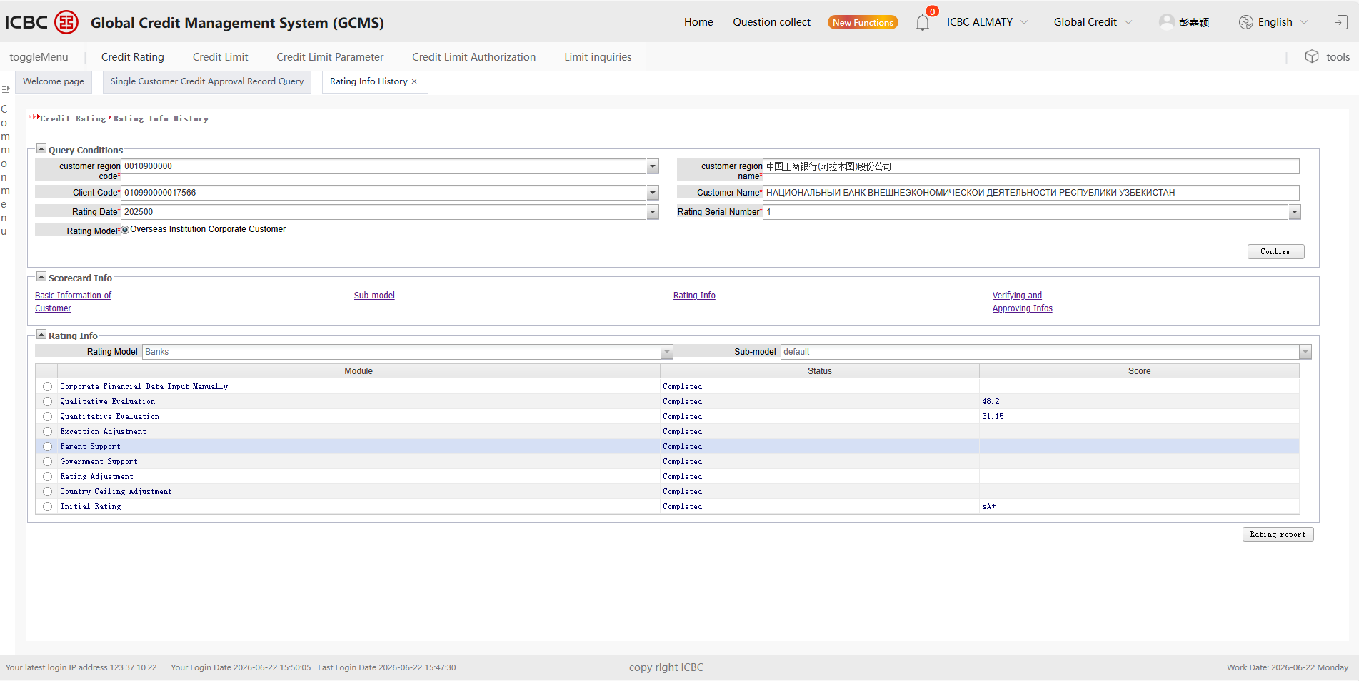
5.2 Credit limit availability
The total credit limit of NBU that Almaty branch has got approved and is still available to use is CNH 350 million, all under interbank financing section. Please see below screenshot:
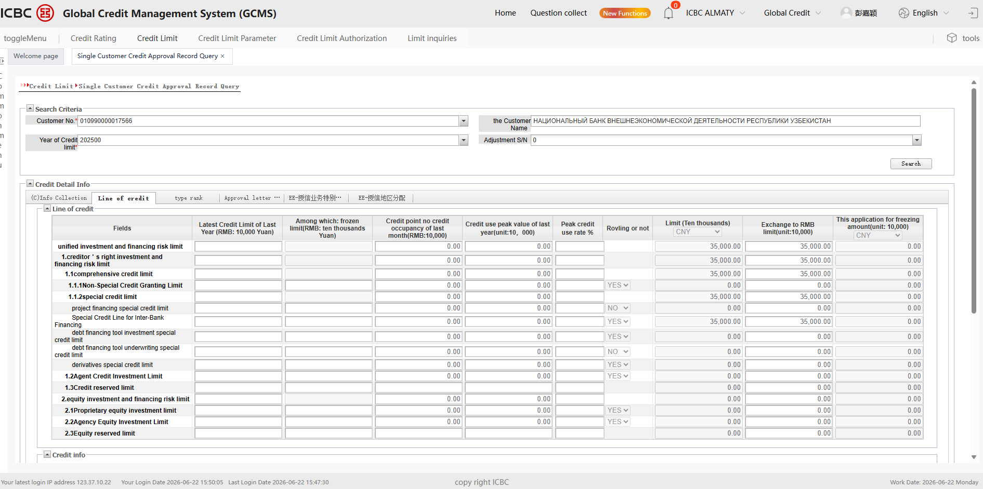
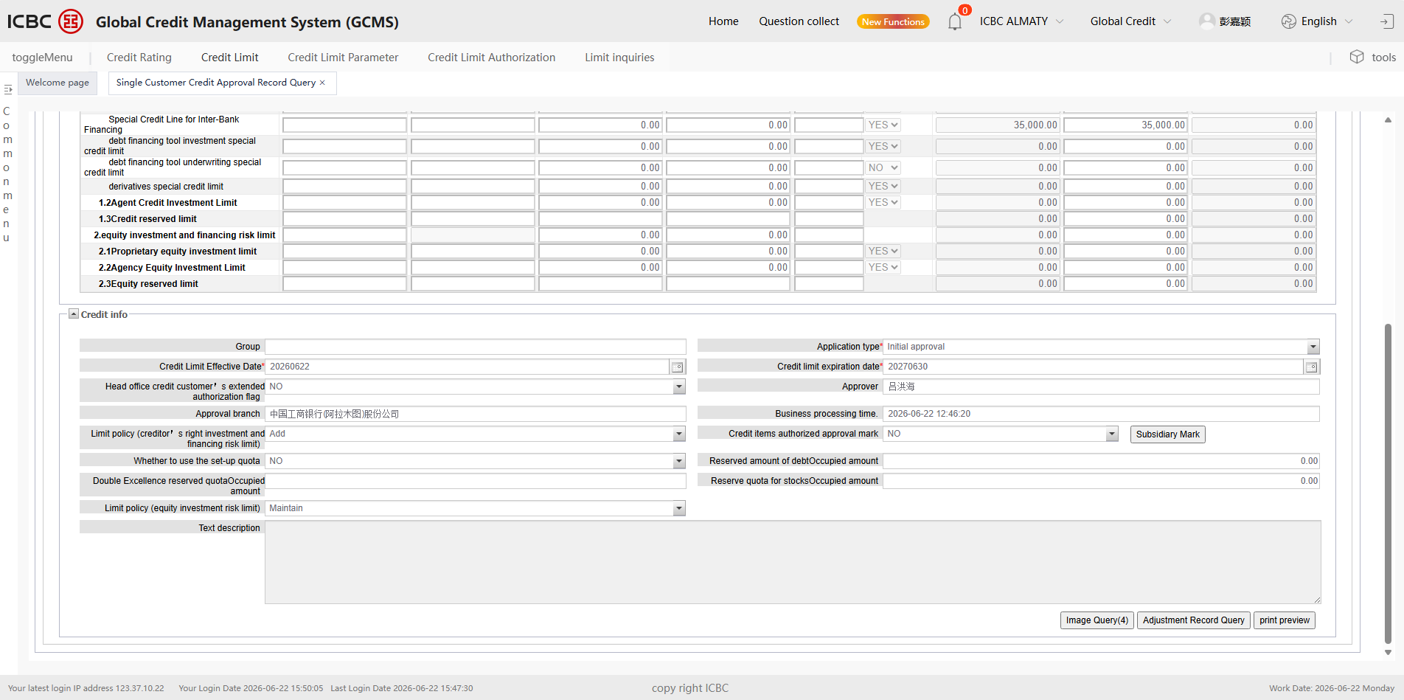
Regarding ICBC Dubai Branch’s single transaction limit application rationale, we apply the standard internal credit methodology to NBU. The process and results are set out below (USD/UZS = 12,150):
CTA = min(CTA1, CTA2) × adj1 × adj2
Parameter | Calculation
CTA1 | = a (risk factor weight) × CT0 =2.5% × USD 200 billion = USD 5 billion
Risk factor weight (a) | Ba3 / BB corresponds to an internal rating of sA+ (pending final approval). Per ICBC internal rule, risk factor weight a = 2.5%.
CT0 | Per ICBC internal rule, CT0 = USD 200 billion.
CTA2 | = b (concentration factor weight) × Total Liabilities = 0.5% × USD 10,270 million = USD 51.4 million
Concentration factor (b) | NBU is a commercial bank with total assets USD 11.9 billion (between USD 10 billion and USD 50 billion threshold). Per ICBC rule, b = 0.5%.
Total Liabilities (USD) | UZS 124,777.0 billion ÷ 12,150 × 1,000 = approximately USD 10,270 million.
Client importance factor (adj1) | NBU is the largest bank in Uzbekistan and a key correspondent in Central Asia. adj1 = 1.0
Client relationship factor (adj2) | Our institution does not have a local branch in Uzbekistan. adj2 = 1.0
CTA = max supportable credit line | = min(USD 5 billion, USD 51.4 million) × 1.0 × 1.0 = USD 51.4 million

5.3 Conutry risk limit
After CRC meeting arrroved this transaction, we hereby apply for the country risk limit of Uzbekistan.
Part 6. Transaction Details
6.1 Cost-Income Analysis
- The revenue and cost analysis below reflects the term-sheet pricing - a fixed interest rate of 3.8% per annum and a 0.6% flat upfront fee - and ICBC (DIFC Branch)'s cost of funds for three-year CNH of 1.87% per annum. Figures are indicative and remain subject to confirmation by Treasury / FID.
- Loan yield (fixed): 3.80% per annum (380 bps).
- Cost of funds (3-year CNH): 1.87% per annum (187 bps).
- Net interest spread: 3.80% - 1.87% = 1.93% per annum (193 bps).
- Upfront fee: 0.60% flat on the committed amount (one-time).
- This transaction does not involve an SBLC or any third-party risk participation, so there is no SBLC fee to deduct and the full spread is retained by ICBC (DIFC Branch).
- Net income to ICBC (DIFC Branch): approximately 1.93% per annum (net interest spread), plus the 0.60% upfront fee.
Applied to ICBC (DIFC Branch)'s own CNH 100 million commitment: net interest income of approximately CNH 1.9 million per annum (CNH 100 million x 1.93%), plus an upfront fee of approximately CNH 0.6 million (CNH 100 million x 0.60%). Over the three-year tenor this totals approximately CNH 6.4 million (about CNH 2.1 million per annum equivalent), or approximately USD 0.93million in aggregate (around USD 0.31 million per annum) at an indicative rate of CNH 6.9 per USD. Final figures depend on the confirmed committed amount, drawn balances and cost of funds. These figures reflect ICBC (DIFC Branch)'s own CNH 100 million commitment and exclude the CNH 100 million fronted for ICBC (Asia) under the risk participation agreement, the economics of which accrue to ICBC (Asia).
6.2 Conclusion
Based on the information mentioned above, our department proposes for the loan transaction as we deem the credit risk of mentioned transaction is controllable, taking consideration of its shareholder strength, market position and financial performance. The principal responsible for the management of this transaction is Rudy Benayoun.

Relationship Manager: Hanfang Bao
Primary Responsible Person of Operation: Rudy Benayoun
Financial Institution Department
June 2026
Reviewed and approved by:
Date:
Hanfang Bao | Chen Xiaotong | Rudy Benayoun
1st Investigator | 2nd Investigator | Head of FID

