SI 211: Numerical Analysis

Homework 1

朱佳会_hw1_2018233141

Problem 1.

Solution:

(a) When x = π, f(π) = 0, so the numerical approximation error is 10-13. Here is the program in Julia.

julia> function f(x)

return (sin(1e+4*x))/x;

end

f (generic function with 1 method)

julia> f(pi)

-1.5459749480948014e-13

(b) The numerical approximation error is 10-2.

According to the form of a factorable function , when x = 10-10:

a0 = x,

a1 = 104*a0 ,

a2 = sin(a1),

a3 = a2 / a0,

f(x) = a3.

In the worst case, the numerical errors associated with evaluating the atom operators Φ1, . . ., ΦN may add up and lead to a potentially large evaluation error ∆aN:

∆a0 ≈ eps

∆a1 ≈  = 104*eps + eps

∆a2 ≈  = cos(10-6)*(104*eps + eps) + eps

∆a3 ≈ 

= *eps + 1010 *cos(10-6)*(104*eps + eps) + eps

≈ 10-2

Problem 2.

Solution:

Here is the program in Julia by using the above routine diff. and the plot of the numerical differentiation error.

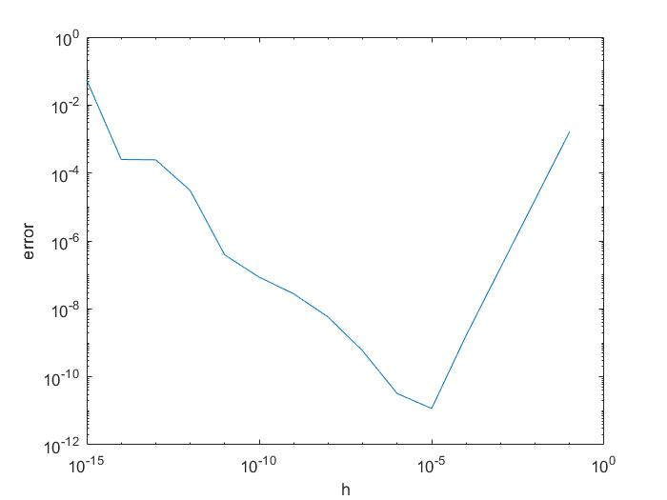From the plot, when h ≈ 10-5, the numerical differentiation error is the minimum.

julia> function f(x)

return exp(x)

end

f (generic function with 1 method)

julia> function diffCentral(f,x,h)

return (f(x+h)-f(x-h))/(2*h)

end

diffCentral (generic function with 1 method)

julia> x = 0.0

0.0

julia> function error(h)

return abs(diffCentral(f,x,h)-1.0);

end

error (generic function with 1 method)

julia> error(1e-1)

0.0016675001984409743

julia> error(1e-2)

1.6666749992122476e-5

julia> error(1e-3)

1.6666668134490692e-7

julia> error(1e-4)

1.6668897373506297e-9

julia> error(1e-5)

1.2102319146833906e-11

julia> error(1e-6)

2.6755486715046572e-11

julia> error(1e-7)

5.26355847796367e-10

julia> error(1e-8)

6.07747097092215e-9

julia> error(1e-9)

2.7229219767832546e-8

julia> error(1e-10)

8.274037099909037e-8

julia> error(1e-11)

8.274037099909037e-8

julia> error(1e-12)

3.3389431109753787e-5

julia> error(1e-13)

0.00024416632504653535

julia> error(1e-14)

0.0007992778373591136

julia> error(1e-15)

0.05471187339389871

Problem 3.

Solution:

(a)The corresponding algorithm for evaluating the derivative of f (x) using the forward mode of algorithmic differentiation (AD) is:

b0 = 1,

b1 = -b0*sin(a0),

b2 = b1*a1 +a1*b1,

b3 = b1*cos(a0),

b4 = b2*a3 +a2*b3,

 = b4

(b)The order of magnitude of the numerical error is zero. Theoretically, there is no error when calculating the function because of x = 0.

Here is the program in Julia. From the result, the numerical error is zero.

julia> import Base.*

julia> import Base.sin

julia> import Base.cos

julia> mutable struct ADV

a

b

end

julia> function *(A::ADV,B::ADV)

return ADV(A.a*B.a,A.b*B.a+A.a*B.b);

end

* (generic function with 344 methods)

julia> function sin(A::ADV)

return ADV(sin(A.a),cos(A.a)*A.b);

end

sin (generic function with 13 methods)

julia> function cos(A::ADV)

return ADV(cos(A.a),-sin(A.a)*A.b);

end

cos (generic function with 13 methods)

julia> function f(x)

return (sin(cos(x)))*(cos(x*x));

end

f (generic function with 1 method)

julia> x = ADV(0.0,1.0);

julia> f(x)

ADV(0.8414709848078965, -0.0)