1. Because $p\left(x_{i}\right)=f(x_{i})$ for all $i∈\{0,…,n\}$

$$p\left(0\right)=a_{0}=1$$

$$p\left(1\right)=a_{0}+ a_{1}+a_{2}=3$$

$$p\left(2\right)=a_{0}+ {2a}_{1}+{4a}_{2}=19$$

Solve the equation: $a_{0}=1,a_{1}=-5,a_{2}=7$

1. Because $p\left(x_{i}\right)=f(x_{i})$ for all $i∈\{0,…,n\}$

$$p\left(0,0\right)=a_{0}=1$$

$$p\left(0,1\right)=a_{0}+a_{3}+a_{4}=3$$

$$p\left(0,2\right)=a_{0}+{2a}_{3}+{4a}_{4}=19$$

$$p\left(1,0\right)=a_{0}+a_{1}+a_{2}=3$$

$$p\left(2,0\right)=a_{0}+{2a}_{1}+{4a}_{2}=19$$

$$p\left(1,1\right)=a_{0}+a_{1}+a_{2}+a_{3}+a_{4}+a_{5}=0$$

Solve the equation: $a_{0}=1,a_{1}=-5,a_{2}=7,a_{3}=-5,a_{4}=7,a_{5}=-5$

3.

(a) the function $f(x) = sin(x)$:

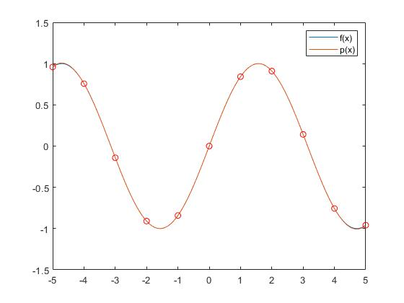

Error values:

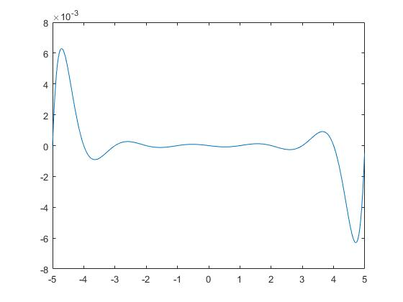

$$\left|f\left(x\right)-p\left(x\right)\right|≤\frac{1}{\left(n+1\right)!}\prod_{j=1}^{n}{\left(x-x_{i}\right)}≤{\frac{1}{\left(n+1\right)!}\left[\overline{x}-\underline{x}\right]}^{n}≤\frac{1}{11!}*{10}^{10}≈250.521$$

(b) the function $f\left(x\right)=\frac{1}{1+x^{2}}$:

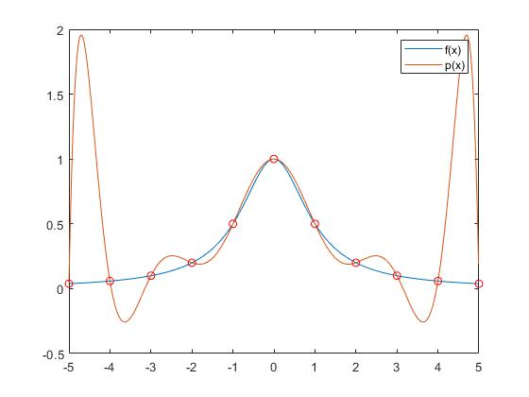

Error values:

$$\left|f\left(x\right)-p\left(x\right)\right|≤\frac{1}{\left(n+1\right)!}\prod_{j=1}^{n}{\left(x-x_{i}\right)}≤{\frac{1}{\left(n+1\right)!}\left[\overline{x}-\underline{x}\right]}^{n}≤\frac{1}{11!}*{10}^{10}≈250.521$$

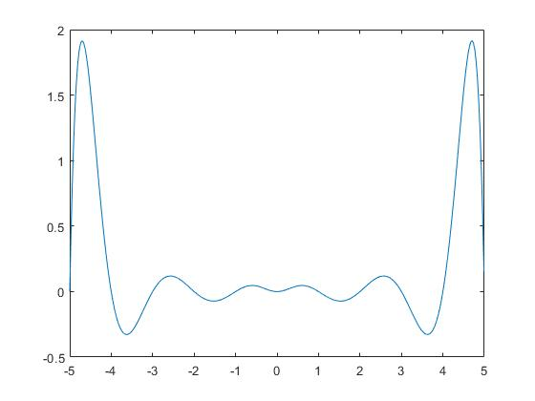

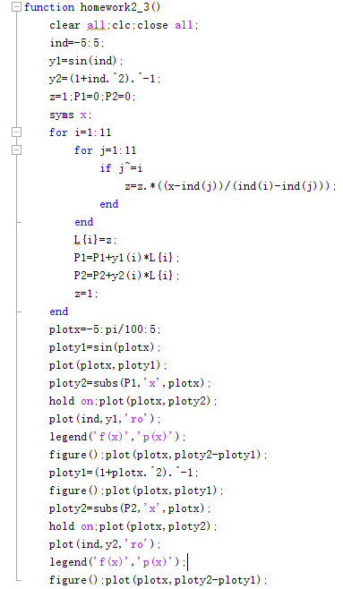Matlab code:

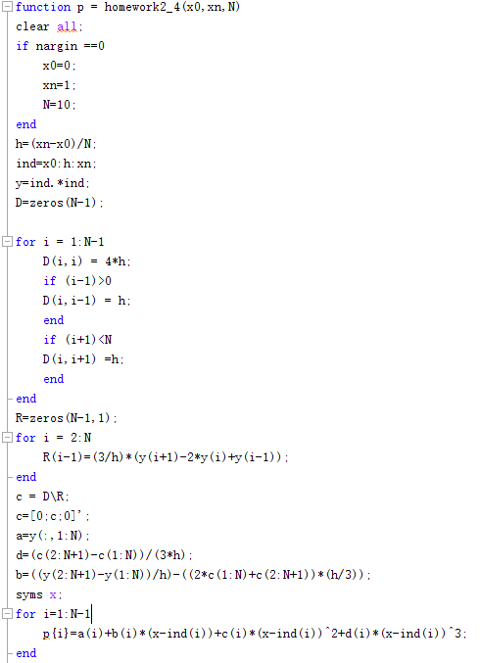4.

5. 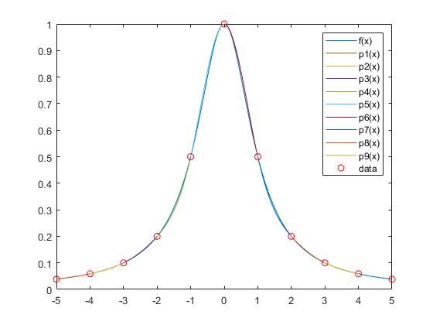

6.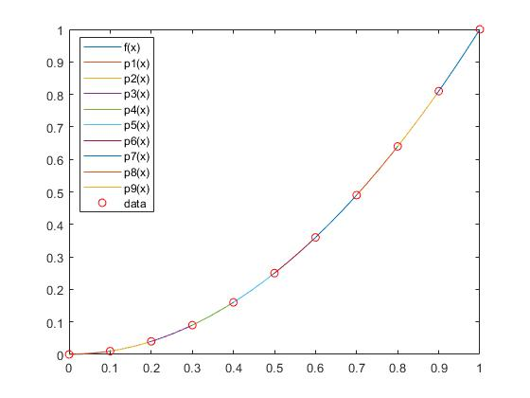

c =

0 1.2680 0.9282 1.0193 0.9945 1.0028 0.9945 1.0193 0.9282 1.2680

a =

0 0.0100 0.0400 0.0900 0.1600 0.2500 0.3600 0.4900 0.6400 0.8100

d =

4.2265 -1.1326 0.3039 -0.0829 0.0276 -0.0276 0.0829 -0.3039 1.1326 -4.2265

b =

0.0577 0.1845 0.4041 0.5989 0.8003 1.0000 1.1997 1.4011 1.5959 1.8155

$$\int_{0}^{1}{{\left[p^{''}\left(x\right)\right]}^{2}dx=3.769061}$$

So $\int_{0}^{1}{{\left[p^{''}\left(x\right)\right]}^{2}dx<}\int_{0}^{1}{{\left[f^{''}\left(x\right)\right]}^{2}dx}$