1.Solution1:

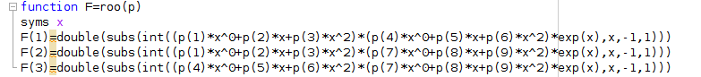



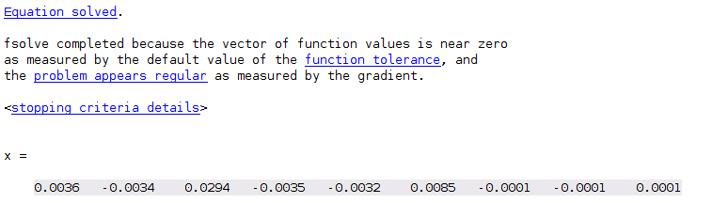

check the result：

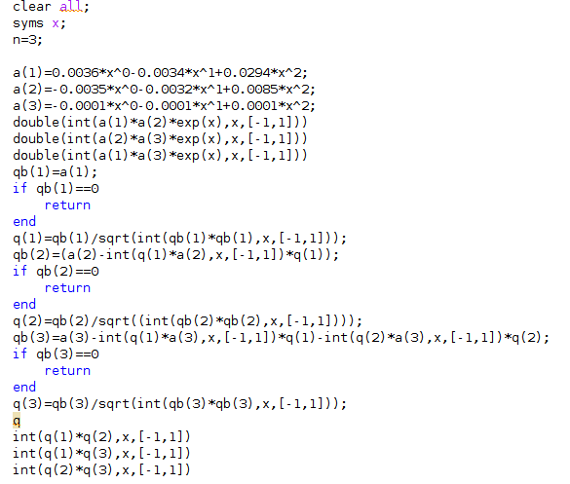

》homework3_1

ans =

-5.5904e-07

ans =

4.8577e-07

ans =

-2.6800e-06

q =

[ (1250*15^(1/2)*12199^(1/2)*((147*x^2)/5000 - (17*x)/5000 + 9/2500))/12199, -(2500*73194^(1/2)*8400539^(1/2)*((2*x)/625 - (17*x^2)/2000 + (317*15^(1/2)*12199^(1/2)*182985^(1/2)*((147*x^2)/5000 - (17*x)/5000 + 9/2500))/892893606 + 7/2000))/8400539, (4000*25201617^(1/2)*(x^2/10000 - x/10000 + (317615*73194^(1/2)*8400539^(1/2)*614869051566^(1/2)*((2*x)/625 - (17*x^2)/2000 + (317*15^(1/2)*12199^(1/2)*182985^(1/2)*((147*x^2)/5000 - (17*x)/5000 + 9/2500))/892893606 + 7/2000))/6886975263430925432 + (389*15^(1/2)*12199^(1/2)*182985^(1/2)*((147*x^2)/5000 - (17*x)/5000 + 9/2500))/35715744240 - 1/10000))/449]

ans =

0

ans =

0

ans =

0

Solution 2:

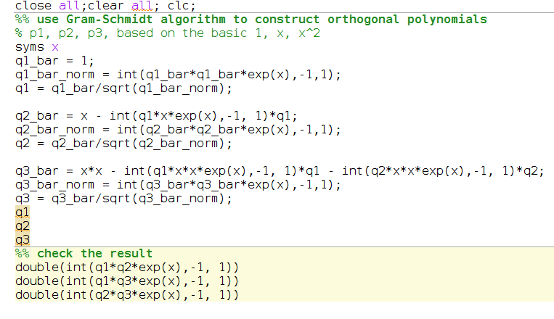

q1 =

1/(exp(1) - exp(-1))^(1/2)

q2 =

((x + (2*exp(-1))/(exp(-1) - exp(1)))*(exp(2) - 1)^(1/2))/(exp(-1)*(exp(4) - 6*exp(2) + 1))^(1/2)

q3 =

((x^2 + (exp(-1)*(exp(2) - 5))/(exp(-1) - exp(1)) + (2*exp(-1)*(x + (2*exp(-1))/(exp(-1) - exp(1)))*(exp(2) - 1)^(1/2)*(exp(4) - 8*exp(2) + 3))/((exp(-1)*(exp(4) - 6*exp(2) + 1))^(1/2)*(exp(-1)*(exp(2) - 1)*(exp(4) - 6*exp(2) + 1))^(1/2)))*(7*exp(2) - 7*exp(4) + exp(6) - 1))/(2*(-exp(-1)*(1179*exp(4) - 257*exp(2) - 2177*exp(6) + 1681*exp(8) - 507*exp(10) + 65*exp(12) - 3*exp(14) + 18*(exp(2) - 1)^(1/2)*(exp(4) - 6*exp(2) + 1)^(1/2)*(7*exp(2) - 7*exp(4) + exp(6) - 1)^(1/2) - 96*exp(2)*(exp(2) - 1)^(1/2)*(exp(4) - 6*exp(2) + 1)^(1/2)*(7*exp(2) - 7*exp(4) + exp(6) - 1)^(1/2) + 140*exp(4)*(exp(2) - 1)^(1/2)*(exp(4) - 6*exp(2) + 1)^(1/2)*(7*exp(2) - 7*exp(4) + exp(6) - 1)^(1/2) - 32*exp(6)*(exp(2) - 1)^(1/2)*(exp(4) - 6*exp(2) + 1)^(1/2)*(7*exp(2) - 7*exp(4) + exp(6) - 1)^(1/2) + 2*exp(8)*(exp(2) - 1)^(1/2)*(exp(4) - 6*exp(2) + 1)^(1/2)*(7*exp(2) - 7*exp(4) + exp(6) - 1)^(1/2) + 19))^(1/2))

ans =

1.1320e-72

ans =

7.2445e-71

ans =

1.1772e-69

2

.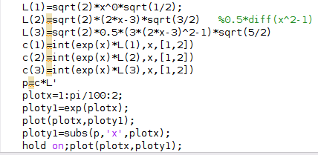

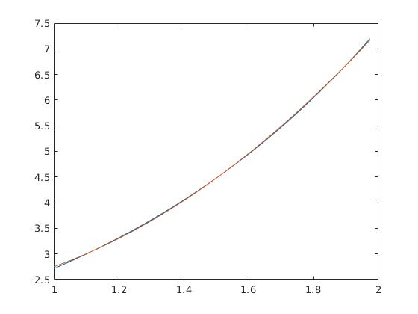

3.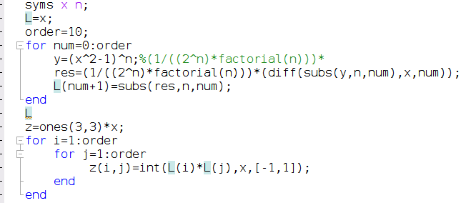

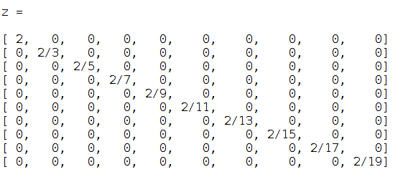

$$<L_{i},L_{j}>=\frac{2}{2i+1}δ_{i,j}$$

4.

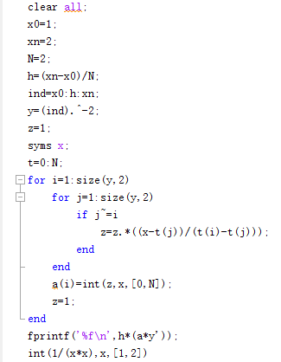

n=2: 0.504630

n=3: 0.502188

n=4: 0.500137

1. The above code computes an integral approximation of the form

$$\int_{a}^{b}{f(x)dx≈\frac{h}{2} f(a)+\sum_{i=1}^{N−1}{hf(x_{i})}+\frac{h}{2}f(b)}$$

$$=\sum_{i=1}^{N−1}{h\frac{f(x_{i})+f(x_{i+1})}{2}}$$

with $x_{i}= a + ih$ and $h =\frac{b−a}{N}$. This approximation corresponds to summed trapezoidal integration rule. Thus, if we run the command

$$integrate(f,0.0,1.0,10)$$

the code would return an approximation of the integral $\int_{0}^{1}{x^{2}}dx$ that is obtained by dividing the interval [0, 1] into 10 sub-intervals and using the trapezoidal rule on each of these intervals.

The summed trapezoidal rule returns the integral approximation

$$\sum_{i=0}^{N−1}{h}\frac{f(x_{i})+f(x_{i+1})}{2}=\sum_{i=0}^{N−1}{\frac{{(\frac{i}{N})}^{2}+{(\frac{i+1}{N})}^{2}}{2N}}$$

$$=\frac{1}{N^{3}}\sum_{i=0}^{N−1}{[i^{2}+i+\frac{1}{2}]}$$

$$=\frac{1}{N^{3}}[\frac{(N−1)N(2N−1)}{6}+\frac{N(N−1)}{2}+\frac{N}{2}]$$

$$=\frac{1}{3}+\frac{1}{6N^{2}}$$

This number must be compared with the exact value $K =\int_{0}^{1}{x^{2}}dx = \frac{1}{3}$, which yields the integration error

$$abs(integrate(f, 0, 1, N) − K) = \frac{1}{6}N^{−2}$$

Thus, we have q = 2