1. What is the bit representations of the floating point number 6.25 using the IEEE standard
for double precision numbers? Please explain all intermediate derivation steps. Use the
JULIA command bitstring(6.25) (or any other programming language) to verify your
result.

IEEE standard for double-precision floating point numbers:
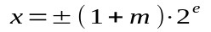 with 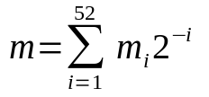 and 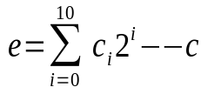

Storage requirement:
- 1 bit to store the sign.
- 11 bits to store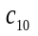, . . . , ∈ {0, 1}; offset 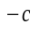 = 1023.
- 52 bits to store 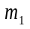 , . . . 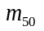 ∈ {0, 1} .
∵ 6.25=(1+9/16)*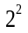
m=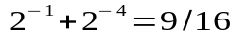
e=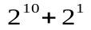-1023=2

∴
- 1 bit :0
- 11 bits:10000000001
- 52 bits:1001000000000000000000000000000000000000000000000000

The bit representations of the floating point number 6.25 using the IEEE standard
for double precision numbers is 0100000000011001000000000000000000000000000000000000000000000000
2. We want to evaluate the function
f (x) =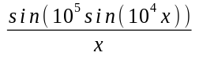
for different values of x.
(a) Evaluate the above function at x = π by using Matlab, Julia, C++ or any other pro-
gramming language of your choice. How big is the numerical approximation error? Can
you explain why you observe this error?
(b) Evaluate the above function at x = 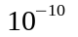. How big is the numerical evaluation error?


(a)

eps=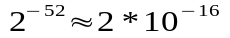
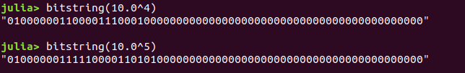

10^4 exponent e=13
10^5 exponent e=16

Because we work with larger numbers,we get larger errors.
(b)

f(x) if factorable,we can do this in Julia to evaluate the numerical evaluation error:
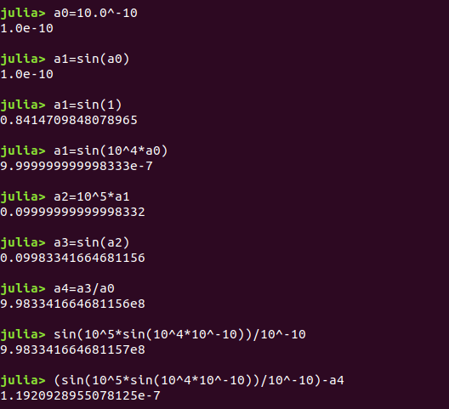

3.Numeric differentiation based on central differences:
(a) Implement a function (for example in Python, Julia, or Matlab) that uses numeric
differentiation based on central differences,
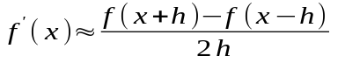
Here, the inputs of the differentiation routine are the scalar function f that we want
to differentiate, the point x at which the derivative should be evaluated, and the finite
perturbation h > 0. Use the syntax
diff(f,x,h) = ...
(b) Evaluate the derivative of the function f (x) = exp(x) at x = 0 using the above routine
diff. Plot the numerical differentiation error in dependence on h ∈ [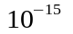 , 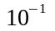 ] and
interpret the result. Use logarithmic scales on both axis!

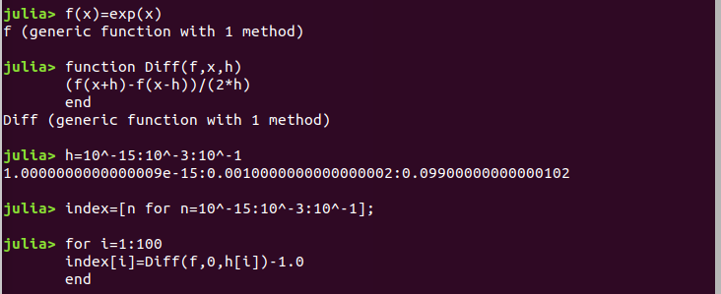
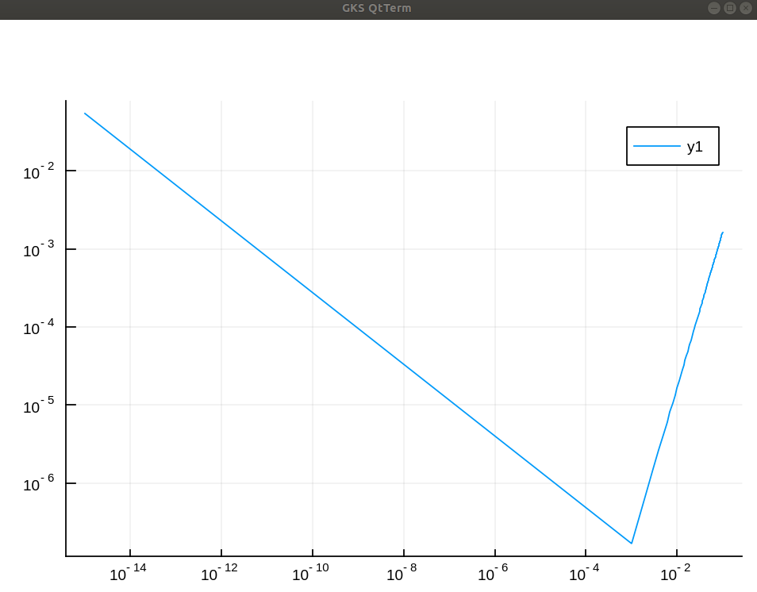
The numerical differentiation error is produced by numerical error and
mathematical error together.
The mathematical approximation error is now 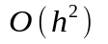
The numerical error is 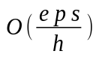
to minimize the total error we choose 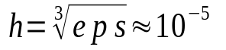

4. Let f be a 5-times continuously differentiable function. Consider the numerical difference
formula
What is the mathematical approximation error? How would you choose h?
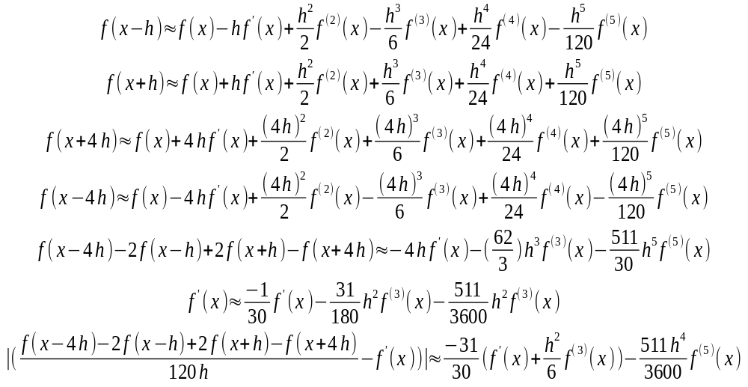
we should choose h to minimize the error. that is to minmize

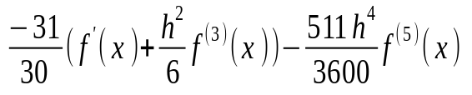

5. In order to evaluate the factorable function f (x) = sin(cos(x))∗cos(x) 2 we write an evaluation
algorithm of the form
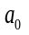 =
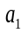 = 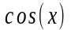
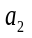 =∗
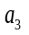 = sin( )
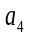 = ∗
f () =
What is the corresponding algorithm for evaluating the derivative of f (x) using the forward
mode of algorithmic differentiation (AD)? What is the order of magnitude of the numerical
error that is associated with evaluating the derivative of f at x = 0 using this AD code?
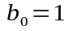
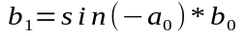
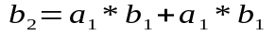
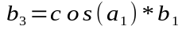
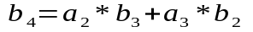
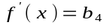

Julia Code :

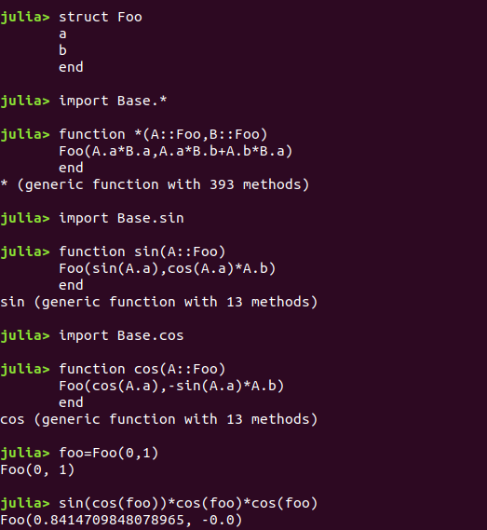

So the derivative of f at x = 0 using this AD code is 0 , the numerical error is also 0,that means the order of magnitude of the numerical error is 0.

