9/24 APIs

1. 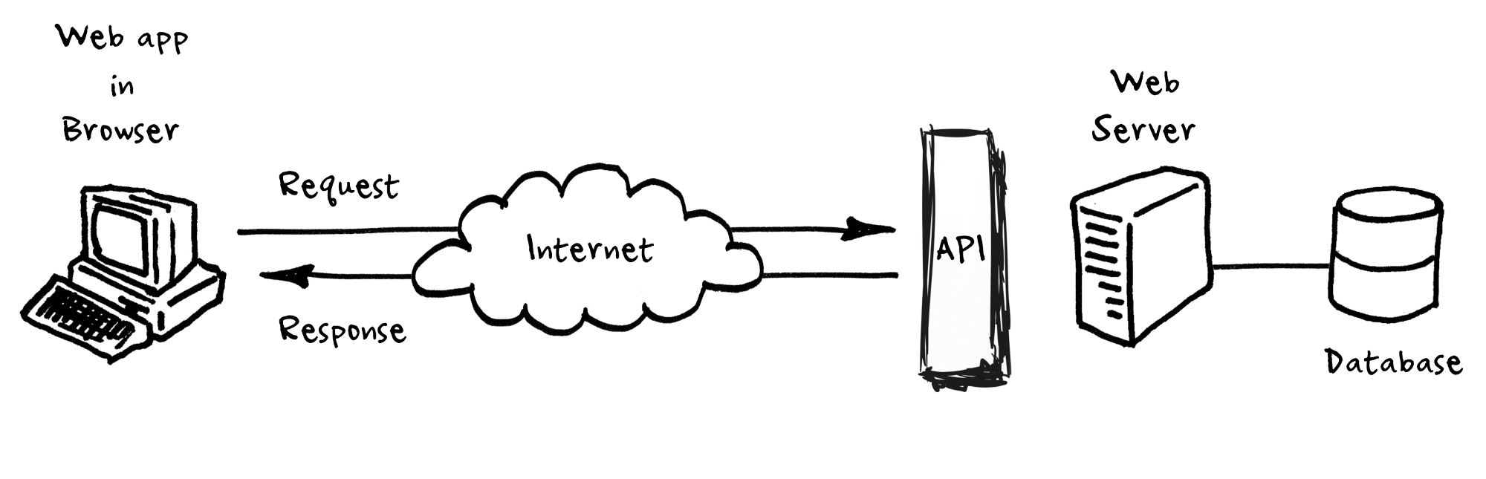Application Programming Interface (API) – it is an access point to an app that can access a database
   1. API allow us to go get data from outside sources
   2. We can send an API a request detailing the information we want
   3. APIs allow our sites to alter data on other applications. For example, the “Share on Facebook” button, when you click one of these buttons, the site you’re visiting can communicate with your Facebook or Twitter account, and alter its data by adding new status or tweet
2. How do you build a public API?
   1. A backend with routing of some sort as mentioned above
   2. A database where your application can store its data
   3. 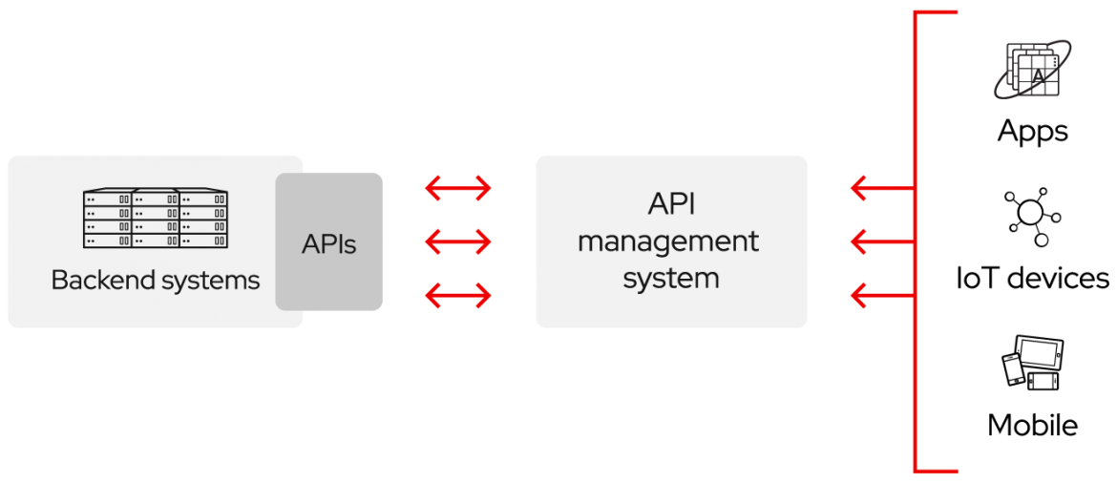A server, likely a VPS (Virtual Private Server) that is accessible to the internet, where your application can run
3. Three approaches to API release policies:
   1. **Private:** The API is only for use internally. This gives companies the most control over their API
   2. **Partner:** The API is shared with specific business partners. This can provide additional revenue streams without compromising quality
   3. **Public:** The API is available to everyone. This allows third parties to develop apps that interact with your API and can be a source for innovation

Resources cited:

<https://medium.com/@perrysetgo/what-exactly-is-an-api-69f36968a41f>

<https://www.redhat.com/en/topics/api/what-are-application-programming-interfaces>