9/26 Kubernetes (K8s)

1. An open-source system fro automating deployment, scaling, and management of containerized applications
   1. It groups containers that make up an application into logical units for easy management and discovery, I,e, you can cluster together groups of hosts running Linux containers, and Kubersnetes helps you easily and efficiently manage those clusters
   2. Planet Scale
   3. Never Outgrow
   4. Run Anywhere
2. Also known as k8s or “kube”
3. Originally developed and designed by engineers at Google
   1. Generates more than 2 billion container deployment a week
   2. Internal platform “Borg”
4. Can span hosts across on-premise, public, private, or hybrid clouds – ideal for hosting cloud-native applications that require rapid scaling, like real-time data streaming through Apache Kafka
5. With Kubernetes, you can:
   1. Orchestrate containers across multiple hosts.
   2. Make better use of hardware to maximize resources needed to run your enterprise apps.
   3. Control and automate application deployments and updates.
   4. Mount and add storage to run stateful apps.
   5. Scale containerized applications and their resources on the fly.
   6. Declaratively manage services, which guarantees the deployed applications are always running the way you intended them to run.
   7. Health-check and self-heal your apps with autoplacement, autorestart, autoreplication, and autoscaling.

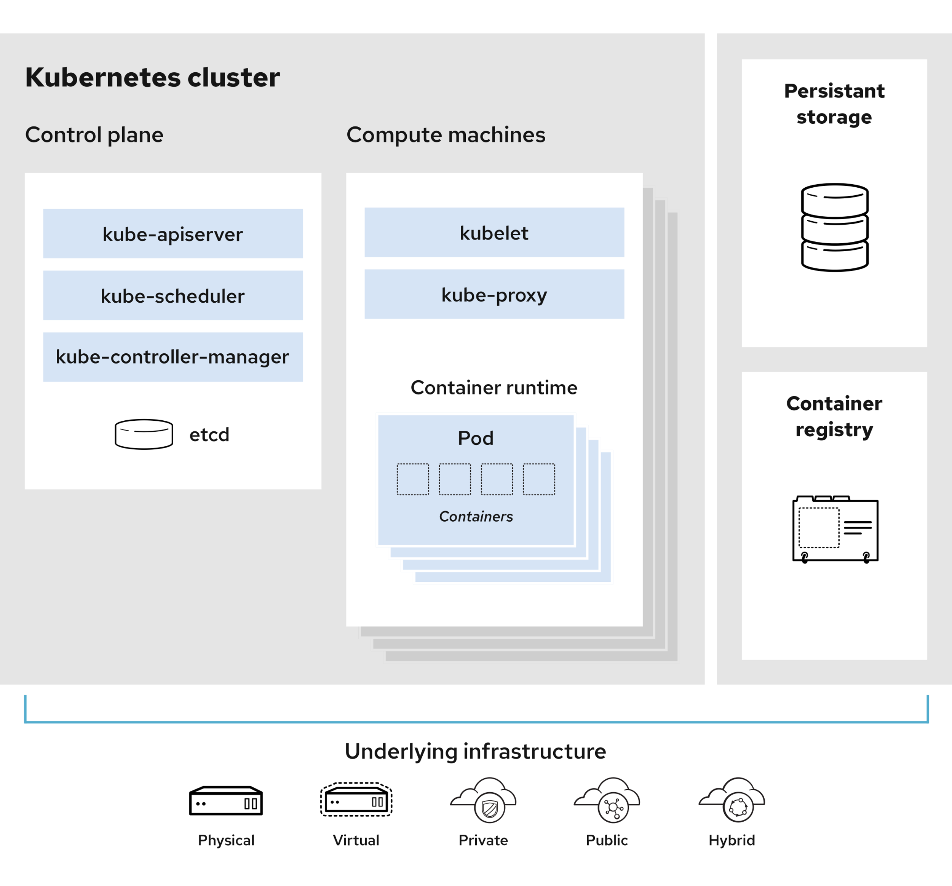

Resources Cited:

<https://kubernetes.io>

https://www.redhat.com