9/27 Day14-Active Directory

1. Active Directory (AD) is Microsoft's proprietary directory service. It runs on [Windows Server](https://searchwindowsserver.techtarget.com/definition/Microsoft-Windows-Server-OS-operating-system) and allows administrators to manage permissions and access to network resources.
2. AD stores data as objects
   1. A printer
   2. A user
   3. A security principal
3. AD categorizes directory objects by name and attributes
4. Active Directory services
   1. Domain Services (AD DS) – main service which stores directory information and handles the interaction of the user with the domain
   2. Lightweight Directory Services
   3. LDAP
   4. Certificate Services
   5. Active Directory Federation Services
   6. Rights Management Services
5. Tiered Layout of AD Domain Services
   1. 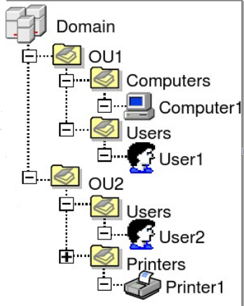Domain (Root) – whereby a user may be granted access to a number of computer resources with the use of a single username and password combination
   2. Organizational Units – container object
   3. Group
   4. User
6. Trusting Terminology
   1. One-way trust
   2. Two-way trust
   3. Trusted domain
   4. Transitive trust
   5. Intransitive trust
7. Domain Controller (DC)
   1. A domain controller is a server that is running a version of the Windows Server operating system and has AD DS installed
   2. Responds to security authentication requests (logging in, checking permissions, etc) within a Windows domain

Resources referenced:

<https://searchwindowsserver.techtarget.com/definition/Active-Directory>

https://medium.com/@yoursproductly/understanding-active-directory-4e7508372b80