9/20 ACID transactions

1. ACID (Atomicity, Consistency, Isolation, Durability)
   1. Set of properties of **database transactions** intended to guarantee **data validity** despite errors, power failures, and other mishaps
   2. **Transactions:** A sequence of database operations that satisfies the ACID properties
      1. Read and write operations, for example
2. 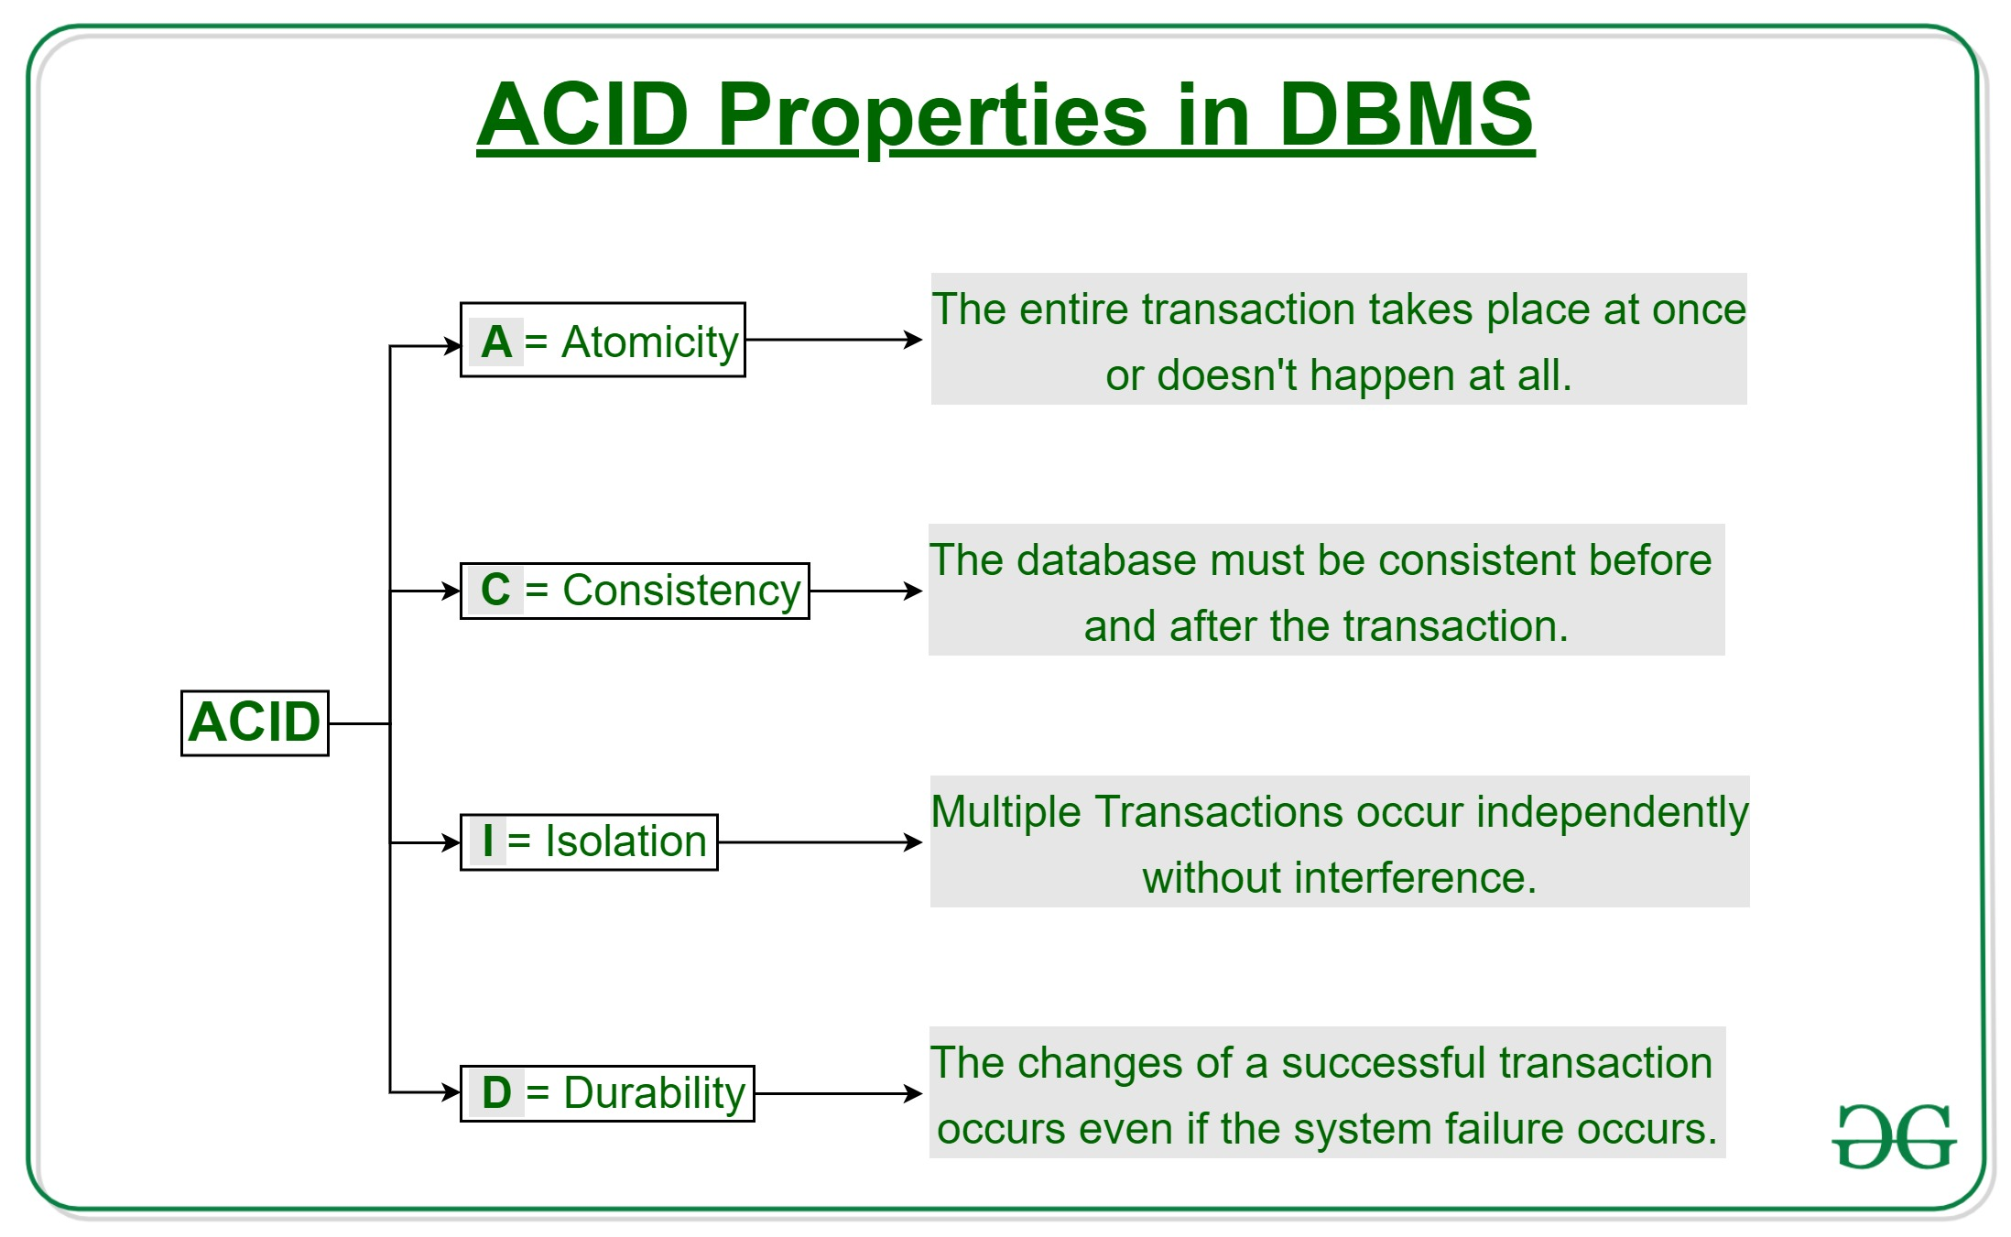ACID Properties in DBMS
3. Atomicity
   1. Involves the following two operations:
      1. Abort –if a transaction aborts, changes made to database are not visible
      2. Commit – if a transaction commits, changes made are visible
   2. All or nothing rule
4. Consistency
   1. Data integrity must be maintained
5. Isolation
   1. Ensures that multiple transactions can occur concurrently without leading to the inconsistency of database state
6. Durability
   1. Ensures that once the transaction has completed execution, the updates and modifications to the database are stored in and written to disk and they persist even if a system failure occurs

Resources cited: https://www.geeksforgeeks.org/acid-properties-in-dbms/