Day 9 - 9/22 Snowflake

News related to Snowflake: stock price soars up to $200+ recently

1. What is Snowflake?
   1. A cloud-based data-warehousing company founded in 2012
   2. “data warehouse-as-a-service”
   3. Allows corporate users to store and analyze data using cloud-based hardware and software
2. Architecture of Snowflake:
   1. True separation of storage and compute
      1. The storage layer keeps the data on immutable cloud storage, such as Amazon S3 or Azure Blob Storage
      2. 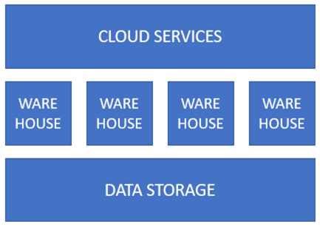The compute layer consists of warehouses
   2. **Cloud services**: the brain of Snowflake which manages crucial resources for the accounts, such as the metadata, authentication and access control, transactions and so on
   3. **Warehouses**: the muscle of the system; elastic virtual machines for compute
   4. **Data Storage**: hybrid columnar storage using micro-partitions
3. Costs
   1. Storage – you pay a certain amount per terabyte per month
   2. Compute – for each second a warehouse is running, you use an amount of credits. The price of a credit depends on the edition of Snowflake you use. An XS warehouse consumes one credit for one full hour of compute. A small warehouse 2 credits, a medium warehouse 4 credits and so on
4. PowerBI and Snowflake
5. Some downsides of Snowflake:
   1. Stored procedures are a combination of JavaScript and SQL
   2. There’s currently no dynamic SQL
   3. The community around Snowflake is quite small and not as vivid as the SQL Server community
   4. The app ecosystem around Snowflake can also use some growth
   5. Snowflake is zero-management, but also zero options

Resources cited:

<https://www.mssqltips.com/sqlservertutorial/9307/get-free-sql-tips--snowflake-tutorial/>