**Round2Day10-Libra**

1. Libra is a permissioned blockchain-based payment system proposed by the American social media company Facebook, Inc. The plan also includes a private currency implemented as a cryptocurrency
2. Code repository: github.com/libra/libra
3. Written language: Rust
4. Facebook wants to make Libra the evolution of PayPal. It is hoping Libra will become simpler to set up, more ubiquitous as a payment method, more efficient with fewer fees, more accessible to the unbanked, more flexible thanks to developers and more long-lasting through decentralization
5. Incentives; rewarding early businesses
6. White Paper: <https://libra.org/en-US/white-paper/>
7. Libra five essential features:
   1. Built on a secure, scalable, and reliable blockchain
   2. It is a stablecoin which is backed by a reserve of assets
   3. It is governed by the independent Libra Association
   4. Uses the LibraBFT consensus mechanism
   5. Smart contract coding is done through “Move” programming language
8. The Libra Blockchain
   1. Not really a blockchain in the traditional sense
   2. Must have the ability to scale to billions of accounts. This requires high transaction throughput, low latency, and an efficient, high-capacity storage system
   3. Must be highly secure, to ensure the safety of funds and financial data
   4. It should be flexible, so that it can power the Libra ecosystem’s governance as well as future innovation in financial services
9. Permissionless v.s. Permissioned
10. Libra’s ‘decentralized, programmable database’
    1. The transactions in Libra will form a sequence (numbered with ever-increasing integers) which will be stored in Merkle Trees

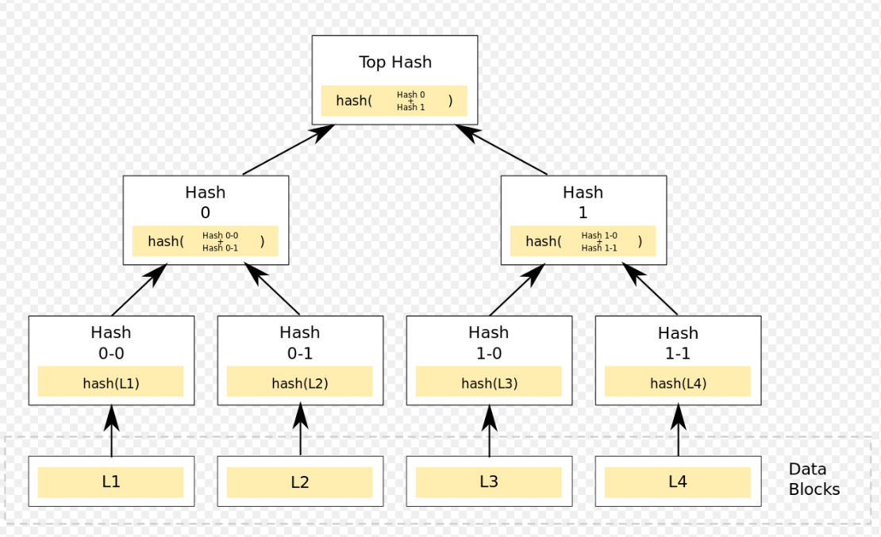

1. Resources referred:
   1. <https://blockgeeks.com/guides/understanding-facebooks-cryptocurrency-libra/>
   2. <https://developers.libra.org/docs/libra-open-source-paper>