Round2Day11 - **Ubuntu**

1. Ubuntu is a Linux distribution based on Debian and mostly composed of free and open-source software.
2. Ubuntu is officially release in three editions: Desktop, Server, and Core for Internet of Things devices and robots.
3. Ubuntu is a popular operating system for cloud computing, with support for OpenStack.
4. OS Family: Linux
5. Initial release: 10/20/2004
6. Ubuntu is developed by Canonical, and a community of other developers, under a meritocratic governance model
7. What is a Linux distribution
   1. An operating system made from a software collection that is based upon the Linux kernel and, often, a package management system
   2. 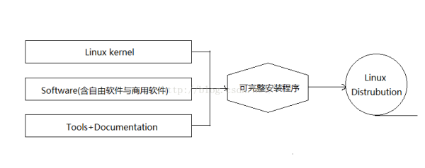A typical Linux distribution comprises a Linux kernel, GNU tools and libraries, additional software, documentation, a window system (the most common being the X window System), a window manager, and a desktop environment
8. Ubuntu Features
   1. Default installation of Ubuntu
   2. Additional software packages are accessible from the built in Ubuntu Software as well as any other APT-based package management tools
9. Resources referred
   1. <https://en.m.wikipedia.org/wiki/Ubuntu>
   2. <https://ubuntu.com/>