Round 2 Day 5 – **Mesos**

1. Apache Mesos is an open-source project to manage computer clusters, and was designed to be completely independent from the underlying infrastructure
2. Written in: C++
3. Mesos uses Linux cgroups to provide isolation for CPU, memory, I/O and file system
4. Airbnb said in July 2013 that it uses Mesos to run data processing systems like Apache Hadoop and Apache Spark
5. As a cluster manager, Mesos was architected to solve for a very different set of challenges:
   1. **Abstract data center resources –** into a single pool to simplify resource allocation while providing a consistent application and operational experience across private or public clouds;
   2. **Colocate diverse workloads –** on the same infrastructure such analytics, stateless microservices, distributed data services and traditional apps to improve utilization and reduce cost and footprint;
   3. **Automate day-two operations –** for application-specific tasks such as deployment, self healing, scaling, and upgrades; providing a highly available fault tolerant infrastructure;
   4. **Provide evergreen extensibility** – to run new application and technologies without modifying the cluster manager or any of the existing applications built on top of it
   5. **Elastically scale –** the application and the underlying infrastructure from a handful, to tens, to tens of thousands of nodes
6. 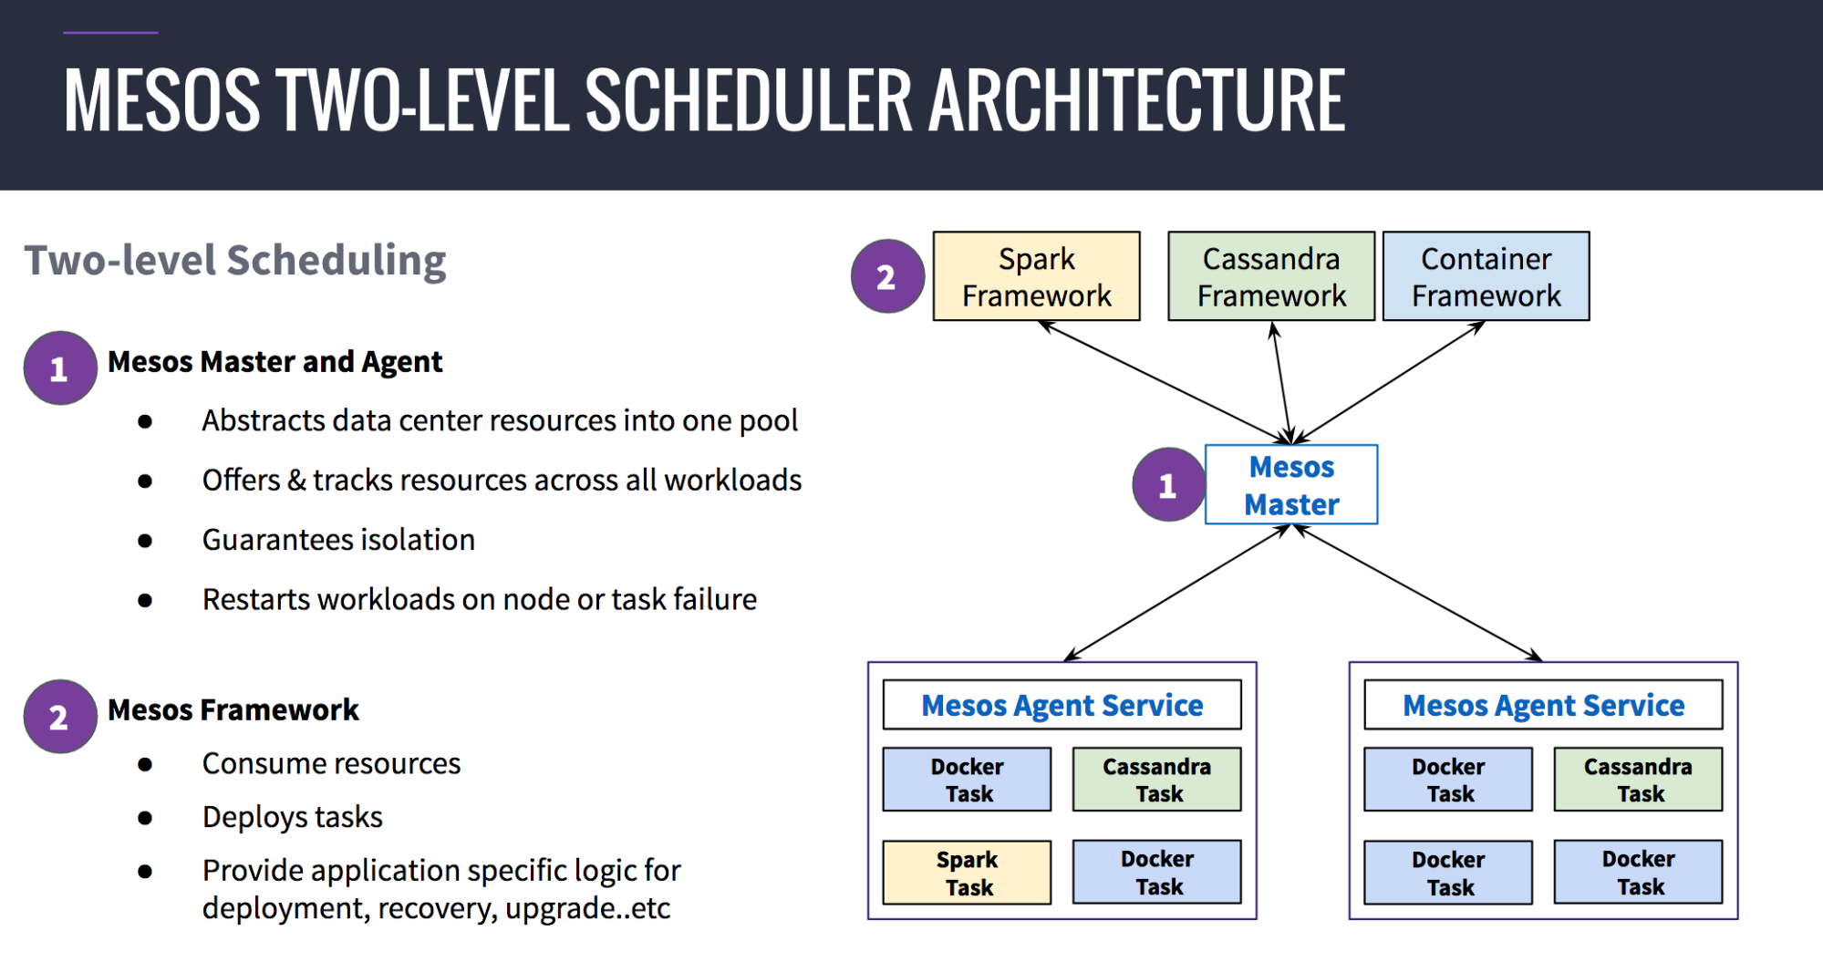 Two-level architecture, enabling “application-aware” scheduling

Resources referred:

<https://en.m.wikipedia.org/wiki/Apache_Mesos>

https://d2iq.com/blog/docker-vs-kubernetes-vs-apache-mesos