**Round2Day8 - Nginx**

* Web server than can also be used as a reverse proxy, load balancer, mail proxy and HTTP cache
* Written language: C
* OS: BSD Variants, HP-UX, IBM AIX, Linux, macOS, Solaris, Windows…
* As of Feb 2020, Nginx is estimated to serve 36.48% of all active websites
* Nginx is built to offer low memory usage and high concurrency
  + Uses an asynchronous, event-driven approach where requests are handled in a single thread
  + One master process can control multiple worker processes
  + Asynchronous means each request can be executed by the worker concurrently without blocking other requests
* Some common features seen in Nginx include:
  + Reverse proxy with caching
  + IPv6
  + Load Balancing
  + FastCGI support with caching
  + WebSockets
  + Handling of static with caching
  + TLS/SSL with SNI
* Nginx vs Apache
  + Apache is another popular open-source web server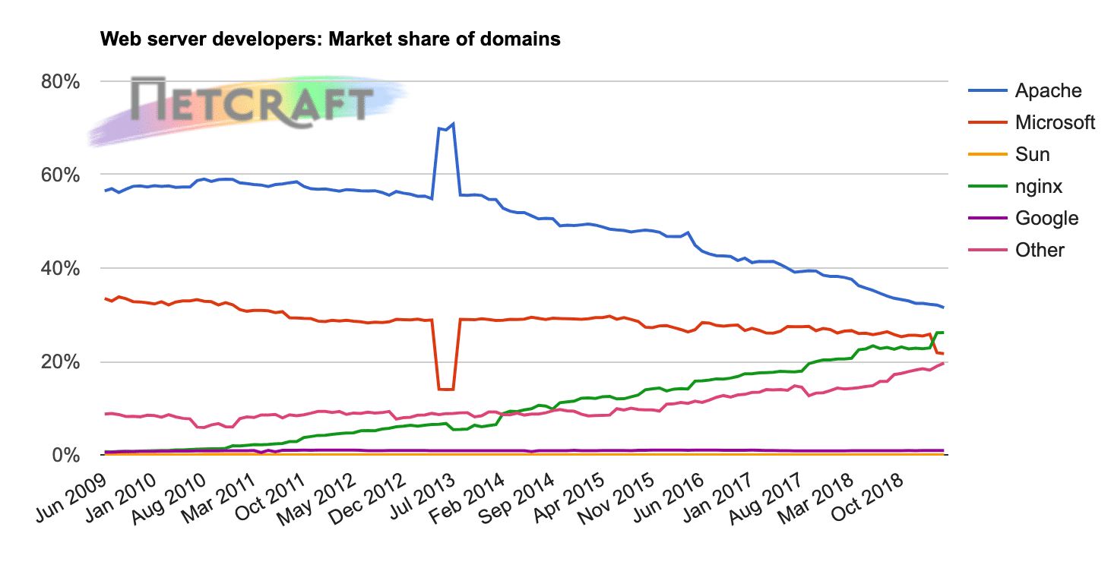 (most popular overall option)
  + Nginx is actually the most popular web server among high-traffic websites
    - Use much less memory than Apache
    - Can handle roughly four times as many requests per second
      * At a cost of decreased flexibility, such as the ability to override systemwide access settings on a per-file basis
    - Has a reputation of being harder to install and configure than Apache

Resources referred:

<https://kinsta.com/knowledgebase/what-is-nginx/>

https://en.m.wikipedia.org/wiki/Nginx