Round2Day9 - **Remote procedure call (RPC)**

* **RPC** is a protocol that one program can use to request a service from a program located in another computer on a network without having to understand the network’s details.
  + It is based on extending the conventional local procedure calling so that the **called procedure need not exist in the same address space as the calling procedure**. The two processes may be on the same system, or they may be on different systems with a network connecting them
  + The calling environment is suspended, procedure parameters are transferred across the network to the environment where the procedure is to execute, and the procedure is executed there
  + When the procedure finishes and produces its results, its results are transferred back to the calling environment, where execution resumes as if returning from a regular procedure call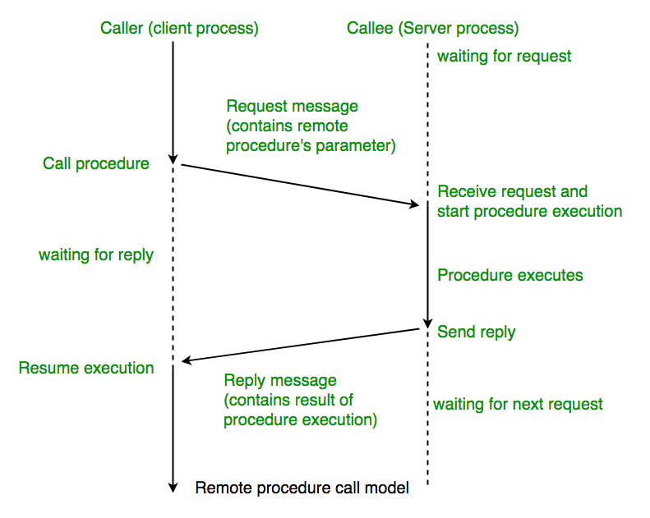
  + RPC is especially well suited for client-server (e.g. query-response) interaction in which the flow of control alternates between the caller and callee. Conceptually, the client and server do not both execute at the same time. Instead, the thread of execution jumps from the caller to the callee and the back again
* The interface definition language (IDL) – the specification language used to describe a software component’s application programming interface (API) — is commonly used in Remote Procedure Call software. In this case, IDL provides a bridge between the machines at either end of the link that may be using different operating systems (OSes) and computer languages.
* Resources referred:

<https://www.geeksforgeeks.org/remote-procedure-call-rpc-in-operating-system/>

<https://en.m.wikipedia.org/wiki/Remote_procedure_call>

<https://searchapparchitecture.techtarget.com/definition/Remote-Procedure-Call-RPC>