1. Convert the following CFG to CNF

S  ABa | AC

A  Ab | a

B  b | C | ●

C  aa

S  ABa | AC | Aa

A  Ab | a

B  b | C

C  aa

S  ABTa | AC | ATa

A  ATb | a

B  b | C

C  TaTa

Ta  a

Tb  b

S  AV1 | AC | ATa

A  ATb | a

B  b | C

C  TaTa

V1  BTa

Ta  a

Tb  b

2. Consider the CNF grammar G = (V,T,S,P) where

V = {S, A, B, C, D }, T = { a, b, c }, S = S and P is given below.

S →AB | AC

A → AA | AB | a

B → BB | BC | b

C → CC | b | c

Use the CKY to determine if the string w = aabbc are in the language L(G). If the string is in L(G) construct the parse tree.

|  |  |  |  |  |  |
| --- | --- | --- | --- | --- | --- |
| i \ j | a | a | b | b | c |
| a | A | A | A, S | A, S | A, S |
| a |  | A | A, S | S | A, S |
| b |  |  | B, C | B, C | B, C |
| b |  |  |  | B, C | B, C |
| c |  |  |  |  | C |

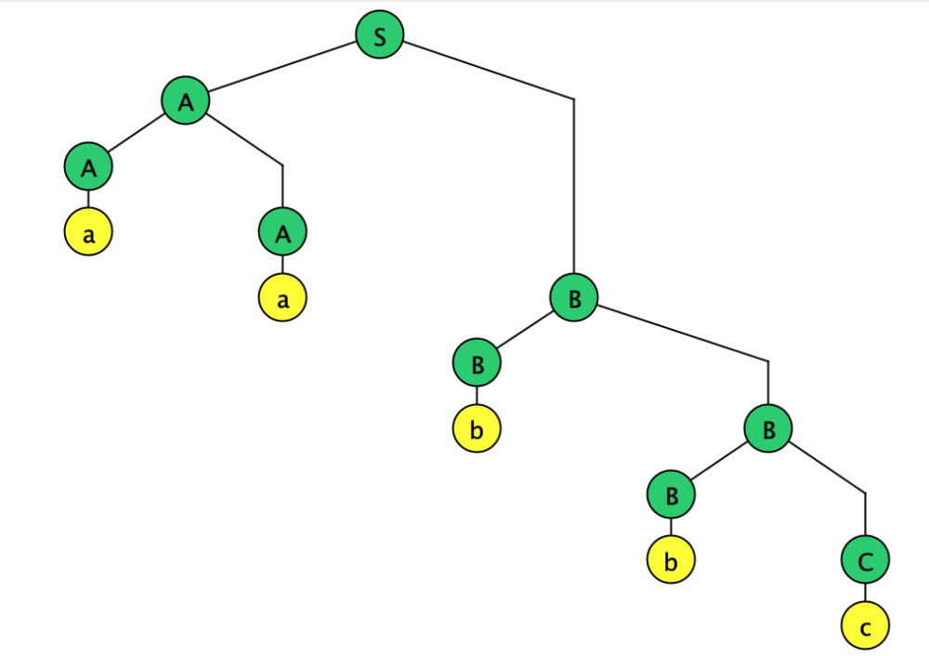

3. Construct an NPDA for the language L = { anbncm| : n ≥ 0, m ≥ 1 }. Include a screenshot of the transition graph below and submit the JFLAP file.

