CS 321 Activity 6

Margaret Walters, Lyell Read

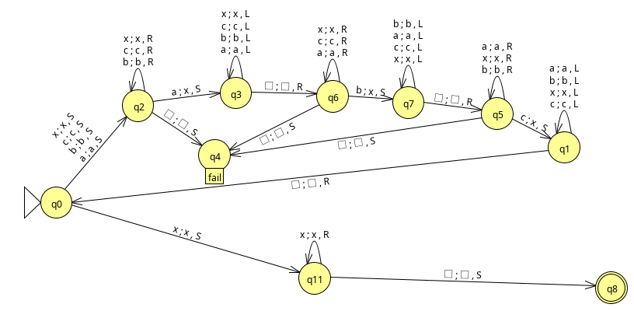
- This Turing machine systematically replaces each set of ‘a’, ‘b’, ‘c’, with ‘x’ to mark that these sets have been found. Each time one of these letters is found, the turning machine restarts to find the next in the sequence. If it finds a string of all ‘x’, we have successfully accepted the language, however if we cannot find any of ‘a’, ‘b’ or ‘c’ in our search for a set, we reject the language.

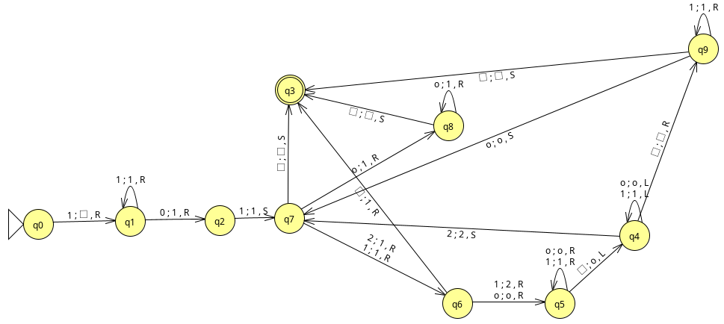
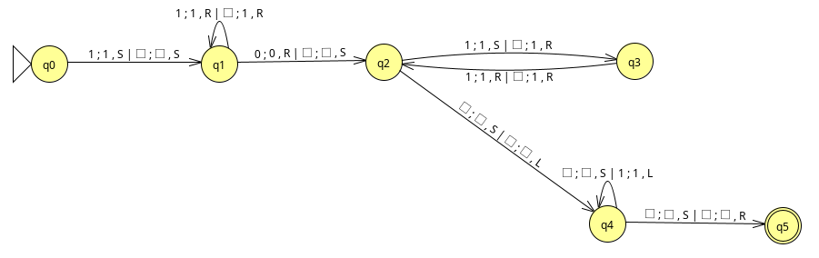
- This Turing machine uses special characters ‘2’ and ‘o’ to add ‘1’ characters to the end of the string as needed to perform the multiplication. This ensures that in the process of multiplication we do not clobber any remaining values for y before we have processed it all. ‘2’ stands for a location where two ones should be, and ‘o’ is a placeholder for a 1 at the end of the string (but is not converted as to ensure that we know where y ends for processing). NOTE: Also included is a two tape version that is significantly easier to understand. It uses the second tape as an output tape, and writes the output onto that tape while reading the first tape.

