ST314 Final Exam
Fall 2020

Take a deep breath. Read every question. Follow directions.
Be confident. Relax. You’ve got this!

Student Name: Lyell Read
Student ID: 000-000-000
Directions:
- This exam is open book and open note. You may use any materials posted on Canvas but please refrain from using any other resources.
- Please do not discuss the exam with anyone else in the class or outside of the class. Also, please do not post questions to online forums for help.
  - Do not share solutions, code, answers, etc. Answers which appear “too similar” will be forwarded to the Office of Student Life for investigation.
- Write you solutions where indicated in the exam document itself. Please don’t make any other alterations to the exam.
  - I’ve tried to include a purple font color to make your solutions “stand out”. If possible, keep the purple color for your solutions.
- When asked, please show your work and write explanations, justifications, etc. using complete sentences.
  - This is really helpful for assigning partial credit in case you do something incorrectly in the short answer section.
  - Do not show your work for the multiple choice questions.
  - If you need to include math, write it out in plain text or using Word’s equation editor.
- Submit your completed exam as a PDF file to Gradescope prior to the deadline shown on Canvas.
  - Indicate where the solutions are in the uploaded document. Not doing this slows the grading process down considerably and will result in a points deduction for each instance the questions are not properly indicated in Gradescope.
- Read each question slowly and carefully. If you don’t understand a question, write a post on the Midterm Exam Question Clarification discussion board on Canvas (But do not include solutions/partial solutions in your post).

Questions 1 – 2 (3 points each): Choose the appropriate statistical procedure for the scenario. That is, which test is most appropriate for answering the question of interest?

- The width of a piston in an internal combustion engine can be measured using an analog caliper or with a digital laser. A piston manufacturer wants to decide if the added expense of purchasing digital lasers is worth the cost. They decide to compare both instruments by measuring each piston in a set of thirty with both instruments. They then compare the average measurements for each instrument.

- One sample z-test for the mean
- One sample t-test for the mean
- Two sample t-test for the difference in the means
- Matched pairs t-test
- Single-factor ANOVA
- Simple linear regression
Answer: C

- A car manufacturer produces a certain automobile at four different plants located throughout the United States. The manufacturer is interested in comparing the average number of cars produced per hour at each factory to see if they are similar or if there’s evidence that one or more factories is producing more, or fewer, automobiles per hour. To accomplish this task, the manufacturer asks each factory to record the number of cars produced in five randomly chosen hours over the course of a week.

- One sample z-test for the mean
- One sample t-test for the mean
- Two sample t-test for the difference in the means
- Matched pairs t-test
- Single-factor ANOVA
- Simple linear regression
Answer: E

Questions 3 – 5 (3 points each): For each set of hypotheses, indicate the matching distribution needed to compute the p-value of the test
- Assume is known

- z-distribution
- t-distribution
- Chi-square distribution
- F distribution
Answer: A

- Assume is unknown

- z-distribution
- t-distribution
- Chi-square distribution
- F distribution
Answer: B

- Assume

- z-distribution
- t-distribution
- Chi-square distribution
- F distribution
Answer: D

Questions 6-10 (3 points each): Use the following scenario to answer the questions.
A manufacturer of videogame cartridges performs an experiment to compare the average time of three assembly methods. The goal of this analysis is to see whether these methods differ in average time to assemble the cartridge. Use the output provided to answer the following questions.
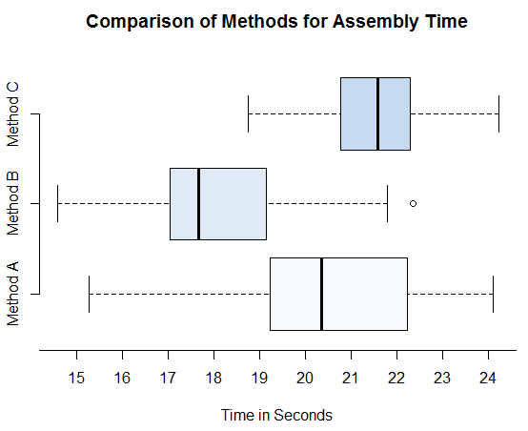
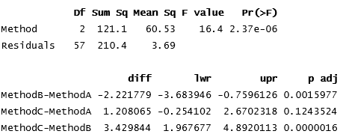
- Based on the side-by-side boxplot, which statement is a FALSE description of the data?

- Method B is typically the fastest.
- Method C is typically the slowest.
- Method A the most variability of the methods.
- No method took longer than 17 seconds to produce a single cartridge.
Answer: D

- From the Single-Factor ANOVA table, which value represents the average between group variation?

- 2.37e-06
- 3.69
- 16.4
- 60.53
Answer: D

- The statistic and -value from the Single-Factor ANOVA table represent a null hypothesis of:

Answer: C
- Based on the test statistic and -value from the Single-Factor ANOVA table, what can we conclude?

- There is convincing evidence the average assembly times of at least two methods are different.
- There is no evidence which suggests the average assembly times for the different methods are different.
- The F test statistic comes from an F distribution of 3 and 60 degrees of freedom.
- The test is not valid since Method B contains an outlier.

Answer: A

- Based on the output from the multiple comparisons procedure, which statement is FALSE (Assume ?

- There is a significant difference between methods A and B.
- Method A has smaller mean than Method B.
- The 95% F-W confidence interval estimates Method B is approximately 1.97 to 4.89 seconds faster than Method C.
- Method B has the fastest average assembly time in comparison to the other groups.

Answer: C

Questions 11 – 12 (3 points each): Use the following scenario to answer the questions.
Consider the residual plots below. What do they tell you about the relationship of the variables in a simple linear regression analysis? Each residual plot matches a specific violation or no violations.
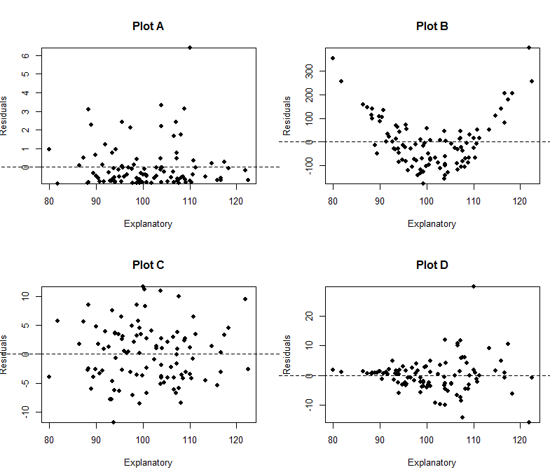

- Which plot provides evidence the variance is not the same for all values of the explanatory variable?

- Plot A
- Plot B
- Plot C
- Plot D
Answer: D

- Which plot provides evidence the relationship between the response and predictors is not linear?

- Plot A
- Plot B
- Plot C
- Plot D
Answer: B
Questions 13 – 15 (3 points each): Answer the following questions.

- The 90% confidence interval for is (1.8, 3.2). Assuming and that is unknown, what is the 95% confidence interval?

- (1.646, 3.384) ← expands
- (1.644, 3.356) ← expands
- (1.926, 3.074) ← wrong
- (1.928, 3.072) ← wrong

Answer: B

- Fill in the blank cells (indicated with a “?”) of the ANOVA table below (Each correct answer is worth 3 points):

I = 6, J=86/6

Source | Degrees of Freedom | Sum of Squares | Mean Squares | F
Treatments | 5 | 3724.5 | 744.9 | 7.8
Error | 80 | 7640.0 | 95.5
Total | 85 | 11364.5

- In a hypothesis test, if we fail to reject a true null hypothesis, we make…

- the correct choice.
- a type I error.
- a type II error.
- All of the above

Answer: A

Questions 16 – 20: Use the following scenario to answer the questions.
A rocket motor is manufactured by bonding together two types of propellants, an igniter and a sustainer. A random sample of 20 specimens is used to investigate the relationship between the shear strength of the bond (in psi) and the age of the propellant (in weeks). Use the R software output to answer the following questions.
Coefficients:
Estimate Std. Error t-value Pr(>|t|)
(Intercept) 2641.185 68.901 38.33 < 2e-16
age -49.550 4.436 -11.17 1.59e-09
---

Residual standard error: 138.3 on 18 degrees of freedom
Multiple R-squared: 0.8739, Adjusted R-squared: 0.8669
F-statistic: 124.8 on 1 and 18 DF, p-value: 1.586e-09

- (8 points) Based on the scatterplot, describe the relationship between the two variables using context

Strength: The strength of this correlation is moderately strong.

Direction: The direction of this relationship is negative.

Form: The form of this relationship appears to be linear.

Outliers: There exists two outliers in this dataset, one at (10, 1750) and one at (22.5, 1250).

- (4 points) Write down the least squares regression equation.

- (4 points) Calculate the residual for the observation that is 12.4 weeks old with bond strength of 1993.8 psi. Write your answer in the blank and show your work.

- (4 points) Based on the residual plot in part below, state all of the conditions for the least squared regression model to be valid, whether or not they are satisfied, and why.

The relationship is linear in the population.
There exists no noticeable U shaped curve, therefore I deem this relationship to be linear.
The response varies normally about the population regression line.
This does not hold – there is a significant number of points more above the line than below it. The variations with respect to the line are not constant either.
Observations are independent.
The observations are independent, as one observation does not impact others.
The standard deviation of the responses is the same for all values of x.
This holds, there appears to be no funnel shape in the graph of residuals.

- (4 points) Interpret the estimated slope of the linear model:

For each additional week that the propellant ages, the shear strength diminishes by 49.55 psi.

- 