Topics:
- Continuous Random Variables and their Probability Density Functions
- Lessons Covered: 8 - 13
Textbook Chapter (Optional): 4

Grading:
- Points are listed next to each question and should total 25 points overall.
- Grading will be based on the content of the data analysis as well as the overall appearance of the document.
- Late assignments will not be graded.

Deadlines:
- Final Submission: Monday, October 12th. All submissions must be PDF files.

Instructions:
- Clearly label and type answers to the questions on the proceeding pages in Word, Google Docs, or other word processing software.
- Insert diagrams or plots as a picture in an appropriate location.
- Math Formulas need to be typed with Math Type, LaTeX, or clearly using key board symbols such as +, -. *, /, sqrt() and ^
- Submit assignment to the Gradescope link as a PDF. Indicate the pages to the individual questions and also verify the correct document has been uploaded.

Allowances:
- You may use any resources listed or posted on the Canvas page for the course.
- You are encouraged to discuss the problems with other students, the instructor and TAs, however, all work must be your own words. Duplicate wording will be considered plagiarism.
- Outside resources need to be cited. Websites such as Chegg, CourseHero, Koofers, etc. are discouraged, but if used need to be cited and used within the boundaries of academic honesty.

Part 1. (6 points) Identify the distribution

For each random variable:

State the distribution that will best model random variable. Choose from the common distributions: Uniform, Exponential or Normal distribution. Explain your reasoning.

State the parameter values that describe the distribution.

Give the probability density function.

Random Variable 1.

A statistics student has a part time job as a coffee shop barista, she realizes the time between customer orders is a random variable. During an eight-hour shift, she measures time between successive customer order and finds that the time between customer orders is on average 30 seconds. Furthermore, she discovers times are more likely to be close to 0, and less likely as they get further away from 0.

- Exponential, as the further the time between drinks gets from 0, the less likely they get. Given that orders cannot be a negative amount of time apart, this fits the exponential curve quite well.
- 𝜆 = 1/30.
- f(x) = {(1/30)e^((-1/30)x) on x >= 0
{0 otherwise

Random Variable 2.

In a board game, individuals must attempt to guess a phrase based on clues from their teammate. If they successfully guess the phrase before a buzzer sounds, their teammate may give clues for another phrase. Each correctly guessed phrase, before the buzzer sounds, gives them a point in the game. The buzzer is set to a random time increment anywhere between 30 and 90 seconds. Consider time until the buzzer sounds a random variable where any time between 30 and 90 has an equal likelihood.

- Uniform, as any buzzer sounding time in the valid range 30s to 90s has an equal likelihood.
- Parameter Values: a = 30, b = 90.
- f(x) = {1/(60) on 30 <= x <= 90
{0 otherwise

Random Variable 3.

An industrial process yields a large number of steel cylinders. The length of the cylinder is a random variable with an average of 3.25 inches and a standard deviation of 0.003 inches. The distribution of cylinder lengths is symmetrical, where lengths are more likely to be close to the mean rather than further away from the mean.

- Normal distribution, as the probability is highest close to the mean, and decreases symmetrically on either side thereof.
- 𝜇 = 3.25, 𝜎 = 0.003
- f(x) = (1/(sqrt(2*pi*(0.003)^2)))*e^(-((x-3.25)^2/2*(0.003)^2)) for all values of x

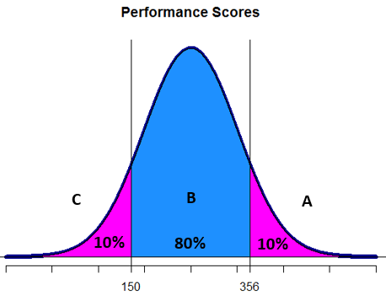
Part 2. (6 points) Normal Distributions Some companies "grade on a bell curve" to compare the performance of their managers and professional workers. This forces the use of some low performance ratings so that not all workers are listed as "above average." Ford Motor Company's "performance management process" for this year assigned 10% A grades, 80% B grades, and 10% C grades to the company's managers. Suppose Ford's performance scores really are Normally distributed. This year, managers with scores less than 150 received C grades and those with scores of at least 356 received A grades.

(2 point) What are the z scores associated with the 10th and 90th percentiles from the standard normal distribution?

For a standard normal distribution, 𝜎 = 1, 𝜇 = 0. Therefore, we can use the

10th Percentile (qnorm(0.1, 0, 1): -1.2815
90th Percentile (qnorm(0.9, 0, 1): 1.2815

(2 point) What is the mean and standard deviation of the performance scores? Show work.

Mean = 𝜇 = (150 + 356)/2 = 253

Now, using the 10th percentile, we solve for 𝜎, as we know 𝜇 = 253:
X_{p/100} = z_{p/100} * 𝜎 + 𝜇
150 = qnorm(0.1, 0, 1) * 𝜎 + 253

-103 = qnorm(0.1, 0, 1) * 𝜎

-103/qnorm(0.1, 0, 1) = 𝜎

Standard Deviation = 𝜎 = 80.3713

(2 point) Suppose the company adds grades D and F so there are 5 categories to grade performance. If they want to give A’s only to those in the top 3%, what performance score must a manager exceed to get an A?

To find this, we calculate the 97th percentile:

qnorm(0.97, 253, -103/qnorm(0.1, 0, 1)) = 404.1619

Part 3. (13 points) Simulation of Gamma Random Variables

Background: When we use the probability density function to find probabilities for a random variable, we are using the density function as a model. This is a smooth curve, based on the shape of observed outcomes for the random variable. The observed distribution will be rough and may not follow the model exactly. The probability density curve, or function, is still just a model for what is actually happening with the random variable. In other words, there can be some discrepancies between the actual proportion of values above x and the proportion of area under the curve above the same value x. Our expectation is as the number of observations increase, literally or theoretically, the observed distribution will align more with the density curve. Over the long run, the differences are negligible, the model is sufficient and more convenient to find desired information.

Simulation: Use R to simulate 1000 observations from a gamma distribution. To begin, set alpha = 2 and beta = 7. Highlight and run the parameters and observation values. Run the simulation code to plot the observations and fit the probability density function over the observations. You don’t need to change anything. You may run the section all at once by highlighting all of the section and running it by clicking the run button at the top of the script window.

Given the values are from a gamma distribution with alpha= 2 and beta = 7,

(1 points) What is the expression for the probability density function?

Γ(α) = (α − 1)!
Γ(α) = 1! = 1

f(x) = {(1/(7^2 * 1))*(x^1)*(e^(-x/7)) on x >=0
{0 otherwise

(1 point) What is the average and standard deviation of the random variable? Show work in regards to how you derived these quantities.

Average: 𝜇_{x} = 𝛼𝛽 = 2*7 = 14
Standard Deviation = 𝜎_{x} = sqrt(𝜎_{x}²) = sqrt(𝛼𝛽²) = sqrt(2 * 49) = 9.8995

(1 point) What is the probability x is less than 4? Show work.

Using R, we can do:

pgamma(4, 2, 1/7) = 0.1126

(2 point) Run the simulation and paste your plot. Comment on the general shape of the distribution. How well does the density curve fit the observations?
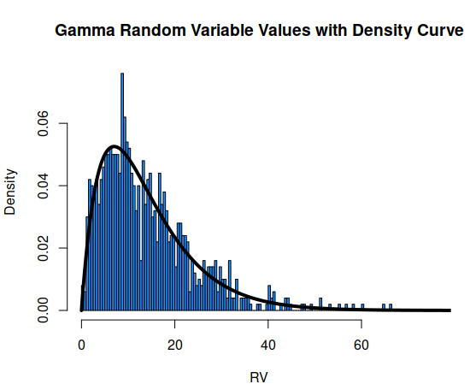
The shape of the distribution starts off with an increase or a hump, which then reduces and approaches zero as we go off the right side of the graph.
The data from our run fits roughly with the curve of the pdf, however there are notable times when the individual densities exceed the curve, notably around RV 13-15, and around RV 27-30 or so. There are also spots where the densities are much less than the curve, notably around RV 16-17, and RV 23-25 and from 35-40.

(2 point) What is the exact proportion of values below 4? How does the actual proportion compare to the probability from the density curve in part 2-a-iii?

The proportion is 0.119, which is higher than the theoretical value calculated in part 2-a-iii, of 0.1126.

(1.5 point) Increase the number of observations to 10000, rerun the simulation. Paste your plot. How does increasing the number of observations affect the fit of the density curve?
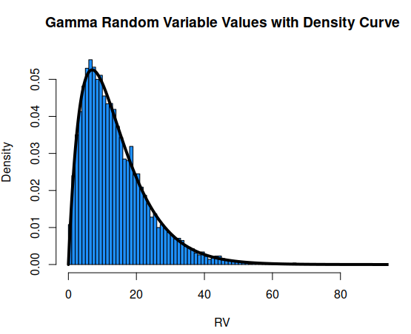

Increasing the numbers unsurprisingly makes the data much more accurately fit the theoretical curve. There are fewer places where the data exceeds or is less than the theoretical curve, and when it is in excess or less than the curve, it appears to be so by less than when we had n=1000 trials.

(1.5 point) What is the exact proportion of values below 4? How does increasing the number of observations affect the accuracy of the model? Make a comparison between this proportion and 2-a-iii and 2c.

Now, the proportion of values under 4 is 0.1111, which is much closer to the theoretical (2-a-iii) value of 0.1126 than part 2c’s 0.119.

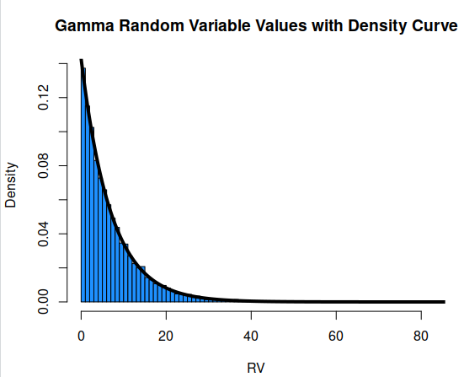
(1 point) Rerun the simulation with alpha = 1, beta = 7, and observations = 10000. Paste your plot. Comment on the general shape of the distribution.

Now that alpha <= 1, the plot is strictly decreasing on the domain x >= 0. The shape therefore has no ‘up’ at the beginning, and rather continually declines starting at 0.

(2 points) The model in part (f) is a special case of the gamma distribution, what is it specifically? What is the expression for the probability density function?

This change results in the special case of the Gamma distribution called the exponential distribution. The expression for the pdf of that distribution is:

𝛼 = 1
𝛽 = 1/𝜆 = 7
𝜆 = 1/7

f(x) = {(1/7)e^(-(1/7)*x) on x >= 0
{0 otherwise

Optional: Change the parameter values and take note of the effect of increasing or decreasing parameter values.

Increasing Beta results in a taller graph. Increasing alpha results in a graph further from x = 0, that is also taller.

