ST314 Midterm Exam
Fall 2020

Take a deep breath. Read every question. Follow directions.
Be confident. Relax. You’ve got this!

Student Name: Lyell Read
Student ID: 000-000-000
Directions:
- This exam is open book and open note. You may use any materials posted on Canvas but please refrain from using any other resources.
- Please do not discuss the exam with anyone else in the class or outside of the class. Also, please do not post questions to online forums for help.
  - Do not share solutions, code, answers, etc. Answers which appear “too similar” will be forwarded to the Office of Student Life for investigation.
- Write you solutions where indicated in the exam document itself. Please don’t make any other alterations to the exam.
  - I’ve tried to include a purple font color to make your solutions “stand out”. If possible, keep the purple color for your solutions.
- When asked, please show your work and write explanations, justifications, etc. using complete sentences.
  - This is really helpful for assigning partial credit in case you do something incorrectly in the short answer section.
  - Do not show your work for the multiple choice questions.
  - If you need to include math, write it out in plain text or using Word’s equation editor.
- Submit your completed exam as a PDF file to Gradescope prior to the deadline shown on Canvas.
  - Indicate where the solutions are in the uploaded document. Not doing this slows the grading process down considerably and will result in a points deduction for each instance the questions are not properly indicated in Gradescope.
- Read each question slowly and carefully. If you don’t understand a question, write a post on the Midterm Exam Question Clarification discussion board on Canvas (But do not include solutions/partial solutions in your post).

Questions 1 – 3 (3 points each): Choose the appropriate probability distribution for the scenario. That is, which probability distribution should be used to most accurately represent the scenario.

- Typographical errors in a single chapter of a statistics textbook occur at a rate of 2 errors per chapter. Which probability distribution would you use to model the number of errors in a random chapter of a statistics textbook?

- Binomial Distribution
- Poisson Distribution
- Exponential Distribution
- Uniform Distribution
- Normal Distribution
Answer: D

- Wood screws produced by a certain manufacturing company will be defective with a probability of 0.01, independently of each other. The company sells screws in packages of 10. Which probability distribution would you use to model the number of defective screws in a randomly selected package?

- Binomial Distribution
- Poisson Distribution
- Exponential Distribution
- Uniform Distribution
- Normal Distribution
Answer: A

- The number of miles that a car is able to moves under its own power starts “high” and gradually declines, at a rate of per mile, as the number of miles its driven increases. Which probability distribution would you use to model the lifetime of a car?

- Binomial Distribution
- Poisson Distribution
- Exponential Distribution
- Uniform Distribution
- Normal Distribution
Answer: B
Questions 4 – 6 (3 points each): Use the following scenario to answer the questions.
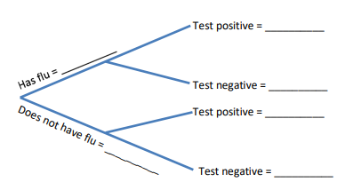
In a population of one-million people, one in every one-thousand members of the population has a rare, non-contagious super-flu virus. The population’s public health agency develops a test which is 98% accurate. That is, it correctly indicates whether a person has the virus (tests positive) or does not have the virus (tests negative) 98% of the time.

- If everyone in the population gets tested, how many people will have the virus and receive a negative test result?

- 10
- 20 = 1000000×(0.001×0.02)
- 1,000
- 20,000
Answer: B

- Given that a particular person tests positive for having the super-flu, what is the probability that they are actually infected?

- 0.00098
- 0.001
- 0.04676 = (0.001×0.98)/((0.001×0.98)+(0.999×0.02))
- 0.09016
Answer: C

- What is the probability a randomly chosen person tests positive for the flu?

- 0.00098
- 0.0196
- 0.02096 = (0.001×0.98)+(0.999×0.02)
- 0.98
Answer: C

Questions 7 – 9 (3 points each): Use the following scenario to answer the questions.
During a shift at a Student Success Learning Center, there are always five tutors scheduled to help. The following probability mass function represents the number of available tutors (tutors that are not currently helping other students) at any given moment during a single shift.
x= | 0 | 1 | 2 | 3 | 4 | 5
p(x) | 0.08 | 0.24 | 0.32 | 0.19 | 0.10 | 0.07

- What is the probability there will be three or more tutors available during a given shift?

- 0.17
- 0.19
- 0.36 = .19+.1+.07
- 0.83
Answer: C

- How many tutors are expected to be available during a single shift?

- 2.2 = (0×0.08) + (1 × 0.24) + (2 × 0.32) + (3 × 0.19) + (4 × 0.10) + (5 × 0.07)
- 2.5
- 3.0
- 3.2
Answer: A

- What is the standard deviation for the number of tutors available during a single shift?

- 0.101
- 1.319 = sqrt((0^2 × 0.08) + (1^2 × 0.24) + (2^2 × 0.32) + (3^2 × 0.19) + (4^2 × 0.10) + (5^2 × 0.07) − ((0×0.08) + (1 × 0.24) + (2 × 0.32) + (3 × 0.19) + (4 × 0.10) + (5 × 0.07))^2)
- 1.740
- 1.871
Answer: B

Questions 10 – 12 (3 points each): Use the following scenario to answer the questions.
According to an industrial company’s records of 302 accidents, the time in days between accidents has the following distribution.
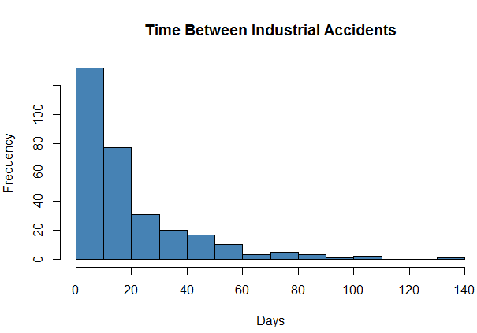

- Based on the shape of the distribution, what type of probability distribution would be the most appropriate to model days between accidents?

- Binomial
- Exponential
- Normal
- Uniform
Answer: A

- The cumulative distribution function for days between accidents is:

What is the probability the time between accidents is more than 40 days?

- 0.1025
- 0.1084 = 1−(1−e^((−40)/18 ))
- 0.8916
- 0.8975
Answer: B

- Based on and the distribution of time between accidents, what is the approximate median?

- 0.0274
- 5.4185
- 12.4767 = 0.5 = F(mu) = -18*ln(0.5)
- 18.0
Answer: C

Questions 13 – 14 (3 points each): Use the following scenario to answer the questions.
The average birth weight of a full-term newborn baby is approximately normal with a mean of 7.5 pounds and a standard deviation of 1.25 pounds.
- Suppose a random sample of 12 full-term newborn babies is taken with an average weight of 7.41 pounds. Further suppose that another random sample of 12 full-term newborn babies is taken and yields an average weight of 7.46 pounds. If we were to continue sampling every possible sample of size 12, which plot below would represent the sampling distribution of the sample means?

[Sdx = 1.25/sqrt(12)]

Answer: Plot A

- What is the approximate probability that the average birth weight for a randomly selected sample of 12 full-term newborns is greater than 7.2 pounds?

- 0.2029
- 0.4052
- 0.5948
- 0.7971 = 1-pnorm(7.2, 7.5, 1.25/sqrt(12))

Answer: D

Questions 15 – 17 (3 points each): Use the following scenario to answer the questions.
A process for producing vinyl floor covering has been stable for a long period. The surface hardness measurement of the flooring is normally distributed with a mean of 5 and a standard deviation of 1.2. Suppose a new crew of workers have been hired and trained. To monitor the production of the new crew, a random sample of 15 vinyl specimens are measured for hardness. The sample yields an average of 5.2.

- Calculate the 95% confidence interval for the average hardness of vinyl.

- (2.848, 7.552)
- (4.3927, 5.6073)
- (4.5927, 5.8073) = 5.2+/−(1.96×(1.2/sqrt(15)))
- (4.6904, 5.7096)

Answer: C

- Suppose the engineer would like the entire 95% confidence interval to be no wider than 0.4 units. What is the smallest sample size needed to obtain the desired margin of error?

- = (1.96×(1.2/sqrt(139))) = 0.199494, 138 is >0.2

Answer: D

- Suppose the engineers wanted to conduct a hypothesis test at the significance level to see if there was evidence that the population mean surface hardness was more than 5.0. Which of the following represents the appropriate alternative hypothesis?

Answer: B

Questions 18 – 20 (3 points each): Answer the following questions.

- Suppose a 95% confidence interval for the population mean of some computational process is (4.3, 5.9) microseconds. Which of the following statements is TRUE:

- a 90% confidence interval will be wider than the 95% confidence interval. [false]
- There’s a 95% probability the true population mean is between 4.3 and 5.9 microseconds.
- The margin of error is equal to 1.6. [no, it’s half that]
- The sample mean is equal to 5.1. [possibly, not a sample mean though]

Answer: B

- When our goal is to make inferences from a sample to a desired population, the single most important condition for the inference to be valid is:

- a large sample size.
- a random sample. [slides 58, 47, 46, 27 in W4]
- a population that is normally distributed.
- a sample that is normally distributed.

Answer: B

- In a hypothesis test, if we fail to reject a false null hypothesis, we make…

- the correct choice.
- a type I error.
- a type II error.
- All of the above (← Thanks for the idea, Zach!)

Answer: C

Questions 21 – 26: Use the following scenario to answer the questions.
Metal wires produced in a chip-manufacturing process have a target thickness of 8 micrometers () and a known population standard deviation of 0.8 micrometers. The manufacturer routinely samples batches to ensure the average thickness is within this specification. If there is evidence the average thickness is other than 8 micrometers (), the manufacturer will need to evaluate the process and possibly remove the batch of wires. The following is data from a batch of 27 randomly selected wires from a batch, for which the sample mean value was 8.26 micrometers.
Question of interest: Is there evidence the average wire thickness is different than 8 micrometers ()? Use a significance level of 0.05.
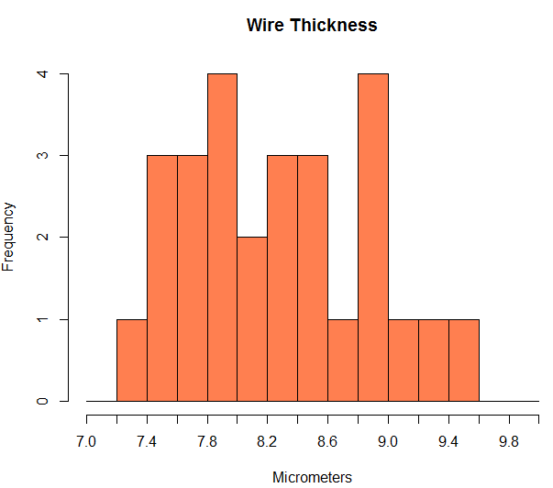

- (8 points) Describe the sample distribution using the context of the problem and terms for the shape, center and spread of the distribution. Is there visual evidence the average wire thickness is different than 8 micrometers?

The sample distribution does not closely resemble any standard shape. It appears to be centered around 8.0-8.1, with a spread of +/-1 micrometer, approximately. If a shape was required to be ascribed to this graph, it would be a right skewed distribution, possibly bimodal with two centers, one at around 7.6, and one around 8.6. It would be possible to ascribe a normal distribution to this graph too. There is no significant visual evidence that points to the wire thickness average of this sample being significantly different from 8.0 micrometers.
- (4 points) State the null and alternative hypotheses for the appropriate hypothesis test, based on the scenario. Use correct statistical notation.

- (8 points) Compute (1) the value of the test statistic for the test as well as (2) the appropriate p-value given the hypotheses you wrote in Question 22. (Show your work. Writing your work as “R code” is fine but don’t include extraneous steps). Highlight the computed values if possible to make them easy to find.

(1) Compute the test statistic for 22.

(2) Compute the appropriate p-value given the hypothesis in 22.
We find the area under the tail of the graph from 1.67 on (using the negative measure, as the Z table is counted for all values to the left of a certain z). We multiply it by 2, as we are considering both tails, given our hypothesis is double sided.

- (4 points) Compute a 95% confidence interval for the population mean wire thickness (Show you work. Writing you work as “R code” is fine but don’t include extraneous steps). Write your answer as an interval, i.e. “(Lower bound, Upper bound)”

We calculate this using the formula for confidence intervals:

- (8 points) Write a 4-part conclusion, based on your work from above. Be sure to answer the question of interest in your conclusion, i.e. is there evidence the average wire thickness is different than 8 micrometers ()? Use complete sentences.

There is not sufficient evidence to declare that the wire diameter is different than 8 micrometers. There is moderate strength of evidence against H₀, however not enough to refute H₀. The null hypothesis would be rejected at a significance level of 0.05, and our p-value was one of 0.09492, which is higher than this significance level (z-stat = 1.67). The sample estimates the wire diameter to be 8 micrometers with a 95% confidence interval of 7.958 to 8.562 micrometers. Given this, we can say that we are unable to claim that the wire diameter average is not 8 micrometers, and we fail to reject H₀.

- (8 points) Would a 90% confidence interval contain the target population mean of 8 micrometers? How would you answer this question without making any additional computations than what you computed in Questions 21 through 25? Answer this question using 2-3 complete sentences.

Yes, this 90% confidence interval would indeed contain the target population mean of 8 micrometers. It would do so because a 90% confidence interval would indicate that we must use a significance level of 0.1, which is pretty much exactly the p-value that we determined. This combined with the fact that the strength of evidence at a significance level of 0.1 is “slightly suggestive” indicates that despite technically refuting H₀ in this case, we do it with very little certainty, as we are right on the edge.

- 