### Topics:

* One and Two Sample t Procedures
* Describing Visual Displays
* Hypothesis Testing and Confidence Intervals
* Lessons Covered: 26 - 30
* Textbook Chapter (Optional): 8 and 9

### Grading:

* Points are listed next to each question and should total 25 points overall.
* Grading will be based on the content of the data analysis as well as the overall appearance of the document.
* Late assignments will not be graded.

### Deadlines:

* Final Submission: **Thursday, November 19th**. All submissions must be PDF files.

### Instructions:

* Clearly label and **type answers** to the questions on the proceeding pages in Word, Google Docs, or other word processing software.
* Insert **diagrams or plots as a picture** in an appropriate location.
* Math Formulas need to be typed with Math Type, LaTeX, or clearly using key board symbols such as +, -. *, /, sqrt() and ^
* Submit assignment to the Gradescope link as a PDF. **Indicate the pages to the individual questions and also verify the correct document has been uploaded. Failing to follow this direction may result in point deductions.**

### Allowances:

* You may use any resources listed or posted on the Canvas page for the course.
* You are encouraged to discuss the problems with other students, the instructor and TAs, however, all work must be your own words. Duplicate wording will be considered plagiarism.
* Outside resources need to be cited. Websites such as Chegg, CourseHero, Koofers, etc. are discouraged, but if used need to be cited and used within the boundaries of academic honesty.

**Part 1. (15 points)**

The microbeersW19.csv dataset is a representative sample of 1,244 microbrews from around the United States. The variable abv represents the percent of alcohol by volume for each craft beer. According to the National Institute of Health, one standard serving of alcohol is 12 ounces of regular beer, which is usually about 5% alcohol by volume (abv).

*Does the sample of microbrews provide evidence the average alcohol by volume of all craft beers is different from a standard serving of beer at 5% abv?*

Use this dataset and the R script DA5_t_procedures.R to complete the following:

1. (1 point) What is the parameter of interest in this scenario? Provide the symbol and context.

<Delete this and write your answer here>

1. (1 point) State the null and alternative hypothesis to answer the question of interest.

<Delete this and write your answer here>

1. (2 point) Make a histogram or boxplot to visualize the variable abv. Is there visual evidence the average alcohol by volume is different than 5%?

<Delete this and write your answer here>

1. (1 point) Calculate the sample mean and standard deviation using R. State the values.

<Delete this and write your answer here>

1. (1 point) Check the conditions for inference. State them and whether they are met.

<Delete this and write your answer here>

1. (1 point) Calculate the test statistic by hand. Show work.

<Delete this and write your answer here>

1. (1 point) State the p-value. Is it one or two sided?

<Delete this and write your answer here>

1. (2 points) Calculate the 95% Confidence Interval by hand. Show work.

<Delete this and write your answer here>

1. (1 point) Use the t.test() command in R to verify the results of the t test. How do your answers compare?

<Delete this and write your answer here>

1. (4 points) From the R output, write a four-part conclusion describing the results. Use . Provide a statement in terms of the alternative hypothesis. State whether (or not) to reject the null. Give in context an interpretation of the point and interval estimate. Include any other information you might feel to relevant.

<Delete this and write your answer here>

**Part 2. (10 points)**

The goal of this analysis is to compare the average time spent doing schoolwork during a week for ST314 students who are either in-class students (attend lectures in person) or online students (completing the course online). This data is from the combined ST314 Winter 2019 student information survey. The following software output is an analysis of this data:



|  |  |  |  |
| --- | --- | --- | --- |
|  | Mean | Std. Dev. | N |
| In Class | 20.31 | 17.22 | 150 |
| Online | 18.31 | 12.67 | 67 |

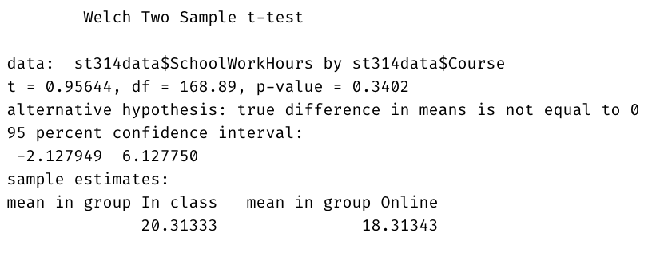

***Do these data provide evidence of a difference between the average time spent doing schoolwork in a week among in-class and online students?***Use a significance level of 0.05 and answer the following questions using the software output**.**

1. (2 points) Describe the side-by-side boxplot. Is there visual evidence time spent doing schoolwork is different among in-class and online students? Explain your answer in 1-2 sentences.

<Delete this and write your answer here>

1. (2 point) State the null and alternative hypothesis to answer the question of interest. Is the alternative one or two sided?

<Delete this and write your answer here>

1. (2 points) Check conditions for the test. State each condition and whether it is met. If not met, state why. Then continue, even if the conditions aren’t met.

<Delete this and write your answer here>

1. (4 points) From the R output, write a four-part conclusion describing the results. Provide a statement in terms of the alternative hypothesis. State whether (or not) to reject the null. Give in context an interpretation of the point and interval estimate. Make sure to provide a *direction* to your interval, for example, one group had a smaller (or larger) mean than the other, include this relationship in your point and interval estimate. Include any other information you might feel to relevant.

<Delete this and write your answer here>