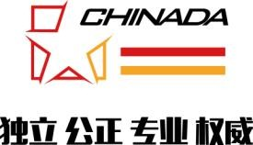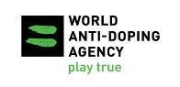In partnership with

# INVITATION

**First Session of CHINADA International Anti-Doping Symposium**

16th-17th July, 2019 Beijing, China

Dear Colleagues,

The China Anti-Doping Agency, in partnership with the World Anti-Doping Agency, under the auspices of the General Administration of Sport of China, is pleased to invite you to attend our first annual **International Anti-Doping Symposium**, which will be held on 16th-17th July 2019 in Beijing.

The symposium venue will be at the Beijing International Convention Center, Beijing, just around the Bird Nest, the Water Cube and the National Indoor Stadium which are all main competition venues for both Beijing 2008 Summer Olympic Game and 2022 Winter Olympic Game.

The theme of our First Symposium will focus on **Anti-Doping Program in Major Events**. It is a platform to share experience, achievements, and to enhance anti-doping system in major events. Your presence will be critical important to the success of the symposium.

* Tentative schedule:

15 July Participants’ Arrival

16 July International Symposium Day 1 & Reception 17 July International Symposium Day 2

18 July All Departure

We hereby confirm that your travel and accommodation expenses will have to be at your cost. Any question concerning the meeting, please do not hesitate to contact with Ms. Zhang Xiaoyan, Tel: +86(0)1084378270

Fax: +86(0)1064912136

E-mail: [zhangxiaoyan@chinada.cn](mailto:zhangxiaoyan@chinada.cn) Look forward to seeing you in July. Your sincerely,

Chen Zhiyu Kazuhiro HAYASHI

Executive Director General Director

China Anti-Doping Agency WADA Asia&Oceania Regional Office