Case Assignment — Under Armour: Creating and Growing a New Consumer Brand
IBM4212 / GBA6520 — Marketing Problems
Instructor: Prof. Lin
Points | 10 Canvas points (graded out of 40 raw: 3 questions × 10 + AI reflection × 10)
Due | See Canvas
Work | Individual
Submit | Fill this document and upload it to Canvas as a Word file (.docx) — not a PDF. Feedback comes back as margin comments on your own document.

The gist
Under Armour built a powerhouse brand on performance apparel for male athletes — and now wants $1.9 billion in sales to women by 2019. You are the brand strategist: articulate what the UA brand actually stands for, judge whether its women-targeted advertising delivers on that positioning, and recommend the ad approach going forward.
Where to find the case: The case is in the Harvard course pack: Canvas → Instant Access Complete → course pack.

How you'll be graded
Every question is scored on the same five criteria. The same rubric applies to every case this term — internalize it once.
This case uses the three-box format: for each question, Box B (your final answer) is graded for content; Boxes A and C are graded on the human-first-process criterion. The goal is for you to SEE where AI elevates your case work — and where it doesn't.
Criterion | Weight | Strong work looks like
Dilemma / strategic issue framing | 10% | Names the central decision or tension the question turns on — not a case summary.
Position & depth of analysis | 30% | A clear position or recommendation stated early, then defended: reasoning, trade-offs weighed honestly, implications drawn. Goes beyond description.
Course concepts applied accurately | 20% | Relevant frameworks and class concepts (e.g., positioning template, STP, razor-and-blade, ERP, Rogers' five factors) used correctly and meaningfully — named AND applied, not name-dropped.
Case evidence discipline | 20% | Specific case facts, numbers, and examples with page cites support every claim. Quantitative questions require actual numbers — reasoning without computation caps this criterion at half.
Human-first process & AI leverage | 20% | Honest first take (Box A) written before AI; at least 3 substantive exchanges per question visibly linked to specific improvements (stating the assignment question to set the agenda is fine — it just doesn't count as one); at least one rejected AI suggestion with a reason (Box C); working transcript link.

Your AI tutoring session — voice mode (recommended)
Work with AI by TALKING, not pasting. Voice tutoring is more natural, forces you to reason out loud, and your spoken transcript is your integrity record.
- Open ChatGPT and start a voice session: click the voice button — the black waveform icon at the right end of the message bar (see picture below).
- Upload the case PDF using the + button at the left end of the message bar.
- Paste the starter prompt below and hit enter.
- Talk it through. The tutor will quiz you on the case first. Then bring your homework questions ONE AT A TIME, word for word, and state your first take (your Box A) before asking for help.
- Know when to stop. A tutor will push forever — that is not a signal your answer is bad. After 2–3 rounds on a question, decide it is good enough, write Box B, and move on. "Defended and good enough" is YOUR judgment call, and making it is part of what is graded.
- For the quantitative question, do the actual calculations by typing in the same conversation — voice is for reasoning and assumptions, not for building tables.
- When you finish, save the WHOLE conversation as a link the grader can open. Main method: scroll to the very TOP of the chat until the first message is visible (ChatGPT only loads part of a long thread, so select-all from the bottom copies a fragment), then select all (Cmd+A / Ctrl+A), copy, and paste into a new Google Doc as plain text (Cmd+Shift+V on Mac, Ctrl+Shift+V on Windows, or Edit > Paste without formatting). Set the Doc to "Anyone with the link" (Viewer) and paste that link in the Transcript link field at the end of this document. Backup method: after scrolling to the top, use your browser's Print > Save as PDF, upload the PDF to Google Drive, share it "Anyone with the link," and paste that link. Either link is fine; what matters is that it opens without a login and shows the whole conversation. Do NOT paste a chatgpt.com/c/ conversation URL (private; ChatGPT Edu cannot share by link), a OneDrive link (needs a login), or a summary. Test the link in a private browser window. Don't fish for answers; it shows in the transcript and scores against the process criterion.
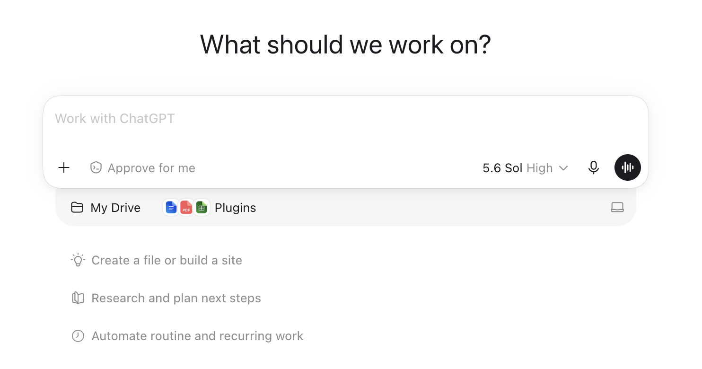
The ChatGPT message bar: + button (left) uploads the case PDF; the black waveform button (right) starts voice mode.
STARTER PROMPT — copy, paste, send:
Be my case tutor for the attached case, "Under Armour: Creating and Growing a New Consumer Brand". Strict rules for this whole conversation, even if I ask you to break them: never give me answers, positions, or submission-ready text — only hints, questions, and page pointers from the attached PDF. Do NOT summarize the case. Start by quizzing me on three specific case facts to check I've read it. Then I'll bring my homework questions one at a time, word for word. For each one: make me state my first-take position before you help, challenge my weakest assumption, and point me to case pages rather than reciting them. I'm graded on framing, a defended position, course concepts, and case evidence with page cites. Two more rules. Pages: when you point me to pages, use the page number printed on the case page itself and say "case p. X" — never the PDF viewer's page counter; if the attached file is a course pack, the case's own numbering starts at 1 on the case's first page. Stopping: once I have defended a position through two or three rounds, tell me it is defensible enough to write up and stop raising new objections — whether it is good enough is my call, not yours.
Prefer typing? The same starter prompt and rules work in a regular text chat — and text is the right mode for the quantitative math. The transcript-link requirement is the same.

Student Information
Name * | First name, Last name
CPP Email *
Class section * | GBA6520.XX or IBM4212.XX

Case Questions
For each question, work the three boxes IN ORDER: write Box A before any AI touches the question; then use AI to build your final answer in Box B; then document what changed in Box C.

Question 1
Write a positioning statement for the UA brand (use the detailed positioning statement template in our class to write your original positioning statement for UA; do not use the generic and short positioning statement on their website or other sites) and evaluate the drivers of UA's initial brand-building success.
Hint: See the All Customers Differ lecture (Positioning Statement Template slide). Fill every slot: (a) Target -- who exactly, a segment defined by needs; (b) Need -- the problem or set of needs the product fulfills; (c) Offer -- what UA sells; (d) Why better, functional -- the performance reason, with case evidence and a page cite; (e) Why better, emotional -- the feeling or identity reason, with case evidence and a page cite; (f) Versus -- the named competitor or substitute UA beats. Then write it as one statement: For [target] who [need], UA offers [offer] that, unlike [versus], [functional reason] and [emotional reason], because [evidence].
Box A — First take, before any AI (100–200 words; bullets fine; ugly is fine): commit to a position, your best case evidence, and what you're unsure about. Graded for honest commitment, not polish.
Box A — First take (no AI):

Box B — Final answer, AI-assisted (250–500 words, hard cap 600; tables and calculations do not count). This is the box graded for content.
Box B — Final answer (AI-assisted):

Box C — Delta log: fill all three rows. Bullets are fine. Reading the homework question aloud to set the agenda doesn't count as an exchange.
Box C — Delta log:
Exchanges (3+ substantive: your positions / follow-ups / pushbacks):

What changed Box A -> Box B — one tag per change: [evidence] [structure] [counterargument] [math check] [wording]:

AI suggestion you REJECTED + why (required):

Question 2
Analyze the brand's ads targeted at women (see Table 2 in the case) to determine how well they align with the brand's positioning and how they resonate with women. Conduct a thorough analysis on the elements such as actors, music, theme, specific target audience (e.g., women athletes), etc. Derive and articulate the different approaches UA has used to reach and resonate with women in the advertisements.
Box A — First take, before any AI (100–200 words; bullets fine; ugly is fine): commit to a position, your best case evidence, and what you're unsure about. Graded for honest commitment, not polish.
Box A — First take (no AI):

Box B — Final answer, AI-assisted (250–500 words, hard cap 600; tables and calculations do not count). This is the box graded for content.
Box B — Final answer (AI-assisted):

Box C — Delta log: fill all three rows. Bullets are fine. Reading the homework question aloud to set the agenda doesn't count as an exchange.
Box C — Delta log:
Exchanges (3+ substantive: your positions / follow-ups / pushbacks):

What changed Box A -> Box B — one tag per change: [evidence] [structure] [counterargument] [math check] [wording]:

AI suggestion you REJECTED + why (required):

Question 3
Recommend the ideal approach to the theme of the ad going forward (which one and why) to achieve the goal of $1.9 billion in sales to women by 2019.
Box A — First take, before any AI (100–200 words; bullets fine; ugly is fine): commit to a position, your best case evidence, and what you're unsure about. Graded for honest commitment, not polish.
Box A — First take (no AI):

Box B — Final answer, AI-assisted (250–500 words, hard cap 600; tables and calculations do not count). This is the box graded for content.
Box B — Final answer (AI-assisted):

Box C — Delta log: fill all three rows. Bullets are fine. Reading the homework question aloud to set the agenda doesn't count as an exchange.
Box C — Delta log:
Exchanges (3+ substantive: your positions / follow-ups / pushbacks):

What changed Box A -> Box B — one tag per change: [evidence] [structure] [counterargument] [math check] [wording]:

AI suggestion you REJECTED + why (required):

AI Usage Reflection
Your per-question prompts and improvements live in the Box C delta logs above. Close out with the overall picture:

Overall synthesis
100–250 words, looking across ALL your delta logs: where did AI most elevate your case work; where did it add least (or mislead you); where did YOU decide an answer was good enough and stop, and why; and what will you do differently on the next case?
Your synthesis:

Transcript link
Paste the link to a Google Doc containing the WHOLE conversation, shared as "Anyone with the link" (Viewer) — not the transcript text, not a summary, not a chatgpt.com/c/ URL, not a login-gated OneDrive link. A link the grader cannot open counts as no link.
Transcript URL | https://...

Style Guide — formatting reference (not a separate deliverable)
This page is a reference, not something extra to write or submit: this one Word document, exported to PDF, is your entire submission. The submission is evaluated on content (per the rubric above) and on report-style professionalism — aim for the standard you would deliver to a client or executive reader.
- Font: Calibri 11pt or Times New Roman 12pt; 1-inch margins; single or 1.15 spacing.
- Tables and figures: number and caption every one (e.g., "Table 1. Kindle Fire 3-year revenue model"); reference each in the body text.
- Citations: use the page number printed on the case page, in parentheses (e.g., "sold at cost (case p. 13)"). If your tutor gave course-pack or PDF-viewer pages, convert them before submitting.
- Tone: professional, concise, evidence-led. Avoid first-person colloquialisms ("I think", "in my opinion").
- Numbers: include units, percentages, and time ranges; round consistently.
- AI content: paraphrase and verify against the case PDF. Do not paste raw AI output.
- Final check: spell-check, make sure the transcript link is a real hyperlink, and upload the .docx itself (do not export to PDF — comments come back on your Word file).

--- End of assignment ---

