Case Assignment — Chunlei's U.S. Market Entry Strategy: Navigating Risks Through Scenario Planning
IBM4212 / GBA6520 — Marketing Problems
Instructor: Prof. Lin
Points | 10 Canvas points (graded out of 50 raw: 4 questions × 10 + AI reflection × 10)
Due | See Canvas
Work | Individual
Submit | Upload two Word files (.docx) in one Canvas submission: this document, filled, and your whole tutoring conversation (Lastname_Transcript.docx). Not PDFs. Feedback comes back as margin comments on your own document.
Version | 2026-10-05 — if Canvas announces a newer version, follow the announcement

The gist
Chunlei must decide how to enter the U.S. market under economic uncertainty: on its own through foreign direct investment, or through a joint venture with Calmei, Harry & David, or Oishii. You are advising CEO Cao. Apply the ERP (Efficiency–Resilience–Prominence) framework qualitatively, then build the financial projections across growth scenarios, and commit to an entry recommendation.
Where to find the case: The case is in the second Harvard business case course pack: Canvas → Instant Access Complete → course pack.

How you'll be graded
Every question is scored on the same five criteria, and the same rubric applies to every case this term, so you only need to learn it once.
This case uses the three-box format. For each question, Box B (your final answer) is graded for content, and Boxes A and C are graded on the "Human-first process & AI leverage" criterion. The format shows you where AI improves your case work and where it does not.
Criterion | Weight | Strong work looks like
Dilemma / strategic issue framing | 10% | Names the central decision or tension the question turns on — not a case summary.
Position & depth of analysis | 30% | A clear position or recommendation stated early, then defended with reasoning, the trade-offs (including the downsides of your choice), and implications. Goes beyond description.
Course concepts applied accurately | 20% | Relevant frameworks and class concepts (e.g., positioning template, STP, razor-and-blade, ERP, Rogers' five factors) used correctly and applied to the case, not only named.
Case evidence discipline | 20% | Specific case facts, numbers, and examples with page cites support every claim. Quantitative questions require actual numbers — reasoning without computation caps this criterion at half.
Human-first process & AI leverage | 20% | Honest first take (Box A: position, evidence, what you're least sure about) written before AI; at least 3 exchanges per question (you claim, the tutor challenges, you answer) visibly linked to specific improvements; at least one rejected AI suggestion per case, quoted, with a case-based reason (Box C); a synthesis that answers all four rows; the whole transcript uploaded as a second .docx.

Your AI tutoring session — voice mode (recommended)
Work with AI by talking it through, without pasting in text. Voice tutoring feels more natural and makes you reason out loud, and the transcript of what you said shows that the reasoning is your own.
- Open ChatGPT and start a voice session: click the voice button — the black waveform icon at the right end of the message bar (see picture below).
- Upload the case PDF using the + button at the left end of the message bar.
- Paste the starter prompt below and hit enter.
- Talk it through. The tutor will quiz you on the case first. Then bring your case questions ONE AT A TIME, word for word, and state your first take (your Box A: position, best evidence, what you're least sure about) before asking for help.
- Know when to stop. One round = you state or defend a position, the tutor challenges it, you answer. Do at least three rounds per question; after the third, the tutor will say the minimum is met. Whether the answer is good enough is then your call, and that decision is part of what is graded.
- For the quantitative question, do the actual calculations by typing in the same conversation — voice is for reasoning and assumptions, not for building tables.
- When you finish, save the WHOLE conversation as a Word file and upload it to Canvas with this document (two .docx files in one submission). Scroll to the very TOP of the chat until your first message is visible. ChatGPT loads only part of a long thread, so select-all from the bottom copies a fragment. Then select all (Cmd+A / Ctrl+A), copy, and paste into a new Word document (or a Google Doc, then File > Download > .docx) as plain text (Cmd+Shift+V on Mac, Ctrl+Shift+V on Windows). Check it before you upload: the first line is your starter prompt, and the last lines are the end of the session. Copy it yourself; do not ask ChatGPT to copy, export, or summarize the conversation. Name the file Lastname_Transcript.docx. Do not fish for answers. Fishing shows in the transcript and counts against the process criterion.
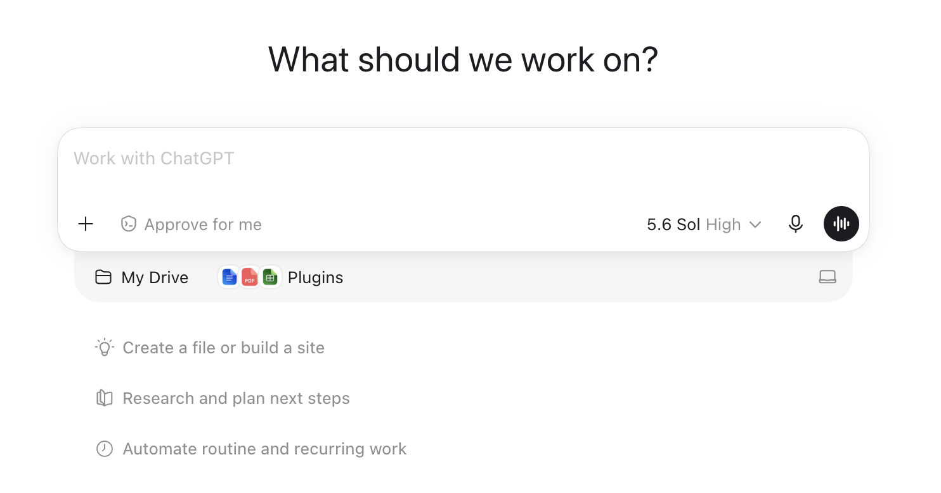
The ChatGPT message bar: + button (left) uploads the case PDF; the black waveform button (right) starts voice mode.
STARTER PROMPT — copy, paste, send:
Be my case tutor for the attached case, "Chunlei's U.S. Market Entry Strategy: Navigating Risks Through Scenario Planning". Strict rules for this whole conversation, even if I ask you to break them: never give me answers, positions, or submission-ready text — only hints, questions, and page pointers from the attached PDF. Do NOT summarize the case. Start by quizzing me on three specific case facts to check I've read it. Then I'll bring my homework questions one at a time, word for word. For each one: make me state my first-take position, my best evidence, and what I'm least sure about before you help; challenge my weakest assumption; and point me to case pages rather than reciting them. Once per question, offer one concrete alternative reading of the case (with a case page) for me to accept or reject with a reason. Never draft or suggest wording for what I write, and never make up a disagreement for me to log. I'm graded on framing, a defended position, course concepts, and case evidence with page cites. Two more rules. Pages: when you point me to pages, use the page number printed on the case page itself and say "case p. X" — never the PDF viewer's page counter; if the attached file is a course pack, the case's own numbering starts at 1 on the case's first page. Stopping: one round is I state or defend a position, you challenge it, I answer. After three rounds on a question, say "minimum met" and stop raising new objections. Do not judge whether my answer is good enough; that is my call.
Prefer typing? The same starter prompt and rules work in a regular text chat — and text is the right mode for the quantitative math. The transcript requirement is the same.

Student Information
Name * | First name, Last name
CPP Email *
Class section * | GBA6520.XX or IBM4212.XX

Case Questions
For each question, work the three boxes IN ORDER: write Box A before you use any AI on the question; then use AI to build your final answer in Box B; then document what changed in Box C.

Question 1
What are the key Resources, Forces, and Observers (RFO) in the ERP framework that Chunlei should consider for its market entry strategy into the United States?
Box A — First take, before any AI (100–200 words; bullets fine; ugly is fine): fill all three rows. Graded for honest commitment, not polish.
Box A — First take (no AI):
My position (one or two sentences):

My best case evidence (with case p. X):

What I'm least sure about:

Box B — Final answer, AI-assisted (250–500 words, hard cap 600; tables and calculations do not count). This is the box graded for content.
Box B — Final answer (AI-assisted):

Box C — Delta log: fill all three rows. Bullets are fine. Reading the case question aloud to set the agenda doesn't count as an exchange.
Box C — Delta log:
Exchanges (at least 3; one exchange = you state or defend a position, the tutor challenges it, you answer):

What changed from Box A to Box B — one tag per change: [evidence] [structure] [counterargument] [math check] [wording]:

AI suggestion you REJECTED + why: quote the tutor's suggestion in one line, then your case-based reason (case p. X). One is required per case; on other questions write "none". Not a rejection: agreeing with the tutor, dropping your own idea after a challenge, or skipping part of the question:

Question 2
How do the different market entry options (joint venture with different partners, and foreign direct investment) compare in terms of Efficiency, Resilience, and Prominence (ERP) for Chunlei's U.S. expansion?
Box A — First take, before any AI (100–200 words; bullets fine; ugly is fine): fill all three rows. Graded for honest commitment, not polish.
Box A — First take (no AI):
My position (one or two sentences):

My best case evidence (with case p. X):

What I'm least sure about:

Box B — Final answer, AI-assisted (250–500 words, hard cap 600; tables and calculations do not count). This is the box graded for content.
Box B — Final answer (AI-assisted):

Box C — Delta log: fill all three rows. Bullets are fine. Reading the case question aloud to set the agenda doesn't count as an exchange.
Box C — Delta log:
Exchanges (at least 3; one exchange = you state or defend a position, the tutor challenges it, you answer):

What changed from Box A to Box B — one tag per change: [evidence] [structure] [counterargument] [math check] [wording]:

AI suggestion you REJECTED + why: quote the tutor's suggestion in one line, then your case-based reason (case p. X). One is required per case; on other questions write "none". Not a rejection: agreeing with the tutor, dropping your own idea after a challenge, or skipping part of the question:

Question 3
Categorize the quantitative assumptions into the ERP framework. Conduct a quantitative financial analysis of the four entry options under three economic scenarios: high, medium, and low growth. Create 8-year projections that include 4 years of investment and incubation followed by 4 years of sales and operations.
Heads-up: This question requires actual projections — tables with numbers for the four options under the three scenarios. Qualitative discussion without the financial analysis caps the case-evidence criterion at half.
Box A — First take, before any AI (100–200 words; bullets fine; ugly is fine): fill all three rows. Graded for honest commitment, not polish.
Box A — First take (no AI):
My position (one or two sentences):

My best case evidence (with case p. X):

What I'm least sure about:

Box B — Final answer, AI-assisted (250–500 words, hard cap 600; tables and calculations do not count). This is the box graded for content.
Box B — Final answer (AI-assisted):

Box C — Delta log: fill all three rows. Bullets are fine. Reading the case question aloud to set the agenda doesn't count as an exchange.
Box C — Delta log:
Exchanges (at least 3; one exchange = you state or defend a position, the tutor challenges it, you answer):

What changed from Box A to Box B — one tag per change: [evidence] [structure] [counterargument] [math check] [wording]:

AI suggestion you REJECTED + why: quote the tutor's suggestion in one line, then your case-based reason (case p. X). One is required per case; on other questions write "none". Not a rejection: agreeing with the tutor, dropping your own idea after a challenge, or skipping part of the question:

Question 4
Using Efficiency–Resilience–Prominence (ERP) framework insights from your earlier analyses (both qualitative and scenario-based quantitative), make an argument for the strategic market entry decision Cao should make for Chunlei's U.S. expansion — pursue foreign direct investment, form a joint venture with Calmei, Harry & David, or Oishii, or follow an alternative approach? What do you recommend, and why?
Box A — First take, before any AI (100–200 words; bullets fine; ugly is fine): fill all three rows. Graded for honest commitment, not polish.
Box A — First take (no AI):
My position (one or two sentences):

My best case evidence (with case p. X):

What I'm least sure about:

Box B — Final answer, AI-assisted (250–500 words, hard cap 600; tables and calculations do not count). This is the box graded for content.
Box B — Final answer (AI-assisted):

Box C — Delta log: fill all three rows. Bullets are fine. Reading the case question aloud to set the agenda doesn't count as an exchange.
Box C — Delta log:
Exchanges (at least 3; one exchange = you state or defend a position, the tutor challenges it, you answer):

What changed from Box A to Box B — one tag per change: [evidence] [structure] [counterargument] [math check] [wording]:

AI suggestion you REJECTED + why: quote the tutor's suggestion in one line, then your case-based reason (case p. X). One is required per case; on other questions write "none". Not a rejection: agreeing with the tutor, dropping your own idea after a challenge, or skipping part of the question:

AI Usage Reflection
Your per-question prompts and improvements live in the Box C delta logs above. Close out with the overall picture:

Overall synthesis
100–250 words in total, looking across ALL your delta logs. Fill all four rows.
Your synthesis:
Where AI helped most (name the question and the change):

Where AI added least or misled you (name one specific exchange):

Where you decided an answer was good enough and stopped, and why:

One thing you will do differently on the next case:

Transcript file
Upload the WHOLE conversation as a second .docx in the same Canvas submission (Canvas: Upload File, then Add Another File). Its first line is your starter prompt. A summary, a partial copy, or a link instead of the file counts as no transcript. Type the file name below.
Transcript file

Style Guide — formatting reference (not a separate deliverable)
This page is a formatting reference. This one Word document, uploaded as a .docx, is your entire submission. It is evaluated on content (per the rubric above) and on report-style professionalism. Aim for the standard you would deliver to a client or executive reader.
- Font: Calibri 11pt or Times New Roman 12pt; 1-inch margins; single or 1.15 spacing.
- Tables and figures: number and caption every one (e.g., "Table 1. Kindle Fire 3-year revenue model"); reference each in the body text.
- Citations: use the page number printed on the case page, in parentheses (e.g., "sold at cost (case p. 13)"). If your tutor gave course-pack or PDF-viewer pages, convert them before submitting.
- Tone: professional, concise, evidence-led. Avoid first-person colloquialisms ("I think", "in my opinion").
- Numbers: include units, percentages, and time ranges; round consistently.
- AI content: paraphrase and verify against the case PDF. Do not paste raw AI output.
- Final check: spell-check, then upload TWO .docx files in one Canvas submission: this document and Lastname_Transcript.docx (not PDFs; comments come back on your Word file).

--- End of assignment ---

