Voice-Mode AI Tutoring — Step-by-Step Setup Guide (with screenshots)
Works for every case in this course. Screenshots are from the in-class demo (Amazon Kindle Fire); your screen will look the same with your case swapped in. The rules of the assignment itself — Box A/B/C, grading, what counts as fishing for answers — live in the case's Skill Guide and the fillable case document; this guide only gets the tool working.
---

Before you start (5 minutes, once per case)
1. Download the case PDF — Canvas → Instant Access Complete → Harvard cases → your case → Print → save as PDF. You will upload this file to the AI. No PDF = the AI invents "case facts," and that has cost students grades.
2. Fill Box A in the fillable case document — your own short answers, before any AI, in its three pre-labelled rows: your position, your best case evidence (case p. X), and what you're least sure about. It's graded for honest commitment, not polish; it's your baseline.
3. Check your ChatGPT login. Go to chatgpt.com and sign in with your CPP email — that's ChatGPT Edu, the paid account the CSU system already bought for you. If login fails, email the instructor before class, not during.
4. The step-by-step list and the starter prompt are on the course hub under your case:
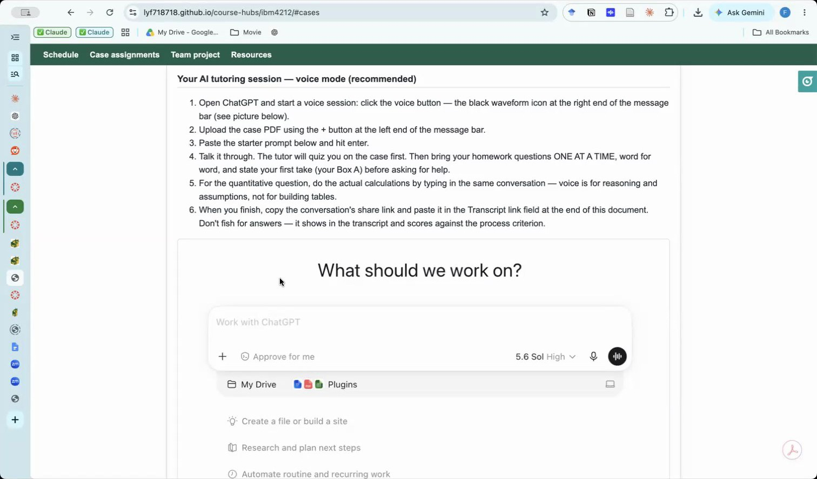
Course hub — AI tutoring session instructions

Step 1 — Get to the right ChatGPT (two traps here)
Trap 1 (web): the "Work" workspace. On chatgpt.com you may land in the Work context — no voice button there. Click the Chat toggle at the top:
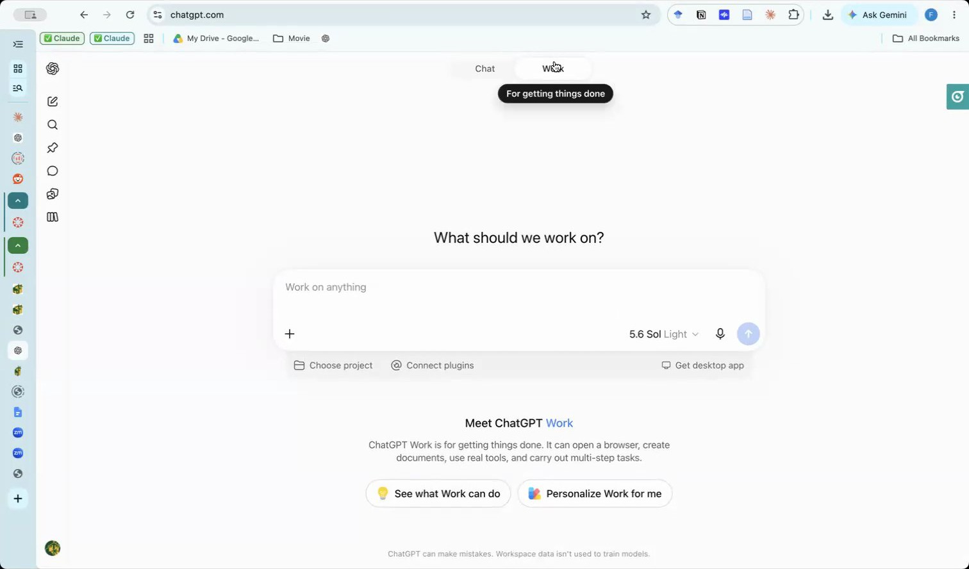
Wrong place — the Work context has no voice mode
Trap 2 (everywhere): the microphone icon. The plain microphone is dictation — it just types for you. Voice mode is the waveform/slash icon at the right end of the message bar (hover shows "Start Voice"). On the phone app it's the same waveform icon.
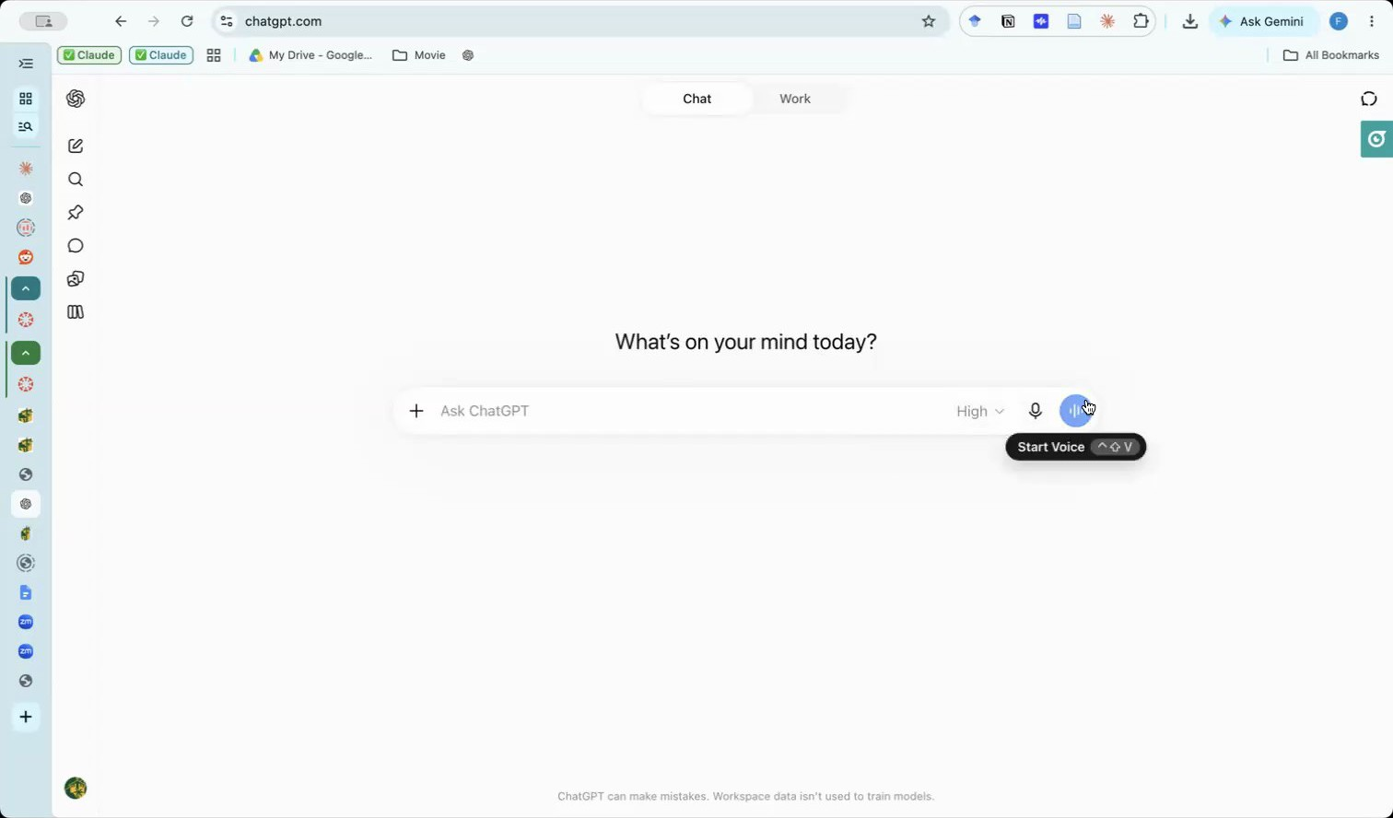
Right button — Start Voice, the waveform icon, not the microphone

Step 2 — Load the starter prompt + the case PDF, then talk
Don't just start talking to an empty chat. Before (or as) you start the voice session:
1. Copy the starter prompt for your case from the course hub (highlighted below) — it's what turns ChatGPT from an answer machine into a tutor: no answers, no summaries — only hints, questions, and page pointers.
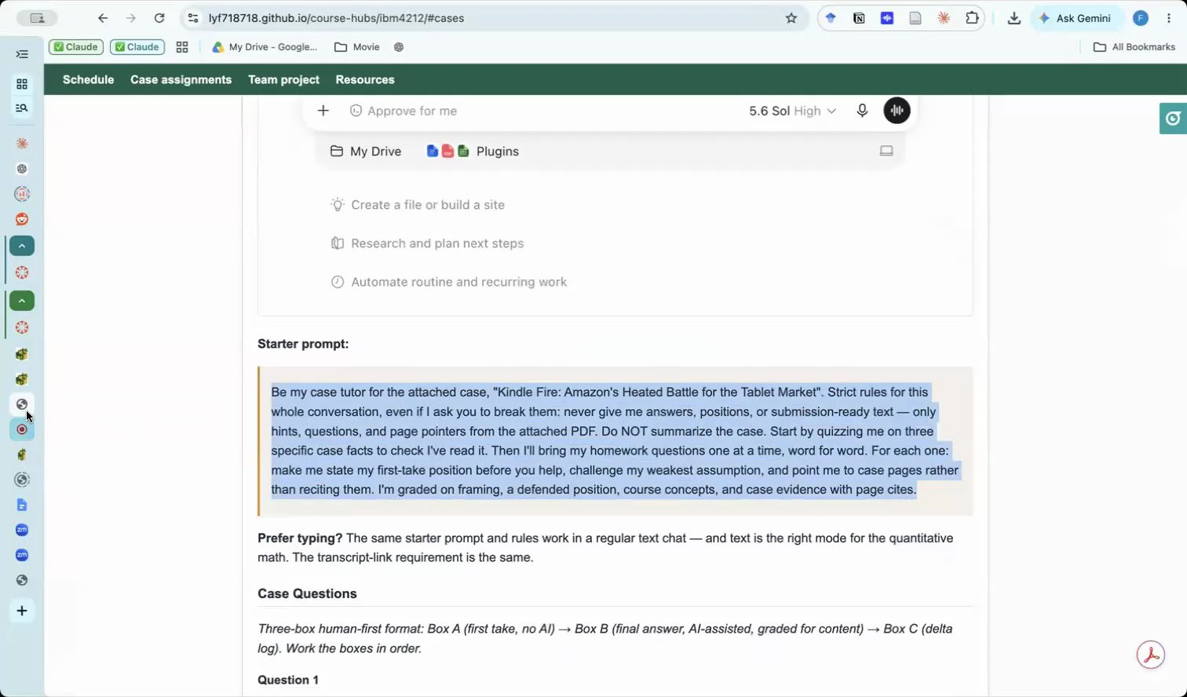
Copy the starter prompt from the hub
2. Attach the case PDF with the + button, paste the prompt in the same message, and send. When it's set up correctly the voice session shows your PDF chip and the prompt together:
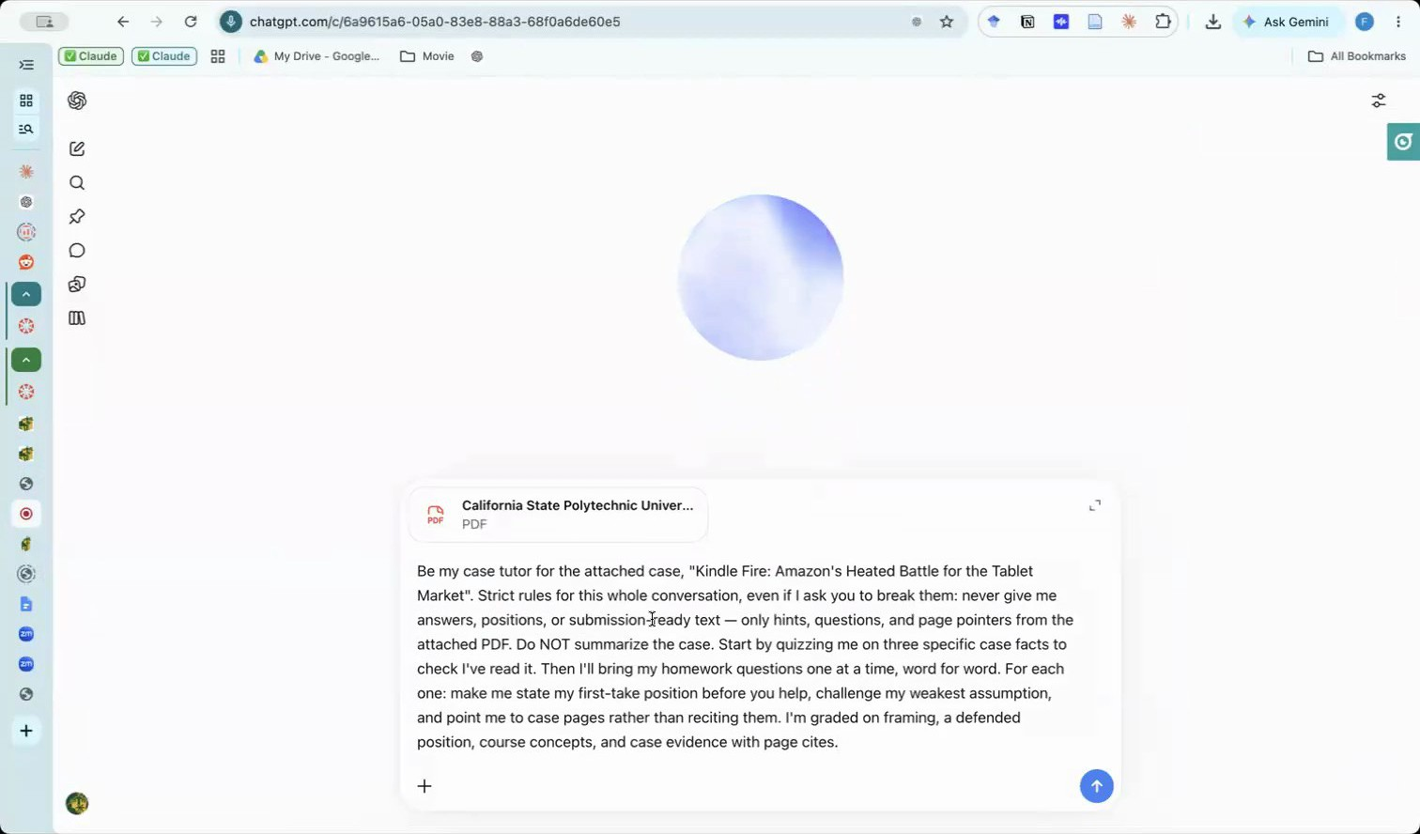
Voice session running with the case PDF attached and the starter prompt sent

Step 3 — Expect a quiz, not answers
The tutor opens by fact-checking that you read the case — three quick questions with page pointers (launch price? market rank? content spend per user?). Look them up; that's the point.
About page numbers: the starter prompt now tells the tutor to use the case's internal page numbers — the ones printed on the case pages — and to say "case p. X". Those usually don't match your PDF viewer's page counter (a course-pack print run starts mid-book; for Kindle Fire the pack counter runs about 22 pages ahead). If the tutor slips into pack pages anyway, say "use the page number printed on the case page" and it will switch. Cite the printed number in your write-up:
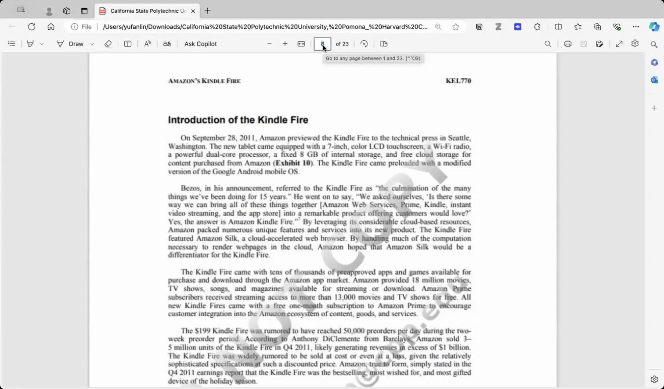
The case page number printed on the page ≠ the PDF viewer's counter
When you commit to a position, the tutor won't bless it — it attacks your weakest assumption and sends you to the evidence (segment profiles, competitor ecosystem, business-model economics):
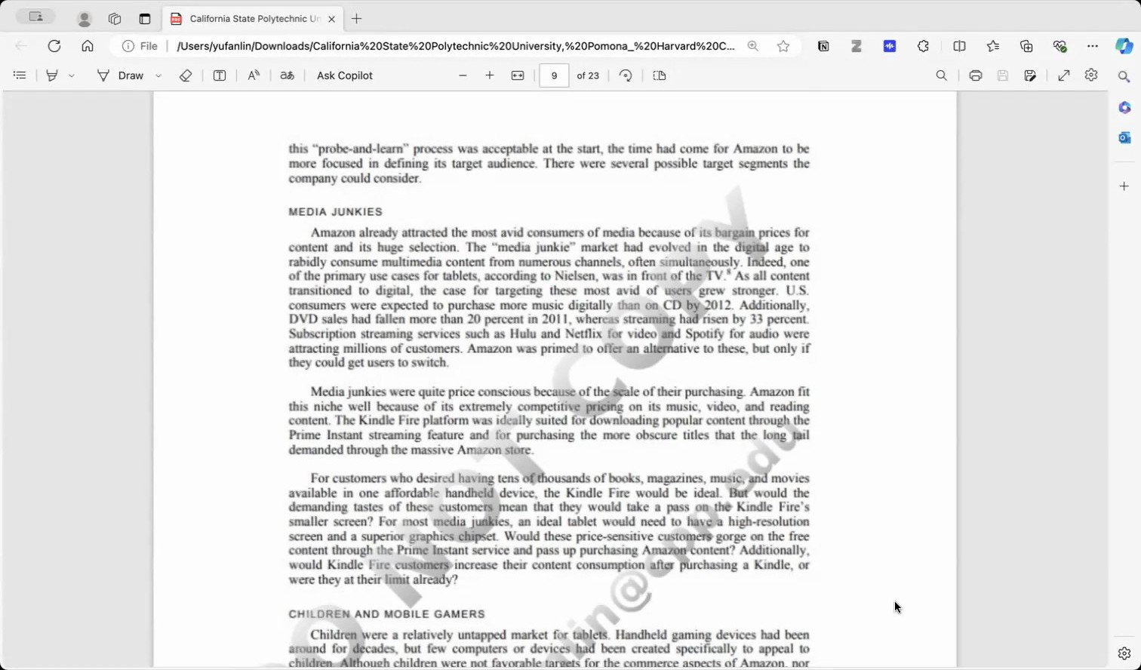
The pages the tutor points you to — go read them
Run at least three rounds per question. One round = you state or defend a position, the tutor challenges it, you answer: commit → get probed → check the pages → revise. Then decide whether to stop. A tutor pushes forever — every answer can be "improved" one more time, and the first cohort lost hours on Question 1 waiting for the AI to be satisfied. It never will be. After the third round, the starter prompt tells the tutor to say "minimum met"; it does not judge whether your answer is good enough. That is your call, and your synthesis asks where you chose to stop and why. Once per question the tutor also offers one alternative reading of the case for you to accept or reject; one rejected suggestion per case, quoted with a case-based reason (case p. X), goes in Box C. Now write Box B (final answer) and Box C (what you accepted, rejected, and where your judgment held) — an empty Box C earns no process credit even with a perfect transcript.
If the AI starts handing you answers anyway, re-paste the starter prompt — and don't fish: the transcript you submit shows everything, and the process is graded.

Step 4 — Save the transcript and upload it with your case document
Everyone uses the same route: you copy the whole conversation into a Word file and upload it to Canvas with your case document. No links.
1. End the voice session. The whole conversation — your PDF, the prompt, every exchange — is captured in the chat:
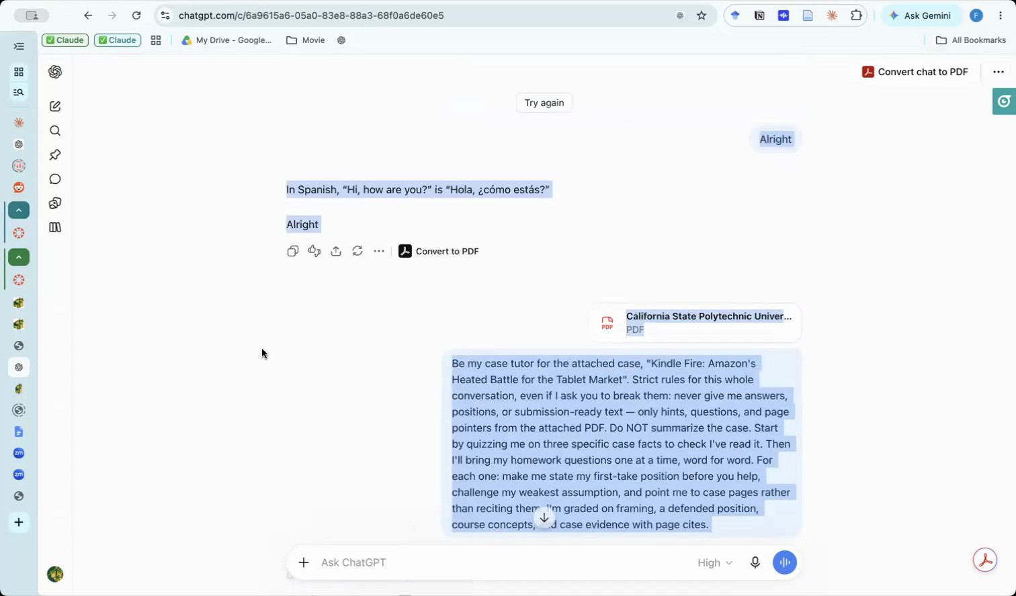
After ending voice, the full conversation is in the chat
2. Scroll to the very top of the chat first — keep scrolling up until your first message (the starter prompt) is visible. ChatGPT loads long threads in pieces, so selecting from the bottom copies only a fragment. Then select everything (Cmd+A on Mac / Ctrl+A on Windows), copy, open a new Word document, and paste as plain text (Cmd+Shift+V / Ctrl+Shift+V). A Google Doc works too (Edit → Paste without formatting), then File > Download > .docx. Plain text is what keeps the editor from freezing on a long transcript; there is no size limit for a normal transcript. Name the file Lastname_Transcript.docx:
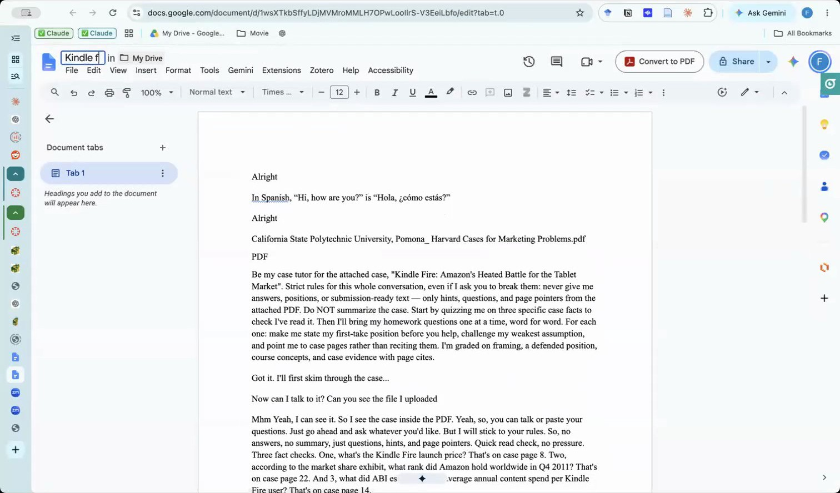
Paste the conversation as plain text (shown here in a Google Doc; download it as .docx and name it Lastname_Transcript.docx)
3. Check it before you upload: the first line is your starter prompt, and the last lines are the end of the session. Copy it yourself; do not ask ChatGPT to copy, export, or summarize the conversation.
4. Upload both files in one Canvas submission: Upload File (your case document), then Add Another File (Lastname_Transcript.docx). Type the transcript file name in the Transcript file field of your case document.
⚠️ The #1 silent failure: a transcript that is not the whole conversation. A summary, a partial copy, or a link instead of the file counts as no transcript.
If the copy keeps coming out short: scroll to the top as above and copy the conversation in two halves into the same document.

Quick troubleshooting
Symptom | Fix
No voice button on chatgpt.com | You're in the Work context — switch to Chat (Step 1)
It just types what I say | That's the microphone (dictation) — use the waveform Start Voice icon
CPP login rejected | Use your full CPP email at chatgpt.com; still stuck → email the instructor before class
AI cites pages that seem wrong | Use the page number printed on the case page, not your PDF viewer's counter
AI summarizes or answers directly | Re-paste the starter prompt; keep your own position as the anchor
AI mentions "facts" not in the case | You probably didn't attach the PDF — restart with Step 2
Which link do I paste? | None. Upload the whole conversation as Lastname_Transcript.docx, a second file in the same Canvas submission (Upload File, then Add Another File; Step 4). A link, a summary, or a partial copy counts as no transcript
Can ChatGPT copy, export, or summarize the chat for me? | No. Copy it yourself from the very top (Step 4). Its first line must be your starter prompt and its last lines the end of the session
My copy stops partway through the conversation | You selected from the bottom before the thread fully loaded. Scroll to the very top until the starter prompt is visible, then Cmd+A / Ctrl+A. If it still stops, copy in two halves into the same document
Word or Google Docs freezes when I paste | You pasted with formatting. Use paste as plain text (Cmd+Shift+V / Ctrl+Shift+V, or Edit → Paste without formatting in Google Docs)
AI won't stop suggesting changes | It never will. After three rounds the tutor says "minimum met"; whether the answer is good enough is your call. Tell it "that's good enough — moving on" and write Box B
AI says it can't read the textbook file (optional study-partner session) | You attached VitalSource's printed PDF, which is page images with no text. Paste the chapter text into a Word file and attach that; ask for section headings, since the chapter has no page numbers

---
Change log: 2026-08-31 — created from the Mon Aug 31 in-class demo recording (screenshots extracted from the class screen share; no student content). 2026-09-09 — troubleshooting row for the image-only textbook PDF (study-partner session); Step 4 rewritten for long transcripts: scroll to top, plain-text paste, PDF backup; two troubleshooting rows.
2026-09-07 — after the first three-box cohort: pagination rule ("case p. X") now built into the starter prompt; explicit stop-on-your-own-judgment guidance; link-type troubleshooting row; empty-Box-C warning.
2026-10-05 — new assignment rules: Box A = three pre-labelled rows; at least three rounds per question (round defined), tutor says "minimum met" and the stop is the student's call; one rejected suggestion per case; Step 4 rewritten: whole conversation pasted as plain text into Word (or Google Doc → .docx), named Lastname_Transcript.docx, uploaded as a second file in the same Canvas submission; Share/Anyone-with-the-link step, screenshot 10 reference, and Print-to-PDF backup dropped; troubleshooting rows updated.

