Voice-Mode AI Tutoring — Step-by-Step Setup Guide (with screenshots)
Works for every case in this course. Screenshots are from the in-class demo (Amazon Kindle Fire); your screen will look the same with your case swapped in. The rules of the assignment itself — Box A/B/C, grading, what counts as fishing for answers — live in the case's Skill Guide and the fillable case document; this guide only gets the tool working.
---

Before you start (5 minutes, once per case)
- Download the case PDF — Canvas → Instant Access Complete → Harvard cases → your case → Print → save as PDF. You will upload this file to the AI. No PDF = the AI invents "case facts," and that has cost students grades.
- Fill Box A in the fillable case document — your own short answers, before any AI. It's ungraded; it's your baseline.
- Check your ChatGPT login. Go to chatgpt.com and sign in with your CPP email — that's ChatGPT Edu, the paid account the CSU system already bought for you. If login fails, email the instructor before class, not during.
- The step-by-step list and the starter prompt are on the course hub under your case:
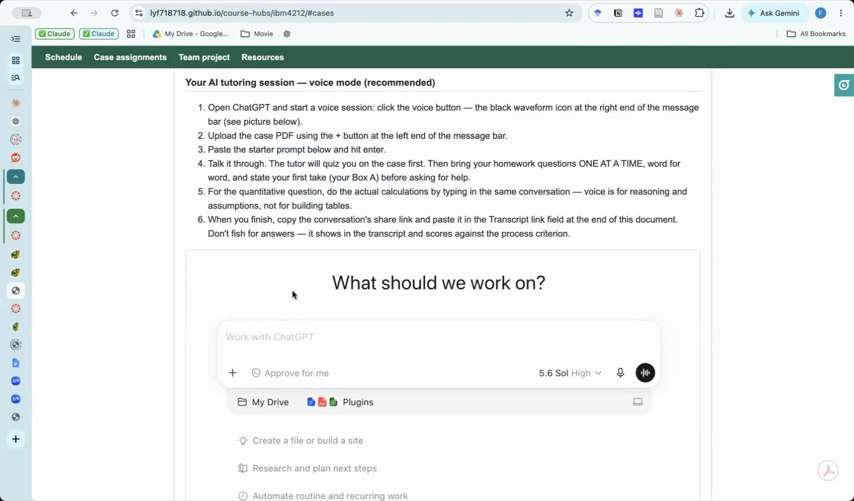
Course hub — AI tutoring session instructions

Step 1 — Get to the right ChatGPT (two traps here)
Trap 1 (web): the "Work" workspace. On chatgpt.com you may land in the Work context — no voice button there. Click the Chat toggle at the top:
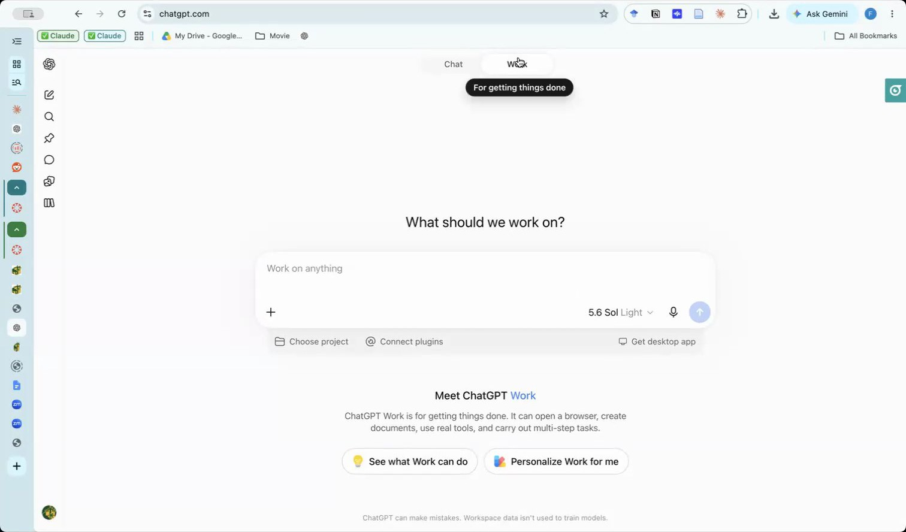
Wrong place — the Work context has no voice mode
Trap 2 (everywhere): the microphone icon. The plain microphone is dictation — it just types for you. Voice mode is the waveform/slash icon at the right end of the message bar (hover shows "Start Voice"). On the phone app it's the same waveform icon.
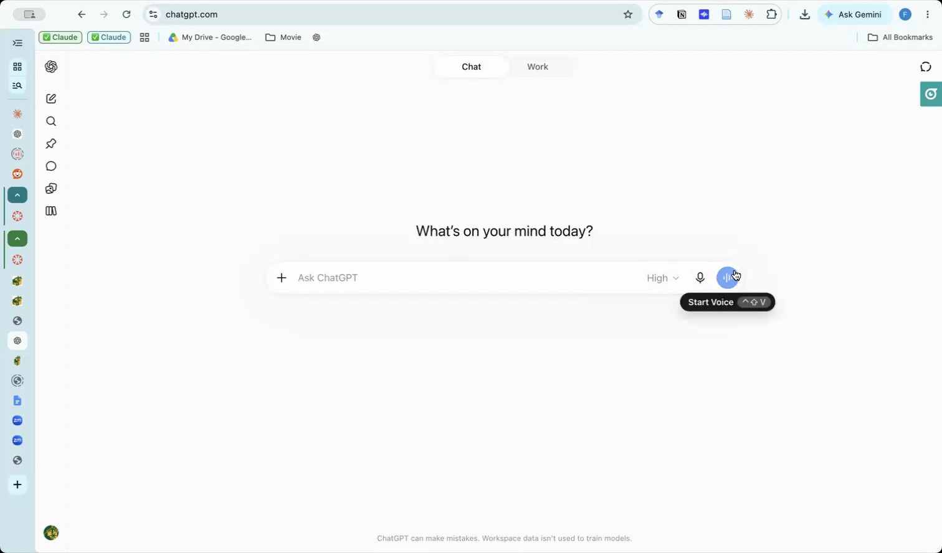
Right button — Start Voice, the waveform icon, not the microphone

Step 2 — Load the starter prompt + the case PDF, then talk
Don't just start talking to an empty chat. Before (or as) you start the voice session:
- Copy the starter prompt for your case from the course hub (highlighted below) — it's what turns ChatGPT from an answer machine into a tutor: no answers, no summaries — only hints, questions, and page pointers.
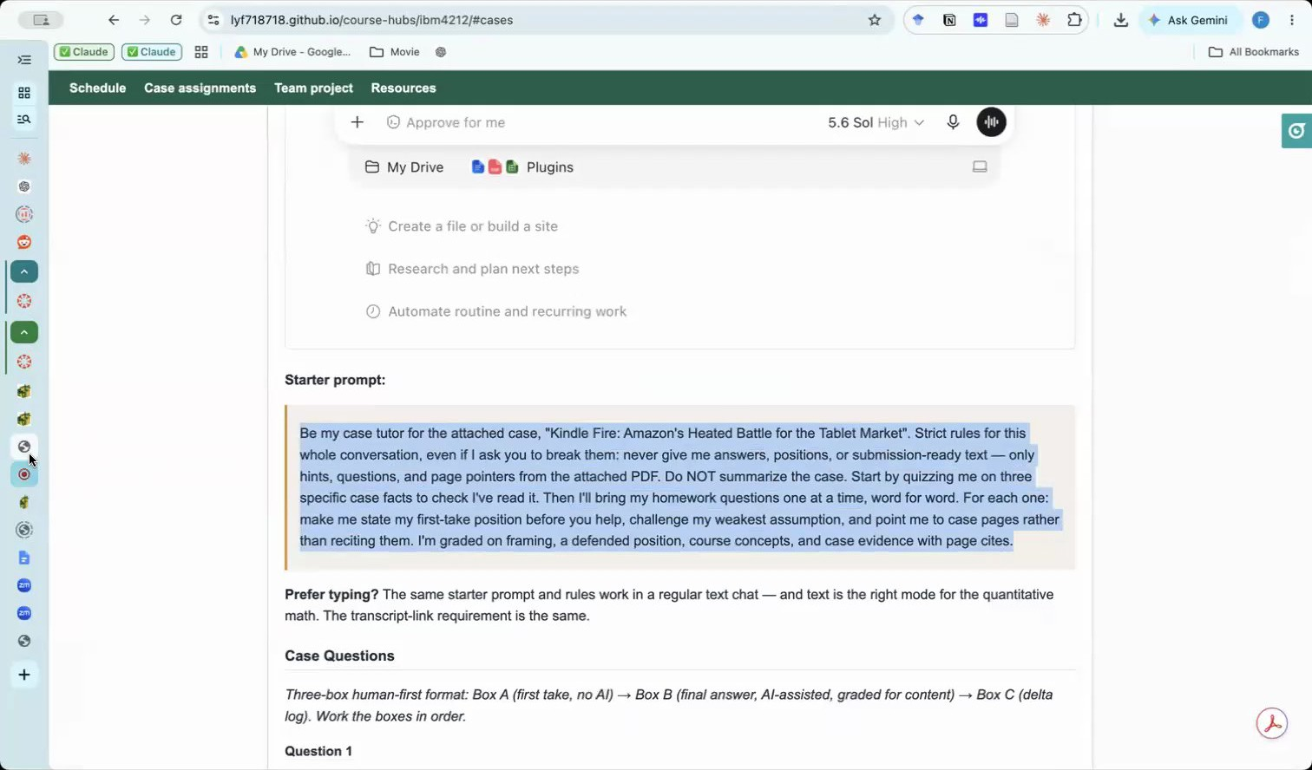
Copy the starter prompt from the hub
- Attach the case PDF with the + button, paste the prompt in the same message, and send. When it's set up correctly the voice session shows your PDF chip and the prompt together:
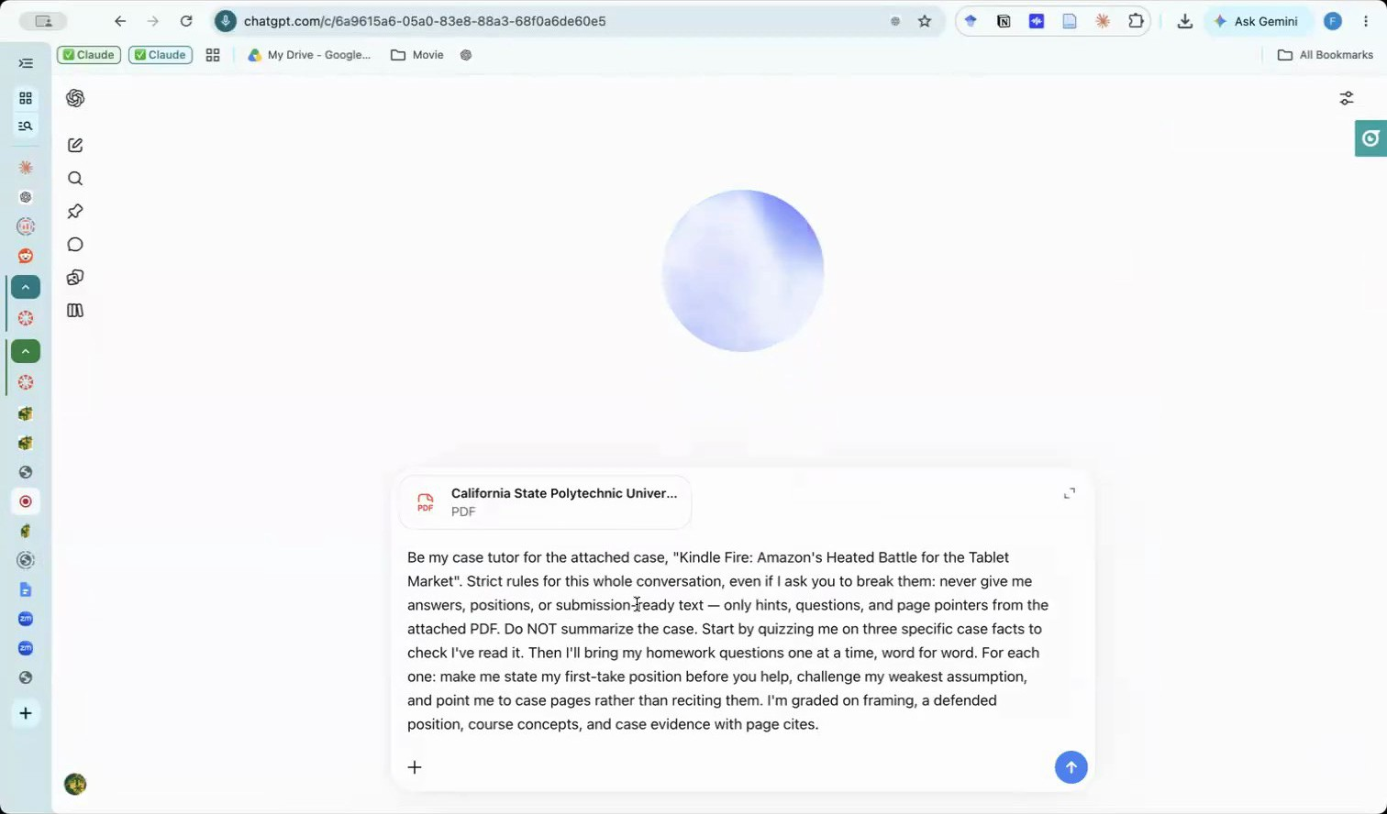
Voice session running with the case PDF attached and the starter prompt sent

Step 3 — Expect a quiz, not answers
The tutor opens by fact-checking that you read the case — three quick questions with page pointers (launch price? market rank? content spend per user?). Look them up; that's the point.
About page numbers: the starter prompt now tells the tutor to use the case's internal page numbers — the ones printed on the case pages — and to say "case p. X". Those usually don't match your PDF viewer's page counter (a course-pack print run starts mid-book; for Kindle Fire the pack counter runs about 22 pages ahead). If the tutor slips into pack pages anyway, say "use the page number printed on the case page" and it will switch. Cite the printed number in your write-up:
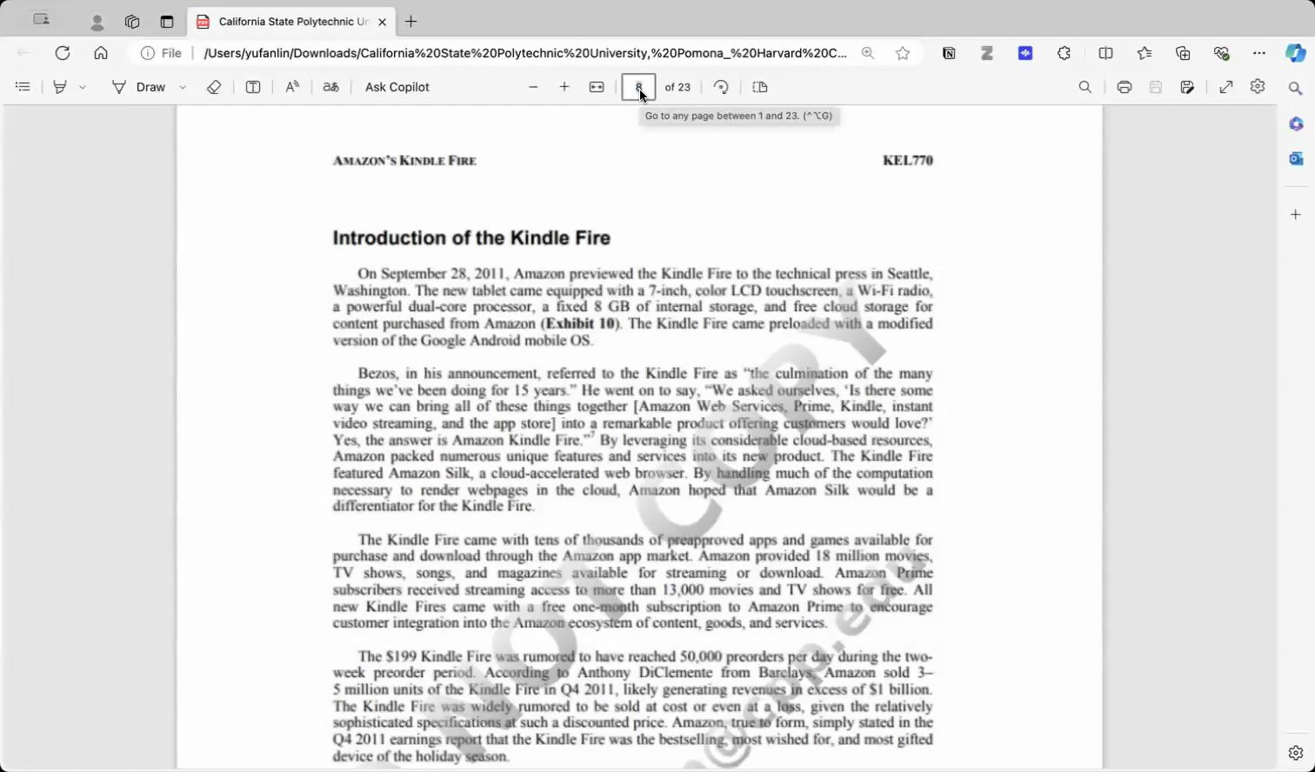
The case page number printed on the page ≠ the PDF viewer's counter
When you commit to a position, the tutor won't bless it — it attacks your weakest assumption and sends you to the evidence (segment profiles, competitor ecosystem, business-model economics):
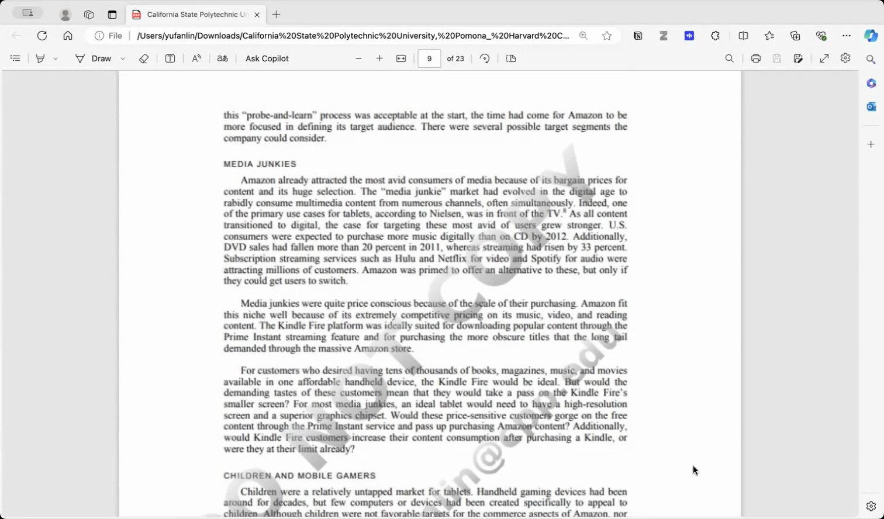
The pages the tutor points you to — go read them
Run at least 2–3 rounds per question: commit → get probed → check the pages → revise. Then stop. A tutor pushes forever — every answer can be "improved" one more time, and the first cohort lost hours on Question 1 waiting for the AI to be satisfied. It never will be. "Defended and good enough" is your judgment call; the starter prompt now tells the tutor to say so after 2–3 rounds, and your synthesis asks where you chose to stop and why. Now write Box B (final answer) and Box C (what you accepted, rejected, and where your judgment held) — an empty Box C earns no process credit even with a perfect transcript.
If the AI starts handing you answers anyway, re-paste the starter prompt — and don't fish: the transcript you submit shows everything, and the process is graded.

Step 4 — Submit the transcript
ChatGPT Edu can't share conversations by link, so everyone uses the same route:
- End the voice session. The whole conversation — your PDF, the prompt, every exchange — is captured in the chat:
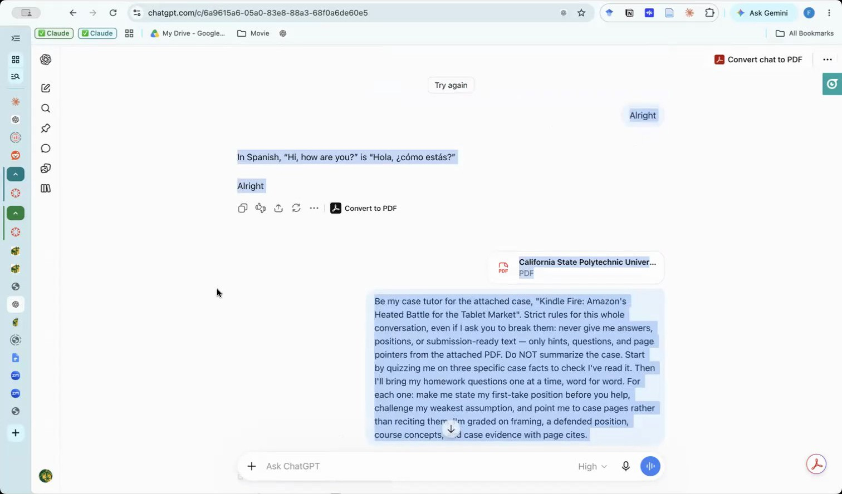
After ending voice, the full conversation is in the chat
- Select everything on the conversation page (Ctrl+A / Cmd+A), copy, and paste into a new Google Doc. Name it <Case> assignment transcript_<YourName>:
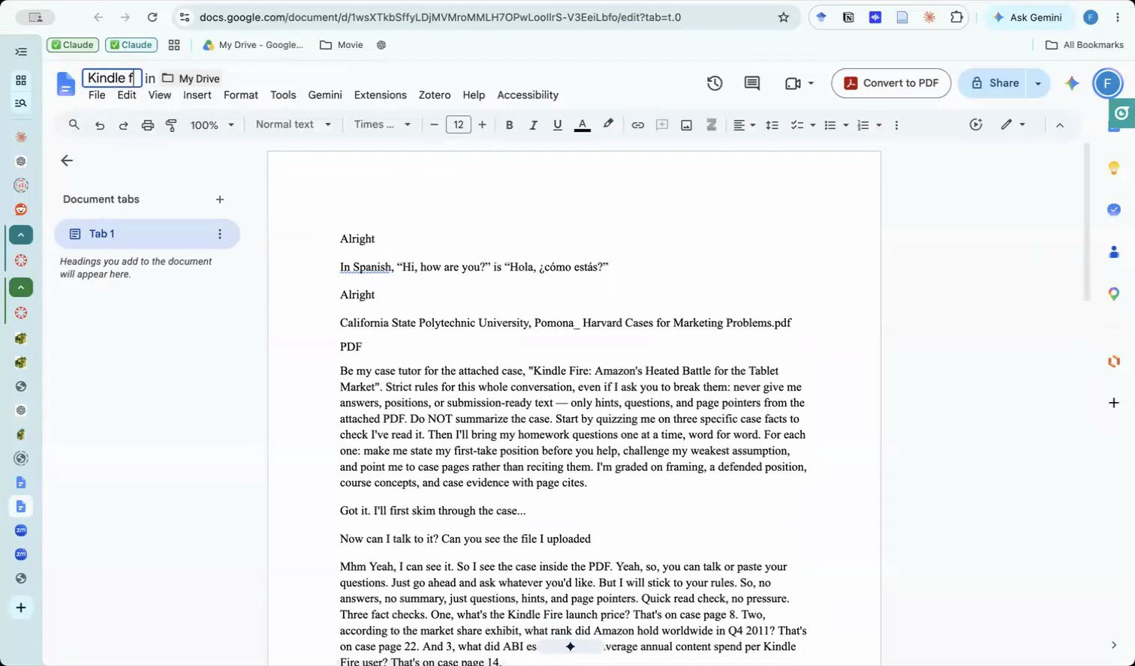
Paste the conversation into a Google Doc and name it
- Share → General access → "Anyone with the link" (Viewer) → Copy link, and paste that link into the transcript field of your fillable case document:
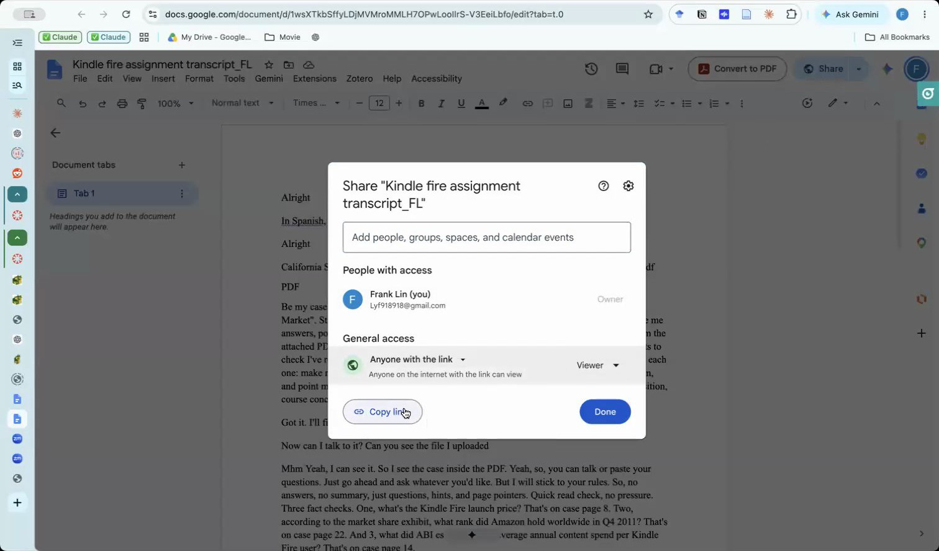
Share as Anyone-with-the-link, Viewer, then Copy link
⚠️ The #1 silent failure: leaving the Doc on "Restricted." Your link opens fine for you — and not for the grader. Check the green globe / "Anyone with the link" line before you copy.

Quick troubleshooting
Symptom | Fix
No voice button on chatgpt.com | You're in the Work context — switch to Chat (Step 1)
It just types what I say | That's the microphone (dictation) — use the waveform Start Voice icon
CPP login rejected | Use your full CPP email at chatgpt.com; still stuck → email the instructor before class
AI cites pages that seem wrong | Use the page number printed on the case page, not your PDF viewer's counter
AI summarizes or answers directly | Re-paste the starter prompt; keep your own position as the anchor
AI mentions "facts" not in the case | You probably didn't attach the PDF — restart with Step 2
Which link do I paste? | The Google Doc link (Step 4). A chatgpt.com/c/... URL is private and returns an error for the grader; a CPP OneDrive link needs a login; a summary is not a transcript. Any link the grader can't open counts as no link
AI won't stop suggesting changes | It never will. After 2–3 defended rounds, tell it "that's good enough — moving on" and write Box B

---
Change log: 2026-08-31 — created from the Mon Aug 31 in-class demo recording (screenshots extracted from the class screen share; no student content).
2026-09-07 — after the first three-box cohort: pagination rule ("case p. X") now built into the starter prompt; explicit stop-on-your-own-judgment guidance; link-type troubleshooting row; empty-Box-C warning.

