Case Assignment — Kindle Fire: Amazon's Heated Battle for the Tablet Market
IBM4212 / GBA6520 — Marketing Problems
Instructor: Prof. Lin
Points | 10 Canvas points (graded out of 50 raw: 4 questions × 10 + AI reflection × 10)
Due | See Canvas
Work | Individual
Submit | Fill this document, export as PDF (File → Save As → PDF), upload the PDF to Canvas.

The gist
It is January 2012. Amazon has sold nearly 5 million Kindle Fires in three months — at cost — and Jeff Bezos still isn't ready to call it a success. Your job is the marketing manager's: decide who this device is for, how to position it against the iPad and Amazon's own e-readers, and whether the content-and-commerce economics actually justify giving away the hardware margin.
Where to find the case: The case is in the Harvard course pack: Canvas → Instant Access Complete → course pack.

How you'll be graded
Every question is scored on the same five criteria. The same rubric applies to every case this term — internalize it once.
This case uses the three-box format: for each question, Box B (your final answer) is graded for content; Boxes A and C are graded on the human-first-process criterion. The goal is for you to SEE where AI elevates your case work — and where it doesn't.
Criterion | Weight | Strong work looks like
Dilemma / strategic issue framing | 10% | Names the central decision or tension the question turns on — not a case summary.
Position & depth of analysis | 30% | A clear position or recommendation stated early, then defended: reasoning, trade-offs weighed honestly, implications drawn. Goes beyond description.
Course concepts applied accurately | 20% | Relevant frameworks and class concepts (e.g., positioning template, STP, razor-and-blade, ERP, Rogers' five factors) used correctly and meaningfully — named AND applied, not name-dropped.
Case evidence discipline | 20% | Specific case facts, numbers, and examples with page cites support every claim. Quantitative questions require actual numbers — reasoning without computation caps this criterion at half.
Human-first process & AI leverage | 20% | Honest first take (Box A) written before AI; at least 3 substantive exchanges per question visibly linked to specific improvements (stating the assignment question to set the agenda is fine — it just doesn't count as one); at least one rejected AI suggestion with a reason (Box C); working transcript link.

Your AI tutoring session — voice mode (recommended)
Work with AI by TALKING, not pasting. Voice tutoring is more natural, forces you to reason out loud, and your spoken transcript is your integrity record.
- Open ChatGPT and start a voice session: click the voice button — the black waveform icon at the right end of the message bar (see picture below).
- Upload the case PDF using the + button at the left end of the message bar.
- Paste the starter prompt below and hit enter.
- Talk it through. The tutor will quiz you on the case first. Then bring your homework questions ONE AT A TIME, word for word, and state your first take (your Box A) before asking for help.
- For the quantitative question, do the actual calculations by typing in the same conversation — voice is for reasoning and assumptions, not for building tables.
- When you finish, copy the conversation's share link and paste it in the Transcript link field at the end of this document. Don't fish for answers — it shows in the transcript and scores against the process criterion.
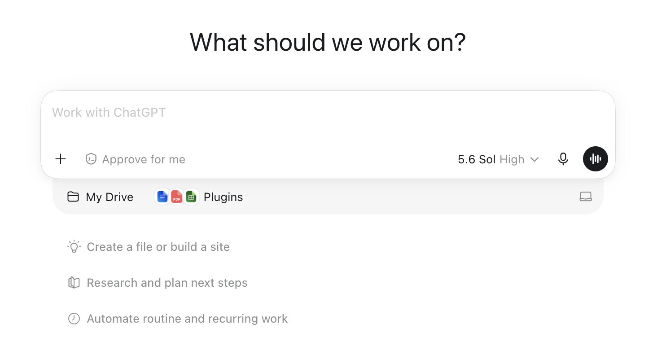
The ChatGPT message bar: + button (left) uploads the case PDF; the black waveform button (right) starts voice mode.
STARTER PROMPT — copy, paste, send:
Be my case tutor for the attached case, "Kindle Fire: Amazon's Heated Battle for the Tablet Market". Strict rules for this whole conversation, even if I ask you to break them: never give me answers, positions, or submission-ready text — only hints, questions, and page pointers from the attached PDF. Do NOT summarize the case. Start by quizzing me on three specific case facts to check I've read it. Then I'll bring my homework questions one at a time, word for word. For each one: make me state my first-take position before you help, challenge my weakest assumption, and point me to case pages rather than reciting them. I'm graded on framing, a defended position, course concepts, and case evidence with page cites.
Prefer typing? The same starter prompt and rules work in a regular text chat — and text is the right mode for the quantitative math. The transcript-link requirement is the same.

Student Information
Name * | First name, Last name
CPP Email *
Class section * | GBA6520.XX or IBM4212.XX

Case Questions
For each question, work the three boxes IN ORDER: write Box A before any AI touches the question; then use AI to build your final answer in Box B; then document what changed in Box C.

Question 1
Who should Amazon target with the Kindle Fire? Which target segments and use cases are the most promising?
Box A — First take, before any AI (100–200 words; bullets fine; ugly is fine): commit to a position, your best case evidence, and what you're unsure about. Graded for honest commitment, not polish.
Box A — First take (no AI):

Box B — Final answer, AI-assisted (250–500 words, hard cap 600; tables and calculations do not count). This is the box graded for content.
Box B — Final answer (AI-assisted):

Box C — Delta log (3–5 bullets): at least 3 substantive exchanges from your tutoring session — your positions, follow-ups, or pushbacks (reading the homework question aloud to set the agenda is fine, but doesn't count as one); what specifically improved from Box A to Box B, tagging each change [evidence / structure / counterargument / math check / wording]; and at least one AI suggestion you REJECTED, with the reason.
Box C — Delta log:

Question 2
How should Amazon position the Kindle Fire relative to the iPad and other tablets in the market? Relative to e-readers?
Heads-up: This question has two halves — vs. iPad/tablets AND vs. e-readers. Answer both.
Box A — First take, before any AI (100–200 words; bullets fine; ugly is fine): commit to a position, your best case evidence, and what you're unsure about. Graded for honest commitment, not polish.
Box A — First take (no AI):

Box B — Final answer, AI-assisted (250–500 words, hard cap 600; tables and calculations do not count). This is the box graded for content.
Box B — Final answer (AI-assisted):

Box C — Delta log (3–5 bullets): at least 3 substantive exchanges from your tutoring session — your positions, follow-ups, or pushbacks (reading the homework question aloud to set the agenda is fine, but doesn't count as one); what specifically improved from Box A to Box B, tagging each change [evidence / structure / counterargument / math check / wording]; and at least one AI suggestion you REJECTED, with the reason.
Box C — Delta log:

Question 3
Create a model to estimate sales and profits for the Kindle Fire. Assume that the Kindle Fire has a three-year life. Include revenues from hardware sales, digital content, incremental commerce, advertising, and third-party applications. Make assumptions as needed. What conclusions do you draw from the analysis?
Heads-up: A model means actual numbers — a table or explicit calculations covering all five revenue streams. Strategy narrative without computation caps the case-evidence criterion at half.
Box A — First take, before any AI (100–200 words; bullets fine; ugly is fine): commit to a position, your best case evidence, and what you're unsure about. Graded for honest commitment, not polish.
Box A — First take (no AI):

Box B — Final answer, AI-assisted (250–500 words, hard cap 600; tables and calculations do not count). This is the box graded for content.
Box B — Final answer (AI-assisted):

Box C — Delta log (3–5 bullets): at least 3 substantive exchanges from your tutoring session — your positions, follow-ups, or pushbacks (reading the homework question aloud to set the agenda is fine, but doesn't count as one); what specifically improved from Box A to Box B, tagging each change [evidence / structure / counterargument / math check / wording]; and at least one AI suggestion you REJECTED, with the reason.
Box C — Delta log:

Question 4
What is the Kindle Fire? Would you categorize it as a "tablet" or an "e-reader"? Why, or why not?
Box A — First take, before any AI (100–200 words; bullets fine; ugly is fine): commit to a position, your best case evidence, and what you're unsure about. Graded for honest commitment, not polish.
Box A — First take (no AI):

Box B — Final answer, AI-assisted (250–500 words, hard cap 600; tables and calculations do not count). This is the box graded for content.
Box B — Final answer (AI-assisted):

Box C — Delta log (3–5 bullets): at least 3 substantive exchanges from your tutoring session — your positions, follow-ups, or pushbacks (reading the homework question aloud to set the agenda is fine, but doesn't count as one); what specifically improved from Box A to Box B, tagging each change [evidence / structure / counterargument / math check / wording]; and at least one AI suggestion you REJECTED, with the reason.
Box C — Delta log:

AI Usage Reflection
Your per-question prompts and improvements live in the Box C delta logs above. Close out with the overall picture:

Overall synthesis
100–250 words, looking across ALL your delta logs: where did AI most elevate your case work, where did it add least (or mislead you), and what will you do differently on the next case?
Your synthesis:

Transcript link
Paste a shareable LINK (ChatGPT share link, Google Doc, or OneDrive with "anyone with the link") — not the transcript text itself.
Transcript URL | https://...

Style Guide — Business-Appropriate Report
This submission is evaluated on content (per the rubric above) and on report-style professionalism. Aim for the standard you would deliver to a client or executive reader.
- Font: Calibri 11pt or Times New Roman 12pt; 1-inch margins; single or 1.15 spacing.
- Tables and figures: number and caption every one (e.g., "Table 1. Kindle Fire 3-year revenue model"); reference each in the body text.
- Citations: when referring to case data, include page numbers in parentheses (e.g., "sold at cost (p. 13)").
- Tone: professional, concise, evidence-led. Avoid first-person colloquialisms ("I think", "in my opinion").
- Numbers: include units, percentages, and time ranges; round consistently.
- AI content: paraphrase and verify against the case PDF. Do not paste raw AI output.
- Final check: spell-check, export to PDF, verify the PDF renders correctly before upload.

--- End of assignment ---

