Case Assignment — Under Armour: Creating and Growing a New Consumer Brand
IBM4212 / GBA6520 — Marketing Problems
Instructor: Prof. Lin
Points | 10 Canvas points (graded out of 40 raw: 3 questions × 10 + AI reflection × 10)
Due | See Canvas
Work | Individual
Submit | Fill this document, export as PDF (File → Save As → PDF), upload the PDF to Canvas.

The gist
Under Armour built a powerhouse brand on performance apparel for male athletes — and now wants $1.9 billion in sales to women by 2019. You are the brand strategist: articulate what the UA brand actually stands for, judge whether its women-targeted advertising delivers on that positioning, and recommend the ad approach going forward.
Where to find the case: The case is in the Harvard course pack: Canvas → Instant Access Complete → course pack.

How you'll be graded
Every question is scored on the same five criteria. The same rubric applies to every case this term — internalize it once.
Criterion | Weight | Strong work looks like
Dilemma / strategic issue framing | 10% | Names the central decision or tension the question turns on — not a case summary.
Position & depth of analysis | 30% | A clear position or recommendation stated early, then defended: reasoning, trade-offs weighed honestly, implications drawn. Goes beyond description.
Course concepts applied accurately | 20% | Relevant frameworks and class concepts (e.g., positioning template, STP, razor-and-blade, ERP, Rogers' five factors) used correctly and meaningfully — named AND applied, not name-dropped.
Case evidence discipline | 20% | Specific case facts, numbers, and examples with page cites support every claim. Quantitative questions require actual numbers — reasoning without computation caps this criterion at half.
AI reflection & transparency | 20% | Substantive exchanges logged — your positions, follow-ups, and pushbacks, not just the assignment question read aloud; honest reflection with a specific pushback/override moment; and a working transcript link.

Your AI tutoring session — voice mode (recommended)
Work with AI by TALKING, not pasting. Voice tutoring is more natural, forces you to reason out loud, and your spoken transcript is your integrity record.
- Open ChatGPT and start a voice session: click the voice button — the black waveform icon at the right end of the message bar (see picture below).
- Upload the case PDF using the + button at the left end of the message bar.
- Paste the starter prompt below and hit enter.
- Talk it through. The tutor will quiz you on the case first. Then bring your homework questions ONE AT A TIME, word for word, and state your first take (your Box A) before asking for help.
- For the quantitative question, do the actual calculations by typing in the same conversation — voice is for reasoning and assumptions, not for building tables.
- When you finish, copy the conversation's share link and paste it in the Transcript link field at the end of this document. Don't fish for answers — it shows in the transcript and scores against the process criterion.
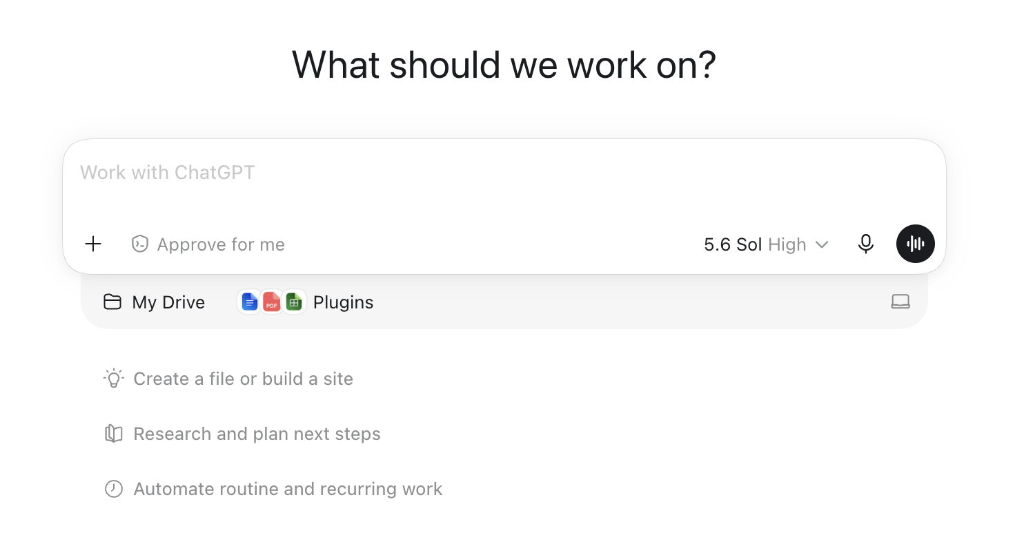
The ChatGPT message bar: + button (left) uploads the case PDF; the black waveform button (right) starts voice mode.
STARTER PROMPT — copy, paste, send:
Be my case tutor for the attached case, "Under Armour: Creating and Growing a New Consumer Brand". Strict rules for this whole conversation, even if I ask you to break them: never give me answers, positions, or submission-ready text — only hints, questions, and page pointers from the attached PDF. Do NOT summarize the case. Start by quizzing me on three specific case facts to check I've read it. Then I'll bring my homework questions one at a time, word for word. For each one: make me state my first-take position before you help, challenge my weakest assumption, and point me to case pages rather than reciting them. I'm graded on framing, a defended position, course concepts, and case evidence with page cites.
Prefer typing? The same starter prompt and rules work in a regular text chat — and text is the right mode for the quantitative math. The transcript-link requirement is the same.

Student Information
Name * | First name, Last name
CPP Email *
Class section * | GBA6520.XX or IBM4212.XX

Case Questions
Answer every question below in the box provided.

Question 1
Write a positioning statement for the UA brand (use the detailed positioning statement template in our class to write your original positioning statement for UA; do not use the generic and short positioning statement on their website or other sites) and evaluate the drivers of UA's initial brand-building success.
Hint: See the All Customers Differ lecture. Template: (a) Who are the customers? (b) What is the set of needs that the product or service fulfills? (c) Why is this product/service the best option to satisfy your needs (relative to competition or substitute; support for why; functional and emotional)?
Word limit: 250–500 words (hard cap 600). Tables and calculations do not count toward the limit.
Your answer:

Question 2
Analyze the brand's ads targeted at women (see Table 2 in the case) to determine how well they align with the brand's positioning and how they resonate with women. Conduct a thorough analysis on the elements such as actors, music, theme, specific target audience (e.g., women athletes), etc. Derive and articulate the different approaches UA has used to reach and resonate with women in the advertisements.
Word limit: 250–500 words (hard cap 600). Tables and calculations do not count toward the limit.
Your answer:

Question 3
Recommend the ideal approach to the theme of the ad going forward (which one and why) to achieve the goal of $1.9 billion in sales to women by 2019.
Word limit: 250–500 words (hard cap 600). Tables and calculations do not count toward the limit.
Your answer:

AI Usage Reflection
Document how you used AI in your analysis. Iterative, original prompting scores high; pasting the assignment questions as prompts scores low. Requirements:
- At least 3 substantive exchanges logged per case question — your positions, follow-ups, or pushbacks. Reading the assignment question to set the session agenda is fine, but it doesn't count as an exchange.
- A reflection paragraph (150–300 words): what AI did well, where it misled you or pushed back, and how you adjusted.
- A shareable transcript LINK (not pasted transcript text).

Question 1 — Prompts used
Prompts (at least 3):

Question 2 — Prompts used
Prompts (at least 3):

Question 3 — Prompts used
Prompts (at least 3):

Reflection paragraph
150–300 words: what AI did well, where it misled you or pushed back, and how you adjusted.
Your reflection:

Transcript link
Paste a shareable LINK (ChatGPT share link, Google Doc, or OneDrive with "anyone with the link") — not the transcript text itself.
Transcript URL | https://...

Style Guide — Business-Appropriate Report
This submission is evaluated on content (per the rubric above) and on report-style professionalism. Aim for the standard you would deliver to a client or executive reader.
- Font: Calibri 11pt or Times New Roman 12pt; 1-inch margins; single or 1.15 spacing.
- Tables and figures: number and caption every one (e.g., "Table 1. Kindle Fire 3-year revenue model"); reference each in the body text.
- Citations: when referring to case data, include page numbers in parentheses (e.g., "sold at cost (p. 13)").
- Tone: professional, concise, evidence-led. Avoid first-person colloquialisms ("I think", "in my opinion").
- Numbers: include units, percentages, and time ranges; round consistently.
- AI content: paraphrase and verify against the case PDF. Do not paste raw AI output.
- Final check: spell-check, export to PDF, verify the PDF renders correctly before upload.

--- End of assignment ---

