PA7 Excel Walkthrough — one RQ of each type, step by step
This walkthrough runs every PA7 step on the posted data files for four example research questions. Open PA7_Excel_Walkthrough.xlsx next to this document: each step names the sheet that does it, and every number below comes from that workbook.
The four example RQs (W1–W4) are reserved. They do not count toward your own RQs, so build your report from your PA6 plan.
ID | Research question | Type | Test
W1 | How would partnering with local outdoor clubs affect trust in Neo and purchase interest (Q32)? | Descriptive | Mean, SD, % distribution
W2 | Does the Q32 rating differ between women and men? | Differences | Independent-samples t-test
W3 | Does choosing build quality as the top value driver (Q31) differ between women and men? | Differences | Two-way chi-square
W4 | Is the Q32 rating related to 24-month purchase likelihood (Q7)? | Association | Pearson correlation

Step 1 — Prepare the data (sheets 1_Data and 2_Prep)
1. Keep the default sample. In each file, turn on Data → Filter and keep Analysis_Sample = Yes. Copy the visible rows to a new sheet. That leaves 600 aytm rows and 205 class-survey rows. (The workbook stacks both files in one sheet so one formula serves both; the Source column tells them apart. Working in two files is fine.)
2. Recode the ratings. Rating columns hold text at the ends of the scale ("1 - Decrease a lot", "5 - Increase a lot") and digits in between. Add a column next to each one you use: =IF(G2="","",VALUE(LEFT(TRIM(G2),1))), then fill it down.
3. Check the recode. aytm Q32 must count 44 / 42 / 379 / 95 / 40 for ratings 1–5. If your 1s and 5s are missing, the recode skipped the labelled values.
4. Build the groups each test needs. W2 and W3 use women vs. men (Gender_2grp); the 13 class-survey respondents who answered Non-binary or Prefer not to say drop out of those two tests, and the report says so. W3 also needs Q31 split into "Build quality" vs. "Other driver" (Top_driver).
PivotTable route. The workbook's tables use COUNTIFS and AVERAGEIFS. A PivotTable gives the same numbers: select the prepared sheet → Insert → PivotTable → Rows = Gender_2grp, Columns = Source, Values = Q32_num (set it to Count, then add it again as Average and as StdDev).

Step 2 — One results block per RQ (Appendix A format)

W1 results block
Field | Entry
Research question | W1: How would partnering with local outdoor clubs affect trust in Neo and purchase interest?
Type | Descriptive
aytm Q# | Q32
Test or statistic | Mean, SD and % distribution of the 1–5 rating
Result sentence with statistics | Mean rating is 3.08 (SD = 0.89, n = 600) on aytm and 3.19 (SD = 0.87, n = 205) in the class survey, close to 3 (no change). 22.5% (aytm) and 33.2% (class) say partnerships would increase trust (4–5).
Practical meaning for Neo | Most homeowners say club partnerships would not change their view of Neo. Partnerships can support the brand in outdoor communities, but they are not a reason to buy for most people, so keep them a small part of the budget.
Chart | below

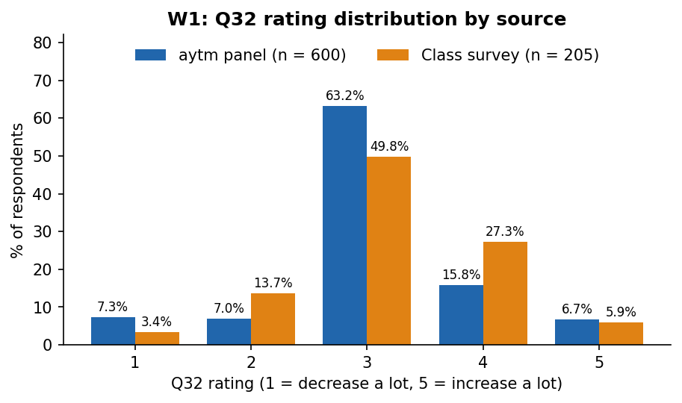

W2 results block
Field | Entry
Research question | W2: Does the Q32 rating differ between women and men?
Type | Differences
aytm Q# | Q32 × Gender
Test or statistic | Independent-samples t-test (α = .05)
Result sentence with statistics | aytm: women M = 2.95 (n = 306), men M = 3.20 (n = 294); t(598) = -3.44, p < .001. Class survey: women 3.14, men 3.23; t(190) = -0.74, p = .461.
Practical meaning for Neo | Nationally, men respond a little more to club partnerships than women (a gap of 0.25 points on a 5-point scale). The class survey points the same way, but its gap is smaller and not significant. The gap is too small to justify gender-targeted sponsorships.
Chart | below

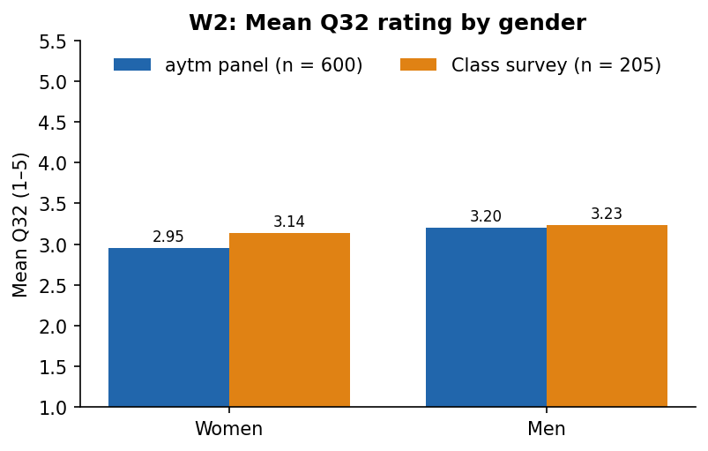

W3 results block
Field | Entry
Research question | W3: Does choosing build quality as the top value driver differ between women and men?
Type | Differences
aytm Q# | Q31 × Gender
Test or statistic | Two-way chi-square (2×2, α = .05)
Result sentence with statistics | aytm: 132 of 306 women (43.1%) vs. 146 of 294 men (49.7%) name build quality; χ²(1) = 2.57, p = .109. Class survey: 30.7% vs. 34.1%; χ²(1) = 0.25, p = .618.
Practical meaning for Neo | Build quality is the top driver for women and men alike, in both sources. One quality message can serve the whole market; Neo does not need gender-specific quality claims.
Chart | below

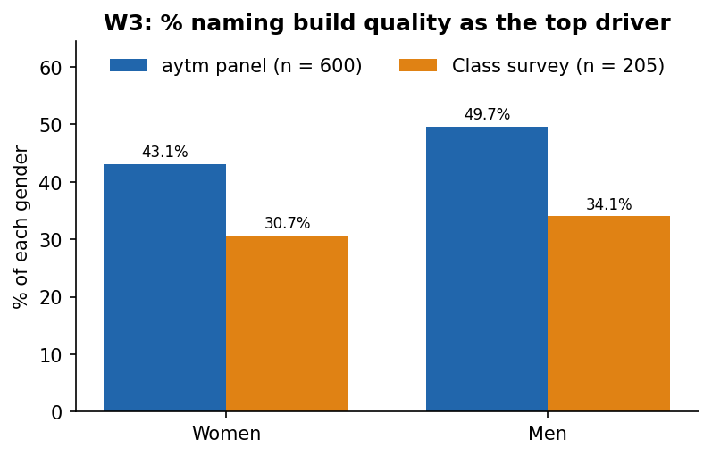

W4 results block
Field | Entry
Research question | W4: Is the Q32 rating related to 24-month purchase likelihood?
Type | Association
aytm Q# | Q32 × Q7
Test or statistic | Pearson correlation
Result sentence with statistics | r = 0.43 (p < .001, n = 600) on aytm and r = 0.25 (p < .001, n = 205) in the class survey: positive in both, moderate nationally and weak in the class sample.
Practical meaning for Neo | People who would trust Neo more after a club partnership are also more likely to buy. The link is moderate at best, and a correlation does not show that partnerships cause purchases; treat club sponsorship as a way to reach already-interested buyers.
Chart | below

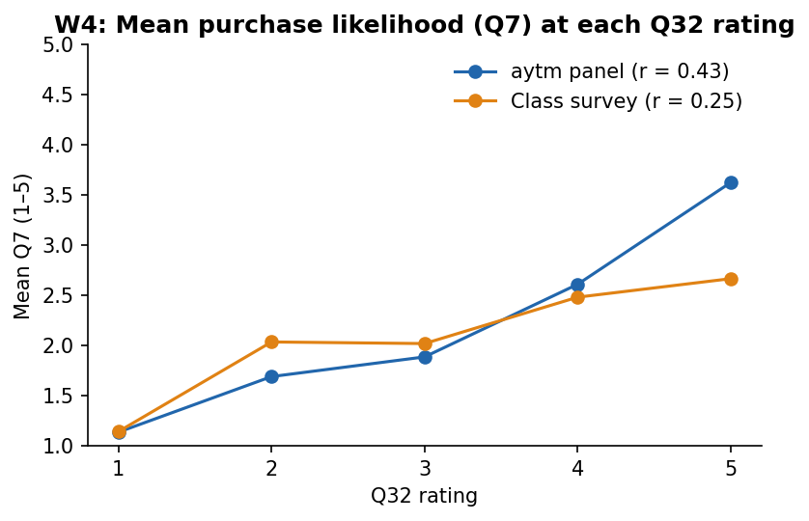

Step 3 — Hand calculation 1: independent-samples t-test (sheet 4_t-test, aytm column)
Excel counts as a hand calculation when every step has its own cell and the report writes out the arithmetic, as below. Pasting only T.TEST output is not a hand calculation.
1. Hypotheses. H₀: μ(women) = μ(men). H₁: μ(women) ≠ μ(men). α = .05, two-tailed.
2. Group statistics (software step, rows 5–10). Women: n = 306, M = 2.9542, SD = 0.8969. Men: n = 294, M = 3.2007, SD = 0.8569. Tool: Excel COUNTIFS, AVERAGEIFS, and the SD formula on the sheet (a PivotTable gives the same values).
3. Standard error. SE = √(SD₁²/n₁ + SD₂²/n₂) = √(0.8045/306 + 0.7343/294) = √(0.00263 + 0.00250) = √0.00513 = 0.0716
4. t. t = (M₁ − M₂) / SE = (2.9542 − 3.2007) / 0.0716 = -0.2464 / 0.0716 = -3.442
5. df. df = n₁ + n₂ − 2 = 306 + 294 − 2 = 598
6. p and decision. p = T.DIST.2T(ABS(t), df) = 0.0006. Critical t at α = .05 is ±1.964; |t| = 3.442 > 1.964, and p < .05. Reject H₀.
7. Conclusion. Women and men differ in how club partnerships would affect their trust: men rate the effect higher (M = 3.20 vs. 2.95). The difference is statistically significant but small, about a quarter of a point on a 5-point scale.
Same steps on the class survey (column C): SE = 0.1246, t(190) = -0.740, p = 0.4605 → fail to reject H₀.

Step 4 — Hand calculation 2: two-way chi-square (sheet 5_Chi-square, class-survey block)
1. Hypotheses. H₀: gender and top-driver choice are independent. H₁: they are associated. α = .05.
2. Observed table (software step). Excel COUNTIFS on Source, Gender_2grp and Top_driver (or a PivotTable with Count).
 | Build quality | Other driver | Row total
Women | 31 | 70 | 101
Men | 31 | 60 | 91
Column total | 62 | 130 | 192

3. Expected frequencies. E = row total × column total ÷ n
Cell | Calculation | E
Women, build quality | 101 × 62 ÷ 192 | 32.61
Women, other | 101 × 130 ÷ 192 | 68.39
Men, build quality | 91 × 62 ÷ 192 | 29.39
Men, other | 91 × 130 ÷ 192 | 61.61

All four expected counts are above 5, so the test is valid.
4. Cell contributions.
Cell | O | E | O − E | (O − E)² | (O − E)²/E
Women, build quality | 31 | 32.61 | -1.61 | 2.6069 | 0.0799
Women, other | 70 | 68.39 | +1.61 | 2.6069 | 0.0381
Men, build quality | 31 | 29.39 | +1.61 | 2.6069 | 0.0887
Men, other | 60 | 61.61 | -1.61 | 2.6069 | 0.0423
 |  |  |  | χ² | 0.249

5. df = (2 − 1) × (2 − 1) = 1
6. p and decision. p = CHISQ.DIST.RT(χ², 1) = 0.6177. Critical χ² at α = .05 is 3.841; χ² = 0.249 < 3.841, and p > .05. Fail to reject H₀. (CHISQ.TEST on the observed and expected tables returns the same p: use it as a check, not as the calculation.)
7. Conclusion. In the class survey, women (30.7%) and men (34.1%) name build quality as the top driver at about the same rate. There is no evidence of a gender difference in this sample, which is not the same as proving the two groups are identical.
Same steps on aytm (top block): χ²(1) = 2.565, p = 0.1092 → fail to reject H₀.

Step 5 — Compare the two sources (sheet 7_Compare, Appendix B format)
Metric | aytm Q# | aytm value (n = 600) | Student value (n = 205) | Difference | Convergent? (Y/N)
Mean Q32 rating (1–5) | Q32 | 3.08 | 3.19 | +0.11 | Y
% rating Q32 4–5 | Q32 | 22.5% | 33.2% | +10.7 pts | N
Women − men gap in mean Q32 | Q32 × Gender | -0.25 | -0.09 | +0.15 | Y
% naming build quality the top driver | Q31 | 46.3% | 32.3% | -14.0 pts | N
r between Q32 and Q7 | Q32 × Q7 | 0.43 | 0.25 | -0.18 | N

Thresholds here: means within ±0.30, percentages within ±10 points, r within ±0.15. Use the thresholds your team set in PA6.
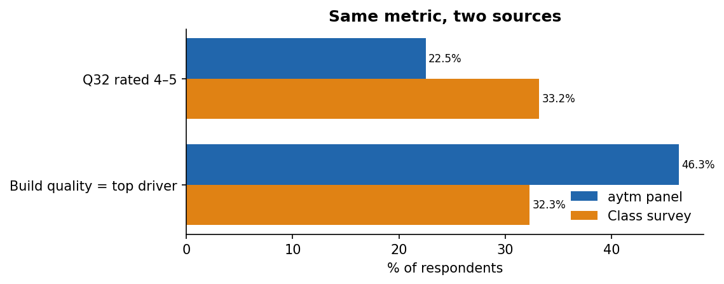
Example interpretation paragraph. The two sources agree that club partnerships move few people: the mean sits near "no change" in both (3.08 vs. 3.19). The women–men gap is similar in size (-0.25 vs. -0.09 points), but only the aytm gap is significant, partly because aytm has about three times as many respondents. The sources diverge on how many would trust Neo more (22.5% vs. 33.2%), on how many name build quality as the top driver (46.3% vs. 32.3%), and on how closely Q32 tracks purchase likelihood (r = 0.43 vs. 0.25). The class survey reached students' friends and family, who are younger and more active outdoors than the national panel, so a larger share open to club partnerships is expected. Neo can act on the convergent finding (partnerships are a small add-on, not a reason to buy) and should not build a SoCal campaign on the gender gap.

Step 6 — The same steps with ChatGPT, quickly and cheaply (after your two hand tests)
Human first. Do the two hand tests yourself before any AI touches them; the brief requires it. After that, ChatGPT is useful in two ways: checking your hand arithmetic, and running the remaining RQs faster. The posted files contain no personal information, so you can upload them.
Pick Instant. Open Thinking effort in the message box and drag the slider to Instant. Instant answers in seconds and is enough for recodes, counts, checks and charts. Move to a higher setting only when Instant gets something wrong twice or the task needs a judgment call, such as choosing a test.
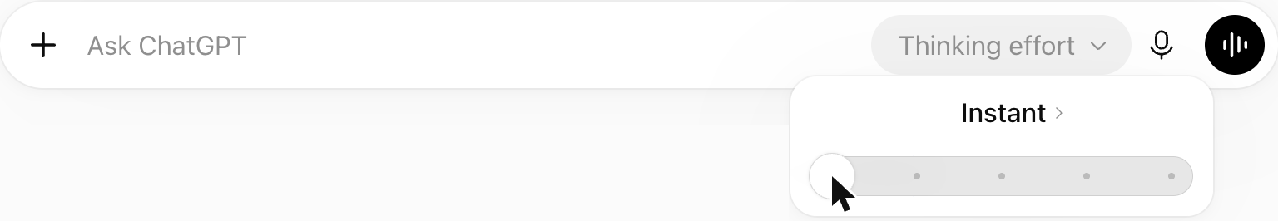
Prompt 1 — data prep (upload both CSV files first).
The two files have identical columns: aytm_CLEAN.csv (national panel) and student_CLEAN.csv (class survey). Data prep only, no tests yet. (1) In each file keep rows where Analysis_Sample = Yes. (2) Recode Q32_Sponsorship_Trust to numbers 1-5 using its first character ("5 - Increase a lot" becomes 5, "3" stays 3). (3) Show one table: count of each rating 1-5 and n, with one column per file. (4) Give me the Excel formula that does the recode in step 2.
Check it: the counts must match sheet 3 of the workbook (44 / 42 / 379 / 95 / 40 for aytm; n = 600 and 205). They do, and the formula is the same one the workbook uses.
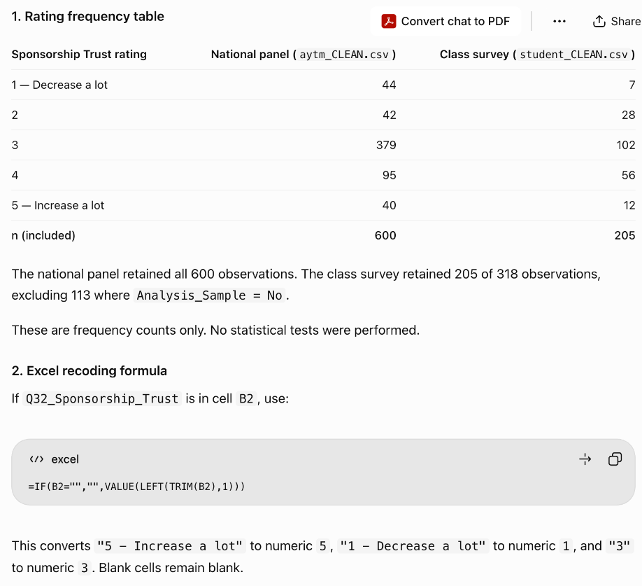
Prompt 2 — check your hand calculation. Paste your own numbers and ask for a match table, not a lecture.
Check my hand calculation; do not redo the explanation. Independent-samples t-test of recoded Q32 between Female and Male, aytm file, Analysis_Sample = Yes. My values: women n = 306, M = 2.9542, SD = 0.8969; men n = 294, M = 3.2007, SD = 0.8569; SE = 0.0716; t = -3.442; df = 598; p = 0.0006. Use SE = sqrt(SD1^2/n1 + SD2^2/n2) and df = n1 + n2 - 2. Reply with one table: step, my value, your value, match (yes/no).
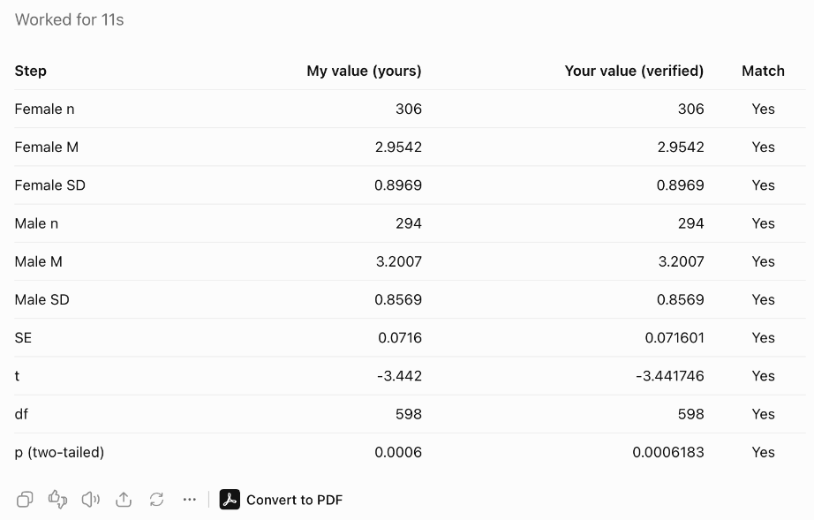
Prompt 3 — run the next RQ and draw the chart. Give the test, the output you want, and the colors.
Next RQ (Association). Using the same filtered, recoded data, also recode Q7_Purchase_Likelihood the same way. For each file, report Pearson r between Q32 and Q7, with n and two-tailed p, in one table. Then make one line chart: mean Q7 at each Q32 rating (1-5), aytm in blue #2166AC, class survey in orange #E08214, with a title and axis labels. Keep the reply short.
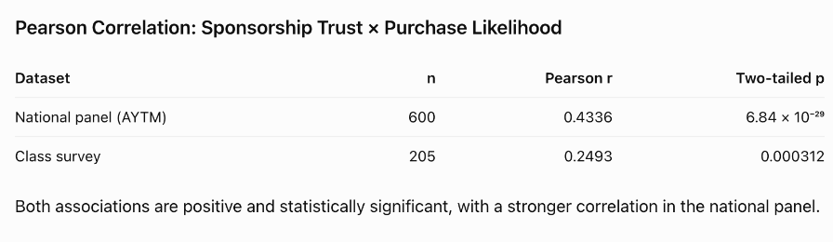
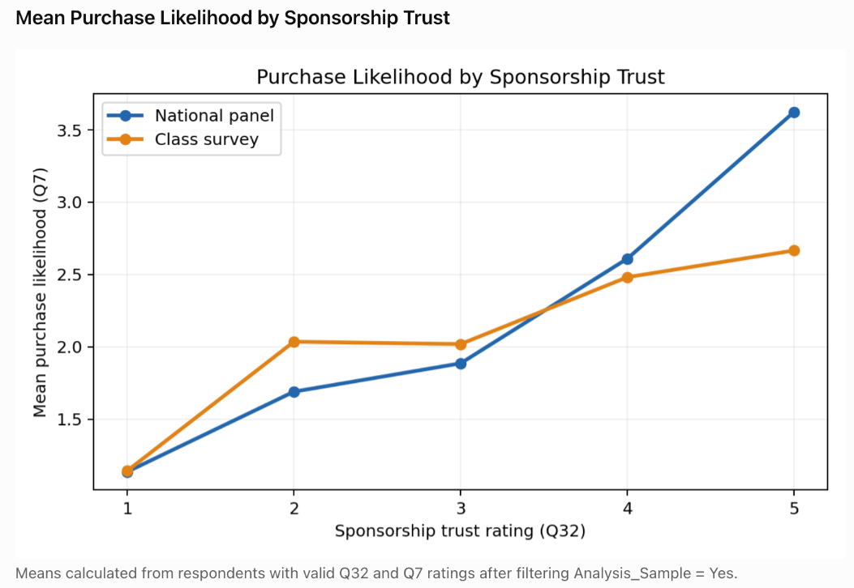
Both r values match sheet 6 (r = 0.4336 and 0.2493), and the chart matches the W4 chart above.
Habits that keep it cheap and correct:
- One task per prompt, in the same chat, so ChatGPT keeps the filter and recode from earlier prompts.
- Ask for a table and "keep the reply short". Long explanations cost time and hide the numbers.
- Spot-check at least one number per answer against Excel before you paste it into your report.
- If ChatGPT offers cleaned files to download, check the row counts before you use them.
- Keep the chat. Paste it into your AI transcript (Word) and say in your report which tests were done by hand and which by ChatGPT (rubric item 2c).

Common mistakes
- Averaging the text columns, or a recode that turns the labelled 1s and 5s into blanks. Check the counts after recoding.
- Forgetting the filter: the class survey has 318 rows in the file but 205 in the default sample.
- Pasting T.TEST or CHISQ.TEST output as the hand calculation. Every step needs its own cell and written arithmetic.
- Leaving out the expected-frequency table or the cell contributions in the chi-square.
- Reading p > .05 as "the groups are the same". Write "no evidence of a difference in this sample".
- Reading a correlation as cause and effect.
- Charts without a title or axis labels, or swapping the source colors between charts (keep aytm = blue, class = orange).

How this maps to the rubric
Criterion | Where this example shows it
1. Answer every RQ with the right test (45%) | Step 2: one results block per RQ with the right test, real numbers, a labeled chart and a takeaway for Neo
2. Show your work: hand calculations + Process & AI reflection (30%) | Steps 3–4: every step in its own cell and written out. Step 6: AI used after the hand tests, every answer checked, manual vs. AI stated, plus the four reflection prompts
3. Compare the two sources (25%) | Step 5: metrics with numbers from both sources, a verdict per row, one color per source, an interpretation tied to the samples

