PA9 SlideDocs walkthrough — model pages on a practice story
These pages show what each part of a strong PA9 report looks like, using the practice story from the PA7 and PA8 walkthroughs: should Neo sponsor local outdoor clubs? It uses the four reserved practice RQs (W1–W4), so it earns no credit. Your report answers your own RQs.  - Pages labeled MODEL PAGE are what a report page looks like.  - Gold coach notes explain why a page works. They are not part of the model.  - A real report has every RQ, a 2–3 page Executive Summary, and the full appendix. These pages show one of each part. | SlideDocs, in one line: a landscape Word document, one idea per page, the text on one side and the chart beside it, written to be read without a presenter.  Order of work: skeleton → Methods → Results → Limitations and Recommendations → Appendix → Executive Summary last.

MODEL PAGE — practice story (earns no credit)

Outdoor-Club Partnerships and the Tahoe Mini
A research report for Neo Smart Living  Prepared by: Team N (names)  IBM 3302 Marketing Research  Date: (finals week) | Contents  Executive Summary … 3  Background and Objectives … 5  Methods … 6  Results … 7  Limitations … 11  Recommendations … 12  Appendix … 13
Coach note Title page and contents on one page are fine. The contents page numbers must match the real pages.

MODEL PAGE — practice story (earns no credit)

Table of Research Questions
# | Research question | Item | Page
1 | How would partnering with local outdoor clubs affect trust in Neo? | Q32 | 7
2 | Does the Q32 rating differ between women and men? | Q32 × gender | 8
3 | Does naming build quality as the top value driver differ by gender? | Q31 × gender | 9
4 | Is the Q32 rating related to 24-month purchase likelihood? | Q32 × Q7 | 10

Coach note A separate page, numbered in Results order, with page numbers. A manager uses it to jump straight to an answer.

MODEL PAGE — practice story (earns no credit)

Executive Summary
Background. Neo Smart Living asked whether sponsoring local outdoor clubs would help sell the Tahoe Mini, a $23,000 backyard unit.
Methods. The team compared a national aytm panel of 600 homeowners with a class survey of 205 homeowners, mostly in Southern California, on the same questions.
Key findings. Club partnerships would change few homeowners' trust in Neo (mean 3.08 and 3.19 on a 1–5 scale, where 3 means no change). The 22.5% nationally who said trust would rise were likelier to buy (r = 0.43). Build quality was the top value driver for women and men alike.
Recommendations. Neo should treat club events as a small, measured test channel, lead with a quality-first message, and test any sponsor discount inside that pilot before funding it.
Coach note Written last, in third person and past tense, led by the decision-relevant finding. Yours runs 2–3 pages; this one is shortened to show the four parts.

MODEL PAGE — practice story (earns no credit; the funnel numbers below are MADE UP)

Methods
The team adapted the aytm Tahoe Mini questionnaire into a Google Form with the same items, screeners and answer options, plus demographics. Respondents saw the product description before the purchase questions.  Each member fielded five qualified surveys. At least two per member came from people outside friends and family, reached at named local venues.  Sample arithmetic (example team): 48 contacts → 31 qualified → 24 completes → 20 counted. Response rate = completes ÷ contacts = 24 ÷ 48 = 50.0%. | Samples analyzed. The aytm panel (n = 600) was a national online panel of homeowners screened for outdoor space. The class survey (n = 205 after the course's default filter) pooled two class waves.  Representativeness. The aytm panel was older and mostly White. The class sample was younger, more Hispanic and Asian-American, and reached through students' networks, so it described those networks, not all Southern California homeowners.
Coach note Past-tense prose, no bullet fragments. Report YOUR team's PA5.5 funnel, summed across members, and the response rate arithmetic. The class-wide numbers are not your funnel.

MODEL PAGE — practice story (earns no credit)

Partnerships Barely Move Trust
RQ: How would partnering with local outdoor clubs affect trust in Neo?  Questionnaire item: Q32 (1 = decrease a lot, 5 = increase a lot)  Finding. Most homeowners chose 3, no change. The mean was 3.08 nationally and 3.19 in the class survey. 22.5% and 33.2% said a partnership would increase their trust.  What it means for Neo. Partnerships would not change most buyers' view of Neo, so they should stay a small part of the budget.  n = 600 (aytm), 205 (class survey). | 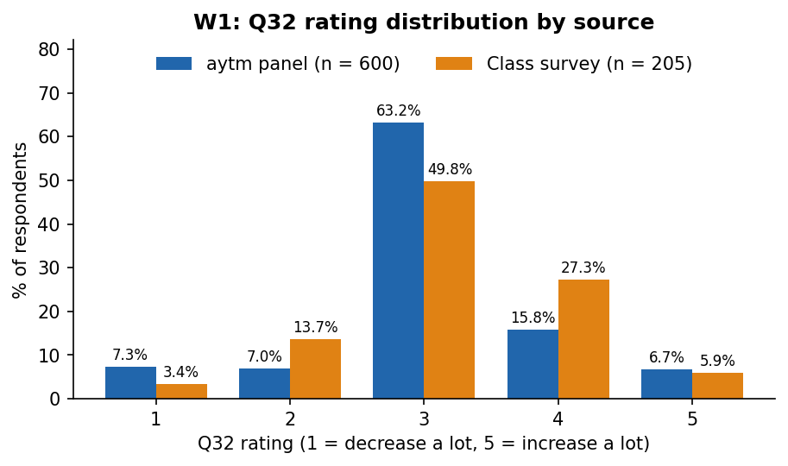

MODEL PAGE — practice story (earns no credit)

Men Respond Slightly More
RQ: Does the Q32 rating differ between women and men?  Questionnaire item: Q32 × gender  Finding. Nationally, men rated partnerships higher than women (M = 3.20 vs. 2.95), a significant but small gap.¹ The class survey showed a smaller gap that was not significant.  What it means for Neo. The gap is too small to justify gender-targeted sponsorships.  n = 600 (aytm), 192 (class survey, women and men only). | 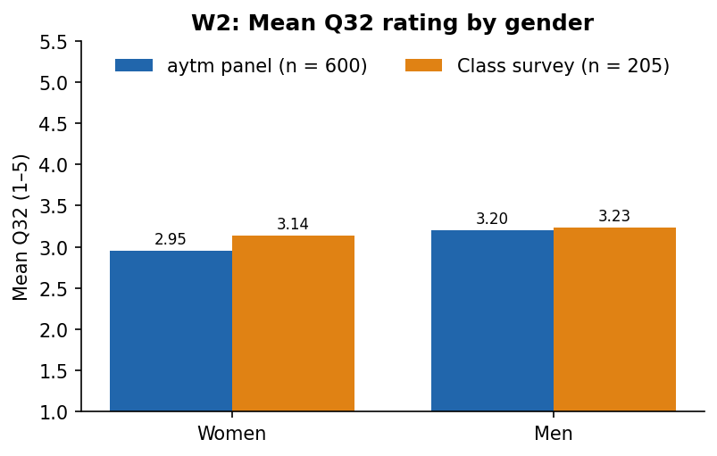
¹ Independent-samples t-test, aytm: t(598) = -3.44, p < .001. Class survey: t(190) = -0.74, p = 0.46.

MODEL PAGE — practice story (earns no credit)

Quality Leads for Everyone
RQ: Does naming build quality as the top value driver differ by gender?  Questionnaire item: Q31 × gender  Finding. Build quality was the most named driver for women and men. Nationally 43.1% of women and 49.7% of men chose it, and the difference was not significant in either source.²  What it means for Neo. One quality-first message can serve the whole market.  n = 600 (aytm), 192 (class survey). | 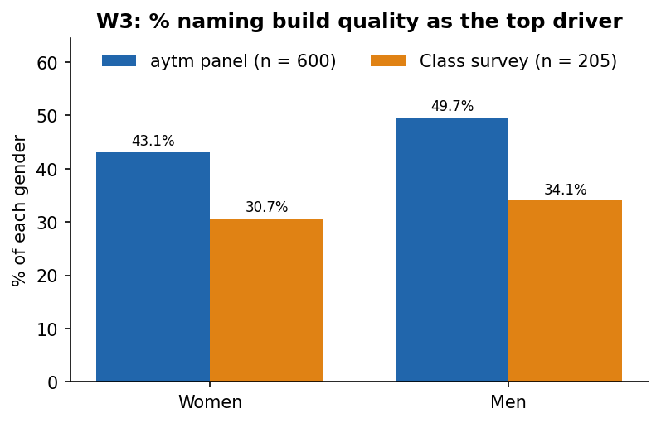
² Two-way chi-square, aytm: χ²(1) = 2.57, p = 0.11. Class survey: χ²(1) = 0.25, p = 0.62.

MODEL PAGE — practice story (earns no credit)

Trust and Buying Move Together
RQ: Is the Q32 rating related to 24-month purchase likelihood?  Questionnaire item: Q32 × Q7  Finding. Homeowners who said a partnership would raise their trust were likelier to buy: r = 0.43 nationally and 0.25 in the class survey (both p < .001).  What it means for Neo. Partnerships may help reach buyers who already lean toward the Tahoe Mini. The data do not show that a partnership causes a purchase.  n = 600 (aytm), 205 (class survey). | 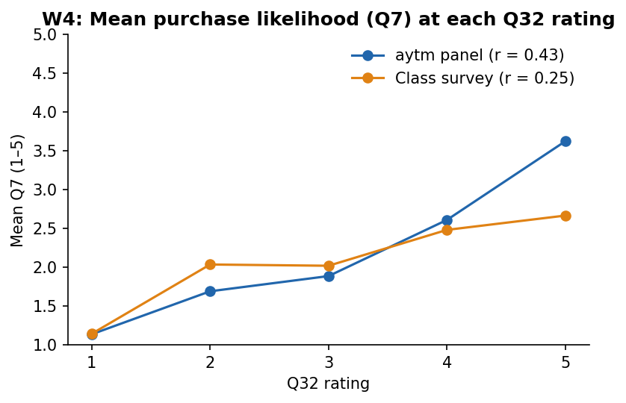
Coach note Every Results page: a ≤ 5-word heading, the RQ and item, the finding with numbers and n, a takeaway, a percent chart beside it, and statistics in a footnote (Word: References → Insert Footnote).

MODEL PAGE — practice story (earns no credit)

Limitations
- Coverage. The class survey reached students' networks, so its percentages describe those networks, not all Southern California homeowners.
- Stated, not observed. Respondents reported how a partnership would affect their trust. No one saw a real sponsorship, so actual behavior may differ.
- One wave, one moment. Each source was fielded once. The results show associations at that time, not change over time or cause and effect.
Coach note Each limitation bounds what the findings can claim. "We ran out of time" or "we had trouble getting responses" are project problems, not limitations.

MODEL PAGE — practice story (earns no credit)

Recommendations
- Run club events as a small test channel, measured by leads. Few homeowners said a partnership would raise their trust (22.5% nationally), so a large sponsorship budget is not supported (RQ 1, p. 7).
- Target the homeowners who respond to partnerships. They were likelier to buy (r = 0.43, RQ 4, p. 10).
- Lead with a quality-first message for everyone. Build quality was the top driver for women and men (RQ 3, p. 9).
- Test before offering any sponsor discount. Partnerships moved trust little (mean 3.08, RQ 1, p. 7), and no RQ measured a discount, so the club test should compare leads with and without one before Neo funds it.
Coach note Each bullet: the action, the reason, and the finding it rests on, with its RQ and page. A recommendation no result supports does not belong.

MODEL PAGE — practice story (earns no credit)

Appendix B — RQ ↔ Question table
RQ | Questionnaire item(s) | Analysis | Output page
1 | Q32 | Frequency table, mean, SD | A-3
2 | Q32 × gender | Independent-samples t-test | A-4
3 | Q31 × gender | Two-way chi-square | A-5
4 | Q32 × Q7 | Pearson correlation | A-6

Coach note The appendix also holds the verbatim fielded questionnaire (not a summary, not a link) and the analysis output, one block per RQ, in this order.

Common mistakes
- First person ("we found") or present tense in Methods.
- Results headings that are whole questions, or that say "Research Question".
- Pie charts, or charts of counts instead of percents.
- Statistics in the body text instead of a footnote, or a test with no df or p.
- Limitations that are project problems.
- Recommendations with no finding behind them.
- An Executive Summary that previews the report ("this report will discuss…") instead of summarizing it.

Checking your draft with ChatGPT (after you have written it)
Write the report yourselves first. Then, with ChatGPT on Instant, upload the report and run two checks. Read every flag yourself before changing anything, and keep the chat for your AI transcript.
Check voice and tense only, no rewriting. The PDF is our report draft. List every sentence that uses first person (we, I, our) anywhere, or present tense in the Methods section, with its page. One table: page, sentence, problem. If there are none, say so.
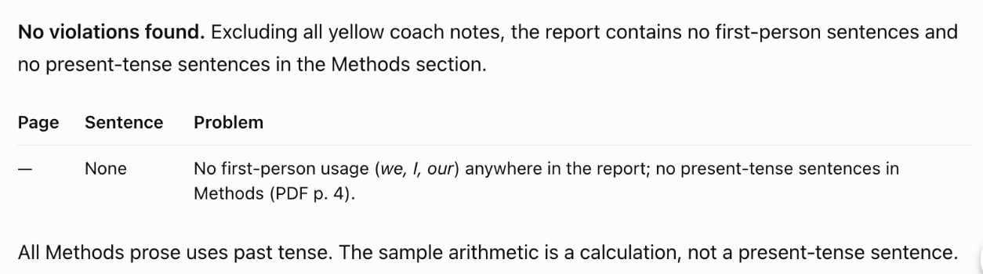
For each recommendation, name the finding it rests on and check that the cited RQ and page really show that finding. Flag any recommendation without a matching finding. One table: recommendation, finding cited, page checked, OK (yes/no).
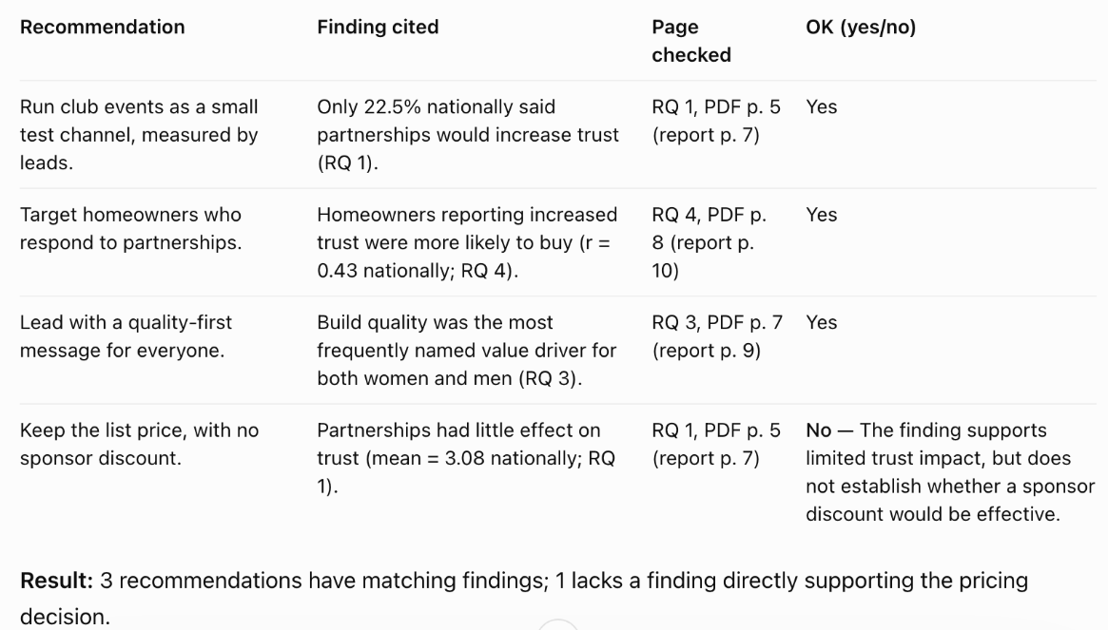
It caught a weak link. The first draft said "keep the list price, with no sponsor discount", but no RQ measured a discount. The fix, on the Recommendations page above: test a discount inside the club pilot before funding it. Read each flag and decide yourself; ChatGPT can also flag a sound recommendation.

How this maps to the rubric
Criterion | Where these pages show it
1. Front matter, methods & executive summary (35%) | Title page and contents, Table of RQs, Executive Summary, Methods
2. Results for every RQ (30%) | The four Results pages: heading, RQ and item, finding, takeaway, chart, footnote
3. Limitations, recommendations + Process & AI reflection (35%) | Limitations, Recommendations, Appendix B; your template adds the four reflection prompts

