An Open-Source MATLAB Toolbox for LDPC Decoding and Analysis in GNSS Receivers

User Manual

Yafeng Li，Anyi Lv

Beijing Information Science and Technology University

Manual Overview

Scope
Scope | Supported Functions
LDPC simulation | GPS L1C and BDS B1C/B2a/B2b; conventional and neural decoding
Real-signal processing | GPS L1C and BDS-3 B2b post-processing workflows and configuration
Acceleration | Selection and compilation entry points for MATLAB, SIMD MEX, and CUDA MEX
Outputs | BER, FER, iteration count, acquisition, tracking, and PVT outputs

Compatibility and Validation Scope
- MATLAB environment: MATLAB R2023b.

Introduction to toolbox
GNSS LDPC Decoding and Analysis is an open-source MATLAB codebase for investigating low-density parity-check (LDPC) encoding, soft-information generation, iterative decoding, model-driven parameter training, and software-receiver-level validation with real intermediate-frequency (IF) signals. The source code is publicly available at https://github.com/lyf8118.

Three Primary Workflows
- GPS simulation: binary LDPC codes for GPS L1C CNAV-2 subframes 2 and 3, with support for BP, MS, NeuralMS, and the NMS/SNMS implementations in the training directories.
- BDS simulation: GF(64) nonbinary LDPC codes for B1C_2, B1C_3, B2a, and B2b, with support for QSPA, FFT-QSPA, EMS, NEMS, and SNEMS.
- Real-signal processing: detection, acquisition, tracking, navigation-message recovery, LDPC decoding, and positioning from raw GPS L1C and BDS-3 B2b IF data.
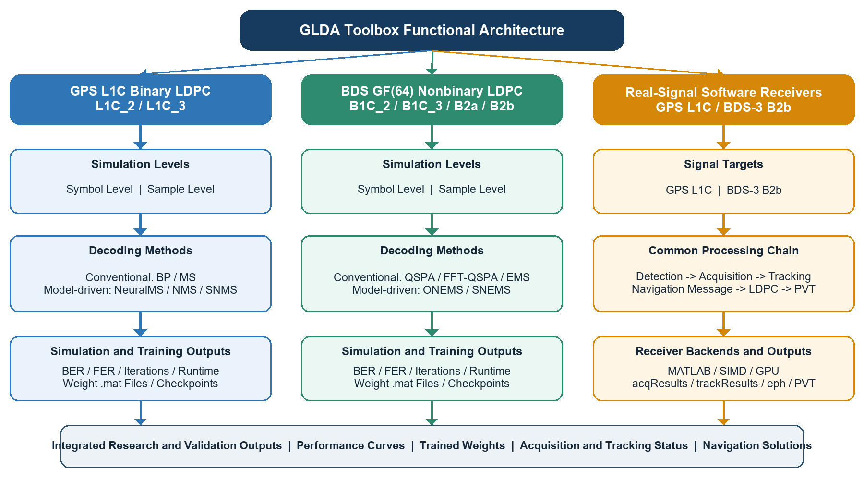
Toolbox functional architecture. The GPS and BDS modules provide symbol-level and sample-level simulation with conventional and model-driven decoding.

Signal and Algorithm Support Matrix
Signals, code types, and principal decoders supported by the Toolbox
System/Signal | Code Type | Information Length/Code Length | Principal Algorithms | Primary Directory
GPS L1C_2 | Binary | k=600, n=1200 | BP, MS, NeuralMS | GPS
GPS L1C_3 | Binary | k=274, n=548 | BP, MS, NeuralMS | GPS
BDS B1C_2 | GF(64) | 100/200 symbols | QSPA, FFT-QSPA, EMS, NEMS, SNEMS | BDS
BDS B1C_3 | GF(64) | 44/88 symbols | As above | BDS
BDS B2a | GF(64) | 48/96 symbols | As above | BDS
BDS B2b | GF(64) | 81/162 symbols | As above | BDS

System Requirements and Installation

Software and Hardware
Runtime environment and functional dependencies
Item | Requirement | Description
MATLAB | MATLAB R2023b or a comparable release | Entry points and core call chains were checked in MATLAB R2023b.
Communications Toolbox | Required | The code uses gf objects for GF(2) and GF(64) operations.
Parallel Computing Toolbox | Required for specific functions | parfor, multicore parallelism, gpuArray, and GPU acquisition depend on this product.
C/C++ compiler | Required only to recompile SIMD MEX files | 64-bit Windows MEX binaries are supplied with the code.
CUDA toolchain and NVIDIA GPU | Required only for GPU acquisition/tracking or mexcuda | GPU memory and driver versions must conform to the MATLAB support matrix.
Raw IF data | Required for real-signal processing | Raw sample files are not included and must be supplied by the user.

Installation Procedure
- Extract the code archive. Preserve the relative locations of the GPS, BDS, and Live_Signal_Demo directories and all of their subdirectories.
- Start MATLAB, set the Current Folder to the extracted toolbox root, and run toolboxRoot = pwd. Then switch to the directory containing the entry script to be executed.
- Verify the installed products. Run ver in the Command Window to confirm that Communications Toolbox is available. Also confirm Parallel Computing Toolbox when parallel or GPU processing is required.
- Begin with a symbol-level demonstration. Run the SYMBOL_LEVEL example in GPS/BP or BDS/QSPA to verify the paths and dependencies.
- Then enable sample-level or real-signal processing. These modes require more memory and execution time. Real-signal processing also requires the sample format to match initSettings.m exactly.

Directory Structure
toolbox/
├─ User_Manual.docx User manual
├─ README.md English project description
├─ readme_chinese.md Chinese project description
├─ license.txt License
├─ output/ Saved result figures
├─ GPS/
│ ├─ Common/ Common signal, encoding, statistics, and plotting functions
│ ├─ BP/ BP demonstration and decoder
│ ├─ MS/ Min-sum demonstration and decoder
│ ├─ NeuralMS/ Inference with pretrained NeuralMS weights
│ ├─ NMSTrain/ NMS training and testing
│ ├─ SNMS/ Shared-weight SNMS training and testing
│ └─ compare_gps.m Common entry point for multi-algorithm comparisons
├─ BDS/
│ ├─ Common/ GF(64) encoding, channel, statistics, and plotting functions
│ ├─ QSPA/ QSPA
│ ├─ FFT-QSPA/ FFT-accelerated QSPA
│ ├─ EMS/ EMS and parameter sweeps
│ ├─ NEMS/ Inference with pretrained NEMS weights
│ ├─ SNEMS/ Inference with pretrained SNEMS weights
│ ├─ NEMSTRAIN/ NEMS training
│ ├─ SNEMSTRAIN/ SNEMS training
│ └─ compareldpc.m Common entry point for multi-algorithm comparisons
└─ Live_Signal_Demo/
├─ GPS_L1C/ GPS L1C software receiver
├─ BDS-3_B2b/ BDS-3 B2b software receiver
└─ Mex_files/ SIMD/CUDA source code and 64-bit Windows MEX files

Post-Installation Checks
- which initSettings -all should display only the version required for the current task. At minimum, confirm that the first result is from the target directory.
- which ldpcDecoderGPS -all or which ldpcDecoderBDS -all should point to the selected algorithm directory.
- exist('gf','file') should indicate that the function is available. Otherwise, check Communications Toolbox.
- When GPU processing is required, run gpuDevice and confirm that MATLAB recognizes a supported device.
- Before real-signal processing, run dir(settings.fileName) and verify the file path and size.

Using the Toolbox

First Run
First verify the environment using SYMBOL_LEVEL, a small number of trials, and three C/N0 points. The following example uses BDS B2b with EMS. The GPS procedure is identical except that a GPS directory and L1C_2 or L1C_3 must be selected.
Select messageType and simLevel in the entry script. Set common parameters, including cn0Range, numTrials, and maxIterations, in GPS/Common/initSettings.m or BDS/Common/initSettings.m. Do not modify the LDPC matrix dimensions manually.
- Open BDS/EMS/ldpcEmsBDSDemo.m.
- Set simLevel to 'SYMBOL_LEVEL' and messageType to 'B2b'.
- Open BDS/Common/initSettings.m. Temporarily set numTrials to 10 and cn0Range to [28 30 32].
- Set the MATLAB Current Folder to BDS/EMS and run ldpcEmsBDSDemo.
- Confirm that the Command Window reports BER, FER, and AvgIter at each point and that three result figures are displayed.
- For a wider B2b experiment, explicitly set cn0Range to 26:1:33, as used by the supplied figures, and increase numTrials as needed. The code defaults remain cn0Range=16:1:22 and numTrials=1000.
% BDS/EMS/ldpcEmsBDSDemo.m
simLevel = 'SYMBOL_LEVEL';
messageType = 'B2b';
% BDS/Common/initSettings.m (quick verification)
settings.numTrials = 10;
settings.cn0Range = [28 30 32];
% MATLAB Command Window
cd(fullfile(toolboxRoot, 'BDS', 'EMS'));
ldpcEmsBDSDemo

GPS L1C Binary LDPC
The following example uses BP, L1C_2, and symbol-level simulation.
toolboxRoot = 'C:\path\to\LDPC_Toolbox';
cd(fullfile(toolboxRoot, 'GPS', 'BP'));
ldpcBpGPSDemo
- In the entry script, simLevel can be set to 'SYMBOL_LEVEL' or 'SAMPLE_LEVEL'.
- messageType can be set to 'L1C_2' or 'L1C_3'.
- Set cn0Range, numTrials, maxIterations, alpha, and offset in GPS/Common/initSettings.m.
- The script plots BER, FER, and mean iteration-count curves after execution.

BDS Nonbinary LDPC
The following example uses QSPA, B2b, and symbol-level simulation.
toolboxRoot = 'C:\path\to\LDPC_Toolbox';
cd(fullfile(toolboxRoot, 'BDS', 'QSPA'));
ldpcQspaBDSDemo
- messageType can be set to 'B1C_2', 'B1C_3', 'B2a', or 'B2b'.
- Set cn0Range, numTrials, maxIterations, nmEms, alpha, and offset in BDS/Common/initSettings.m.
- BDS processing uses GF(64). Calls to gf will fail if Communications Toolbox is unavailable.

Comparing Multiple Algorithms Under Common Conditions
Multi-algorithm comparison entry points
Target | Command | Default Algorithm Set | Execution Notes
GPS | GPS/compare_gps.m | BP, MS, NeuralMS | Defaults: L1C_2, SAMPLE_LEVEL. MS uses offset=0.2. Algorithm paths are loaded separately.
BDS | BDS/compareldpc.m | EMS, FFT-QSPA, QSPA, NEMS, SNEMS | Defaults: B2b, SYMBOL_LEVEL. EMS uses alpha=0.8, offset=0. Reduce numTrials for a quick check.
cd(fullfile(toolboxRoot, 'GPS'));
compare_gps
cd(fullfile(toolboxRoot, 'BDS'));
compareldpc

Simulation Modes and Key Parameters

Select the Signal Before Setting the Data-Component C/N0
messageType does more than change a label. It selects the LDPC code, information length, data-component modulation, code rate, and coherent integration time. The waterfall region depends on the signal, so a single cn0Range should not be applied indiscriminately to all BDS signals.
Recommended ranges for reproducing the supplied result figures
Signal and messageType | LDPC/Data-Component Model | Integration Time | Result-Figure Sweep Range  (dB-Hz)
GPS L1C subframe 2  'L1C_2' | Binary; data-component BOC(1,1) | 10 ms | 16:1:22
GPS L1C subframe 3  'L1C_3' | Binary; data-component BOC(1,1) | 10 ms | 16:1:22
BDS B1C subframe 2  'B1C_2' | GF(64); data-component BOC(1,1) | 10 ms | 16:1:23
BDS B1C subframe 3  'B1C_3' | GF(64); data-component BOC(1,1) | 10 ms | 16:1:23
BDS B2a  'B2a' | GF(64); data-component BPSK(10) | 5 ms | 19:1:25
BDS B2b  'B2b' | GF(64); I-channel data-component BPSK(10) | 1 ms | 26:1:33
The result-figure sweep ranges in the table are derived from output/figures and are intended to reproduce those curves. The current Common settings default to 16:1:22 for both GPS and BDS; apply the listed signal-specific ranges explicitly. Quick checks confirm execution only and must not support scientific conclusions.
In all algorithm simulations in this manual, the horizontal axis denotes the carrier-to-noise density ratio of the data component, rather than total-signal C/N0 after combining the data and pilot powers. Convert an externally measured total C/N0 according to the power allocation: (C/N0)data = (C/N0)total + 10log10(Pdata/Ptotal). For equal data and pilot powers, the data-component value is approximately 3.01 dB below the total value.
% Single-algorithm entry point: apply run-specific overrides after
% settings = initSettings(...)
settings.numTrials = 1000;
settings.maxIterations = 15;
settings.cn0Range = 26:1:33; % Range used by the existing B2b figures
% When comparing multiple algorithms with compare_gps.m or compareldpc.m,
% apply the common settings directly in the corresponding Common/initSettings.m.

Two Simulation Fidelity Levels
Differences between SYMBOL_LEVEL and SAMPLE_LEVEL
Mode | Data Chain | Advantages | Applicable Tasks | Cost/Limitations
SYMBOL_LEVEL | Generate statistically equivalent I/Q correlator outputs directly; treat the noise variance as known | Fast execution and low memory use | Algorithm validation, parameter sweeps, training, and theoretical baselines | Does not include IF generation, the correlator, or noise-estimation error
SAMPLE_LEVEL | LDPC encoding -> signal-specific data-component waveform/IF -> ideal carrier and code wipeoff -> coherent integration -> noise estimation | More closely represents the receiver processing chain | Evaluation of engineering robustness, estimation error, and implementation loss | Higher computational and memory cost; pilot-assisted acquisition and tracking are still not simulated explicitly

Data Component, Synchronization Assumptions, and waveformMode
% GPS/Common/initSettings.m or BDS/Common/initSettings.m
settings.waveformMode = 'SIGNAL_SPECIFIC'; % Recommended: select BOC/BPSK(10) by signal
% settings.waveformMode = 'BPSK_EQUIVALENT'; % For legacy-model regression only
Simulation scope: SYMBOL_LEVEL and the current SAMPLE_LEVEL implementations use an equivalent model of the data component and assume ideal carrier and code synchronization. The pilot component does not carry the LDPC-coded navigation message and is not generated explicitly in the algorithm-level Monte Carlo simulations. Receiver operations such as pilot-assisted acquisition and tracking are evaluated with the real-signal software receivers.
I_P and Q_P are the in-phase and quadrature outputs of the same data-component correlator, not separate data and pilot components. Under ideal carrier phase, the data are concentrated primarily in I_P, whereas Q_P is used mainly for noise estimation.

Common Processing Workflow
- Generate random information according to messageType and perform LDPC encoding.
- Generate statistically equivalent symbols or an IF waveform according to simLevel.
- Obtain the I/Q correlator outputs. Sample-level processing also estimates and normalizes the noise variance.
- Call ldpcDecoderGPS or ldpcDecoderBDS from the active algorithm directory.
- Calculate the BER, FER, actual iteration count, and execution time per trial.
- Plot the performance curves using plotResults or plotMultiAlgoResults.

Common GPS Parameters
Current defaults in GPS/Common/initSettings.m. The MS branch applies offset=0.2 by default, so it executes offset MS.
Parameter | Current Default | Function
numTrials | 1 | Number of Monte Carlo frames at each C/N0 point. Use a substantially larger value for final performance curves.
cn0Range | 16:1:22 | Carrier-to-noise density sweep range in dB-Hz.
maxIterations | 15 | Maximum number of decoding iterations.
alpha | 1 | MS normalization coefficient. The default offset=0.2 selects offset MS.
offset | 0.2 | Default offset-MS correction. Set to 0 for standard or normalized MS.
samplingFreq | 8e6 Hz | Sampling rate for sample-level simulation.
intermediateFreq | 2e6 Hz | Intermediate frequency for sample-level simulation.
fileType | 1 | Real-IF samples. The current sample-level simulator supports fileType=1.
FeBandwidth | 3e6 Hz | Total front-end bandwidth; the baseband low-pass cutoff is half this value.
waveformMode | SIGNAL_SPECIFIC | Applies only to SAMPLE_LEVEL; selects BOC(1,1) for L1C.

Common BDS Parameters
Current defaults in BDS/Common/initSettings.m. These differ from the receiver and training settings. The EMS branch applies alpha=0.8 and offset=0 by default, so it executes normalized EMS.
Parameter | Current Default | Function
numTrials | 1000 | Number of Monte Carlo frames at each C/N0 point.
cn0Range | 16:1:22 | Common code default for every BDS messageType. Set B2b figure sweeps to 26:1:33 explicitly.
maxIterations | 15 | Maximum number of decoding iterations.
nmEms | 4 | Number of EMS candidates retained.
alpha | 0.8 | Default normalized EMS. Set alpha=1 with offset=0 for unnormalized EMS.
offset | 0 | Default disables offset correction. A positive offset takes precedence over alpha normalization.
gfBits / gfSize | 6 / 64 | GF(64) parameters.
bitsPerSymbol | 6 | Each nonbinary symbol corresponds to 6 bits.
intermediateFreq | B1C: 4e6 Hz  B2a/B2b: 15e6 Hz | Real-IF carrier frequency for sample-level simulation.
samplingFreq | B1C: 16e6 Hz  B2a/B2b: 60e6 Hz | Sampling frequency for sample-level simulation.
FeBandwidth | B1C: 5e6 Hz  B2a/B2b: 25e6 Hz | Total front-end bandwidth; the low-pass cutoff is half this value.
fileType | 1 | Real-IF samples. The current sample-level simulator supports fileType=1.
waveformMode | SIGNAL_SPECIFIC | Applies only to SAMPLE_LEVEL; B1C uses BOC(1,1), whereas B2a/B2b uses data-component BPSK(10).

Output Metrics
- BER: the fraction of decoded information bits that differ from the original information bits. For BDS, the GF(64) symbols are converted to bits before the BER is calculated.
- FER: a frame is counted as erroneous if it contains at least one erroneous bit.
- Mean iteration count: the average number of iterations completed before the decoder stops. This metric indicates convergence speed.
- Mean execution time: the current scripts divide the total time at one C/N0 point by numTrials. Parallel-pool startup overhead can bias the first point.

GPS L1C Simulation Guide

Entry Scripts
GPS single-algorithm and training entry points
Function | Directory | Entry Script | Description
BP | GPS/BP | ldpcBpGPSDemo.m | Binary BP performance baseline.
MS | GPS/MS | ldpcMsGPSDemo.m | MS family; defaults to offset MS with alpha=1 and offset=0.2.
NeuralMS inference | GPS/NeuralMS | ldpcNmsGPSDemo.m | Loads pretrained weights.
NMS training | GPS/NMSTrain | neuralMsGPSDemo.m | doTraining selects training or weight loading.
SNMS training | GPS/SNMS | neuralMsGPSDemo.m | Shared weights and hard-example mining.
Common comparison | GPS | compare_gps.m | Compares BP, the configured MS variant, and NeuralMS. Defaults: L1C_2, SAMPLE_LEVEL.

Single-Algorithm Procedure
- Open the algorithm directory, for example, GPS/MS.
- Select simLevel and messageType in the demonstration script.
- Set C/N0, the number of trials, the maximum iteration count, alpha, and offset in GPS/Common/initSettings.m.
- Run the entry script and inspect BER, FER, AvgIter, and the time per trial in the Command Window.
- Inspect the BER, FER, and mean iteration-count figures. Save settings together with the results.

Selecting an MS Variant
Use alpha and offset to select the MS approximation
Target | alpha | offset | Interpretation
Standard MS | 1 | 0 | No amplitude correction.
Normalized MS | Typically below 1 | 0 | Scales the check-node output.
Offset MS | 1 | Above 0 | Subtracts an offset from the output magnitude and clips the result.

BDS Nonbinary LDPC Simulation Guide

Entry Scripts
BDS single-algorithm, training, and parameter-sweep entry points
Function | Directory | Entry Script | Description
QSPA | BDS/QSPA | ldpcQspaBDSDemo.m | High-accuracy probability-domain baseline.
FFT-QSPA | BDS/FFT-QSPA | ldpcFftQspaBDSDemo.m | Uses the FFT to accelerate check-node convolution.
EMS | BDS/EMS | ldpcEmsBDSDemo.m | Candidate-truncated EMS family; defaults to normalized EMS (alpha=0.8, offset=0).
EMS sweep | BDS/EMS | ldpcEmsParamSweepNm.m /  ldpcEmsParamSweepIter.m | Sweeps the truncation count or maximum iteration count.
NEMS | BDS/NEMS | ldpcNemsBDSDemo.m | Uses pretrained edge-specific weights.
SNEMS | BDS/SNEMS | ldpcSnemsBDSDemo.m | Inference with pretrained shared weights.
Common comparison | BDS | compareldpc.m | Compares five algorithm families.

Procedure
- Open the target algorithm directory, for example, BDS/EMS.
- Set simLevel and messageType. Use B2b with SYMBOL_LEVEL for an initial execution check.
- First reduce numTrials in BDS/Common/initSettings.m and adjust cn0Range as required.
- Set nmEms, maxIterations, alpha, and offset.
- Run the demonstration script and inspect the BER, FER, mean iteration count, and execution time.

EMS-Family Parameters
- nmEms: the number of high-reliability candidates retained for each message. Increasing this value generally improves performance but increases computational cost.
- alpha: the simulation default is 0.8. Set alpha=1 and offset=0 for unnormalized EMS; use 0<alpha<1 and offset=0 for normalized EMS.
- offset: the simulation default is 0. Positive values select offset EMS; in the current implementation, offset correction takes precedence over alpha normalization.
- maxIterations: a higher limit may increase error-correction capability but also increases worst-case execution time.
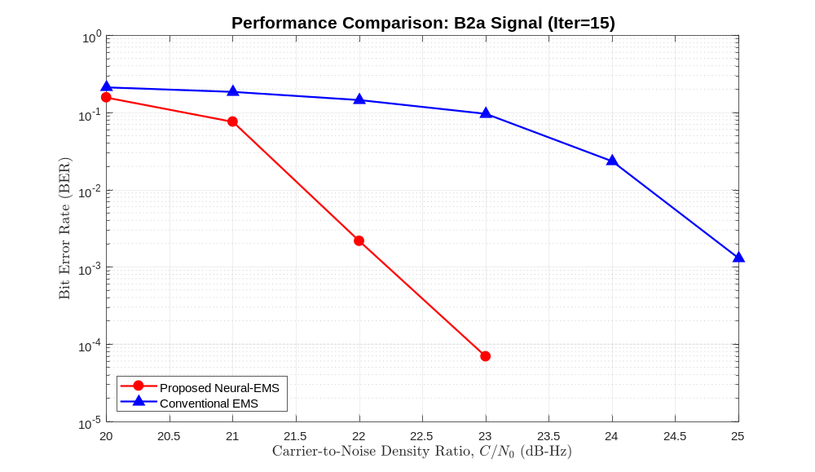
Example BER comparison between B2a SNEMS and conventional EMS supplied with the code

Model-Driven Decoder Training and Weights
The training modules use iterative unfolding and treat the scaling or damping parameters in conventional MS/EMS as trainable variables. The current code calculates the loss, gradients, and Adam updates explicitly on MATLAB arrays, without directly calling dlarray or dlgradient.

Training Entry Points and Default Weights
Training scripts and output files
Target | Training Directory | Entry Point | Default Output
GPS NMS | GPS/NMSTrain | neuralMsGPSDemo.m | NMS_Weights_L1C_2_Final.mat
GPS SNMS | GPS/SNMS | neuralMsGPSDemo.m | SNMS_SharedWeights_L1C_2_Final.mat
BDS NEMS | BDS/NEMSTRAIN | neuralEmsDemo.m | neural_ems_B2b_final.mat
BDS SNEMS | BDS/SNEMSTRAIN | ShareNeuralEmsDemo.m | neural_ems_B2a_final.mat
Default switches: GPS/NMSTrain loads weights (doTraining=false); GPS/SNMS trains (true). BDS/NEMSTRAIN loads B2b weights (false), and BDS/SNEMSTRAIN loads B2a weights (false). GPS NMS uses NMS_Weights_L1C_3_Final.mat when messageType is L1C_3. Each training folder has its own settings.

Training and Inference Switch
% Train new weights
doTraining = true;
% Load pretrained weights from the current directory
doTraining = false;
- Open the entry script in the corresponding training directory.
- Select messageType and set doTraining.
- Verify the epoch count, training C/N0 range, maximum iteration count, and number of test frames.
- During training, record the random seed, code version, parameters, and output weight file.
- During inference, confirm that the weight-file name, variable structure, and signal type match exactly.

Weight Structures
- GPS NMS: scaling weights are organized by check-node degree and iteration layer.
- GPS SNMS: each iteration layer uses shared C2V/VN weights, together with hard-example mining and mixed training.
- BDS NEMS: C2V weights can be organized by Tanner-graph edge and iteration layer, resulting in a comparatively large parameter set.
- BDS SNEMS: each iteration layer shares scalar weights, reducing model storage requirements.

GPS L1C Real-Signal Receiver
Live_Signal_Demo/GPS_L1C is a post-processing software receiver. The default configuration uses GPU acquisition and channel-parallel GPU MEX tracking (trkMode=1, correlatorType=2). init.m reads the settings, inspects the raw data, and waits for confirmation before acquisition, tracking, CNAV-2/LDPC decoding, and navigation.

Parameters That Must Be Configured Before Execution
Key parameters in Live_Signal_Demo/GPS_L1C/initSettings.m
Parameter | Current Default | Required User Action
fileName | D:\xiangze\GPS L1C.iq | Replace with the absolute path to the local raw IF/IQ file.
dataType / fileType | int8 / 2 | Confirm the sample width; 2 denotes interleaved I/Q samples.
IF / samplingFreq | 0 / 25e6 Hz | Values must match the front-end acquisition configuration.
msToProcess | 40000 ms | The navigation solution code requires at least 36000 ms.
numberOfChannels | 15 | Adjust according to the number of visible satellites and available memory.
gpuACQflag | 1 | 0 selects acquisitionCPU; 1 selects acquisitionGPU.
trkMode | 1 | 0 selects serial-channel processing; 1 selects parallel-channel processing.
correlatorType | 2 | Default GPU MEX. 0 selects MATLAB; 1 selects SIMD; 2 selects GPU.
ldpcDecoderType | MS | MS, BP, or NeuralMS. Default MS uses ldpcMsAlpha=1 and ldpcMsOffset=0.2.
ldpcMaxIterations | 15 | Maximum iterations for MS and BP; NeuralMS uses ldpcNeuralMaxIterations=15.
plotTracking | 1 | Controls the channel-tracking figures.

Run Command
cd(fullfile(toolboxRoot, 'Live_Signal_Demo', 'GPS_L1C'));
init
- init.m calls initSettings.m and executes probeData.
- Confirm that the sample amplitudes and data format shown in the inspection figure are reasonable.
- Enter 1 at the prompt to begin processing or 0 to exit.
- After acquisition, inspect acqResults and the channel status.
- trackingResults.mat is saved automatically after tracking.
- postNavigation returns navSolutions and eph. Save these variables explicitly if they must be retained.
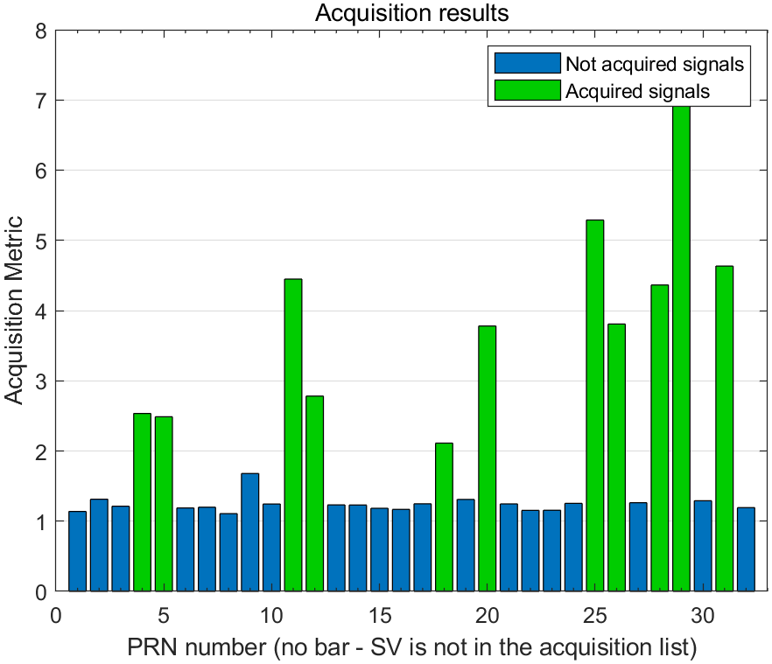
Example GPS L1C acquisition metrics
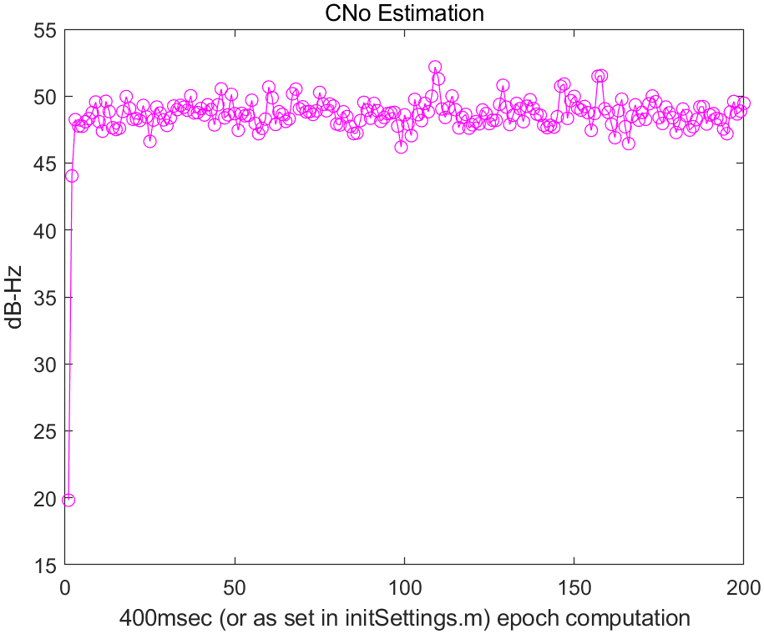
Example C/N0 estimates from GPS L1C tracking. The plotted 400 ms window belongs to the saved example; the current default is CNoInterval=20 with intTime=0.01 s (200 ms).

GPS Receiver Processing Chain
- Acquisition: acquisitionCPU.m or acquisitionGPU.m detects the PRN, carrier frequency, code phase, and peak metric.
- Tracking: trkChannelsSerial.m or trkChannelsParallel.m is used. correlatorType selects the correlator backend.
- Frame synchronization: CNAV2decoding.m uses correlation with the L1C pilot overlay code.
- LDPC decoding: subframe 2 uses H2.mat and subframe 3 uses H3.mat. The dispatcher supports MS, BP, and NeuralMS.
- Navigation: postNavigation.m extracts the ephemerides, pseudoranges, and satellite positions, and then computes a least-squares PVT solution.

BDS-3 B2b Real-Signal Receiver
The workflow in Live_Signal_Demo/BDS-3_B2b is similar to GPS L1C. The default uses GPU acquisition and SIMD MEX tracking (trkMode=1, correlatorType=1). postProcessing.m always calls GPU_acquisition.m when acquisition is needed; gpuACQflag does not select a CPU implementation.

Parameters That Must Be Configured Before Execution
Key parameters in Live_Signal_Demo/BDS-3_B2b/initSettings.m
Parameter | Current Default | Required User Action
fileName | D:\xiangze\BDS_B2I_B2b.bin | Replace with the path to the actual raw B2b data.
dataType / fileType | int16 / 2 | Confirm whether the file contains interleaved int16 I/Q samples.
IF / samplingFreq | 0 / 30e6 Hz | Values must match the data-acquisition front end.
msToProcess /  numberOfChannels | 49000 ms / 15 | The minimum value checked by the navigation solution code is 24000 ms.
acqSatelliteList | 6:58 | B2b PRN search range.
acqSearchBand /  acqSearchStep | 5000 / 500 Hz | Adjust according to dynamics and local-oscillator error.
acqThreshold | 3 | Acquisition decision threshold.
trkMode /  correlatorType | 1 / 1 | Default SIMD MEX. trkMode selects MATLAB (0), SIMD (1), or GPU (2); correlatorType is initialized from it.
decoderType | SNEMS | Select EMS, FFT-QSPA, NEMS, or SNEMS.
nmEms / maxIterations | 4 / 15 | Candidate-retention count and iteration limit.
alpha / offset | 1 / 0 | Receiver EMS correction settings; independent of BDS/Common simulation defaults.

Run Command
cd(fullfile(toolboxRoot, 'Live_Signal_Demo', 'BDS-3_B2b'));
init
- Edit initSettings.m and confirm that the raw data can be read.
- Run init and inspect the probeData figure.
- Enter 1 to start GPU acquisition, channel initialization, and tracking.
- BCNAV3decoding.m performs synchronization and LDPC decoding for B-CNAV3 messages.
- postNavigation.m requires at least four satellites with valid ephemerides to compute a three-dimensional position solution.

Operation Without a GPU
- With matching acqResults loaded, configure settings, set skipAcquisition=1 and trkMode=0, and call postProcessing directly. Do not rerun init, which clears the workspace.
- Without matching precomputed acqResults, the current B2b receiver requires its GPU acquisition implementation; no CPU acquisition branch is supplied.
- For MATLAB tracking, set plotTracking=0 to avoid the current DataCNo/CNo plotting-field mismatch, and validate the processing chain separately for the dataset.

Selecting a B2b Decoder
The B2b receiver defaults to SNEMS. NEMS denotes neural EMS; conventional normalized EMS uses EMS or NORMALIZED-EMS with 0<alpha<1 and offset=0. Decoder aliases do not set alpha or offset.
decoderType | Actual Call | Intended Use
EMS / OEMS /  OFFSET-EMS /  NORMALIZED-EMS | emsDecode | Conventional EMS; alpha and offset control the correction.
FFT-QSPA / QSPA and aliases | fftQspaDecode | FFT-QSPA reference; QSPA is an alias in this receiver.
NEMS / Neural-EMS and aliases | Loads nems_B2b_weights.mat | Edge-specific neural weights.
SNEMS / Shared-EMS and aliases | Loads snems_B2b_weights.mat | Shared-weight model.

SIMD and GPU Acceleration
Live_Signal_Demo/Mex_files contains both C++/CUDA source code and .mexw64 files. The supplied binaries can be used directly on 64-bit Windows when the MATLAB ABI is compatible. Recompilation is required on Linux, macOS, or incompatible MATLAB versions.

Backend Mapping
Correlators used for real-signal tracking
Receiver | Mode | MEX File
GPS L1C | Serial + SIMD | corrSIMDSerialQPSK
GPS L1C | Parallel + SIMD | corrSIMDParallelQPSK
GPS L1C | Serial + GPU | corrGPUSerialQPSK
GPS L1C | Parallel + GPU | corrGPUParallelQPSK
BDS B2b | Parallel + SIMD | corrSIMDParallelBPSK
BDS B2b | Parallel + GPU | corrGPUParallelBPSK

Recompilation Examples
cd(fullfile(toolboxRoot, 'Live_Signal_Demo', 'Mex_files'));
% CPU SIMD examples
mex corrSIMDParallelQPSK.cpp
mex corrSIMDParallelBPSK.cpp
% CUDA examples
mexcuda corrGPUParallelQPSK.cu
mexcuda corrGPUParallelBPSK.cu
- First run mex -setup C++ and select a supported compiler.
- For CUDA builds, run mexcuda -setup and confirm that nvcc matches a CUDA toolchain supported by MATLAB.
- Before execution, use which <mexName> -all to confirm that the intended file will be loaded.
- If MEX reports an invalid binary, entry-point error, or architecture mismatch, switch to the MATLAB backend before recompiling.

Interpreting Results and Conducting Reproducible Experiments

Simulation Results
- A BER or FER of zero indicates only that no error was observed in the finite set of trials. It does not imply a true error rate of zero.
- Increase the number of trials in the waterfall region to observe a sufficient number of erroneous frames at each critical point.
- Algorithm comparisons must use the same code, C/N0 values, simLevel, numTrials, maximum iteration count, and random-input conditions.
- A lower mean iteration count does not necessarily imply a shorter total execution time. Per-iteration complexity and the MATLAB implementation also affect runtime.
- The measured seconds per trial need not decrease monotonically with C/N0. Current timings include fixed overhead from random-data generation, encoding, signal and noise generation, correlation, parfor scheduling, just-in-time compilation, and memory allocation. Only the decoding component is strongly affected by the mean iteration count. Warm up the parallel pool and increase numTrials before formal comparisons. To study decoder complexity alone, time only the ldpcDecoderGPS or ldpcDecoderBDS call.

Example Algorithm-Comparison Figures
The following figures were exported directly from the MATLAB .fig files in output/figures. They help determine whether the selected C/N0 range covers the waterfall region. Every horizontal axis represents data-component C/N0. Reproduction also requires identical simLevel, numTrials, maxIterations, algorithm parameters, and random conditions.
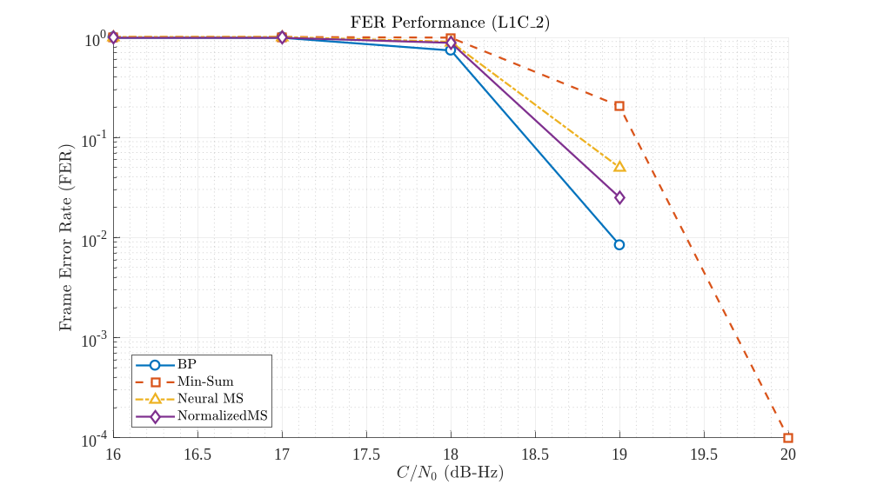
GPS L1C_2 FER comparison among BP, min-sum, Neural MS, and normalized MS
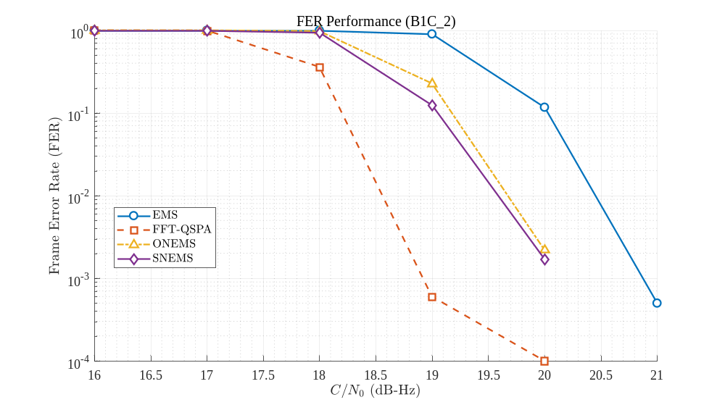
BDS B1C_2 FER comparison among EMS, FFT-QSPA, NEMS, and SNEMS
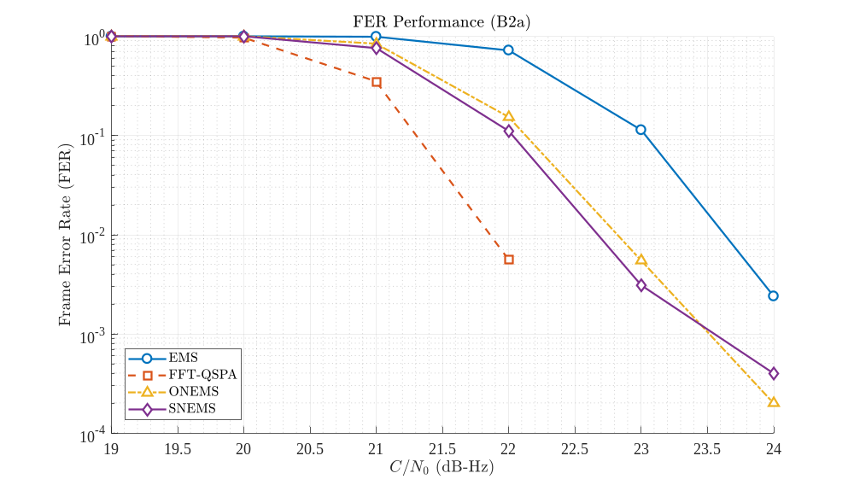
BDS B2a FER comparison among EMS, FFT-QSPA, NEMS, and SNEMS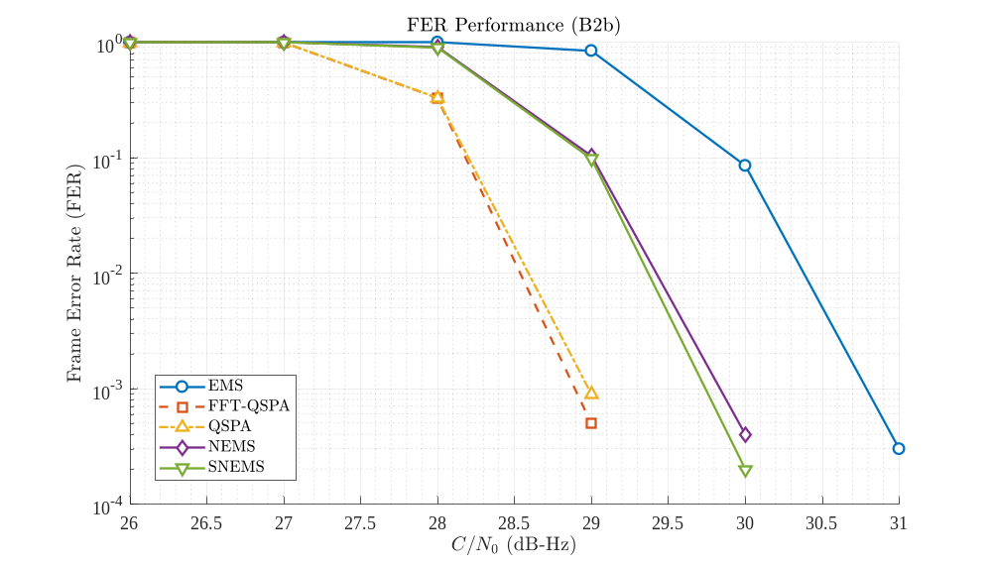
BDS B2b FER comparison among EMS, FFT-QSPA, QSPA, NEMS, and SNEMS
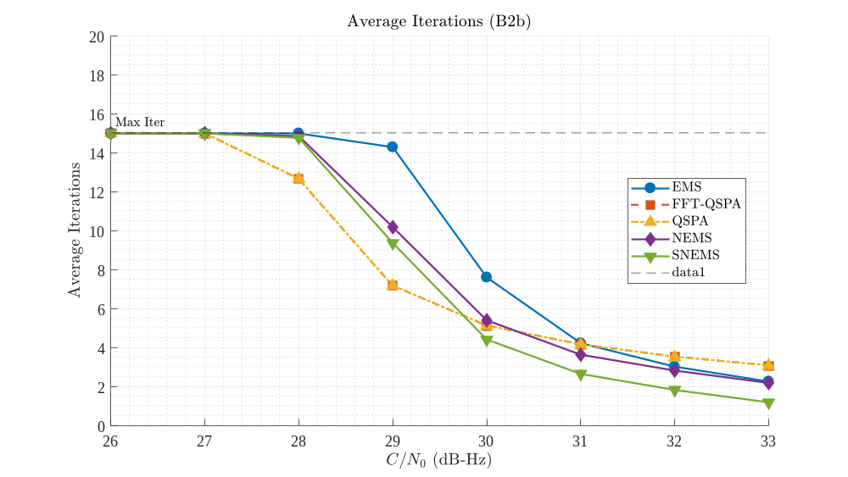
BDS B2b comparison of mean iteration counts across decoding algorithms
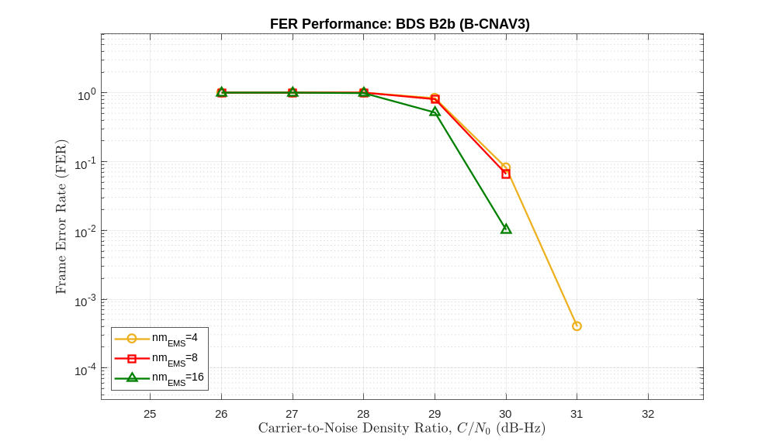
Effect of the EMS candidate-retention parameter nmEms on the BDS B2b FER
Do not interpret the figures from a single C/N0 point. Evaluate the FER waterfall location, mean iteration count, and execution time together. QSPA and FFT-QSPA serve as performance references, whereas the MS/EMS families emphasize low complexity. NEMS and SNEMS assess whether model-driven parameters provide a better balance among performance, convergence, and model storage.

Real-Signal Results
Principal variables and their purposes
Variable | Stage | Contents
acqResults | Acquisition | Carrier frequency, code phase, and peak or acquisition metrics.
channel | Channel initialization | PRN, initial carrier/code frequencies, and channel status.
trackResults | Tracking | I/Q correlation values, code phase, carrier frequency, C/N0, and absolute sample position.
eph | Message decoding | Ephemerides, TOW, and valid-message flags.
navSolutions | Positioning | Pseudoranges, ECEF coordinates, latitude/longitude/height, ENU coordinates, DOP, and satellite azimuth/elevation.

Experimental Metadata
- Code commit or archive version, MATLAB version, and Toolbox versions.
- messageType, simLevel, decoder name, and all settings.
- Random-number strategy, number of Monte Carlo frames, and number of parallel workers.
- CPU/GPU model, memory capacity, operating system, and MEX backend.
- Raw IF filename, byte count, hash, sampling rate, intermediate frequency, data type, and starting offset.
- Output .mat files, figures, console logs, and execution start and end times.
% Simple result-archiving example
runTag = datestr(now, 'yyyymmdd_HHMMSS');
save(['results_' runTag '.mat'], ...
'settings', 'berResults', 'ferResults', ...
'avgIterResults', 'avgTimeResults');

Troubleshooting
Symptom-based diagnosis
Symptom | Common Cause | Corrective Action
Undefined function gf | Communications Toolbox is missing or unlicensed | Check with ver/license, then install and enable the product.
Incorrect number of input arguments for initSettings | A same-named function in another directory is being called | Open the target directory, run clear functions, and inspect which -all.
Results do not match the selected algorithm | ldpcDecoderGPS/BDS is shadowed | Do not recursively add the entire repository to the path. Use the comparison scripts' dynamic path mechanism.
parfor cannot start | Parallel Computing Toolbox, profile, or worker issue | Use for for functional verification, then inspect the parpool configuration.
gpuArray or GPU acquisition fails | No compatible GPU, driver, or Toolbox | Use CPU acquisition for GPS. For BDS, see Operation Without a GPU.
Invalid MEX file | Platform, MATLAB ABI, or compiler mismatch | Switch to the MATLAB backend or rebuild with mex/mexcuda on the local system.
Unable to read file | Incorrect fileName or insufficient permissions | Use an absolute path and confirm that the file exists and is readable.
No satellite is acquired | Sampling rate, IF, data type, search band, or threshold mismatch | Inspect probeData, then verify the front-end parameters and search configuration.
Tracking rapidly loses lock | Incorrect initial frequency, loop bandwidth, or integration time | Inspect the acquisition results and adjust the DLL/PLL parameters incrementally.
No ephemeris or position solution | Insufficient data, failed frame synchronization, or fewer than four valid satellites | Increase the data duration and inspect the LDPC checks and message type.
Neural weight file not found | Filename, directory, or messageType mismatch | Confirm that the pretrained .mat file is in the active algorithm directory, or retrain the model.
Excessive SAMPLE_LEVEL memory use | Sampling rate, code length, frame count, or parallelism is too high | Begin with SYMBOL_LEVEL, then reduce the C/N0 range and number of trials.

Path-Cleanup Template
% Lightweight cleanup before switching algorithms
clear functions
rehash
% Inspect the functions that will actually be called
which initSettings -all
which ldpcDecoderGPS -all % or ldpcDecoderBDS

Appendix: Entry-Script Reference

Entry-Script Reference
Most frequently used commands
Task | Current Directory | Run Command
GPS BP | GPS/BP | ldpcBpGPSDemo
GPS MS | GPS/MS | ldpcMsGPSDemo
GPS NeuralMS | GPS/NeuralMS | ldpcNmsGPSDemo
GPS multi-algorithm comparison | GPS | compare_gps
GPS NMS training | GPS/NMSTrain | neuralMsGPSDemo
GPS SNMS training | GPS/SNMS | neuralMsGPSDemo
BDS QSPA | BDS/QSPA | ldpcQspaBDSDemo
BDS FFT-QSPA | BDS/FFT-QSPA | ldpcFftQspaBDSDemo
BDS EMS | BDS/EMS | ldpcEmsBDSDemo
BDS NEMS | BDS/NEMS | ldpcNemsBDSDemo
BDS SNEMS | BDS/SNEMS | ldpcSnemsBDSDemo
BDS multi-algorithm comparison | BDS | compareldpc
BDS NEMS training | BDS/NEMSTRAIN | neuralEmsDemo
BDS SNEMS training | BDS/SNEMSTRAIN | ShareNeuralEmsDemo
GPS L1C real-signal processing | Live_Signal_Demo/GPS_L1C | init
BDS B2b real-signal processing | Live_Signal_Demo/BDS-3_B2b | init

