Prototypes:
Construction of prototypes will involve two design phases: CAD and assembly.
Assembly:
The prototype boards will be acquired in a mostly preassembled package or assembled by hand by placing components and wires on stripboards and connected by soldering. Stripboards are PCBs which connect components in the same way as a breadboard but are able to deal with more complicated and quicker circuitry due to reduced parasitic loses. Each prototype board (whether preassembled or not) will be paired with pin headers for connectivity. The prototype boards can then be connected to each other using wire jumpers while some will connect using the pin headers directly. Following this method, dedicated prototype boards will be employed for the accelerometer, multiplexer, flash storage, microcontroller, and GNSS receiver.
Three accelerometer breakout boards were acquired from Sparkfun Electronics in a ready-to-use package (aside from the installation a 5-pin header). Two of these breakout boards were hand soldered and successfully passed testing. The untouched third accelerometer is being held as a backup.
During the prototype design phase, it was discovered that due to technical limitations, the flash memory utilized in the previous design is insufficient for usage in GNSS storage applications. This delayed the prototype phase for several weeks and required effort into additional design research. The swap from a single flash memory package to a dual package requires the use of a larger multiplexer. This will require redesign of the mux components. This will be built on stripboards using dual-inline package (DIP) multiplexer IC’s.
Our current memory solution utilizes a pair of Micron 1GB serial flash NAND IC’s packaged in a 63-ball Very Fine pitch Ball Grid Array (VFBGA) which requires custom fabricated PCBs for prototype use. The schematic and layout for this PCB was drawn in Eagle CAD and sent to Quick Turn Circuits in Salt Lake City for fabrication. Estimated time of arrival is Friday, Nov. 13th. SD/MMC card breakout boards were acquired from Sparkfun Electronics as a fallback storage solution if the dual VFBGA solution proves impractical.
An MSP430 F1xx test board is available for use from the 2008-2009 clinic team and has successfully passed testing. In addition, an MSP430 test board for the F5xx series has been acquired in case the F1xx series proves insufficient.
The SiGe 4120L GNSS receiver is packaged in a 24-QFN which also requires the use of PCB breakout boards for prototyping. However, less expensive premade PCBs are available for these parts and can be hand soldered. Once assembled, breakout boards for the GNSS receiver will attach through pin headers into a GPS main board built using a stripboard. The GPS main board will house components for the receiver such as a 16.368 MHz crystal oscillator, antenna, and any passives required for operation.
CAD:
The CAD phase consists of schematics design, board layout, and parts sourcing. The 2008-2009 Sandia clinic team used Eagle CAD to draw their design. Any potentially functional parts of the design will be used as a starting point for the prototype designs in order to save time.
Using Eagle CAD, the schematics from 2008-2009 were reorganized for better readability. Additional library parts were created for the new flash memory IC. Surface mount parts were swapped with through-hole components where possible. Finally, the design was sectioned into corresponding functional units to allow for individual prototype board designs for each section.
Eagle CAD is used again for the prototype board layouts. Because the prototype boards are to be built on stripboards, the components are placed vertically in the CAD design using 0.1” spacing between terminals. Pin headers and jumper wires are used to connect boards to each other or to the microcontroller so these are placed in the CAD layout design as well.
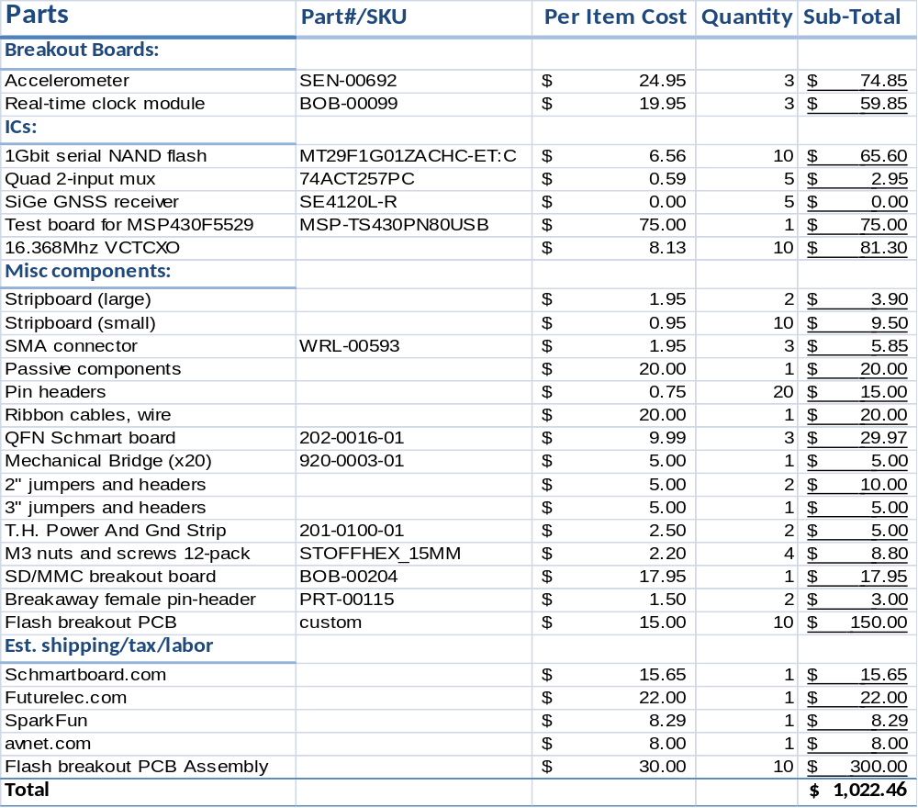
Table x: Prototype parts list

