

***Bluetooth*® Low Energy**

**CC2541 Advanced Remote Control Kit**

**User's Guide**



**Document Number: SWRU343**

**Document Version: 1.0**

**Development Kit Part Number: CC2541DK-RC**

Table of Contents

1. References 3

1.1 Printed Copy Included in the Box with CC2541-ARC 3

1.2 Included with Texas Instruments *Bluetooth* Low Energy Software Installer 3

1.3 Available from *Bluetooth* Special Interest Group (SIG) 3

2. Introduction 4

2.1 Kit Contents Overview 4

2.2 System Requirements 5

2.2.1 Dongle 5

2.2.2 Windows 8 5

2.2.3 Debugging 5

3. Using the CC2540 USB Dongle 6

3.1 Plugging it into a computer 6

3.2 Connecting to the Advanced Remote Control 7

3.2.1 First Time Pairing 7

3.2.2 Connection for Devices which are Already Bonded 7

3.2.3 Disconnecting 7

3.2.4 Removing long term bond-data 8

3.2.5 LED states 8

3.2.6 Button Actions 8

4. Connecting the Advanced Remote Control to Windows 8 9

4.1 Open the “Devices” tab of “PC Settings” and click “Add a Device” 9

4.2 Adding the Advanced Remote Control 10

5. Using the Advanced Remote Control 11

5.1 Advertise and connect 11

5.2 Keyboard input 11

5.3 Consumer control 11

5.4 Mouse input 11

5.5 Remove bond information 11

5.6 Calibrate 11

6. Programming / Debugging the CC2541 Advanced Remote 12

6.1 Hardware Setup for Advanced Remote 12

6.2 Hardware Setup for USB Dongle 13

6.3 Using SmartRF Flash Programmer Software 14

6.3.1 Reading or Writing a Hex File to the CC2540/41 14

6.3.2 Reading or Writing the CC2540/41 Device Address 15

6.4 Using IAR for Debugging and Programming 15

6.4.1 Advance Remote Project Files 15

6.4.2 HID Dongle Project Files 15

7. Software Overview 16

7.1 HID over GATT 16

7.1.1 BLE HID Terminology 16

7.1.2 GATT Services 16

7.1.3 Data Flow 17

7.1.4 HID Report Overview 18

8. General Information 19

8.1 Document History 19

# References

The following references provide additional information on the CC2540, CC2541, the Texas Instruments *Bluetooth®* low energy (BLE) stack, the BLE HID over GATT profile the HID Service, and the BLE specification in general. (All path and file references in this document assume that the BLE development kit software has been installed to the default path C:\Texas Instruments\BLE-CC254x-1.3.1\)

## Printed Copy Included in the Box with CC2541-ARC

1. CC2541 Advanced Remote Control Kit Quick Start Guide (SWRU341)

## Included with Texas Instruments *Bluetooth* Low Energy Software Installer

(The software installer is available for download at [**www.ti.com/ble-stack**](http://www.ti.com/ble-stack))

1. Texas Instruments *Bluetooth*® Low Energy Software Developer’s Guide (SWRU271)  
   C:\Texas Instruments\BLE-CC254x-1.3\Documents\TI_BLE_Software_Developer's_Guide.pdf
2. TI BLE Vendor Specific HCI Reference Guide  
   C:\Texas Instruments\BLE-CC254x-1.3\Documents\TI_BLE_Vendor_Specific_HCI_Guide.pdf
3. Texas Instruments BLE Sample Applications Guide (SWRU297)  
   C:\Texas Instruments\BLE-CC254x-1.3\Documents\TI_BLE_Sample_Applications_Guide.pdf

## Available from *Bluetooth* Special Interest Group (SIG)

1. HID over GATT profile, Version 1.0 (27-Dec-2011)  
   **<https://www.bluetooth.org/docman/handlers/downloaddoc.ashx?doc_id=245141>**
2. HID Service, Version 1.0 (27-Dec-2011)  
   [**https://www.bluetooth.org/docman/handlers/downloaddoc.ashx?doc_id=245140**](https://www.bluetooth.org/docman/handlers/downloaddoc.ashx?doc_id=245140)
3. Specification of the Bluetooth System, Covered Core Package version: 4.0 (30-June-2010)  
   [**https://www.bluetooth.org/technical/specifications/adopted.htm**](https://www.bluetooth.org/technical/specifications/adopted.htm)

# Introduction

Thank you for purchasing a Texas Instruments (TI) *Bluetooth®* low energy (BLE) Advanced Remote Control Kit. The purpose of this document is to give an overview of the hardware and software included in the CC2541 Advanced Remote Control Kit (CC2541ARC).

The information in this guide will get you up and running with the kit; however for more detailed information on BLE technology and the TI BLE protocol stack, please consult the Texas Instruments *Bluetooth*® Low Energy Software Developer’s Guide [2].

For more information on the HID over GATT profile (Human Interface Device over Generic Attribute Profile), HOGP for short, which is the BLE profile used to transfer HID Reports such as keyboard and mouse keys, see the HID over GATT profile[5] and HID Service[6] specifications available from the *Bluetooth®* Special Interest Group website.

## Kit Contents Overview

The kit contains the following hardware components including cables:

|  |  |  |  |
| --- | --- | --- | --- |
|  | Advanced Remote Control | CC2540 USB Dongle | CC Debugger |
| CC2541DK-RC | • | • | • |

The **CC2541 Advanced Remote Control** is designed to act as a HID Peripheral Device (BLE Slave), operating according to the specifications laid out in the HID over GATT profile [5]. It comes pre-assembled in plastic casing with rubber buttons, battery enclosure and a hole to access the programming header.

The Advanced Remote Control operates on three 1.5V alkaline AAA (LR03) batteries. Available peripheral hardware on the board includes a buzzer, gyroscope, accelerometer and shift registers for key scanning. The PCB design also includes a 3.3V LDO (TPS78330) to lower the voltage from a maximum 4.5 Volt to 3.3 Volt for use by the integrated circuits.

The **CC2540 USB Dongle** can be used to emulate any Bluetooth low energy behavior but is usually acting as a Central Device (BLE Master) and HID Host. In this kit it comes pre-loaded with firmware that acts in a Central role and as a *HID Service* client towards the Advanced Remote Control and sends received input data to emulated Human Interface Devices (USB HID) on a connected Windows, Linux or OSX computer.

The **CC Debugger** is used to flash the software onto both the USB Dongle as well as the Advanced Remote Control. It can also be used for debugging software using IAR Embedded Workbench.



Figure 1 – Hardware Included with CC2541ARC

The RF Boards in this kit are FCC and IC certified and tested to comply with ETSI/R&TTE over temperature from 0 to +35°C.

**Caution!** The kits include a non-rechargeable lithium battery. Always make sure the battery is removed from the CC2540/41 Keyfob when it is connected to an external power source (Do not apply voltage > 3.6V). Dispose the battery properly and keep out of the reach of children. If swallowed, contact a physician immediately.



**Caution!** The kits contain ESD sensitive components. Handle with care to prevent permanent damage.

## System Requirements

### Dongle

To use the CC2540USB dongle as a bridge between the Advanced Remote Control and a host computer, only USB HID support in the operating system is necessary.

For computers without *Bluetooth*® low energy capable hardware and native support for the HID over GATT profile in the operating system, using the dongle is a good way to start, as it hides the wireless aspect completely from the operating system.

From a hardware standpoint, the Windows PC must contain one free USB port. An additional free USB port is required in order to use the CC Debugger and the USB Dongle simultaneously.

### Windows 8

For computers running Windows 8, the requirement is a *Bluetooth*® 4.0 dual mode dongle or internal hardware, with hardware drivers that support *Bluetooth®* low energy. This can be verified in the Windows Device Manager by checking that there are references to e.g. “Bluetooth LE Enumerator”

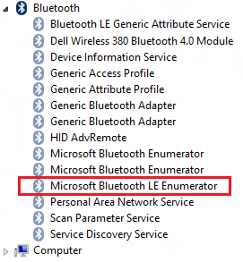

**Figure 2** Bluetooth devices as seen in Windows Device Manager

### Debugging

**IAR Embedded Workbench for 8051** development environment is required in order to make changes to the keyfob software. More information on IAR can be found in the Texas Instruments *Bluetooth*® Low Energy Software Developer’s Guide [1].

# Using the CC2540 USB Dongle

This section describes how the USB dongle appears to a computer running Windows 7, how it operates and how to use the buttons on the dongle.

## Plugging it into a computer

As the CC2540 USB dongle comes pre-programmed with emulated Human Interface Device USB endpoints, no extra drivers are necessary, and it should work out of the box. After the USB dongle has been discovered and configured by Windows you will notice some extra USB HID devices in the device manager.

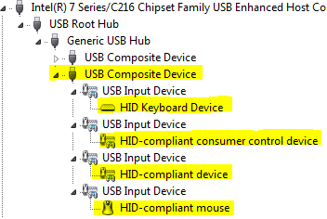

**Figure 3** CC2540 USB Dongle, when viewed in Device Manager sorted by connection.

Figure 3 above shows the USB dongle enumerated as a *USB Composite Device* with four interfaces which represent different capabilities of the Advanced Remote Control and USB dongle:

*HID Keyboard Device*

* + Number keys, arrow keys, OK and Back on the Advanced Remote

*HID-compliant consumer control device*

* + Volume buttons, play, pause, rewind and similar consumer device control buttons

*HID-compliant mouse*

* + Movement data sent from the Advanced Remote when the mouse is activated

*HID-compliant device*

* + Control point for communication between USB dongle firmware and applications running on the computer. Can be used for pairing, pin codes, feedback, resetting etc. Not in use by the pre-programmed USB dongle firmware.

## Connecting to the Advanced Remote Control

### First Time Pairing

When the devices are programmed, they lose all stored pairing information. The dongle will power up and show a solid red LED. To initiate a connection to an ARC press the SW2 button on the HID dongle. This will cause the HID Dongle to scan for an ARC for 5 seconds. While scanning, the red LED will blink once a second. Press any key on the ARC to start advertising.

Once a suitable advertisement has been found, the CC2540 USB dongle will connect, pair and exchange long-term bonding information with the remote, perform discovery of the services and characteristics used by the HID over GATT profile and enable GATT notifications to be sent for button presses and mouse movements from the Advanced Remote.

The green LED will light up when the connection is alive, and the red LED will blink when data is received. The connection will be terminated to save power after the Advanced Remote has been idle for 60s.

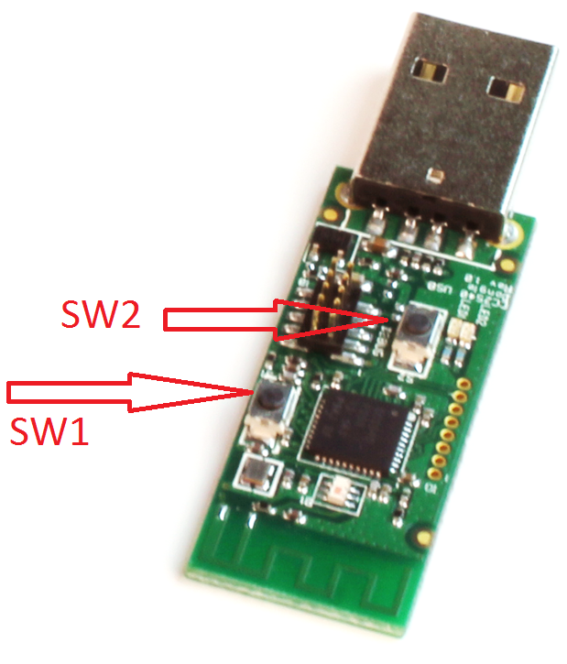

**Figure 4:**

**SW1** - Clear bonding information

**SW2** - Scan and pair with Advanced Remote Control

**Sequence**

1. Press **SW2** to start scanning for remote. Blinking red LED indicates scanning.
2. Press any key on remote to start advertising.
3. Verify green LED which indicates a successful connection.

### Connection for Devices which are Already Bonded

If a HID Dongle and Advanced Remote previously paired and stored bonding data, then the HID Dongle will continuously scan for this specific Advanced Remote. When in this continuous scanning mode, the HID Dongle will blink the green LED once a second.

A HID dongle only stores pairing information for one remote, so other remotes will not be able to connect to the HID dongle until the bonding info is cleared.

### Disconnecting

Pressing **SW2** on the dongle will cause it to disconnect from the Advanced Remote Control and go back to scanning, but to retain long-term bonding information.

Since the Advanced Remote and the USB dongle are bonded and notifications are enabled on the remote, activating the Advanced Remote Control will cause it to start advertising, reconnect and immediately transmit the button press(es) recorded while disconnected.

### Removing long term bond-data

Pressing **SW1** as seen onFigure 4 while not in a connection will cause the USB dongle to erase its record of the long-term bonding data stored for the Advanced Remote in the Flash memory of the USB dongle.

This will not affect the data stored on the Advanced Remote. See the section on the Advanced Remote for information on how to erase this data.

### LED states

|  |  |
| --- | --- |
| LED Action | HID Dongle State |
| Solid Red | Idle |
| Blinking Red | Scanning for any BLE advanced remote |
| Solid Green | Connected |
| Blinking Green | Scanning for previously bonded remote |

### Button Actions

|  |  |  |
| --- | --- | --- |
| Button | State | Action |
| SW1 | Idle | Erase bonding info |
| SW2 | Idle | Start scanning |
| SW2 | Connected | Disconnect |

# Connecting the Advanced Remote Control to Windows 8

Once *Bluetooth*® low energy capable hardware is installed in a Windows 8 computer and updated drivers are installed (refer to section 2.2.2), you can discover and use the Advanced Remote Control by following the steps below.

## Open the “Devices” tab of “PC Settings” and click “Add a Device”

On the PC, move your mouse pointer to the lower right hand corner and click on “Settings”.

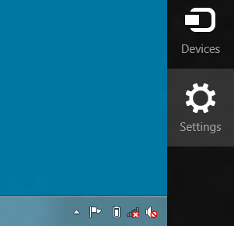

**Figure 5** “Settings” icon visible when moving cursor to lower right hand corner

A new widget will appear, allowing you to click on “Change PC settings”.

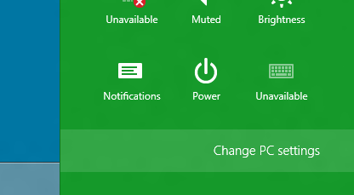

**Figure 6** Click ”Change PC settings”

This will open up the PC settings panel, allowing you to add and remove devices.

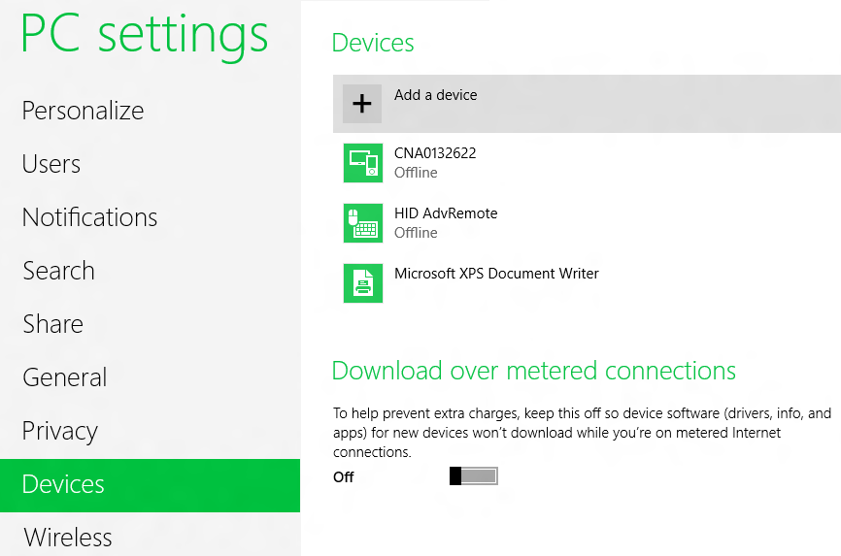

**Figure 7** Adding a device

## Adding the Advanced Remote Control

After clicking on HID AdvRemote in Figure 8 Windows will try and connect to the Advanced Remote. The Advanced Remote only advertises for 30 seconds, so the user may have to press a key on the remote to place it in advertising mode.

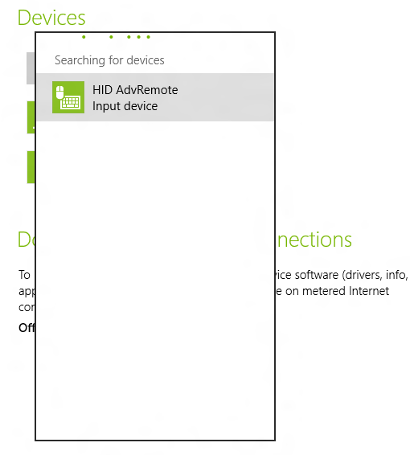

Figure

# Using the Advanced Remote Control

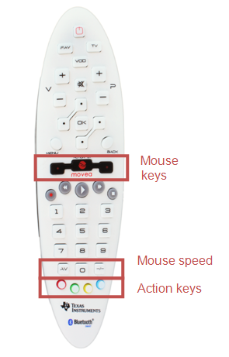

Figure – Advanced Remote Control

## Advertise and connect

Almost all the keys will make the Advanced Remote start advertising and be discoverable by hosts scanning for HID capable BLE devices.

## Keyboard input

Pressing any number will act as a keyboard input of that number. The same goes for OK which is Enter, Back which is Backspace and the four keys surrounding OK, which act as directional or arrow keys.

## Consumer control

Buttons such as Volume, Mute, Play/Pause etc. are consumer control keys, and will control media settings on your computer.

## Mouse input

Holding down the middle mouse button will prompt the Advanced Remote to interpret your movement of the remote as mouse input and send this to the computer.

Double clicking the middle button will lock the mouse function. The left and right buttons act as left and right mouse buttons.

Pressing AV and –/– will decrease and increase mouse speed.

## Remove bond information

Pressing the Red action key (leftmost) will remove bonding information stored on the Advanced Remote. Pairing will have to be done again, using passkey entry if applicable. If the remote is in a connection, the connection will be dropped, and then the bonding information will be erased.

## Calibrate

Pressing the Blue action key (rightmost) will recalibrate the onboard motion sensors. The mouse function must be off and the device must lie on a flat surface when doing this. If the Advanced Remote is not ready for calibration, a high pitched note will sound. Just press the blue key again. During calibration a low-pitched tick will sound for 12 seconds. A high-pitched note at the end indicates success.

# Programming / Debugging the CC2541 Advanced Remote

The CC Debugger included with the Advanced Remote kit allows for debugging using IAR Embedded Workbench for 8051, as well as for reading and writing hex files to the CC2540/41 flash memory using the SmartRF Flash Programmer software. The hex files are included with the installer. SmartRF Flash Programmer also has the capability to change the IEEE address of the CC2540/41 device. This section details the hardware setup when using the CC Debugger, as well as information on using SmartRF Flash Programmer. Information on using IAR Embedded Workbench for debugging can be found in the Texas Instruments *Bluetooth*® Low Energy Software Developer’s Guide [2].

## Hardware Setup for Advanced Remote

The debug port is found on the back side of the remote. Connect the debugger as shown. The red stripe (pin 1) should be on the same side as the blue and #3 keys. When connected properly, the debugger LED will show green after pressing the CC debugger reset button.

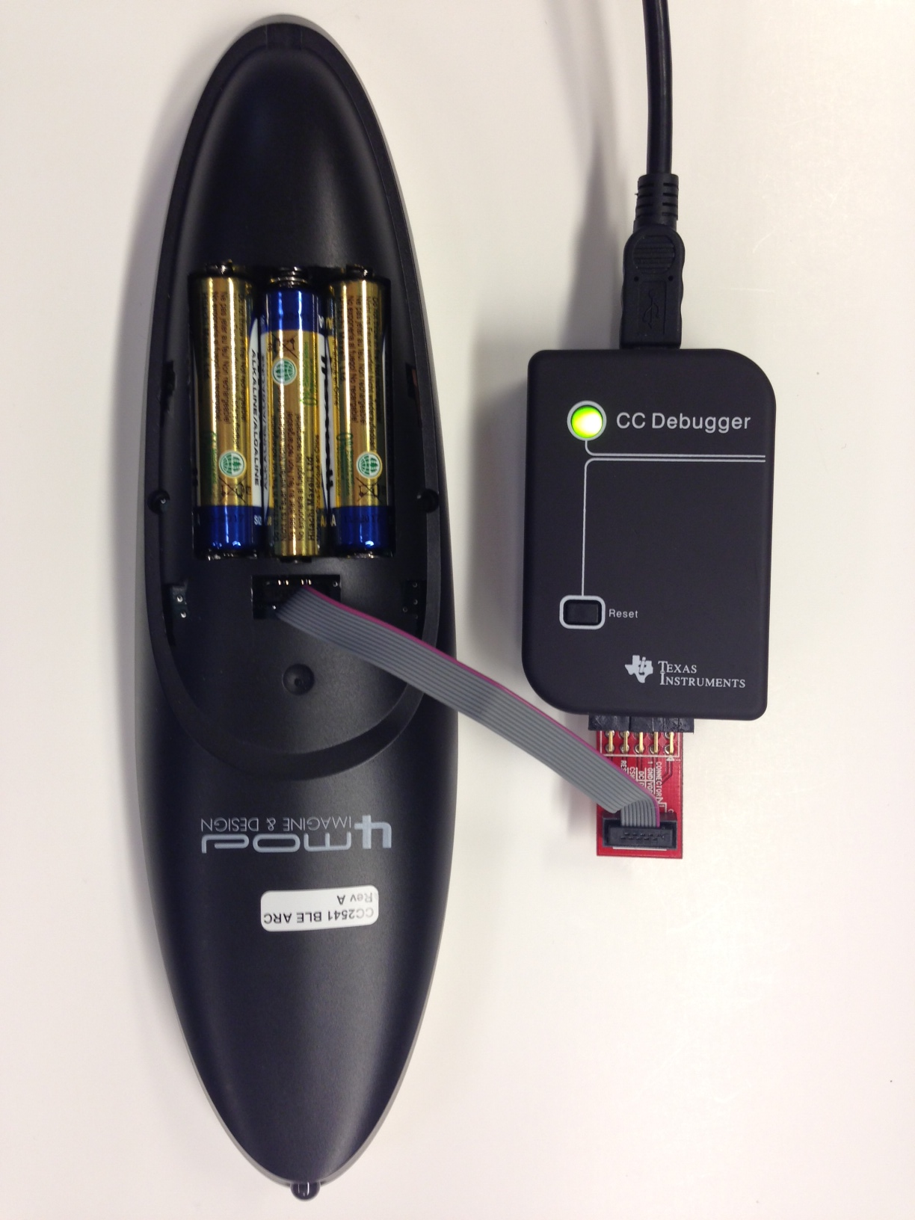

Figure 10 Advanced Remote Programming Setup

**Power Savings Tip: Leaving the remote in debug mode will cause some extra power drain on the battery. To exit debug mode, remove the debugger cable and power cycle the remote.**

## Hardware Setup for USB Dongle

The setup process for flashing the USB Dongle is very similar to the process when flashing the remote. Connect the CC Debugger to the USB Dongle as shown below. Be sure that the ribbon cable is oriented properly, with the red stripe connected to pin 1 as shown in figure below. The USB dongle also must be powered to program, and should be placed in a USB port prior to programming with CC Debugger.

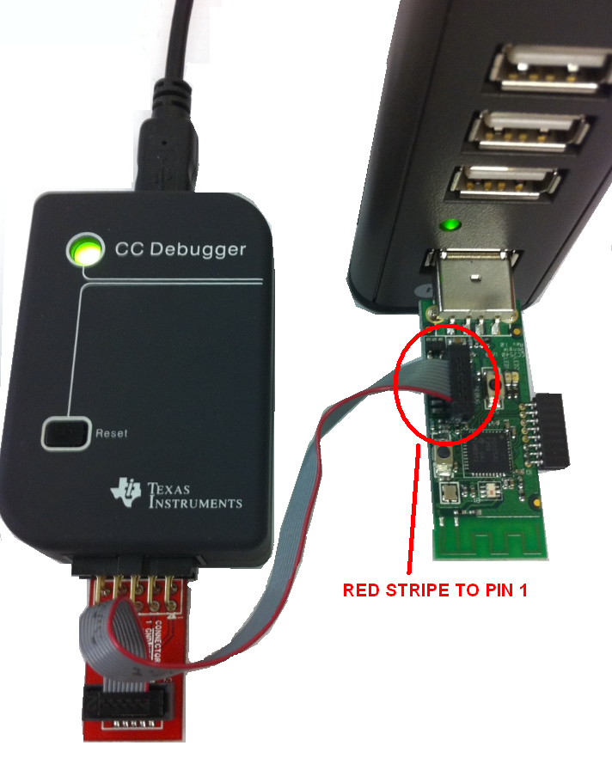

Figure 11 CC2540 USB Dongle Connected to CC Debugger

Connect the CC Debugger to the PC USB port. The status indicator LED on the CC Debugger should turn on. If the LED is red, that means no CC2540 device was detected. If it is green, then a CC2540 device has been detected. If the USB Dongle is connected and the LED is red, try pressing the reset button on the CC Debugger. This resets the debugger and re-checks for a CC2540 device. If the LED still does not turn green, re-check that all cables are securely connected. Once the CC Debugger status LED is showing green, you are ready to use IAR to debug or to read or write a hex file from/to the USB Dongle.

## Using SmartRF Flash Programmer Software

Note: the instructions in the section apply to the latest version of SmartRF Flash Programmer (version 1.12.6), which is available at the following URL: <http://www.ti.com/tool/flash-programmer>

To start the application go into your programs by choosing Start > All Programs > Texas Instruments > SmartRF Flash Programmer > SmartRF Flash Programmer. The program start-up screen is shown below.

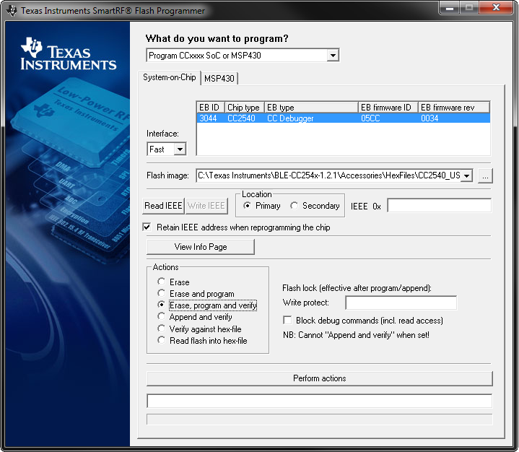

Flash Programmer

**Note.** If you get prompted to update the EB Firmware (CC Debugger), follow the presented instructions to update the CC Debugger.

### Reading or Writing a Hex File to the CC2540/41

To read or write a hex file to the CC2540/41, select the “System-on-Chip” tab (default). The connected CC2540/41 should be detected and show up in the list of devices. Under “Flash image” select the desired hex file that you would like to write to the device. If you are reading from the CC2540/41, under “Flash image” enter the desired path and filename for the hex file. To write to the CC2540/41, under “Actions” select “Erase, program and verify”. To read from the CC2540/41, under “Actions” select “Read flash into hex-file”. To begin the read or write, click the button “Perform actions”.

If the action completes successfully, you should see the progress bar at the bottom of the window fill up, and either one of the following two messages, depending on whether a write or a read was performed: “CC254*X* - ID*XXXX*: Erase, program and verify OK” or “CC254*X* - ID*XXXX*: Flash read OK”.

There are two pre built image files intended for the Advanced Remote Kit.

|  |  |
| --- | --- |
| Project | Directory |
| HIDAdvRemote | \Accessories\HexFiles\CC2541_ARC_HIDAdvRemote.hex |
| HIDAdvRemoteDongle | \Accessories\HexFiles\CC2540_USBdongle_HIDAdvRemoteDongle.hex |

### Reading or Writing the CC2540/41 Device Address

Every CC2540/41 device comes pre-programmed with a unique 48-bit IEEE address. This is referred to as the device’s “primary address”, and cannot be changed. It is also possible to set a “secondary address” on a device, which will override the primary address upon power-up. Flash Programmer can be used to read the primary address, as well as to read or write the secondary address. For more information refer to the Texas Instruments *Bluetooth*® Low Energy Software Developer’s Guide [2].

## Using IAR for Debugging and Programming

IAR is the compiler and IDE used to develop the Advanced Remote and HID dongle. For more information on using IAR refer to the Texas Instruments *Bluetooth*® Low Energy Software Developer’s Guide [2]. This section provided a high level overview of advanced remote kit software projects

There are two projects intended for the Advanced Remote Kit.

|  |  |
| --- | --- |
| Project | Directory |
| HIDAdvRemote | \Projects\ble\HIDAdvRemote |
| HIDAdvRemoteDongle | \Projects\ble\HIDAdvRemoteDongle |

### Advance Remote Project Files

The following are important file componets of the Advance Remote Control project. After opening the project in IAR, these will be visble in the left hand project explorer.

|  |  |
| --- | --- |
| File | Description |
| hidAdvRemote.c | Top level application. Initialization of remote hardware, connection settings, GATT, and top level task handlers. Keys and gyro/accelerometer callbacks are handled here. |
| battservice.c | Service for battery. Support characteristics for battery. |
| devinfoservice.c | Service for device info. Support characteristics such as manufacturer, serial number, etc. |
| hidDev.c | Service for HID. Support HID reads, writes, queuing reports, state machine. |
| hidkbmservice.c | Service for keyboard, mouse and consumer control reports. |
| hid_uuid.h | List of UUIDs for supported HID reports. |
| Scanparamsservice.c | Service for scan parameters. |

### HID Dongle Project Files

The following are important file components of the HID Dongle project.

|  |  |
| --- | --- |
| File | Description |
| hidApp.c | Top level application. Initialization of dongle hardware, service discovery, and connection state machines. |
| Usb_hid_reports.c | HID to USB report handling. |
| hid_uuid.h | List of UUIDs for supported HID reports. |

# Software Overview

## HID over GATT

The software supports the HID Over GATT Profile specification which was approved by the BT SIG in December 2011. The specification is publicly available at bluetooth.org. Microsoft Windows 8 supports HID over GATT.

### BLE HID Terminology

|  |  |
| --- | --- |
| **HID Host** | The target machine that the user interacts with (e.g. Laptop, tablet, phone, etc...) |
| **HID Device** | The device that is used by the user to interact with the Host (e.g. Keyboard, mouse, remote control, game controller, etc...) |
| **HID Report** | A data message sent between the host and device.  Input reports go from device-to-host, such as a mouse movement or keyboard press.  Output reports go from host-to-device, such as a PC changing the caps lock LED on a keyboard |
| **HID Report Descriptor** | A data structure that the device sends to the host which describes the HID device’s capabilities, including the types, sizes, and directions of the reports that are supported |

### GATT Services

The following services are defined in the HID profile specification as either mandatory or optional. The software included with the Advance Remote Kit includes all of these services.

|  |  |  |
| --- | --- | --- |
| Service | Requirement | Supported |
| HID Service | Mandatory | Yes |
| Battery Service | Mandatory | Yes |
| Device Information Service | Mandatory | Yes |
| Scan Parameter Service | Optional | Yes |

### Data Flow

The following data flow shows how HID reports are sent to Central device.

Periodic sensor poll

hal_motion.c

MOVEA library

AIR_MOTION_LIB_3G3A-Banked.r51

Application callback

hidAdvRemote.c : MotionSensorCback

Build HID report

hidAdvRemote.c : hidMouseSendReport

Queue report

hidDev.c : HidDev_Report

Send report

hidDev.c : hidDevSendReport

BLE Stack

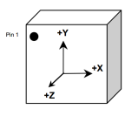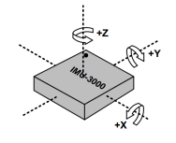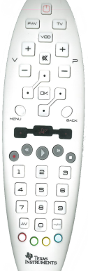

Raw I2C sensor data

X + Y ”Mickeys”

X + Y ”Mickeys”

HID Mouse Input report

HID Mouse/Kbd/CC Input report

GATT Notification

Scan keys on ISR

hal_key.c / OSAL.c / hal_drivers.c

Application callback

hidAdvRemote.c : KeyCback

HID Kbd/CC Input report

Build HID report

hidAdvRemote.c :hid[Key|CC]SendReport

OTA to Central device acting as HOGP Host

Keyscan result, row & col

Command, Usage page

### HID Report Overview

The following HID reports are supported in the Advanced Remote Control.

|  |  |  |  |
| --- | --- | --- | --- |
| Type | Bytes | Data | Function Ref |
| Mouse | 4 | Buttons, X, Y, wheel | hidMouseSendReport |
| Consumer Control | 2 | Bitmap command | hidCCSendReport |
| Keyboard | 8 | Modifier, reserved, key code 1..6 | hidKeyboardSendReport |

# General Information

## Document History

|  |  |  |
| --- | --- | --- |
| **Revision** | **Date** | **Description/Change** |
| SWRU343 (1.0) | 2013-03-22 | Initial release |