Fri 01/22/10 04:17:10 PM

Runs as a service: SYSTEM must be allows remote launch and activation permissions.
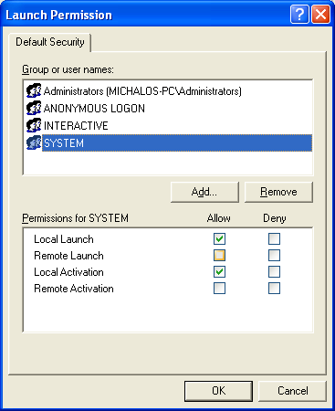

When I tried to run the service as SYSTEM. STILL DIDN’T WORK!!!!!!!!!!

Instead I had run the service as an authenticated account.
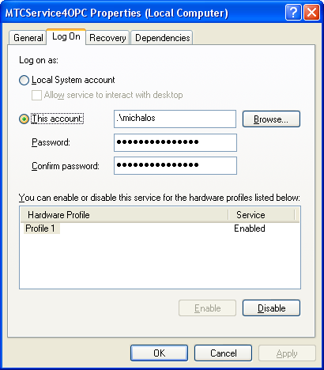

WTF

