MTConnect .NET Agent
User Guide - Based on MTConnect Specification 0.9

Draft
June 15, 2010

Table of Contents
Table of Contents 2
Revision History 3
Copyright 3
Disclaimer 3
Terminology 4
Background 5
Windows Service 7
Basic Installation 8
MAZAK 8
Installation Requirements 9
Installation Steps 9
Installation Parameters 11
Uninstall 13
SIEMENS 840D 13
Installation Requirements 14
Installation Steps 15
Uninstall 17
FANUC SHDR INSTALLATION 17
Installation Requirements 18
Installation Steps 18
Uninstall 19
Remote Installation 20
Installation Requirements 21
Installation Steps 21
Installation Parameters 23
Installation Troubleshooting 24
OPC Troubleshooting 25
OPC Background 28
OPC Server Connect 29
OPC Group and Item Subscription 30
OPC Config File Parameters 31
FAQ 33
How do I send a Request to the Core Agent? 33
How do I configure the MT Connect Agent? 33
How can I view all the data stored by the Agent? 33
How can I see what version of the Agent is running? 33
Is Source Code available? 33
How do I upgrade the MTConnect Agent service? 33
Comments or Questions 34

Revision History
Date Description Author Version
Date | Description | Author | Version
8/15/2008 | Initial MTConnect Agent SDK | Ga Tech  See:  mtconnect.org/index.php?option=com_content&task=blogcategory&id=56&Itemid=28 | 1.0
6/1/2010 | Revamped for Multi-device, SCM service as well as for Mazak and OPC deployment | NIST | 2.0

Copyright
Software produced by the National Institute of Standards and Technology (NIST), an agency of the U.S. government and by statute is not subject to copyright in the United States. Recipients of this software assume all responsibility associated with its operation, modification, maintenance, and subsequent redistribution.

Disclaimer
No approval or endorsement of any commercial product by the National Institute of Standards and Technology is intended or implied. Certain commercial equipment, instruments, or materials are identified in this report in order to facilitate understanding. Such identification does not imply recommendation or endorsement by the National Institute of Standards and Technology, nor does it imply that the materials or equipment identified are necessarily the best available for the purpose.

Terminology
Adapter An optional software component that connects the Agent to the Device. IN THIS MANUAL EITHER Mazak SHDR or OPC CLIENT/SERVER Connection.

Agent A process that implements the MTConnect specification, acting as an interface
to the device.

Current A snapshot request to the Agent to retrieve the current values of all the data items specified in the path parameter. If no path parameter is given, then the values for all components are provided.

Device A piece of equipment capable of performing an operation. A device is composed of a set of components that provide data to the application. The device is a separate entity with at least one Controller managing its operation.

HTTP Hyper-Text Transport Protocol The protocol used by all web browsers and web applications.

Sample A sample is a data point for continuous data items, that is, the value of a data item at a point in time.

Background

MTConnect is a new standard sponsored by the Association for Manufacturing Technology (who run IMTS) developed to facilitate the exchange of data on the manufacturing floor. The MTConnect open specification provides for cost effective data acquisition on the manufacturing floor for machine tools and related devices.

MTConnect is based upon prevalent Web technology including XML and HTTP. Figure 1 shows the MT Connect architecture. An “MTConnect Device” is a piece of equipment – a Mazak, DST, Echospeed or other machine tool, which includes an MTConnect Adapter so that we can get data from it. The “Agent” is a process that acts as a “bridge” between a device and a factory “Client Application”, in this case the Boeing dashboard. To learn more about MTConnect see: http://www.amtonline.org

Figure 1 shows the expected MTConnect Agent system architecture, which is a dual Ethernet solution that provides a safety and security buffer for the CNC by isolating it from the main corporate intranet but still allowing TCP/IP connectivity through a front-end PC (FEPC). Both the Mazak and Siemens 840D deployments assume this model, although the FEPC could connect to the CNC through any Ethernet port.

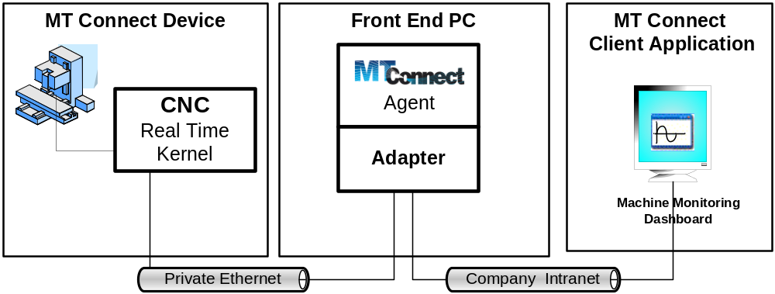
Figure 1 MT Connect Architecture
Currently there are three supported MTConnect Agent architectures:

- MAZAK: For Mazak CNCs to communicate to the MT Connect agent, Mazak provides a SHDR (shudder) Adapter, which is a telnet service that runs on socket port 7878 on the CNC (not shown). Installation of the generic SHDR MTConnect Agent needs to be installed and configured to talk to the Mazak CNC through the SHDR protocol.

- SIEMENS 840D: For DST/Echospeed or any other Siemens 840D to communicate to the MT Connect agent, there is an embedded OPC adapter within a customized MTConnect Agent software.

- FANUC: For Fanuc iSeries CNC to communicate a SHDR (shudder) Adapter must be installed on the Operator Panel PC. The SHDR service assume a HighSpeedSerialBus (HSSB) to the Fanuc CNC. The Fanuc Operator Panel PC must have the HSSB Focas library installed to allow communication to the controller. Once the SHDR software has been installed, installation of the generic SHDR MTConnect Agent needs to be installed and configured to talk to the FANUC CNC through the SHDR protocol. (Please note, there are many iSeries controller with subtle differences in how they handle states and modes.)

Output from the MTConnect agent as displayed in an Internet Explorer web page would look something like this:
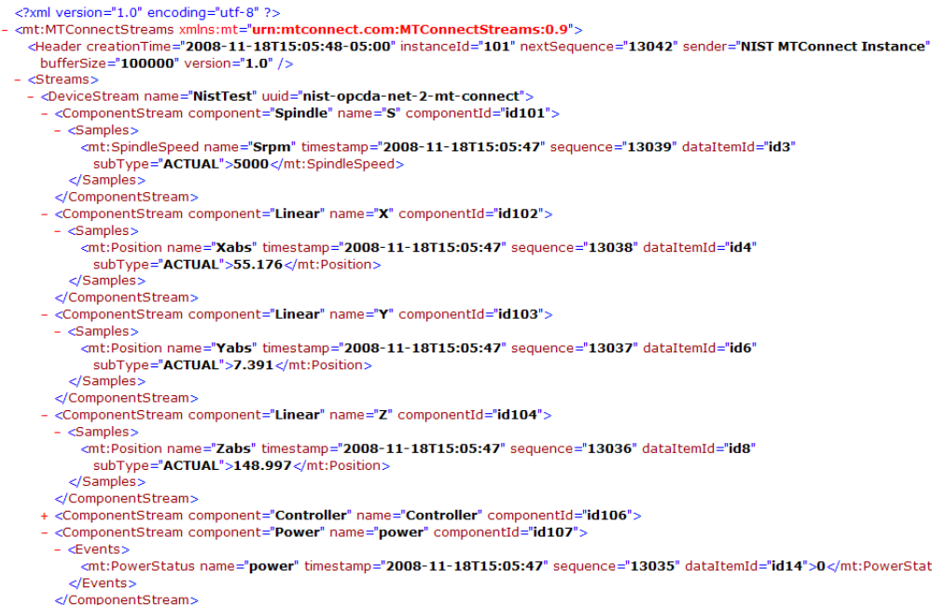
Figure 2 Sample MTConnect XML Web Page
Ole for Process Control (OPC) Data Access (DA) provides a standard mechanism for communicating to data sources on a factory floor originally targeting process and batch industries, but with some CNC market presence. To learn more about OPC see: http://www.opcfoundation.org

Windows Service

 PLEASE READ 
Both MTConnect agent installations are services and the exe cannot be clicked to start them. Only the Windows SCM can start/stop the programs.

The MTConnect Agent service aborts every day at midnight, and assumes the Windows SCM will automatically restart the service after “failure”!!!

Since both MTConnect Agents are installed as Windows Services, so that they cannot be started by double clicking like a regular “exe”. It is important to understand the Windows Service Control Manager (SCM) manages creating, deleting, starting and stopping of Windows services. The SCM maintains the database of installed services.

The Windows SCM supports the ability to automatically perform some defined action in response to a failure. The recovery action is specified in the Recovery tab of the service property page (which can be found in Settings->Control Panel->Administrative Tools -> Services). The Recovery tab allows you to define actions that can be performed on the 1st failure, 2nd failure, and subsequent failures, and also provides support for resetting the failure counters and how long to wait before taking the action. The allowed actions are

- Take No Action (default)
- Restart the Service
- Run a Program
- Restart the Computer

THE MTCONNECT AGENTS assume all failures will Restart the Service! This behavior is ON PURPOSE, as the reliability of the OPC Servers and telnet sockets is not guaranteed and a daily restart seems to fix any long term issues.
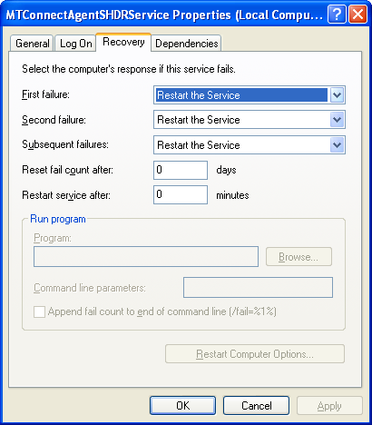
Please double check the MTConnect Agent service Recovery properties:

Unfortunately, this can be a problem if IIS is installed and running. Port 80 will be already engaged and causes the MTConnect to abort and ask if you want the JIT Debugger to run. This is good, as you will know port 80 is occupied. You will need to change “Restart the Service” to “Take No Action” .

One final note the installer must have sufficient privileges to install and run services as system.

Basic Installation

There are no install wizards, instead some manual and batch script configuration is necessary in order to get things to run properly.
 PRELIMINARY NOTES 
1) YOU MUST INSTALL Microsoft .NET FRAMEWORK 3.5 FIRST.
2) MTConnect agent uses port 80 for communication to the outside WWW. If a hardware or software firewall is blocking this port, no MTConnect XML data will be available.
3) Ping the Mazak or Siemens IP address to make sure the CNC is online.
4) If Mazak, test the MTConnect data stream with telnet or http

There are two installation packages: one for the Mazaks and one for CNCs with Siemens 840D controller.

Some notes to consider before installing. YOU MUST INSTALL Microsoft .Net Framework 3.5. Microsoft .Net Framework *IS NOT* supported by Microsoft Windows NT or Windows 2000.

The MTConnect agent uses port 80 for communication to the outside WWW. If a hardware or software firewall is blocking this port, no MTConnect XML data will be available. You should ping the CNC IP address to make sure the CNC is online.

You can test the Mazak MTConnect SHDR data stream with the following
http://mazakcnc-ipaddress:7878
where you use the actual ip address for mazakcnc-ipaddress or use telnet:
Start->Run telnet
------------------------
Welcome to Microsoft Telnet Client

Escape Character is 'CTRL+]'

Microsoft Telnet> open ipaddress:7878

MAZAK

The Mazak natively support MTConnect by providing a SHDR MTConnect adapter. The MTConnectAgentSHDRService program is a Windows service that is described in this document and is targeted for communication between an MTConnect Agent client running on the and the Mazak MTConnect Adapter running on the CNC. Figure 3 shows the MTC Adapter running on the CNC and the MTConnect Agent running on Front-End PC.

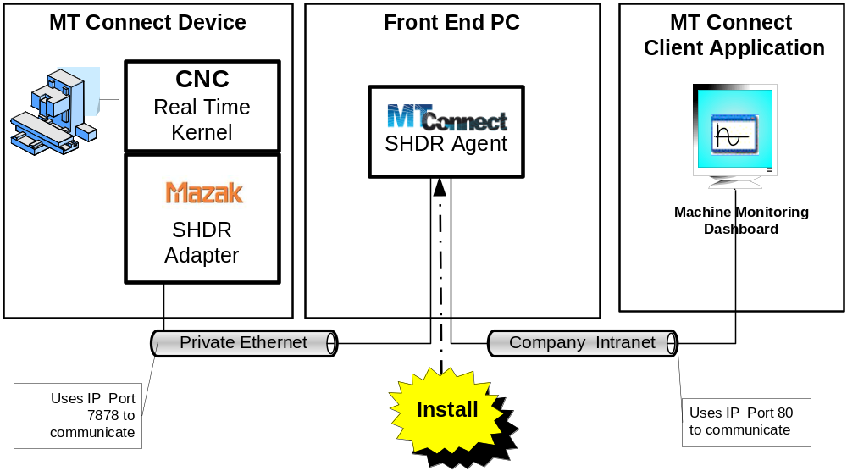
Figure 3 Mazak MTConnect Installation Architecture

Installation Requirements
The MTConnectAgentSHDRService software installation requirements were:

- MT-Connect requires installation of .Net Framework 3.5.
- Mazak SHDR service has been installed and configured for port 7878 on the CNC.

Installation Steps
1) The software is archived at the NIST ftp site.

⇨ Goto: ftp://ftp.isd.mel.nist.gov/pub/MTConnect/

Download and save:

04/19/2010 01:44PM 149,167 MTConnectAgentDistribution.zip

2) UNZIP and extract MTConnectAgentDistribution.zip to C:\ or anywhere you like.

FILE | PURPOSE
configureservice.vbs | THIS IS BATCH INSTALL FILE
Devices.xml | Describes all the MTConnect devices
mtcagent.ini | Ga Tech SDK file - IGNORE
mtcagent.xsd | Ga Tech SDK file - IGNORE
MTConnectAgentSHDRService.exe | Service EXE. Will not execute as expected if double clicked.
MTConnectAgentSHDRService.exe.config | THIS IS THE CONFIG FILE – used to edit Mazak IP address(es).
MTConnectPage.vbs | Test vbscript to see if the
Novell.Directory.Ldap.dll | Ga Tech SDK file - IGNORE
startservice.bat | Batch script to start the MTConnectAgentSHDRService service.
stopservice.bat | Batch script to stop the MTConnectAgentSHDRService service.
test.bat | Batch script to query MTConnectAgentSHDRService service status.
uninstall.vbs | Batch script to uninstall the MTConnectAgentSHDRService service from the Windows Service Control Manager (SCM). After uninstalling the service, you can delete this folder.

Please note: those rows colored blue are important in installation.
FILENAME | THIS IS IMPORTANT

3) Move to C:\MTConnectAgentDistribution folder (or wherever you extracted the zip contents - shouldn't matter.)

DOUBLECLICK: configureservice.vbs

This automatically installs the "MTConnectAgentSHDRService" into the Microsoft Service Control Manager (SCM) as automatic service with error recovery. You can confirm this in the Windows SCM.

4) CHANGE the ip address of the SHDR pc in "MTConnectAgentSHDRService.exe.config" that is bolded and italicized:

⇨ <add key="ipaddrs" value="192.168.1.102" />

5) start MTConnectAgentSHDRService

⇨ DOUBLECLICK: startservice.bat

Optionally, you can go into the Windows Service control manager and manually start the process.
MyComputer->Right Click (Select Manage) -> Services and Applications -> Services -> MTConnectAgentSHDRService -> Right Click (Start)

6) See if agent is getting data.

⇨ DOUBLECLICK: MTConnectPage.vbs

will pop open an internet explorer web page with MTConnect data and update every 3 seconds..

or manually enter into Internet Explorer ]

⇨ http://127.0.0.1/current/

and you should see a web page of XML. If not, please see the INSTALLATION TROUBLESHOOTING SECTION.

Figure 4 shows that if you only see a small amount of XML data as shown below and the Mazak is running, then the MT Connect agent may not be communicating with the Mazak SHDR adapter, so you will need to refer to the Troubleshooting section.
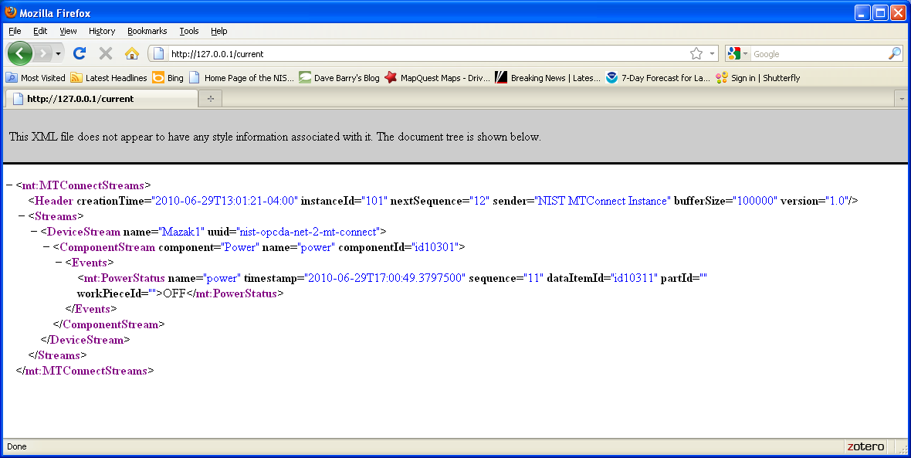
Figure 4 Potential MTConnect Agent Problem
However, if the Mazak if OFF, then Figure 4 should be expected.

Installation Parameters
Below is a explanation of the installation parameters found in the exe.config file:
MTConnectAgentSHDRService.exe.config File
<add key="devices" value="Mazak1" /> | Device name as found in the Devices.xml configuration file. Please refer to the MTConnect documentation for information on how devices are named.
<add key="ipaddrs" value="192.168.1.102" /> | IP Address of CNC and SHDR service
<add key="ports" value="7878" /> | SHDR port
<add key="ipport" value="80" /> | MTConnect Port Number
<add key="debug" value="0" /> | Level of debug tracing. 0-5 range, with 0 being minimal. Logs to file debug.txt
<add key="ReadTimeout" value="60000" /> <!--> Time before assuming socket zombieland </!--> | Time to wait for socket connection to send data (in milliseconds) or the SHDR socket connection will be reset it self.
<add key="RestartLogAppend" value="true" /> <!--> restart/truncate log file every time we run </!--> | If true, resets debug.txt, otherwise appends.
<add key="SampleSize" value="50" /> | Size to keep of MTConnect samples. Larger samples take longer to process on the FEPC.
<!--> THis is here as filler - service manually added by script, technically "works"--> | EMBEDDED SERVICE - IGNORE
<add key="ServiceName" value="MTConnectAgentSHDRService" />
<add key="ServiceUser" value="" />
<add key="ServicePassword" value="" />
<add key="ServiceName" value="MTConnectAgentSHDRService" />
<add key="ResetPeriod" value="60" />
<!--> Reset Service Parameters </!--> | DAILY RESET SERVICE
<add key="ResetTime" value="00:00:00" /> | Clock time to reset Service: 12AM
<add key="ResetCycleWait" value="20000" /> <!--> Time to wait between thread loop (important for stopping too </!--> | Time to delay in reset cycle.
<add key="ResetFlag" value="true" /> <!--> Do reset every evening </!--> | Reset flag, if true service will be reset at the ResetTime every day. Otherwise runs continuously.

The MTConnect Agent software has the ability to read data from multiple SHDR servers. The maximum number is defined in the Devices.xml file (where the MTConnect sample and event itmes are also defined.) Currently, the limit is four Mazaks, but can easily be changed.

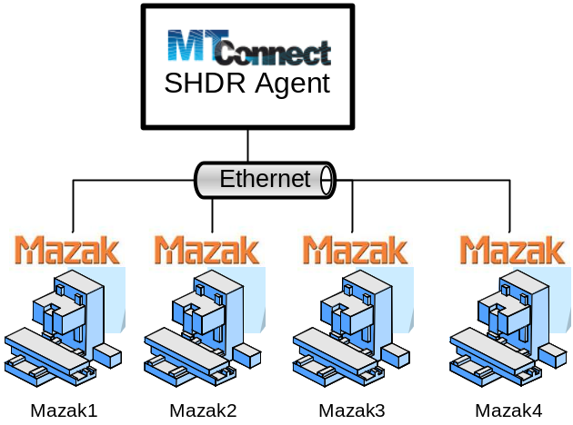
Figure 5 Multiple Mazaks MTConnect Installation
For example to configure the MTConnectAgentSHDRService.exe.config file to communicate with 3 Mazaks, the following code. Note ipaddrs is the only parameter that really changes from deployment to deployment.
<add key="devices" value="Mazak1,Mazak2,Mazak3" />
<add key="ipaddrs" value="192.168.1.102, 192.168.1.103, 192.168.1.104" />
<add key="ports" value="7878,7878,7878" />

Uninstall
To uninstall the Mazak MTConnect Agent service, run the uninstall.vbs in the installation folder. The Batch script uninstall.vbs will first Stop the MTConnectAgentSHDRService service and then Remove service from the Windows Service Control Manager (SCM). Note, you may get a vbscript error if the service is not running. You should be able to ignore this.

No other registry modifications were done.

After removing the service from the SCM, you can delete the installation folder.

SIEMENS 840D
This section describes MTCAdapter4OPC an MTConnect adapter that contains both an MTConnect Agent and an OPC .Net client to do data access to local/remote OPC Server. The MTCAdapter4OPC program is configurable to change name and locations of OPC Server as well as properties of the MT Connect Agent.

The Siemens do not natively support MTConnect. The MTCAdapter4OPC Windows service described in this document is targeted for communication between an OPC client running on the FEPC with the MTConnect Agent and the Siemens 840D OPC Server running on a CNC. Unfortunately, this architecture uses DCOM which is plagued with security issues, configuration nightmares, firewalls, and a multitude of Windows policies. Figure 1 shows the OPC Server running on the CNC and the MTConnect and OPC Client running on Front-End PC. The dual Ethernet solution provides a safety and security buffer for the CNC by isolating it from the main corporate intranet but still allowing TCP/IP connectivity through a front-end PC (FEPC).

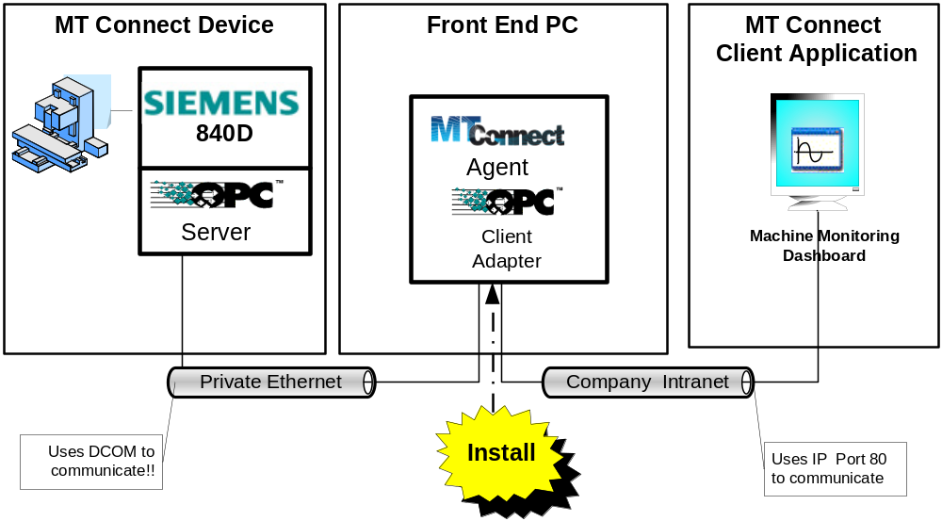
Figure 6 Siemens 840D Dual-Ethernet Deployment System Architecture

Installation Requirements
The MTCAdapter4OPC software installation requirements were:

- MT-Connect requires installation of .Net Framework 3.5.
- OPC .NET Api requires installation of .Net Framework 2.0.
- Fortunately, the .Net Framework 3.5 is backwards compatible with .Net Framework 2.0.
- The OPC Proxy/Stub DLLs need to be installed on the FEPC.
- All CNC Data Access exe or DLL files are located in the same directory as the exe file being used. The following table list the files that need to in this directory:

Software Module | Description
OPC Core Components Redistributable 3.00.101.zip | Contains setup file for installing OPC DA proxy DLL. Note: OPCEnum is not used by the OPC client adapter. Unzip and double click msi.
MTCAdapter4OPC.exe | NIST modification of Ga Tech SDK C# MT Connect Agent
MTCAdapter4OPC.exe.config | Configuration file for NIST developed C# MT Connect Agent
DeviceEntry.log | Diagnostics file Generated by agent.
Devices.xml | Contains device description and elements such as:  - MTConnect URI for the device  - configured to handle up to *4* “Mazak” devices. Device name is not important for now, just used to retrieve data item names.  XML adheres to mtcagent.xsd schema.
mtcagent.ini | MTConnect Agent configures itself based upon values in the configuration file. The configuration file is an xml file named mtcagent.ini,
mtcagent.xsd | MTConnect Device Description schema.
MTConnectAgentCore.dll | MTConnect HTTP .net framework DLL
Novell.Directory.Ldap.dll | LDAP Directory services dll NOT USED
MTConnectAgentSHDR.dll | MTConnect interface to AgentCore
BELOW ARE INSTALL AND SERVICE SCRIPTS
configureservice.vbs | THIS IS THE BATCH INSTALL FILE
startservice.bat | Batch script to start the MTConnectAgentSHDRService service.
stopservice.bat | Batch script to stop the MTConnectAgentSHDRService service.
test.bat | Batch script to query MTConnectAgentSHDRService service status.
uninstall.vbs | Batch script to uninstall the MTConnectAgentSHDRService service from the Windows Service Control Manager (SCM). After uninstalling the service, you can delete this folder.

Installation Steps
1) Setup MTC Agent configuration found in the file "MTCService4Opc.exe.config"

You will need to configure this item:

<add key="OPCMachine" value="192.168.16.100" />

a) OPCMachine gives the name or ip address of the Siemens 840D OPC Server

If you are having problems connecting to the OPC server you may need to change:
<add key="User" value="" />
<add key="Password" value=" " />

b) User is the Siemens 840D CNC login name on the remote machine: may be blank
c) Password Siemens 840D CNC password for the given User.

For example, connecting to the OPC Server you can try to User Authentication across the network.
<add key="User" value=".\auduser" />
<add key="Password" value="SUNRISE" />

Note: If you use a domain name service for logon, use its name then your username,
e.g., DOMAIN\auduser
if you are using the local logon service on the machine precede user name with .\
e.g., .\auduser

Note: if your password has non-html friendly characters, e.g., & or < >, use the html equivalent in the config file
& = &amp;
> = &gt;
< = &lt;

Beware this can be a problem.

2) Move to C:\MTConnect4OPC folder (or wherever you extracted the zip contents - shouldn't matter.)

⇨ DOUBLECLICK: configureservice.vbs

This automatically installs the "MTConnect4OPCService" into the Microsoft Service Control Manager (SCM) as automatic service with error recovery. You can confirm this in the Windows SCM.

3) Start MTConnect4OPCService

⇨ DOUBLECLICK: startservice.bat

Optionally, you can go into the Windows Service control manager and manually start the process.

MyComputer->Right Click (Select Manage) -> Services and Applications -> Services -> "MTConnect4OPCService" -> Right Click (Start)

4) See if agent is getting data.
⇨ DOUBLECLICK: MTConnectPage.vbs

will pop open an internet explorer web page with MTConnect data and update every 3 seconds..

or manually enter into Internet Explorer ]

⇨http://127.0.0.1/current/

and you should see a web page of XML. If you only see the POWER=OFF , please see the TROUBLESHOOTING and OPC sections.

Uninstall
To uninstall either the Siemens 840D MTConnect Agent service, run the uninstall.vbs in the installation folder. The Batch script uninstall.vbs will first Stop the MTConnect4OPC service and then Remove service from the Windows Service Control Manager (SCM). Note, you may get a vbscript error if the service is not running. You should be able to ignore this.

No other registry modifications were done.

After removing the service from the SCM, you can delete the installation folder.

FANUC SHDR INSTALLATION
Installing the MTConnect Agent for the Fanuc CNC, involves installing a SHDR Adapter and a MTConnect Agent with the SHDR Adapter. Please see the Mazak section for installation of the MTConnect Agent with the SHDR Adapter. This section describes installing a custom SHDR Adapter developed for Fanuc that uses the Focas HSSB library. The setup is straightforward, as there is a MSI (Microsoft installation) program to install the SHDR adapter program. Figure 7 shows the components involved.
 NOTE 
Since “fanuc” logon is not an administrator SHDR cannot be installed as a service. Instead, it is installed as program into:

Run->Startup Folder

to run at logon.

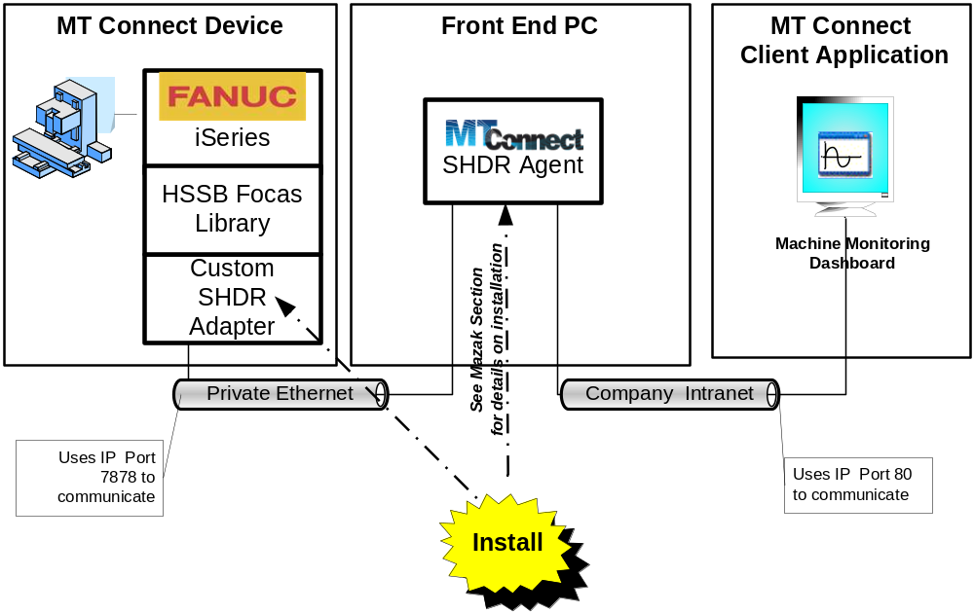
Figure 7 Fanuc Installation Overview

Installation Requirements
The Fanuc software installation requirements were:

- Focas1 HSSB library must be installed and located in the system Path

Installation Steps
- Download FanucShdrStartup.msi from ftp://ftp.isd.mel.nist.gov/pub/MTConnect

- Run FanucShdrStartup.msi, and you should see an Install Wizard step. You can safely just Next, Next, … , Finish

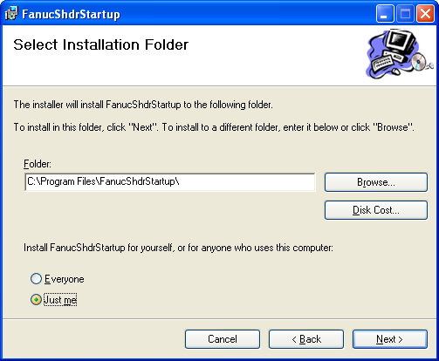
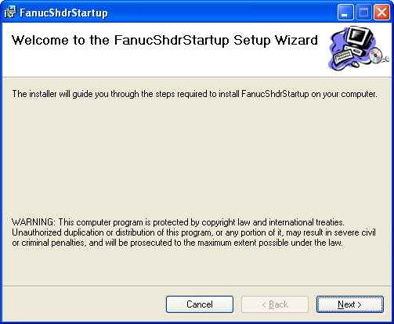⇨ ⇨ ...

- Choose Just Me (since fanuc is the only user logon).

- Now a short to the FanucShdrStartup program is installed in the Startup Folder, which will be run every time the “fanuc” user logs on:
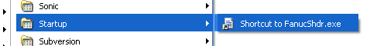

- FanucShdrStartup exe will run automatically on logon but it will be undetectable as it is a windowless program. You can use the Task Manager to see if its running or to kill the FanucShdr program. To kill, you can also use the Start->Programs->FanucShdr->KillFanucShdr to stop the SHDR program.

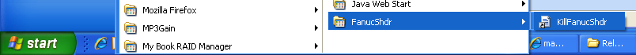

Uninstall
Since FanucShdr is installed by a MSI wizard, it can uninstalled using the Control Panel -> Add/Remove programs:
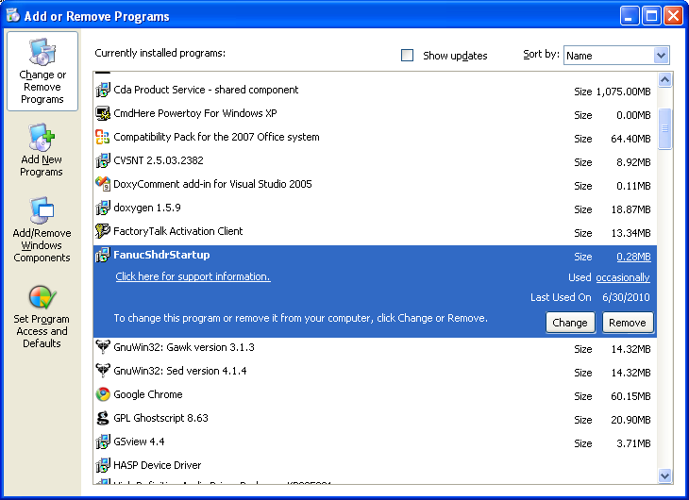

Remote Installation
The ability to copy the MTConnect Agent installation folder and remotely configure and start the service is often desirable due to the distance to the FEPC or inability to do a RemoteDesktop to the FEPC. This section assumes the user installing the software has sufficient privileges/authentication credentials to remotely access the computer and run scripts. It also assumes the firewall does not prevent the PSTools from running remotely. Generally access to \\REMOTE\C$ must be enabled for pstools to work. You can get more information at http://technet.microsoft.com/en-us/sysinternals/bb897553.aspx

Installation Requirements
The remote software installation files are:

FILE | DESCRIPTION
pdh.dll | PSTools DLL
psexec.exe | PSTool to remotely run a program on remote computer
psservice.exe | PSTool to remotely run a service command on remote computer
Readme.txt | Explanation on how to remotely install and run service
remotecmd.vbs | This is a tool to run an interactive DOS shell on a remote computer.
remotecopy.vbs | This copies the files in the folder above (including these remote tools) to the remote computer directory C:\SERVICENAME .  Enter the name of the remote computer.
remoteinstall.vbs | This runs the vbscript C:\SERVICENAME\configureservice.vbs on the remote computer,
remotestart.vbs | Remotely command to start a service on remote computer. Enter the name of the remote computer.
remotestop.vbs | Remotely command to stop a service on remote computer. Enter the name of the remote computer and optionally the service name.

Installation Steps
1) Change to the folder .\remote in the Installation directory. Then, to copy all the files to the remote pc

⇨Double click "remotecopy.vbs" which is a vb script.

⇨Enter the name of the computer you wish to copy the agent files.
- The files will be copied to the remote folder \\COMPUTER\C$\SERVICENAME

For example, tt will create and copy all the files and subfolders to C:/ MTConnectAgentSHDRService or C:/MTC4OPCService on that machine

3) Remote install the MT Connect Agent

⇨ Double click "remoteinstall.vbs" which is a vb script.

Enter the name of the computer you wish to copy the agent files.
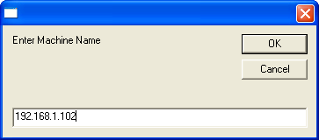

4) Now you can remotely access the Service Control Manager instead of using remote{start,stop}.vbs

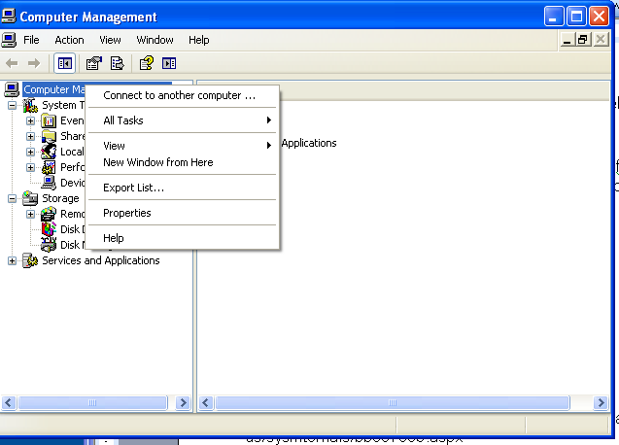

And enter the machine name:

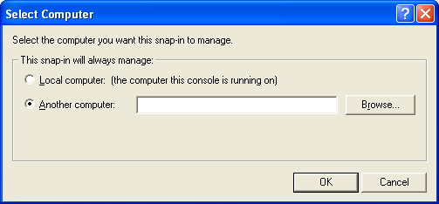

Instead of the Remote SCM:
4) Remote start of the MT Connect Agent

⇨ Double click "remotestart.vbs" which is a vb script.

Enter the name of the computer you wish to start the service.

5) To stop or uninstall the service run the

⇨ Double click "remotestop.vbs"
Enter the name of the computer you wish to stop the service.
Enter the name of the service you wish stop.

To Uninstall:
⇨ Double click "remoteuninstall.vbs"

Installation Parameters
See OPC section for an explanation of the installation parameters found in the exe.config file.
Installation Troubleshooting
Possible reasons the MT Connect agent fails to run:
- Microsoft IIS or other web browser is listening on port 80. Solution: Uninstall web server. See section:
- MTConnectAgent already installed and service running. Check Task Manager to see if MTConnectAgentSHDRService already running.
- Files were mangled. Visually inspect xml and ini files to make sure CR/LF weren’t converted to LF only. Solution: Redownload.
- Cannot see MTConnect agent outside of local PC. Check firewall port 80 blocking.

The program checks to make sure only one instance is running. It is a standalone program that listens to TCP/IP socket port 80. Potential problems:
- YOU MUST INSTALL Microsoft .NET FRAMEWORK 3.5 FIRST, OR YOU WILL GET ERRORS.
- Collision with another program using port 80, specifically Microsoft IIS. To see if Microsoft IIS is installed and running, Control Panel -> Add Remove Programs -> Add/Remove Windows Components and see if Internet Information Service (IIS) is checked. If checked, then uncheck and reboot. Other web browsers (e.g., Apache) can be removed using Control Panel -> Add Remove Programs.
- If you are using Windows XP Service Pack 2 with Firewall enabled, check to make sure the HTTP is allowed through the firewall of blocked socket numbers. This will not prevent MTConnectAgent service from appearing to work, but http Port 80 must be available to communicate to the MT Connect Agent.

To see if http port 80 is available on the FEPC, do the following: Run->Control Panel -> Firewall ->Exceptions. You should see the list of programs and services that can use sockets. HTTP should be checked.

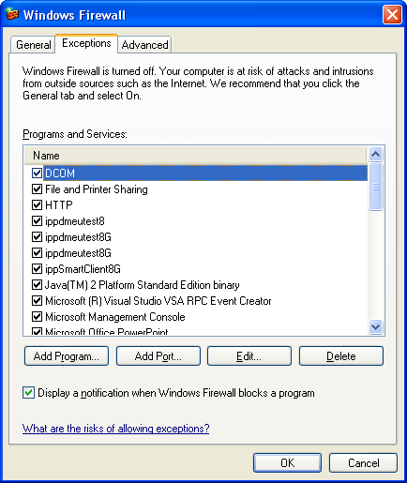

Above, if DCOM is ON, this means we should be able to directly access an 840D OPC Server.

OPC Troubleshooting
OPC relies DCOM, which requires setting Windows security and firewalls, access control lists, server identities, etc. Often and aggravatingly, OPC may not work and troubleshooting can be difficult because each problem masks itself with a variety of symptoms. This checklist gives an in order list of common things to check, related problems and causes, and potential solutions.
Table 1 OPC Troubleshooting Checklist
FEPC | Ping server
CNC | No firewall blocking | - check for 3rd party firewalls in task manager, eg. Window Firewall, Juniper networks, BlackIce, etc. You may need to check the TaskManager to see if a firewall is running.
CNC | No NAT box
CNC | DCOM enabled | Run->dcomcnfg  ConsoleRoot->ComponentService->Computers->My Computer (Right click select Properties)  [Default Properties] -> Enabled Distributed COM on this machine CHECK  [Default Properties] -> Default Authentication Level -> NONE  [Default Properties] -> Default Impersonation Level –> Identity
CNC | DCOM Limits | Run->dcomcnfg  ConsoleRoot->ComponentService->Computers->My Computer (Right click select Properties)  [COM Security] Access Permissions : Edit Default  : System, Everyone  [COM Security] Launch and Activation Permissions : Edit Default  : Admin, System, Everyone, Interactive
CNC | OPC Server Configure | Run->dcomcnfg  ConsoleRoot->ComponentService->Computers->My Computer -> DCOM Config (Double Click)  Select OPC.SINUMERIK.MachineSwitch – Right Click Properties  [GENERAL] Authentication Level -> NONE  [LOCATION] Run application on this computer – CHECKED  [SECURITY] Launch and Activation Permissions : Customize  : Admin, System, Everyone, Interactive  [SECURITY] Access Permissions: Customize  : System, Everyone, Interactive  [ENPOINTS]  [IDENTITY] The interactive user ?????????????????  REBOOT
FEPC | Authentication Level=None,  If you have non-domain users, check if you have included "Everyone” in the  1. access and  2. launch permissions | Run->dcomcnfg  ConsoleRoot->ComponentService->Computers->My Computer (Right click select Properties)  [Default Properties] -> Enabled Distributed COM on this machine CHECK  [Default Properties] -> Default Authentication Level -> NONE must match NONE on CNC  [COM Security] Access Permissions : Edit Default  : System, Everyone  [COM Security] Launch and Activation Permissions : Edit Default  : Admin, System, Everyone, Interactive
CNC | Interactive User | Admin group? Or User? What is the difference?
FEPC | Opc.exe Test | smiley face?  Domain user?  No user?  Local user? .\auduser SUNRISE – don’t forget .\
FEPC | Service Test | Domain user?  No user?  Local user? .\auduser SUNRISE – don’t forget .\
CNC |  | Use Event Viewer to find out additional auditing information on why the DCOM connection fail – MUST BE ENABLE using Local Policy  Start -> Administrative Tools->Local Security Policy.  Local Policies-> Audit Policy  1. Enable auditing for success and failure for the following options: Audit logon events,  2. Audit object access,  3. Audit privilege use.
FEPC | Policy Management | GROUP POLICY  Start->Run-> gpedit.msc  1. Go to Computer Configuration | Windows Settings | Security Settings | Local Policies | Security Options.  2. In the right pane, double-click "DCOM: Machine access restrictions ..." . Check "Enable policy", click "Edit security" and give full permissions to the same users as above.  3. Do the same for "DCOM: Machine launch restrictions ...".  4. Close the console.
LOCALSECURITYPOLICY????????
Since we logon to a domain (NW)

5. If you log on to a domain (YOU DO AS SNV6295 ) Repeat the same steps for the "Default Domain Policy" (see Start | Programs | Administrative tools|LocalSecurityPolicy).

DCOM is used to remotely create the OPC Server component for the OPC Client. To do this, DCOM obtains the Client's current username associated with the current. Windows guarantees that this user credential is authentic. DCOM then passes the username to the machine or process where the component is running. DCOM on the component's machine then validates the username again using whatever authentication mechanism is configured (can be NONE) and checks the access control list for the component. If the OPC Client's username is not included in this list (either directly or indirectly as a member of a group of users), DCOM rejects the call before the component is ever involved. The figure “OPC Server DCOM Component Creation Timeline” below describes the sequence events in creating the remote OPC Server component that involves permissions to remote log on, permissions to launch(create) the OPC Server component, permission to access the OPC Server component.

If *ANY* of these fails, you get same error message, the dreaded:

0x80070005 - General access denied error

Generally, if there is a firewall blocking DCOM socket port access, you will get this error message.
0x800706ba - The RPC server is unavailable
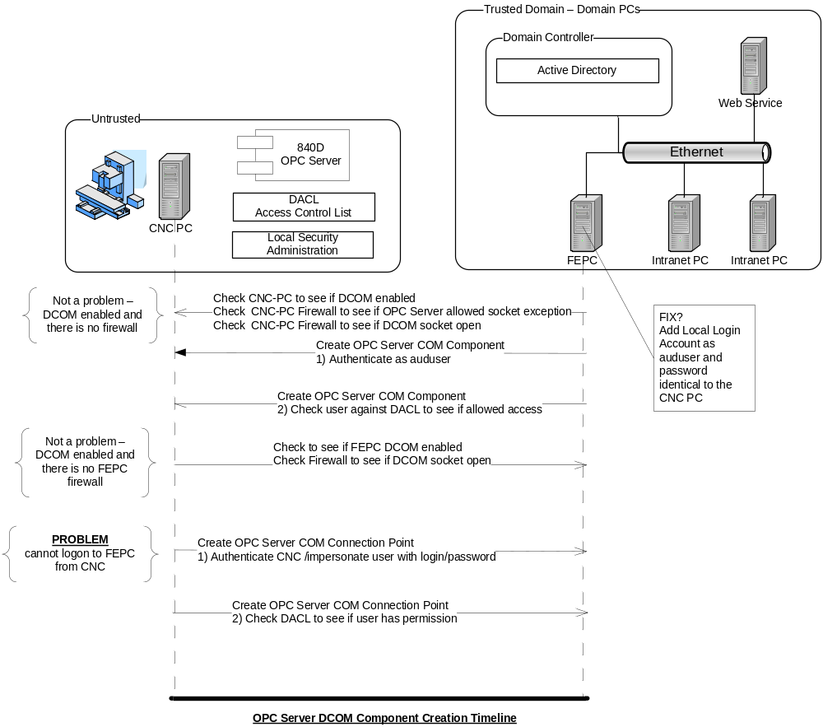

OPC Background
This section gives a more in depth discussion on the features and configuration of the MTConnect Agent that uses an OPC Client adater. The Figure below details the basic operation of the adapter program. The program reads the MTCService4Opc.exe.config file which determines the OPC client parameterization. And then a sequence of operations, based on the config settings which will be described in greater detail.

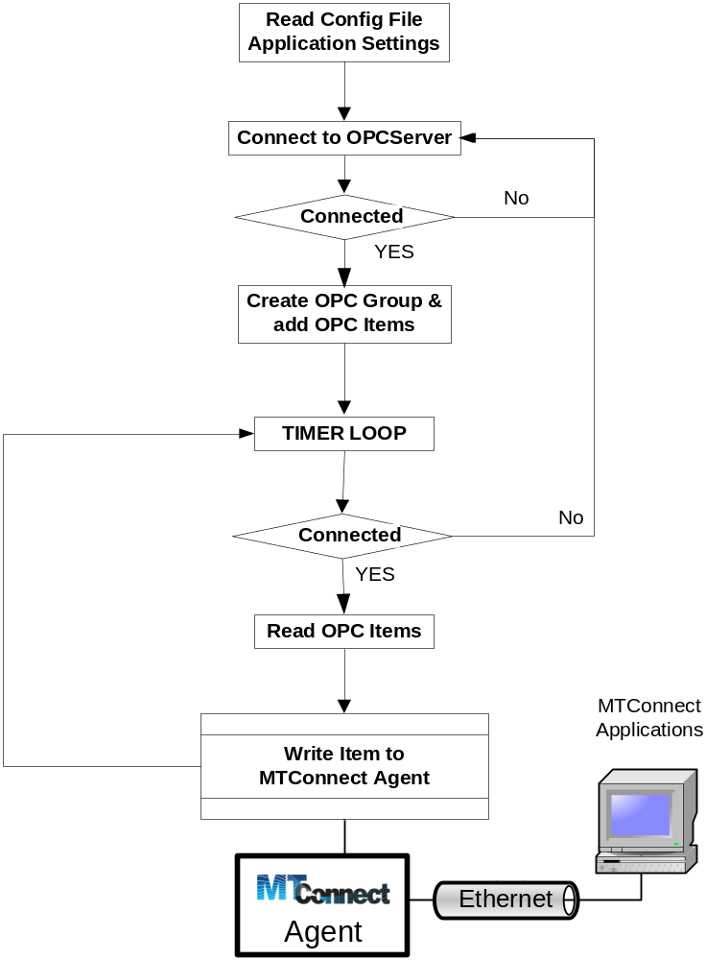
Figure 8 OPC Client Adapter Process

OPC Server Connect
First, the OPC client will attempt to establish a communication link with the OPC server. This step will repeat as often and as long as is specified by CONFIG file parameters – AutoConnect, and ServerRetryPeriod. The AutoConnect parameter determines whether automatically attempting to connect to the OPC server is done. DO NOT CHANGE THIS. If not auto connection then the push button must be used, which is not visible in the service. The QueryServerPeriod parameter determines how long to wait (in milliseconds) before attempting the next connection.

<add key="AutoConnect" value="true" /> DO NOT CHANGE!!
<add key="ServerRetryPeriod" value="5000" />

The CLSID tag describes Microsoft’s Component Object Model (COM) GUID (Globally Unique Identifier) of the OPC server. It is hard coded as a Class ID (CLSID) and not a Program ID, because if you are trying to activate a remote OPC server and the Program ID is not registered in the local registry, the remote COM creation may fail. THIS VALUE WILL NOT BE CHANGED AND WORKS FOR ALL Siemens OPC Servers. Documentation is for user clarification only.

<add key="PROGID" value="OPC.SINUMERIK.Machineswitch" />
<add key="OpcServerClsid" value="75d00afe-dda5-11d1-b944-9e614d000000" />

OPC Group and Item Subscription
OPCDA control device objects and interfaces are called OPC Servers. Applications, called OPC Clients, can connect to OPC Servers provided by one or more vendors. Once the OPC Server connection has been established, an OPC group is created and tags are added for data monitoring.

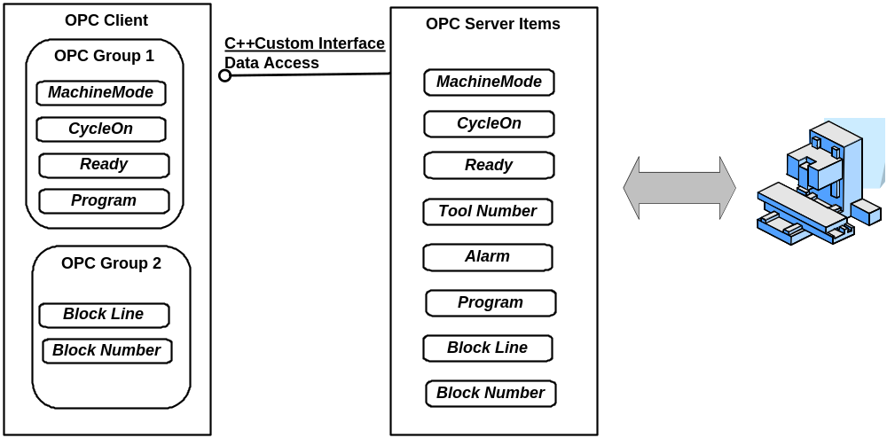
Figure 9 OPC System Architecture

Figure 9 shows the functionality of the OPC DA specification within a CNC Architecture, which includes the following concepts:

- OPC Server is a COM object to which the OPC client first connects. The OPC Server handles connectivity to automation hardware. Its responsibility is to manage OPC groups, translate errors, provide server status, and allow browsing of OPC items.

- OPC Group is a COM object for logically organizing data items. OPC clients can pick and choose among the known OPC items on the OPC server in order to create groups. OPC Groups are managed by the OPC client who can activate or deactivate the group, change the group name or update rate among and subscribe for data change event notification. Reading and writing of OPC data is done through the OPC Group.

- OPC Item is a single tag (or automation device data point) managed by the OPC server. OPC does not define any application item tag names, e.g., AxisLocation. Instead, OPC clients rely on the vendor to allow clients to browse for OPC data items, or provide a list of OPC data items.

Figure 9 OPC System ArchitectureFigure 9 shows OPC data management for a simple CNC OPC Server example. The OPC Client creates 2 OPC Groups, Group 1 containing the MachineMode, CycleOn, Ready and Program OPC Items, while Group 2 contains the BlockLine and BlockNumber OPC Items. Group 1 and 2 could run at different update rates if the data timeliness is an issue. To improve performance, if the CNC is in Manual mode, the Group 2 items BlockLine and BlockNumber could be deactivated. Note, only one OPC group and a set of tags are possible with the current setup.
 Note, the OPC client only allows one OPC Group with a set of items.

Under an OPC Server section in the INI file, is a mapping of MT Connect tags into an equivalent OPC Server tag. Because MT Connect has two forms of tags – Sample and Event, the general form of the tag definition is
<add key="Tag.{Enum|Const}.[Sample|Event]" value="OPCTag” />
{X|Y} means optionally X or Y and where [X |Y] means one of X or Y. For example, Tag.Sample.Srpm specifies that the Spindle tag is a Sample, whose MT Connect name is “Srpm” and whose OPC tag is /Channel/Spindle/actSpeed[1] as defined below.

<add key="Tag.Sample.Srpm" value="/Channel/Spindle/actSpeed[1]" />

There is no enum involved in the Srpm. In the case of machine mode, the tag uses an Enum to specify this and Enum tags are associated with various mode values.
<add key="Tag.Enum.Event.controllermode" value="/Bag/State/opMode" />
Shown below enumeration strings are assigned to tag mode in the INI file using the mode MT Connect terminology mapping OPC server values (0,1,2).
<add key="Enum.controllermode.0" value="MANUAL" />
<add key="Enum.controllermode.1" value="MANUAL_DATA_ENTRY" />
<add key="Enum.controllermode.2" value="AUTOMATIC" />

OPC Config File Parameters

<appSettings>
<add key="OPCMachine" value="xxx.xxx.xxx.xx" /> | Sets IP address of CNC
<add key="User" value="" /> | If DCOM identity user authorization is needed. If blank, user authorization is ignored.
<add key="Password" value="" /> | If DCOM identity password authorization is needed
<!--> Service Manager Parameters </!-->
<add key="ServiceName" value="MTCService4OPC" /> | IGNORE Embedded service mgt utilities.
<add key="ServiceType" value="Auto" /> | IGNORE Embedded service mgt utilities.
<add key="ServiceUser" value=".\michalos" /> | IGNORE Embedded service mgt utilities.
<add key="ServicePassword" value=" " /> | IGNORE Embedded service mgt utilities.
<!--> Reset Service Parameters </!--> | RESETS SERVICE AT MIDNITE
<add key="ResetPeriod" value="60" /> | How long to wait before resetting in seconds.
<add key="ResetTime" value="1" />
<add key="ResetCycleWait" value="20000" />
<add key="ResetFlag" value="true" /> | Flag to RESET SERVICE AT MIDNITE – LEAVE TRUE.
<!--> OPC Parameters </!-->
<add key="opcflag" value="true" /> | DO OPC Client Adapter polling.
<add key="Domain" value="" /> | IGNORE.
<add key="ServerUpdatePeriod" value="1000" /> | Time to wait between OPC client polls.
<add key="OPCServer" value="OPC.SINUMERIK.Machineswitch" /> | Name of OPC Server. (For diagnostic purpose only.)
<add key="OpcServerClsid" value="75d00afe-dda5-11d1-b944-9e614d000000" /> | CLSID of OPC Server. DO NOT CHANGE. It matches the PROGID of above.
<add key="AutoConnect" value="true" /> | Legacy parameter. Automatically connect on startup.
<add key="ServerRetryPeriod" value="5000" /> | Time to wait between OPC Server connect operations, in milliseconds.
<add key="ProcessPriority" value="64" /> | Windows process priority at which to run MTConnect agent. Currently lower priority.
<add key="Synchronous" value="True" /> | Synchronous flag, true means poll OPC Server data. NOTE because of DCOM issues flag equal “False” is not support as asychronous is DCOM onerous.
<add key="LocaleID" value="1033" /> | IGNORE.
<!--> MT Connect Parameters </!-->
<add key="MTConnectURL" value="127.0.0.1" /> | URL of MTConnect agent.
<add key="MTConnectPort" value="80" /> | Port at which MTConnect agent listens. Note if you change, you break MTConnect Agent convention, but may be required if existing Web Server is running on PC.
<add key="MTDevice" value="Mazak1" /> | Name of MTCOnnect device, matching name in the file Devices.xml. The NAME must exist in file or service aborts.
<!--> Application Parameters </!-->
<add key="Debug" value="0" /> | If not zero, levels of debug information is logged to file debug.txt located in the exeuction folder.
<add key="RestartLogAppend" value="true" /> | If flag is true, resets debug.txt file each time the service is restarted. Otherwise appends messages to end of existing debug.txt file.

FAQ


How do I send a Request to the Core Agent?
- On the FEPC enter a valid MTConnect request in your browser.
- Examples include:
  - http://127.0.0.1/probe
  - http://127.0.0.1/current
- For a complete overview of MTConnect requests, please see the MTConnect 0.9 standard.

How do I configure the MT Connect Agent?
When the Agent starts, it reads the devices.xml file and configures itself based upon the contents of the file. To configure the agent:
- Stop the Agent through the GUI.
- Edit the Devices.xml file that is located in the same directory as the executable file. Please note that the Devices.xml file must adhere to the MTConnectDevices.xsd schema.
- Start the Agent.

How can I view all the data stored by the Agent?
- Use the http debug request.
- An example: http://127.0.0.1/debug.

How can I see what version of the Agent is running?
- Use the http version request.
- An example: http://127.0.0.1/version.

Is Source Code available?
- Yes. Recently the Mazak version was pared down from the Ga Tech SDK to simplify DLL management. The OPC version is emebedded in the Ga Tech highly modified SDK code.

For the Mazak: ftp://ftp.isd.mel.nist.gov/pub/MTConnect/MTConnectAgentSource.zip
For the OPC: ftp://ftp.isd.mel.nist.gov/pub/MTConnect/GaTechSDKSrc.zip

How do I upgrade the MTConnect Agent service?
- Stop the service. Upgrade the Exe, and the Restart the Service.

Comments or Questions

Please contact:

John Michaloski
Intelligent Systems Division
National Institute of Standards and Technology
John.Michaloski@nist.gov
+1 301-975-3458

