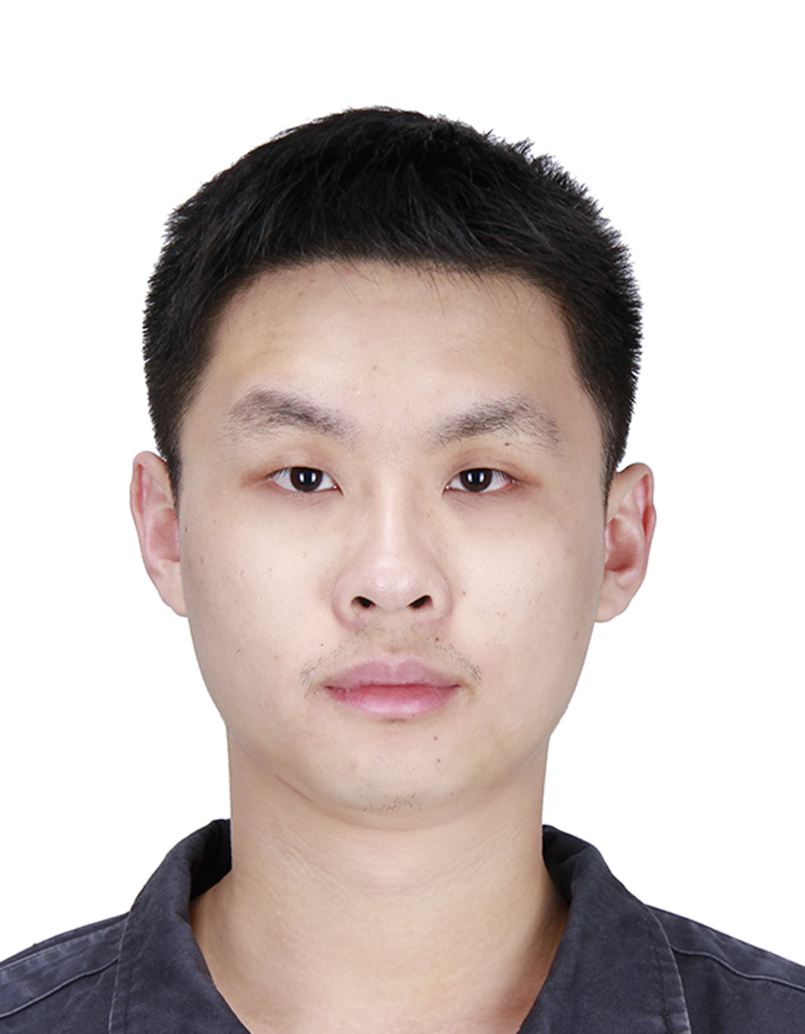**Yihan Lin**

|  |  |  |
| --- | --- | --- |
| (+86)188-0130-2019 | linyh20@mails.tsinghua.edu.cn |  |
|  | WeChat ID: ordinarabbit | Personal Page: lyh983012.github.io |

**Education Experience**

|  |  |  |
| --- | --- | --- |
| 9/2020~ | Ph.D. Candidate  Center for Brain-Inspired Computing Research  Department of Precision Instrument | **Tsinghua University** |
| 9/2016~7/2020 | Undergraduate student (B.S. degree) | **GPA: 3.85/4**  Major in Instruments Science and Technology  Department of Precision Instrument **Rank: 2/62** | **Tsinghua University** |
| 9/2018~7/2020 | Minor Degree in CS | **GPA: 3.91/4**  Department of Computer Science and Technology | **Tsinghua University** |

**Research Interests**

|  |  |  |
| --- | --- | --- |
|  | * Brain-inspired Learning Algorithms |  |
|  | * Neuromorphic Vision Sensor |  |
|  | * Low-level Computer Vision |  |

**Publications**

|  |  |
| --- | --- |
| 1. Yang Z†, Wang T†, **Lin Y**†, et al, and Luping Shi, A Vision Sensor Chip with Complementary Pathways for Open-world Sensing, ***Nature***, March 2024, Accepted. (IF: 64.8, Q1, Cover) 2. **Lin Y**, et al. "Rethinking Pretraining as a Bridge From ANNs to SNNs." ***IEEE Transactions on Neural Networks and Learning Systems,*** Early Access***,*** 2022. (IF: 10.4, Q1) 3. **Lin Y**†, Sun J†, et al., “Spatiotemporal Input Control: Leveraging Temporal Variation in Network Dynamics,” in***IEEE/CAA Journal of Automatica Sinica***, vol. 9, no. 4, pp. 635-651, April 2022. (IF: 11.8, Q1) 4. **Lin Y**, Ding W, Qiang S, et al. ES-ImageNet: A Million Event-Stream Classification Dataset for Spiking Neural Networks. ***Frontiers in Neuroscience***, 2021: 1546. (IF: 4.3 Q2) 5. Wu Z, Zhang H, **Lin Y**. et al. LIAF-Net: Leaky Integrate and Analog Fire Network for Lightweight and Efficient Spatiotemporal Information Processing. 2021, ***IEEE Transactions on Neural Networks and Learning Systems,*** PP(99):1-14. (IF: 10.4, Q1) | |
| **Work Experience** | |
| 8/2021~now | Intern ISP engineer in Lynxi co., Beijing. |
| 7/2018~now | Research Assistant of CBICR in THU. |
| 6/2023~8/2023 | Intern computer vision algorithm engineer in Yealink Co., Xiamen. |
| 9/2020~2/2021 | Teaching Assistant for the class *Computer principle and Application.* |
| 7/2019~9/2019 | Research Assistant of IoF laboratory in NTU. |

**Social Activities**

|  |  |
| --- | --- |
| 9/2019~6/2020 | Chairman of Student Association for science and technology of DPI, Tsinghua University |
| 9/2018~6/2019 | Vice Chairman of Student Association for science and technology of DPI, Tsinghua University. |
| 1/2018~2/2018 | Team leader of 'Coal to Gas' research team in Wangdu, Hebei Province, P. R. China |
| 9/2017~6/2018 | Director of the office of Fujian Cultural Exchange Association of Tsinghua University. |
| 1/2018~2/2018 | Team leader of research team of targeted poverty alleviation in Ninghua, Fujian Province, P. R, China. |

**Honors & Awards**

|  |  |
| --- | --- |
| 10/2023 | Scholarship for Excellence in Social Activitiy, THU |
| 10/2023 | Comprehensive first-class scholarship for PhD studentss, THU |
| 10/2022 | Comprehensive first-class scholarship for PhD Candidates, THU |
| 10/2021 | Comprehensive second-class scholarship for PhD students, THU |
| 6/2020 | Scholarship for future scholars **(Top 3%),** THU |
| 6/2020 | Outstanding graduates of Beijing |
| 6/2020 | Outstanding graduates of Tsinghua University **(Top 2%),** THU |
| 6/2020 | Outstanding contribution award for graduates of Department of Precision Instrument**,** THU |
| 10/2019 | Scholarship for Excellent Student work **,** THU |
| 10/2019 | XCMG scholarship **(Top 1%),** THU |
| 10/2019 | Scholarship for Comprehensive Excellence **,** THU |
| 12/2018 | Second prize of HuaLuoGeng cup mathematical modeling contest of Tsinghua University |
| 10/2018 | Science and Technology Innovation Excellence Award**,** THU |
| 10/2018 | National scholarship **(Top 2%)** |
| 07/2018 | Second prize of the 34th national optoelectronic Design Competition |
| 10/2017 | Scholarship for Social practice Excellence **,** THU |
| 10/2017 | Scholarship for Volunteer public welfare Excellence **,** THU |
| 10/2017 | Scholarship for Comprehensive Excellence **,** THU |

**Certificates and Skills**

|  |  |
| --- | --- |
| **Language** | English (CET4/CET6) |
| **Computer** | Python and Deep Learning Frameworks (Pytorch, SpikingJelly, For data science)  Java, C/C++ (For software engineering, testing)  Maintenance and network safety on Ubuntu Server operation system |