1. **Goal：**test the capability of pix2pixHD on face generation from hand-drawn sketches
2. Method
   1. Compare the results of Model2 and Model3 to see the effects of SLRN
   2. Compare the results of Model3 and Model8 to see whether the effects is caused by SLRN
   3. Compare the results of Model7 and Model2 to see the effects of data augmentation to solve global alignment
   4. To test the performance of model trained on celebAmask in drawingboard
3. **Settings：**
   1. Model: Image resolution: 512x512.

|  |  |  |  |  |  |  |  |  |  |
| --- | --- | --- | --- | --- | --- | --- | --- | --- | --- |
|  | Dataset | | Generator | | Data augmentation | | Norm | | |
|  | Contour | Mask-edge | Global Generator | Full  Model | rotation | translation | IN | SLRN  (down sample)  +IN | Remove norm of down sample |
| Model0 | √ |  | √ |  | √ | √ | √  (remove first two IN) |  |  |
| Model2 | √ |  | √ |  | √ | √ | √ |  |  |
| Model3 | √ |  | √ |  | √ | √ |  | √ |  |
| Model5 |  | √ | √ |  | √ | √ |  | √ |  |
| Model6  (baseline) |  | √ | √ |  |  |  | √ |  |  |
| Model7  (baseline) | √ |  | √ |  |  |  | √ |  |  |
| Model8 | √ |  | √ |  | √ | √ |  |  | √ |
| Model9 |  | √ | √ |  | √ | √ | √ |  |  |
| Model10 | √ |  | √ |  | √ | √ |  | √  (use SLRN to replace first two  IN) |  |

* 1. Dataset:

Generate contours by extracting 68 face landmarks from photos. The line width for rendering contours are 2 pixels.

* 1. Training dataset:
     1. Numbers :14973
     2. Data augmentation: rotation (-7degree ~ +7degree)and translation(-25pix ~ +25pix)
  2. Hand-drawn sketches by our web interface

1. Algorithm
   1. Spatial Local Response Normalization



1. **Results：** 
   1. When sketches are not aligned, the model fails.

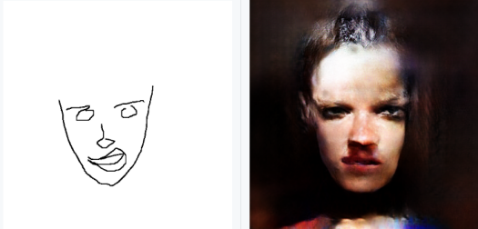 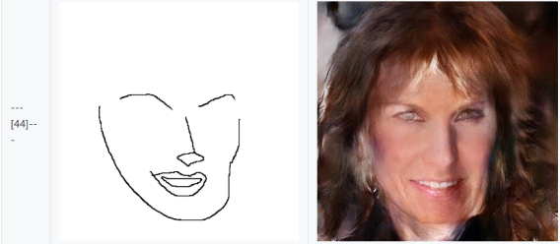

* 1. When contours are globally aligned, good results.

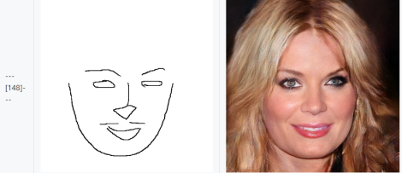 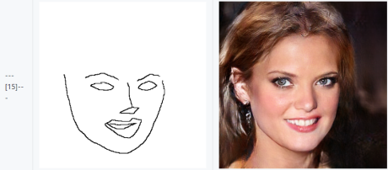

* 1. When contours contain details that are not appear in the training dataset, some are good, some are bad.

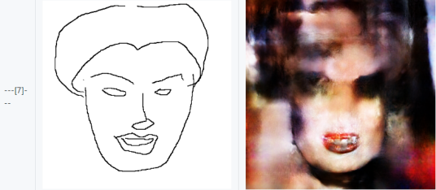 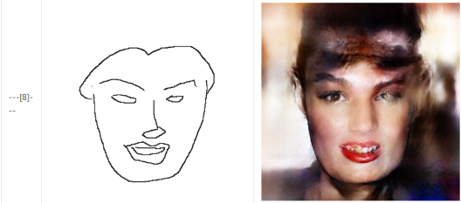

* + - 1. Noticeable degradation in quality caused by adding hair strokes, which are most blank region in training examples.

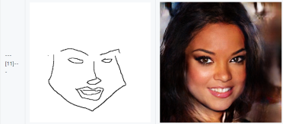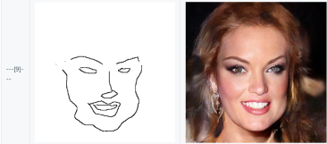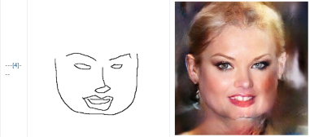

(2) Little effect on the results with imperfet cheek shape. This is mainly because the distribution of cheek strokes covers a wide range. If the drawn strokes locate in this range, the model is able to produce visually good results.

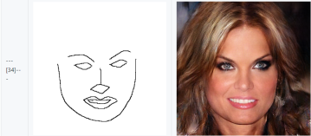 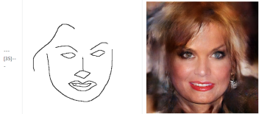 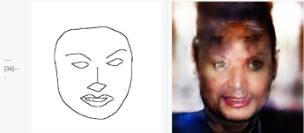

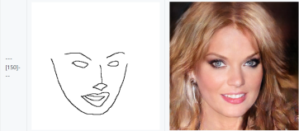 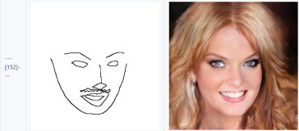 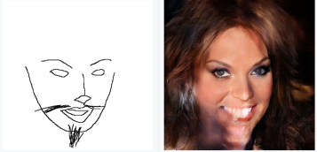

(3) starting from a good contour image, adding different strokes leads to different results. I think the quality depends on the region where the strokes are added.

d）When change part shapes locally, the results are not bad.

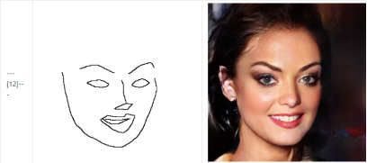 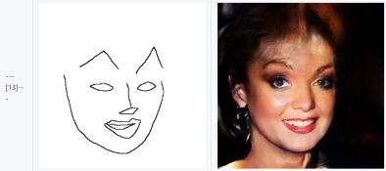 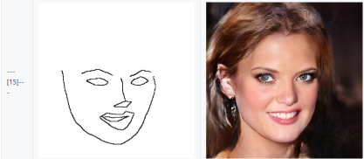

1. **Conclusion**
   1. The instance normalization plays a critical role in the quality. Propose new normalization term.
   2. While contours do not contain sufficient details, change the training data to mask-sketch that contains enough details such as hair, decoration and so on.