Sketch2Face Generation

In this experiment, we conduct an experiment to test sketch-based face generation from sketches using the sketches generated by facial masks.

# Model

* Pix2pixHD with global generator

# Dataset

## Mask edge

* + Training number:~15000
  + Augmentation: none
  + One-pixel edge

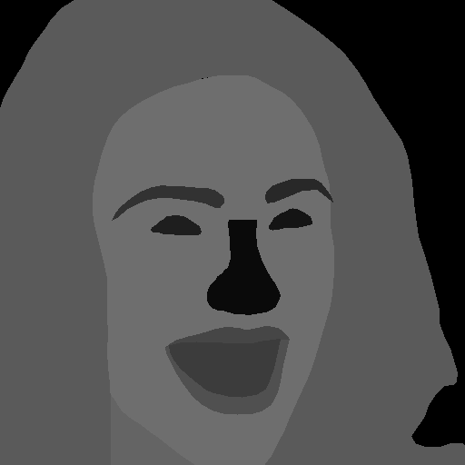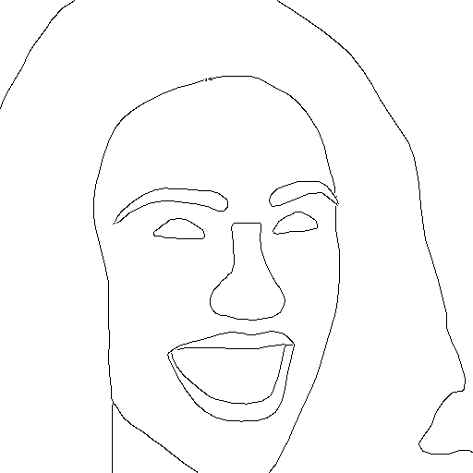

## Hand-drawn sketch

* Lines are smooth, due to being drawn by drawing board
* Paired with real face images
* Complete face structures
* Different levels of details
* ~50 sketches only – few-shot

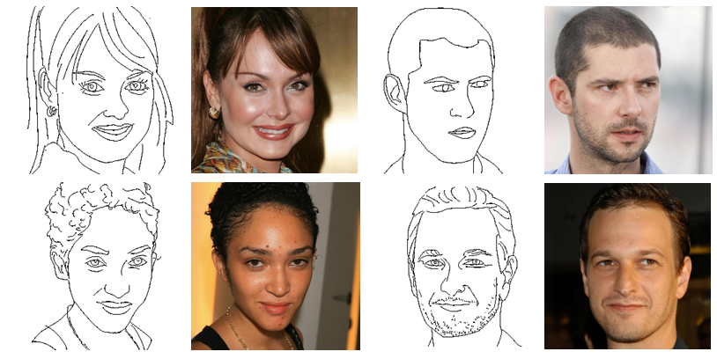

# Results

## Training data

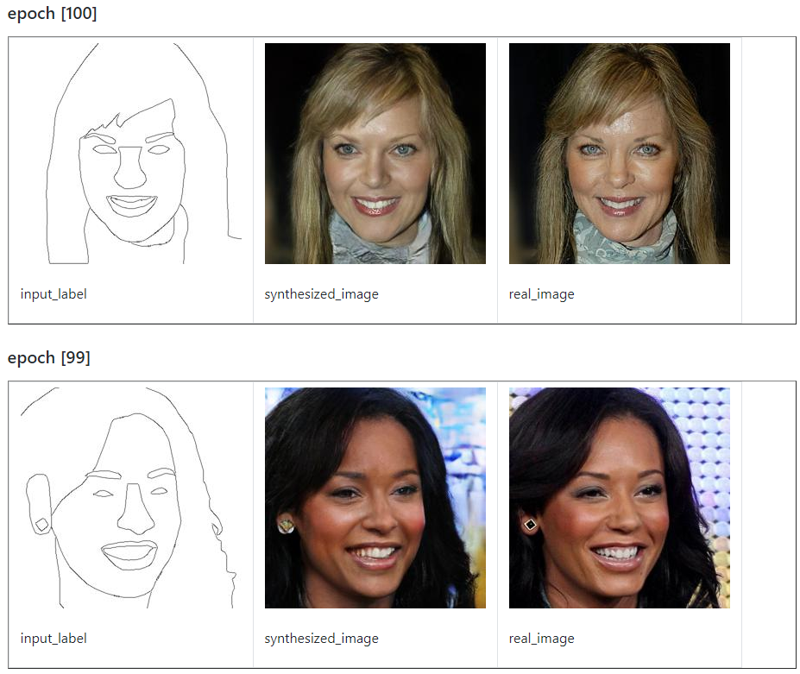

## Test data

* Mask edge

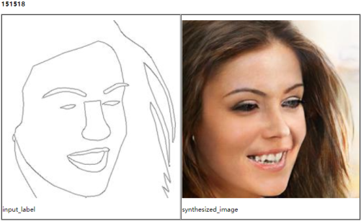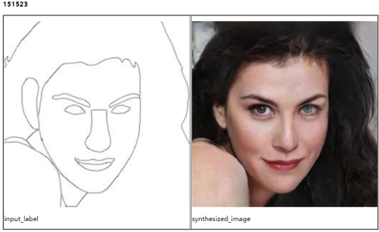

* Hand-drawn sketches

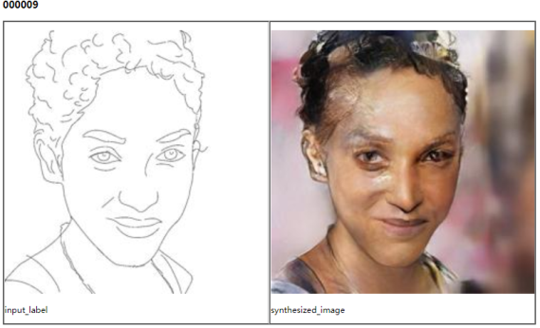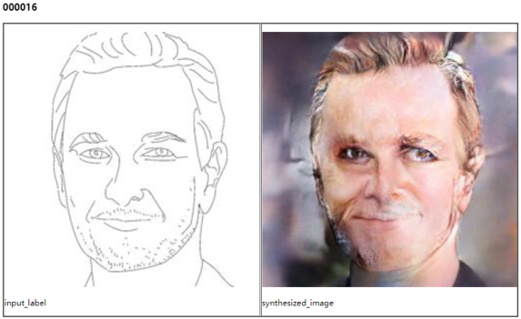

# Discussion

This model can generate good results for synthesized sketches. But it fails to generate good results for hand-drawn sketches. There might be two reasons

1. Is the hand-drawn sketch globally aligned? If not, could you please manually transform it to a globally aligned shape and test the results?

This problem is supposed to be solved by adding random rotations and translations, which are/will be added to every training and to-train model, to the training data. So, it is unnecessary to manually transform the test hand-drawn examples.

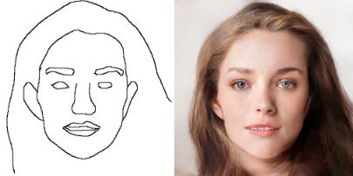

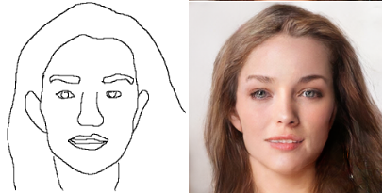

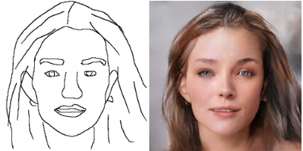

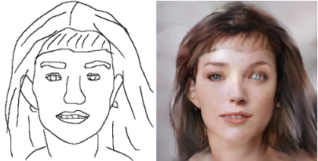

1. The hand-drawn sketch style is different from synthesized sketches since there are many details. Could you please simplify the hand-drawn sketches with different level of details?

Experiment 1:

Test the model by an example from test set, and then progressively adding to the example sketch,

Experiment 2

Test the model by a hand-drawn sketch and then progressively adding to the example sketch,

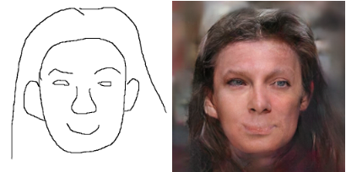

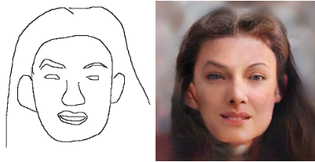

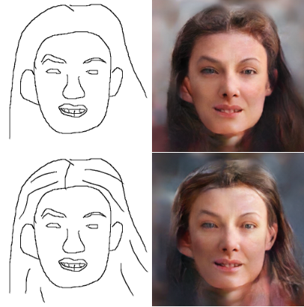

Experiment 3

Same setting as Experiment 2, but another initial sketch.

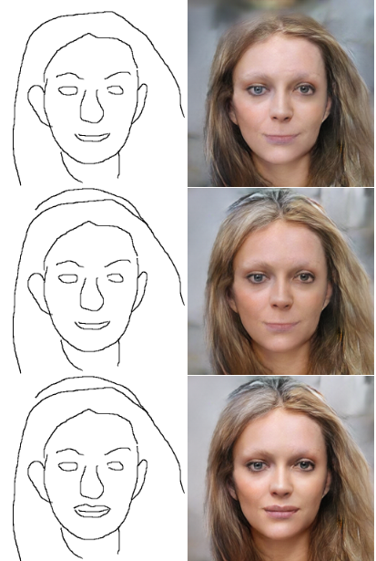

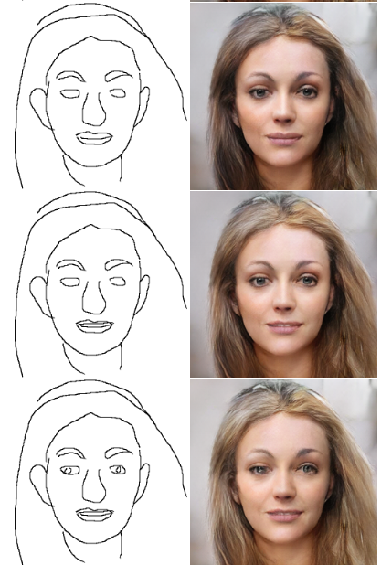

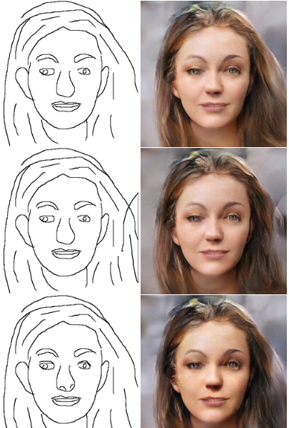

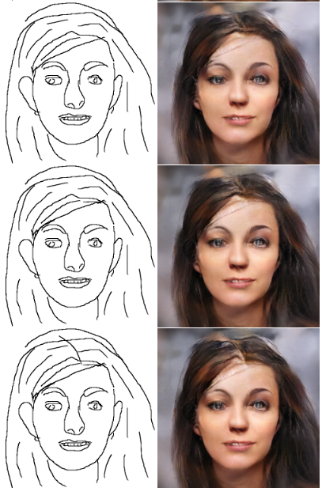

See https://github.com/lyhangustc/FaceProject/tree/master/results/pix2pixHD/mask_edge2photo/facesketcher for more results.

# Conclusion

* Experiment1:

The model can generate a good result from a sketch of test set. But the results get worse as more details are added to the sketch. The model is not able to handle sketches with different levels of details.

* Experiment 2/3:

The model cannot generate good enough results from hand-drawn sketches. As the more and more details added, the best appears to be the sketch with similar level of details as the training data (with red square). This is another aspect to reveal the conclusion that the model is not able to handle sketches with different levels of details.