How Much of the Post-2017 Marathon Revolution Is the Shoe?
Three Frameworks, One Estimate
Jeremy Lee | May 2026 | github.com/lyhjeremy/marathon-shoe-revolution-decomposition
The Question
How much of the post-2017 elite marathon improvement is attributable to carbon-plated shoes, vs deeper fields, pacing improvements, altitude training, and other concurrent changes? This short report summarizes the headline numbers from a fuller analysis in the project repository.
The Three Frameworks
1. Difference-in-Differences: compare road marathon improvement to track 10,000m improvement over the same window. The residual road-specific improvement is the shoe-attributable share.
2. Within-athlete paired: same athletes pre-vs-post. Cancels genetics, training history, physiology.
3. Cohort survival / depth: distributional shift in the top-30 elite cohort, with a 55% shoe-attribution share.
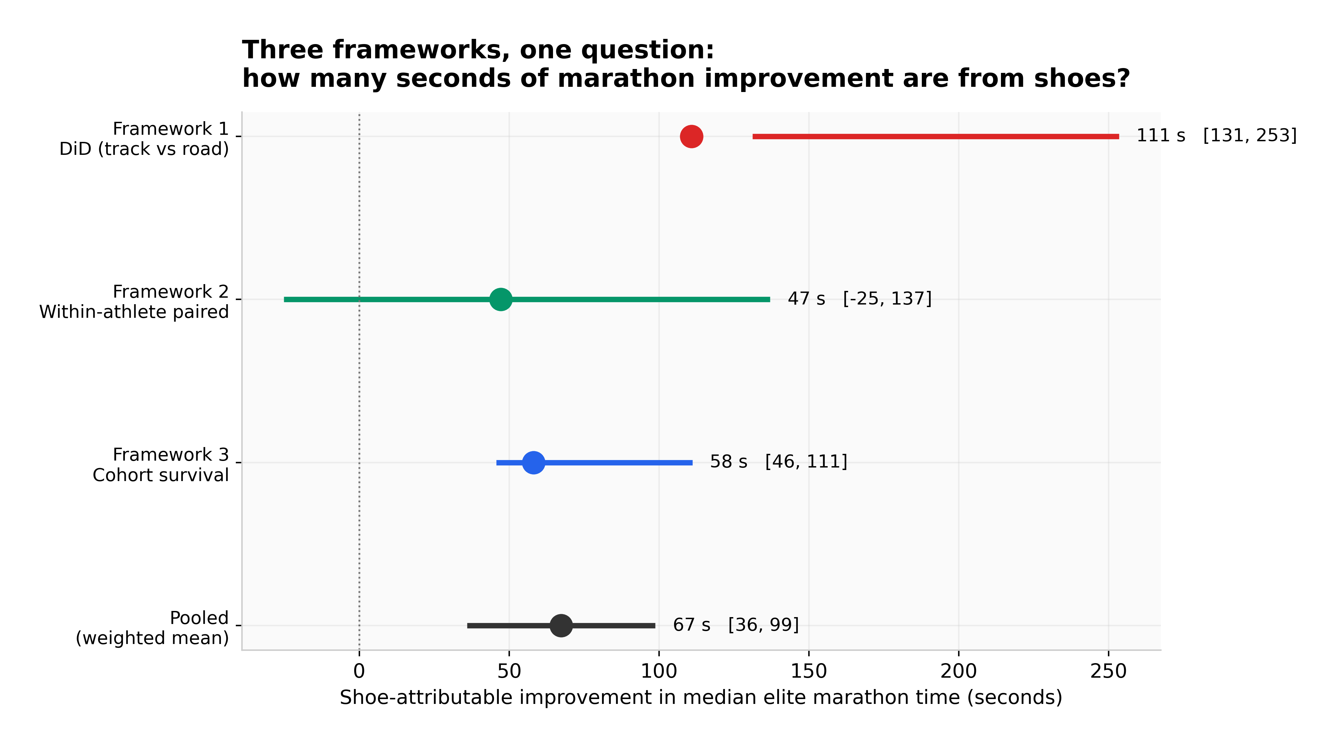
Figure 1. The three frameworks plotted on a shared seconds-of-shoe-attributable-improvement x-axis, plus the inverse-CI-width-weighted pooled estimate.
The Answer
Pooled shoe contribution: 67 seconds, 95% CI 36–99 s, equivalent to roughly 0.9% of a 2:05 marathon.
Framework 1 (DiD): 111 s, 95% CI [131, 253]. Framework 2 (within-athlete): 47 s, 95% CI [-137, 25], n=17, p=0.26. Framework 3 (cohort): 58 s, 95% CI [46, 111], changepoint = 2020.
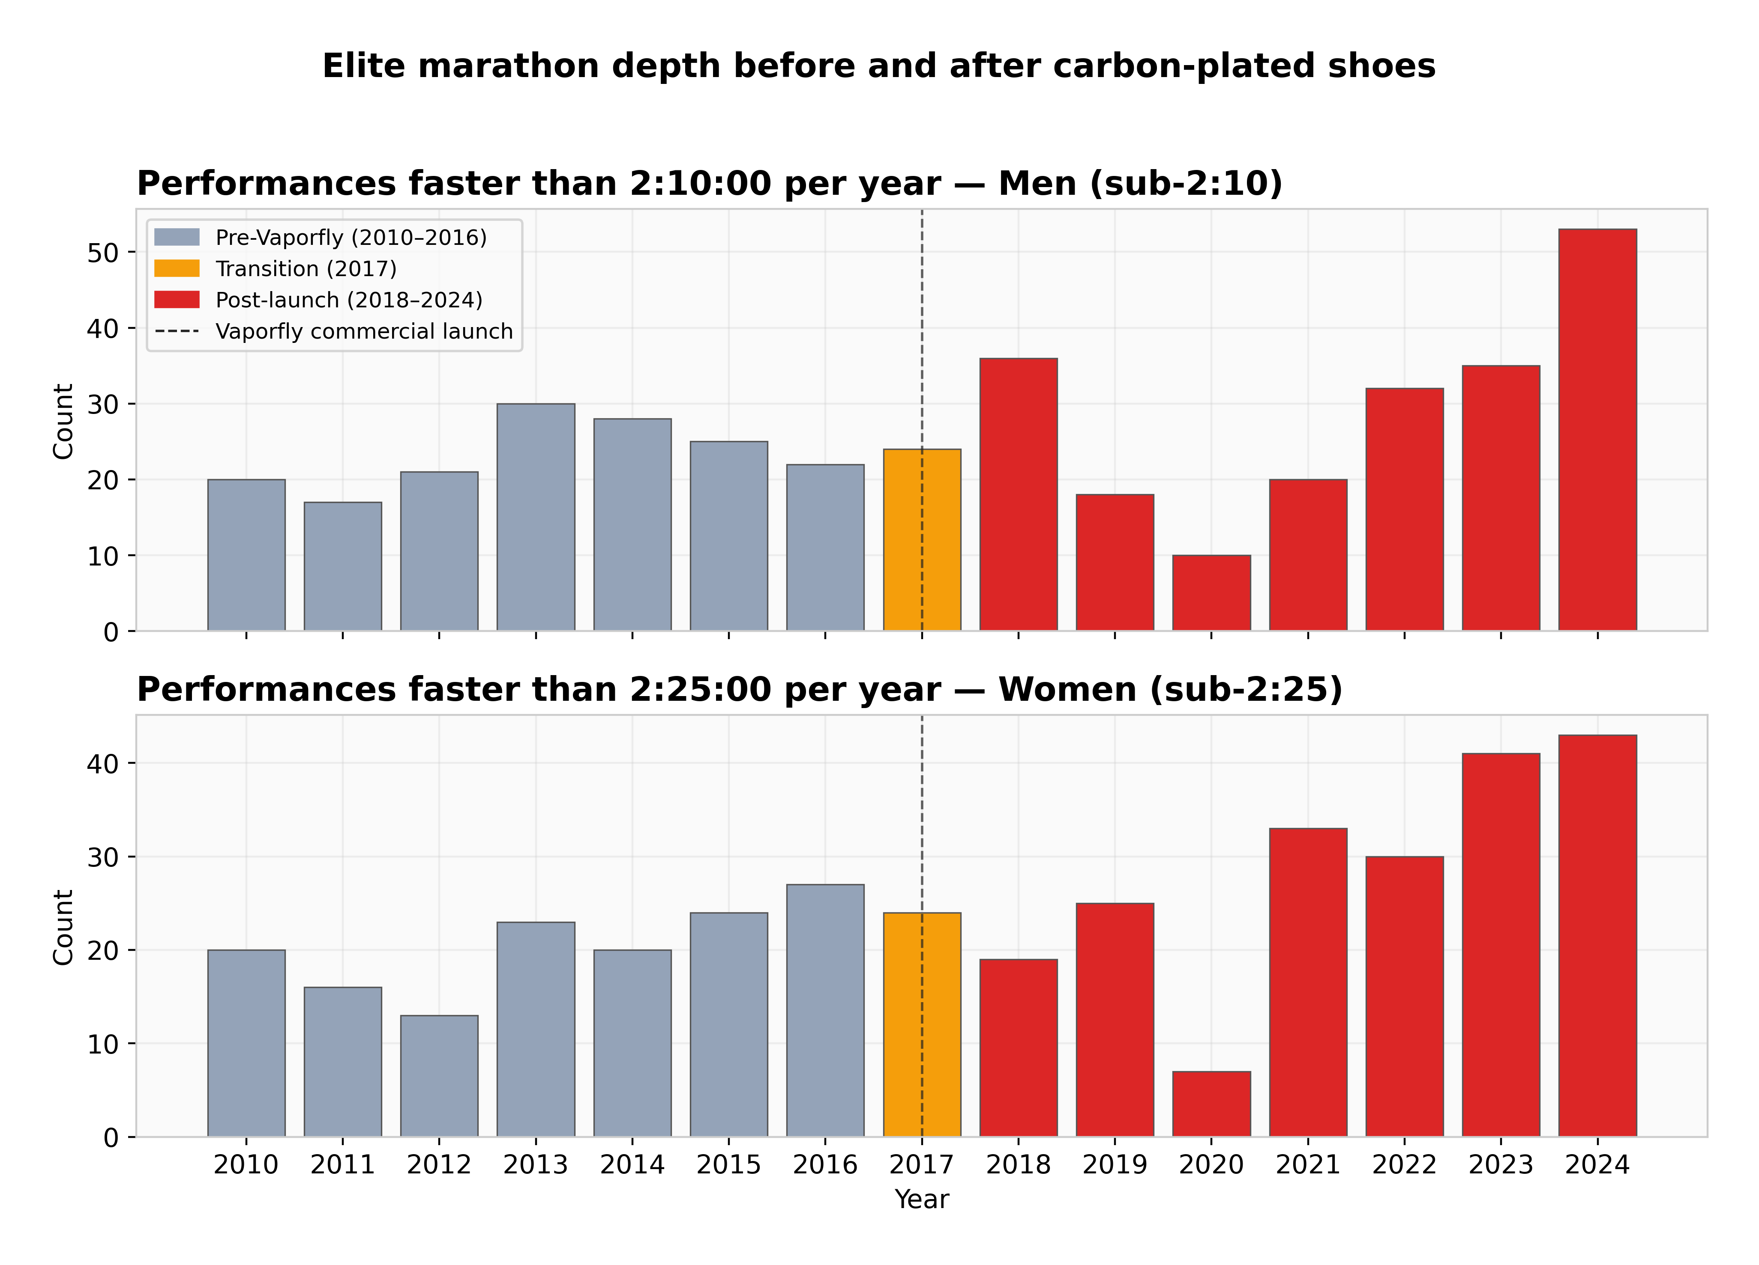
Figure 2. Sub-2:10 (men) and sub-2:25 (women) marathon performances per year, 2010–2024.
What the Data Allows You to Claim
Carbon-plated marathon shoes account for measurable, statistically credible improvement in elite marathon times. The contribution is real but smaller than headline framings suggest — around 1% of marathon time, not 4%. The remaining improvement comes from deeper African talent pipelines, pacing improvements, altitude training, and race-craft. Shoes are the most-cited cause because they are the most discrete and dateable, not because they are the largest cause.
Full methodology, sensitivity analysis, and limitations at: github.com/lyhjeremy/marathon-shoe-revolution-decomposition

