

**Version 10.0**

**Java SE 8 Programmer II**

**1z0-809**

File Version: 10.0

Time Limit: 120 min

Passing Score: 800

Number: 1z0-809

**1z0-809.examcollection.premium.exam.207q**

.

IntFunction<Integer> inFu= x -> y -> x*y;

IntStream stream = IntStream.of (1,2,3);

Given:

**QUESTION 2**

**Reference:**

**Explanation/**

**Explanation**

**Section: (none)**

**Correct Answer:** A

IntStream newStream = stream.map(inFu.apply(10));

n3

line

A compilation error occurs at

D.

.

n2

line

A compilation error occurs at

C.

IntFunction<UnaryOperator> inFu = x -> y -> x*y;

BiFunction<IntUnaryOperator> inFu = x -> y -> x*y;

with:

line n1

C. Replace

IntFunction<IntUnaryOperator> inFu = x -> y -> x*y;

with:

line n1

B. Replace

.

with:

line n1

A. Replace

Which modification enables the code fragment to compile?

//line n2

//line n1

newStream.forEach(System.output::print);

= x;

public void speed () {

//line n1

int value = 0;

class Car {

//line n3

int timeTravel = time;

{

public void increSpeed(int time)

}

value = distance /timeTravel;

this distance

Vehicle (int x) {

distance;

{ int

Class Vehicle

Given the definition of the Vehicle class:

**QUESTION 1**

**Exam A**

and this code fragment:

n1

line

A compilation error occurs at

B.

kmph

A. Velocity with new speed 1

What is the result?

v.increSpeed(60);

Vehicle v = new Vehicle (100);

}

}

//line n3

speed();

}

}

System.out.println (“Velocity with new speed”+value+”kmph”);

//line n2

> ( );

**Section: (none)**

**Explanation**

**Explanation/**

**Reference:**

**QUESTION 4**

Given the code

fragment:

public class Foo {

public static void main (String [ ] args)

{ Map<Integer, String> unsortMap = new

HashMap< unsortMap.put (10, “z”);

unsortMap.put (5, “b”);

unsortMap.put (1, “d”);

unsortMap.put (7, “e”);

unsortMap.put (50, “j”);

**Correct Answer:** A

Map<Integer, String> treeMap = new TreeMap <Integer, String> (new

Comparator<Integer> ( )

{

@Override public int compare (Integer o1, Integer o2) {return

o2.compareTo

(o1); }

} );

treeMap.putAl

l

(unsortMap);

for (Map.Entry<Integer, String> entry : treeMap.entrySet () ) {

System.out.print (entry.getValue () + “ “);

}

}

}

.map(n -> n*2)

D. Replace

line n2

with:

IntStream newStream = stream.map(inFu.applyAsInt (10));

**Correct Answer:** B

**Section: (none)**

**Explanation**

**Explanation/**

**Reference:**

**QUESTION 3**

Given the code

fragment:

List<Integer> values = Arrays.asList (1, 2, 3);

values.stream ()

//line n1

.peek(System.out::print)

//line n2

.count();

What is the result?

A. 246

B.

The code produces no output.

C.

A compilation error occurs at

line n1.

D.

A compilation error occurs at

line n2.

{

public class Counter

Given:

**QUESTION 6**

20several%20closely%20related%20classes.&f=false

n6baAhVEhZAKHeiEDTgQ6AEIMDAB#v=onepage&q=You%20want%20to%20share%20code%20among%

&sig=uVFS0KB15BqyEgghXnnjJSUdcrE&hl=pt-BR&sa=X&ved=0ahUKEwjlsKe-

public static void main (String[ ] args) {

+share+code+among+several+closely+related+classes.&source=bl&ots=3oYOu2XXN-

5&dq=You+want+to

pg=PT235&lpg=PT23

id=nS2tBQAAQBAJ&

com.br/books?

option?

A compilation error occurs.

D.

is thrown.

AssertionError

An

C.

0

B.

A. -10

–ea

What is the result of running the code with the

}

}

System.out.println (c);

int с = a / b;

assert (b >=1) : “Invalid Denominator”;

int b = -1;

int a = 10;

**Correct Answer:** C

abstract classes?

interfaces instead of

should you use

Which two reasons

**QUESTION 5**

**Reference:**

**Explanation/**

**Explanation**

**Section: (none)**

(Choose two.)

D. z b d e j

C. j z e b d

d b e z j

B.

A compilation error occurs.

A.

What is the result?

E.

https://books.google.

Reference:

**Reference:**

**Explanation/**

**Explanation**

**Section: (none)**

**Correct Answer:** BE

You want to take advantage of multiple inheritance of type.

You want to declare non-static on non-final fields.

D.

You want to share code among several closely related classes.

C.

You expect that unrelated classes would implement your interfaces.

B.

access modifiers other than public.

You expect that classes that implement your interfaces have many common methods or fields, or require

A.

{ bird::fly();

1. abstract

Given:

**QUESTION 8**

**Reference:**

**Explanation/**

**Explanation**

**Section: (none)**

**Correct Answer:** C

}

class Shape

D. static void fly (Supplier<? extends Bird> bird)

}

{ bird.get( ) fly ();

C. static void fly (Supplier<Bird> bird)

}

{ bird.accept( ) fly ();

B. static void fly (Consumer<? extends Bird> bird)

}

{ bird :: fly ();

3.

Square int side {

int side;

8.

7.

{

6. class Square extends Shape

5.

}

4. }

A. static void fly (Consumer<Bird> bird)

2.

(“Shape”);

protected void area ( ) { System.out.println

}

(“Shape”);

{ System.out.println

Shape ( )

{

{

{

}

n fly”); }

.print(“Ca

System.out

{

()

void fly

public

System.out.print(“Cannot fly”); }

class Bird

Given:

**QUESTION 7**

**Reference:**

**Explanation/**

**Explanation**

**Section: (none)**

**Correct Answer:** C

fly( ( ) -> new Bird ( ));

class to compile?

Birdie

, enables the

line n1

Which code fragment, when inserted at

}

/* line n1 */

}

fly (Penguin : : new);

{

public static void main (String [ ] args)

class Birdie {

and the code fragment:

}

{

public void fly ()

class Penguin extends Bird

**QUESTION 9**

this. lstIndex = end;

this stIndex = start;

this.data = data;

{

public Sum (int [ ]data, int start, int end)

int [ ] data;

= 3; int stIndex, lstIndex;

{ static final int THRESHOLD_SIZE

class Sum extends RecursiveAction

Given:

}

**Reference:**

**Explanation/**

**Explanation**

**Section: (none)**

**Correct Answer:** DF

public void area ( ) {

At line 20, use

F.

super (); super.side = x;

} else {

and the code fragment:

}

}

}

).compute ();

THRESHOLD_SIZE)

(lstIndex, stIndex +

Math.min

new Sum (data, stIndex,

new Sum (data, stIndex + THRESHOLD_SIZE, lstIndex).fork( );

At line 17, insert

System.out.println(sum);

}

{ sum += data [i];

for (int i = stIndex; i < lstIndex; i++)

{

THRESHOLD_SIZE)

if (lstIndex – stIndex <=

{ int sum = 0;

protected void compute ( )

//line n1

}

{

Rectangle (int x, int y)

int len, br;

18.

17.

16.

15.

14. class Rectangle extends Square {

}

13.

/* insert code here */

(“Square”);

public void area ( ) { System.out.println

12.

11.

10.

9.

}

this.side = side;

/* insert code here */

abstract

E.

super (x);

At line 17, insert

D.

public

At line 12, remove

C.

super ( );

At line 9, insert

B.

At line 1, remove

A.

Which two modifications enable the code to compile? (Choose two.)

}

(“Rectangle”);

21. }

20. void area ( ) { System.out.println

}

19.

len = x, br = y;

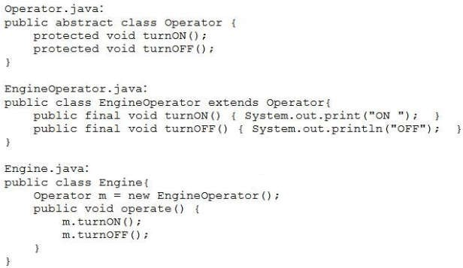

What is the result?

**QUESTION 10**

Given the

content of

Operator.jav

a,

EngineOperat

or.java,

and

Engine.java

files:

and the code fragment:

**Reference:**

A.

The

Engine.java

file fails to compile.

B.

The

EngineOperator.java

file fails to compile.

C.

ForkJoinPool fjPool = new ForkJoinPool ( );

int data [ ] = {1, 2, 3, 4, 5, 6, 7, 8, 9, 10}

fjPool.invoke (new Sum (data, 0,

data.length));

and given that the sum of all integers from 1 to 10 is 55.

Which statement is true?

A.

The program prints several values that total 55.

B.

The program prints 55.

A compilation error occurs at

line n1

.

D.

The program prints nothing.

**Correct Answer:** A

**Section: (none)**

**Explanation**

**Explanation/**

courses.txt

to enable the

n1

line

inserted at

fragment can be

Which code

accessible.

is

code to print the

Assume the

// line n1

);

(“courses.txt”

Paths.get

Path file =

fragment:

Given the code

G. List<String> fc = readAllLines(file);

**Reference:**

**Explanation/**

**Explanation**

**Section: (none)**

**Correct Answer:** D

fc.forEach (s - > System.out.println(s));

H. Stream<String> fc = Files.lines (file);

fc.stream().forEach (s - > System.out.println(s));

**QUESTION 12**

fc.forEach (s - > System.out.println(s));

F. Stream<String> fc = Files.readAllLines (file);

fc.stream().forEach (s - > System.out.println(s));

E. List<String> fc = Files.list(file);

file?

courses.txt

content of the

**Section: (none)**

Arrays.asList (“1”, “John”),

Stream<List<String>> iStr= Stream.of (

fragment:

Given the code

**QUESTION 11**

**Reference:**

**Explanation/**

**Explanation**

Arrays.asList (“2”, null));

**Correct Answer:** A

ON OFF

D.

file fails to compile.

Operator.java

C. The

NullPointerException

**Reference:**

**Explanation/**

**Explanation**

**Section: (none)**

**Correct Answer:** D

A compilation error occurs.

D.

is thrown at run time.

A

C.

B. 12

A. 1John2null

What is the result?

nInSt.forEach (System.out :: print);

Stream<<String> nInSt = iStr.flatMapToInt ((x) -> x.stream ());

**Reference:**

and

6. }

Exception

if (Math.random() >-1 throw new Exception (“Try again”);

void doStuff() throws ArithmeticException, NumberFormatException,

5.

{

4.

fragments:

Given the code

**QUESTION 14**

24. try {

**Explanation/**

**Explanation**

**Section: (none)**

**Correct Answer:** A

The method throws an IOException.

D.

directory.

Projects

The method executes and does not make any changes to the

C.

System.out.println (e.getMessage()); }

Replace line 26 with:

C.

} catch (Exception | ArithmeticException | NumberFormatException e) {

Replace line 26 with:

B.

Comment the lines 28, 29 and 30.

A.

?

Try again

Which modification enables the code to print

30. }

directory only.

29.

{

28. catch (Exception e)

System.out.println (e.getMessage()); }

27.

{

e)

26. } catch (ArithmeticException | NumberFormatException | Exception

doStuff ( ):

25.

if (aFile.isDirectory ())

}

}

aFile.delete ();

if (aFile.getName ().endsWith (“.class”))

{

else

}

());

(aFile.getAbsolutePath

recDelete

{

}

{

for (File aFile : listOfFiles)

{

listOfFiles.length >0)

(dirName) .listFiles(); if (listOfFiles ! = null &&

{ File [ ] listOfFiles = new File

public void recDelete (String dirName) throws IOException

Given the code fragment:

**QUESTION 13**

A.

Projects

files of the

.class

The method deletes the

B.

directory and its subdirectories.

Projects

files in the

.class

The method deletes all the

What is the result?

method when it is invoked.

recDelete ()

to the

files and is passed as an argument

.class

contains subdirectories that contain

Projects

Assume that

}

**Section: (none)**

new Country (“Japan”, Country.Continent.ASIA), new

Country (“Italy”, Country.Continent.EUROPE),

new Country (“Germany”, Country.Continent.EUROPE));

Map<Country.Continent, List<String>> regionNames =

couList.stream ()

.collect(Collectors.groupingBy (Country ::getRegion,

Collectors.mapping(Country::getName, Collectors.toList()))));

System.out.println(regionNames);

A. {EUROPE = [Italy, Germany], ASIA = [Japan]}

B. {ASIA = [Japan], EUROPE = [Italy, Germany]}

C. {EUROPE = [Germany, Italy], ASIA = [Japan]}

D. {EUROPE = [Germany], EUROPE = [Italy], ASIA = [Japan]}

**Correct Answer:** B

List<Country> couList = Arrays.asList (

**Explanation**

**Explanation/**

**Reference:**

**QUESTION 16**

Given the code

fragment:

Map<Integer, String> books = new TreeMap<>();

books.put (1007, “A”);

books.put (1002, “C”);

books.put (1001, “B”);

books.put (1003, “B”);

System.out.println (books);

What is the result?

public class

} catch (ArithmeticException | NumberFormatException e) {

D. Replace line 27 with:

throw e;

**Correct Answer:** C

**Section: (none)**

**Explanation**

**Explanation/**

**Reference:**

**QUESTION 15**

Given the definition

of the Country

class:

country {

public enum Continent {ASIA, EUROPE}

String name;

Continent region;

public Country (String na, Continent reg)

{ name = na, region = reg;

}

public String getName () {return name;}

public Continent getRegion () {return

region;}

}

and the code fragment:

false

The program prints

B.

.

true

The program prints

A.

Which statement is true?

//line n2

(b1.equals(b2));

System.out.println

.

Programing”);

“Java

(102,

Book

new

=

b2

Book

Book b1 = new Book (101, “Java Programing”);

and the code fragment:

**Correct Answer:** A

:

s

sage.propertie

/resourses/Mes

of

Given the content

**QUESTION 18**

**Reference:**

**Explanation/**

**Explanation**

**Section: (none)**

//line n1

System.out.println (b1.equals((Object) b2));

with:

line n2

A compilation error occurs. To ensure successful compilation, replace

D.

{

boolean equals (Book obj)

with:

line n1

A compilation error occurs. To ensure successful compilation, replace

C.

= C, 1003 = B, 1007 = A}

SortedMap and

TreeMap inherits

Reference:

**Reference:**

**Explanation/**

**Explanation**

**Section: (none)**

**Correct Answer:** B

= A, 1001 = B, 1003 = B, 1002 = C}

{1007

D.

automatically sorts

{1002

C.

}

A

= B, 1002 = C, 1003 = B, 1007 =

{1001

B.

= A, 1002 = C, 1001 = B, 1003 = B}

{1007

A.

this.id = id;

}

}

return output;

}

output = true;

if (this.name.equals(b name))}

Book b = (Book) obj;

boolean output = false;

public boolean equals (Object obj) {

}

this.name = name;

{

String name)

(int id,

public Book

String name;

int id;

class Book {

Given:

**QUESTION 17**

the element's key

jdbc.propert

Use the

H.

the driver class.

method to load

ass.forName

java.lang.Cl

Use the

G.

file.

ies

DriverManage

class in a

JDBC driver

Include the

F.

JAR file.

ces folder of the

META-INF/servi

class to the

Add the driver

E.

Given the code

A. An exception is thrown at run time.

exist. What is the result?

directory does NOT

Pics

Assume that the

“:” + p1.getFileName());

“:” + p1.getName(1) +

System.out.println (p1.getNameCount() +

Path p1 = Paths.get(“/Pics/MyPic.jpeg”);

fragment:

using JDBC3.0?

**QUESTION 20**

**Reference:**

**Explanation/**

**Explanation**

**Section: (none)**

**Correct Answer:** C

the driver class.

method to load

r.getDriver

What is the result?

C.

stack trace

Exception

followed by an

B. Good day!

stack trace

Exception

followed by an

Test

A. Good day!

Good

System.out.println(prop.getProperty(“welcome3”));

System.out.println(prop.getProperty(“welcome2”, “Test”));//line n1

System.out.println(prop.getProperty(“welcome1”));

prop.load(fis);

FileInputStream fis = new FileInputStream (“/resources/Message.properties”);

Properties prop = new Properties ();

and given the code fragment:

welcome1=”Good day!”

n1

database driver by

be used to load a

Which action can

**QUESTION 19**

**Reference:**

**Explanation/**

**Explanation**

**Section: (none)**

**Correct Answer:** C

.

line

at

error occurs

compilation

A

D.

null

Test

day!

ta[x].start();

The program prints 1 1 1.

G.

The program prints 1 2 3.

F.

The program prints 1 2 3 and the order is unpredictable.

E.

Which statement is true?

}

H.

{

for (int x= 0; x < 3; x++)

Thread [] ta = {thread1, thread2, thread3};

Thread(new MyThread());

new

=

thread3

Thread

A compilation error occurs.

**Correct Answer:** A

**Section: (none)**

**Explanation**

**Explanation/**

**Reference:**

**QUESTION 22**

Given the code

fragment:

public static void main (String [ ] args) throws IOException

{ BufferedReader br = new BufferedReader (new InputStremReader

(System.in)); System.out.print (“Enter GDP: “);

//line 1

}

Which code fragment, when inserted at line 1, enables the code to read the GDP from the user?

**Explanation/**

private static AtomicInteger count = new AtomicInteger (0);

Runnable {

implements

class MyThread

fragments:

Given the code

**QUESTION 21**

**Reference:**

public void run ()

**Explanation**

**Section: (none)**

**Correct Answer:** B

D. 2:Pics: MyPic.jpeg

C. 3:.:MyPic.jpeg

B. 2:MyPic.jpeg: MyPic.jpeg

{

int x = count.incrementAndGet();

System.out.print (x+” “);

}

}

and

Thread thread1 = new Thread(new MyThread());

Thread

thread2

=

new

Thread(new

MyThread());

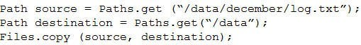

{

public String toString()

}

city;

{ this.course = course; this.name = name; this.city =

public Student (String name, String course, String city)

city;

name,

course,

String

{

class Student

Given:

**QUESTION 24**

**Reference:**

**Explanation/**

**Explanation**

**Section: (none)**

**Correct Answer:** D

Student

.forEach(src, res) -> System.out.println(scr));

e))

.collect(Collectors.groupingBy(Student::getCours

stds.stream()

“Chicago”));

ME”,

“Java

(“Mark”,

is thrown at run time.

new

new Student (“Helen”, “Java EE”, “Houston”),

new Student (“Jessy”, “Java ME”, “Chicago”),

List<Student> stds = Arrays.asList(

and the code fragment:

}

return course + “:” + name + “:” + city;

**Explanation/**

the code fragment:

not exist and given

does

/log.txt

/data/december

file

Assuming that the

**QUESTION 23**

**Reference:**

What is the result?

**Explanation**

**Section: (none)**

**Correct Answer:** A

D. int GDP = Integer.parseInt (br.next());

C. int GDP = br.nextInt();

B. int GDP = br.read();

A. int GDP = Integer.parseInt (br.readline());

file is copied to it.

NoSuchFileException

A

D.

is thrown at run time.

FileNotFoundException

A

C.

The program executes successfully and does NOT change the file system.

B.

log.txt

/data/december/

directory and the content of the

/data

is created in the

log.txt

A file with the name

A.



//line n2

line n1

A compilation error occurs at

C.

3

B.

2

A.

What is the result?

.

System.out.println(c);

.count();

.filter(cf2

.filter(cf1)

long c = strs.stream()

};

}

(“Java”);

**Reference:**

pending

--------------------------------------------

*2021-07-10 16:56:12*

***trinhduc.giang***

Given:

**QUESTION 26**

{ return s.contains

**Explanation/**

**Explanation**

**Section: (none)**

**Correct Answer:** B

.

line n2

A compilation error occurs at

D.

[Java EE: Helen:Houston]

**Reference:**

**Explanation/**

**Explanation**

**Section: (none)**

**Correct Answer:** B

A compilation error occurs.

D.

C. [Java ME: Jessy:Chicago, Java ME: Mark:Chicago]

ME

Java

B. Java EE

[Java ME: Jessy:Chicago, Java ME: Mark:Chicago]

A. [Java EE: Helen:Houston]

What is the result?

{

public boolean test (String s)

//line n1

{

Predicate cf2 = new CourseFilter()

Predicate<String> cf1 = s - > s.length() > 3;

List<String> strs = Arrays.asList(“Java”, “Java EE”, “Java ME”);

and

{

}

}

return str.equals (“Java”);

public default boolean test (String str)

interface CourseFilter extends Predicate<String>

Given the code fragments:

**QUESTION 25**

**Explanation**

QUARTER(25);

DIME (10),

NICKLE(5),

{ PENNY (1),

public enum USCurrency

Given:

**QUESTION 27**

**Reference:**

**Explanation/**

private int

**Section: (none)**

**Correct Answer:** B

(Emp::getlName).reserved

eOrder().map

**s**

er

**v**

.map(Emp::getfName).sorted(Comparator.re

{

}

}

System.out.println(usCoin.getValue()):

USCurrency.DIME;

=new

usCoin

USCurrency

D.

public static void main (String[] args)

public class Coin {

}

{return value;}

public int getValue()

}

{ this.value = value;

public USCurrency(int value)

value;

}

emp.stream()

new Emp (“Thomas”, “Wale”));

new Emp (“Peter”, “Sam”),

new Emp (“John”, “Smith”),

List<Emp> emp = Arrays.asList (

and the code fragment:

}

public String getlName() { return lName; }

public String getfName() { return fName; }

//line n1

lName = ln;

fName = fn;

{

fn, String ln)

public Emp (String

String lName;

{ String fName;

public class Emp

eOrder())

**s**

er

**v**

.map(Emp::getfName).sorted(Comparator.re

C.

B. .sorted (Comparator.comparing(Emp::getfName).thenComparing(Emp::getlName))

(Emp::getlName))

.sorted (Comparator.comparing(Emp::getfName).reserved().thenComparing

A.

?

lName

and then ascending order of

fName

Which code fragment, when inserted at line n1, sorts the employees list in descending order of

st());

.collect(Collectors.toLi

System.out.print (“Printer closed.”);

{

ImagePrinter iw = new ImagePrinter())

try (ImageScanner ir = new ImageScanner();

and this code fragment:

}

}

{System.out.print(“Print.”);

public void printImage ()

}

ir.scanImage();

public void close () throws Exception {

class ImagePrinter implements AutoCloseable {

}

}

throw new Exception(“Unable to scan.”);

System.out.print (“Scan.”);

public void scanImage () throws Exception {

}

System.out.print (“Scanner closed.”);

B. Scan.Scanner closed. Printer

**Reference:**

**Explanation/**

**Explanation**

**Section: (none)**

**Correct Answer:** A

closed.

D. Scan. Unable to scan. Scanner

C. Scan. Unable to scan.

closed.Unable to scan.

public void close () throws Exception {

closed. Unable to scan.

A. Scan.Printer closed. Scanner

What is the result?

}

));

{ System.out.print(e.getMessage(

catch (Exception e)

}

iw.printImage();

Make the

usCoin

keyword from the instantion of

new

Remove the

C.

.

public

enumeration constructor

USCurrency

.

B.

class.

Coin

enumeration declaration within the

USCurrency

Nest the

A.

Which two modifications enable the given code to compile? (Choose two.)

value

class ImageScanner implements AutoCloseable {

Given:

**QUESTION 28**

**Reference:**

**Explanation/**

**Explanation**

**Section: (none)**

**Correct Answer:** BC

.

keyword in the declaration of

final

Add the

E.

method public.

getValue()

Make the

D.

Given the code

}

this.address = address;

{

address)

Employee (Optional<Address>

address;

{ Optional<Address>

class Employee

fragments:

public

**QUESTION 30**

**Reference:**

**Explanation/**

**Explanation**

**Section: (none)**

**Correct Answer:** C

is thrown as runtime.

NullPointerException

A

String city = “New York”;

}

}

return city;

{

toString()

} public String

return city:

{

public String getCity

D.

{

class Address

}

}

address;

return

getAddress(){

Optional<Address>

try (Connection con = DriveManager.getConnection(URL, username,

Statement st = newConnection.createStatement();

get DBConnection ();

public static void main (String [] args) throws SQLException {

}

return newConnection;

}

newConnection = con;

{

password))

st.executeUpdate(“INSERT INTO student VALUES (102,

public static Connection get DBConnection () throws SQLException {

static Connection newConnection =null;

{

public class Test

Given:

Student (id INTEGER, name VARCHAR)

Given the structure of the STUDENT table:

**QUESTION 29**

A.

is thrown as runtime.

SQLException

A

C.

record.

The program executes successfully and the STUDENT table is NOT updated with any

B.

record.

The program executes successfully and the STUDENT table is updated with one

What is the result?

The SQL query is valid.

The appropriate database is accessible with the URL, userName, and passWord exists.

The required database driver is configured in the classpath.

Assume that:

}

}

‘Kelvin’)”);

e();

line n1

A compilation error occurs at

B.

All files and directories under the home directory are listed along with their attributes.

A.

What is the result?

});

//line n2

.

ex.printStackTrac

ex) {

} catch (IOException

());

Basic.File.Attributes.class).creationTime

+ Files.readAttributes(aPath,

ame + “:”

**Section: (none)**

int vno;

{

class Vehicle

Given:

**QUESTION 32**

**Reference:**

**Explanation/**

**Explanation**

System.out.println(fN

**Correct Answer:** A

.

line n2

A compilation error occurs at

D.

The files in the home directory are listed along with their attributes.

C.

available”;

**Explanation**

**Section: (none)**

**Correct Answer:** B

D. A NoSuchElementException is thrown at run time.

C. null

B. City Not available

A. New York

What is the result?

**Explanation/**

addrs1.get().getCity() : “City Not

String eAddress = (addrs1.isPresent()) ?

Employee e1 = new Employee (addrs1);

Optional<Address> addrs1 = Optional.ofNullable (address);

Address address = null;

and

hs.get(System.

ath();

fName.toAbsoluteP

Path aPath =

try {

files.forEach (fName -> {

//line n1

ser.home”)));

getProperty(“u

Files.walk(Pat

files =

Stream<Path>

fragment:

Given the code

**QUESTION 31**

**Reference:**

contains:

try (FileInputStream fis = new FileInputStream (“course.txt”);

char c;

{ int i;

public static void main (String[ ] args)

fragment:

and given the code

Java

Course : :

InputStreamReader isr = new InputStreamReader(fis);)

accessible and

course.txt is

Given that

**QUESTION 33**

**Reference:**

**Explanation/**

**Explanation**

**Section: (none)**

}

ur :: va

A.

What is the result?

}

}

);

{ e.printStackTrace(

} catch (Exception e)

**Correct Answer:** D

System.out.print(c);

= (char) i;

i = isr.read (); c

isr.skip(2);

//line n1

{

{ while (isr.ready())

public String toString ()

(); vehicles.add(new Vehicle (10123,

vehicles = new TreeSet <>

Set<Vehicle>

and this code fragment:

}

}

return vno + “:” + name;

{

“Ford”)); vehicles.add(new Vehicle (10124,

}

this.name = name;

this.vno = vno,;

{

public Vehicle (int vno, String name)

String name;

A compilation

time.

thrown at run

is

xception

ClassCastE

A

D.

error occurs.

C.

10123 Ford

B. 10124 BMW

10124 BMW

A. 10123 Ford

What is the result?

“BMW”)); System.out.println(vehicles);

Test<Integer> type1 = new Test<>();

**Explanation/**

**Explanation**

**Section: (none)**

**Correct Answer:** A

type1.set (Integer(100));

with:

line n2

A compilation error occurs. To rectify it, replace

D.

**Reference:**

with:

line n1

A compilation error occurs. To rectify it, replace

C.

>java.lang.Integer@<hashcode>

*hashcode*

java.lang.string@<

B.

A. Java 100

name)

}

}

{ return name;

String getName()

}

name;

=

this.name

{

What is the result?

(String

void setName

String name;

{

class Vehicle

of the Vehicle class:

Given the definition

**QUESTION 35**

**Correct Answer:** B

public T get ()

{ private T t;

public class Test<T>

Given:

**QUESTION 34**

**Reference:**

**Explanation/**

**Explanation**

**Section: (none)**

{

.

line n1

A compilation error occurs at

D.

The program prints nothing.

C.

B. ueJa

Test<String> type = new Test<>();

}

}

type1.get());

n2 System.out.print(type.get() + “ “ +

//line

type1.set(100);

type.set(“Java”);

//line n1

Test type 1 = new Test ();

{

public static void main (String args [ ] )

}

{

this.t = t;

public void set (T t)

}

return t;

}

p1.price > p2.price ? p1

.reduce((p1, p2) - >

products.stream().parallel()

products.add(p);

return new Product (p1.id, p1.price);});

p1.price+=p2.price;

Product p = products.stream().reduce(new Product (4, 0), (p1,

new Product (2, 30));

new Product (2, 30),

List<Product> products = Arrays.asList(new Product(1, 10),

and the code fragment:

: p2)

}

price;

return id + “:” +

{

public String toString()

}

this.price = price;

this.id = id;

{

int price)

public Product (int id,

4 :

**Explanation**

**Section: (none)**

**Correct Answer:** C

E. The program prints nothing.

1 : 10

3 : 20

2 : 30

60

4 :

D.

60

int id; int price;

C.

0

4 :

B.

30

2 :

A.

What is the result?

p2) -> {

tln);

.ifPresent(System.out: :prin

variable

name

Make the

D.

.

public

method

getName

Make the

C.

.

public

variable

name

Make the

B.

.

public

class

Vehicle

Make the

A.

Which action encapsulates the Vehicle class?

method

{

public class product

Given:

**QUESTION 36**

**Reference:**

**Explanation/**

**Explanation**

**Section: (none)**

**Correct Answer:** D

.

private

getName

Make the

F.

.

private

method

setName

Make the

E.

.

private

D.

**Reference:**

**Explanation/**

**Explanation**

**Section: (none)**

**Correct Answer:** D

is thrown at run time.

Exception

An

Explanation:

.

compareTo()

class does not override the abstract method

Book

A compilation error occurs because the

C.

B. [Beginning with Java:2.0, A Guide to Java Tour:3.0]

[A Guide to Java Tour:3.0, Beginning with Java:2.0]

fragment:

F. listVal.stream().map(x -> x.length()>3).count()

E. listVal.stream().filter(x -> x.length()>3).count()

length is greater than three?

Which code fragment, when inserted at line n1, enables the code to print the count of string elements whose

);

// line n1

System.out.println (

List<String> listVal = Arrays.asList(“Joe”, “Paul”, “Alice”, “Tom”);

A.

Given the code

**QUESTION 38**

Java Tour:3.0.

java:2.0, A guide to

Beginning with

would be B,

to List, the output

If asList is changed

public Book ()

return b1.name.compareTo(b2.name);

public int compare(Book b1, Book b2)

}

this.price = price;

this.name = name;

public Book(String name, double price)

{

{}

}

double price;

String name;

{

public class Book implements Comparator<Book>

Given the code fragments:

**QUESTION 37**

**Explanation/Reference:**

List<Book>books = Arrays.asList

What is the result?

System.out.print(books);

Collections.sort(books, new Book());

);

Tour”, 3)

2), new book (“A Guide to Java

( new Book (“Beginning with Java”,

and

}

}

return name + “:” + price;

{

public String toString()

{

Run Runner

A compilation error occurs at

C.

Call Caller : Run

Run Runner

The program terminates after printing:

B.

And the program does not terminate.

Call Caller : null

line n1

The program prints:

E.

What is the result?

}

//line n1 System.out.println(str1+ “:” + str2);

String str2 = (String) f2.get();

String str1 = (String) f1.get();

**Explanation**

Drawable {

implements

Canvas

public class

Given:

**QUESTION 40**

**Reference:**

**Explanation/**

Future f2 = es.submit (new Runner (“Run”));

**Section: (none)**

**Correct Answer:** A

is thrown at run time.

Execution

An

D.

.

**Reference:**

str.concat (“Caller”);}

public String call()throws Exception { return

public Caller (String s) {this.str=s;}

{ String str;

class Caller implements Callable<String>

fragments:

Given the code

**QUESTION 39**

}

**Explanation/**

**Explanation**

**Section: (none)**

**Correct Answer:** A

D. listVal.stream().filter(x -> x.length()>3).mapToInt(x -> x).count()

C. listVal.stream().peek(x -> x.length()>3).count().get()

class Runner implements Runnable

{ String str;

public Runner (String s)

{this.str=s;}

public void run ()

{ System.out.println (str.concat

(“Runner”));}

}

and

public static void main (String[] args)

InterruptedException,

ExecutionException

{

ExecutorService es = Executors.newFixedThreadPool(2);

Future f1 = es.submit (new Caller (“Call”));

.filter(test)

**Section: (none)**

**Explanation**

**Explanation/**

**Reference:**

**QUESTION 41**

Given the code

fragment:

List<String> str = Arrays.asList (“my”, “pen”, “is”, “your’, “pen”);

Predicate<String> test = s -> {

int i = 0;

boolean result = s.contains (“pen”);

System.out.print(i++) + “:”);

return result;

};

str.stream()

**Correct Answer:** E

.findFirst()

.ifPresent(System.out ::print);

What is the result?

F. 0 : 0 : pen

G. 0 : 1 : pen

C.

0 : 0 : 0 : 0 : 0 : pen

D.

0 : 1 : 2 : 3 : 4 :

E. A compilation error occurs.

**Correct Answer:** A

**Section: (none)**

**Explanation**

**Explanation/**

**Reference:**

interface Drawable

public void draw ()

{ }

}

public abstract class Board extends Canvas {

} public class Paper extends Canvas {

protected void draw (int color)

{

}

}

public class Frame extends Canvas implements Drawable {

public void resize ()

{ }

}

public

{ public abstract void draw

();

}

Which statement is true?

A. Board

does not compile.

B. Paper

does not compile.

C. Frame

does not compile.

D. Drawable

does not compile.

E.

All classes compile successfully.

}

**Explanation**

**Explanation/**

**Reference:**

**QUESTION 43**

Given:

interface

Rideable

{Car getCar

(String name);

}

class Car {

private String name;

public Car (String name)

this.name = name;

}

**Section: (none)**

{

Which code fragment creates an instance of

Car

?

A. Car auto = Car (“MyCar”): : new;

B. Car auto = Car : : new;

Car vehicle = auto : : getCar(“MyCar”);

C. Rideable rider = Car : : new;

Car vehicle = rider.getCar(“MyCar”);

D. Car vehicle = Rideable : : new : : getCar(“MyCar”);

**Correct Answer:** C

**Section: (none)**

**Explanation**

**Explanation/**

**Reference:**

A compilation error

**QUESTION 42**

Given the code fragment:

List<String> empDetails = Arrays.asList(“100, Robin, HR”,

“200, Mary, AdminServices”,

“101, Peter, HR”);

empDetails.stream()

.filter(s-> s.contains(“1”))

.sorted()

.forEach(System.out::println); //line n1

What is the result?

A. 100, Robin, HR

101, Peter,

HR

B.

occurs at

line

n1

.

C. 100, Robin, HR

101, Peter,

HR

200, Mary,

AdminServices

D. 100, Robin, HR

200, Mary,

AdminServices

101, Peter, HR

**Correct Answer:** A

Reference:

Given the code

**QUESTION 46**

java/

manager-class-in-

oftheday.com/driver

https://javaconcept

fragment:

**Reference:**

**Explanation/**

**Explanation**

**Section: (none)**

**Correct Answer:** A

database.

specific

vendors for their

different

it is written by

I. nums.stream().max(Comparator.comparing(a ->

**QUESTION 47**

**Reference:**

**Explanation/**

**Explanation**

**Section: (none)**

**Correct Answer:** A

L. nums.stream().map(a -> a).max()

K. nums.stream().max()

J. nums.stream().max(Integer : : max).get()

a)).get()

H.

list?

nums

the code to print the maximum number in the

to enable

line n1

Which code fragment must be inserted at

);

//line n1

System.out.println (

List<Integer> nums = Arrays.asList (10, 20, 8):

It accepts one argument and returns

**Explanation/**

**Explanation**

**Section: (none)**

**Correct Answer:** D

It accepts an argument and produces a result of any data type.

D.

It accepts one argument and always produces a result of the same type as the argument.

C.

.

boolean

**Reference:**

B.

.

void

It accepts one argument and returns

A.

interface?

java.util.function.Function

Which statement is true about the single abstract method of the

**QUESTION 44**

It executes SQL

property

jdbc.drivers

in the

class mentioned

database driver

It loads the

G.

database.

against the

statements

F.

database.

instance of

It returns an

E.

class?

DriverManager

true about the

Which statement is

**QUESTION 45**

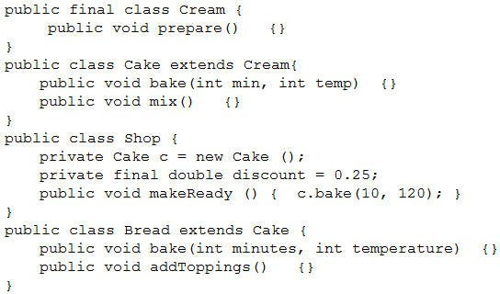

programs are

J.

information.

currency

include data and

bundle files

Resource

I.

localized data.

created using

Language

region-specific

Language and

H.

the code.

hard-coded in

GUI labels) are

(messages and

elements

Textual

**Explanation/**

notes/guides/intl/

m/javase/7/docs/tech

http://docs.oracle.co

Reference:

**Reference:**

G.

**Explanation**

**Section: (none)**

**Correct Answer:** AE

letters.

use uppercase

region codes

letters and

lowercase

codes use

Cake

.

Bread

A compilation error occurs in

D.

.

Shop

A compilation error occurs in

C.

.

E.

A compilation error occurs in

B.

.

Cream

A compilation error occurs in

A.

Which statement is true?

Given:

about localizing an

the code.

recompilation of

not require

languages does

regional

Support for new

F.

(Choose two.)

application?

statements are true

Which two

**QUESTION 48**

**Reference:**

**Explanation/**

**Explanation**

**Section: (none)**

**Correct Answer:** E

All classes compile successfully.

F.

<<The content of the data.xml file>>

<<The content of the data.txt file>>

Exception

The program prints:

G.

file.

data.txt

The program prints the content of

C.

What is the result?

);

}

}

”);

{ System.out.println(“Exception

} catch (IOException e)

.forEach(System.out::println); //line n1

A compilation error occurs at

line n1

.

D. The program prints the content of the three files.

**Correct Answer:** A

**Section: (none)**

**Explanation**

**Explanation/**

**Reference:**

**QUESTION 51**

Given:

final class Folder {

//line n2

//line n1

**Correct Answer:** B

**QUESTION 49**

Which statement is true about

java.util.stream.Stream

?

A.

A stream cannot be consumed more than once.

B.

The execution mode of streams can be changed during processing.

C.

Streams are intended to modify the source data.

D.

A parallel stream is always faster than an equivalent sequential stream.

E.

Stream operation accepts lambda expressions as its parameters.

**Section: (none)**

**Explanation**

**Explanation/**

**Reference:**

**QUESTION 50**

The data.doc, data.txt and data.xml files are accessible and contain text.

Given the code fragment:

Stream<Path> paths = Stream.of (Paths. get(“data.doc”),

Paths. get(“data.txt”),

Paths. get(“data.xml”));

paths.filter(s-> s.toString().contains(“data”)).forEach(

s -> {

try {

Files.readAllLines(s)

.stream()

static

hashCode

() and

equals

Override

H.

.

private

Make the constructor

G.

.

() methods of the java.lang.Object class.

Make the class

F.

two statements enforce the singleton nature of the design? (Choose two.)

You want to create a singleton class by using the Singleton design pattern. Which

**QUESTION 52**

**Reference:**

**Explanation/**

**Explanation**

**Section: (none)**

**Correct Answer:** AE

static

fragment:

Given the code

**QUESTION 53**

**Reference:**

**Explanation/**

**Explanation**

**Section: (none)**

**Correct Answer:** BF

final.

and

}

Make the single instance created

K.

interface.

Serializable

Implement the

J.

reference to point to the single instance.

public

Use a

I.

f.open();

with:

line n1

Replace

A.

? (Choose two.)

Open Close

Which two modifications enable the code to print

}

}

}

class Folder implements AutoCloseable {

{

{ try (Folder f = new Folder())

public static void main (String [] args) throws Exception

public class Test {

}

}

”);

{ System.out.print(“Open

public void open ()

class Folder extends Exception {

System.out.print(“Close”);

public void close () throws IOException {

At line n2, insert:

E.

}

”);

{ System.out.print(“Close

final void close ()

At line n2, insert:

D.

with:

line n1

Replace

C.

class Folder extends Closeable {

with:

line n1

Replace

B.

What is the result?

occ

r

erro

on

pilati

com

A

C.

20.0

B. 10.0

30.0

A. 20.0

urs.

codes.forEach(c -> System.out.println(c));

codes.replaceAll(uo);

UnaryOperator<Double> uo = s -> s +10.0;

List<Integer> codes = Arrays.asList (10, 20);

fragment:

Given the code

**QUESTION 54**

**Reference:**

**Explanation/**

**Explanation**

**Section: (none)**

wn

Given:

**QUESTION 55**

**Reference:**

**Explanation/**

**Explanation**

**Section: (none)**

**Correct Answer:** C

.

time

run

at

**Correct Answer:** C

thro

is

ion

ept

Exc

mat

For

ber

Num

A

D.

stmt.executeQuery(“SELECT id FROM Customer”);

The required database driver is configured in the classpath.

Assume that:

20. }

System.out.println (“Error”);

19.

18. } catch (Exception e) {

}

17.

rs.getInt(“id”));

System.out.println(“Employee ID: “+

//process the results

while (rs.next()) {

The appropriate database is accessible with the

16.

15.

14.

13.

12.

ResultSet rs = stmt.executeQuery(query);

{

11. try (Statement stmt = conn.createStatement())

10. String query = “SELECT id FROM Employee”;

9. Connection conn = DriveManager.getConnection(dbURL, userName, passWord);

SQL queries are valid.

compilation fails on line 13.

D.

.

Error

The program prints

C.

The program prints customer IDs.

B.

The program prints employee IDs.

A.

What is the result of compiling and executing this code fragment?

tables are available and each table has id column with a few records and the

Customer

and

Employee

The

exists.

passWord

, and

userName

,

dbURL

And given the code

usernam

bURL,

ction(d

etConne

nager.g

DriveMa

conn =

ion

Connect

10.

9. try {

fragment:

e,

INTEGER

QUANTITY<

•

PRICE, REAL

•

VARCHAR(100)

DESCRIP,

•

PK

ID, INTEGER:

•

11.

“ + rs.getInt(“Quantity”));

“ + rs.getDouble(“Price”));

System.out.println(Quantity:

System.out.println(“Price:

18.

17.

16.

15.

14.

13.

12.

Item table

“ + rs.getString(“Descrip”));

System.out.println(“Description:

“ + rs.getInt(“Id”));

System.out.println(“ID:

{

while(rs.next())

ResultSet rs = stmt.executeQuery(query);

Statement stmt = conn.createStatement();

String query = “Select * FROM Item WHERE ID = 110”;

d);

passwor

{

Customer c3 = new Customer(“Penny”, “Jones”);

c2 = new Customer(“Pedro”, “Gonzales”);

c1 = new Customer(“Larry”, “Smith”); Customer

public static void main (String [] args){ Customer

{

public class App

}

{return count; }

public static int getCount()

}

0;

count =

Customer c4 = new Customer(“Lars”, “Svenson”);

static

++count;}

last;

{fName = first, lName =

first, String last)

public customer (String

private static int count;

private String lName;

{ private String fName;

public class Customer

3

Given:

**QUESTION 56**

**Reference:**

**Explanation/**

**Explanation**

**Section: (none)**

**Correct Answer:** D

5

E.

4

D.

C.

2

B.

0

A.

What is the result?

}

}

System.out.println (Customer.getCount());

c3 = c2;

c4 = null;

}

Master

and

Worker

methods of both the

run

You have been asked to ensure that the

worker.start();

Worker worker = new Worker(cb);

//line n2

Master master = new Master();

and the code fragment:

classes are

}

System.out.println(“Master…”);

public void run (){

class Master implements Runnable {//line n1

}

}

}

{

ex)

} catch (Exception

CyclicBarrier cb = new CyclicBarrier(1);

CyclicBarrier cb = new CyclicBarrier(master);

, insert

line n2

At

H.

CyclicBarrier cb = new CyclicBarrier(1, master);

, insert

line n2

At

G.

n(“Worker…”);

, insert

line n2

At

F.

CyclicBarrier cb = new CyclicBarrier(2, master);

, insert

line n2

At

E.

executed. Which modification meets the requirement?

The appropriate database is accessible with the

B.

An exception is thrown at runtime.

A.

What is the result?

The SQL query is valid.

exists.

passWord

, and

userName

,

dbURL

Compilation fails.

The required database driver is configured in the classpath.

Assume that:

22. }

System.out.println(“Error”);

21.

{

20. } catch (SQLException se)

}

19.

**Reference:**

System.out.printl

cb.await();

{ try{

public void run ()

cb) { this.cb = cb; }

public Worker(CyclicBarrier

CyclicBarrier cb;

class Worker extends Thread {

Given:

**QUESTION 57**

**Explanation/**

**Explanation**

**Section: (none)**

**Correct Answer:** D

The code prints information about Item 110.

D.

.

Error

The code prints

C.

G. MPEGJPEG

**Reference:**

**QUESTION 59**

Given the code

fragment:

List<String> codes = Arrays.asList (“DOC”, “MPEG”, “JPEG”);

codes.forEach (c -> System.out.print(c + “ “));

String fmt = codes.stream()

.filter (s-> s.contains (“PEG”))

.reduce((s, t) -> s + t).get();

System.out.println(“\n” + fmt);

What is the result?

E. DOC MPEG JPEG

MPEGJPEG

F. DOC MPEG MPEGJPEG

MPEGMPEGJPEG

**Explanation/**

MPEGJPEG

H. java.uti

l.NoSuch

ElementE

xception

is thrown.

**Correct Answer:** A

**Section: (none)**

**Explanation**

**Explanation/**

**Reference:**

**QUESTION 60**

Given the code

fragment:

What is the result?

**Correct Answer:** C

**Section: (none)**

**Explanation**

**Explanation/**

**Reference:**

**QUESTION 58**

Given the code

fragment:

String str = “Java is a programming language”;

ToIntFunction<String> indexVal = str: : indexOf;

//line

n1 int x = indexVal.applyAsInt(“Java”);

//line n2

System.out.println(x);

A.

0

B.

1

C.

A compilation error occurs at

line n1

.

D.

A compilation error occurs at

line n2

.

**Correct Answer:** A

**Section: (none)**

**Explanation**

C. Moveable

**Section: (none)**

**Correct Answer:** A

cannot be used in a lambda expression.

D. Movable

animal.walk(20);

animal.run(100);

Moveable animal = (Integer n1, Integer n2) -> n+ n2;

can be used as below:

**Explanation**

animal.walk(20);

animal.run(100);

Moveable<Integer> animal = n - > n + 10;

can be used as below:

B. Moveable

animal.walk(20);

animal.run(100);

Moveable<Integer> animal = n - > System.out.println(“Running” + n);

**Explanation/**

**Reference:**

**QUESTION 62**

Which two code

blocks correctly

initialize a Locale

variable? (Choose

two.)

E. Locale loc1

= "UK";

F. Locale loc2

=

Locale.getIn

stance("ru")

;

**Explanation**

List<String> nL = Arrays.asList(“Jim”, “John”, “Jeff”);

Function<String, String> funVal = s -> “Hello : “.contact(s);

nL.Stream()

.map(funVal)

.peek(System.out::print);

What is the result?

A. Hello : Jim Hello : John Hello : Jeff

B. Jim John Jeff

C.

The program prints nothing.

D.

A compilation error occurs.

**Correct Answer:** C

**Section: (none)**

**Explanation/**

**Reference:**

**QUESTION 61**

Given:

public

interface

Moveable<Integ

er>

{

public default void walk (Integer distance) {System.out.println(“Walking”);)

public void run(Integer distance);

}

Which statement is true?

E. Moveable

can be used as below:

C.

with

line n2

Replace

D.

{

throws Exception

void ride()

with

line n2

Replace

private void

{

ride() throws Exception

protected void

with

line n1

Replace

B.

{

FuelNotAvailException

ride() throws

Given the definition of the

{

this.eAge = eA;

this.eName = eN;

Emp(String eN, Integer eA)

eAge;

private Integer

private String eName;

public class Emp

class:

Emp

public void

**QUESTION 64**

**Reference:**

**Explanation/**

**Explanation**

**Section: (none)**

**Correct Answer:** B

{

FuelNotAvailException

ride() throws

Given:

//line n1

}

}

}

System.out.println(“Happy Journey!”);

{

void ride() throws FuelNotAvailException

{

class Vehicle

class FuelNotAvailException extends Exception {

class SolarVehicle extends Vehicle

**QUESTION 63**

**Reference:**

**Explanation/**

**Explanation**

**Section: (none)**

**Correct Answer:** DE

E. Locale loc5 = new Locale ("ru", "RU");

D. Locale loc4 = Locale.UK;

C. Locale loc3 = Locale.getLocaleFactory("RU");

Vehicle v = new SolarVehicle ();

with

line n1

Replace

A.

?

Happy Journey!

print

Which modification enables the code fragment to

}

v.ride();

{

public static void main (String[] args) throws FuelNotAvailException, Exception

and the code fragment:

}

}

//line n2

{ super ride ();

public void ride () throws Exception

{

**Section: (none)**

For which three

objects must a

vendor provide

implementations in

its JDBC driver?

(Choose three.)

E. Time

F. Date

G. Statement

H. ResultSet

I. Connection

J. SQLException

K. DriverManage

r

**Correct Answer:** CDE

**QUESTION 65**

**Explanation**

**Explanation/**

**Reference:**

Explanation:

Database vendors support JDBC through the JDBC driver interface or through the ODBC connection. Each

driver must provide implementations of java.sql.Connection, java.sql.Statement, java.sql.PreparedStatement,

java.sql.CallableStatement, and java.sql.Re sultSet. They must also implement the java.sql.Driver interface for

use by the generic java.sql.DriverManager interface.

**QUESTION 66**

Given the code fragment:

LocalDate valentinesDay =LocalDate.of(2015, Month.FEBRUARY, 14);

LocalDate nextYear = valentinesDay.plusYears(1);

nextYear.plusDays(15); //line n1

System.out.println(nextYear);

A. Sam John Jim

}

public Integer getEAge () {return eAge;}

public String getEName () {return eName;}

**}**

and code fragment:

List<Emp>li = Arrays.asList(new Emp(“Sam”, 20), New Emp(“John”, 60), New Emp

(“Jim”, 51));

Predicate<Emp> agVal = s -> s.getEAge() > 50;

//line n1

li = li.stream().filter(agVal).collect(Collectors.toList());

Stream<String> names = li.stream()map.(Emp::getEName);

//line

n2 names.forEach(n -> System.out.print(n + “ “));

What is the result?

B. John Jim

C.

A compilation error occurs at

line n1

.

D.

A compilation error occurs at

line n2

.

**Correct Answer:** B

**Section: (none)**

**Explanation**

**Explanation/**

**Reference:**

daylight saving

**Section: (none)**

**Correct Answer:** C

based values.

It defines date-

H.

based values.

It defines time-

G.

time.

**Explanation**

It preserves

F.

zones.

It tracks time

E.

?

tion

java.time.Dura

true about

List<Double> loanValues = Arrays.asList(1000.0, 2000.0);

line n1

UnaryOperator<Integer> uo1 = s -> s*2;

fragment:

Given the code

**QUESTION 69**

-duration

essing-the-time-of-a

Which statement is

e/duration.html#acc

v.com/java-date-tim

http://tutorials.jenko

Reference:

**Reference:**

**Explanation/**

.

BiFunction<Integer, Double, Integer> val = (t1, t2) -> t1 + t2;

fragment:

Given the code

**QUESTION 67**

**Reference:**

**Explanation/**

**Explanation**

**Section: (none)**

**Correct Answer:** A

System.out.println(val.apply(10, 10.5));

line n1

D. A compilation error occurs at

C. 2016-02-29

is thrown.

DateTimeException

B. A

A. 2016-02-14

What is the result?

D.

**QUESTION 68**

**Reference:**

**Explanation/**

**Explanation**

**Section: (none)**

**Correct Answer:** C

.

line n2

A compilation error occurs at

.

line n1

A compilation error occurs at

C.

B. 20.5

A. 20

What is the result?

//line n1

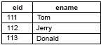

Employee

<key>menu2</key><value>View Menu</value>

C. menu1, File Menu, menu2, View Menu

Menu

D. menu1 = File Menu

menu2 = View

Menu

**Correct Answer:** D

**Section: (none)**

**Explanation**

**Explanation/**

**Reference:**

**QUESTION 71**

Given the records

from the

B. <key>menu1</key><value>File Menu</value>

table:

and given the code fragment:

try {

Connection conn = DriverManager.getConnection (URL, userName, passWord);

Statement st = conn.createStatement(ResultSet.TYPE_SCROLL_INSENSITIVE,

ResultSet.CONCUR_UPDATABLE);

st.execute(“SELECT*FROM Employee”);

ResultSet rs = st.getResultSet();

while (rs.next())

{

if (rs.getInt(1) ==112)

{

rs.updateString(2, “Jack”);

A compilation

loanValues.stream()

.filter(lv -> lv >= 1500)

.map(lv -> uo1.apply(lv))

.forEach(s -> System.out.print(s + “ “));

What is the result?

A. 4000.0

B. 4000

C.

A compilation

error occurs at

line n1

.

D.

error occurs at

line n2

.

**Correct Answer:** D

**Section: (none)**

**Explanation**

**Explanation/**

**Reference:**

**QUESTION 70**

You have been asked to create a ResourceBundle which uses a properties file to localize an application.

Which code example specifies valid keys of menu1 and menu2 with values of File Menu and View Menu?

E. <key name = ‘menu1”>File Menu</key>

<key name = ‘menu2”>View Menu</key>

RateOfInterest

{

switch (accountType)

String accountType = “LOAN”;

int rateOfInterest = 0;

public static void main (String[]

{

args)

{

case “RD”;

class

Given:

**QUESTION 72**

**Reference:**

**Explanation/**

**Explanation**

**Section: (none)**

**Correct Answer:** C

}

Rate of interest: 0

A.

What is the result?

java –ea RateOfInterest

and the command:

}

}

System.out.println (“Rate of interest:” + rateOfInterest);

.

assert false: “No interest for this account”; //line n1

default:

break;

rateOfInterest = 10;

case “FD”;

break;

rateOfInterest = 5;

raised”);

, and

userName

,

URL

The appropriate database accessible with the

The required database driver is configured in the classpath.

Assume that:

}

passWord

{ System.out.println(“Exception is

} catch (SQLException ex)

System.out.println(rs.getInt(1) + “ “ + rs.getString(2));

rs.absolute(2);

}

}

112 Jack

Exception is raised

The program prints

D.

112 Jerry

The Employee table is not updated and the program prints:

C.

112 Jack

and the program prints:

B. The Employee table is updated with the row:

112 Jerry

and the program prints:

112 Jack

A. The Employee table is updated with the row:

What is the result?

exists.

line n1

**Explanation/**

**Explanation**

**Section: (none)**

**Correct Answer:** B

is thrown at run time.

ExecutionException

An

D.

.

**Reference:**

A compilation error occurs at

C.

and does not terminate.

Call Call

The program prints

B.

and terminates.

Call Call

public void run () System.out.println(fName);}

{

Projects”)); listOfFiles.forEach(line ->

Stream<Path> listOfFiles = Files.walk(Paths.get(“Java

Executors.newCachedThreadPool();

ExecutorService executor =

{

InterruptedException

public static void main (String[] args) throws IOException,

The program prints

}

{ this.fName = fName;

public FileThread(String fName)

{ String fName;

public class FileThread implements Runnable

fragment:

Given the code

**QUESTION 74**

**Correct Answer:** B

{ String str;

class CallerThread implements Callable<String>

fragment:

Given the code

**QUESTION 73**

**Reference:**

**Explanation/**

**Explanation**

**Section: (none)**

public CallerThread(String s)

.

line n1

A compilation error occurs at

D.

C. No interest for this account

An AssertionError is thrown.

B.

{

A.

Which statement is true?

}

System.out.println(str);

String str = f1.get().toString();

Future f1 = es.submit (newCallerThread(“Call”));

ExecutorService es = Executors.newFixedThreadPool(4);

//line n1

ExecutionException

public static void main (String[] args) throws InterruptedException,

and

}

}

return str.concat(“Call”);

public String call() throws Exception {

{this.str=s;}

//line n1

?

Cat Lion Tiger

Rat

line n1 to enable the code to print

Which code fragment should be inserted at

}

“);

{ System.out.print (s + “

for (String s : strArray)

E. Arrays.sort(strArray,

“Lion”};

String[] strArray = new String [] {“Tiger”, “Rat”, “Cat”,

and the code fragment:

}

}

{ return s1 length() – s2.length();

public static int checkValue (String s1, String s2)

{

CheckClass : : new : :

fragments:

Given the code

**QUESTION 76**

**Reference:**

**Explanation/**

**Explanation**

**Section: (none)**

**Correct Answer:** A

checkValue);

CheckClass

H. Arrays.sort(strArray,

new).checkValue);

(CheckClass : :

G. Arrays.sort(strArray,

checkValue);

(CheckClass : : new) : :

F. Arrays.sort(strArray,

CheckClass : : checkValue);

//

The program throws a runtime exception at

A.

What is the result?

directory exists and contains a list of files.

Java Projects

The

}

}

line n2

line n2

executor.awaitTermination(5, TimeUnit.DAYS);

executor.shutdown();

});

//

line n1

()));

executor.execute(new FileThread(line.getFileName().toString

.

class

Given:

**QUESTION 75**

**Reference:**

**Explanation/**

**Explanation**

**Section: (none)**

**Correct Answer:** B

line n1

A compilation error occurs at

D.

The program prints files names sequentially.

C.

The program prints files names concurrently.

B.

.

The

yellow.txt

The

F.

is deleted.

file

yellow.txt

file content and the

yellow.txt

file content is replaced by the

green.txt

file content is replaced by the

E.

Which statement is true?

Files.delete(source);

Files.move(source, target, StandardCopyOption.ATOMIC_MOVE);

Path target = Paths.get(“/colors/yellow.txt);

een.txt);

Paths.get(“/gr

Path source =

code fragment:

accessible, and the

H.

Given:

**QUESTION 78**

**Reference:**

**Explanation/**

**Explanation**

**Section: (none)**

**Correct Answer:** D

is thrown at runtime.

FileAlreadyExistsException

A

are

directory.

/colors

is moved to the

green.txt

The file

G.

thrown.

file content and an exception is

green.txt

}

Which should be inserted at line n1 to print Java-Oracle

//line n1

Stream<TechName> stre = tech.stream();

);

new TechName(“J2EE-“)

new TechName(“Oracle DB-“),

( new TechName(“Java-“),

List<TechName> tech = Arrays.asList

and

}

DB-J2EE-?

chName;

this.techName=te

{

techName)

TechName (String

techName;

{ String

class TechName

**Correct Answer:** B

.txt

/colors/yellow

and

/green.txt

Given that

**QUESTION 77**

**Reference:**

**Explanation/**

**Explanation**

**Section: (none)**

t);

D. stre.forEachOrdered(System.out::prin

;

a).forEachOrdered(System.out::print)

C. stre.map(a->

t);

a.techName).forEach(System.out::prin

B. stre.map(a->

A. stre.forEach(System.out::print);

**QUESTION 79**

.flatMap(list -> list.stream())

A. Stream.of(list1, list2)

15 30?

Which code fragment, when inserted at line n1, prints 10 20

//line n1

30);

List<Integer> list2 = Arrays.asList(15,

List<Integer> list1 = Arrays.asList(10, 20);

fragment:

Given the code

.forEach(s -> System.out.print(s

**Reference:**

**Explanation/**

**Explanation**

**Section: (none)**

**Correct Answer:** AE

}

}

{

public void doThat (String s)

.forEach(s ->

**Explanation**

**Section: (none)**

**Correct Answer:** A

+ “ “));

.forEach(s -> System.out.print(s

list.stream())

.flatMapToInt(list ->

D. Stream.of(list1, list2)

System.out.println(s + “ “));

}

1 -> e1.stream())

.flatMap(list2.stream().flatMap(e

C. list1.stream()

+ “ “));

.forEach(s -> System.out.print(s

list.intStream())

.flatMap(list ->

B. Stream.of(list1, list2)

+ “ “));

}

public void doSomething(Integer i)

C. public abstract class Job implements Doable {

}

}

{

public void doYourThing(Boolean b)

public abstract void doSomething(String s)

B. public abstract class Work implements Doable {

}

{

{

s)

{ public void doSomethingElse(String

public class Task implements Doable

A.

Which two class definitions compile? (Choose two.)

}

public void doSomething (String s);

interface Doable {

{

{

public void doSomething(String s)

}

{

public void doSomething(Integer i)

public class Do implements Doable {

E.

}

}

public String doThis(Integer j)

}

{

public void doSomething(Integer i)

}

{

D. public class Action implements Doable {

}

}

The code prints the content of the

B.

A compilation error occurs at

line n1

.

C.

A compilation error occurs at

line n2

.

D.

.

employee.txt

file and throws an exception at

line n3

.

**Correct Answer:** D

**Section: (none)**

**Explanation**

**Explanation/**

e

2

}

brCopy.

rea

dy(

);

//

lin

**Reference:**

n3;

}

Assume that the ready method of the BufferedReader, when called on a closed BufferedReader, throws an

exception, and employee.txt is accessible and contains valid text.

What is the result?

A.

A compilation error occurs at

line n3

Book b2 = new EBook(); b2.read(

}

Test.java:

public class Test

{

public static void main (String[] args)

{

Book b1 = new Book();

b1.read(“Java Programing”);

}

“http://ebook.com/ebook”);

}

}

What is the result?

A.

Read Java Programming

View http:/ ebook.com/ebook

return “Read” + bname

**QUESTION 81**

Given:

Book.java:

public class

Book

{

private String read(String bname)

{

n

}

}

EBook.java:

public class EBook extends Book

{

public class String read (String url)

{

return “View” + url

c

.

f

o

r

E

a

c

h

(

)

-

>

S

y

s

t

{ //

**Explanation/Reference:**

**QUESTION 80**

Given the code fragment:

public static void main (String[] args) throws IOException

{ BufferedReader brCopy = null;

try (BufferedReader br = new BufferedReader (new

FileReader(“employee.txt”)))

e

line n1

br.

l

i

n

e

s

(

r

brC

o

p

y

=

b

;

;

/

/

l

i

n

e

i

m

.

o

u

t

.

p

r

n

t

l

n

(

c

)

)

An exception is thrown at

**QUESTION 83**

**Reference:**

**Explanation/**

**Explanation**

**Section: (none)**

**Correct Answer:** A

.

line n1

Given the code

H.

G. Travel time is 8 hours

F. Travel time is 6 hours

E. Travel time is 4 hours

What is the result?

System.out.println(“Travel time is” + hrs + “hours”);

long hrs = ChronoUnit.HOURS.between(depart, arrive); //line n1

5”));

What is the result?

/server/exe/readme

D. /app/./sys/log

/readme

C. /app/./sys/log

/server/exe/readme

B. /app/log/sys

/readme/server/exe

I. /app/sys/log

-

System.out.println(res2);

System.out.println(res1);

Path res1 = path1.resolve(“/readme/”);

Paths.get(“/server/exe/”);

Path path2 =

Path res1 = path1.resolve(“log”);

Path path1 = Paths.get(“/app/./sys/”);

fragment:

The

**QUESTION 82**

**Reference:**

**Explanation/**

**Explanation**

**Section: (none)**

**Correct Answer:** D

file fails to compile.

Test.java

Given the code

D.

file fails to compile.

EBook.java

The

C.

Read http:/ ebook.com/ebook

B. Read Java Programming

-

ZoneID.of(“UTC

0,

15, 9, 0, 0,

of(2015, 1,

ZonedDateTime.

arrive =

ZonedDateTime

7”));

ZoneID.of(“UTC

0,

15, 3, 0, 0,

of(2015, 1,

ZonedDateTime.

depart =

ZonedDateTime

fragment:

{

(String

doRegister

void

public

{

class App

fragment:

and the code

}

name, int

UserException

extends

xception

AgeOutOfLimitE

class

}

{

Exception

extends

} else {

}

t.doRegister(“Mathew”, 60);

App t = new App ();

{

UserException

public static void main(String[ ] args) throws

}

}

System.out.println(“User is registered.”);

UserException

throw new AgeOutOfLimitException ();

{

} else if (age >= 60)

throw new UserException ();

{

(name.length () < 6)

{ if

throws UserException, AgeOutOfLimitException

age)

List<String> colors = Arrays.asList(“red”, “green”, “yellow”);

A. Searching...

What is the result?

.allMatch(test);

.filter(c -> c.length() > 3)

colors.stream()

};

return n.contains(“red”);

System.out.println(“Searching…”);

Predicate<String> test = n - > {

B. Searching...

fragment:

Given the code

**QUESTION 84**

**Reference:**

**Explanation/**

**Explanation**

**Section: (none)**

**Correct Answer:** C

compilation

class

Given:

**QUESTION 85**

**Reference:**

**Explanation/**

**Explanation**

**Section: (none)**

**Correct Answer:** A

error occurs.

A

D.

Searching...

Searching...

C. Searching...

Searching...

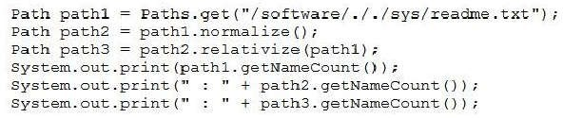

D.

fragment:

What is the result?

A.

5 :

3 : 6

B.

6 :

5 : 6

C.

3 :

3 : 4

Given the code

4 :

4 : 4

**Correct Answer:** D

**Section: (none)**

**Explanation**

**Explanation/**

**Reference:**

**QUESTION 87**

Given:

is thrown.

}

What is the result?

A. User is registered.

B.

An

AgeOutOfLimitException

is thrown.

C.

A

UserException

D.

A compilation error occurs in the

main

method.

**Correct Answer:** B

**Section: (none)**

**Explanation**

**Explanation/**

**Reference:**

**QUESTION 86**

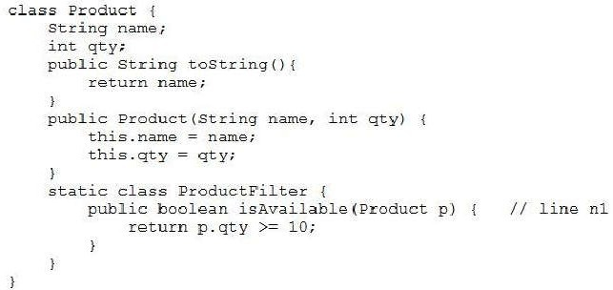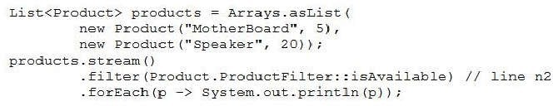

.filter (p -> Product: :ProductFilter: :isAvailable ())

public static boolean isAvailable (Product p) {

C.

Replace

line n2

with:

.filter (p -> p.ProductFilter: :isAvailable (p))

D.

Replace

line n2

with:

with:

**Correct Answer:** B

**Section: (none)**

**Explanation**

**Explanation/**

**Reference:**

**QUESTION 88**

Given the content:

Product.ProductFilter

and the code fragment:

Which modification enables the code fragment to print

Speaker

?

A.

Implement

Predicate

in the

class and replace

line n2

with

.filter

(p

-> p.ProductFilter.test (p))

B.

Replace

line n1

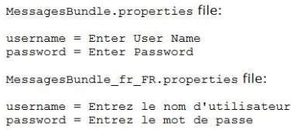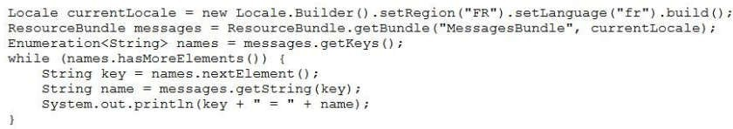

D.

Given:

**QUESTION 89**

**Reference:**

**Explanation/**

**Explanation**

**Section: (none)**

**Correct Answer:** A

The program prints nothing.

A compilation error occurs.

C.

password = Enter Password

B. username = Enter User Name

password = Entrez le mot de passe

A. username = Entrez le nom d’utilisateur

What is the result?

and the code fragment:

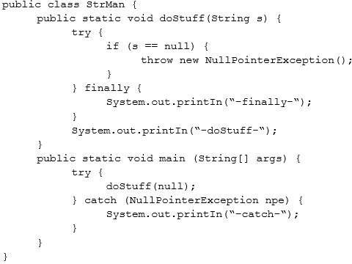

D. –finally

Explanation:

**Reference:**

**Explanation/**

**Explanation**

**Section: (none)**

**Correct Answer:** C

-catch-

-dostuff-

-catch-

C. –finally-

B. –catch-

-dostuff-

-finally-

A. –catch-

What is the result?

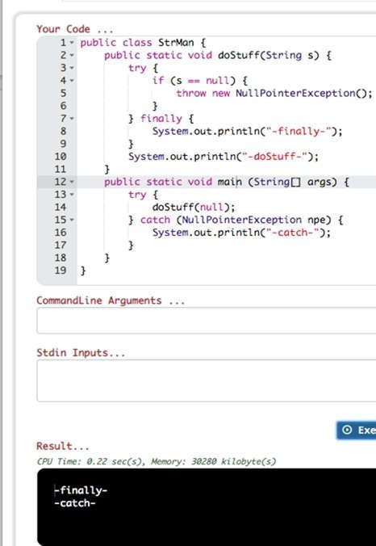

**QUESTION 90**

Given:

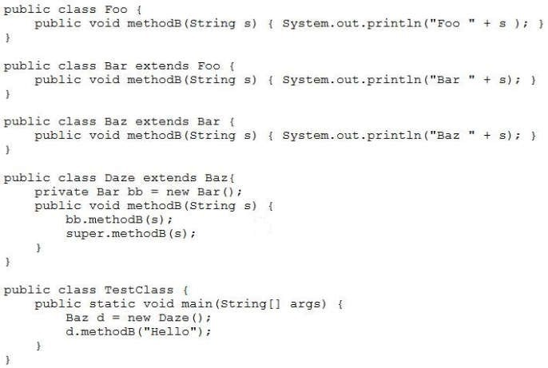

Every worker is a

**Explanation**

**Explanation/**

**Reference:**

**QUESTION 91**

Given the content

of the

employee.txt

file:

**Section: (none)**

master.

Given that the

employee.txt

file is accessible and the file

allemp.txt

does NOT exist, and the

code fragment:

C. Baz Hello

What is the result?

A. Bar Hello

Foo

Hello

B. Bar Hello

Baz

Hello

D.

A

compilation

error occurs

in the

Daze

class.

**Correct Answer:** B

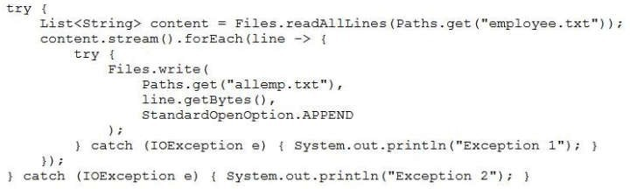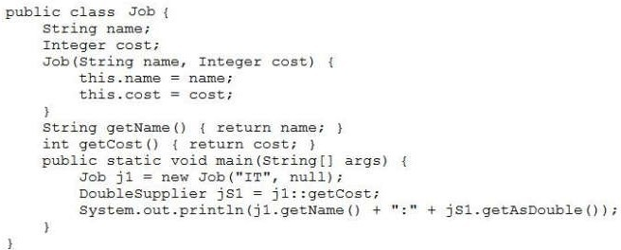

**Reference:**

**Section: (none)**

**Correct Answer:** D

D. IT:0.0

A compilation error occurs.

C.

is thrown at run time.

NullPointerException

A

B.

A. IT:null

What is the result?

Given:

**QUESTION 92**

**Explanation/**

**Explanation**

**Section: (none)**

**Correct Answer:** A

is copied to it.

employee.txt

is created and the content of

D. allemp.txt

The program executes, does NOT affect the system, and produces NO output.

C.

B. Exception 2

A. Exception 1

What is the result?

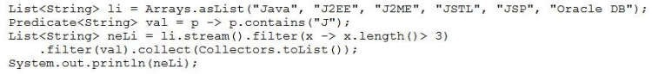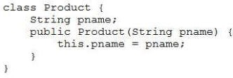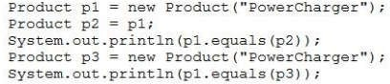

**Explanation/**

false

C. false

true

B. false

true

A. true

What is the result?

and the code fragment:

Given:

**QUESTION 94**

**Reference:**

**Explanation**

**Section: (none)**

**Correct Answer:** D

D. [Java, J2EE, J2ME, JSTL]

C. null

B. [Java, J2EE, J2ME, JSTL, JSP]

A compilation error occurs.

A.

What is the result?

Given the code fragment:

**QUESTION 93**

**Explanation/Reference:**

**Explanation**

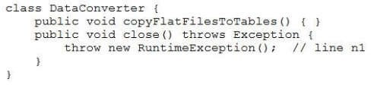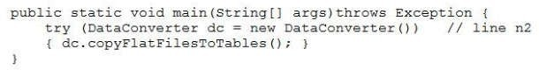

**Correct Answer:** B

catch

or

finally

block.

C.

A compilation error occurs at

line n1

.

D.

The program compiles successfully.

block doesn’t have a

**Section: (none)**

**Explanation**

**Explanation/**

**Reference:**

**QUESTION 96**

Given the code

fragment:

Given:

D.

true

false

**Correct Answer:** D

**Section: (none)**

**Explanation**

**Explanation/**

**Reference:**

**QUESTION 95**

and the code fragment:

What is the result?

A.

A compilation error occurs at

line n2

.

B.

A compilation error occurs because the

try

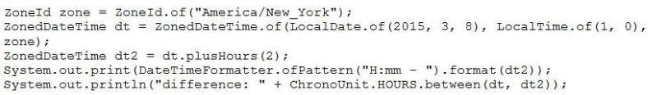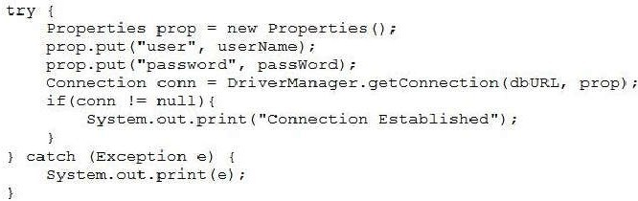

C.

**Explanation/**

**Reference:**

**QUESTION 97**

In 2015, daylight saving time in New York, USA, begins on March 8th at 2:00 AM. As a result, 2:00 AM

becomes 3:00 AM.

Given the code fragment:

Which is the result?

A.

3:00

– difference: 2

B.

2:00

– difference: 1

**Explanation**

4:00

– difference: 3

D.

4:00

– difference: 2

**Correct Answer:** D

**Section: (none)**

**Explanation**

is thrown at runtime.

and the information:

The required database driver is configured in the classpath.

The appropriate database is accessible with the

dbURL, usernam

e, and

passWord

exists.

What is the result?

A.

A

ClassNotFoundException

B.

The program prints nothing.

C.

The program prints

Connection Established

.

D.

A

SQLException

is thrown at runtime.

**Correct Answer:** C

**Section: (none)**

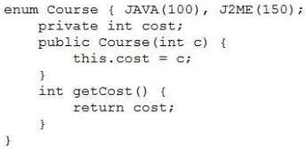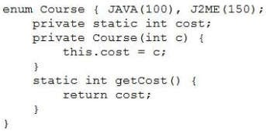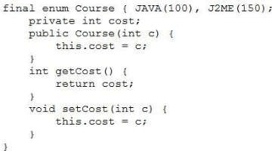

**Explanation/Reference:**

**QUESTION 98**

Given the code fragment:

Which is the valid definition of the

Course

enum?

A.

B.

C.

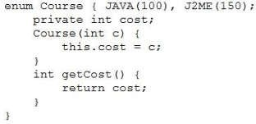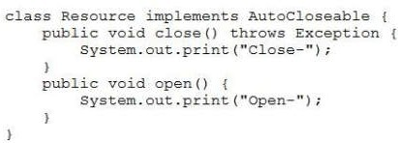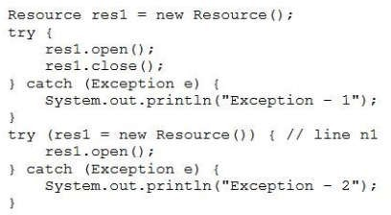

A. Open-Close–

line n1.

error occurs at

A compilation

C.

Open–Close–

B. Open–Close–

Open–Close–

Exception – 1

What is the result?

and this code fragment:

Given:

**QUESTION 99**

**Reference:**

**Explanation/**

**Explanation**

**Section: (none)**

**Correct Answer:** D

D.

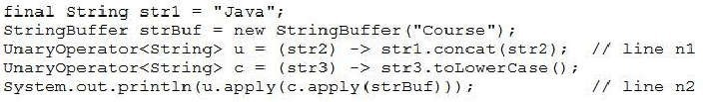

D.

**Explanation/**

**Reference:**

**QUESTION 101**

Given the code

fragment:

What is the result?

A.

A compilation error occurs at

line n1.

B. courseJava

C. Javacourse

**Explanation**

A compilation error occurs at

line n2.

**Correct Answer:** A

**Section: (none)**

**Explanation**

**Explanation/**

**Reference:**

**QUESTION 102**

Given:

Which code fragment, when inserted at

D.

Open–Close–Open–

**Correct Answer:** C

**Section: (none)**

**Explanation**

**Explanation/**

**Reference:**

**QUESTION 100**

Given the code

fragment:

line n1

, ensures

false

is printed?

A. boolean b = cs.stream() .findAny() .get() .equals(“Java”);

B. boolean b = cs.stream() .anyMatch (w -> w.equals (“Java”));

C. boolean b = cs.stream() .findFirst() .get() .equals(“Java”);

D. boolean b = cs.stream() .allMatch(w -> w.equals(“Java”));

**Correct Answer:** B

**Section: (none)**

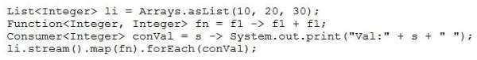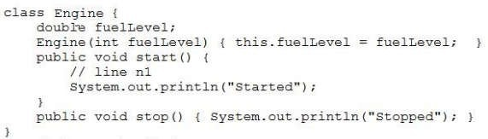

**Section: (none)**

**Reference:**

**QUESTION 103**

Given the code

fragment:

What is the result?

A. Val:20 Val:40 Val:60

B. Val:10 Val:20 Val:30

C.

A compilation error occurs.

D. Val: Val: Val:

**Correct Answer:** A

**Explanation/**

**Explanation**

**Explanation/**

**Reference:**

**QUESTION 104**

Given the code

fragments:

is less than or equal to zero.

Your design requires that:

fuelLevel

of Engine must be greater than zero when the

start()

method is invoked.

The code must terminate if

fuelLevel

of

Engine

Which code fragment should be added at

line n1

to express this invariant condition?

A. assert (fuelLevel) : “Terminating…”;

B. assert (fuelLevel > 0) : System.out.println (“Impossible fuel”);

C. assert fuelLevel < 0: System.exit(0);

D. assert fuelLevel > 0: “Impossible fuel” ;

**Correct Answer:** C

**Section: (none)**

**Explanation**

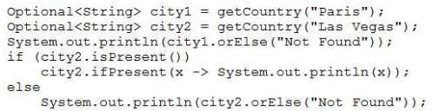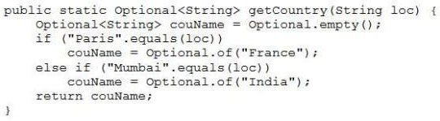

A. Path iP = new Paths (“/First.txt”);

**QUESTION 105**

Given the code

fragment:

Which code fragment, when inserted at

line n1

, enables the code to print

/First.txt

?

**Reference:**

B. Path iP = Paths.toPath (“/First.txt”);

C. Path iP = new Path (“/First.txt”);

D. Path iP = Paths.get (“/”, “First.txt”);

**Correct Answer:** D

**Explanation/**

**Explanation**

**Section: (none)**

**Correct Answer:** D

Not Found

D. France

Not Found

C. Optional[France]

Optional [NotFound]

B. Optional [France]

Optional[NotFound]

A. France

What is the result?

and

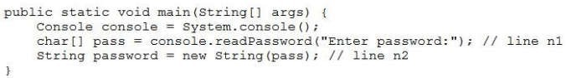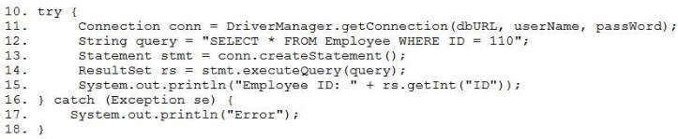

line n1.

The code prints

Error.

**Correct Answer:** A

**Section: (none)**

**Explanation**

**Explanation/**

**Reference:**

**QUESTION 107**

Given the code

fragment:

What is the result?

A.

A compilation error occurs at

D.

B.

A compilation error occurs at

line n2.

C.

The code reads the password without echoing characters on the console.

D.

A compilation error occurs because the

IOException

isn’t declared to be thrown or caught?

**Correct Answer:** A

**Section: (none)**

passWord

**Section: (none)**

**Explanation**

**Explanation/**

**Reference:**

**QUESTION 106**

Given the code

fragment:

Assume that:

The required database driver is configured in the classpath.

The appropriate database is accessible with the

dbURL, userName

, and

exists

The

Employee

table has a column

ID

of type integer and the SQL query matches one record.

What is the result?

A.

Compilation fails at line 14.

B.

Compilation fails at line 15.

C.

The code prints the employee ID.

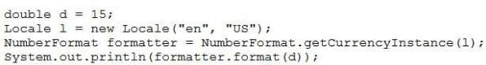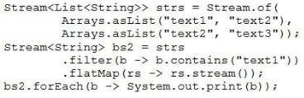

**Explanation/**

**Explanation**

**Section: (none)**

**Correct Answer:** A

D. [text1, text2]

C. text1

B. text1text2text2text3

A. text1text2

What is the result?

fragment:

Given the code

**QUESTION 109**

**Reference:**

**Explanation**

**Section: (none)**

**Correct Answer:** A

D. USD $15

C. USD 15.00

15 $

B.

$15.00

A.

What is the result?

and the code fragment?

**QUESTION 108**

**Explanation/Reference:**

**Explanation**

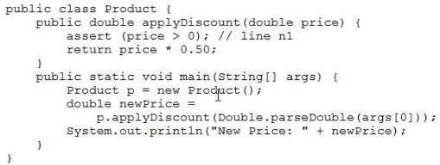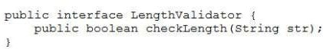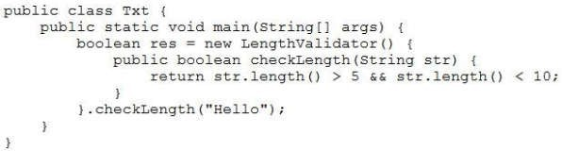

package-

**Reference:**

Reference:

https://docs.oracle.c

om/javase/8/docs/a

pi/java/util/function/

**Explanation/**

summary.html

**QUESTION 111**

Given:

and the command:

Txt

**Explanation/Reference:**

**QUESTION 110**

Given:

and

Which interface from the

java.util.function

package should you use to refactor the class

?

A. Consumer

B. Predicate

C. Supplier

D. Function

**Correct Answer:** C

**Section: (none)**

**Explanation**

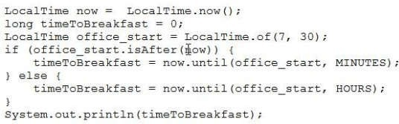

D.

**QUESTION 112**

Given the code

fragment:

Assume that the value of now is 6:30 in the morning.

What is the result?

A.

An exception is thrown at run time.

B.

0

C. 60

**Reference:**

1

**Correct Answer:** C

**Section: (none)**

**Explanation**

**Explanation/**

**Reference:**

**QUESTION 113**

Given the code

fragments:

.

java Product 0

What is the result?

A.

An

AssertionError

is thrown.

B.

A compilation error occurs at

line n1

C. New Price: 0.0

D.

A

NumberFormatException

is thrown at run time.

**Correct Answer:** C

**Section: (none)**

**Explanation**

**Explanation/**

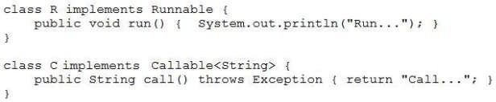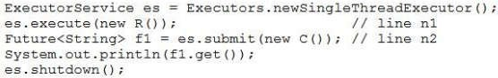

static

constructor to

private

a

H.

reference

singleton

a copy of the

method to return

the class

public

a

G.

single instance

instantiate the

method to

public

**Section: (none)**

fragment:

Given the code

**QUESTION 115**

**Reference:**

**Explanation/**

**Explanation**

a

**Correct Answer:** BD

single instance

point to the

reference to

public

a

I.

B.

**Correct Answer:** C

line n2.

A compilation error occurs at

D.

Call…

C. Run…

line n1.

A compilation error occurs at

**Section: (none)**

and throws an exception.

Run…

The program prints

A.

What is the result?

and

**Explanation**

**Explanation/**

**Reference:**

**QUESTION 114**

Which two are

elements of a

singleton class?

(Choose two.)

E.

a

transient

reference to

point to the

single instance

F.

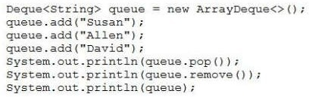

Allen

Explanation:

**Reference:**

**Explanation/**

**Explanation**

**Section: (none)**

**Correct Answer:** C

David]

[Susan,

Allen

E. Susan

[Susan]

D. David

[David]

Allen

C. Susan

[Susan, Allen]

Susan

B. Susan

[Susan, Allen]

David

A. David

What is the result?

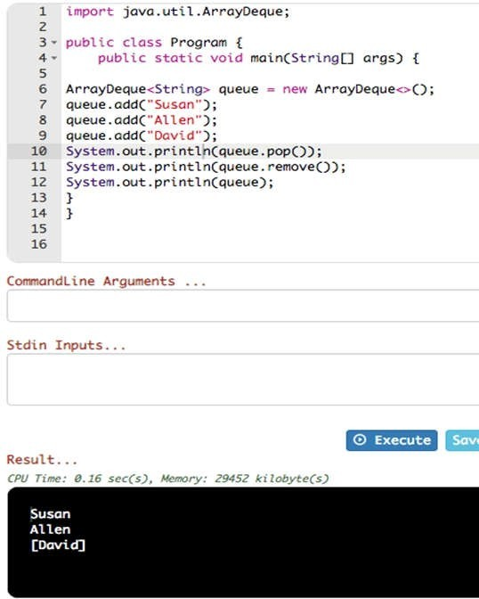

**QUESTION 116**

Given:

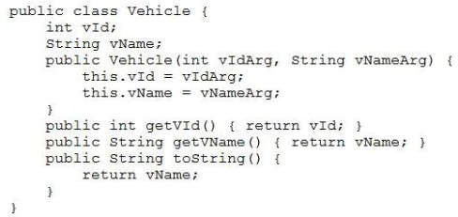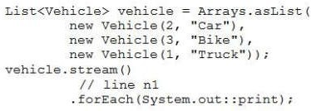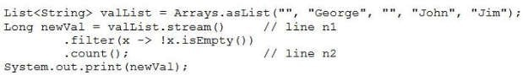

E. .sorted(Comparator.comparing ((Vehicle v) -> v.getVId()))

What is the result?

fragment:

Given the code

**QUESTION 117**

**Reference:**

**Explanation/**

**Explanation**

**Section: (none)**

**Correct Answer:** DE

D. .sorted((v1, v2) -> Integer.compare(v1.getVId(), v2.getVid()))

.sorted ()

C. .map (v -> v.getVid())

B. .sorted (Comparable.comparing (Vehicle: :getVName)).reversed ()

A. .sorted ((v1, v2) -> v1.getVId() < v2.getVId())

?

TruckCarBike

independently, enable the code to print

line n1

Which two code fragments, when inserted at

and the code fragment:

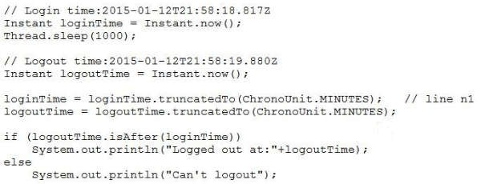

Logged out at: 2015-01-12T21:58:00Z

fragment:

What is the result?

A. A compilation error occurs at

line n1.

B.

Logged out at: 2015-01-12T21:58:19.880Z

C.

Can’t logout

D.

Given the code

**Correct Answer:** D

**Section: (none)**

**Explanation**

**Explanation/**

**Reference:**

**QUESTION 119**

Given the code

fragment:

D.

A.

A compilation error occurs at

line n2

.

B.

3

C.

2

A compilation error occurs at

line n1.

**Correct Answer:** A

**Section: (none)**

**Explanation**

**Explanation/**

**Reference:**

**QUESTION 118**

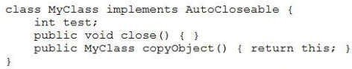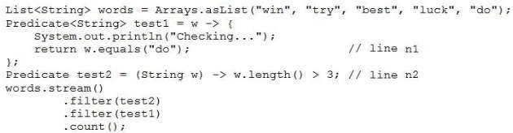

G. Stream<Path> stream = Files.list (Paths.get (“customers.txt”));

is accessible and

contains multiple

lines.

Which code

fragment prints the

contents of the

customers.txt

file?

E. Stream<String> stream = Files.find (Paths.get (“customers.txt”));

stream.forEach((String c) -> System.out.println(c));

F. Stream<Path> stream = Files.find (Paths.get (“customers.txt”));

stream.forEach( c) -> System.out.println(c));

customers.txt

stream.forEach( c) -> System.out.println(c));

H. Stream<String> lines = Files.lines (Paths.get (“customers.txt”));

lines.forEach( c) -> System.out.println(c));

**Correct Answer:** D

**Section: (none)**

**Explanation**

**Explanation/**

**Reference:**

**QUESTION 121**

Given:

error occurs

What is the result?

A.

A compilation error occurs at

line n1.

B. Checking…

C. Checking…

Checking…

D.

A

compilation

at

line

n2

.

**Correct Answer:** A

**Section: (none)**

**Explanation**

**Explanation/**

**Reference:**

**QUESTION 120**

Assume

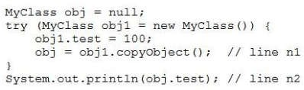

Reference:

ge-summary.html

ava/util/stream/packa

m/javase/8/docs/api/j

https://docs.oracle.co

**QUESTION 123**

**Reference:**

**Explanation/**

**Explanation**

**Section: (none)**

**Correct Answer:** AB

I. filter ()

H. peek ()

”);

**Explanation**

**Section: (none)**

**Correct Answer:** B

(“org.xyzdata.jdbc.NetworkDriver”);

M. DriverManager.loadDriver

(“jdbc:xyzdata://localhost:3306/EmployeeDB”);

L. Connection con = DriverManager.getConnection

G. distinct ()

K. Class.forName(“org.xyzdata.jdbc.NetworkDriver

(“jdbc:xyzdata://localhost:3306/EmployeeDB”);

J. Connection con = Connection.getDriver

driver?

to load a JDBC 3.0

fragment is required

Which code

100

block.

finally

or

catch

block is declared without a

try

A compilation error occurs because the

C.

D.

B.

.

line n2

A. An exception is thrown at

What is the result?

and the code fragment:

A compilation error occurs at

line n1

.

**Correct Answer:** B

**Section: (none)**

**Explanation**

**Explanation/**

**Reference:**

**QUESTION 122**

Which two methods from the

java.util.stream.Stream

interface perform a reduction operation? (Choose

two.)

E. count ()

F. collect ()

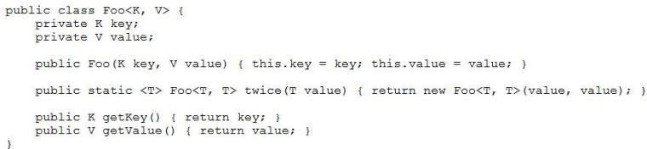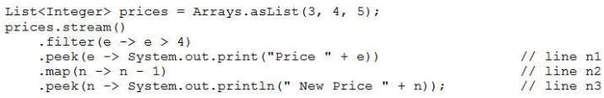

D.

remove

line n3

B.

Replace

line n2

with

.mapToInt (n -> n – 1);

C.

Replace

line n1

with

.forEach (e -> System.out.print (“Price” + e))

and

Replace

line n3

with

.forEach (n -> System.out.println (“New Price” + n));

**Correct Answer:** D

**Section: (none)**

**Explanation**

**Explanation/**

**Reference:**

**QUESTION 126**

**Explanation/**

**Explanation/Reference:**

**QUESTION 124**

Given:

Which option fails?

A. Foo<String, Integer> mark = new Foo<String, Integer> (“Steve”, 100);

B. Foo<String, String> pair = Foo.<String>twice (“Hello World!”);

C. Foo<Object, Object> percentage = new Foo<String, Integer>(“Steve”, 100);

D. Foo<String, String> grade = new Foo <> (“John”, “A”);

**Correct Answer:** A

**Section: (none)**

**Explanation**

**Reference:**

**QUESTION 125**

Given the code

fragment:

Which modification enables the code to print

Price 5 New Price 4

?

A.

Replace

line n2

with

.map (n -> System.out.println (“New Price” + n –1))

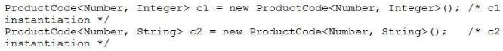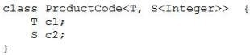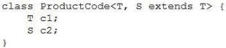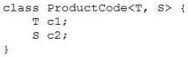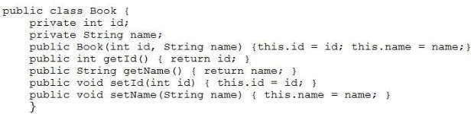

Which definition of

Given the code

fragment:

You have been asked to define the

ProductCode

class. The definition of the

ProductCode

class must allow

c1

instantiation to succeed and cause a compilation error on

c2

instantiation.

**QUESTION 127**

ProductCode

meets the requirement?

A.

B.

C.

C.

Given the definition of the

Book

class:

Which statement is true about the

Book

class?

A.

It demonstrates encapsulation.

B.

It is defined using the factory design pattern.

It is defined using the singleton design pattern.

D.

It demonstrates polymorphism.

E.

It is an immutable class.

**Correct Answer:** A

**Section: (none)**

**Explanation**

**Explanation/**

**Reference:**

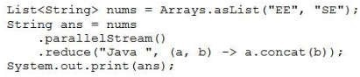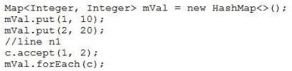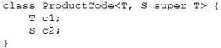

ps://www.concretep

unction-bipredicate-

a-8-biconsumer-bif

e.com/java/jdk-8/jav

ag

Reference: htt

**Reference:**

**Explanation/**

**Explanation**

exampl

e

**QUESTION 129**

Given the code

fragment:

What is the result?

A. Java EEJava EESE

B. Java EESE

C.

The program prints either:

Java EEJava SE

**QUESTION 128**

A. BiConsumer<Integer,Integer> c = (i, j) ->

?

1,2; 1,10; 2,20;

to print

line n1

Which statement can be inserted into

fragment:

Given the code

{System.out.print (i + “,” +

**Reference:**

**Explanation/**

**Explanation**

**Section: (none)**

**Correct Answer:** B

D.

j+ “; “);};

B. BiFunction<Integer, Integer, String> c = (i, j)

–>

{System.out.print (i + “,” +

j+ “; “)};

C. BiConsumer<Integer, Integer, String> c = (i, j)

–>

{System.out.print (i + “,” +

j+ “; “)};

D. BiConsumer<Integer, Integer, Integer> c = (i, j)

–>

{System.out.print (i + “,”

+ j+ “; “);};

**Correct Answer:** B

**Section: (none)**

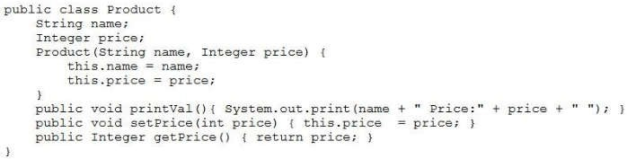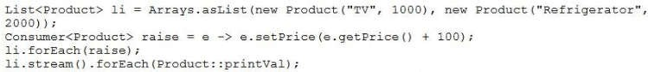

What is the result?

Given:

**QUESTION 131**

**Reference:**

**Explanation/**

**Explanation**

**Section: (none)**

**Correct Answer:** A

The program prints nothing.

D.

C. TV Price :1000 Refrigerator Price :2000

A compilation error occurs.

B.

A. TV Price :110 Refrigerator Price :2100

and

fragments :

Given the code

**QUESTION 130**

**Reference:**

**Explanation/**

**Explanation**

**Section: (none)**

**Correct Answer:** D

SE

Java EEJava

D.

Java SEJava EE

or

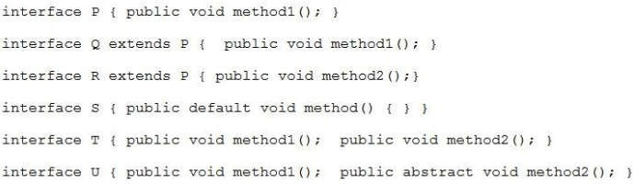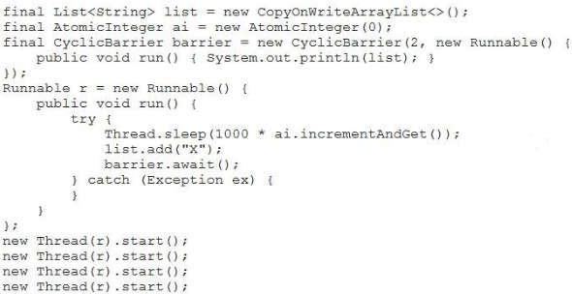

U

[X, X]

[X]

A.

What is the result ?

fragment:

Given the code

**QUESTION 132**

**Reference:**

**Explanation/**

**Explanation**

**Section: (none)**

**Correct Answer:** CD

F.

Q

E.

S

D.

P

C.

R

B.

T

A.

Which two interfaces can you use to create lambda expressions? (Choose two.)



D. Stream<Path> stream = Files.list

to enable the code to print only

/company/emp

?

A. Stream<Path> stream = Files.list (Paths.get (“/company”));

B. Stream<Path> stream = Files.find(

Paths.get (“/company”), 1,

(p,b) –> b.isDirectory (),

FileVisitOption.FOLLOW_LINKS);

C. Stream<Path> stream = Files.walk

(Paths.get (“/company”));

line n1

(Paths.get (“/company/emp”));

**Correct Answer:** B

**Section: (none)**

**Explanation**

**Explanation/**

**Reference:**

**QUESTION 134**

Given:

**Section: (none)**

[X, X, X]

[X, X, X, X]

B. [X, X]

C. [X]

[X, X]

[X, X, X]

D. [X, X]

[X, X, X, X]

**Correct Answer:** A

**Explanation**

**Explanation/**

**Reference:**

**QUESTION 133**

Given that these

files exist and are

accessible:

and given the code fragment:

Which code fragment can be inserted at

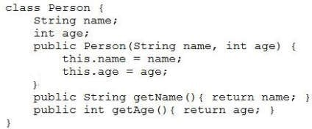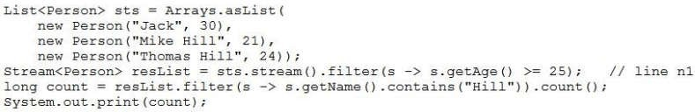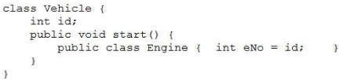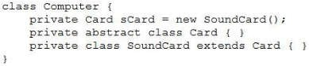

2

B.

A.

definition compiles?

Which class

**QUESTION 135**

**Reference:**

**Explanation/**

**Explanation**

**Section: (none)**

**Correct Answer:** B

D.

is thrown at run time.

Exception

An

C.

line n1.

A compilation error occurs at

B.

0

A.

What is the result?

and the code fragment:

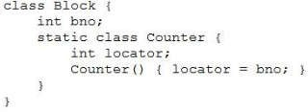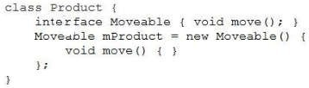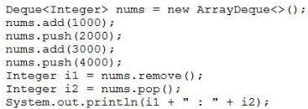

version.txt

D.

1000 :

2000

**Correct Answer:** B

**Section: (none)**

**Explanation**

**Explanation/**

**Reference:**

**QUESTION 137**

Given that

4000

is

accessible and

contains:

1234567890

and given the code

fragment:

fragment:

C.

D.

**Correct Answer:** B

**Section: (none)**

**Explanation**

**Explanation/**

**Reference:**

**QUESTION 136**

Given the code

What is the result?

A.

4000 :

2000

B.

4000 :

1000

C.

1000 :

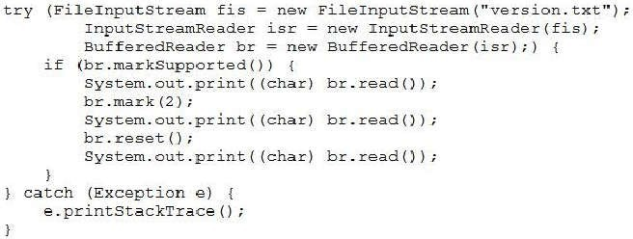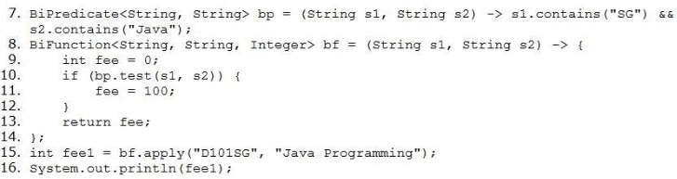

**QUESTION 138**

**Reference:**

**Explanation/**

**Explanation**

**Section: (none)**

**Correct Answer:** A

A compilation error occurs at line 15.

D.

A compilation error occurs at line 8.

C.

100

B.

A. A compilation error occurs at line 7.

What is the result?

**Reference:**

**Explanation/**

**Explanation**

**Section: (none)**

**Correct Answer:** B

D. The program prints nothing.

135

C.

122

B.

121

A.

What is the result?

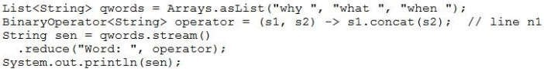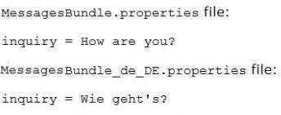

C. Word: why Word: what Word: when

**Explanation**

**Explanation/**

**Reference:**

**QUESTION 140**

Given the code

fragment:

What is the result?

A. Word: why what when

B. Word: why Word: why what Word: why what when

**Section: (none)**

D.

Compilation fails at

line n1.

**Correct Answer:** A

**Section: (none)**

**Explanation**

(“DE”).build();

**QUESTION 139**

Given the content:

and given the code fragment:

Which two code fragments, when inserted at

line 1

independently, enable the code to print “Wie geht’s?”

A. currentLocale = new Locale (“de”, “DE”);

B. currentLocale = new Locale.Builder ().setLanguage (“de”).setRegion

C. currentLocale = Locale.GERMAN;

D. currentlocale = new Locale();

currentLocale.setLanguage (“de”);

currentLocale.setRegion (“DE”);

E. currentLocale =

Locale.getInstance(Locale.GERMAN,

Locale.GERMANY);

**Correct Answer:** BD

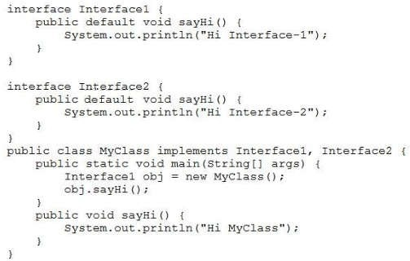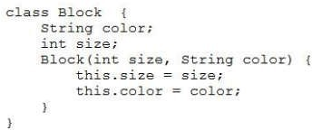

D. Hi MyClass

and the code fragment:

Given:

**QUESTION 142**

**Reference:**

**Explanation/**

**Explanation**

**Section: (none)**

**Correct Answer:** D

C. Hi Interface-1

A compilation error occurs.

B.

A. Hi Interface-2

What is the result?

Given:

**QUESTION 141**

**Explanation/Reference:**

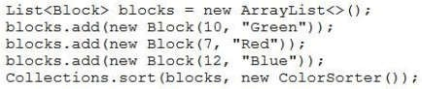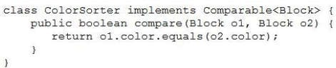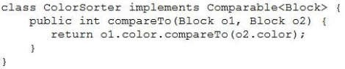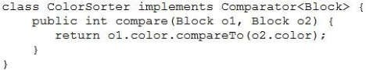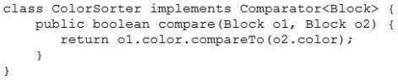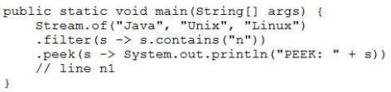

**QUESTION 143**

?

PEEK: Unix

independently, result in the output

line n1

Which two code fragments, when inserted at

fragment:

Given the code

**Reference:**

**Explanation/**

**Explanation**

**Section: (none)**

**Correct Answer:** C

D.

C.

B.

A.

class sorts the blocks list?

ColorSorter

Which definition of the

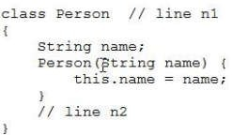

line n2

C.

Replace

line n1

with

class Person implements

Comparable<Person>

D.

At

line n2

insert

public int compare (Person p1, Person p2) {

return p1.name.compareTo (p2.name);

}

E.

At

}

insert:

public int compareTo (Person p, Person p2) {

return p1.name.compareTo (p2.name);

}

F.

Replace

line n1

with

class Person implements Comparator<Person>

**Correct Answer:** BC

**Section: (none)**

**Explanation**

Which two modifications enable to sort the elements of the

A. .anyMatch ();

B. .allMatch ();

C. .findAny ();

D. .noneMatch ();

E. .findFirst ();

**Correct Answer:** CE

**Section: (none)**

**Explanation**

**Explanation/**

**Reference:**

**QUESTION 144**

Given the code

fragments:

and

emps

list? (Choose two.)

A.

Replace

line n1

with

class Person extends Comparator<Person>

B.

At

line n2

insert

public int compareTo (Person p)

{ return this.name.compareTo

(p.name);

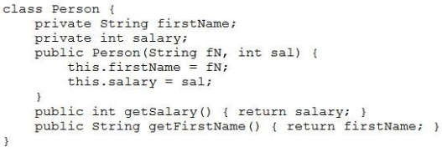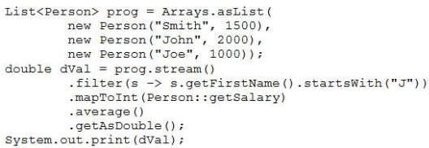

D.

fragment:

Given the code

**QUESTION 146**

**Reference:**

**Explanation/**

**Explanation**

**Section: (none)**

**Correct Answer:** B

2000.0

C. A compilation error occurs.

1500.0

B.

0.0

A.

What is the result?

and the code fragment:

Given:

**QUESTION 145**

**Explanation/Reference:**

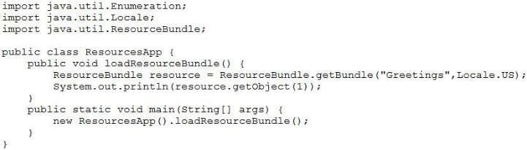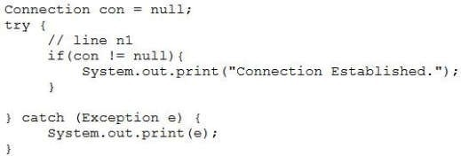

**Reference:**

prop.put(“url”, dbURL);

con = DriverManager.getConnection

(prop);

D. con = DriverManager.getConnection (dbURL);

con.setClientInfo (“user”, userName);

con.setClientInfo (“password”, password);

**Correct Answer:** A

**Section: (none)**

**Explanation**

**Explanation/**

prop.put (“password”, password);

**QUESTION 147**

Given the

Greetings.prop

erties

file,

containing:

and given:

?

Assume that

dbURL, userName

, and

password

are valid.

Which code fragment can be inserted at

line n1

to enable the code to print

Connection Established

A. Properties prop = new Properties();

prop.put (“user”, userName);

prop.put (“password”, password);

con = DriverManager.getConnection

(dbURL, prop);

B. con = DriverManager.getConnection

(userName, password, dbURL);

C. Properties prop = new Properties();

prop.put (“userid”, userName);

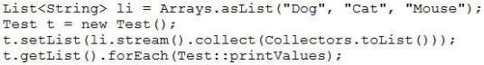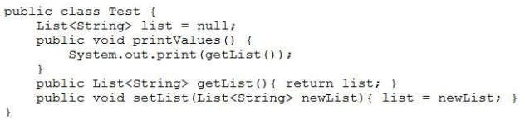

**Explanation/**

A. null

B.

A compilation error occurs.

C. DogCatMouse

D. [Dog, Cat, Mouse]

**Correct Answer:** D

**Section: (none)**

**Explanation**

What is the result?

**Reference:**

**QUESTION 149**

Given the records

from the

STUDENT

table:

**Correct Answer:** A

What is the result?

A.

Compilation fails.

B. GOODBY_MSG

C. Hello, everyone!

D. Goodbye everyone!

E. HELLO_MSG

**Section: (none)**

**Explanation**

**Explanation/**

**Reference:**

**QUESTION 148**

Given the code

fragments:

and

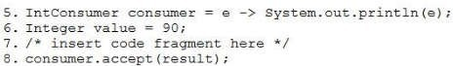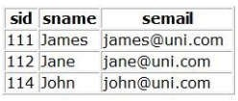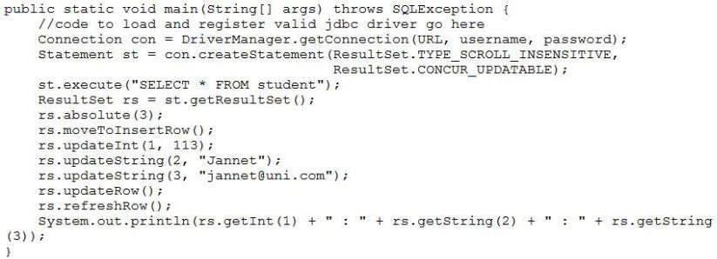

**Explanation**

STUDENT

table is updated with the record:

113 : Jannet : jannet@uni.com

and the program prints:

113 : Jannet : jannet@uni.com

D. A

SQLException

is thrown at run time.

**Correct Answer:** D

**Section: (none)**

The

**Explanation/**

**Reference:**

**QUESTION 150**

Given the code

fragment:

Which code fragment, when inserted at line 7, enables printing

100

?

Given the code fragment:

Assume that the

URL, username,

and

password

are valid.

What is the result?

A.

The

STUDENT

table is not updated and the program prints:

114 : John : john@uni.com

B.

The

STUDENT

table is updated with the record:

113 : Jannet : jannet@uni.com

and the program prints:

114 : John : john@uni.com

C.

Which two

J.

executed.

statement when

synchronized

intrinsic lock on a

acquires the

automatically

A thread

I.

two.)

and locks? (Choose

about synchronization

statements are true

The intrinsic lock will be retained by a thread if return from a synchronized method is caused by an

**QUESTION 152**

ork-and-join.html

ava-multi-threading/f

j

core-java-tutorial/

ogicbig.com/tutorials/

ww.l

**Explanation/**

fragment:

Given the code

**QUESTION 153**

cksync.html

ential/concurrency/lo

m/javase/tutorial/ess

https://docs.oracle.co

Reference:

**Reference:**

**Explanation**

**Section: (none)**

**Correct Answer:** AB

Threads cannot acquire intrinsic locks on classes.

M.

method.

A thread automatically acquires the intrinsic lock on a synchronized method’s object when entering that

L.

releases it.

A thread exclusively owns the intrinsic lock of an object between the time it acquires the lock and the time it

K.

uncaught exception.

**Explanation/**

used when a

subclass is

k

RecursiveTas

The

E.

(Choose two.)

Framework?

about the Fork/Join

statements are true

Which two

**QUESTION 151**

**Reference:**

task does not

**Explanation**

**Section: (none)**

**Correct Answer:** A

int result = funRef.apply (value);

D. ToIntFunction funRef = e –> e + 10;

int result = funRef.applyAsInt (value);

C. ToIntFunction<Integer> funRef = e –> e + 10;

Integer result = funRef.apply (10);

B. IntFunction funRef = e –> e + 10;

Integer result = funRef.apply(value);

A. Function<Integer> funRef = e –> e + 10;

implements a

Reference: https://w

**Reference:**

**Explanation/**

**Explanation**

**Section: (none)**

**Correct Answer:** AC

solution.

The Fork/Join solution when run on multicore hardware always performs faster than standard sequential

H.

algorithm.

work-stealing

framework

The Fork/Join

G.

hardware.

multicore

advantage of

help you take

framework can

The Fork/Join

F.

result.

need to return a

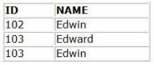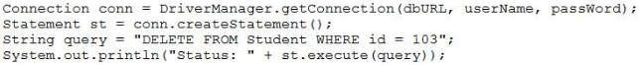

Student table.

SQLException

A

C.

Student table.

and two records are deleted from the

Status: false

The program prints

B.

is thrown at runtime.

and two records are deleted from the

Status: true

The program prints

A.

What is the result?

exists.

passWord

**Section: (none)**

**Reference:**

**Explanation/**

**Explanation**

, and

**Correct Answer:** B

table are not deleted.

Student

but the records from the

Status: false

The program prints

D.

B. IntStream str = IntStream.of (1, 2, 3, 4);

**QUESTION 154**

**Reference:**

**Explanation/**

**Explanation**

**Section: (none)**

**Correct Answer:** C

D. Stream str = Stream.of (1, 2, 3, 4);

C. DoubleStream str = Stream.of (1.0, 2.0, 3.0, 4.0);

Given the structure

A. IntStream str = Stream.of (1, 2, 3, 4);

?

Average = 2.5

to print

line n1

Which should be inserted into

)

dbURL, userName

The appropriate database is accessible with the

The required database driver is configured in the classpath.

Assume that:

Given the code fragment:

table:

STUDENT

Given the records from the

VARCHAR

, name

INTEGER

Student (id

table:

Student

of the

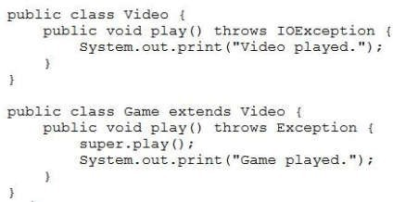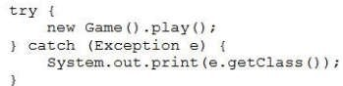

It provides a

F.

It is used to get

an instance of a

Connection

object by using

JDBC drivers.

G.

It provides a

cursor to fetch

the resulting

data.

H.

database.

class for

executing SQL

statements and

returning the

results.

**Correct Answer:** D

**Section: (none)**

**Explanation**

**Explanation/**

**Reference:**

**Explanation**

**QUESTION 155**

Given the code fragments:

and

What is the result?

A. Video played.Game played.

B.

A compilation error occurs.

C. class java.lang.Exception

D. class java.io.IOException

**Correct Answer:** C

**Section: (none)**

**Explanation/**

**Reference:**

**QUESTION 156**

What is true about

the

java.sql.State

ment

interface?

E.

It provides a

session with the

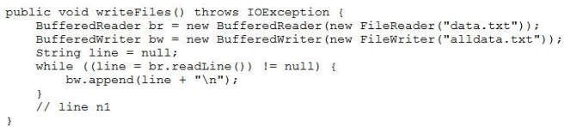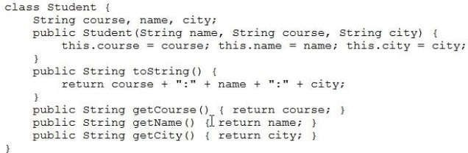

A. br.close();

and the code fragment:

Given:

**QUESTION 158**

**Reference:**

**Explanation/**

**Explanation**

**Section: (none)**

**Correct Answer:** D

D. bw.flush();

C. br.flush();

B. bw.writeln();

?

data.txt

with

alldata.txt

to enable the code to overwrite

line n1

What is required at

Given that data.txt and alldata.txt are accessible, and the code fragment:

**QUESTION 157**

Reference: https://docs.oracle.com/cd/E13222_01/wls/docs45/classdocs/java.sql.Statement.html

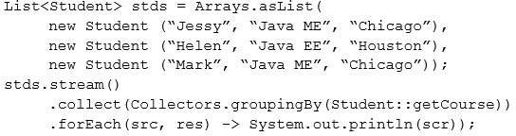

[Java EE: Helen:Houston]

Explanation:

**Reference:**

**Explanation/**

**Explanation**

**Section: (none)**

**Correct Answer:** D

A compilation error occurs.

D.

C. [Java ME: Jessy:Chicago, Java ME: Mark:Chicago]

ME

Java

B. Java EE

[Java ME: Jessy:Chicago, Java ME: Mark:Chicago]

A. [Java EE: Helen:Houston]

What is the result?

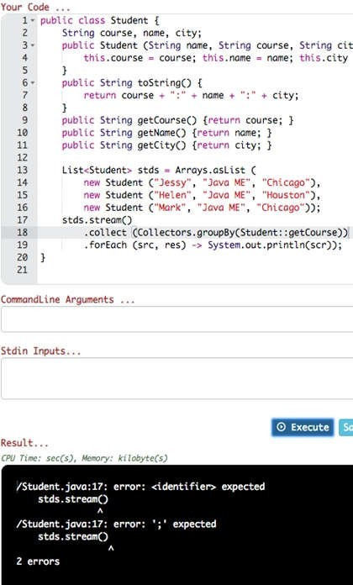

**QUESTION 159**

Given:

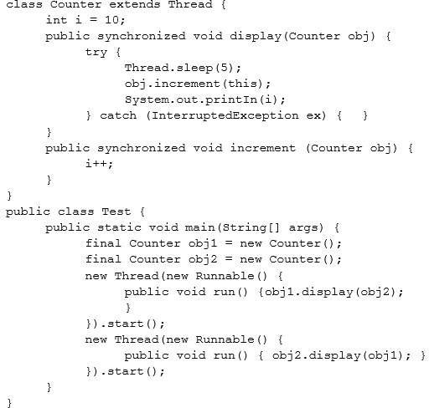

livelock

class:

of the Employee

Given the definition

**QUESTION 160**

**Reference:**

**Explanation/**

**Explanation**

**Section: (none)**

**Correct Answer:** B

D.

starvation

C.

deadlock

B.

race condition

A.

From what threading problem does the program suffer?

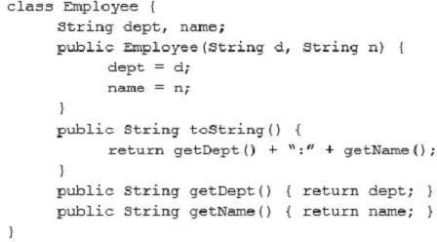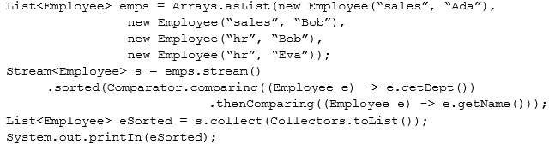

Callable {

void run

()

{ System.o

ut.print

(“Runnable

”) ; }

}

class

ThreadCaller

implements

public

Public String

call () throws

Exception

{return

“Callable”; )

}

and

**Explanation**

and this code fragment:

What is the result?

A. [sales:Ada, hr:Bob, sales:Bob, hr:Eva]

B. [Ada:sales, Bob:sales, Bob:hr, Eva:hr]

C. [hr:Eva, hr:Bob, sales:Bob, sales:Ada]

D. [hr:Bob, hr:Eva, sales:Ada, sales:Bob]

**Correct Answer:** A

**Section: (none)**

**Explanation/**

**Reference:**

**QUESTION 161**

Given the code

fragments:

class

ThreadRunner

implements

Runnable {

300.32

**Reference:**

**QUESTION 162**

Given the code

fragment:

List<Double> doubles = Arrays.asList (100.12, 200.32);

DoubleFunction funD = d –> d + 100.0;

doubles.stream (). forEach (funD);

// line n1

doubles.stream(). forEach(e –> System.out.println(e));

// line n2

What is the result?

A. A compilation error occurs at

line n2

.

B. 200.12

**Explanation/**

C. 100.12

200.32

D. A

compilatio

n error

occurs at

line n1

.

**Correct Answer:** A

**Section: (none)**

**Explanation**

**Explanation/**

**Reference:**

Explanation:

c1

ExecutorService es = Executors.newCachedThreadPool ();

Runnable r1 = new ThreadRunner ();

Callable c1 = new ThreadCaller ();

// line n1

es.shutdown();

Which code

fragment can be

inserted at

line

n1

to start

r1

and

threads?

A.

Future<String> f1 = (Future<String>) es.submit (r1);

es.execute (c1);

B. es.execute (r1);

Future<String> f1 = es.execute (c1) ;

C.

Future<String> f1 = (Future<String>) es.execute(r1);

Future<String> f2 = (Future<String>) es.execute(c1);

D. es.submit(r1);

Future<String> f1 = es.submit (c1);

**Correct Answer:** D

**Section: (none)**

**Explanation**

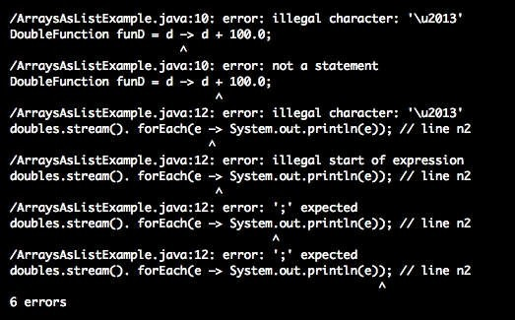

B. 2:30

return new Product (p1.id, p1.price);});

products.add(p);

products.stream().parallel()

.reduce((p1, p2) - >

p1.price > p2.price ? p1

: p2)

.ifPresent(System.out: :prin

tln);

What is the result?

A. 4:60

p1.price+=p2.price;

C. 4:60

2:30

3:20

1:10

D. 4:0

E. The

progra

m prints

nothing

Public String

**QUESTION 163**

Given:

public class Product {

int id; int price;

public Product (int

id, int price) {

this.id = id;

this.price = price;

}

toString ()

{ return id + “:” +

price;)

}

and the code fragment:

List<Product> products = new ArrayList <> (Arrays.asList(new Product(1, 10),

new Product (2, 30),

new Product (3, 20));

Product p = products.stream().reduce(new Product (4, 0), (p1, p2) -> {

A.

ouston]

Helen:H

EE:

C. [Java

ME

Java

B. Java EE

A compilation error occurs.

[Java

What is the result?

.forEach(src, res) -> System.out.println(scr));

e))

.collect(Collectors.groupingBy(Student::getCours

stds.stream()

“Chicago”));

ME”,

D. [Java ME: Jessy:Chicago, Java ME: Mark:Chicago]

Given:

**QUESTION 165**

**Reference:**

**Explanation/**

**Explanation**

**Section: (none)**

**Correct Answer:** B

[Java EE: Helen:Houston]

“Java

icago]

Mark:Ch

ME:

Java

hicago,

Jessy:C

ME:

Given:

{ this.course = course; this.name = name; this.city =

public Student (String name, String course, String city)

city;

name,

course,

String

{

class Student

city;

**QUESTION 164**

**Reference:**

**Explanation/**

**Explanation**

**Section: (none)**

**Correct Answer:** C

public String getCity() {return city;}

(“Mark”,

Student

new

new Student (“Helen”, “Java EE”, “Houston”),

new Student (“Jessy”, “Java ME”, “Chicago”),

List<Student> stds = Arrays.asList(

and the code fragment:

public String getName() {return name;}

public String getCourse() {return course;}

}

return course + “:” + name + “:” + city;

{

public String toString()

}

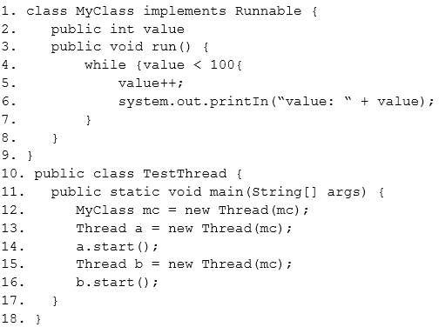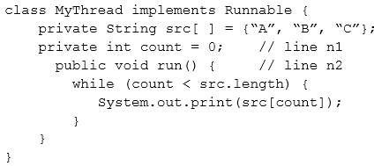

D.

and the code fragment:

Given:

**QUESTION 166**

**Reference:**

**Explanation/**

**Explanation**

**Section: (none)**

**Correct Answer:** B

public synchronized int value;

Line 2:

public volatile int value;

Line 2:

C.

class MyClass extends Thread {

Line 1:

B.

public synchronized void run() {

Line 3:

A.

What change should you make to guarantee a single order of execution (printed values 1 -100 in order)?

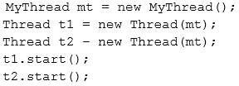

fragment:

Long fCount = paths.count();

FileVisitOption.FOLLOW_LINKS);

(“txt”),

(p, a) -> p.getFileName().toString().endsWith

maxDepth,

Stream<Path> paths = Files.find(Paths.get(“/sports”),

=2;

int maxDepth

System.out.println(fCount);

and given the code

ODI.txt

cricket/data/

/sports/

players.txt

cricket/

/sports/

info.txt

3

**Explanation**

**Section: (none)**

**Correct Answer:** D

is thrown at runtime.

Exception

An

H.

/sports/

G.

2

F.

1

E.

the result?

Assuming that there are NO soft-link/symbolic links to any of the files in the directory structure, what is

A.

B.

block.

synchronized

within a

t2

and

t1

start the threads

Replace line n1 with:

Which modification meets the requirement?

You have been asked to modify the code to make the threads execute synchronously and prints ABC.

execute asynchronously and possibly prints ABCA or AACB.

t2

and

t1

The threads

**Correct Answer:** A

accessible:

files exist and are

Given that these

**QUESTION 167**

**Reference:**

**Explanation/**

**Explanation**

**Section: (none)**

volatile int count = 0;

Replace line n2 with:

D.

public synchronized void run () {

Replace line n2 with:

C.

private synchronized int count = 0;

Happy Journey!

line n1

Replace

B.

{

FuelNotAvailException

public void ride() throws

with

line n1

Replace

A.

?

with

Which modification enables the code fragment to print

}

v.ride();

Vehicle v = new SolarVehicle ();

{

public static void main (String[] args) throws Exception

and the code fragment:

}

}

//line n2

{ super ride ();

line n2

Given:

**QUESTION 170**

**Reference:**

**Explanation/**

**Explanation**

**Section: (none)**

**Correct Answer:** C

{

FuelNotAvailException

private void ride() throws

with

public void ride () throws FuelNotAvailException

Replace

D.

FuelNotAvailException, Exception {

public void ride()throws

with

line n2

Replace

C.

{

protected void ride() throws Exception

It accepts one argument and returns

**Reference:**

**Explanation/**

**Explanation**

**Section: (none)**

**Correct Answer:** B

It accepts an argument and produces a result of any data type.

D.

It accepts one argument and always produces a result of the same type as the argument.

C.

.

boolean

B.

.

void

It accepts one argument and returns

A.

interface?

java.util.function.Predicate

Which statement is true about the single abstract method of the

**QUESTION 168**

**Explanation/Reference:**

**QUESTION 169**

{

class SolarVehicle extends Vehicle

}

}

System.out.println(“Happy Journey!”);

{

void ride() throws FuelNotAvailException

} class Vehicle{

class FuelNotAvailException extends Exception {

//line n1

Given:

ate-interface

oint.com/java-predic

ww.javatp

Reference: https://w

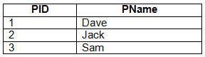

}

try {

Connection conn = DriverManager.getConnection(URL, username, password);

Statement st= conn.createStatement(

ResultSet.TYPE_SCROLL_SENSITIVE,

ResultSet.CONCUR_UPDATABLE);

st.execute (“SELECT * FROM Player”);

st.setMaxRows(2);

ResultSet rs = st.getResultSet();

rs.absolute(3); while

(rs.next ()) {

System.out.println(r

s.getInt(1) + “

“ +

rs.getString(2))

;

and given the code fragment:

} catch (SQLException ex)

{ System.out.print(“SQLException is

thrown.”);

}

Assume that:

The required database driver is configured in the classpath.

The appropriate database is accessible with

URL, username,

and

password.

The SQL query is valid.

What is the result?

A.

2 Jack

B.

public class Counter

{

public static void main (String[ ] args) {

int a = 10;

int b = -1;

assert (b >=1) : “Invalid Denominator”;

int с = a / b;

System.out.println (c);

}

}

What is the result of running the code with the

–da

option?

A. -10

0

C.

An

AssertionError

is thrown.

D.

A compilation error occurs.

**Correct Answer:** A

**Section: (none)**

**Explanation**

**Explanation/**

**Reference:**

**QUESTION 171**

Given records from

the Player table:

19.

dbURL

The appropriate database is accessible with the

The required database driver is configured in the classpath.

Assume that:

22. }

System.out.println(“Error”);

21.

{

20. } catch (SQLException se)

}

,

“ + rs.getString(4));

“ + rs.getString(3));

System.out.println(Quantity:

System.out.println(“Price:

18.

17.

16.

15.

14.

13.

C.

**Reference:**

**Explanation/**

**Explanation**

**Section: (none)**

**Correct Answer:** B

The code prints information about Item 110.

D.

.

Error

The code prints

12.

Compilation fails.

B.

An exception is thrown at runtime.

A.

What is the result?

The SQL query is valid.

exists.

passWord

, and

userName

**Reference:**

VARCHAR(10

DESCRIP,

•

PK

INTEGER:

ID,

•

Item table

Given:

**QUESTION 172**

0)

**Explanation/**

**Explanation**

**Section: (none)**

**Correct Answer:** D

D. SQLException is thrown.

C. 3 Sam

The program prints nothing.

B.

3 Sam

String query = “Select * FROM Item WHERE ID = 110”;

11.

10.

“ + rs.getString(2));

System.out.println(“Description:

“ + rs.getString(1));

System.out.println(“ID:

{

while(rs.next())

ResultSet rs = stmt.executeQuery(query);

Statement stmt = conn.createStatement();

Connection conn = DriveManager.getConnection(dbURL, username, password);

9. try {

fragment:

And given the code

INTEGER

QUANTITY<

•

REAL

PRICE,

•



**Correct Answer:** D

What is the result?

A.

2

B.

3

C.

A compilation error occurs at

line n1

.

D.

A compilation error occurs at

line n2

.

//line n2

**Section: (none)**

**Explanation**

**Explanation/**

**Reference:**

**QUESTION 174**

Given:

Which option fails?

A. Foo<String, Integer> mark = new Foo<Object, Object> (“Steve”, 100);

B. Foo<String, String> pair = Foo.<String>twice (“Hello World!”);

C. Foo<Object, Object> percentage = new Foo<Object, Object>(“Steve”, 100);

D. Foo<String, String> grade = new Foo <> (“John”, “A”);

//line n1

**QUESTION 173**

Given the code fragments:

interface CourseFilter extends Predicate<String>

{

{

public default boolean test (String str)

return str.contains (“Java”);

}

}

and

List<String> strs = Arrays.asList(“Java”, “Java EE”, “Embedded Java”);

Predicate<String> cf1 = s - > s.length() > 3;

Predicate cf2 = new CourseFilter()

{ public boolean test

(String s)

{

return s.startsWith (“Java”);

}

};

long c = strs.stream()

.filter(cf1)

.filter(cf2

.count();

System.out.println(c);

protected void draw (int color)

}

abstract void open ();

{ }

public void resize ()

public class Frame extends Canvas implements Drawable {

}

}

{

public

} public class Paper extends Canvas {

public abstract class Board extends Canvas {

}

{ }

public void draw ()

public class Canvas implements Drawable {

Given:

**QUESTION 176**

interface Drawable

{ public abstract void draw

();

}

Which statement is true?

A. Board

does not compile.

B. Paper

does not compile.

C. Frame

does not compile.

D. Drawable

does not compile.

E.

All classes compile successfully.

What is the result?

**Correct Answer:** C

**Section: (none)**

**Explanation**

**Explanation/**

**Reference:**

**QUESTION 175**

Given the code

fragment:

Map<Integer, String> books = new TreeMap<>();

books.put (1007, “A”);

books.put (1002, “C”);

books.put (1003, “B”);

books.put (1003, “B”);

System.out.println (books);

A.

{1007=A, 1003=B, 1002=C}

B.

{1007=A, 1003=B, 1003=B,

1002=C}

C.

{1007=A, 1002=C, 1003=B,

1003=B}

D.

{1002=C, 1003=B, 1007=A}

**Correct Answer:** D

**Section: (none)**

**Explanation**

**Explanation/**

**Reference:**

System.out.println(res2);

**Correct Answer:** D

**Section: (none)**

**Explanation**

**Explanation/**

**Reference:**

**QUESTION 178**

Given the code

fragment:

Path path1 = Paths.get(“/app/./sys/”);

Path res1 = path1.resolve(“log”);

Path path2 =

Paths.get(“/server/exe/”);

Path res1 = path2.resolve(“/readme/”);

System.out.println(res1);

.

What is the result?

E. /app/sys/log

/readme/server/exe

B. /app/log/sys

/server/exe/readme

C. /app/./sys/log

/readme

D. /app/./sys/log

/server/exe/readme

**Correct Answer:** D

**Section: (none)**

**Explanation**

**Explanation/**

**Reference:**

.map(lv -> uo1.apply(lv))

**Correct Answer:** C

**Section: (none)**

**Explanation**

**Explanation/**

**Reference:**

**QUESTION 177**

Given the code

fragment:

UnaryOperator<Double> uo1 = s -> s*2;

//line n1

List<Double> loanValues = Arrays.asList(1000.0, 2000.0);

loanValues.stream()

.filter(lv -> lv >= 1500)

//line n2

.forEach(s -> System.out.print(s + “ “));

What is the result?

A. 4000.0

B. 4000

C.

A compilation

error occurs at

line n1

.

D.

A compilation

error occurs at

line n2

System.out.println(“Searching…”);

return n.contains(“red”);

};

colors.stream()

.filter(c -> c.length() >= 3)

.allMatch(test);

What is the result?

E. Searching…

F. Searching…

Searching…

G. Searching…

Searching…

Predicate<String> test = n - > {

Searching…

H.

A compilation

error occurs.

**Correct Answer:** C

**Section: (none)**

**Explanation**

**Explanation/**

**Reference:**

**QUESTION 181**

Given the definition

of the

Emp

class:

A compilation error occurs.

**QUESTION 179**

Given the code fragment:

List<String> nL = Arrays.asList(“Jim”, “John”, “Jeff”);

Function<String, String> funVal = s -> “Hello : “.concat(s);

nL.Stream()

.map(funVal)

.forEach(s-> System.out.print (s));

What is the result?

A. Hello : Jim Hello : John Hello : Jeff

B. Jim John Jeff

C.

The program prints nothing.

D.

**Correct Answer:** C

**Section: (none)**

**Explanation**

**Explanation/**

**Reference:**

Explanation:

The program prints

nothing because

the method is

concat.

**QUESTION 180**

Given the code

fragment:

List<String> colors = Arrays.asList(“red”, “green”, “yellow”);

{

output = true;

if (this.id = = b.id) {

Book b = (Book) obj;

boolean output = false;

public boolean equals (Object obj) {

//line n1

}

this.name = name;

this.id = id;

}

String name)

(int id,

public Book

String name;

int id;

class Book {

Given:

**QUESTION 182**

=

//line n2

(b1.equals(b2));

System.out.println

Programing”);

“Java

(102,

Book

new

**Reference:**

b2

Book

Book b1 = new Book (101, “Java Programing”);

and the code fragment:

}

}

return output;

{

//line n1

Predicate<Emp> agVal = s -> s.getEAge() <= 60;

(“Jim”, 51));

List<Emp>li = Arrays.asList(new Emp(“Sam”, 20), New Emp(“John”, 60), New Emp

and code fragment:

**}**

public String getEName () {return eName;}

public Integer getEAge () {return eAge;}

}

li = li.stream().filter(agVal).collect(Collectors.toList());

this.eAge = eA;

this.eName = eN;

Emp(String eN, Integer eA)

eAge;

private Integer

private String eName;

public class Emp

line n1

**Explanation/**

**Explanation**

**Section: (none)**

**Correct Answer:** C

.

line n2

A compilation error occurs at

D.

.

A compilation error occurs at

C.

B. John Jim

A. Sam John Jim

What is the result?

n2 names.forEach(n -> System.out.print(n + “ “));

//line

Stream<String> names = li.stream()map.(Emp::getEName);

extends

}

{

UserException

extends

xception

AgeOutOfLimitE

class

}

{

Exception

and the code

UserException

class

Given:

**QUESTION 184**

**Reference:**

**Explanation/**

**Explanation**

**Section: (none)**

**Correct Answer:** D

.

{ if

}

}

System.out.println(“User is registered.”);

} else {

throw new AgeOutOfLimitException ();

{

} else if (age > 60)

throw new UserException ();

{

(name.length () <= 60)

line n1

throws UserException, AgeOutOfLimitException

age)

name, int

(String

doRegister

void

public

{

class App

fragment:

C.

System.out.println (b1.equals((Object) b2));

with:

line n2

A compilation error occurs. To ensure successful compilation, replace

D.

{

boolean equals (Book obj)

with:

line n1

A compilation error occurs. To ensure successful compilation, replace

**Correct Answer:** B

.

false

The program prints

B.

.

true

The program prints

A.

Which statement is true?

LocalDate nextYear = next15days.plusYears(1); // line n1

error occurs at

D. A compilation

C. 2016-02-29

is thrown.

ion

DateTimeExcept

B. A

A. 2016-03-01

What is the result?

System.out.println(nextYear);

LocalDate next15days = valentinesDay.plusDays (15);

LocalDate valentinesDay =LocalDate.of(2015, Month.FEBRUARY, 14);

fragment:

Given the code

**QUESTION 183**

**Reference:**

**Explanation/**

**Explanation**

**Section: (none)**

@Override public int compare (Integer o1, Integer o2) {return

System.out.print (entry.getValue () + “ “);

for (Map.Entry<Integer, String> entry : treeMap.entrySet () ) {

(unsortMap);

putAll

treeMap.

} );

(o2); }

o2.compareTo

}

{

Comparator<Integer> ( )

Map<Integer, String> treeMap = new TreeMap <Integer, String> (new

> ( );

unsortMap.put (50, “j”);

unsortMap.put (7, “e”);

unsortMap.put (1, “d”);

C.

**Reference:**

**Explanation/**

**Explanation**

**Section: (none)**

**Correct Answer:** D

z b d e j

D.

j z e b d

unsortMap.put (5, “b”);

d b e z j

B.

A compilation error occurs.

A.

What is the result?

}

}

What is the result?

UserException

A

C.

is thrown.

AgeOutOfLimitException

An

B.

A. User is registered.

is thrown.

}

}

t.doRegister(“Mathew”, 60);

App t = new App ();

{

public static void main(String[ ] args) throws UserException

D.

A compilation error occurs in the main

method.

**Correct Answer:** C

**Section: (none)**

**Explanation**

**Explanation/**

**Reference:**

**QUESTION 185**

Given the code

fragment:

public class Foo {

public static void main (String [ ] args)

{ Map<Integer, String> unsortMap = new

HashMap< unsortMap.put (10, “z”);

C.

**Correct Answer:** D

is thrown at run time.

ExecutionException

An

D.

.

line n1

A compilation error occurs at

**Section: (none)**

Call Caller : Run

Run Runner

The program terminates after printing:

B.

And the program does not terminate.

Call Caller : null

Run Runner

int vno;

{

public String toString ()

}

this.name = name;

this.vno = vno,;

{

public Vehicle (int vno, String name)

String name;

The program prints:

class Vehicle

implements Comparable<Vehicle>{

Given:

**QUESTION 187**

**Reference:**

**Explanation/**

**Explanation**

str.concat (“Caller”);}

{ System.out.println (str.concat

public void run ()

{this.str=s;}

public Runner (String s)

String str;

{

class Runner implements Runnable

}

(“Runner”));}

public String call()throws Exception { return

public Caller (String s) {this.str=s;}

{ String str;

class Caller implements Callable<String>

Given the code fragments:

**QUESTION 186**

Future f2 = es.submit (new Runner (“Run”));

A.

What is the result?

}

es.shutdown();

System.out.println(str1+ “:” + str2);

String str2 = (String) f2.get();

//line n1

String str1 = (String) f1.get();

Future f1 = es.submit (new Caller (“Call”));

ExecutorService es = Executors.newFixedThreadPool(2);

{

ExecutionException

public static void main (String[] args) throws InterruptedException,

and

}

{ int i;

= (char) i;

i = isr.read (); c

isr.skip(2);

//line n1

{ while (!isr.close()) {

InputStreamReader isr = new InputStreamReader(fis);)

try (FileInputStream fis = new FileInputStream (“course.txt”);

char c;

System.out.print(c);

public static void main (String[ ] args)

fragment:

and given the code

Java

Course : :

contains:

accessible and

course.txt is

F. ueJa

**Correct Answer:** C

.

n1

line

A compilation error occurs at

H.

The program prints nothing.

G.

Given that

E. ur :: va

What is the result?

}

}

);

{ e.printStackTrace(

} catch (Exception e)

}

Set<Vehicle>

,

10123:Ford

A. [

What is the result?

“BMW”)); System.out.println(vehicles);

“Ford”)); vehicles.add(new Vehicle (10124,

(); vehicles.add(new Vehicle (10123,

vehicles = new TreeSet <>

10124:BMW]

and this code fragment:

}

this.name.compareTo(o.name);

{ return

public int compareTo(Vehicle o)

}

return vno + “:” + name;

A

**QUESTION 188**

**Reference:**

**Explanation/**

**Explanation**

**Section: (none)**

**Correct Answer:** A

is thrown at run time.

ClassCastException

D.

A compilation error occurs.

C.

10123:Ford]

,

10124:BMW

B. [

Assume the

to enable the

n1

line

inserted at

fragment can be

Which code

accessible.

is

courses.txt

code to print the

// line n1

);

(“courses.txt”

Paths.get

Path file =

fragment:

Given the code

**QUESTION 190**

**Reference:**

H. Stream<String> fc = Files.list (file);

fragment:

Given the code

**QUESTION 191**

**Reference:**

**Explanation/**

**Explanation**

**Section: (none)**

**Correct Answer:** C

fc.forEach (s -> System.out.println(s));

**Explanation/**

fc.stream().forEach (s -> System.out.println(s));

G. List<String> fc = Files.readAllLines(file);

fc.forEach (s - > System.out.println(s));

F. Stream<String> fc = Files.readAllLines (file);

fc.stream().forEach (s -> System.out.println(s));

E. List<String> fc = Files.list(file);

file?

courses.txt

content of the

e depart =

e arrive =

ZonedDateTim

7”));

TC-

ZoneID.of(“U

0, 0,

1, 15, 1, 0,

e.of(2015,

ZonedDateTim

ZonedDateTim

ZonedDateTim

fragment:

Given the code

**QUESTION 189**

**Reference:**

**Explanation/**

**Explanation**

**Section: (none)**

A. Travel time is 4 hours

**Explanation**

**Section: (none)**

**Correct Answer:** C

.

line n1

An exception is thrown at

D.

C. Travel time is 8 hours

B. Travel time is 6 hours

What is the result?

System.out.println(“Travel time is” + hrs + “hours”);

long hrs = ChronoUnit.HOURS.between(depart, arrive); //line n1

5”));

TC-

ZoneID.of(“U

0, 0,

1, 15, 9, 0,

e.of(2015,

A. 20

.

line n2

A compilation error occurs at

D.

.

line n1

A compilation error occurs at

C.

B. 20.5

**Correct Answer:** D

What is the result?

//line n1

System.out.println(val.apply(10, 10.5));

//line n2

BiFunction<Integer, Double, Integer> val = (t1, t2) -> t1 + t2;

fragment:

Given the code

**QUESTION 192**

**Reference:**

String

{

public String toString()

}

city;

{ this.course = course; this.name = name; this.city =

public Student (String name, String course, String city)

city;

name,

course,

**Explanation/**

{

class Student

Given:

**QUESTION 193**

**Reference:**

**Explanation/**

**Explanation**

**Section: (none)**

System.out.println(fN

//line n2

e();

ex.printStackTrac

ex) {

} catch (IOException

());

Basic.File.Attributes.class).creationTime

+ Files.readAttributes(aPath,

ame + “:”

});

ath();

fName.toAbsoluteP

Path aPath =

try {

files.forEach (fName -> {

//line n1

Stream<Path> files = Files.list(Paths.get(System.getProperty(“user.home”)));

.

**Explanation**

**Section: (none)**

**Correct Answer:** C

.

line n2

A compilation error occurs at

D.

The files and folders in the home directory are listed along with their attributes.

C.

line n1

A compilation error occurs at

B.

directory are listed along with their attributes.

home

All files and directories under the

A.

What is the result?

address)

}

address;

return

{

getAddress()

Optional<Address>

public

}

this.address = address;

{

}

Employee (Optional<Address>

address;

{ Optional<Address>

class Employee

fragments:

Given the code

**QUESTION 194**

**Reference:**

**Explanation/**

**Explanation**

return city;

System.out.println(eAddress);

available”;

addrs1.get().getCity() : “City Not

String eAddress = (addrs1.isPresent()) ?

Employee e1 = new Employee (addrs1);

Optional<Address> addrs1 = Optional.ofNullable (address);

Address address = new Address;

and

}

}

**Section: (none)**

{

String toString()

} public

city:

return

{

public String getCity

String city = “New York”;

{

class Address

new

.forEach(src, res) ->

ourse))

.collect(Collectors.groupingBy(Student::getC

stds.stream()

“Chicago”));

“Houston”), new Student (“Mark”, “Java ME”,

EE”,

“Java

(“Helen”,

Student

System.out.println(res));

new Student (“Jessy”, “Java ME”, “Chicago”),

List<Student> stds = Arrays.asList(

and the code fragment:

public String getCity() {return city;}

public String getName() {return name;}

public String getCourse() {return course;}

}

return course + “:” + name + “:” + city;

[Java

**Correct Answer:** B

[Java EE: Helen:Houston]

D. [Java ME: Jessy:Chicago, Java ME: Mark:Chicago]

icago]

Mark:Ch

ME:

Java

hicago,

Jessy:C

ME:

ouston]

Helen:H

EE:

C. [Java

ME

Java

B. Java EE

A compilation error occurs.

A.

What is the result?

F.

directory.

Projects

The method executes and does not make any changes to the

G.

directory only.

Projects

files of the

.class

The method deletes the

H.

directory and its subdirectories.

Projects

files in the

.class

The method deletes all the

E.

What is the result?

method when it is invoked.

recDelete ()

fragment:

100, Robin, HR

A.

What is the result?

.forEach(System.out::println); //line n1

.sorted()

.filter(s-> s.contains(“r”))

empDetails.stream()

AdminServices”,“101, Peter, HR”);

List<String> empDetails = Arrays.asList(“100, Robin, HR”, “200, Mary,

the

Given the code

**QUESTION 196**

**Reference:**

**Explanation/**

**Explanation**

**Section: (none)**

**Correct Answer:** B

The method throws an IOException.

is thrown at run time.

public void recDelete (String dirName) throws IOException

fragment:

Given the code

**QUESTION 195**

**Reference:**

**Explanation/**

**Explanation**

**Section: (none)**

**Correct Answer:** C

{ File [ ] listOfFiles = new File

NoSuchElementException

A

D.

C. null

B. City Not available

A. New York

What is the result?

aFile.delete ();

files and is passed as an argument to

.class

contains subdirectories that contain

Projects

Assume that

}

}

}

}

if (aFile.getName ().endsWith (“.class”))

{

if (!aFile.isDirectory ())

{

for (File aFile : listOfFiles)

{

listOfFiles.length >0)

(dirName) .listFiles(); if (listOfFiles ! = null &&

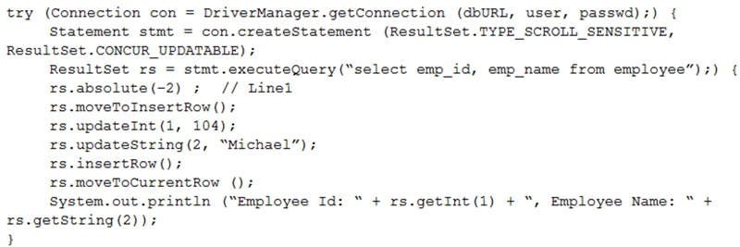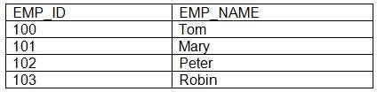

A new record is inserted and

A.

The program throws a runtime exception at

Line 1

.

B.

A compilation error occurs.

C.

A new record is inserted and

Employee Id: 102, Employee Name: Peter

is displayed.

D.

Assuming the database supports scrolling and updating, what is the result?

Employee Id: 104, Employee Name: Michael

is displayed.

**Correct Answer:** D

**Section: (none)**

**Explanation**

**Explanation/**

**Reference:**

**QUESTION 198**

101, Peter, HR

101, Peter, HR

B.

E. A compilation error occurs at

line n1

.

C. 101, Peter, HR

200, Mary, AdminServices

D. 100, Robin, HR

200, Mary, AdminServices

**Correct Answer:** D

**Section: (none)**

**Explanation**

**Explanation/**

**Reference:**

**QUESTION 197**

Given the

EMPLOYEE

table:

Given the code fragment:

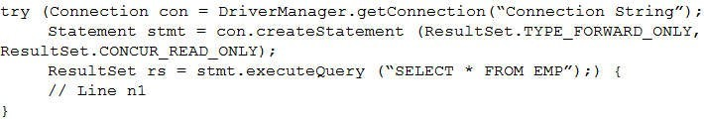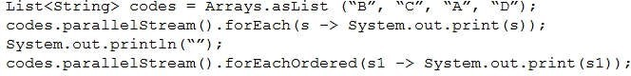

C. rs.last();

Given the code

fragment:

Which code fragment, inserted at

Line n1

, helps you determine the number of records in

ResultSet

?

A. ResultSetMetaData rsmd = rs.getMetaData();

int totRows = rsmd.getRowCount();

B. int totRows=0;

while(rs.next()){

totRows++;

}

records.

int totRows =

rs.getRowCount();

D. rs.last();

int totRows =

rs.getRowId(1);

**Correct Answer:** A

**Section: (none)**

**Explanation**

**Explanation/**

**Reference:**

BCAD

Given the code fragment:

What is the result?

A. ACBD //

in random order

ABCD

B. ABCD //

in random order

ABCD //

in random order

C. ABCD //

in random order

D.

A compile time error

occurs.

**Correct Answer:** B

**Section: (none)**

**Explanation**

**Explanation/**

**Reference:**

**QUESTION 199**

Given the

information: Emp

table has 10

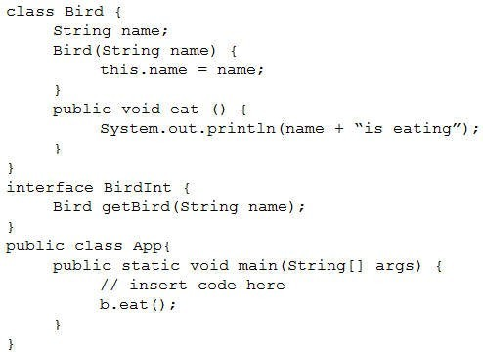

Bird b = b1.getBird(“Peacock”);

Explanation:

**Reference:**

**Explanation/**

**Explanation**

**Section: (none)**

**Correct Answer:** B

D. Bird b = Bird::new(“Peacock”);

C. BirdInt b = new Bird (“Peacock”);

B. BirdInt b1 = Bird::new;

A. BirdInt b = new::Bird(“Peacock”);

?

Peacock is eating

Which code fragment can be inserted to print:

Given:

**QUESTION 200**

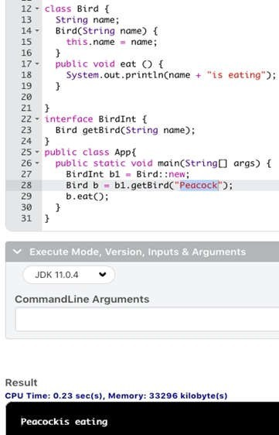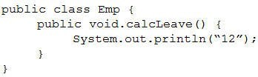

**QUESTION 201**

Given:

and the code fragment:

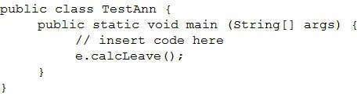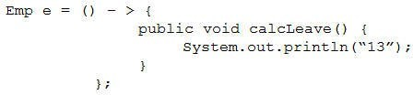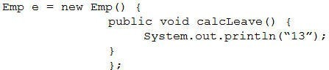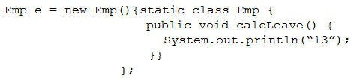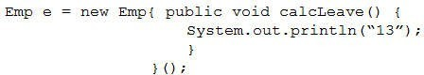

**Explanation**

fragment:

Given the code

**QUESTION 202**

**Reference:**

**Explanation/**

**Section: (none)**

**Correct Answer:** B

D.

C.

B.

A.

?

13

Which code fragment can be inserted to print

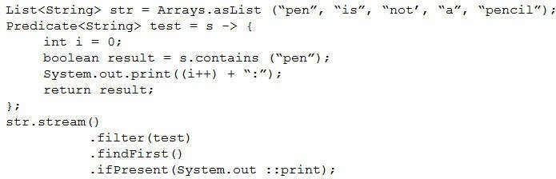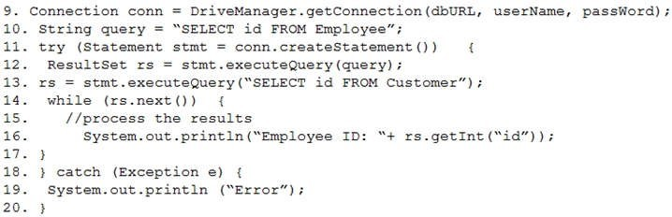

**QUESTION 203**

The program prints

Exception

.

D.

compilation fails on line 13.

**Correct Answer:** C

**Section: (none)**

**Explanation**

**Explanation/**

**Reference:**

C.

Given the code

fragment:

What is the result?

A. 0 : 0 : pen

B. 0 : 1 : pen

C. 0 : pen

D.

0 : 1 : 2 : 3 : 4 :

The

Assume that:

The required database driver is configured in the classpath.

The appropriate database is accessible with the

dbURL

,

userName

, and

passWord

exists.

Employee

and

Customer

tables are available and each table has id column with a few records and the

SQL queries are valid.

What is the result of compiling and executing this code fragment?

A.

The program prints employee IDs.

B.

The program prints customer IDs.

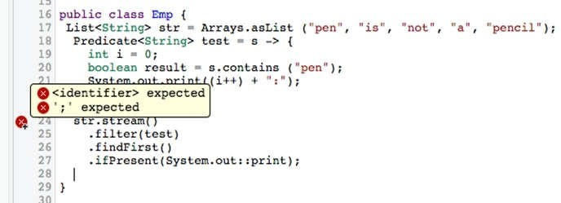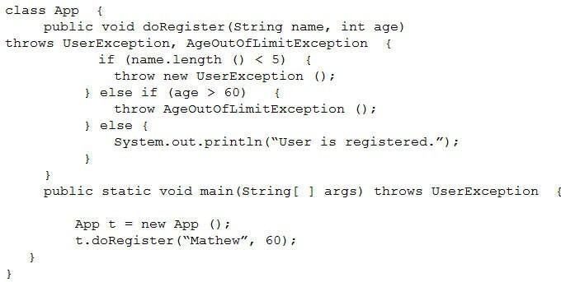

Given:

is thrown.

AgeOutOfLimitException

An

B.

A. User is registered.

What is the result?

and the code fragment:

**QUESTION 204**

Explanation:

**Reference:**

**Explanation/**

**Explanation**

**Section: (none)**

**Correct Answer:** E

E. A compilation error occurs.

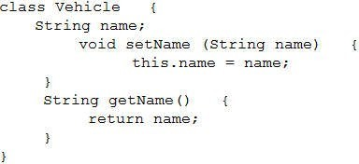

Make the

**Explanation**

**Section: (none)**

**Correct Answer:** B

.

private

method

setName()

and

getName()

**Explanation/**

E.

.

private

variable

name

Make the

D.

.

Path res2 = path2.resolve(“/readme/”);

/server/exe/readme

B. /app/log/sys

/readme/server/exe

F. /app/sys/log

What is the result?

System.out.println(res2);

System.out.println(res1);

public

Paths.get(“/server/exe/”);

Path path2 =

Path res1 = path1.resolve(“log”);

Path path1 = Paths.get(“/app/./sys/”);

fragment:

Given the code

**QUESTION 206**

**Reference:**

method.

Which action encapsulates the Vehicle class?

of the Vehicle class:

Given the definition

**QUESTION 205**

**Reference:**

**Explanation/**

**Explanation**

**Section: (none)**

**Correct Answer:** B

A.

doRegister

A compilation error occurs in the

D.

is thrown.

UserException

A

C.

variable

method

setName()

and

getName()

Make the

C.

.

public

name

Make the

B.

.

private

class

Vehicle

Make the

A.

o1.compareTo

(o2); }

} );

treeMap.putAl

l

(unsortMap);

for (Map.Entry<Integer, String> entry : treeMap.entrySet () ) {

System.out.print (entry.getValue () + “ “);

}

}

}

What is the result?

@Override public int compare (Integer o1, Integer o2) {return

A compilation error occurs.

B.

d b e z j

C.

j z e b d

D.

z b d e j

**Correct Answer:** B

**Section: (none)**

**Explanation**

**Explanation/**

**Reference:**

fragment:

C. /app/./sys/log

/readme

D. /app/./sys/log

/server/exe/readme

**Correct Answer:** B

**Section: (none)**

**Explanation**

**Explanation/**

**Reference:**

**QUESTION 207**

Given the code

public class Foo {

public static void main (String [ ] args)

{ Map<Integer, String> unsortMap = new

HashMap< unsortMap.put (10, “z”);

unsortMap.put (5, “b”);

unsortMap.put (1, “d”);

unsortMap.put (7, “e”);

unsortMap.put (50, “j”);

> ( );

Map<Integer, String> treeMap = new TreeMap <Integer, String> (new

Comparator<Integer> ( )

{