Cảm ơn.
21:52
/-heart
2
/-heart
/-strong
/-heart
:>
:o
:-((
:-h
Ours pleasure
22:02
/-heart
1
/-strong
/-heart
:>
:o
:-((
:-h
13/04/2026
안녕하세요, 지금 어디에 계신가요? 곧 버스 출발 시간인데, 버스에 돌아오셨나요?
08:18
/-heart
1
/-strong
/-heart
:>
:o
:-((
:-h

네 버스 안에 있어요
08:18
/-heart
1
/-heart
/-strong
/-heart
:>
:o
:-((
:-h
T4 06/05/2026


Hong Jung Eun/1977-26/05-45D Laos-chưa tt
[Hình ảnh]
Hello~ on the 26th May ~ 45days ~ Laos fast track Is it possible?
14:05
14:52 06/05/2026
안녕하세요, 잠시만 기다려 주세요. 버스를 확인해 드리겠습니다.
Dear valued partners and customers, 😔 We would like to inform that our trip Nha Trang <=> Bo-Y Laos 45-day Bo - Y Border Laos - Fast Track service is temporarily suspended starting from April 23, until further notice. ❗During this time, our shuttle buses will still transport you to the border gate entrance, but all passengers will need to walk in to complete the manual visa run process as per standard regulations. 🔥We are working hard to reactivate this service as soon as possible and sincerely apologize for this inconvenience. Thank you for your understanding 🙇‍♀️🙇‍♀️🙇‍♀️ 🫡For bookings and inquiries: ​Please contact our manager at www.easytripvisa.com for full assistance.

Easy Trip & VisaVietnam's Top Visa Service Provider (Visa run, E-visa, Taxi, Flight ticket, Apartment for rent, Motorbike for rent)www.easytripvisa.com
14:53
15:29 06/05/2026
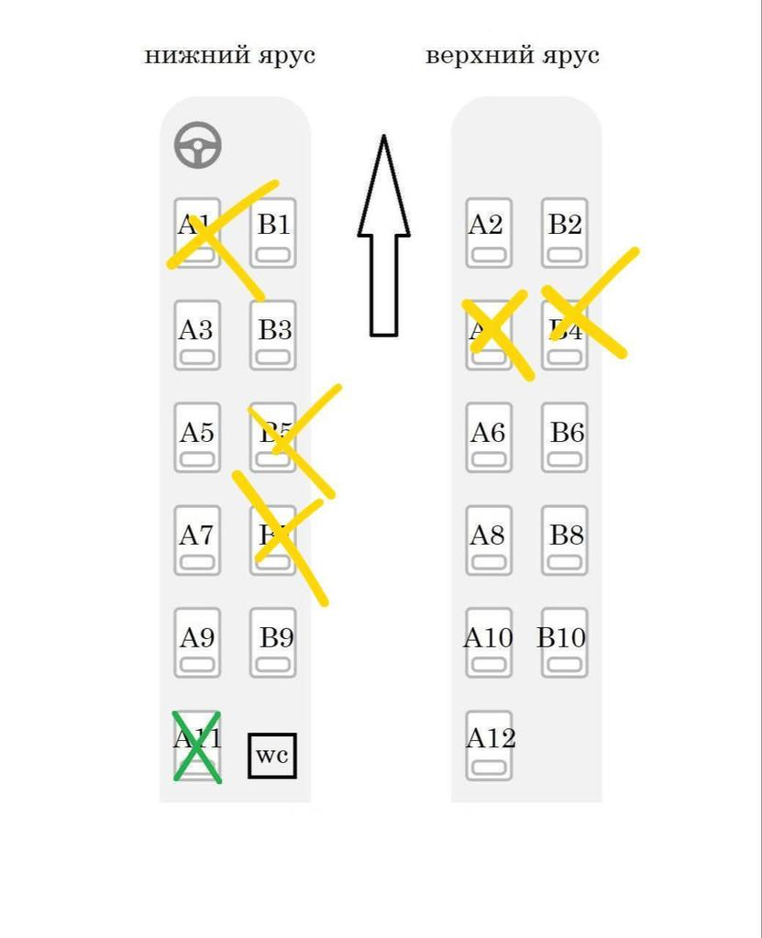
/-strong
/-heart
:>
:o
:-((
:-h
15:29


Easy Trip Visa
[Link] Dear valued partners and customers, 😔 We would like to inform that our trip Nha Trang <=> Bo-Y Laos 45-day Bo - Y Border Laos - Fast Track service is temporarily suspended starting from April 23, until further notice. ❗During this time, our shuttle buses will still transport you to the border gate entrance, but all passengers will need to walk in to complete the manual visa run process as per standard regulations. 🔥We are working hard to reactivate this service as soon as possible and sincerely apologize for this inconvenience. Thank you for your understanding 🙇‍♀️🙇‍♀️🙇‍♀️ 🫡For bookings and inquiries:​Please contact our manager at www.easytripvisa.com for full assistance.
It means only bus booking possible , i have to do by my self at the border gate entrance from Vietnam to Laos
15:33
네, 그렇습니다. :((
15:34
:-((
1
/-strong
/-heart
:>
:o
:-((
:-h
T6 08/05/2026

Please book 26th
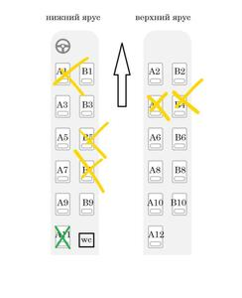
Easy Trip Visa
[Hình ảnh]
B6
16:20
/-strong
1
/-strong
/-strong
/-heart
:>
:o
:-((
:-h
Hong Jung Eun/1977-26/05-45D Laos-chưa tt
Please book 26th
감사합니다. 바로 예약을 진행해 드리겠습니다.
26/05 - 45d - Laos Hong Jung Eun 1977 B6 픽업 장소: 혼총 40번지, 오후 9시 30분 https://maps.app.goo.gl/LmwZhraVzHBuxoTm9
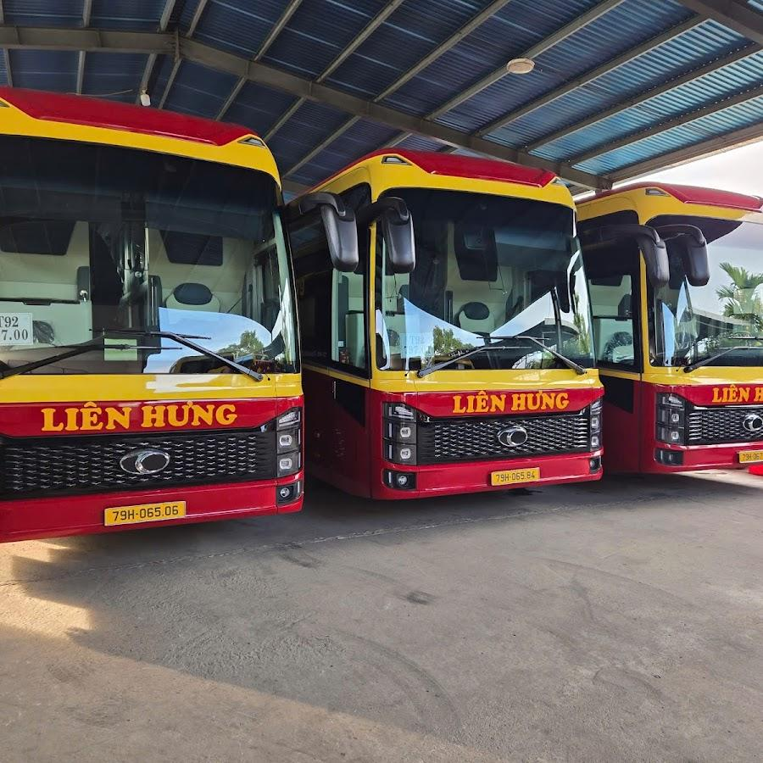
Easy Trip & Visa - Pickup Place - Visarun · 40 Hòn Chồng, Bắc Nha Trang, Khánh…★★★★★ · Bãi đỗ xemaps.app.goo.gl
/-strong
/-heart
:>
:o
:-((
:-h
고객님을 위해 자리를 예약해 두었습니다.
16:31
/-strong
1
/-strong
/-heart
:>
:o
:-((
:-h


비행기 티켓값을 저희가 내드릴까요?
베트남어 번역이 조금 불분명하네요!
15:52

Nếu có thể, tôi sẽ thanh toán phí visa và vé máy bay vào tuần tới.
/-heart
1
/-heart
/-strong
/-heart
:>
:o
:-((
:-h
Vui lòng mua vé vào lúc đó.
15:53
Lim Hwiyoung - Choi Jiwong/99- 13/5Fly 15/5 EV CXR
Vui lòng mua vé vào lúc đó.
예
15:53

15:53
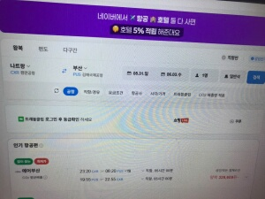
Lim Hwiyoung - Choi Jiwong/99- 13/5Fly 15/5 EV CXR
[Hình ảnh]
항공권 결제 정보가 필요합니다...
은행 송금 정보를 어떻게 얻어야 할지 모르겠어요!
다음 주에 저희를 안내해 주세요!
15:55
/-heart
1
/-strong
/-heart
:>
:o
:-((
:-h

15:55
즐거운 주말 보내세요!
15:55
/-heart
1
/-strong
/-heart
:>
:o
:-((
:-h

15:55
/-share
15:55
/-heart
1
/-strong
/-heart
:>
:o
:-((
:-h

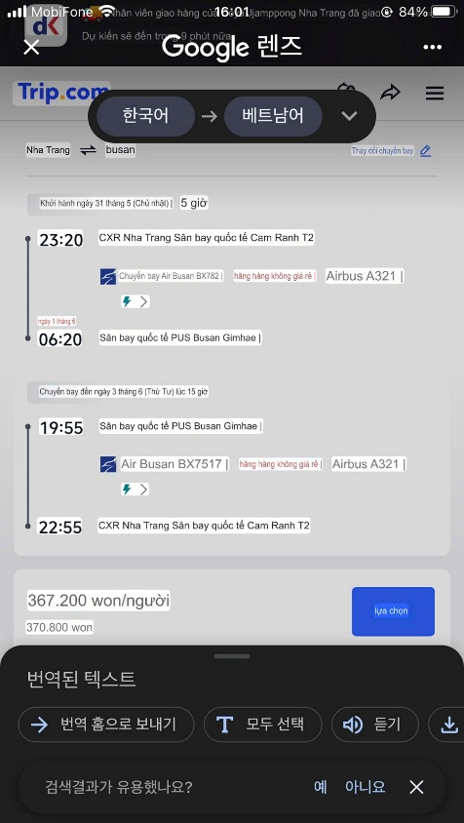
/-heart
2
/-heart
/-strong
/-heart
:>
:o
:-((
:-h
16:01

Thank you! you too
15:24
/-heart
1
/-strong
/-heart
:>
:o
:-((
:-h
T5 07/05/2026
07/05 - 45D Cam Francisco Javier Cervello Maulén 1975 B4 Bus number: 79H - 042.29 Wifi: 19002679 Pick up place: 40 Hòn Chồng, 21:30 pm https://maps.app.goo.gl/LmwZhraVzHBuxoTm9

Easy Trip & Visa - Pickup Place - Visarun · 40 Hòn Chồng, Bắc Nha Trang, Khánh…★★★★★ · Bãi đỗ xemaps.app.goo.gl
Good afternoon sir
This is your bus information
15:24
/-heart
1
/-strong
/-heart
:>
:o
:-((
:-h
15:55 07/05/2026

Noted. Thank you
15:55
/-heart
1
/-heart
/-strong
/-heart
:>
:o
:-((
:-h
21:24 07/05/2026

Cuộc gọi thoại đến
3 phút 25 giây
Gọi lại
I'm on the bus already. Perfect. Thank you!
21:52
Wish you a good trip
21:54
T6 08/05/2026

Good morning. Please let me know what time the bus returns to Nha Trang. I need to get back to Tuy Hoa today and it might be better if I make my own way back.
09:02
/-strong
1
/-strong
/-strong
/-heart
:>
:o
:-((
:-h
Francisco - 07/05 FREE VISA 90D - đã tt
Good morning. Please let me know what time the bus returns to Nha Trang. I need to get back to Tuy Hoa today and it might be better if I make my own way back.
Good morning Sir, the bus depart at around 1pm and returns Nha Trang app 9.00 pm
09:06

Ok thank you. I will let you know
09:07
13:20 08/05/2026

I'm already on a bus on my way to Tuy Hoa, thank you!
13:20
/-heart
2
/-heart
/-strong
/-heart
:>
:o
:-((
:-h
Our pleasure /-share
13:21
/-heart
1
/-strong
/-heart
:>
:o
:-((
:-h
14:38 08/05/2026
Cuộc gọi thoại đi
1 phút 8 giây
Gọi lại
14:38
Đã gửi

Số: 106960476/EV N0 Mã: E260504USA56636282481 Code
12:44
/-heart
1
/-strong
/-heart
:>
:o
:-((
:-h

And what is the place where the visa was issued?
12:58
Bạn đã hủy
Cuộc gọi video
Gọi lại
Cuộc gọi thoại đi
1 phút 49 giây
Gọi lại
13:01

Pre-Arrival Information - Cục Quản lý xuất nhập cảnh https://share.google/eYC5oSTmXxQ7hdhUr
13:03
/-heart
1
/-heart
/-strong
/-heart
:>
:o
:-((
:-h
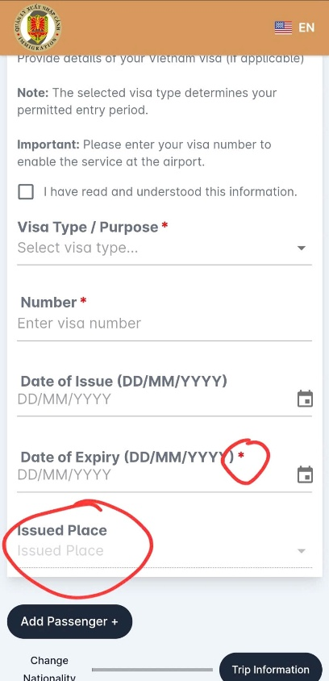
/-strong
/-heart
:>
:o
:-((
:-h
This question is not mandatory => you can skip it.
but waiting
13:07

Ok
13:07
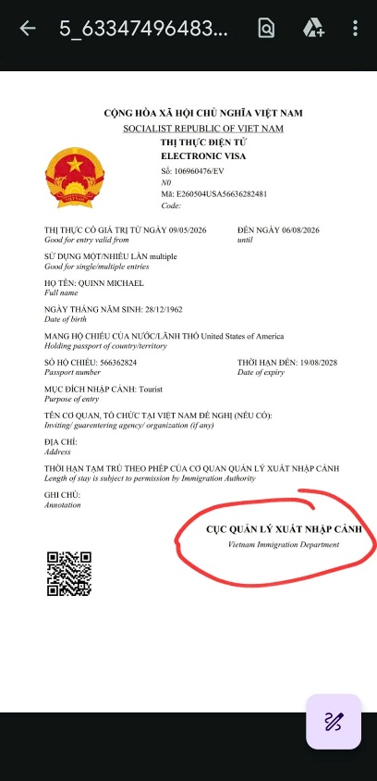
/-strong
/-heart
:>
:o
:-((
:-h
This place
Vietnam Immigration Department
/-heart
1
/-strong
/-heart
:>
:o
:-((
:-h
Easy Trip Visa
Vietnam Immigration Department
This is the answer Dr. Michael
13:08
/-strong
/-heart
:>
:o
:-((
:-h
13:41 08/05/2026
Tin nhắn đã được thu hồi
13:41

All done, thanks again!
14:06
/-heart
1
/-heart
/-strong
/-heart
:>
:o
:-((
:-h

비자가 6월 1일에 만료되시는 게 맞나요?
13:50
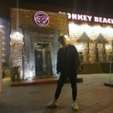
네
13:59
14:40 06/05/2026
그럼 5월 28일 목요일에 출발하실 수 있나요?
14:40

네
14:40
네, 잠시만 기다려 주세요. 버스를 확인해 드리겠습니다.
/-heart
1
/-strong
/-heart
:>
:o
:-((
:-h
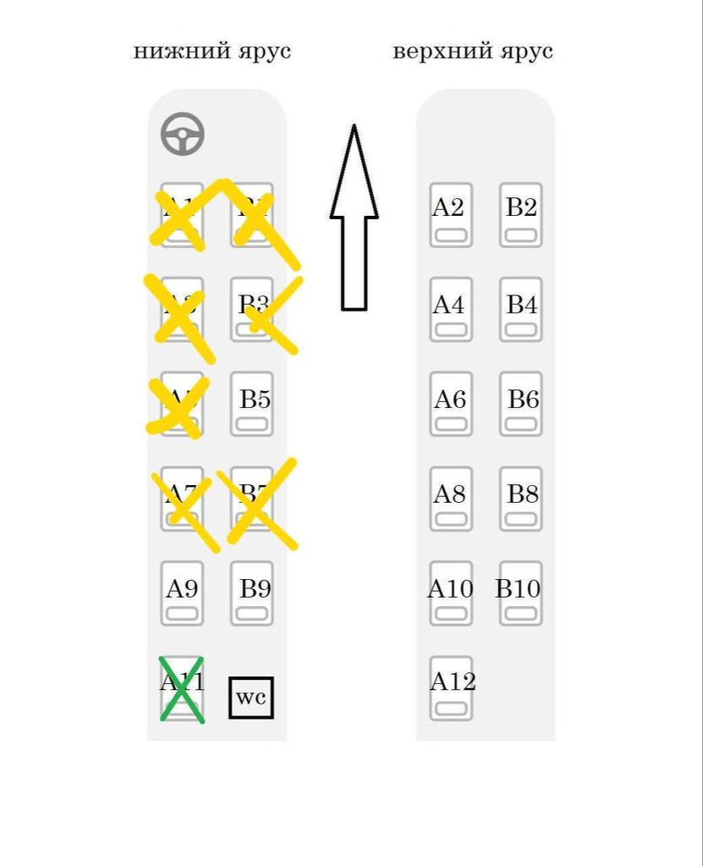
/-strong
/-heart
:>
:o
:-((
:-h
14:44

B5
14:45
/-heart
1
/-heart
/-strong
/-heart
:>
:o
:-((
:-h
Mr Kim Chul Ha/ 1979 B5 04 Muong Thanh 📍https://maps.app.goo.gl/ew7bXTr79tZfu4FLA
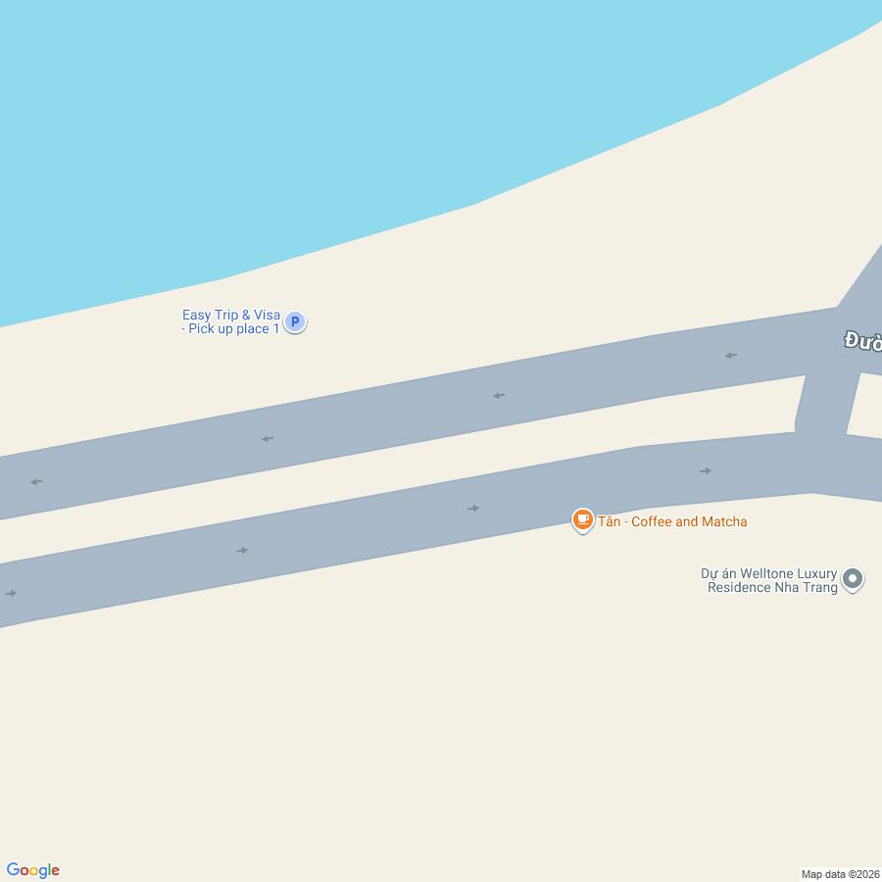
Google MapsFind local businesses, view maps and get driving directions in Google Maps.maps.app.goo.gl
14:58

3,550,000 × 4
/-heart
1
/-heart
/-strong
/-heart
:>
:o
:-((
:-h
14,200,000vnd
15:02
네, 맞습니다.
15:03

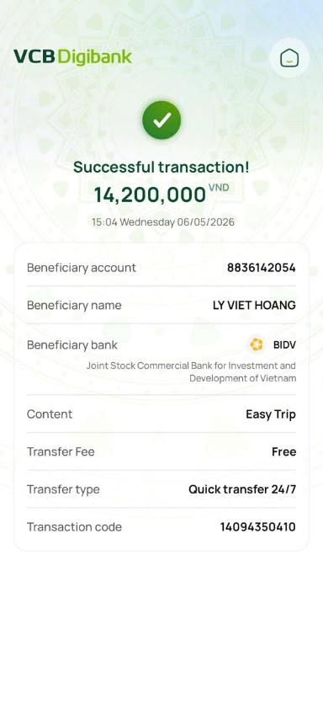
/-heart
1
/-heart
/-strong
/-heart
:>
:o
:-((
:-h
15:04
19/05 – 90D – Laos Ms. Park Sunmi 1983 A5 Ms. Yoo Suin 2008 A7 Ms. Yoo Sujin 2010 B7 버스는 다음 장소에서 픽업합니다: 04 Muong Thanh 📍https://maps.app.goo.gl/ew7bXTr79tZfu4FLA 28/05 - 90D - Laos Mr Kim Chul Ha/ 1979 B5 04 Muong Thanh 📍https://maps.app.goo.gl/ew7bXTr79tZfu4FLA
/-heart
1
/-strong
/-heart
:>
:o
:-((
:-h
이것은 고객님의 서비스 주문서 종합입니다.
15:13
/-heart
1
/-strong
/-heart
:>
:o
:-((
:-h

네
15:16
/-heart
1
/-heart
/-strong
/-heart
:>
:o
:-((
:-h

@Ocean Mr Lim 28/11 DN 파란색 버스 43h-166.33
안녕하세요, 괜찮으신가요?
06:09

Sean
탔어요
06:10
/-heart
1
/-heart
/-strong
/-heart
:>
:o
:-((
:-h
12:34 05/05/2026

Sean
1230분 넘었는데 더 기다려야 되요?
12:34
5_63276677583308138
54_1.pdf
243.05 KB
Đã có trên zCloud
/-strong
/-heart
:>
:o
:-((
:-h
E260504KORM93037489
52_1.pdf
243.05 KB
Đã có trên zCloud
/-strong
/-heart
:>
:o
:-((
:-h
저희 직원이 입국 절차를 도와드리겠습니다
13:05
13:57 05/05/2026

Sean
우리 차
버스 오는거에요?
언제 오는지...
13:58
잠시만 기다려주세요. 버스가 오는 중이며 조금 늦어질 예정입니다.
14:06

Sean
탔어요
14:07
/-strong
/-heart
:>
:o
:-((
:-h
예
https://maps.app.goo.gl/B7ZZCderbVH1UdkU6
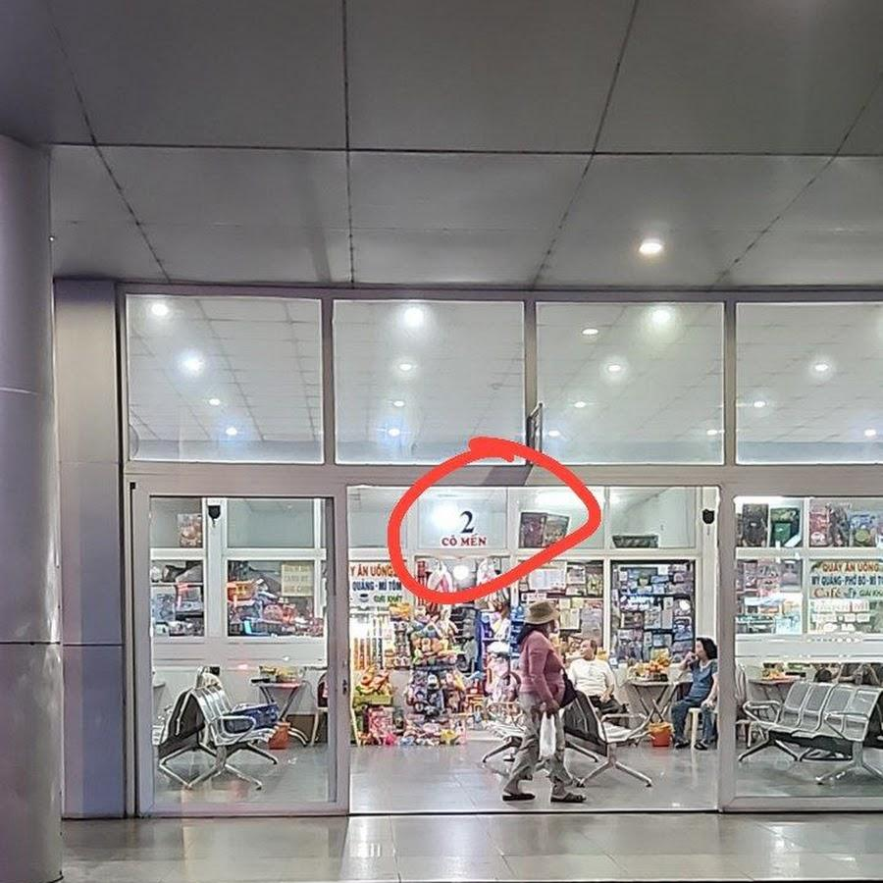
Visarun Danang · 354F+C65, An Khê, Đà Nẵng 550000★★★★★ · Bãi đỗ xemaps.app.goo.gl
/-strong
/-heart
:>
:o
:-((
:-h
저희 비자 서비스를 믿고 이용해 주셔서 진심으로 감사드립니다. 구글 지도 비즈니스 페이지에 리뷰를 남겨주시면 더욱 감사하겠습니다.
14:10


괜찮아요.
15:10

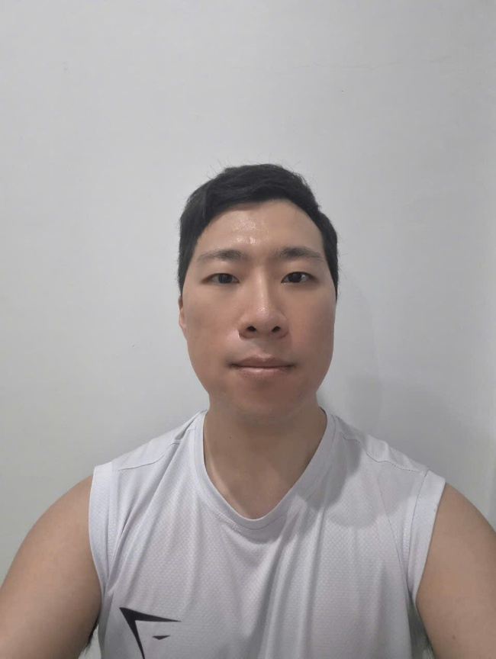
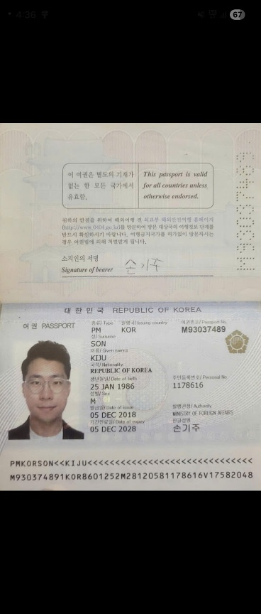
/-strong
/-heart
:>
:o
:-((
:-h
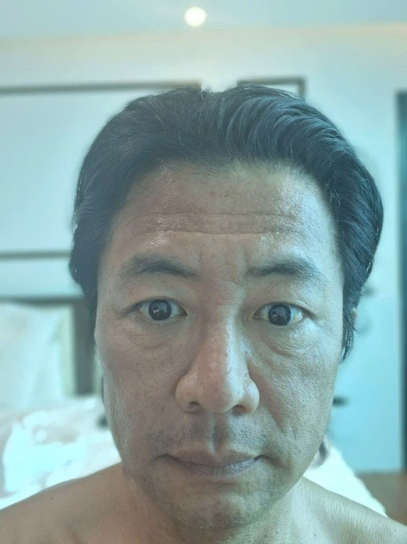
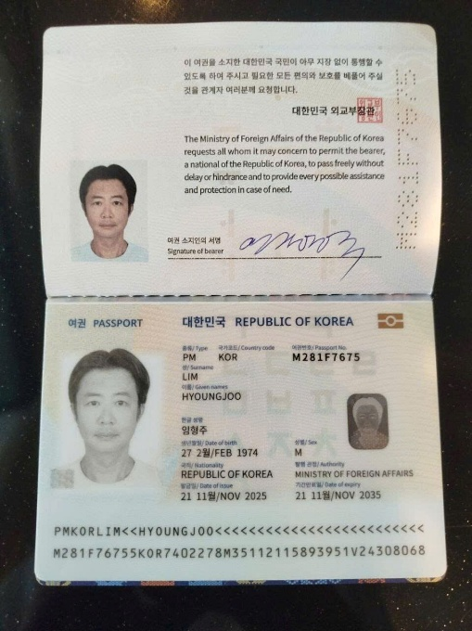
:o
1
:o
/-strong
/-heart
:>
:o
:-((
:-h
15:17
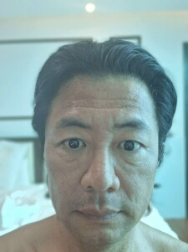
Sean
[Hình ảnh]
그는 저희 단골 고객입니다.
15:17

ㅋㅋ 네 맞아요
소개해줬어요
15:17
:b
15:17

그럼 5.5일 5:45분 출발인거죠
/-heart
1
/-heart
/-strong
/-heart
:>
:o
:-((
:-h
어디로 가요?
15:18
/-strong
/-heart
:>
:o
:-((
:-h
Sean
어디로 가요?
모르겠어요.
15:19
T3 05/05/2026
Cuộc gọi thoại đi
0 phút 0 giây
Gọi lại
12:41
Đã gửi

Perhaps Mr. Hoang will visit your restaurant next week...
Tin nhắn đã được thu hồi
Yes, this holiday period is very long and there have been many misunderstandings regarding the explanation of registration and application deadlines.
20:47
23:27 02/05/2026

Easy Trip Visa
Yes, this holiday period is very long and there have been many misunderstandings regarding the explanation of registration and application deadlines.
Khong sao~~
Easy Trip Visa
Perhaps Mr. Hoang will visit your restaurant next week...
I’m working 7-11pm All day in restarant !!
23:28
CN 03/05/2026

Can u send to me e visa file ?
17:51
Sally 16.12 - ev 3D
Can u send to me e visa file ?
Yes, ma'am
We will send you your E-Visa on May 5th.
17:54

Oke ~!
No need paper ?
17:54
Yes, no need paper
17:55
T3 05/05/2026
LEE SEOUN
G UK.pdf
202.14 KB
Đã có trên zCloud
/-strong
/-heart
:>
:o
:-((
:-h
Luckily that we have your E-Visa before noon :-)
11:48

Tks ~~~~
12:16
/-heart
1
/-heart
/-strong
/-heart
:>
:o
:-((
:-h

25/04 - 45 day Laos + Fast Track Taemo Kim 1987 A1 Yeojun Kim 1970 B1 Bus number: 79H - 067.19 Wifi: 19002679 무옹탄 트란푸 거리 4번지 21:15 https://maps.app.goo.gl/H9j9mJBuebYtw49aA
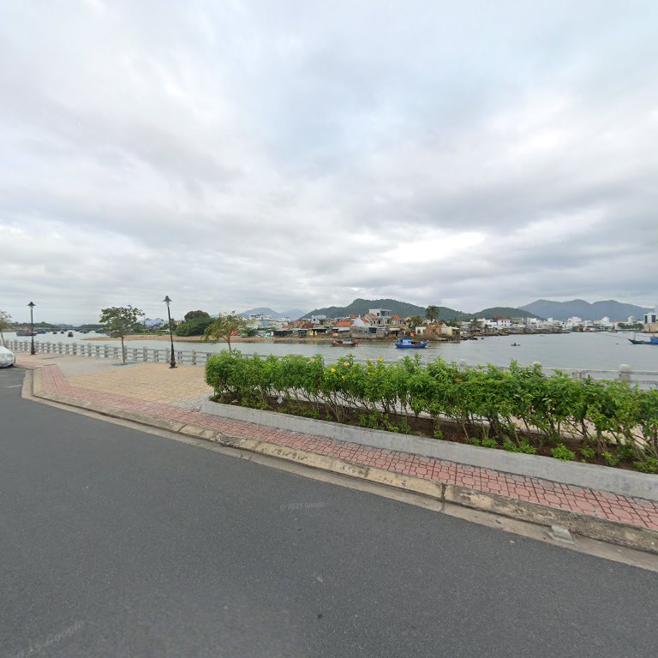
Easy Trip & Visa - Pick up place 1 · Khánh Hòa, Nha Trang, Khánh HòaTìm kiếm các doanh nghiệp địa phương, xem bản đồ và tìm chỉ đường trên Google Maps.maps.app.goo.gl
Hello Sir, this is your bus information
12:04
/-strong
/-heart
:>
:o
:-((
:-h
21:06 25/04/2026
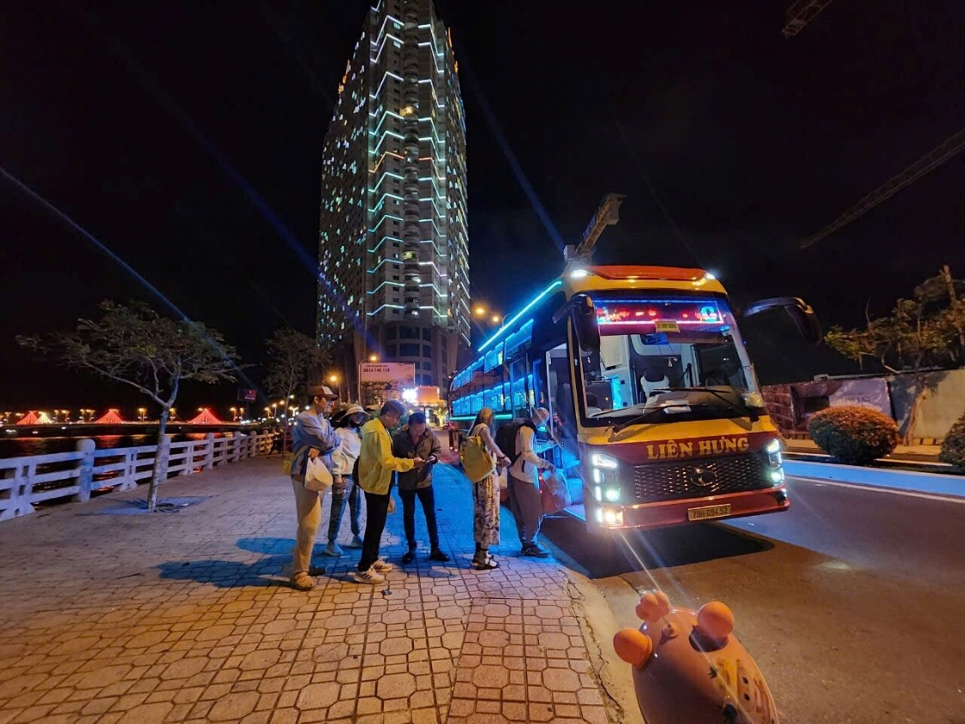
/-strong
/-heart
:>
:o
:-((
:-h
The bus look like this
21:07

got it.
21:07
21:07

Easy Trip Visa
[File] 26-04.pdf
he cancel the trip. can i get refund?
21:07
Mr.Yeojun Kim?
21:08

yes. he will not go
21:08
Taemo Kim - 25/04 - 45 day Laos FT x 2ve - da tt
yes. he will not go
출발 당일 오후 2시 이전에 티켓을 취소하시면 환불받으실 수 있습니다!
21:09

okay. no problem. have good night
21:09
/-heart
1
/-heart
/-strong
/-heart
:>
:o
:-((
:-h
예
21:10


돈에 관심이 많은게 아니고 확실한걸 좋아하는거에요
07:30
이제 결정을 내릴 수 있습니다.
07:31

?
왜 전액을보내줬죠?
07:31
저는 돈에 관심이 없거든요.
환불받으세요. 오전 9시 30분에 버스로 돌아오는 것을 잊지 마세요.
07:32

누가보면 내가 잘못한걸로 보이네요?ㅋㅋㅋㅋ
07:32
김세영Kim SeYoung 23/04 - 45D Laos FT
누가보면 내가 잘못한걸로 보이네요?ㅋㅋㅋㅋ
잘못은 우리에게 있습니다.
김세영Kim SeYoung 23/04 - 45D Laos FT
누가보면 내가 잘못한걸로 보이네요?ㅋㅋㅋㅋ
이제 돈이 다 ​​있으니, 선택하세요.
07:40

무엇을?
07:41
김세영Kim SeYoung 23/04 - 45D Laos FT
무엇을?
Hãy suy nghĩ nhiều hơn về cuộc trò chuyện với tôi sáng nay.
07:43
/-strong
/-heart
:>
:o
:-((
:-h

그냥 정확히 말해주시죠
07:43
09:42 24/04/2026

?
09:42
12:40 24/04/2026

답장안해줄건가요?
그리고 버스가 왜 이제 나짱으로 출발하는건지 궁금합니다
12:41
/-strong
/-heart
:>
:o
:-((
:-h

Thnx
11:15
Thank you very much! :3
11:15
/-heart
1
/-strong
/-heart
:>
:o
:-((
:-h

Your welcome
/-heart
1
/-heart
/-strong
/-heart
:>
:o
:-((
:-h
I gave your website and no. In comments hopefully you will get some buisness from here
11:16
/-heart
1
/-heart
/-strong
/-heart
:>
:o
:-((
:-h
If you have any requests for assistance with your video, please ask. We will do our best to support you. /-punch
11:18
/-heart
1
/-strong
/-heart
:>
:o
:-((
:-h
13:43 05/04/2026

Yes great thank you
13:43
/-heart
1
/-heart
/-strong
/-heart
:>
:o
:-((
:-h
14:28 05/04/2026
Cuộc gọi video đi
4 phút 13 giây
Gọi lại
14:28
07/04/2026

Hello i need to move my 1 bedroom stuff from Nha Trang to Ho Chinh Minh city . If you can recommend me something will be great . Thank you . Let me know if you have any recomendation
15:52
/-heart
1
/-heart
/-strong
/-heart
:>
:o
:-((
:-h
Good afternoon ma'am
16:13

Hello
16:13
Please wait a minute, lets us check for you
16:13
/-strong
/-heart
:>
:o
:-((
:-h

Yes sure thank you so much
16:14
We apologize, we do not offer this particular service
16:19

Ok no problem thank you so much
16:29
/-strong
/-heart
:>
:o
:-((
:-h

Cambodia e-visa + bus +vietnam e-visa, this how much pirce?
16:15
Cuộc gọi video đi
2 phút 38 giây
Gọi lại
eVisa certifi
cate.pdf
973.28 KB
Đã có trên zCloud
/-strong
/-heart
:>
:o
:-((
:-h
Easy Trip Visa
[File] eVisa certificate.pdf
950.000
16:21
/-heart
1
/-strong
/-heart
:>
:o
:-((
:-h

Ok my friend
16:21
okay bro
/-heart
1
/-strong
/-heart
:>
:o
:-((
:-h
thanks a lot
16:22
/-heart
1
/-strong
/-heart
:>
:o
:-((
:-h

Thanks, good man.
Thanks
Best boss in vietnam
16:23
/-heart
1
/-heart
/-strong
/-heart
:>
:o
:-((
:-h
02/04/2026
Good morning Sir! Please provide us your friend portrait photo + passport photo ( full 4 corner of the passport, no finger)
08:57

I'll let you know if my friend makes a decision, because he's a traveler. He might go to another country.
09:01
/-heart
1
/-heart
/-strong
/-heart
:>
:o
:-((
:-h
Got it Sir
09:08

Thank you for your interest.
09:09
/-heart
1
/-heart
/-strong
/-heart
:>
:o
:-((
:-h

Tôi lên xe lúc 18:15 hoặc bây giờ
17:44
/-heart
1
/-heart
/-strong
/-heart
:>
:o
:-((
:-h
5 phút nữa xe sẽ tới chỗ bạn
17:48
/-heart
1
/-strong
/-heart
:>
:o
:-((
:-h

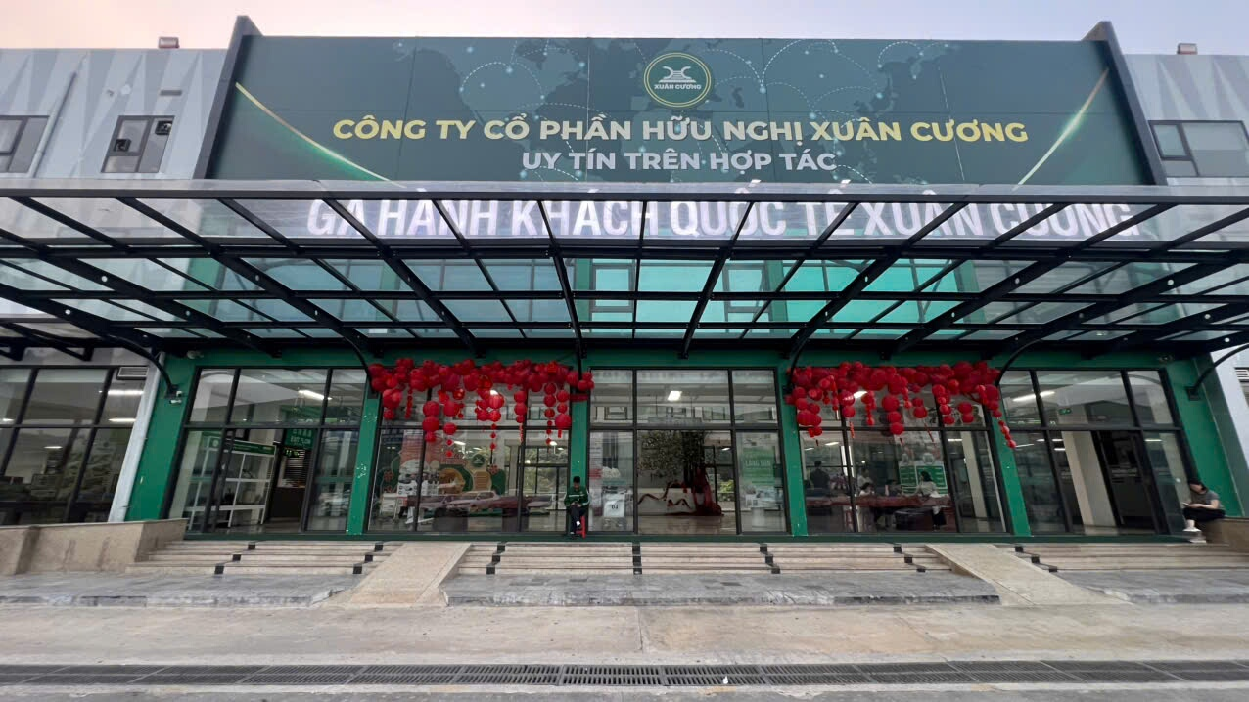
/-heart
1
/-heart
/-strong
/-heart
:>
:o
:-((
:-h
Đây nhé
17:52
/-heart
1
/-heart
/-strong
/-heart
:>
:o
:-((
:-h
저녁 식사할 시간 있으셨어요?
배고프세요?
18:15

아뇨. 식사할 곳이 없어서 못먹었어요.
배고파요 ㅠ
18:15
/-heart
1
/-heart
/-strong
/-heart
:>
:o
:-((
:-h
아직 아무것도 안 드셨나 보군요.
18:17

네
18:17
조금만 더 참아주세요...여행은 곧 끝날 거예요!
18:17
/-strong
/-heart
:>
:o
:-((
:-h

네
18:18
/-heart
1
/-heart
/-strong
/-heart
:>
:o
:-((
:-h
18:21
Đã nhận

버스가 아직 도착 안하고 있어요
21:11
예
조금 늦었네요.
21:16
/-heart
1
/-strong
/-heart
:>
:o
:-((
:-h
20/03/2026

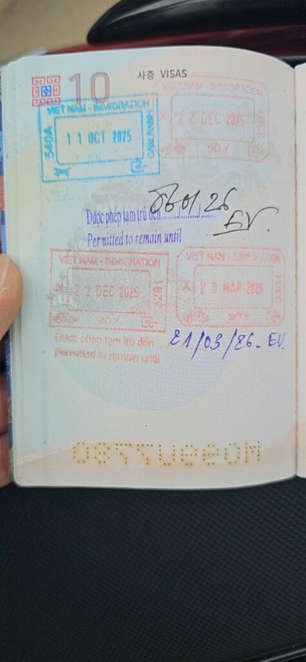
/-heart
2
/-heart
/-strong
/-heart
:>
:o
:-((
:-h
07:18
네, 보내주신 우표 잘 받았습니다.
모든 일이 아주 잘 진행되고 있습니다.
07:19
10:39 20/03/2026
KWAK YOU
NGJU.pdf
202.03 KB
Đã có trên zCloud
/-strong
/-heart
:>
:o
:-((
:-h
here is your e visa, sir
10:39

cam ơn
/-heart
1
/-heart
/-strong
/-heart
:>
:o
:-((
:-h
10:39
10:52

e visa. 만 할경우 비용은 ?
10:59
/-strong
/-heart
:>
:o
:-((
:-h
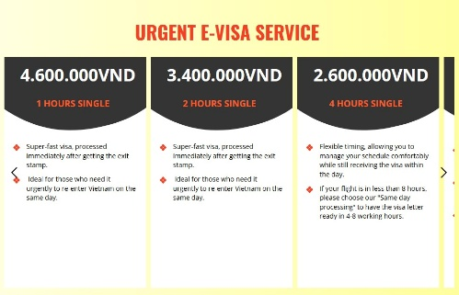
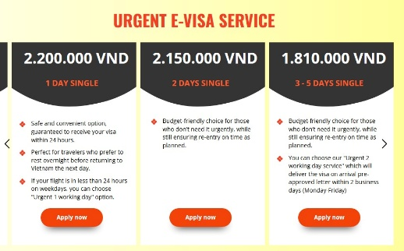
/-strong
1
/-strong
/-heart
:>
:o
:-((
:-h
위는 저희 전자비자 서비스 가격표입니다.
11:02


