

Facial-Expression Follower – YOLOv8-face Detection + FER Classifier (Raspberry Pi 4)
Student Name: HENG Lyhour
ICT 361 002 - Introduction to Robotics
Instructor: SENG Theara
School of Digital Technologies
American University of Phnom Penh

November 30th, 2025

Abstract / Executive Summary
This project develops a facial-expression follower robot that uses two‑stage real‑time facial‑expression follower. The system first detects all faces in the camera stream using a lightweight YOLOv8n-face detector (ONNX), then classifies the emotion of each detected face using a facial expression recognition (FER) classifier. Facial expression recognition (FER) is a key component for affect‑aware human–robot interaction. I fine‑tune a lightweight YOLOv8n classification model on a combination of the Balanced AffectNet dataset and a own custom dataset collected in the target deployment environment. The model predicts five discrete emotional states such as angry, happy, neutral, sad, and surprised, which are mapped to predefined robot motion commands. For deployment on resource‑constrained hardware (Raspberry Pi), the model is exported to ONNX and integrated with a Python‑based control stack. Experiments on a held‑out test set of approximately 7,000 images demonstrate competitive top‑1 accuracy and robust behavior under typical indoor conditions. The final integrated system can follow a user’s emotional state and react with consistent, interpretable robot behaviors in real time.

Table of Contents
Abstract / Executive Summary 2
1. Introduction 4
2. Dataset Collection & Labeling 5
2.1. Public Dataset: Balanced AffectNet 5
2.2. Custom Dataset 6
2.3. Labeling Process 8
2.4. Merged Dataset Structure Train/Validation/Test Split 8
3. Model Architecture and Training 9
3.1. Architecture 9
3.2. Input Processing and Augmentation 10
3.3. Training Process 10
4. Evaluation & Results 11
4.1. Model Performance Metrics 11
4.2. Confusion Matrix and Per-Class Performance 13
4.3. Qualitative Results 13
5. Model Conversion & Deployment 14
5.1. Export and Conversion 14
5.2. Exported Model Validation 14
5.2.1. Face detector 14
5.2.2. FER classifier: 15
5.2.3. Two‑stage pipeline: 16
5.3. Inference Speed (FPS) 16
6. Testing & Real‑World Scenarios 17
6.1. Test Environment 17
6.2. Safety and Edge Cases 17

Figure:
Figure 3.1. Original Balanced Affectnet Dataset 7
Figure 3.2. Sample Balanced Affectnet Dataset in 75 $×$ 75 formats 7
Figure 3.2. Custom Own Dataset 8
Figure 3.3. Training Performance Metrics 12
Figure 4.1. Final Model Performance on Test Set 13
Figure 4.2. ROC AUC Curve 14
Figure 4.2. Confusion matrix 15
Figure 5.1. Python code uses to export onnx format for FER 16
Figure 5.2. Python code uses to export onnx format for YOLOv8-face 16
Figure 5.3. Face detection pre-trained model test 16
Figure 5.4. FER classification 17
Figure 5.5. Test result for FER model on dataset from test_improved_model 17
Figure 5.6. Test result for Face + FER model on dataset from test_two_stage_pipeline 18
Figure 5.7. FPS from testing on AffectNet dataset 18

Introduction
Robots that can sense and respond to human emotions are becoming increasingly important in education, entertainment, and assistive applications. Facial expressions are one of the most direct and universal modalities of human emotion (Ekman & Friesen, 1978), which make FER an attractive sensing channel for human–robot interaction (HRI).
Traditional robotics pipelines often rely on classical vision techniques, which struggle with variations in lighting, viewpoint, and individual facial differences. Modern deep learning methods, especially convolutional neural networks (CNNs), learn discriminative features directly from data and have significantly improved FER performance on benchmarks such as AffectNet and FER2013.
The goal of this project is to design, train, and deploy a FER model that can run on a robot and control its behavior based on a user’s facial expression. The main objectives are:
- Detect a human face and classify the facial expression into 5 categories: angry, happy, neutral, sad, and surprised.
- Map each emotion to a robot action (e.g., move forward, backward, left, right, stop).
- Achieve high accuracy while keeping the model small enough for embedded deployment.
- Validate the model both on a test set and deploy the trained model on a resource-constrained platform (Raspberry Pi) while maintaining real-time performance.
Key challenges include:
- Data variability: Difference lighting conditions, camera distances, head poses, and backgrounds.
- Class imbalance and small custom dataset size: Some emotions (e.g., sad) are naturally rarer in collected data.
- Model training resource: Limited computing resource, which lead to smaller dataset on training
- Real-time constraints: Limited computation on embedded hardware, which constrains model size and complexity.
- End-to-end integration: Ensuring that inference Latency, communication, and motor control are stable and synchronized.
My approach uses a lightweight YOLOv8 classification model fine-tuned on a merged dataset (Balanced AffectNet + custom images). The model is trained in Google Colab with Nvidia T4 GPU acceleration, then exported to ONNX and integrated with a Python-based robot control pipeline.
for FER on low‑cost robots; this work aims to fill this gap with a concrete case study.

Dataset Collection & Labeling

Public Dataset: Balanced AffectNet
I use the Balanced AffectNet dataset from on Kaggle (Prajapati, 2023), which is a curated subset of AffectNet (Mollahosseini et al., 2017). AffectNet contains more than one million facial images consists of pre‑cropped face images with discrete emotion labels.
For this project, we restrict the labels to five emotions relevant to robot control:
- Anger $→$ Mapped to angry
- Happy $→$ Mapped to happy
- Neutral $→$ Mapped to neutral
- Sad $→$ Mapped to sad
- Surprise $→$ Mapped to surprised
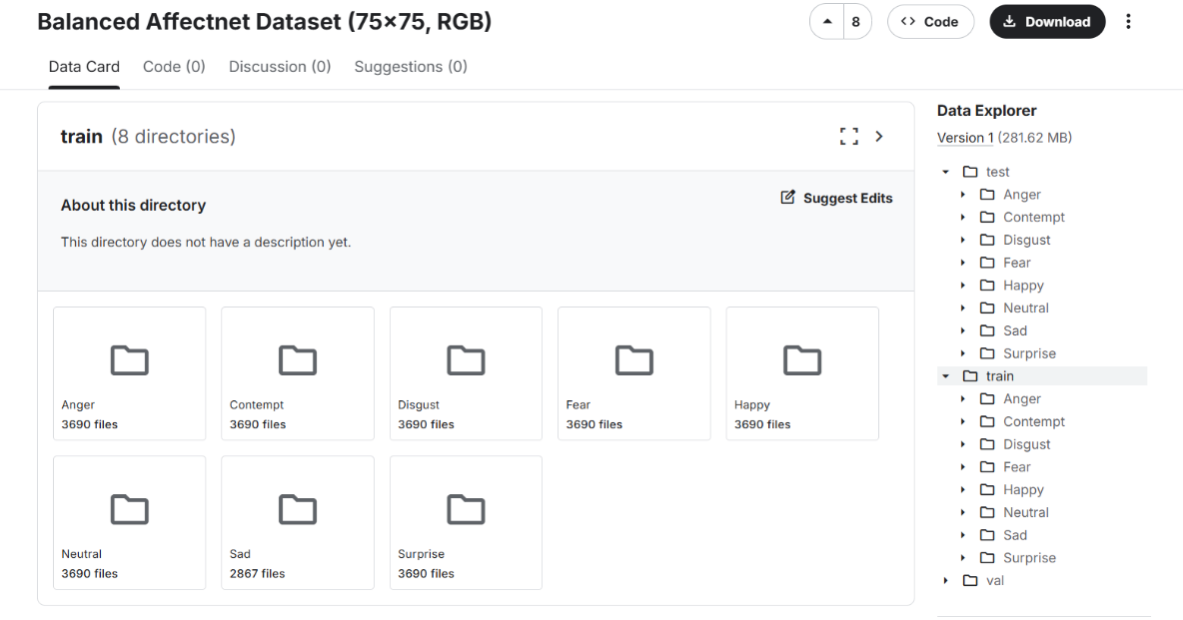

Figure 3.1. Original Balanced Affectnet Dataset
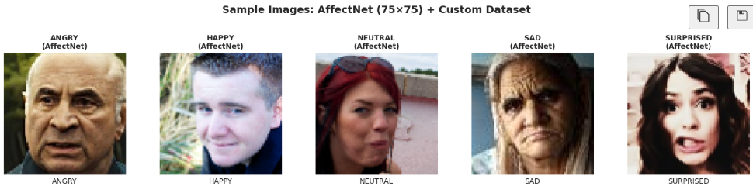

Figure 3.2. Sample Balanced Affectnet Dataset in 75 $×$ 75 formats
Folders with other emotions such as contempt, disgust, and fear are ignored via a mapping dictionary in the preprocessing pipeline. To control memory usage and and avoid overfitting, we cap the number of AffectNet images per class at MAX_AFFECTNET_PER_CLASS = 3000. All selected images for each class are pooled and then split into train/validation/test with a 70/20/10 ratio. All images are resized to 128×128 during preprocessing.

Custom Dataset
To better match the deployment environment, I collect an additional custom dataset. The dataset consists of:
- Angry: 207 images
- Happy: 200 images
- Neutral: 245 images
- Sad: 169 images
- Surprised: 200 images
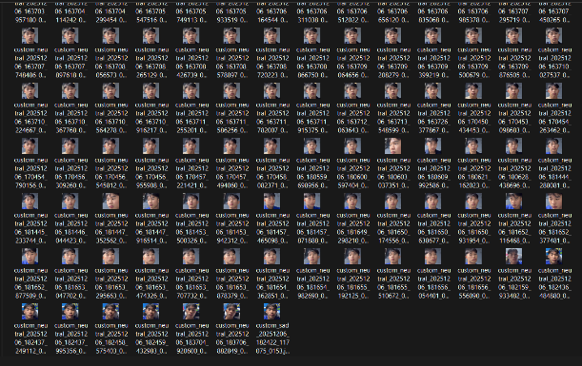
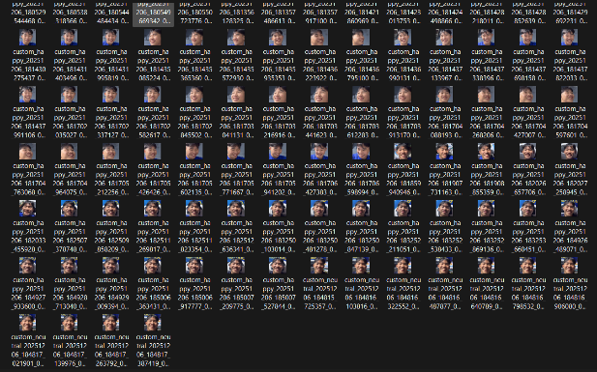
Images are captured using a laptop, connected with smartphone camera using iVCam and then preprocessed into 224×224 RGB format.
Figure 3.2. Custom Own Dataset

Dataset Collection Process
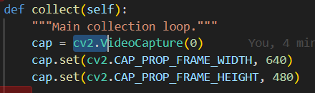
- Capture the video frame using cv2

- Preprocessing
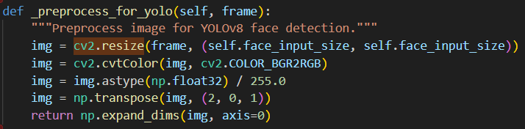
‘

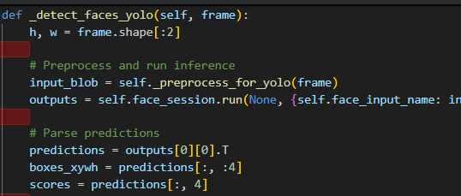
- Face detection (YOLOv8)

- Post-processing (Filter by confidence → NMS → Scale to original size)
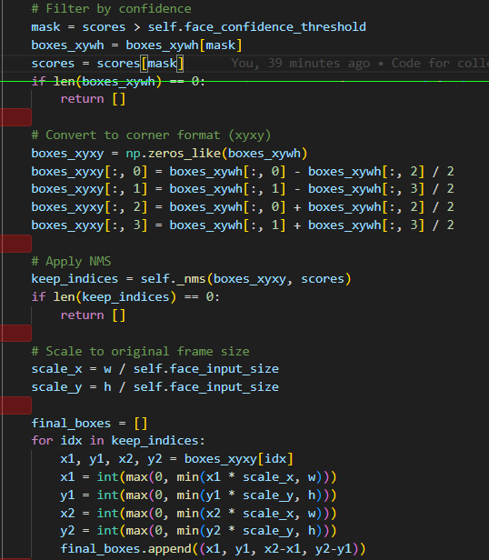

- Face extraction: crop the face region and add 20% padding to the image to have background around
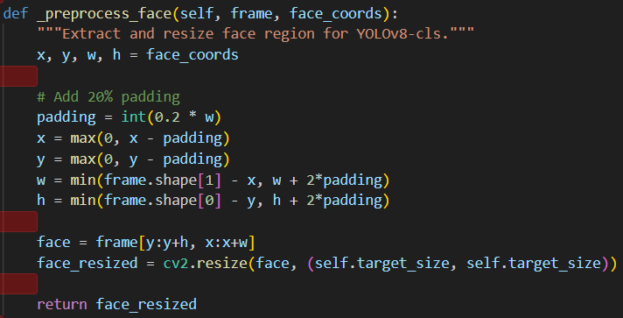

The directory structure follows:
- custom_emotions/angry/
- custom_emotions/happy/
- custom_emotions/neutral/
- custom_emotions/sad/
- custom_emotions/surprised/
These images reflect realistic conditions similar to the final robot setup.

Labeling Process
The custom dataset is labeled manually. Because I use a pure classification pipeline (one emotion label per image), annotation is simpler than bounding boxes:
- Images are saved into folders corresponding to the target emotion label.
- No additional tools are required, though tools like Roboflow or LabelImg are not needed because we don’t need bounding boxes.
Balanced AffectNet comes pre-labeled (folder names such as Anger, Happy, Neutral, Sad, Surprise). A mapping dictionary in the notebook maps these folder names to our target class labels.

Merged Dataset Structure Train/Validation/Test Split
I construct a merged dataset following these steps:
- All selected AffectNet images per class are collected and limited to MAX_AFFECTNET_PER_CLASS. These images are randomly shuffled
and split into:
- 70% training which is equal to 10500 images
- 20% validation which is 3000 images
- 10% testing which is 1500 images
- Custom dataset integration: The custom dataset is split into train/validation/test with a 70/15/15 ratio from flat class folders.
The final YOLOv8‑compatible dataset is organized as:
- train/<class_name>/
- val/<class_name>/
- test/<class_name>/
Each directory contains a mix of AffectNet and custom images.
- angry: 2244 (AffectNet: 2100, Custom: 144)
- happy : 2240 (AffectNet: 2100, Custom: 140)
- neutral: 2271 (AffectNet: 2100, Custom: 171)
- sad : 2218 (AffectNet: 2100, Custom: 118)
- surprised : 2240 (AffectNet: 2100, Custom: 140)

Model Architecture and Training

Architecture
The system consists of two main models:
- Face Detector: YOLOv8n-face (ONNX)
- Pre‑trained detector (yolov8n-face.onnx)
- Input size: 320×320 RGB
- Classification: YOLOv8n-cls
I use YOLOv8n‑cls, the nano-sized classification variant of YOLOv8. It is a CNN with approximately 2.7 million parameters and is pre‑trained. The main reasons for choosing this model are:
- Small size and low latency, suitable for Raspberry Pi.
- Built‑in training pipeline in the Ultralytics library.
- Easy export to ONNX.
The model input is a 128×128 RGB image, and the output is a 5‑dimensional class probability vector for the five emotions.

Input Processing and Augmentation
All training and test images are loaded with OpenCV and then resized to 128×128 pixels.
Data augmentation is handled by YOLOv8’s built‑in options, including:
- Color jitter in HSV space (small random changes in hue, saturation, and value).
- Random rotations up to ±10°.
- Random translation and scaling.
- Horizontal flips with 0.5 probability.
Mosaic augmentation is disabled for this classification setting.

Training Process
Hardware & Environment:
- Platform: Google Colab
- GPU: NVIDIA Tesla T4 (16GB VRAM)
- Framework: Ultralytics YOLOv8
The main hyperparameters for the improved model are:
- Image size: 128×128
- Epochs: 50 (with early stopping, patience 15)
- Batch size: 16
- Optimizer: Adam
- Initial learning rate: 0.001
- Number of classes: 5
- AffectNet cap: 3,000 images per class
- Total trained images: 11,214 images
The training notebook logs loss and accuracy curves, automatically saves the best model (best.pt), and generates plots and a confusion matrix on the validation set. I also keep the baseline model configuration (96×96, 1,200/class) to compare performance.
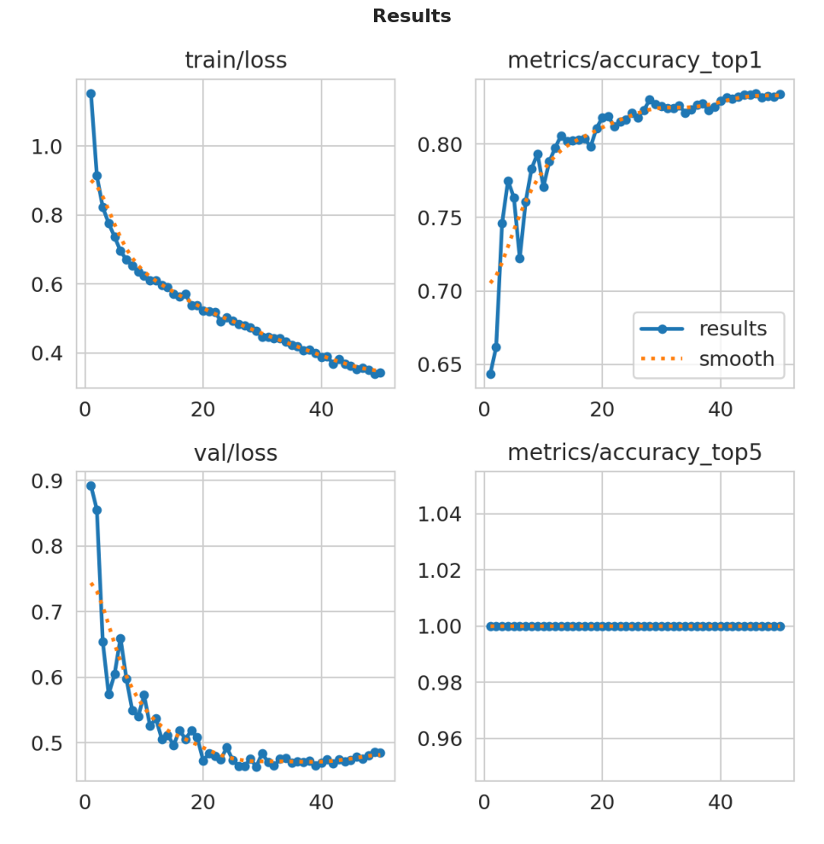

Figure 3.3. Training Performance Metrics
Training and validation curves showing (top-left) training loss from 1.154 to 0.343 which reduced 70.3%, (top-right) validation accuracy (top1_acc) improvement from 64.3% to 83.4%, (bottom-left) validation loss stabilization at 0.49, and (bottom-right) top-5 accuracy maintaining 100% throughout training since we train only 5 classes. The model trained for all 50 epochs without early stopping, with best validation accuracy achieved at epoch 46.

Evaluation & Results

Model Performance Metrics
The model was evaluated against the unseen Test Set containing 1,656 images from the merged dataset. The evaluation metrics show the model's capability to classify facial expressions across five emotional categories.

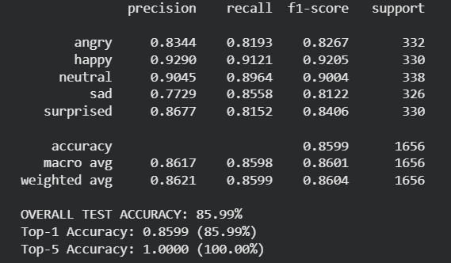

Figure 4.1. Final Model Performance on Test Set
I got 85.99% for Top-1 Accuracy which we can say excellent for a nano-class model used in this context. The 100% Top-5 Accuracy provides high confidence that the correct class is always among the top possible predictions, suggesting minimal risk of misclassification.
We don’t use Mean Average Precision (mAP) because it is mainly used to evaluate object detection models.
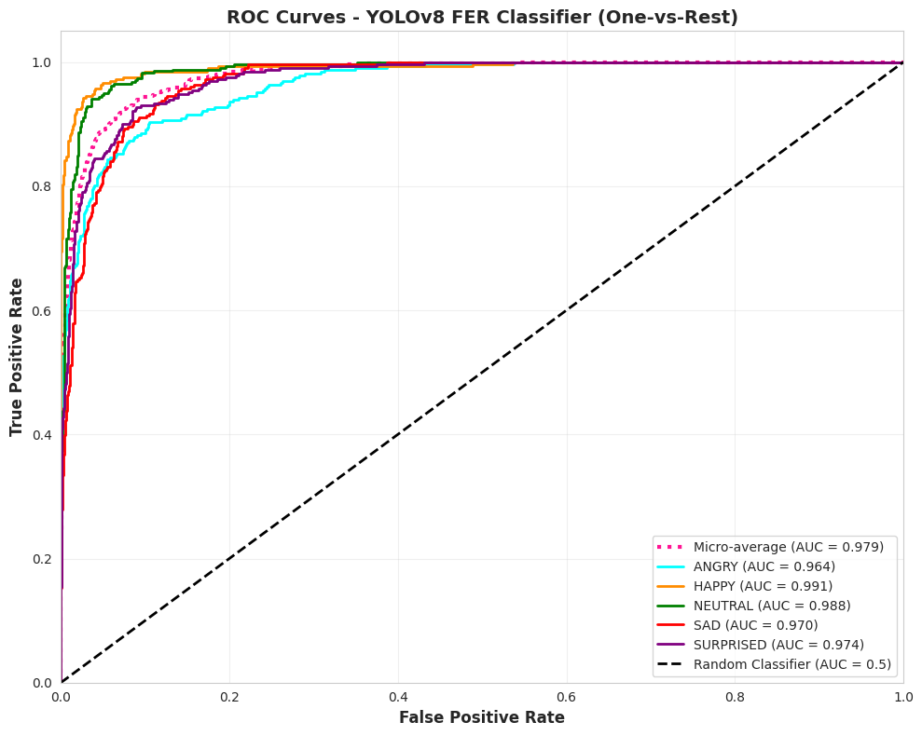

Figure 4.2. ROC AUC Curve
The high ROC AUC scores (all above 0.96) show that the model is very effective at distinguishing each emotion from the others, meaning it rarely confuses one emotion for another.

Confusion Matrix and Per-Class Performance
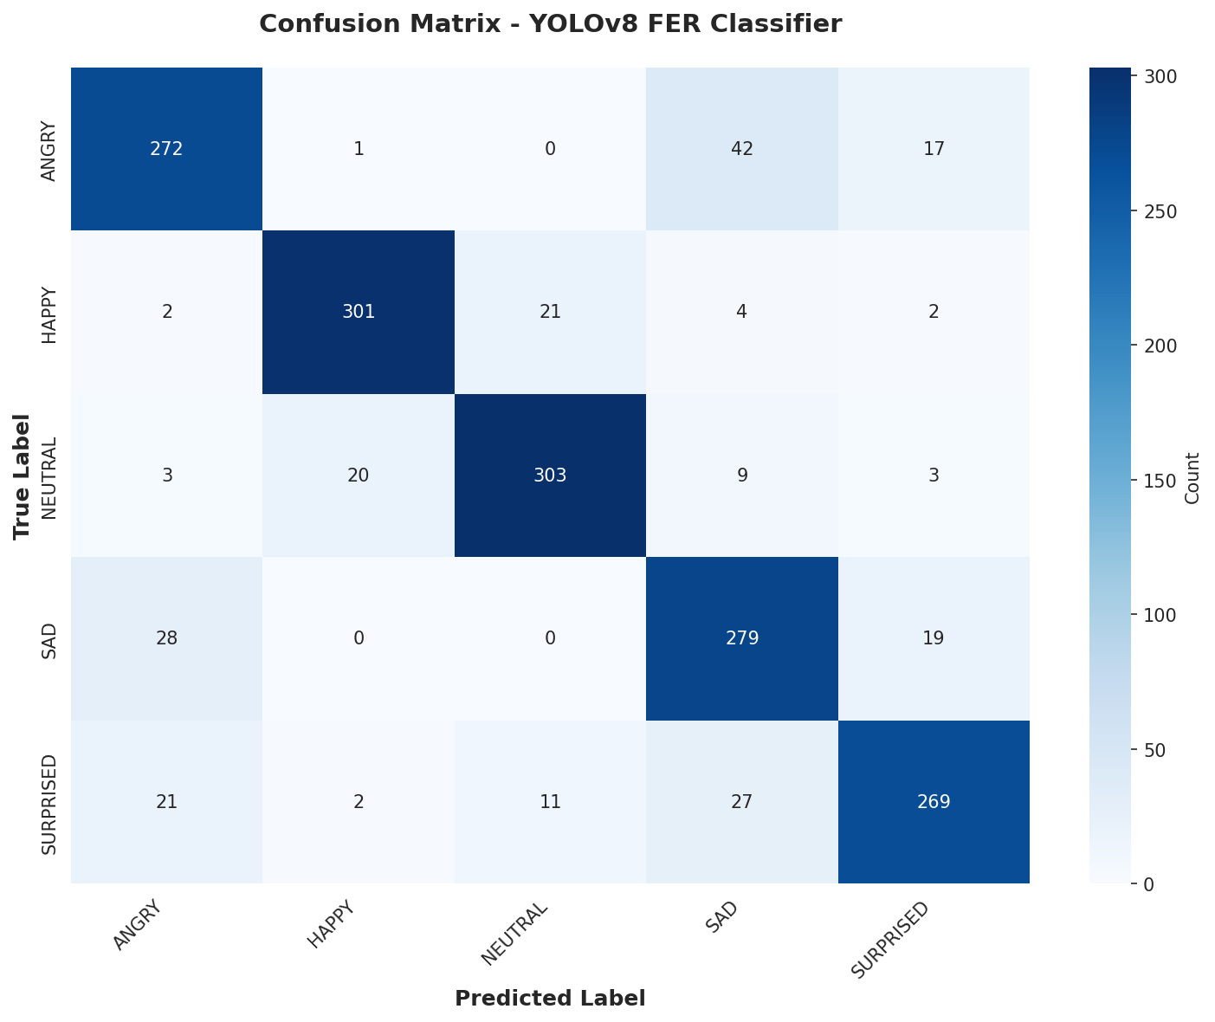

Figure 4.2. Confusion matrix
The primary confusion is between angry and sad. It could be because both emotions often have similar facial expressions: frowning, tense mouth, or eyebrows.

Qualitative Results
- Strong Detection Cases: The model performs well on front-facing faces with clear lighting and exaggerated expressions (theatrical emotions) and also faces centered in frame with minimal occlusion.
- Challenging Detection Cases:
  - Side profiles (face > 45° rotation)
  - Poor lighting conditions (shadows) or too lighting condition
  - Partial occlusions (wears masks)
  - Micro-expressions

Model Conversion & Deployment

Export and Conversion
To match the execution on the Raspberry Pi 4, the trained PyTorch model (fer_yolov8_cls_best.pt) was exported to ONNX formats optimized for the robot:
Figure 5.1. Python code uses to export onnx format for FER
YOLOv8 face model is also exported to ONNX from PyTorch model too.
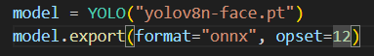

Figure 5.2. Python code uses to export onnx format for YOLOv8-face

Exported Model Validation
Exported models are validated at multiple levels:

Face detector
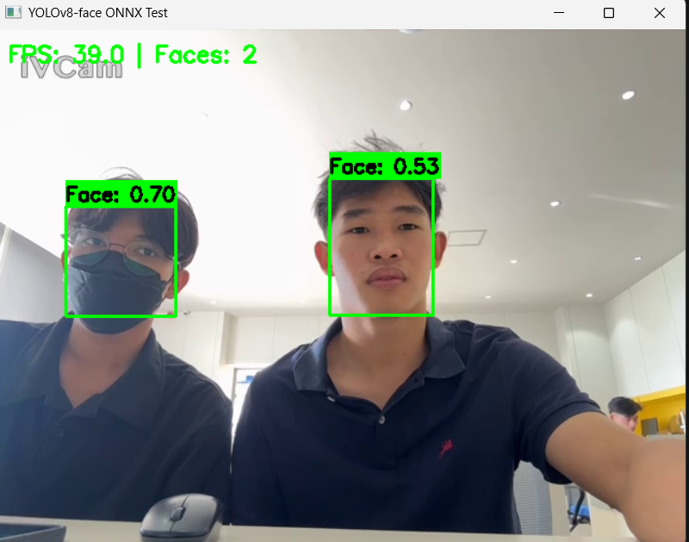
To validate face detector modeltest_yolov8_face_onnx.py provides a full webcam test, drawing bounding boxes, displaying FPS and face count.

Figure 5.3. Face detection pre-trained model test

FER classifier:
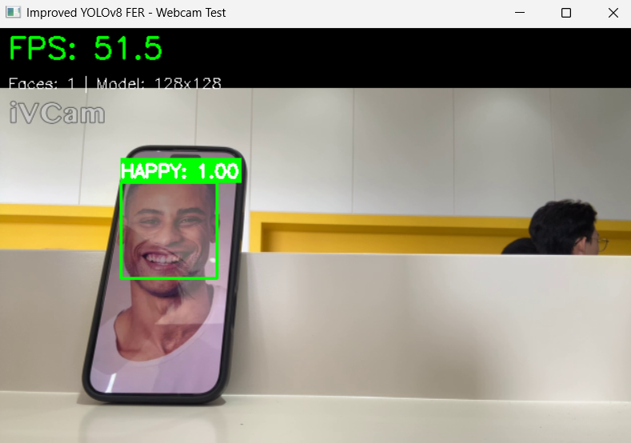
test_webcam_improved.py evaluates the FER model on live webcam frames, overlaying predicted emotions and confidences.

Figure 5.4. FER classification
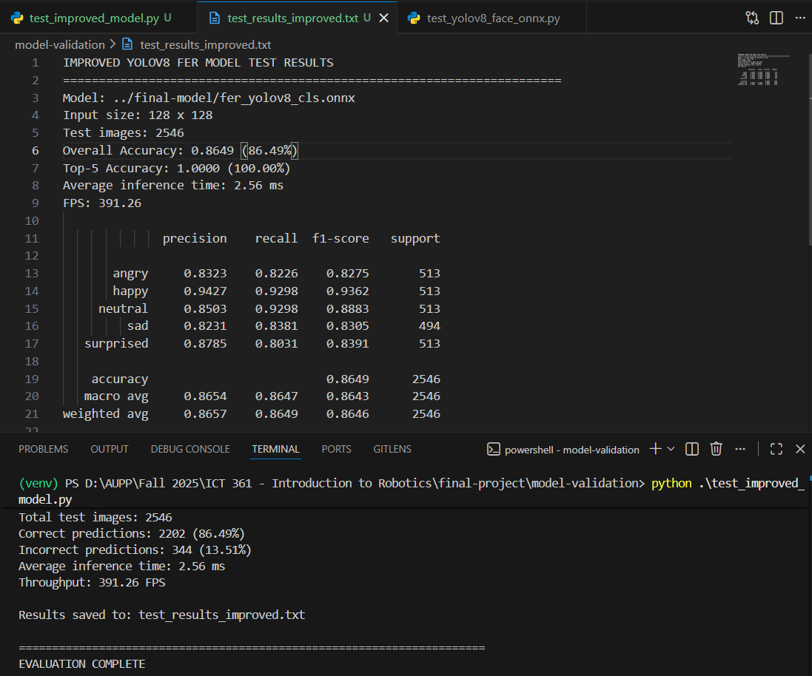
To better validate the FER classifier in ONNX format, I also do dataset‑level evaluation using script test_on_dataset.py.

Figure 5.5. Test result for FER model on dataset from test_improved_model

Two‑stage pipeline:
test_two_stage_pipeline.py is the test the whole flow combined between yolov8n-face.onnx and fer_yolov8_cls.onnx to verify the complete face‑detection + FER pipeline.
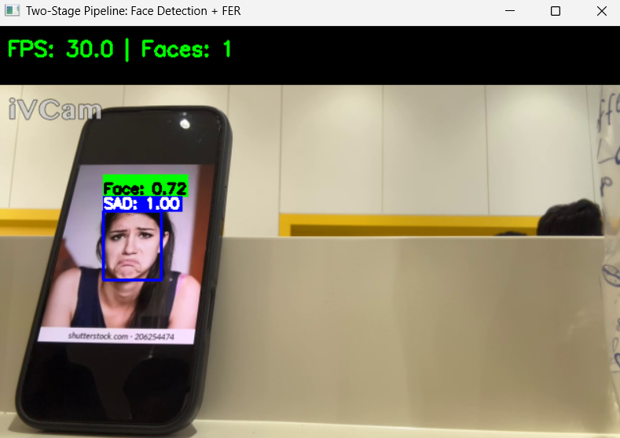

Figure 5.6. Test result for Face + FER model on dataset from test_two_stage_pipeline

Inference Speed (FPS)
On a desktop CPU with ONNX Runtime, using 2,546 test images of size 128×128, the model achieved:
Average inference time per image: 2.56 ms
Throughput (FPS): 391.26 frames per second
Overall top‑1 accuracy: 86.49%
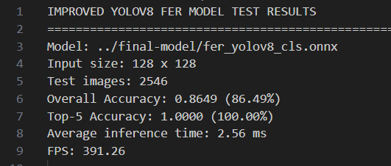

Figure 5.7. FPS from testing on AffectNet dataset

Testing & Real‑World Scenarios

Test Environment
Two primary environments were used:
- Desktop simulation (Windows PC):
Webcam at 640×480.
ROBOT_SIMULATION = True, so the robot controller prints actions instead of controlling hardware.
Most debugging of the two‑stage pipeline, emotion smoothing was done here.
- Embedded deployment (Raspberry Pi 4):
- Raspberry Pi running Python, OpenCV, and ONNX Runtime.
- AUPPBot/Raspbot V2 connected via /dev/ttyUSB0 at 115200 baud.
- USB camera (minimum 640×480).
- Access to the Flask‑based web UI from another device via http://10.30.0.24:5000

Robot Testing Process
The face emotion are mapped to robot action as below:
Emotion | Robot Action
Happy | Move Forward
Angry | Move Backward
Surprised | Turn Left
Sad | Turn Right
Neutral | Stop

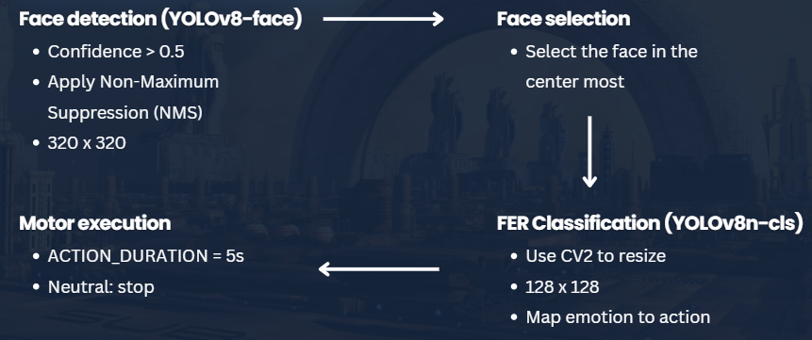

Figure 6.1. Robot testing process flow

Safety and Edge Cases
A major focus of the testing phase was validating the robustness and safety features:
- Detection: Successfully ignored predictions when face detection or FER probability scores were below 0.5.

Demo summary

