全局滤波器：
Learn a filter that minimizes the distance between the collection {yi} and the desired training HR images {xi}.
Y:initial upscaled version X:high resolution images
滤波器h:d*d
A:d*d*M*N的patches(d*d)
B:M*N composed of pixels from x corresponding to the center coordinates(中心坐标) of patches
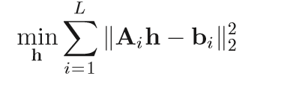
学习过程：
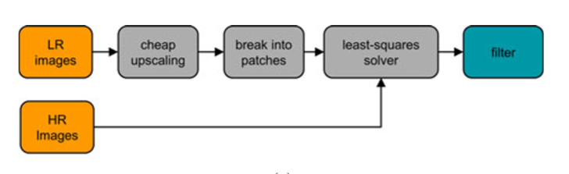
In fact, we typically construct Ai and bi by sampling K patches/pixels from the images on a fixed grid, where K << MN.

The solution is based on the observation that instead of minimizing Eq. (2), we can minimize
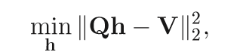where Q = AT A and V = AT b.
Q:d^2*d^2

Furthermore, based on the inherent(固有) deﬁnition of matrix-matrix and matrix vector multiplications, we in fact avoid holding the whole matrix (and vector) in memory.

More speciﬁcally, Q can be computed cumulatively by summing chunks of rows
(for example sub matrices 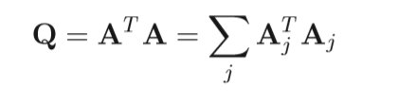), which can be multiplied independently,followed by an accumulation step. The same observation is true for matrix-vector multiplication 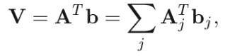
此处还可以并行计算

As for the least squares solver itself, minimizing can be done efﬁciently since Q is a positive semideﬁnite（半正定） matrix, which perfectly suits a fast conjugate gradients（共轭梯度） solver [31].

三、处理aliasing
Cheap upscaling method:双线性插值（interpolation）
The interpolation weights of the bilinear kernel vary according to the pixel’s location；Since a convolution of two linear ﬁlters can be uniﬁed into one ﬁlter
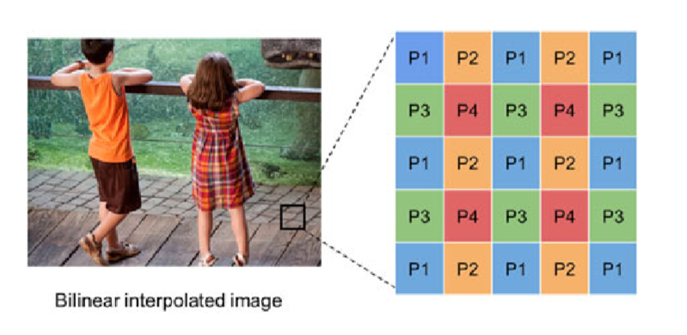
因此学习四种滤波器，对应四种可能的像素类型
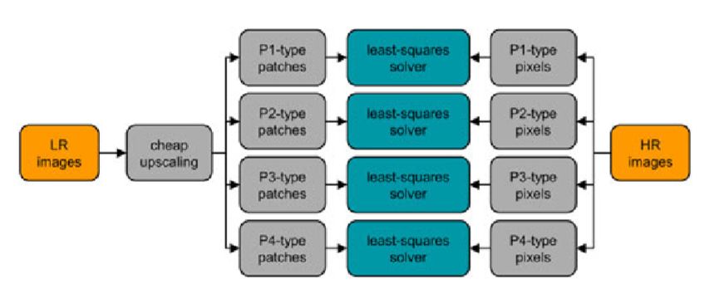
Filters act like bandpass filter, amplifying the mid- frequencies, and suppressing the high-frequencies (which contain aliasing components) ; The learned ﬁlters have similar magnitude response , but different phase response(different shifted versions).
应用过程：
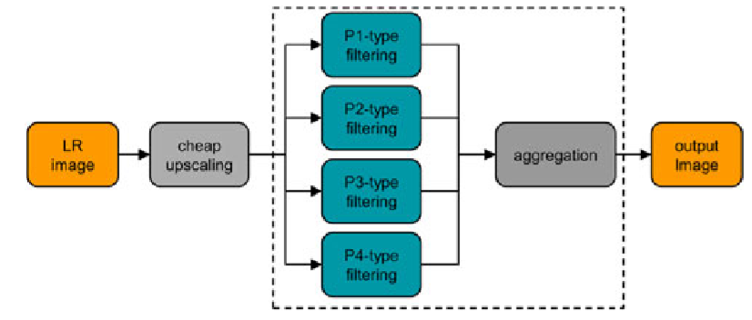
注：upscaling的参数为s，则学习的滤波器个数s²

四、RAISR：基于hash的学习与upscaling
constructing an appropriate ﬁlter per each cluster
Instead of applying “expensive” clustering，we suggest using an efﬁcient hashing approach为了保持线性滤波器的低复杂度。dividing the image patches into groups(buckets) based on an informative and cheap geometry measures.
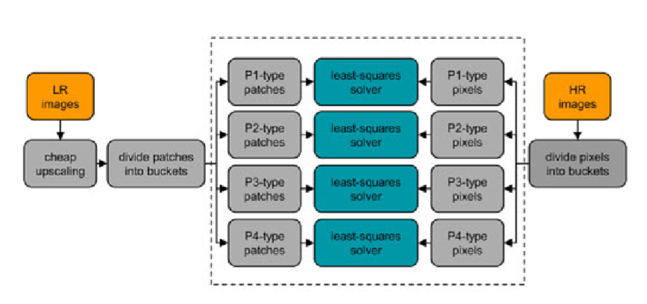
Per each bucket q, we learn a ﬁlter hq by minimizing the following cost function:
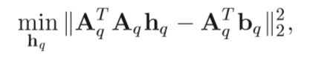
A. Hash-Table Keys: Local Gradient Statistics (Angle, Strength, Coherence)
We suggest evaluating the local gradient characteristics via eigenanalysis, which yields the gradient’s angle and information about the strength and coherence of the nearby gradients.
direction,strength and coherence are computed by utilizing the √n×√n surroundings of each pixel, The basic approach starts with a computation of 2×n matrix, composed from the horizontal and vertical gradients, gx and gy, of the surroundings of the k-th pixel, expressed by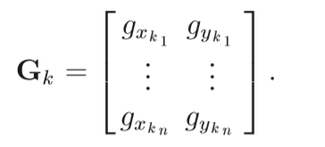. We can compute those characteristics more efﬁciently using an eigen-decomposition of 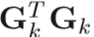which is a 2×2 matrix, which can be computed conveniently in a closed form.
此外，为了在每个像素中合并小的邻域梯度样本，我们采用对角加权矩阵Wk，使用可分离的归一化高斯核构造。the eigenvector φ^{k}₁, corresponding to the largest eigenvalue of 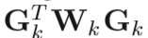, can be used to derive(派生) the angle of the gradient θk, given by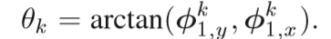
注：根据对称性, a ﬁlter that corresponds to the angle θk is identical to the one corresponding to θk +180◦.
The square root of the largest eigenvalue 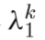 is analogous(similar) to the “strength” of the gradient. .The square root of the smaller eigenvalue 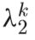 can be considered as the “spread” of the local gradients, or rather how much they vary in direction. Both of these can be measured in units of intensity. The two eigenvalues can be combined into a unitless measure known as “coherence” [35]. The coherence value μ_{k} ranges from 0 to 1, and formulated as
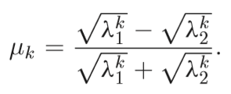
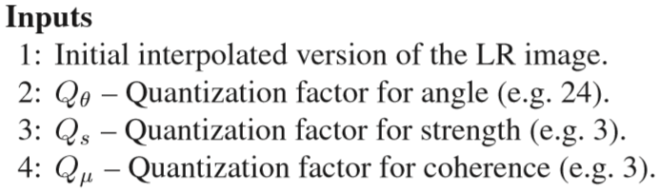
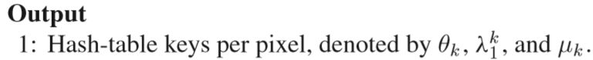
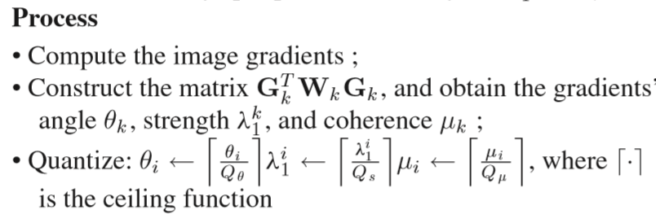
量化因素的意义：A low strength and low coherence often signiﬁes (means) a lack of image structure, and usually corresponds to noise or compression artifacts. High strength, but low coherence often indicates corners or other multi-directional structure. Having a high coherence is generally an edge, or series of stripes in the same direction, with the strength measuring the relative intensity of the stripes.
B. Using Patch Symmetry for Nearly-Free 8×More Learning Examples
training data is not as simple as using 10⁵ ×B patches;
Certain hash values occur much more commonly than other hashes: There are often many more horizontal and vertical structures, and ﬂat regions (such as sky, and painted surfaces)
In order to make the patches that hash to uncommon hash values more effective, we leverage the patch symmetry and increase the learning power of each patch. More speciﬁcally, we can generate 8 different example patches;four 90◦ rotations, and four mirrored 90◦ rotations.
Moreover, the patch transformations do not need to be performed as actual image transformations of each incoming patch: If the gradient angle dependent hash bucket boundaries are symmetric to ﬂips in x, y and xy-swaps, the accumulation for transformed patches can be performed. in our case, having a number of angle buckets that is divisible by 4 satisﬁes this requirement .As such,we can accumulate the per bucket and per pixel-type matrices 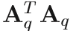and 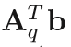 across all training samples, Then, the symmetry can be applied as one last accumulation of permuted matrices, which act as a set of symmetry augmented matrices.
C. Built-in Suppression of Compression Artifacts and Sharpening Effect
We found that an effective suppression of compression artifacts is achieved by learning a mapping from compressed LR images to their HR versions.(the same to the sharpening effect)

D. Blending: An Efﬁcient Structure-Preserving Solution
applying the pre-learned ﬁlters on the initial interpolated image can lead to structure deformations(畸变) due to the sharpening property.
The blending therefore combines the most appropriate contributions from the cheap upscaled and the RAISR ﬁltered image to yield the ﬁnal result.但会导致执行过程变慢，所以提供了一个更快的选择
Inspired by the CT descriptor, we suggest using its outcome as an engine that detect structure deformations and revert the errors of the upscaler.
in practice, when applying the comparisons we allow small variations in the intensity values, controlled by a threshold.
Back to RAISR, we suggest two different blending schemes
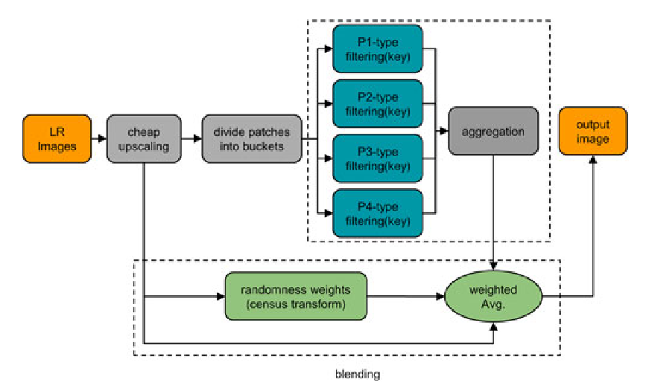
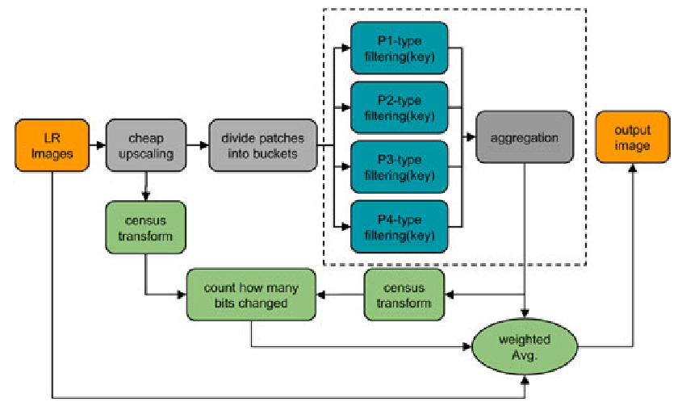
The ﬁrst scheme allows the pre-learned ﬁlters to enhance only the high-frequencies of the image (pre-learned ﬁlters may introduce halos due to their size (11×11 or 9×9) and the sharpening property)
While the second scheme allows the enhancement of a wide range of frequencies, leading to better looking images due to the contrast enhancement effect
C自带锐化与伪影去除:
by applying compression and sharpening as preprocessing steps, the learned ﬁlters are capable to map input compressed LR image to a sharpened HR output. As such, by choice, RAISR not only estimates the missing spatial information, but also suppresses the compression artifacts and ampliﬁes the underlying signal.
D,blending，有效的结构保留办法:
This suggestion relies on the observation that the cheap interpolated image typically does an adequate job on areas of the image that contain low spatial frequencies(e.g. ﬂat regions).On the other hand,the higher spatial frequencies that need to be reconstructed require the careful treatment of the estimated ﬁlters. The blending therefore combines the most appropriate contributions from the cheap upscaled and the RAISR ﬁltered image to yield the ﬁnal result.
为了减少执行时间：Inspired by the CT descriptor [20], we suggest using its outcome as an engine that detect structure deformations and revert the errors of the upscaler.

Train流程：
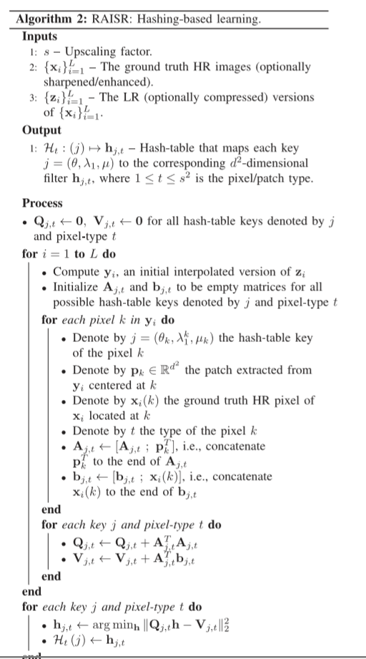

Upscale流程：
