A Design Critique of Online Streaming Sites

| Wenqiang Chen  Hamilton, Canada  chenw25@mcmaster.ca | Carolyn Chong  Hamilton, Canada  chongce@mcmaster.ca | Kevin Ly  Hamilton, Canada  lyk2@mcmaster.ca | Meraj Patel  Hamilton, Canada  patelmu2@mcmaster.ca |
| --- | --- | --- | --- |

# ABSTRACT

A project proposal and software survey is presented here. The proposed project is a design of a movie and television show streaming website. The project proposal will provide an overview of the software and an idea of how we will improve the design of streaming websites. The software survey will introduce four existing streaming websites. Each website will be critiqued based on its navigation and organization.

# introduction

<Give background of streaming websites.>

# Project proposal

<The proposal should include: a) an overview of the topic/software/device of interest – tell me why you want to develop such a system b) an idea of what will be unique/better/improved in your system (versus what already exists – this will be informed by your software survey, see Part 2 below) The proposal should be approximately 300 – 600 words (and no more than 1000 please!). It should be written in a fashion that will lend itself to being re-purposed later for your eventual final report (which will basically serve as a “justification” of your chosen project).>

# software survey

## Crackle

Crackle.com is an online distributor of movies and TV shows. It is a free streaming service with commercials. The navigation of the Crackle interface is overall straightforward. As shown in Figure 1, there is a simple, uncluttered navigation bar at the top of every web page that contains a search bar and quick links to the TV shows library and the movies library. The titles are displayed in rows that span the width of the screen. A user browses all titles by scrolling vertically down the page. The scroll is a never-ending scroll. A user can also opt to use the search bar to quickly find a desired title, actor or genre. Playing a title is simple; a user clicks on the icon and the user is redirected to a page that immediately begins playing the title in a player. See the HTA attached titled “Crackle” that shows the navigation process to play an episode from a specific television series.

The organization of the Crackle interface is cluttered and not intuitive. Media titles can be browsed by categories and genres displayed on the home page, or by media type via the navigation bar. The organization of the media on the home page of Crackle is not intuitive (see Figure 1). Across the top of the home page is a large carousel showcasing movies and shows from random genres. The carousel fills the majority of the screen. It is not clear to the user why these media items were selected to be showcased. Below the carousel are horizontal sections of different media categories and genres. There is no obvious organization in the listing of the categories, and it is unclear as to whether the categories and titles displayed represent the extent of Crackle’s library. Some category titles are in a different colour font than the rest, for no apparent reason. Due to the large sizing and layout of the icons, the variety of selection displayed is limited. As a result, the user is forced to do a lot of scrolling to view the selection of items. Aside from the home page, users can restrict their browsing using the navigation bar to movies or TV shows. Pull-down menus allow the user to narrow their search by genre and length. The user can then sort the titles alphabetically or by date added. There is no option to sort by popularity, trending, year or rating. Once a user selects an item to watch, they are redirected to a new page with the player. Below the player are facts about the movie or show, in addition to “You Might Like This” and “All New This Month” sections. These sections are only found on the player page, and nowhere else on the website. This new page is cluttered and full of content that is distracting to a viewer who has already chosen what to watch. See the HTA attached titled “Crackle” that illustrates the organization of movies.



Figure . Crackle's home page.

**Netflix**

Netflix is an online provider of on-demand streaming media to viewers across the globe. Navigating Netflix is straightforward and simple. Top of the webpage consists of menu bar that allows users to browse media titles by genre. There is also a search bar for browsing by a particular title, actor or genre. On the home page, titles are displayed in genres in the form of subsequent rows. To view more titles of a specific genre, the user has to click on the name, and will be redirected to another page featuring rows of titles. The browse button or search bar can do this as well. To watch a video, the user has to click on a media title and will be redirected to a sequent page that will begin playing the video.

The organization of titles on the front page attempts to appeal to audience interest but lacks ingenuity. From top to bottom are rows of genres, consisting of a carousel of media titles. A few of these rows depict titles that Netflix assumes will appeal to the user. Most often, these media titles do not. This is because, these are based on titles watched, rather then titles liked by a user. Netflix lacks proper functionality to display media that appeals to audience likings. This poor design choice results in the user having to search through the UI, as no significant titles are made visible at first glance.

Netflix chose to organize and display media titles by use of pictures. To view the actual title, the user has to place his cursor over the picture and a prompt will appear showcasing the name. This is a poor design choice, as some media pictures do not clearly display their title (see figure 1). This leaves the user constantly moving his/her cursor from picture to picture just to view a title. Netflix does not offer a way to display media titles by itself.

Media titles are displayed in a one-page format. This means, to navigate through titles the user simply has to scroll down the page. Titles will keep populating until there are not anymore to display. Although this method minimizes the number of clicks for the user, it has its limitations. Given a slow Internet connection, a lot of time is spent rendering these media titles. In effect, an endless loop is displayed to the user. This is a poor design choice as it leaves the user in the dark regarding time spent rendering. As well, having all these titles presented at once creates latency issues for feedback in terms of navigating titles.

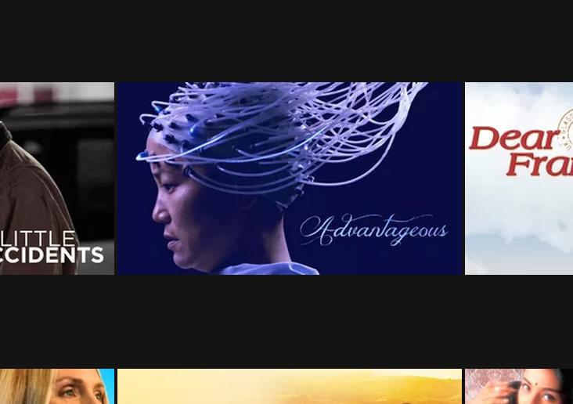

Figure 1. Netflix media title display

## PlexTV

## Shomi

# Conclusion

We have discussed our project proposal. We want to design an effective user interface for a media streaming website.

We also provided a software survey of four popular streaming websites used by the public. For each survey, we critiqued the user interface with regard to navigation and organization.

Overall, we feel existing user interfaces of streaming websites are _____. They suffer from a lack of ______, and are good examples of a poor attempt at ____. They are clunky and inefficient, and frustrate even a frequent user.