Signaling
MFRS - Model Functionnal Requirement Specification
FRS
Draft
Project : 2ST190023

 | Name | Function | Date | Visa
Written By | Arthur LUBAT | MBD ENg | 2022-04-12
Checked by
Checked by
Checked by
Approved by

Document History :

Module: /VLS NG/00 - STD Libraries/SYS Design/Signaling/Signaling
Exported from DOORS on: Sunday, March 5, 2023

aID | Change | Baseline 1.0 | Current Version
S___EF_1 | OBJECT DELETED | 1 Introduction
S___EF_56 | OBJECT DELETED | 1.1 Scope of the document
S___EF_57 | OBJECT DELETED | This document aims to explain how the signaling function shall operate. The system concerned by this dodument is a LED driver able to drive several Leds modules. The input of this function are signaling commands and forcing signals from defect handler. The outputs are PWM to apply on the LEDs  The Functional model of the signaling is composed by :  1) Auxiliary power sypply management : In this subsystem we check if we have the active power supply and the autorization in power to take into acount the signaling request (DRL, PL and TI)  2) Signaling Management : In this subsystem we define the different options that corresponds to the ways the signaling functions are commanded, then and according to the type optical module we define the signal PWM_Module.  3) Function Type Mapping : In this subsystem, for each LED, we verified if it is a signaling LED and we define the LED type. According to the Led Type we give a PWM to each led  4) Sliding TI : This subsytem define the sliding TI feature (how to light the TI Leds one after the other)
S___EF_61 | OBJECT DELETED | 1.2 Defintions
S___EF_58 | OBJECT DELETED | 1.3 Notations in the document
S___EF_59 | OBJECT DELETED | In this document the information inside [ ] are vectors  If only 1 value is inside [] this means that it applies on all vectors values.
S___EF_201 | OBJECT DELETED | 1.4 Convention in the document
S___EF_202 | OBJECT DELETED | 1.5 Reference documents
S___EF_203 | OBJECT DELETED | Document description
S___EF_204 | OBJECT DELETED | Ramp Management (MFRS)
S___EF_200 | OBJECT DELETED | 2 Overview of the functional block
S___EF_2 | OBJECT DELETED | 2.1 Intended use of the function
S___EF_3 | OBJECT DELETED | Finality:  This document aims to explain how the signaling features shall perform in the lighting systems.
S___EF_4 | OBJECT DELETED | Expected services:  The signaling functions of a Headlamp regroup all the functions that answer to the need “To be seen by other road users”.  It is composed by :  - PL (Position Light) function that is intended to enhance the visibility of the vehicle to other road users by night. It is a low intensity white light function.  - DRL (Day running light ) function that is intended to enhance the visibility of the vehicle to other road users during Day. It is a white light with decent intensity to be seeable even in case of sunny weather.  - TI (Turn indicator) function that is intended to provide other road users the information that our vehicle will change direction or change of road lane. It is an orange decent intensity light to be seen even in case of sunny weather.  - SM (side marker) function that is a function intended to highlight the front corner of the vehicle. It is an orange decent intensity light. The side marker is optional in all market areas except in the USA where it is mandatory.
S___EF_182 | OBJECT DELETED | Note: The modules of type DRLPL are modules that can perform on the same LEDs both PL and DRL functions.
S___EF_5 | OBJECT DELETED | 2.2 Block Interfaces
S___EF_7 | OBJECT DELETED | 2.2.1 Inputs
S___EF_46 | OBJECT DELETED | Description
S___EF_8 | OBJECT DELETED | 2.2.2 Outputs
S___EF_47 | OBJECT DELETED | Description
S___EF_9 | OBJECT DELETED | 2.2.3 Parameters
S___EF_50 | OBJECT DELETED | Description
S___EF_330 | OBJECT DELETED | C_E_OpticalModuleOfEachLed  This parameter is a vector of size NumberOfLeds. The Xth value of the vector indicate the module the Xth LED of the system is in. If a Led is not activated in the system it value shall be 0
S___EF_331 | OBJECT DELETED | C_B_IsDRLAutorizedInPower2 :  This parameter is at 1 if the DRL is autorized in auxilary power
S___EF_333 | OBJECT DELETED | C_B_IsPLAutorizedInPower2 :  This parameter is at 1 if the PL is autorized in auxilary power
S___EF_332 | OBJECT DELETED | C_B_IsTIAutorizedInPower2 :  This parameter is at 1 if the TI is autorized in auxilary power
S___EF_302 | OBJECT DELETED | 2.2.4 Constants
S___EF_304 | OBJECT DELETED | Description
S___EF_306 | OBJECT DELETED | NumberOfModules :  Number of LED module drivable by the system
S___EF_307 | OBJECT DELETED | NumberOfLeds :  Number of LED drivable by the system
S___EF_11 | OBJECT DELETED | 3 Functional description
S___EF_135 | OBJECT DELETED | On the driver the module can be lighting or Signaling ones. The parameter C_F_TypeOpticalModule gives the type of each module
S___EF_261 | OBJECT DELETED | 3.1 Signaling Group Management
S___EF_210 | OBJECT DELETED | Due to regulation constraints in different countries, it is needed to provide several different ways to command the signaling functions. The driver shall offers 4 different options that corresponds to the ways the signaling functions are commanded and up to 2 different signaling groups that can be managed separately with a different option through parameter C_F_SignalingConfGrp1 and C_F_SignalingConfGrp2
S___EF_183 | OBJECT DELETED | The parameter C_F_SignalingModuleGroup is a vector of NumberOfModules values. If the Xth module is not a Signaling module then the Xth value of C_F_SignalingModuleGroup will not be taken into account by the system.
S___EF_225 | OBJECT DELETED | The parameters C_F_SignalingConfGrp1 and C_F_SignalingConfGrp2 respectively gives the signaling option for first and second groups
S___EF_226 | OBJECT DELETED | 3.2 Independent TI and DRL/PL option
S___EF_227 | OBJECT DELETED | In this configuration the TI DRL/PL act as independent it means that PL optical set or DRL optical set can be active whatever the state of the TI optical set. This is intended to be used when DRL and PL light are far away from TI light.
S___EF_235 | OBJECT DELETED | Stateflow :
S___EF_236 | OBJECT DELETED | Example of behavior :
S___EF_237 | OBJECT DELETED | 3.3 DRL/PL off During TI cycle
S___EF_238 | OBJECT DELETED | In this configuration, the DRL PL are switched off during the complete TI cycle. A TI cycle is defined as the ON phase + OFF phase of the TI . The vehicle gives TI ON request and a delay is running in the dodeca at TI switch off to ensure that the PL/DRL are kept off during the complete blinking cycle. This behavior is intended to be used in case where PL/DRL and TI are in the same light guide for instance.
S___EF_246 | OBJECT DELETED | Stateflow :
S___EF_248 | OBJECT DELETED | Example of behavior :
S___EF_247 | OBJECT DELETED | 3.4 PL ON during TI OFF phase
S___EF_249 | OBJECT DELETED | In this Configuration, the DRL is not allowed during the whole TI cycle, but if DRL or PL is requested, during the TI off cycle the PL should be forced. This configuration may be necessary in some conditions where DRL/PL light contributor is located near to the TI light contributor and in some specific countries regulation.
S___EF_259 | OBJECT DELETED | Stateflow :
S___EF_260 | OBJECT DELETED | Example of behavior :
S___EF_262 | OBJECT DELETED | 3.5 DRL off/PL Possible during TI cycle
S___EF_263 | OBJECT DELETED | With this option the system shall switch off DRL during the complete TI cycle. PL is still allowed. If DRL is requested during TI then PL shall be activated.
S___EF_276 | OBJECT DELETED | Stateflow :
S___EF_277 | OBJECT DELETED | 3.6 DRL ramp up
S___EF_278 | OBJECT DELETED | The Signaling allows to configure a Ramp for DRL activation
S___EF_279 | OBJECT DELETED | Upon activation the DRL modules shall apply a ramp up. The duration of the ramp up shall be C_F_DrlRampTime.
S___EF_280 | OBJECT DELETED | The ramp on DRL module shall respect requierements form doc R1
S___EF_282 | OBJECT DELETED | After the end of the ramp the PWM on the DRL module shall be 100%
S___EF_281 | OBJECT DELETED | 3.7 Slidding TI
S___EF_283 | OBJECT DELETED | The sliding TI is a feature for TI composed of a branch of LED. With that feature it is possible to light the TI LED one after the other.
S___EF_285 | OBJECT DELETED | A parameter describing the value of the counter from which the LED shall turn on is given to every single LED of the TI.  A ramp can be performed when the LED turns ON. There is no ramp for LED extinction.
S___EF_334 | OBJECT DELETED | Example:  For this example a TI module consisting of 10 LEDs will be considered.  Sliding TI Step Of The Leds : [1;2;3;4;5;6;7;8;9;10]  NbStepTI :10;  TI Sliding Duration:0,2s  Ramp Time Sliding TI:0s  Fading Disable Sliding TI:1;  The Input of this function will be the TI request signal. In this example a square signal of period 1s whose pulse width is 400ms will be considered.  Step 1 :t=T0  TI request is 0.  Counter value : 0  All led are OFF  Step2:t=T1  TI request pass at 1  Counter value :1  First LED turn ON  Step3:t=T1+20ms  TI request stay at 1  Counter value :2  LED1 et 2 are ON  ….  Step11:t=T1+200ms  TI request stay at 1  Counter value :10  All TI LED are ON  Step 12: t=T1+T2 (with T2>200ms and T2<400ms)  TI request stay at 1  Counter value :>10  All TI LED are ON  Step 13: T1+T3 (with T3>=400ms and T3<1s)  TI request at 0  Counter value :0  All TI LED are OFF
S___EF_293 | OBJECT DELETED | 3.8 SIde Markers
S___EF_323 | OBJECT DELETED | 3.9 PL
S___EF_318 | OBJECT DELETED | 3.10 Function to Led mapping
S___EF_329 | OBJECT DELETED | <Picture>
S___EF_295 | OBJECT DELETED | 3.11 Auxiliairy power supply Management

Table of Content
1 Introduction 10
1.1 Scope of the document 10
1.2 Defintions 10
1.3 Notations in the document 10
1.4 Convention in the document 10
1.5 Reference documents 10
2 Overview of the functional block 11
2.1 Intended use of the function 11
2.2 Block Interfaces 11
2.2.1 Inputs 11
2.2.2 Outputs 12
2.2.3 Parameters 12
2.2.4 Constants 13
3 Functional description 14
3.1 Signaling Group Management 14
3.2 Independent TI and DRL/PL option 16
3.3 DRL/PL off During TI cycle 17
3.4 PL ON during TI OFF phase 19
3.5 DRL off/PL Possible during TI cycle 21
3.6 DRL ramp up 22
3.7 Slidding TI 22
3.8 SIde Markers 24
3.9 PL 25
3.10 Function to Led mapping 25
3.11 Auxiliairy power supply Management 25

Index of tables
No table of figures entries found.

Index of figures
No table of figures entries found.

Requirement rules and definitions
Tag and Version:

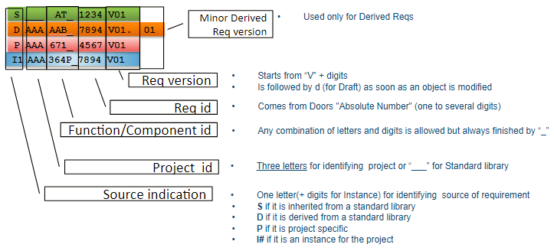
Allocations:
• Imp: indicates the Métier responsible for implementing the requirement
• Test: indicates the Métier responsible for verifying or testing the requirement

Variant:
In case of several variants in a project, identifies for which variants the requirement is applicable
When no variant is precized in the attribute, then the requirement is applicable for all variants.

Object Status:
Indicates the requirement life status (InWork, InReview, Accepted or Cancelled)

Safety Level:
• SL: indicates the ASIL level of the requirement if applicable

Instance:
An instance is declared for each occurrence of the function, and contains the specific inputs, outputs, parameters or characteristics defined for the project.

Introduction

Scope of the document
This document aims to explain how the signaling function shall operate. The system concerned by this dodument is a LED driver able to drive several Leds modules. The input of this function are signaling commands and forcing signals from defect handler. The outputs are PWM to apply on the LEDs

The Functional model of the signaling is composed by :
1) Auxiliary power sypply management : In this subsystem we check if we have the active power supply and the autorization in power to take into acount the signaling request (DRL, PL and TI)

2) Signaling Management : In this subsystem we define the different options that corresponds to the ways the signaling functions are commanded, then and according to the type optical module we define the signal PWM_Module.

3) Function Type Mapping : In this subsystem, for each LED, we verified if it is a signaling LED and we define the LED type. According to the Led Type we give a PWM to each led

4) Sliding TI : This subsytem define the sliding TI feature (how to light the TI Leds one after the other)

Defintions

Notations in the document
In this document the information inside [ ] are vectors
If only 1 value is inside [] this means that it applies on all vectors values.

Convention in the document

Reference documents

Document description | Reference | Identification | link
Ramp Management (MFRS) | R1

Overview of the functional block

Intended use of the function
Finality:
This document aims to explain how the signaling features shall perform in the lighting systems.
Expected services:
The signaling functions of a Headlamp regroup all the functions that answer to the need “To be seen by other road users”.

It is composed by :

- PL (Position Light) function that is intended to enhance the visibility of the vehicle to other road users by night. It is a low intensity white light function.

- DRL (Day running light ) function that is intended to enhance the visibility of the vehicle to other road users during Day. It is a white light with decent intensity to be seeable even in case of sunny weather.

- TI (Turn indicator) function that is intended to provide other road users the information that our vehicle will change direction or change of road lane. It is an orange decent intensity light to be seen even in case of sunny weather.

- SM (side marker) function that is a function intended to highlight the front corner of the vehicle. It is an orange decent intensity light. The side marker is optional in all market areas except in the USA where it is mandatory.
Note: The modules of type DRL\PL are modules that can perform on the same LEDs both PL and DRL functions.

Block Interfaces

Inputs

Description | Mnemonic | Unit | Min | Typical | Max | Resolution | Init Value
V_B_CMD_DRL :  Command to activate the DRL | V_B_CMD_DRL | bool | 0 | NA | 1 | 1 | -
V_B_CMD_PL :  Command to activate the PL | V_B_CMD_PL | bool | 0 | NA | 1 | 1 | -
V_B_CMD_TI :  Command to activate the TI | V_B_CMD_TI | bool | 0 | NA | 1 | 1 | -
Force_DRL_deactivation :  Command to force DRL deactivation. Usually comming from defect handler | Force_DRL_deactivation | bool | 0 | NA | 1 | 1 | -
Force_TI_deactivation :  Command to force TI deactivation. Usually comming from defect handler | Force_TI_deactivation | bool | 0 | NA | 1 | 1 | -
Force_SM_Deactivation :  Command to force SM deactivation. Usually comming from defect handler | Force_SM_Deactivation | bool | 0 | NA | 1 | 1 | -
Force_PL_activation :  Command to force PL activation. Usually comming from defect handler | Force_PL_activation | bool | 0 | NA | 1 | 1 | -
I_ActivePowerSupply :  Signal at 2 if the system is under auxiliary power source | I_ActivePowerSupply | int | 0 | NA | 2 | 1 | -

Outputs

Description | Mnemonic | Unit | Min | Typical | Max | Resolution | Init Value
PwmOutput :  This Output is a vector whose size is NumberOfLeds. It contain the PWM to apply on each output LED | PwmOutput | % | [0] | - | [100] | [0.1] | -

Parameters

Description | Mnemonic | Unit | Min | Max | Resolution
C_F_TypeOpticalModule :  The parameter C_F_TypeOpticalModule is a vector of NumberOfModules values. It gives the type of each module. It shall be :  0 - Not Activated  1 - Low Beam (including Flat and LB spots)  2 - Kink  3 - Pixel Kink  4 - Pixel HB  5 - TI  6 - CL  7 - HB spot  8 - DRL  9 - PL  10 - DRL/PL  11- Fog  12- SideMarker  13- AdditionalModule1  14- AdditionalModule2  15- AdditionalModule3 | C_F_TypeOpticalModule | - | [0] | [15] | [1]
C_F_OpticalModule_PLNominalPWM:  PWM to apply on the PL modules | C_F_OpticalModule_PLNominalPWM | % | 0 | 100 | 1
C_F_SignalingConfGrp1:  This parameter gives the type of the first signaling module group.  1 - Independent TI and DRL/PL  2 - DRL/PL off During TI cycle  3 - PL ON during TI OFF phase  4 - DRL off/PL Possible during TI cycle | C_F_SignalingConfGrp1 | - | 1 | 4 | 1
C_F_SignalingConfGrp2:  This parameter gives the type of the second signaling module group.  1 - Independent TI and DRL/PL  2 - DRL/PL off During TI cycle  3 - PL ON during TI OFF phase  4 - DRL off/PL Possible during TI cycle | C_F_SignalingConfGrp2 | - | 1 | 4 | 1
C_F_SignalingModuleGroup :  this parameter is a vector of NumberOfModules values. | C_F_SignalingModuleGroup | - | [0] | [2] | [1]
C_F_TickTIBlck :  Number of TI ticks before considering the TI mode shall pass off | C_F_TickTIBlck | - | 0 | - | 1
C_F_DrlRampTime :  This parmeter is theramp time when turning ON a DRL led. | C_F_DrlRampTime | s | 0 | 10 | 0.1
C_B_SlidingTiStepOfTheLeds :  This parameter that gives the step of the counter value from which each LED shall be turned ON. If a LED is a simple TI (not a sliding one), the value of this parameter will be 0 for this LED.  This parameter is a vector whose size is NumberOfLeds.  - | C_B_SlidingTiStepOfTheLeds | - | [0] | [C_F_NbStepTI] | [1]
C_F_NbStepTI :  Number of steps to consider in the counter. This number shall be equal to the maximum of C_B_SlidingTiStepOfTheLeds | C_F_NbStepTI | - | 0 | - | 1
C_F_RampTimeSlidingTI :  This parmeter is theramp time when turning ON a Sliding TI LED. | C_F_RampTimeSlidingTI | s | 1 | 10 | 0.1
C_F_FadingDisableSlidingTI :  This parameter that disables the ramp up on Sliding TI LEDs | C_F_FadingDisableSlidingTI | bool | 0 | 1 | 1
C_E_OpticalModuleOfEachLed
This parameter is a vector of size NumberOfLeds. The Xth value of the vector indicate the module the Xth LED of the system is in. If a Led is not activated in the system it value shall be 0
C_B_IsDRLAutorizedInPower2 :
This parameter is at 1 if the DRL is autorized in auxilary power
C_B_IsPLAutorizedInPower2 :
This parameter is at 1 if the PL is autorized in auxilary power
C_B_IsTIAutorizedInPower2 :
This parameter is at 1 if the TI is autorized in auxilary power

Constants

Description | Mnemonic | Unit | Min | Max | Resolution | DefaultValue
NumberOfModules :  Number of LED module drivable by the system | NumberOfModules | - | 1 | - | 1 | 12
NumberOfLeds :  Number of LED drivable by the system | NumberOfLeds | - | 1 | - | 1 | 112

Functional description
On the driver the module can be lighting or Signaling ones. The parameter C_F_TypeOpticalModule gives the type of each module

{ | S___EF_211 V00 | Imp: #SYS Test: #SYS SL: Status: InWork Do not use for design  Test Method: SysValidationTest
The parameter C_F_TypeOpticalModule is a is a vector of NumberOfModules values. It gives the type of each module. It shall be :
0 - Not Activated
1 - Low Beam (including Flat and LB spots)
2 - Kink
3 - Pixel Kink
4 - Pixel HB
5 - TI
6 - CL
7 - HB spot
8 - DRL
9 - PL
10 - DRL/PL
11- Fog
12- SideMarker
13- AdditionalModule1
14- AdditionalModule2
15- AdditionalModule3}

{ | S___EF_212 V00 | Imp: #SYS Test: #SYS SL: Status: InWork Do not use for design  Test Method: SysValidationTest
Only the Signaling modules (TI, DRL, PL, DRL/PL and Side marker) are concerned by the current specification}

{ | S___EF_272 V00 | Imp: #SYS Test: #SYS SL: Status: InWork Do not use for design  Test Method: SysValidationTest
For all the other requierements of the document the DRL\PL modules shall be considered as DRL modules when DRL is requested}

{ | S___EF_273 V00 | Imp: #SYS Test: #SYS SL: Status: InWork Do not use for design  Test Method: SysValidationTest
For all the other requierements of the document the DRL\PL modules shall be considered as PL modules when PL is requested}

Signaling Group Management
Due to regulation constraints in different countries, it is needed to provide several different ways to command the signaling functions. The driver shall offers 4 different options that corresponds to the ways the signaling functions are commanded and up to 2 different signaling groups that can be managed separately with a different option through parameter C_F_SignalingConfGrp1 and C_F_SignalingConfGrp2
The parameter C_F_SignalingModuleGroup is a vector of NumberOfModules values. If the Xth module is not a Signaling module then the Xth value of C_F_SignalingModuleGroup will not be taken into account by the system.

{ | S___EF_213 V00 | Imp: #SYS Test: #SYS SL: Status: InWork Do not use for design  Test Method: SysValidationTest
If the Xth module is a Signaling module and the Xth value of C_F_SignalingModuleGroup is 1, then the Xth module will belong to the first signaling group}

{ | S___EF_214 V00 | Imp: #SYS Test: #SYS SL: Status: InWork Do not use for design  Test Method: SysValidationTest
If the Xth module is a Signaling module and the Xth value of C_F_SignalingModuleGroup is 2, then the Xth module will belong to the second signaling group}

{ | S___EF_215 V00 | Imp: #SYS Test: #SYS SL: Status: InWork Do not use for design  Test Method: SysValidationTest
If the Xth module is a Signaling module and the Xth value of C_F_SignalingModuleGroup is not 1 nor 2, then the Xth module will belong to the first signaling group}
The parameters C_F_SignalingConfGrp1 and C_F_SignalingConfGrp2 respectively gives the signaling option for first and second groups

{ | S___EF_192 V00 | Imp: #SYS Test: #SYS SL: Status: InWork Do not use for design  Test Method: SysValidationTest
If the value of the parameter C_F_SignalingConfGrp1 is 1 then the first group's modules will be commanded with " Independent TI and DRL/PL " option
}

{ | S___EF_216 V00 | Imp: #SYS Test: #SYS SL: Status: InWork Do not use for design  Test Method: SysValidationTest
If the value of the parameter C_F_SignalingConfGrp1 is 2 then the first group's modules will be commanded with the "DRL/PL off During TI cycle" option}

{ | S___EF_218 V00 | Imp: #SYS Test: #SYS SL: Status: InWork Do not use for design  Test Method: SysValidationTest
If the value of the parameter C_F_SignalingConfGrp1 is 3 then the first group's modules will be commanded with the "PL ON during TI OFF phase " option}

{ | S___EF_217 V00 | Imp: #SYS Test: #SYS SL: Status: InWork Do not use for design  Test Method: SysValidationTest
If the value of the parameter C_F_SignalingConfGrp1 is 4 then the first group's modules will be commanded with "DRL off/PL Possible during TI cycle" option}

{ | S___EF_223 V00 | Imp: #SYS Test: #SYS SL: Status: InWork Do not use for design  Test Method: SysValidationTest
If for some reason the value of the parameter C_F_SignalingConfGrp1 is neither 1,2,3 nor 4 then the first group's modules will be commanded with "Independent TI and DRL/PL " option}

{ | S___EF_219 V00 | Imp: #SYS Test: #SYS SL: Status: InWork Do not use for design  Test Method: SysValidationTest
If the value of the parameter C_F_SignalingConfGrp2 is 1 then the second group's modules will be commanded with " Independent TI and DRL/PL " option
}

{ | S___EF_220 V00 | Imp: #SYS Test: #SYS SL: Status: InWork Do not use for design  Test Method: SysValidationTest
If the value of the parameter C_F_SignalingConfGrp2 is 2 then the second group's modules will be commanded with the "DRL/PL off During TI cycle" option}

{ | S___EF_221 V00 | Imp: #SYS Test: #SYS SL: Status: InWork Do not use for design  Test Method: SysValidationTest
If the value of the parameter C_F_SignalingConfGrp2 is 3 then the second group's modules will be commanded with the "PL ON during TI OFF phase " option}

{ | S___EF_222 V00 | Imp: #SYS Test: #SYS SL: Status: InWork Do not use for design  Test Method: SysValidationTest
If the value of the parameter C_F_SignalingConfGrp2 is 4 then the second group's modules will be commanded with "DRL off/PL Possible during TI cycle" option}

{ | S___EF_224 V00 | Imp: #SYS Test: #SYS SL: Status: InWork Do not use for design  Test Method: SysValidationTest
If for some reason the value of the parameter C_F_SignalingConfGrp2 is neither 1,2,3 nor 4 then the second group's modules will be commanded with "Independent TI and DRL/PL " option}

Independent TI and DRL/PL option
In this configuration the TI DRL/PL act as independent it means that PL optical set or DRL optical set can be active whatever the state of the TI optical set. This is intended to be used when DRL and PL light are far away from TI light.

{ | S___EF_228 V00 | Imp: #SYS Test: #SYS SL: Status: InWork Do not use for design  Test Method: SysValidationTest
In the case where a signaling group is in configuration "Independent TI and DRL/PL ", then when receiving the input V_B_CMD_TI at 1 and Force_TI_deactivation is at 0 , the TI modules of the group shall be turned on. Else these modules shall be turned off.}

{ | S___EF_232 V00 | Imp: #SYS Test: #SYS SL: Status: InWork Do not use for design  Test Method: SysValidationTest
In the case where a signaling group is in configuration "Independent TI and DRL/PL ", then when receiving the input V_B_CMD_DRL at 1 and Force_DRL_deactivation is at 0 , the the DRL modules of the group shall be turned on in DRL mode. }

{ | S___EF_233 V00 | Imp: #SYS Test: #SYS SL: Status: InWork Do not use for design  Test Method: SysValidationTest
In the case where a signaling group is in configuration "Independent TI and DRL/PL ", then when receiving the input V_B_CMD_PL at 1 or when receiving Force_PL_activation then the PL modules of the group shall be turned on in PL mode. }

{ | S___EF_234 V00 | Imp: #SYS Test: #SYS SL: Status: InWork Do not use for design  Test Method: SysValidationTest
In the case where the PL and the DRL are requested to be turned on in the same time then the DRL shall have the priority and only the DRL modules shall be turned on.}
Stateflow :
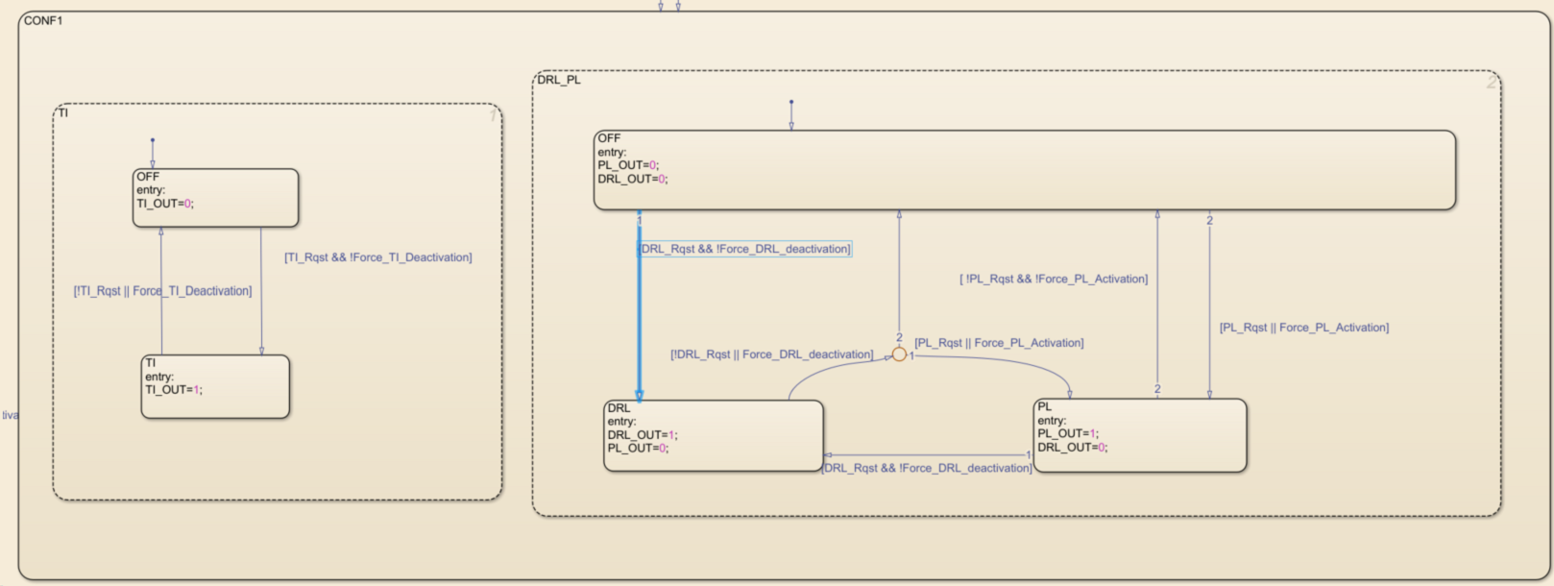

Example of behavior :
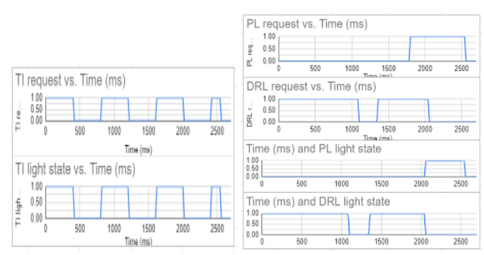

DRL/PL off During TI cycle
In this configuration, the DRL PL are switched off during the complete TI cycle. A TI cycle is defined as the ON phase + OFF phase of the TI . The vehicle gives TI ON request and a delay is running in the dodeca at TI switch off to ensure that the PL/DRL are kept off during the complete blinking cycle. This behavior is intended to be used in case where PL/DRL and TI are in the same light guide for instance.

{ | S___EF_239 V00 | Imp: #SYS Test: #SYS SL: Status: InWork Do not use for design  Test Method: SysValidationTest
In the case where a signaling group is in configuration "DRL/PL off During TI cycle ", then when receiving the input V_B_CMD_TI at 1 and Force_TI_deactivation is at 0 , the TI modules of the group shall be turned on. Else these modules shall be turned off.}

{ | S___EF_240 V00 | Imp: #SYS Test: #SYS SL: Status: InWork Do not use for design  Test Method: SysValidationTest
When module TI is turned on then the system shall enter in TI mode.
When in TI mode DRL, PL and DRL\PL modules cannot be turned on.}

{ | S___EF_241 V00 | Imp: #SYS Test: #SYS SL: Status: InWork Do not use for design  Test Method: SysValidationTest
To leave TI mode the sytem shall received Force_TI_deactivation at or not have reveided any V_B_CMD_TI equal to 1 during the last C_F_TickTIBlck ticks}

{ | S___EF_242 V00 | Imp: #SYS Test: #SYS SL: Status: InWork Do not use for design  Test Method: SysValidationTest
TI have the priotity over other signaling modules. This means that if the system fullfill the requierements to turn on the TI modules then it shall do it and shut off other modules.}

{ | S___EF_243 V00 | Imp: #SYS Test: #SYS SL: Status: InWork Do not use for design  Test Method: SysValidationTest
In the case where a signaling group is in configuration "DRL/PL off During TI cycle ", then when receiving the input V_B_CMD_DRL at 1 and Force_DRL_deactivation is at 0 , the the DRL modules of the group shall be turned on in DRL mode. }

{ | S___EF_244 V00 | Imp: #SYS Test: #SYS SL: Status: InWork Do not use for design  Test Method: SysValidationTest
In the case where a signaling group is in configuration "DRL/PL off During TI cycle ", then when receiving the input V_B_CMD_PL at 1 or when receiving Force_PL_activation then the PL modules of the group shall be turned on. }

{ | S___EF_245 V00 | Imp: #SYS Test: #SYS SL: Status: InWork Do not use for design  Test Method: SysValidationTest
In the case where the PL and the DRL are requested to be turned on in the same time then the DRL shall have the priority and only the DRL modules shall be turned on.}
Stateflow :
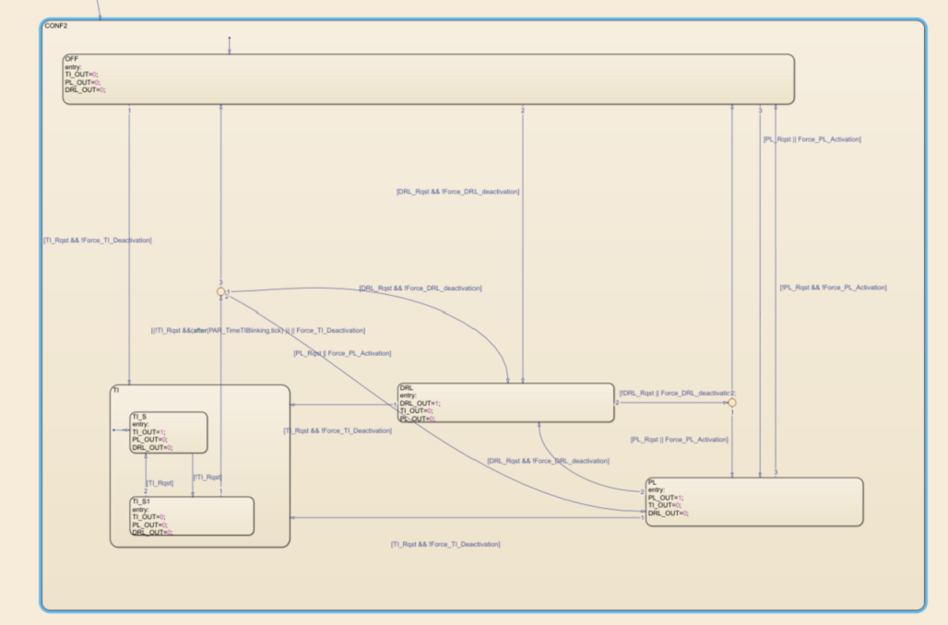
Example of behavior :
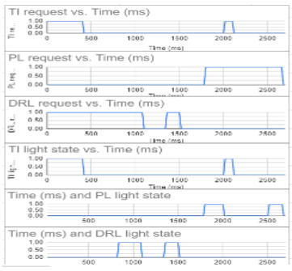

PL ON during TI OFF phase
In this Configuration, the DRL is not allowed during the whole TI cycle, but if DRL or PL is requested, during the TI off cycle the PL should be forced. This configuration may be necessary in some conditions where DRL/PL light contributor is located near to the TI light contributor and in some specific countries regulation.

{ | S___EF_251 V00 | Imp: #SYS Test: #SYS SL: Status: InWork Do not use for design  Test Method: SysValidationTest
In the case where a signaling group is in configuration "PL ON during TI OFF phase ", then when receiving the input V_B_CMD_TI at 1 and Force_TI_deactivation is at 0 , the TI modules of the group shall be turned on. Else these modules shall be turned off.}

{ | S___EF_252 V00 | Imp: #SYS Test: #SYS SL: Status: InWork Do not use for design  Test Method: SysValidationTest
When module TI is turned on then the system shall enter in TI mode.
When in TI mode DRL modules cannot be turned on.
PL and DRL modules can be turned on in PL mode when the TI is not turned on}

{ | S___EF_253 V00 | Imp: #SYS Test: #SYS SL: Status: InWork Do not use for design  Test Method: SysValidationTest
To leave TI mode the sytem shall received Force_TI_deactivation at or not have reveided any V_B_CMD_TI equal to 1 during the last C_F_TickTIBlck ticks}

{ | S___EF_254 V00 | Imp: #SYS Test: #SYS SL: Status: InWork Do not use for design  Test Method: SysValidationTest
TI have the priotity over other signaling modules. This means that if the system fullfill the requierements to turn on the TI modules then it shall do it and shut off other modules.}

{ | S___EF_255 V00 | Imp: #SYS Test: #SYS SL: Status: InWork Do not use for design  Test Method: SysValidationTest
In the case where a signaling group is in configuration "PL ON during TI OFF phase ", then when receiving the input V_B_CMD_DRL at 1 and Force_DRL_deactivation is at 0 , the the DRL modules of the group shall be turned on. }

{ | S___EF_256 V00 | Imp: #SYS Test: #SYS SL: Status: InWork Do not use for design  Test Method: SysValidationTest
In the case where a signaling group is in configuration "PL ON during TI OFF phase ", then when receiving the input V_B_CMD_PL at 1 or when receiving Force_PL_activation then the PL modules of the group shall be turned on. }

{ | S___EF_257 V00 | Imp: #SYS Test: #SYS SL: Status: InWork Do not use for design  Test Method: SysValidationTest
In the case where the PL and the DRL are requested to be turned on in the same time then the DRL shall have the priority and only the DRL modules shall be turned on .}

{ | S___EF_258 V00 | Imp: #SYS Test: #SYS SL: Status: InWork Do not use for design  Test Method: SysValidationTest
The priority of the DRL over the PL apply even in TI mode, this mean that If DRL is request during TI mode and TI off no module shall be activated.}
Stateflow :
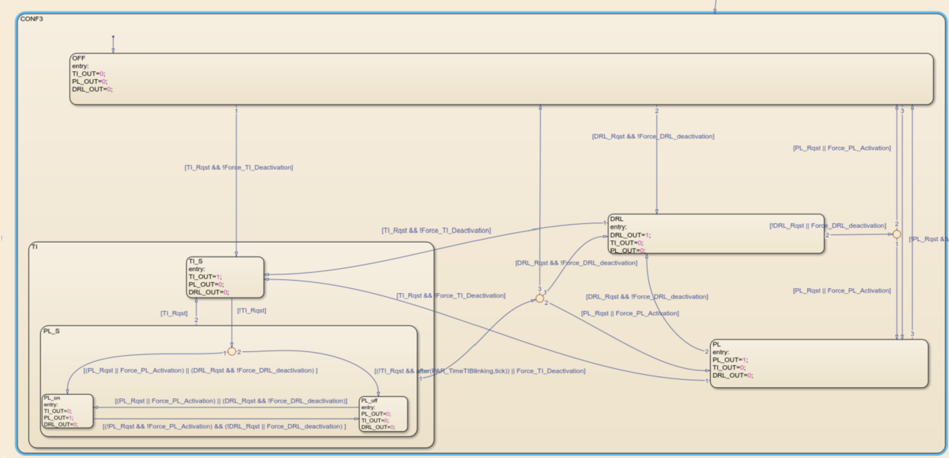
Example of behavior :
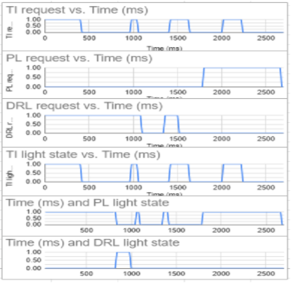

DRL off/PL Possible during TI cycle
With this option the system shall switch off DRL during the complete TI cycle. PL is still allowed. If DRL is requested during TI then PL shall be activated.

{ | S___EF_264 V00 | Imp: #SYS Test: #SYS SL: Status: InWork Do not use for design  Test Method: SysValidationTest
In the case where a signaling group is in configuration "DRL off/PL Possible during TI cycle ", then when receiving the input V_B_CMD_TI at 1 and Force_TI_deactivation is at 0 , the TI modules of the group shall be turned on. Else these modules shall be turned off.}

{ | S___EF_265 V00 | Imp: #SYS Test: #SYS SL: Status: InWork Do not use for design  Test Method: SysValidationTest
When module TI is turned on then the system shall enter in TI mode.
When in TI mode DRL, PL and DRL\PL modules cannot be turned on.}

{ | S___EF_266 V00 | Imp: #SYS Test: #SYS SL: Status: InWork Do not use for design  Test Method: SysValidationTest
To leave TI mode the sytem shall received Force_TI_deactivation at or not have reveided any V_B_CMD_TI equal to 1 during the last C_F_TickTIBlck}

{ | S___EF_268 V00 | Imp: #SYS Test: #SYS SL: Status: InWork Do not use for design  Test Method: SysValidationTest
In the case where a signaling group is in configuration "DRL off/PL Possible during TI cycle ", If the system is not in TI mode, then when receiving the input V_B_CMD_DRL at 1 and Force_DRL_deactivation is at 0 , the the DRL and DRL\PL modules of the group shall be turned on in DRL mode. }

{ | S___EF_270 V00 | Imp: #SYS Test: #SYS SL: Status: InWork Do not use for design  Test Method: SysValidationTest
In the case where a signaling group is in configuration "DRL off/PL Possible during TI cycle ", If the system is in TI mode, then when receiving the input V_B_CMD_DRL at 1 and Force_DRL_deactivation is at 0 , the the PL modules of the group shall be turned on. }

{ | S___EF_269 V00 | Imp: #SYS Test: #SYS SL: Status: InWork Do not use for design  Test Method: SysValidationTest
In the case where a signaling group is in configuration "DRL off/PL Possible during TI cycle", then when receiving the input V_B_CMD_PL at 1 or when receiving Force_PL_activation then the PL modules of the group shall be turned on in PL mode. }

{ | S___EF_271 V00 | Imp: #SYS Test: #SYS SL: Status: InWork Do not use for design  Test Method: SysValidationTest
If TI and PL are requested to be turned on in the same time then they shall be activated together}

{ | S___EF_275 V00 | Imp: #SYS Test: #SYS SL: Status: InWork Do not use for design  Test Method: SysValidationTest
In the case where the PL and the DRL are requested to be turned on in the same time then the DRL shall have the priority and only the DRLmodules shall be turned on .}
Stateflow :
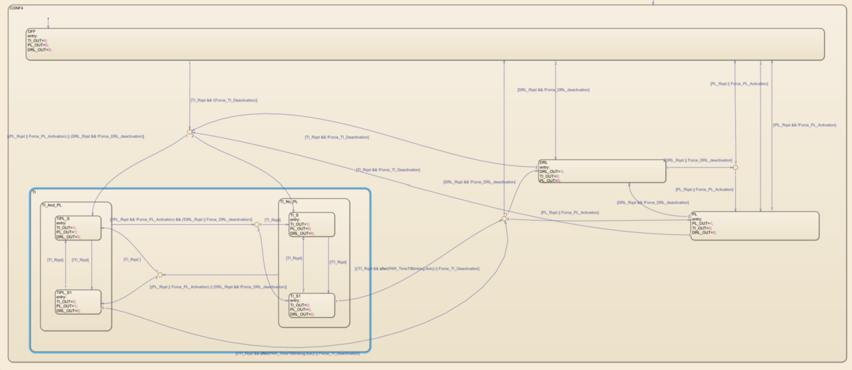

DRL ramp up
The Signaling allows to configure a Ramp for DRL activation
Upon activation the DRL modules shall apply a ramp up. The duration of the ramp up shall be C_F_DrlRampTime.
The ramp on DRL module shall respect requierements form doc R1
After the end of the ramp the PWM on the DRL module shall be 100%

Slidding TI
The sliding TI is a feature for TI composed of a branch of LED. With that feature it is possible to light the TI LED one after the other.

{ | S___EF_284 V00 | Imp: #SYS Test: #SYS SL: Status: InWork Do not use for design  Test Method: SysValidationTest

The algorithm to perform slidding TI shall be the following:
-When TI is requested then a counter start.
-This counter increase at every sample time until the TI request fall to 0
-At the next TI cycle the counter restart.
}

A parameter describing the value of the counter from which the LED shall turn on is given to every single LED of the TI.
A ramp can be performed when the LED turns ON. There is no ramp for LED extinction.

{ | S___EF_286 V00 | Imp: #SYS Test: #SYS SL: Status: InWork Do not use for design  Test Method: SysValidationTest
C_B_SlidingTiStepOfTheLeds is a parameters that give the step of the counter value from which each LED shall be turned ON. If a LED is a simple TI (not a sliding one), the value of this parameter will be 0 for this LED.
This parameter is a vector whose size is NumberOfLeds.}

{ | S___EF_288 V00 | Imp: #SYS Test: #SYS SL: Status: InWork Do not use for design  Test Method: SysValidationTest
C_F_NbStepTI : Number of steps to consider in the counter. This number shall be equal to the maximum of C_B_SlidingTiStepOfTheLeds}

{ | S___EF_287 V00 | Imp: #SYS Test: #SYS SL: Status: InWork Do not use for design  Test Method: SysValidationTest
C_F_TiSlidingDuration: Duration of the TI slide. It represent for the counter the time to go from 0 to NbStepTI }

{ | S___EF_289 V00 | Imp: #SYS Test: #SYS SL: Status: InWork Do not use for design  Test Method: SysValidationTest
C_F_RampTimeSlidingTI ramp time when turning ON a Sliding TI LED.}

{ | S___EF_290 V00 | Imp: #SYS Test: #SYS SL: Status: InWork Do not use for design  Test Method: SysValidationTest
The ramp on TI module shall respect requierements form doc R1}

{ | S___EF_291 V00 | Imp: #SYS Test: #SYS SL: Status: InWork Do not use for design  Test Method: SysValidationTest
After the end of the ramp the PWM on the TI module shall be 100%}

{ | S___EF_292 V00 | Imp: #SYS Test: #SYS SL: Status: InWork Do not use for design  Test Method: SysValidationTest
C_F_FadingDisableSlidingTI is a parameter that disables the ramp up on Sliding TI LEDs}

{ | S___EF_322 V00 | Imp: #SYS Test: #SYS SL: Status: InWork Do not use for design  Test Method: SysValidationTest
If slidding TI is not apply on a TI LED then its output shall be at 100% PWM when TI is requested}
Example:
For this example a TI module consisting of 10 LEDs will be considered.
Sliding TI Step Of The Leds : [1;2;3;4;5;6;7;8;9;10]
NbStepTI :10;
TI Sliding Duration:0,2s
Ramp Time Sliding TI:0s
Fading Disable Sliding TI:1;

The Input of this function will be the TI request signal. In this example a square signal of period 1s whose pulse width is 400ms will be considered.

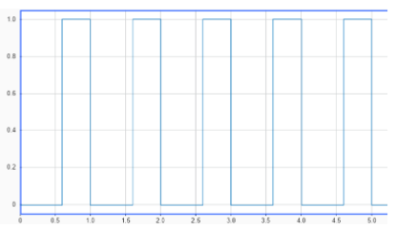

Step 1 :t=T0
TI request is 0.
Counter value : 0
All led are OFF

Step2:t=T1
TI request pass at 1
Counter value :1
First LED turn ON

Step3:t=T1+20ms
TI request stay at 1
Counter value :2
LED1 et 2 are ON

….

Step11:t=T1+200ms
TI request stay at 1
Counter value :10
All TI LED are ON

Step 12: t=T1+T2 (with T2>200ms and T2<400ms)
TI request stay at 1
Counter value :>10
All TI LED are ON

Step 13: T1+T3 (with T3>=400ms and T3<1s)
TI request at 0
Counter value :0
All TI LED are OFF

SIde Markers

{ | S___EF_294 V00 | Imp: #SYS Test: #SYS SL: Status: InWork Do not use for design  Test Method: SysValidationTest
The modules of type SideMaker shall be activated if :
(V_B_CMD_PL = 1 OR V_B_CMD_DRL=1 OR Force_PL_activation = 1) AND Force_SM_Deactivation = 0}

{ | S___EF_321 V00 | Imp: #SYS Test: #SYS SL: Status: InWork Do not use for design  Test Method: SysValidationTest
When the SM modules are turned on all their Leds shall be at 100%.}

PL

{ | S___EF_274 V00 | Imp: #SYS Test: #SYS SL: Status: InWork Do not use for design  Test Method: SysValidationTest
The parameter C_F_OpticalModule_PLNominalPWM is a vector with NumberOfModules values. It give for each module the PWM to apply to the LEDs if the module is a PL one. If the module is not PL or DRL\PL this parameter shall not be used. If the module is DRL\PL then this PWM value shall be apply only if PL is requested.}

Function to Led mapping

{ | S___EF_319 V00 | Imp: #SYS Test: #SYS SL: Status: InWork Do not use for design  Test Method: SysValidationTest
The function shall use the parameters C_E_OpticalModuleOfEachLed to find out the module of each LED}

{ | S___EF_320 V00 | Imp: #SYS Test: #SYS SL: Status: InWork Do not use for design  Test Method: SysValidationTest
All the Led of signaling modules shall be set at the value find out by the previous requierements (cf; figure below)}
<Picture>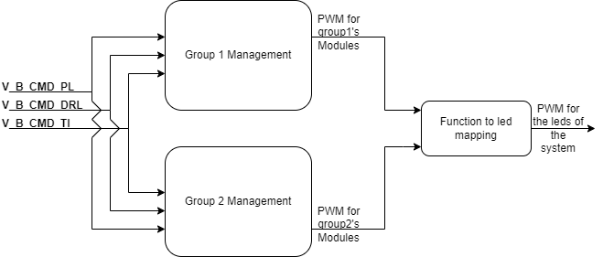

Auxiliairy power supply Management

{ | S___EF_325 V00 | Imp: #SYS Test: #SYS SL: Status: InWork Do not use for design  Test Method: SysValidationTest
When receiving the input I_ActivePowerSupply = 2 with the parameter C_B_IsDRLAutorizedInPower2 = 0 the system shall not take into account the input V_B_CMD_DRL}

{ | S___EF_326 V00 | Imp: #SYS Test: #SYS SL: Status: InWork Do not use for design  Test Method: SysValidationTest
When receiving the input I_ActivePowerSupply = 2 with the parameter C_B_IsPLAutorizedInPower2 = 0 the system shall not take into account the input V_B_CMD_PL}

{ | S___EF_327 V00 | Imp: #SYS Test: #SYS SL: Status: InWork Do not use for design  Test Method: SysValidationTest
When receiving the input I_ActivePowerSupply = 2 with the parameter C_B_IsTIAutorizedInPower2 = 0 the system shall not take into account the input V_B_CMD_TI}

