
Mechatronics and Robotics Engineering Technology

ROBT 4491

Mechatronics Project

Final Project Report:
Non-planar 3d printer

Produced By:
Keaton
Kassia Ferguson
Margareth Sabate
Date: | May 19, 2026
For: | Isaiah Regacho, Matthew Rockall, AM Group


Acknowledgments

We would like to express our deepest appreciation to the following for their assistance and guidance with the Non-Planar 3D Printer:
- The Additive Manufacturing Group, BCIT Mechanical Organization and Project Sponsor
- Ali Mohammad-Vali, Assistant Instructor and Project Sponsor
- Jalal Kahnamouei, Mechanical Instructor and Project Sponsor
- Maejor Sidhu, Assistant Instructor
- Greg Scutt, Mechatronics and Robotics Program Head
- Isaiah Regacho, Mechatronics and Robotics Instructor
- Matthew Rockall, Mechatronics and Robotics Instructor
- Brian Ennis, Assistant Instructor
Additionally, we are extremely thankful for Dan Brogan and his development of the open-source Fractal Cortex slicer: https://github.com/fractalrobotics/Fractal-Cortex
Abstract

Traditional 3D-printers require support structure when printing on angles greater than 45°. In a system such as the Gas Metal Arc Welding Directed Energy Deposition (GMAW DED), supports will fuse permanently to the printed parts, and require expensive and laborious post-processing to remove.
To combat this issue, the AM Group has proposed the idea of a 5 Degree of Freedom (DoF) multi-planar 3D printer as a final student project. The printer eliminated the need for supports, by reorienting the build plate during printing. With the addition of two new axes, a +50˚ pitch and a continuous yaw, the rotation and tilt allow for the toolhead to maintain a perpendicular angle relative to the printing surface.
This project would be multi-year and merged with BCITs’ Mechanical Department. Each year students develop their project, it will be left with the AM Group for future students to develop on.
The Non-Planar 3D Printer was built off of a standard cartesian Fusion Deposition Modeling (FDM) printer. The primary subsystems that were modified or added were the Slicer, Turntable, Angle Monitoring and Visualization System, and Duet Configuration and Integration.
The Slicer was one of the main requests from the AM Group. They requested a slicer that could generate non-planar toolpaths. Due to the tight time constraints, it was decided that the open-source slicer, Fractal Cortex designed by Dan Brogan, would be the base, and would be modified to suit our printer.
The Turntable made up the majority of the mechanical work. It has two degrees of movement, the +50˚ pitch rotation, and the continuous yaw rotation which are controlled by two Clearpath motors. With the addition of these two axes, the printer bed can now move along with the pre-existing cartesian X, Y, and Z axes to keep the toolhead perpendicular to the print plane.
The Angle Monitoring and Visualization is a safety system which tracks the pitch angle of the build plate and alerts the control board if a threshold is passed. Additionally, the subsystem provides a real-time visual representation of the build plate orientation, so that users can control and monitor their print from different locations.
The Duet 2 board controls all systems in the Non-Planar 3D Printer by taking the slicer outputs to control the motors.
The entire system costs around $334 (see Appendix D) in ordered materials with the majority of the cost coming from the Turntable.
In summary, the project was a success as it was fully capable of printing overhanging shapes (see Appendix G) and will become a strong foundation for future students to build off.
Preface

This project was proposed by the Additive Manufacturing Group at the British Columbia Institution of Technology as a final capstone project for both the Mechatronics and Robotics students, and the Mechanical students. This project is meant to be developed over several years, and all work done will be left with the AM Group for future students to build on.
Table of Contents
1 Introduction 1
2 System Overview 1
2.1 System Requirements 1
2.1.1 System Block Diagram 3
2.2 Slicer Subsystem 4
2.3 Turntable Subsystem 4
2.4 Angle Monitoring and Visualization Subsystem 4
2.5 Duet Configuration and Integration 4
3 Slicer 5
3.1 Slicer Requirements 6
3.2 Slicer Design and Implementation 6
3.2.1 G-Code Support 6
3.2.2 Pitch Axis Offset 7
3.2.3 Swapped Pitch Axis 7
4 Turntable 8
4.1 Turntable Requirements 8
4.2 Turntable Design 9
4.2.1 Hardware Design 9
4.3 Turntable Implementation 11
4.3.1 Hardware Implementation 11
4.3.2 Software Implementation 13
5 Angle monitoring and Visualization 14
5.1 Angle monitoring and Visualization Requirements 14
5.2 Angle Monitoring and Visualization Design 14
5.3 Hardware Design 15
5.3.2 Software Design 16
5.4 Angle Monitoring and Visualization Implementation 19
5.4.1 Hardware Implementation 19
5.4.2 Software Implementation 20
6 Duet Configuration and Integration 24
6.1 Duet Configuration and Integration Requirements 24
6.2 Duet Configuration and Integration Implementation 24
6.2.1 Duet As A Controller 24
6.2.2 Duet Web Control 24
6.2.3 Duet and Printer Calibration 24
7 System Verification 27
7.1 System Operation 27
7.2 Performance Metrics 27
8 Project Summary 27
8.1 System Specifications 27
8.2 Recommendations/Future Work 28
9 Conclusion 30
10 Citations 30

Table of Figures
Figure 1 – Non-Planar 3D printer Subsystem Block Diagram 3
Figure 2 – Fractal Cortex GUI Guide 5
Figure 3 – Original commands produced to move the rotational axes 7
Figure 4 – New commands now using G-code completing the same operation 7
Figure 5 – Clearpath SDSK Model Figure 6 – Nema 17 Stepper 8
Figure 7 – Printer Bed CAD 9
Figure 8 – Printer Bed Machined Part Figure 9 – Leveling Plate Machined Part 11
Figure 10 – Implemented Printer bed and Yaw Axis 12
Figure 11 – Turntable With +50˚ Tilt Figure 12 – Turntable With 0˚ Tilt 12
Figure 13 – Worm Gear Drive 13
Figure 14 – Turntable in Action 13
Figure 15 – Schematic for the Angle Monitoring system 15
Figure 16 – Diagram of Data Flow of Angle Monitoring System 16
Figure 17 – BNO055 Gravity Reference Calibration Code 20
Figure 18 – Pitch Angle Calculation Code 21
Figure 19 – Unity UDP DATA Packet Parsing Code 22
Figure 20 – Unity Angle Monitor UI Layout 23
Figure 21 – Unity Verification Status Banner (BAD (left) and GOOD (right)) 24

Table of Tables
Table 1 – Non-Planar 3D printer Subsystem Block Diagram Legend 3
Table 2 - Summary of Angle Monitoring System Design and Implementation 14

Table of Equations
Equation 1 – Pitch Axis Offset Calculations 7
Equation 2 – Swapped Pitch Axis Rotation Matrix 7
Equation 3 – Yaw Axis Belt Drive Reduction Calculation 10
Equation 4 – Pitch Axis Drive Reduction Calculation 10
Equation 5 – Pitch Axis Worm Drive Calculation 10
Equation 6 – Combined Pitch Axis Drive Reduction 10
Equation 7 - Formula for Angle Between 2 Vectors 21

Introduction
The Additive Manufacturing Group at BCIT is aiming to develop a Gas Metal Arc Welding (GMAW) Directed Energy Deposition (DED) system capable of generating metal non-planar 3D models. To support this goal, a functional non-planar 3D printer prototype was requested to validate the feasibility of 5 degree of freedom (5-DoF) printing, build the necessary slicing and control software, and conduct safe testing before moving to metal deposition.
This project develops a 5-DoF non-planar 3D printer by adding two additional axes (pitch and yaw) to the standard 3-axis (X, Y, Z) cartesian printer. This configuration enables printing of complex designs without the support structures they typically require. This system provides AM Group with a working platform to perform tests to refine and tune the software and mechanical elements of non-planar printing before implementing GMAW technology.
This report documents the design, implementation, and validation of the non-planar 3D printer system. The document will walk through each of the 4 main subsystems, which are slicer, turntable, angle monitoring and visualization, and Duet configuration and integration, as well as the verification of the whole system, and recommendations for future work.

System Overview
The Non-Planar 3D printer is an educational mechatronics system for the AM Group, the BCIT Mechanical Department, and the BCIT Mechatronics and Robotics program. The system expands on the capabilities of standard 3D printers through the addition of two new rotational degrees of freedom applied to the build plate. The printer is controlled through a Duet 2 Ethernet controller accessible via a web interface, which coordinates motion across all 4 axes (X, Y, Z, Pitch, Yaw). Toolpaths are generated using a modified Fractal Cortex slicer that outputs G-code that is compatible with the 5-axis system. Real-time angle monitoring is providing by an ESP32-based subsystem that compares commanded angles to measure IMU data and alerts users through both the Duet web interface and a Unity visualization when errors exceed a threshold. The system serves as a functional platform for validating 5-axis printing strategies before implementing them to metal deposition processes.

System Requirements
The non-planar 3D printer must fulfill the following requirements:

Turntable:
- 5-DoF: X, Y, Z (linear), A (yaw), B (pitch)
- Pitch range: 0-50° to enable non-planar printing without nozzle collision
- Yaw range: Continuous 360° rotation
- Positioning accuracy: ±0.2mm (linear), ±3° (rotational)
- Mechanical structure must hold position without slipping during printing
- Build plate support for parts up to 500g without deflection

Slicer and Control:
- 5-axis toolpath generation from 3D models with multiple slicing planes
- G-code output compatible with Duet controller
- Compensation for pitch axis offset from build plate surface
- Web-based interface for uploading G-code and monitoring print progress
- Coordinated motion control across all 5 axes with synchronized speeds

Angle Monitoring and Verification:
- Real-time pitch angle monitoring with ±3° error detection threshold
- Continuous comparison of commanded vs. measured angles during printing
- Operator alerts via Duet web interface and Unity visualization when errors exceed threshold
- 3D visual representation of build plate orientation
- Manual pause/resume capability for operator intervention
- System operates independently without disrupting motion control

Cable Management:
- Wire routing accommodating continuous yaw rotation without tangling or interference
- Sufficient cable slack for full pitch motion range (0-50°)
- Slip ring or cable chain solutions for rotating connections
- Clear cable pathways for easy troubleshooting and maintenance
- Sensor and power cables isolated from moving mechanical components
These requirements ensure safe testing of non-planar printing strategies before transitioning to metal deposition applications.

System Block Diagram
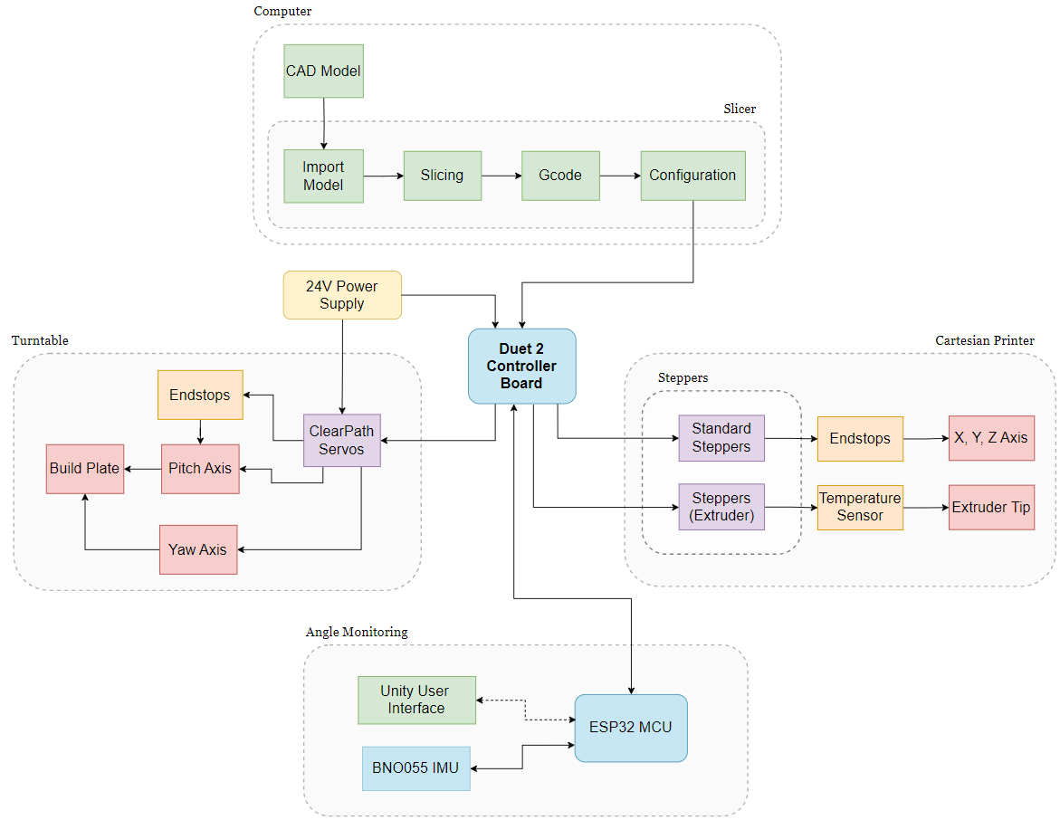
Figure 1 – Non-Planar 3D printer Subsystem Block Diagram
Table 1 – Non-Planar 3D printer Subsystem Block Diagram Legend
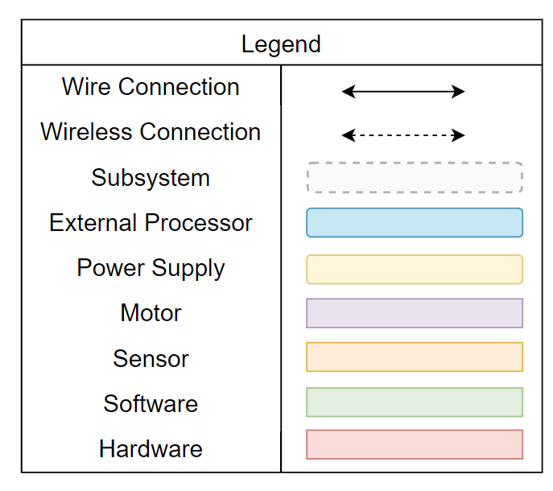

Slicer Subsystem
The Slicer subsystem is a non-negotiable portion of the project. The AM Group requested a slicer capable of generating non-planar toolpath instructions from 3D CAD models as one of the main deliverables. Due to the time constraints of this project, an open-source slicer, Fractal Cortex designed by Dan Brogan, was chosen as the base to be built off. The rest of the physical 3D printer was designed around the capabilities of the slicer.
The modified slicer and control board configuration has been uploaded to GitHub:
https://github.com/Hacker-Cat2/BCIT-Fractal-Cortex-5DoF-Slicer

Turntable Subsystem
The Turntable subsystem is where the Non-Planar 3D Printer strays from traditional cartesian printer systems. This subsystem provides an additional two axes of movement: pitch and yaw. Alongside the cartesian X, Y, and Z, linear movements, the combination of axes allows the 3D printed part to tilt and rotate so that the print orientation is always near perpendicular to the part surface. This subsystem is the main mechanical component of our system that was built from the group up.

Angle Monitoring and Visualization Subsystem
The Angle Monitoring and Visualization subsystem continuously verifies that the build plate is positioned at the commanded angle and alerts users when discrepancies occur. It measures the actual pitch angle of the build plate and compares it against the commanded angle from the Duet Integration subsystem. When the measured angle deviates from the commanded angle by more than the acceptable threshold, alerts are sent to both the printer's control interface and a visualization display.
Real-time feedback is provided to users through a visual representation of the build plate orientation, allowing them to monitor print progress and assess whether errors require intervention. This subsystem operates independently of motion control and does not automatically pause printing, preserving user authority over print continuation decisions.

Duet Configuration and Integration
The Duet Configuration and Integration subsystem serves as the central controller for all the printer motion and communication. It manages the coordination of all 5 axes and the extruder through the Duet 2 board, which is accessible through USB or Ethernet connection. Configuration is handled through the “config.g” file, and the custom Duet web interface, which provides users with real-time monitoring, jogging, and print management. Proper calibration of the system is essential to ensure print quality and prevent mechanical damage.

Slicer
The Slicer subsystem is a major software component required for generating toolpath instructions from 3D CAD models. With the additional 2 rotational axes to control, a very specific and more complex type of slicing software is required. Because creating a custom slicer from scratch would be incredibly tedious and time consuming for a 4-month project, an open-source slicer, Fractal Cortex designed by Dan Brogan, was chosen as a solid starting point.
The modified slicer and control board configuration has been uploaded to GitHub:
https://github.com/Hacker-Cat2/BCIT-Fractal-Cortex-5DoF-Slicer
Source: [4]
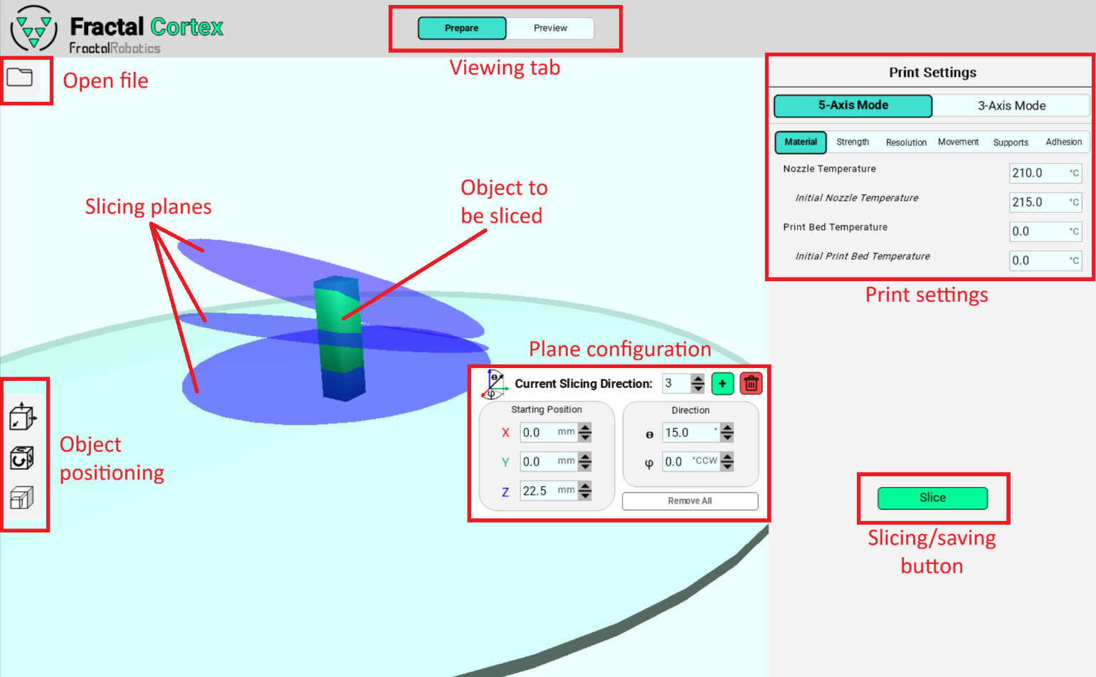
Figure 2 – Fractal Cortex GUI Guide
Fractal Cortex is written entirely in Python and is equipped with both slicing functions and a pleasant GUI to configure slicing. It takes a 3D object, print orientations and settings to create a G-code file that can be directly uploaded to the printer. To generate G-code from an object, there are a few simple steps to follow:
- Select the “open file” button and choose the desired object from the file viewer.
- Position the object as required using controls on the left
- Choose the number of planes for slicing and press “apply”. The build plate counts as the 1st plane, so N-1 planes will be displayed and evenly distributed vertically along the object.
- Adjust angle and position of the planes to preference, noting that higher-index planes take sectioning priority over lower-index planes.
- Adjust print settings to preference. Common settings include:
  - Nozzle temperature (200 - 220 °C for PLA filament)
  - Print speed (capped at 6000mm/min for X/Y and 300mm/min on Z axis)
  - Layer height (0.1mm to 0.3mm, lower resulting in smoother walls)
Note the nozzle diameter is 0.6mm compared to typical printers with 0.4mm.
  - Brim adhesion mode (multiple perimeters around the first layer to increase contact area)
Note that due to lack of a heated bed, PLA will adhere best to the build plate with a layer of masking tape applied and other plastics may not adhere well at all.
- Select the “Slice” button and wait for toolpaths to be generated (this may take a few minutes)
- Select the “Save as G-code” button and choose a file name
- The G-code file can now be uploaded to the Duet2 control board through the web interface or directly with a file transfer to the micro-SD card

Slicer Requirements
The Slicer Subsystem must fulfil the following requirements to ensure quality prints and safe operation:
- Toolpath generation
  - 3D objects are dimensioned correctly after toolpath generation
  - Positioning accuracy equal or better than printer’s capabilities (reduce rounding/noise)
  - Kinematics match that of physical system within ±0.2 mm
  - Slicing on multiple planes
  - Output must be supported on Duet2 (pure G-code)

- User interface
  - Easy manipulation of objects
  - Settings to control how printing is performed (slicing planes, temperature, speed, etc.)

Slicer Design and Implementation
Visually, the slicer remains largely the same as the original Fractal Cortex. Under the hood, however, several changes have been made to improve functionality and integration with the new 5-DoF printer. Most notably, the slicer now fully supports G-code, accounts for offsets between the pitch axis and the surface of the build plate and has swapped the rotational axis of the pitch axis from the X axis to the Y axis.

G-Code Support
Previously, custom commands were produced by the slicer to control the rotational pitch and yaw axes it was designed for. These commands, however, are not generally supported by any hardware outside of the original creator’s system. Therefore, this needed to be changed to make the slicer more broadly compatible with different systems. Because the rest of the commands were G-code, and G-code is an industry standard format for control of axes, the custom commands have been replaced and are now fully supported by the Duet2 control board, as well as any other system with G-code support.
In addition to full G-code support, customizable axis names have been added to allow different configurations for new systems. They are added as variables “YAW_NAME” and “PITCH_NAME” at the top of “slicing_functions.py” with yaw and pitch being “A” and “B” respectively.
“HOME_X” and “HOME_Y” defines also exist in the same location to allow custom resting positions out of the way while the rotational axes are in movement.

openFile.write('MANUAL_STEPPER STEPPER=stepper_a MOVE=' + str(round(AMOVE_Degrees[int(key)], 5)) + ' SPEED=' + str(round(ASPEED_Scaled[int(key)], 5)) + ' SYNC=0' + '\n')
openFile.write('MANUAL_STEPPER STEPPER=stepper_b MOVE=' + str(round(BMOVE_Degrees[int(key)], 5)) + ' SPEED=' + str(round(BSPEED_Scaled[int(key)], 5)) + ' SYNC=1' + ' STOP_ON_ENDSTOP=2' + '\n')
Figure 3 – Original commands produced to move the rotational axes
Only one axis could be told to move per line, and several additional parameters needed to be set as well.

openFile.write(f"G1 F{round(AB_FEEDRATE, 5)} {YAW_NAME}{round(AMOVE_Degrees[int(key)], 5)} {PITCH_NAME}{round(BMOVE_Degrees[int(key)], 5)} ; Moving axes" + "\n")
Figure 4 – New commands now using G-code completing the same operation
It’s more customizable using definable axes names and is automatically linearly interpolated by the controller so both axes will finish at the same time without extra calculations in the slicer.

Pitch Axis Offset
In the original slicer, it is assumed that the top of the build plate is perfectly in line with the axis of pitch. Unfortunately, this is not compatible with this projects’ design, and likely won’t be for future iterations either. Due to this, it was necessary to implement offsets for the X, Y, and Z axes to compensate for the translation caused by pitch rotation. The offset can be easily modified within the “Z_RADIUS” variable defined at the top of “slicing_functions.py” to fit any printer configuration. Specifically, this variable is defined by the distance from the center of the rotational axis to the surface of the build plate. Upwards is defined as positive, but should the printing surface lie below the axis, a negative value should still work correctly though this has not yet been tested.
The offsets were calculated as follows (ϕ = yaw angle, θ = pitch angle):
$$X_{offset}=\sin\left(θ\right)×\cos\left(ϕ\right)×Z_{RADIUS}$$
$$Y_{offset}=-\sin\left(θ\right)×\sin\left(ϕ\right)×Z_{RADIUS}$$
$$Z_{offset}=\left(1-\cos\left(θ\right)\right)×Z_{RADIUS}$$

Equation 1 – Pitch Axis Offset Calculations

Swapped Pitch Axis
Differences in configuration of axes in the physical printer again call for the modification of pitch calculations within the slicer. In this case, this system rotates the pitch about the Y axis, but the slicer was designed for a rotation about the X axis. To remedy this, a 90° angle must be added to the yaw rotation, and the previously installed rotation matrix must be switched from X to Y:
New rotation matrix (θ = pitch angle):
$$R_{Y}\left(θ\right)=\left[\begin{matrix}\cos\left(θ\right) & 0 & sin⁡(θ) \\ 0 & 1 & 0 \\ -sin⁡(θ) & 0 & cos⁡(θ)\end{matrix}\right]$$

Equation 2 – Swapped Pitch Axis Rotation Matrix

Turntable
The Turntable subsystem introduces the additional axes of pitch and yaw. With its current configuration, the pitch has a +50˚ tilt about the X axis, and the yaw has a continuous rotation about the Z axis. The whole system is built directly off the Z axis of the base cartesian printer. The combination of the pitch, yaw and linear X, Y, and Z, movement allows the toolhead to never have to print on an angle greater than 45˚. Both the pitch and yaw will be controlled independently by 2 separately mounted Clearpath servos.

Turntable Requirements

Design Constraints
The following constraints were considered during the designing of this subsystem:
- The subsystems size must fit within the limits of the cartesian printer.
- The system must be built upon the already existing Z axis structure.
- The Turntable must be capable of the full pitch rotation without colliding with the toolhead or support structure.
- The pitch will have to hold the turntable at an angle for extended periods of time without slipping.
- The Turntables weight must not exceed the maximum torques of the pitch and Z axis.
- The yaw axis requires continuous rotation.
- The design must allow for cable routing without axis rotation interference.

Motors
The following motors were provided by the AM Group to use for this subsystem:
ClearPath-SDSK model | Nema 17 Stepper
The ClearPath-SDSK model allows you to precisely servo-control position with integrated closed-loop feedback and encoders.  See specifications in Appendix A. | The Nema 17 stepper motor is integrated with a Planetary gearbox of 100:1 gear ratio. It's a good solution for applications that need low speed and/or high torque.  See specifications in Appendix A.
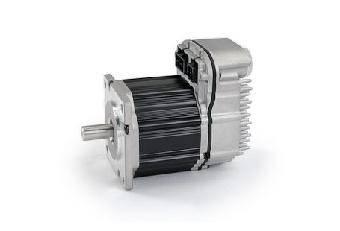 | 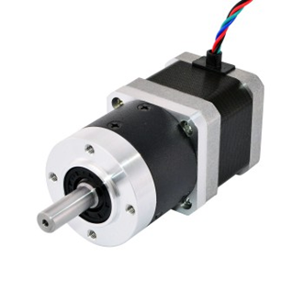
Figure 5 – Clearpath SDSK Model Figure 6 – Nema 17 Stepper
Source: Adapted from [1] Source: Adapted from [2]

Turntable Design
With the Turntable being a primarily mechanical subsystem, software control elements will be omitted from this section. Only the hardware design will be covered in this segment.

4.2.1 Hardware Design
The Turntable subsystem can be broken down into two independent motion systems: pitch and yaw. In addition, the entire system is designed and built on top of the pre-existing cartesian Z axis. This section will go into detail about the designing of each motion system as well as the printer bed.

4.2.1.1 Printer Bed
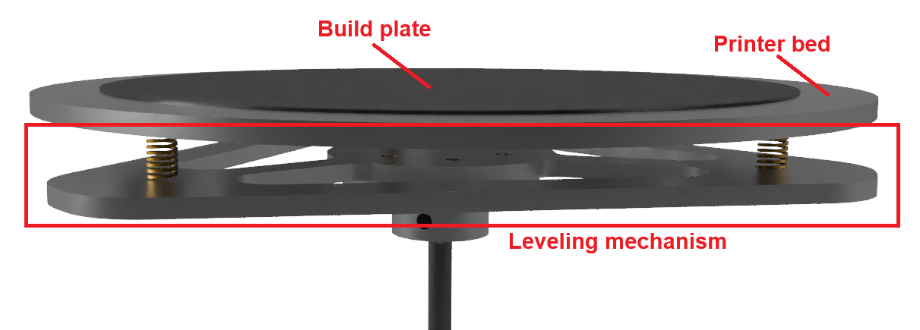
The printer bed of a 3D printer is the flat surface upon which the foundation of the printed part gets constructed.
Figure 7 – Printer Bed CAD

Printer Bed Design
A circular shape was chosen for the printer bed since it was rotating. Since the bed will stick the furthest out from the axis of rotation, it had to be designed to account for its high torque. Cutouts were added to the bed design to reduce weight. To provide a printing surface, a thin, removable build plate was magnetically attached to the top.
See Appendix B for technical drawings.

Shaft Mounting
The printer bed is mounted on a shaft which is held upright by shaft collars and bearings. The tapered roller bearings are designed to handle high radial and axial loads which is important as the type of load from the shaft will change depending on the pitch.

Printer Bed Leveling
Leveling is the process of finely adjusting the height of the printer bed so the distance between the nozzle is consistent across the entirety of the build plate. Supporting the printer bed, there is a triangular plate attached by screws and springs which can be tightened or loosened to level the bed.
See Appendix B for technical drawings.

Yaw

Yaw Axis Drive System
The yaw axis is driven by a continuously rotating Clearpath servo with a belt drive reduction:
$$\frac{18t}{96t}=96:18=16:3$$
Equation 3 – Yaw Axis Belt Drive Reduction Calculation

Pitch

Cradle Design
The Cradle is the rotating bracket which provides the tilt of pitch by hinging on radial ball bearings attached to the Z axis. It acts as the support structure for the weight of the print bed and yaw axis mechanism, as well at the connection point between the Turntable and cartesian Z axis. Since the Cradle is a long piece of unsupported metal, it was designed to distribute the heaviest weights of the printer bed and ClearPaths servo. In addition, folded edges were added for extra strength. In the case of warping, holes were added along the folded edge so that wooden beams may be added for additional reinforcement. See Appendix B for technical drawings.

Worm Drive
The method of driving the pitch was designed around the fact that the ClearPath servo would have to maintain a position for long periods of time without slipping.
The chosen solution is the worm drive for the following reasons:
- Due to the mechanical properties of worm gears, the pitch would be self-locking. This means the ClearPath will have to do very little work to maintain the printer bed angle.
- The self-locking would additionally protect the system in the case of the motor becoming disabled, preventing back driving and the pitch from collapsing.
- The high gear reduction of worm gears will increase motor resolution and reduce the amount of effort required by the ClearPath to tilt the Turntable.

Pitch Axis Drive System
To address the torque limitations of the ClearPath servos, the pitch is driven by a two-stage reduction system:
- Belt Drive Stage
Gear on motor: 18t
Gear on shaft: 80t
$$\frac{18t}{80t}=80:18=40:9$$
Equation 4 – Pitch Axis Drive Reduction Calculation

- Worm Drive Stage
Gear on shaft: Worm (1 continuous tooth)
Gear on plate: 160t
$$\frac{1t}{160t}=160:1$$
Equation 5 – Pitch Axis Worm Drive Calculation
Combined:
$40:9 × 160:1 = 6400:9 ≈ 711:1$
Equation 6 – Combined Pitch Axis Drive Reduction

Turntable Implementation
Many of the largest custom parts were machined in BCIT’s machine shop, while the smaller parts were created with a standard 3D printer. Specialized parts that could not be fabricated were ordered online. See Appendix D for cost breakdown and BOM.

Hardware Implementation

Printer Bed
Printer Bed Machining | Printer Bed Leveling
The printer bed was water jet cut out of aluminum. Additional machining was required to smooth the sharp edges and countersink the screw holes. | The leveling plate was water jet cut out of aluminum. Post processing was required to smooth the sharp edges and enlarge the screw holes.
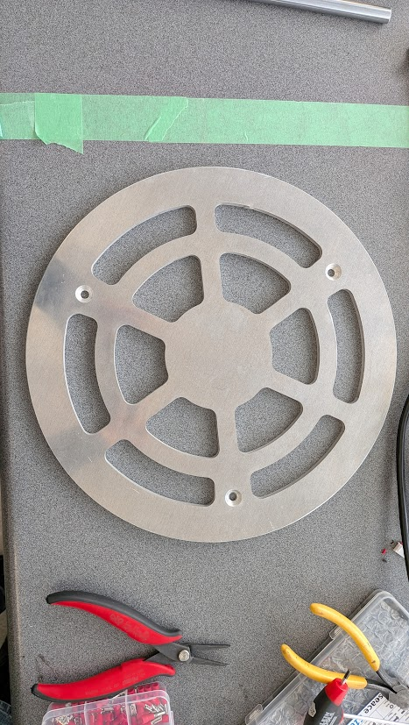 | 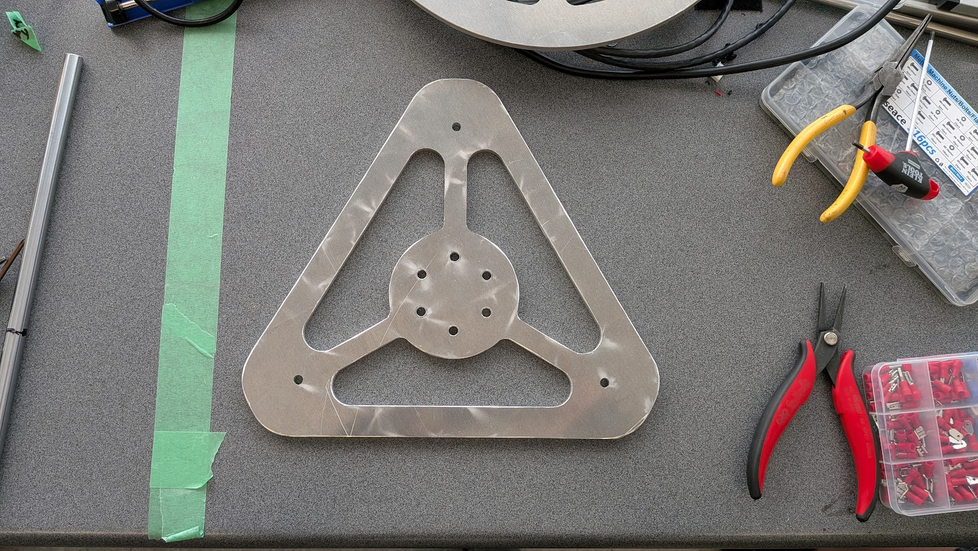
Figure 8 – Printer Bed Machined Part Figure 9 – Leveling Plate Machined Part

Build Plate Adhesion
The adhesion of the foundational layer is crucial because any slippage will destroy the rest of the print. Failed adhesion can lead to warping, shifting or detachment during printing. In the case of a Non-Planar 3D Printer, the adhesion must be extremely strong since the plate will be tilting to large angles. To combat this issue, the build plate was covered with a layer of masking tape with the sticky side attaching to the plate. The porous surface provides a rough surface for the filament to grip. The ideal combination for our printer is general painters’ tape and PLA filament. See Appendix C for photo example.

Yaw
After assembly, the yaw axis is capable of continuous rotation about the Z axis. See Appendix C for additional photo angles.
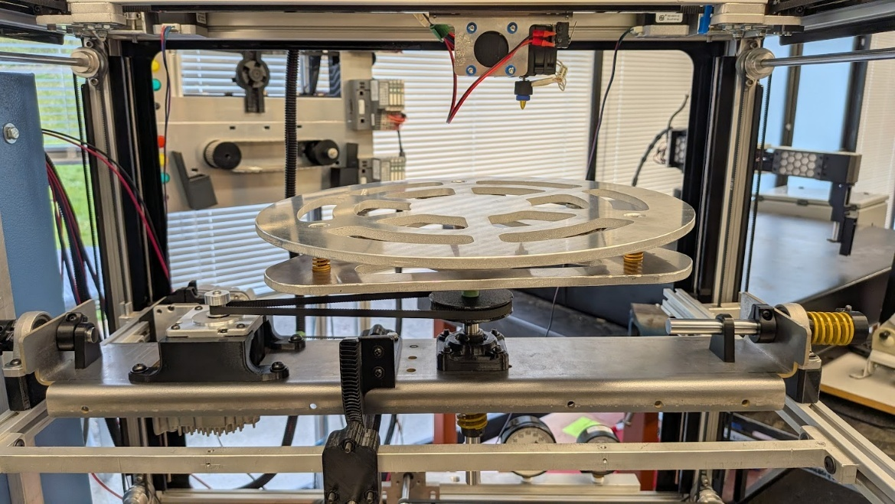
Figure 10 – Implemented Printer bed and Yaw Axis

Pitch
After assembly and implementation, the Turntable is capable of +50˚ tilt.
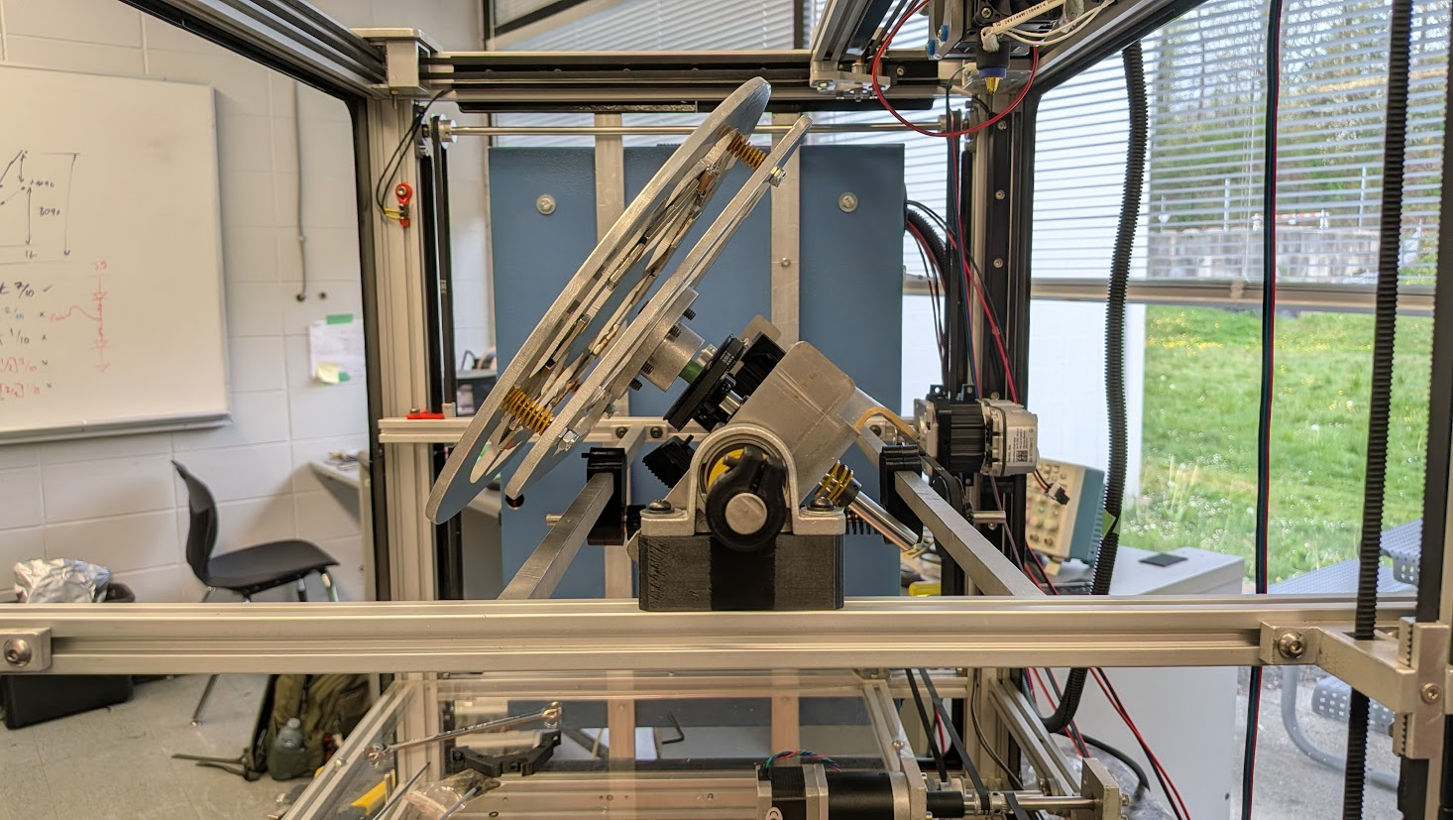 | 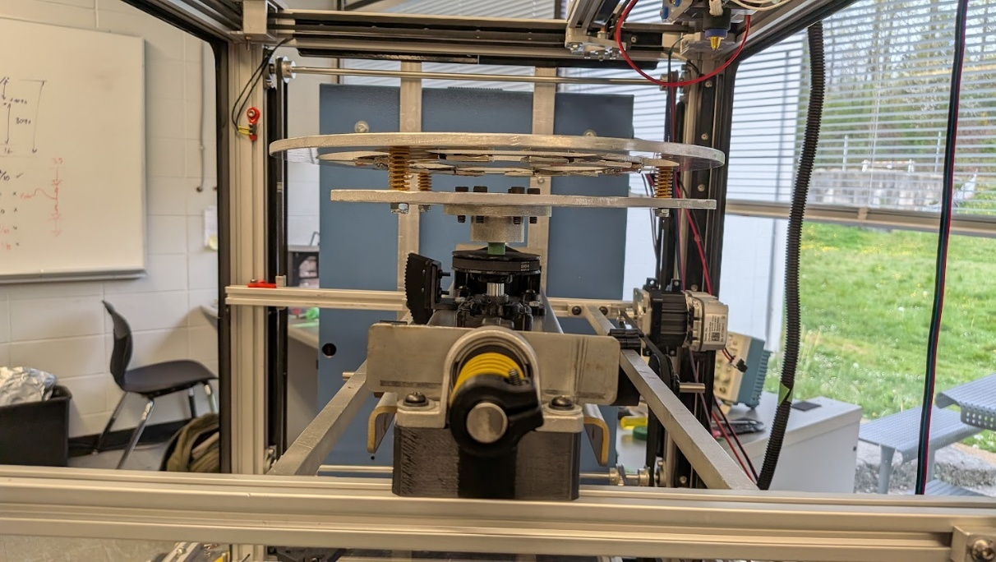
Figure 11 – Turntable With +50˚ Tilt Figure 12 – Turntable With 0˚ Tilt

Cradle
See Appendix C for implementation photo.

Worm Gear
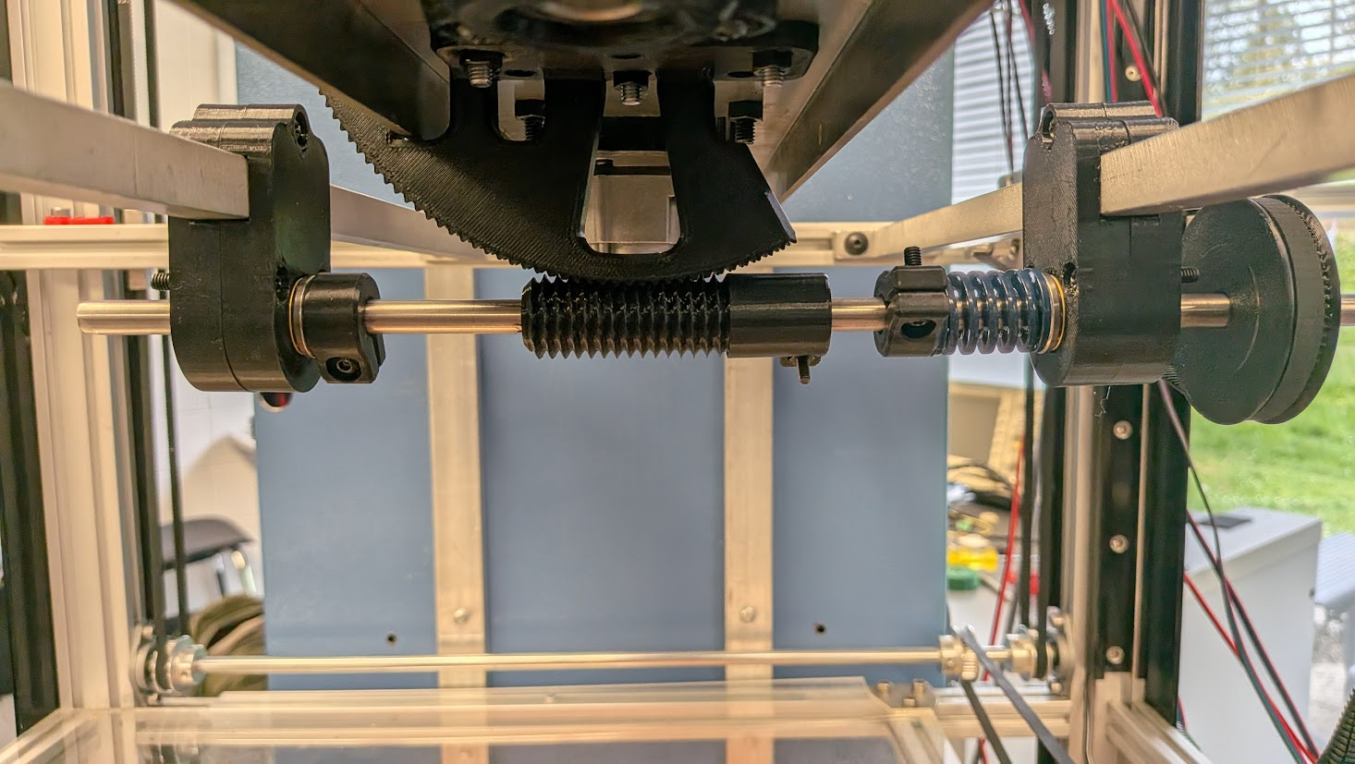
Figure 13 – Worm Gear Drive

Full System
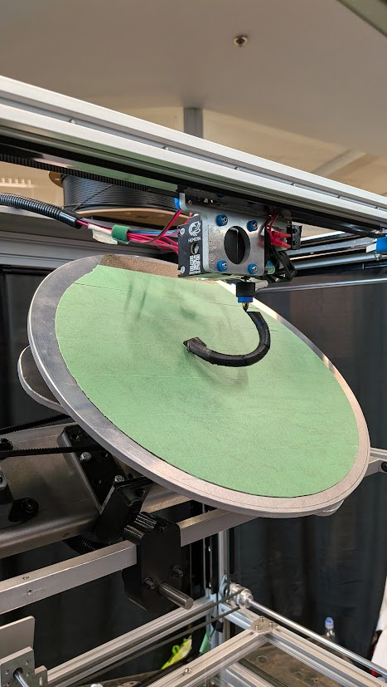
Figure 14 – Turntable in Action
See Appendix G for the results of 3D printed parts.

Software Implementation
The ClearPath SDSK is an advanced servo motor with a built-in feedback and control loop for high resolution and repeatability. Specifically, the SDSK model is designed to take step and direction inputs similar to that of a stepper driver. This makes interfacing the ClearPaths with the Duet2 straightforward, as nearly any of the external drivers can be used to control it, albeit through a 5V level shifter. The ClearPaths also come with a configuration software, ClearPath-MSP 2.0, which is used to configure steps/revolution (up to 6400 pulses, or 0.057°) and PID tuning. The software comes with an auto-tuning feature to sense the load and react accordingly. The tuning process must be completed every time the load changes significantly for best performance.

Angle monitoring and Visualization
The Angle Monitoring Subsystem is a safety mechanism designed to prevent print nozzle to plate collisions on the 5-DOF printer. Due to the build plate pitch angle being able to tilt up to 50° during printing, mechanical failure such as, gear slips or backlash can cause the build plate to be in a position where it can collide with the moving print nozzle.
The system uses a BNO055 IMU sensor mounted on the pitch mechanism to continuously measure the actual build plate angle and compare it against the commanded angle from the Duet controller. When errors exceed 3°, the system sends alerts to both the Duet Web Control interface and a Unity visualization, which displays the real-time pitch and measured yaw angles alongside a 3D representation of the build plate orientation.
This section details the system requirements, design, implementation, and validation results.

Angle monitoring and Visualization Requirements
The Angle Monitoring Subsystem must fulfil the following requirements to ensure print safety and quality.
- Real-time Angle Measurement and Verification
- Measure the build plate pitch angle (0-50°) with ±3 ° accuracy
- Compare IMU measured pitch with Duet-commanded pitch angle

- Error Notification
- Display error notification onto Duet Web Control interface
- Display error notification to Unity Visualization UI
- Allow user to decide whether to pause or continue print

- Communication Protocols
- Continuous real-time data transmission to Unity visualization for smooth visual feedback
- Reliable communication between IMU sensor, microcontroller, and printer controller

- Sensor Configuration
- IMU operates without interference from build plate magnets
- Continuous real-time monitoring

Angle Monitoring and Visualization Design
This section elaborates on the hardware and software design of the Angle Monitoring system
Table 2 - Summary of Angle Monitoring System Design and Implementation
Design | Implementation
Communication Protocols | - ESP32 with I2C communication to BNO055 IMU sensor  - UART to Duet (GPIO16/17)  - Wi-Fi UDP to Unity
Software Components | - Arduino IDE C++ for ESP32 firmware  - C# for Unity visualization
Hardware Components | - BNO055 9-DOF IMU  - ESP32 microcontroller  - Duet 2 Ethernet microcontroller

Hardware Design
The hardware components consist of a BNO055 IMU sensor, ESP32 microcontroller, and communication interfaces to the Duet controller and Unity visualization.

Electrical Schematic and Connections
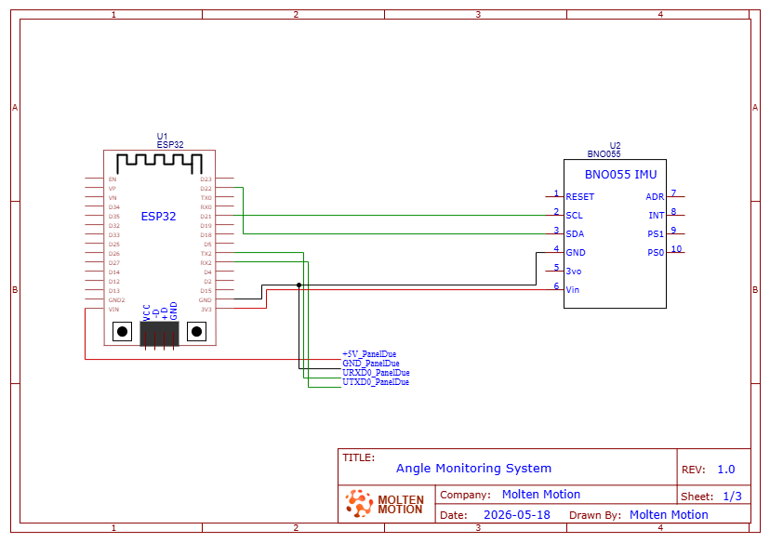
Figure 15 – Schematic for the Angle Monitoring system
(See Appendix F for connection to Duet 2 MCU)

Component Selection
The hardware components were chosen based on hardware requirements and compatibility with existing printer system.

BNO055 IMU Sensor
The BNO055 9-axis sensor was originally selected to measure both pitch and yaw angles of the build plate. The 9-axis capability (accelerometer, gyroscope, and magnetometer) would enable full orientation tracking including the yaw measurement, which was part of the initial design requirements.
However, during testing, the magnetometer was found inconsistent due to the magnetic interference of the magnets on the build plate. Though we considered multiple placements for the IMU to reduce the interference of the magnet, we decided the measurements were too unreliable, making the magnetometer unusable.

Despite this limitation, the BNO055 remained the ideal choice because:
- IMUPLUS Mode: Disables the magnetometer and use only the accelerometer and gyroscope
- Outputs Gravity Vector: Provides drift-free pitch measurement without magnetometer
- On-chip sensor fusion: Reduces ESP32 computational load
- I2C Protocol: Simplified wiring
- Future: The existing magnetometer allows for the addition of yaw measurement in the future
The system was since redesigned to focus on tracking the pitch angle, which is sufficient for collision protection since the pitch axis errors create the greatest safety risk.

ESP32 Microcontroller
The ESP32 is the main microcontroller for the angle monitoring system and serves as the central communication hub, connecting the BNO055 IMU, Duet 2 controller, and Unity visualization.
The ESP32 was selected specifically for its built-in WIFI capabilities, which enables communication with Unity, multi-protocol communication support (UART, I2C, and UDP), and Arduino IDE compatibility providing access to extensive libraries.

Software Design
The software design includes platform and protocol selection, and algorithm design.

Data Flow Diagram
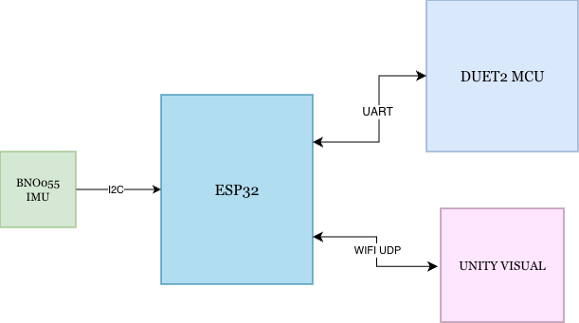
Figure 16 – Diagram of Data Flow of Angle Monitoring System

Platform Selection
Software platforms were chosen based on simplicity, algorithm and communication protocols support.

Unity for Visualization
Unity was selected as the visualization platform for displaying real-time build plate orientation and status.
Unity was chosen because of these reasons:
- 3D Visualization: Unity has 3D visualization capabilities
- Networking Support: Built-in networking libraries for UDP communication
- Simplicity: Easy to create different UI elements
- Cross-platform: Works on Mac, Windows, Linux

Arduino IDE for ESP32 Firmware
The Arduino IDE was chosen for its extensive library support (Adafruit_BNO055, WiFi, Wire), C++ compatibility which aligns with the team’s proficiency from embedded systems courses, and easy integration with the ESP32 microcontroller.

Network Protocol Selection

UDP vs TCP
UDP was selected over TCP for the ESP32 to Unity communication for the following reasons:
- Low Latency: No connection handshake needed, can constantly send data without confirmation
- Acceptable Data Loss: Losing occasional data does not affect safety since a packet arrives every 100ms
- Simple Implementation: Less code complexity than TCP
- Broadcast Capability: Can send data to multiple devices on network

Verification Logic and Data Exchange Design
This section describes the angle verification algorithm and the exchange formats used for communication between the ESP32, Duet controller, and Unity visualization.

Angle Verification Algorithm
The angle verification algorithm continuously monitors the build plate pitch angle and compares it against the commanded angle from the Duet 2 microcontroller.
The pseudocode for this logic:
EVERY LOOP (100ms):
- Read current gravity vector from BNO055
- Calculate pitch angle using dot product method
- Read commanded pitch from Duet via M114 command
- Calculate error = |measured_pitch - commanded_pitch|
- Send current data to Unity via UDP
IF commanded_pitch changed:
Start 5-second settling timer
IF timer done (5 seconds since last movement):
IF error > 3 degrees:
Send M117 message to Duet (display error on screen)
Send ERROR packet to Unity (red background)
ELSE:
Send GOOD packet to Unity (green background)
A 5-second settling period is used before verifying angles after movement commands to prevent false error detection by allowing the build plate to settle to commanded angles after movement commands.

Error Notification Strategy
The system notifies the user of errors but does not automatically pause the print. This design decision allows for user judgment of error severity and IMU inaccuracies. This also helps prevent print disruptions that may occur when resuming from pausing prints and provides flexibility for users to monitor error trends before deciding to intervene.
Though automatic pausing when an error occurs may seem like the straightforward solution, we determined that manual error verification is sufficient for this application. This decision allows user judgment of error severity and prevents unnecessary interruptions. However, automatic pausing could be implemented as a future enhancement.

GCode Commands
The ESP32 communicates with the Duet controller using standard GCode commands to retrieve printer status and send notifications.

M114 - Get Current Position:
- Purpose: Request current axis positions from Duet 2 controller
- Polling rate: Every 200ms (5 Hz)
- Response format: X:150.0 Y:200.0 Z:5.5 A:180.5 B:45.2 . . .

M408 S0 - Get Printer Status
- Purpose: Request printer status (idle, printing, paused)
- Polling rate: Every 200ms (5 Hz)
- Response format: JSON with status and fraction_printed fields

M117 - Display Message
- Purpose: Display error message on Duet Web Control interface
- Usage: Sent when pitch error exceeds 3° threshold
- Example: M117 ANGLE ERROR - Check pitch axis!

M25 and M24 - Pause and Resume
- Purpose: Manual pause/resume commands from Unity interface
- M25: Pause print
- M24: Resume print
- User-initiated via Unity buttons

UDP Packet Format
The ESP32 sends data to Unity (and vice versa) using UDP packets with a structured format to ensure reliable parsing and display.

Data Packet Structure:
Format:
"DATA,CP:<cmd_pitch>,MP:<meas_pitch>,CY:<cmd_yaw>,X:<x>,Y:<y>,Z:<z>,FP:<fraction>,S:<status>,EP:<error>"

Example:
"DATA,CP:45.23,MP:44.85,CY:180.50,X:150.0,Y:200.0,Z:5.5,FP:0.42,S:P,EP:0.38"

Variables:
CP = Commanded Pitch (from Duet, degrees)
MP = Measured Pitch (from BNO055, degrees)
CY = Commanded Yaw (from Duet, degrees)
X, Y, Z = Print head position (mm)
FP = Fraction Printed (0.0 to 1.0)
S = Status (I=Idle, P=Printing, A=Paused)
EP = Error Pitch (absolute difference, degrees)
Status Messages:
"ERROR" - Sent when pitch error > 3 degrees
"GOOD” - Sent when pitch error within acceptable range
The data packets use a comma-delimited format with prefix tags (CP:, MP:, etc.) for easy C++/C# parsing, with all data instances being sent in a single packet to reduce overhead and ensure data synchronization.

Angle Monitoring and Visualization Implementation
This section describes how the design was physically built and implemented, including hardware placement and assembly, calibration procedures, and software implementation.

Hardware Implementation
The BNO055 IMU was mounted on the pitch cradle to measure the rotation of the pitch assembly. The ESP32 microcontroller was installed in the non-planar 3D printer panel box, with jumper wires connected to the BNO055, and is powered by the Duet 2 MCU.

Calibration Procedure

Initial Calibration Steps
- Ensure BNO055 IMU is securely mounted on pitch cradle and ESP32 is powered off
- Place build plate in perfectly leveled position in reference to print nozzle
- Power on ESP32 visa USB
- Wait 10 seconds for BNO055 gyroscope and accelerometer calibration
- Firmware reads gravity vector from BNO055
- Observe gravity vector values: (0.48, -0.10, 9.79)
- Hard code these values into firmware as gravityRef constant
- Upload firmware to ESP32

Hard Coded gravityRef Calibration
Calibration values (gravityRef) were hard coded in firmware rather than dynamically measured at ESP32 startup to ensure the system survives ESP32 reboots during printing. If the ESP32 crashes and reboots mid-print, dynamic zeroing would incorrectly zero at the current measured pitch angle, rather than at the leveled (0 °) angle. This approach also simplifies the startup procedure for the user as they only must calibrate once as long as the BNO055 is not physically remounted.

Software Implementation

Firmware File Structure
ESP32 firmware files are organized into multiple files for modularity:
- ESP32_Main.ino — Main program loop and initialization
- IMUFunctions.cpp — BNO055 initialization and angle calculation functions
- AngleVerification.cpp — Error detection and notification logic
- DuetCommunication.cpp — UART communication with Duet controller
- UDPCommunication.cpp — UDP communication with Unity visualization
- globals.h — Shared variable declarations and function prototypes

Software Implementation

IMU Initialization Code
The gravity reference is currently hard coded to the calibrated 0° reference values. To calibrate, the bno.getVector() line is uncommented to capture a new reference from the live sensor. It is then displayed onto the serial monitor where it would be noted down.
gravityRef = imu::Vector<3>(0.48, -0.10, 9.79); // calibrated reference at 0° pitch

//gravityRef = bno.getVector(Adafruit_BNO055::VECTOR_GRAVITY); // uncomment to recalibrate

Serial.print("Gravity Reference X: "); Serial.println(gravityRef.x());
Serial.print("Gravity Reference Y: "); Serial.println(gravityRef.y());
Serial.print("Gravity Reference Z: "); Serial.println(gravityRef.z());
Figure 17 – BNO055 Gravity Reference Calibration Code
File: IMUFunctions.ino, Function: initializeIMU ()

Angle Calculation Code
The pitch angle is calculated by using the dot product of the current BNO055 measured gravity vector and the calibrated reference gravity vector, following the standard formula for the angle between vectors formula shown below. The dot product is them clamped between -1.0 and 1.0 before arcos () is applied to prevent any floating-point errors.
$$θ_{pitch}=\cos^{-1}{\frac{\overset{⃑}{g}​⋅\overset{⃑}{g_{ref}}​}{\overset{⃑}{|g}|​⋅|\overset{⃑}{g_{ref}|}}​​}$$
Equation 7 - Formula for Angle Between 2 Vectors
Where:
- $\vec{g}$= current gravity vector from BNO055
- ${\vec{g}}_{ref}$= calibrated reference gravity vector at 0° pitch
- $θ$= measured pitch angle in degrees
// Magnitude of current and reference gravity vectors
float gravityMag = sqrt(gravity.x()*gravity.x() + gravity.y()*gravity.y() + gravity.z()*gravity.z());
float gravityRefMag = sqrt(gravityRef.x()*gravityRef.x() + gravityRef.y()*gravityRef.y() + gravityRef.z()*gravityRef.z());
// Dot product between current and reference gravity vectors
float dotGravity = ( gravity.x() * gravityRef.x() ) + ( gravity.y() * gravityRef.y() ) + ( gravity.z() * gravityRef.z() );
// Angle between vectors = pitch relative to calibrated 0°
float denom = gravityMag * gravityRefMag;
if (denom < 0.001) return; // avoid dividing by zero
float cosAngle = constrain(dotGravity / denom, -1.0, 1.0);
measPitch = acos(cosAngle) * (180.0 / PI);
Figure 18 – Pitch Angle Calculation Code
File: IMUFunctions.ino, Function: calcEuler ()

Data Packet Code
Incoming UDP packets are parsed in Unity’s RecieveData () function, which is running on a background thread. Data packets prefixed with DATA are split by prefix tags (CP:, MP:, CY:, etc.) using ParseValue () to extract each field into its corresponding variable, following the packet format described in Section 5.2.2.4. ERROR and GOOD status packets are sent separately from the data packet by the ESP32 and set the pendingStatus variable directly, which is then read by the main thread to update the verification status banner.
byte[] data = udpClient.Receive(ref serverInfo);
string message = Encoding.UTF8.GetString(data).Trim();

if (message.StartsWith("DATA")) {
commandedPitch = ParseValue(message, "CP:");
pitch = ParseValue(message, "MP:");
commandedYaw = ParseValue(message, "CY:");
currentX = ParseValue(message, "X:");
currentY = ParseValue(message, "Y:");
currentZ = ParseValue(message, "Z:");
decValue = ParseValue(message, "FP:");
errorPitch = ParseValue(message, "EP:");

duetStatus = parseChar(message, "S:");

}
else if (message.StartsWith("ERROR")) {
pendingStatus = "BAD"; // pitch error exceeded threshold
}
else if (message.StartsWith("GOOD")) {
pendingStatus = "GOOD"; // pitch within acceptable range
} else{
continue; // Ignore unknown messages
}
Figure 19 – Unity UDP DATA Packet Parsing Code
File: BuildPlateController.cs, Function: ReceiveData ()

Unity Visual Implementation
The unity angle monitoring UI provides users with real-time feedback on the non-planar 3D printer orientation during printing. The dashboard displays the measured pitch from the BNO055 alongside the commanded pitch from the Duet 2 MCU, allowing the user to spot any discrepancies immediately. The verification status banner updates based on the ERROR and GOOD packets sent by the ESP32, turning red when the pitch error exceeds 3° and green when within range. The 3D viewport shows synchronized view of the physical build plate using the pitch (measured) and yaw (commanded) values from the UDP packet.
The UI consists of 5 sections: measured and commanded pitch, commanded yaw, cartesian coordinates, verification status banner, and print progress bar.
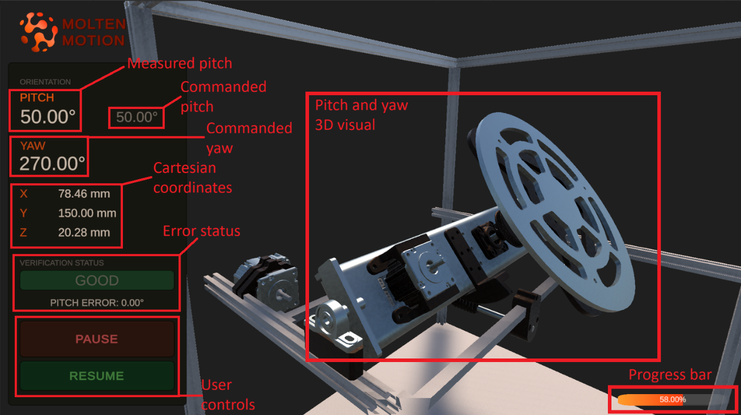
Figure 20 – Unity Angle Monitor UI Layout
The verification status banner displays BAD in red, when the measured pitch differs from the commanded pitch for more than the 3° threshold, and GOOD in green when within range.
In the example below you can see in the BAD state, the measured pitch reads 41.30° against a commanded 45.00°, resulting in a 3.70° pitch error. In the GOOD state, both values read 50.00° with 0.00° error.
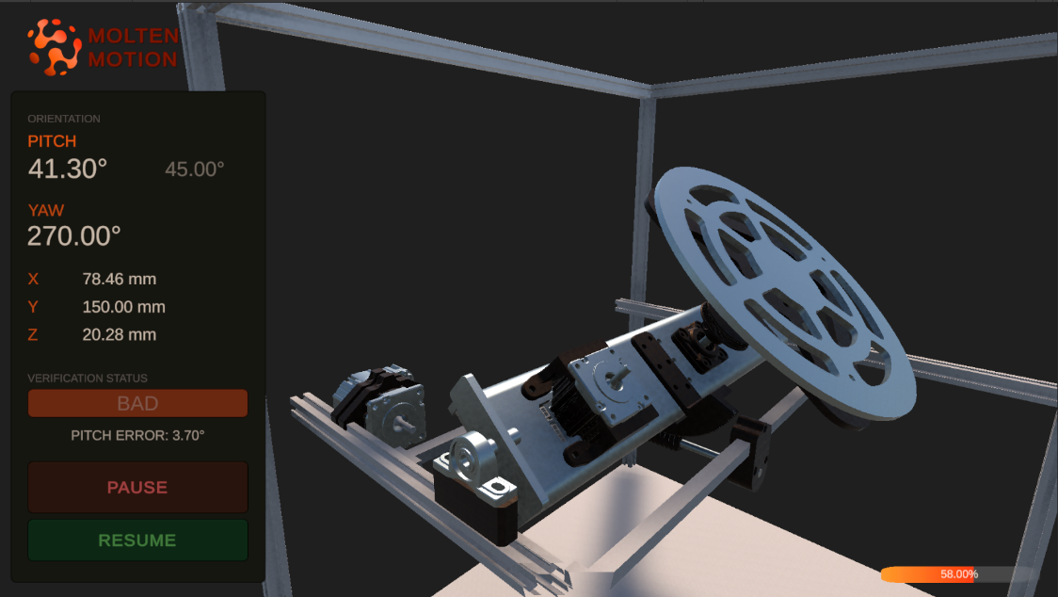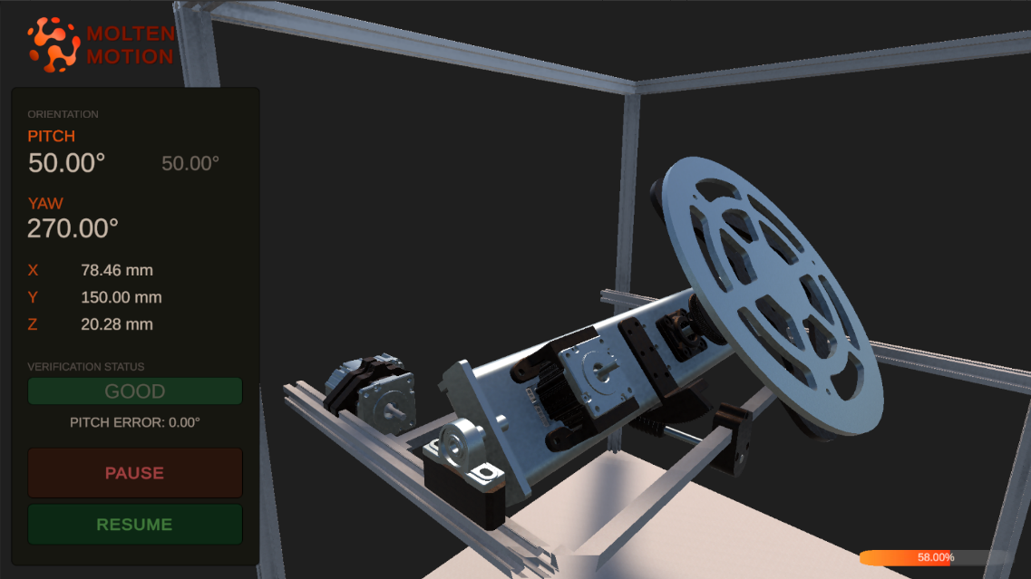
Figure 21 – Unity Verification Status Banner (BAD (left) and GOOD (right))

Duet Configuration and Integration
The Duet Configuration and Integration subsystem uses the Duet2 board as the primary controller for the entire system, including actuators, sensors, and communication between devices. The board and configuration can be accessed either over Ethernet or through a USB-UART scheme, operating at 115200 Baud. All system configuration files can be found through the Duet Web Control or by directly connecting the microSD card to a computer within the “sys” directory, primarily “config.g”. Calibration of the system is also a necessity for maintaining quality prints and reducing the risk of mechanical failure.

Duet Configuration and Integration Requirements
- The Duet2 must be able to control 5 axes and an extruder simultaneously
- Must be capable of positioning within 0.1mm and 0.1° of target
- Can communicate to multiple devices: laptop, ESP32

Duet Configuration and Integration Implementation
The Duet2 board is the main controller board for the printer. With either a USB or Ethernet connection, instructions can be sent to the Duet board and executed. For commands to execute successfully however, the board must first be configured using the “config.g” file located within “sys” on the microSD card. If Ethernet capabilities are already established, files can be uploaded and edited through the web control interface.

Duet As A Controller
The Duet2 board is configured to control 6 motors total: Three steppers for cartesian X, Y, Z, one stepper in the extruder, and two ClearPath servos for the turntable. Additionally, four end stops are configured for X, Y, Z, and the pitch axis. All end stops are active low. The X and Y end stops are high-end (most positive) while the Z and pitch stops are low-end (most negative). A temperature sensor and heating element are utilized to control the nozzle temperature for plastic extrusion.

Duet Web Control
The Duet Web Control can be accessed by connecting through Ethernet to the Duet2. The currently configured IP address of the Duet is http://192.168.1.14, though this is subject to change in the future and can be modified within “config.g”. If the printer is not immediately available, ensure your drivers are up to date and the Ethernet adapter is configured with the correct IP and subnet mask (192.16.1.14 and 255.255.255.0 respectively).
The web interface allows the control of almost everything on the printer including jogging, starting prints, and executing individual G-code commands. It also conveniently monitors temperature inputs and faults.
To print a file, follow the steps below:
- Locate the “Jobs” tab and select the upload button
- Choose the G-code file from the file viewer
- When the file has completed uploading, click it and confirm “yes” to starting the print
- The status page will automatically open, giving details on the current print

Duet and Printer Calibration
Calibration is an important step of setting up the printer. Without this, prints can easily fail and potentially even cause damage to the machine. In a standard 3-axis cartesian printer, manual bed calibration can already be a tedious and time-consuming task. When attempted with 5 axes, this joyous time only intensifies. The instructions below should be followed to maintain quality prints and a functioning printer:
- Check axis of pitch:
  - Disconnect power and confirm the pitch rotation axis is parallel to the Y-axis by using a square
  - If the axis is not parallel, loosen and adjust one end of the turntable assembly until it is
  - Be sure to firmly secure the assembly again after modification
- Level build plate yaw axis:
  - Connect power and perform a home on all axes using the Duet Web Control
  - Remove the magnetic build plate
  - Lower the bed about 10mm (+10mm Z axis) and jog the extruder tip over the outer edge of the plate
  - Raise the bed again a few millimeters at a time until the nozzle is about 5mm above the surface
  - Perform a full revolution of the yaw (“A”) axis and observe if there is much wobble in the distance between the nozzle and plate
  - Adjust the screws on sections that seem raised or lowered relative to other sides
  - Perform another revolution to confirm adjustments have made an improvement
  - Repeat e through g, moving the nozzle closer to the plate each time until within 1mm
  - Slide a piece of paper between the nozzle and the plate
  - Perform another full revolution of the yaw axis while gently sliding the paper back and forth between the nozzle and plate
  - Sections that catch more may need to be lowered, and sections without any friction may need to be raised
  - Repeat i through k until within 0.2mm, moving the nozzle 0.2mm closer each time
  - Once adjusted, the paper should have fairly even friction throughout the rotation
  - Home the axes and replace the magnetic build plate
- Calibrate Z axis:

  - Home all axes and then lower the bed 10mm (+10mm Z axis)
  - Move the nozzle to the center of the plate (theoretically X=0, Y=0)
  - With the magnetic build plate in place, put a piece of paper lying flat between the nozzle and plate
  - Decrease the gap between the nozzle and plate until there is some friction when trying to move the paper
  - The paper should slide under the nozzle when pushed and not bend
  - Take note of the current position of the Z axis and modify the “posz.g” file by subtracting the current position from the value after “G92 Z” and replacing it
  - Verify by homing all axes again and lowering the bed 10mm
  - Move X and Y to (0, 0) again and incrementally move the bed closer to 0
  - Using the paper, there should again be some friction, but not enough to bend it
- Calibrate pitch axis:
  - Home all axes and lower the bed 10mm (+10mm Z axis)
  - Move the nozzle to X100, Y0
  - Using the paper method, incrementally raise the build plate until there is a small bit of friction when trying to move the paper
  - Take note of the Z position and mark it as Z₁
  - Move the Z axis back to 10mm and move the nozzle to X-100, Y0
  - Apply the paper method again and record the Z position as Z₂
  - Using the formula $\arctan\left(\frac{Z_{1}-Z_{2}}{200}\right)$, find the angle (in degrees) that the bed is rotated relative to the X axis
  - In “config.g”, locate the M208 command within the “Axes” section
  - Sum the first value (minimum position, before colon) after the B (“B” = pitch axis) with the calculated angle and replace the previous value
  - Be sure to restart the main board for changes to take effect
  - Home all axes and confirm the bed is level by repeating a through f (Z₁ = Z₂, within 0.2mm)
- Calibrate X and Y axes:
  - Print “x y calibrate v3.gcode” until the second block is done (pause or stop the print)
  - Keeping track of which side is X and Y, use a caliper to measure the offset of layers where the angle transition occurred
  - Keep track of these values as d_{X} and d_{Y} (only magnitude, no sign for now)
  - If the top is overlapping the bottom on the negative X (away from home position), invert the sign of d_{X}
  - If the top is overlapping the bottom on the negative Y (away from home position), invert the sign of d_{Y}
  - In “config.g”, locate the M208 command within the “Axes” section
  - Sum the second value after the X (maximum position, after colon) with $\frac{d_{X}}{2}$ and replace the previous value
  - Sum the second value after the Y (maximum position, after colon) with $\frac{d_{Y}}{2}$ and replace the previous value
  - Be sure to restart the main board for changes to take effect
  - Try printing the test print again
  - If the result is worse, the most likely problem is either adding instead of subtracting or mixing up X and Y measurements
  - This calibration may need to be performed more than once for best results
Congratulations! Calibration is now complete.

System Verification
System verification was conducted across all subsystems to confirm that the implemented system met the defined requirements and operated as intended under real printing conditions.

System Operation
The complete 5-DoF system was verified through a series of test prints and operational checks across all subsystems. The turntable successfully achieved the full pitch range of 0–50° and continuous 360° yaw rotation without mechanical interference. The worm gear self-locking mechanism-maintained pitch position throughout extended prints without slipping.
The modified Fractal Cortex slicer successfully generated 5-axis G-code, which was uploaded and executed through the Duet 2 web interface. Non-planar test parts were sliced and printed, confirming end-to-end system functionality, though the slicer still requires further tuning to improve print quality and toolpath accuracy.
The angle monitoring subsystem continuously measured pitch angle and operated alongside printing without disrupting motion control, with alerts and real-time pitch data displayed through both the Unity visualization and Duet web interface. Yaw angle monitoring was not achieved due to magnetometer interference from the build plate magnets and remains a limitation of the current system.

Performance Metrics
The system met or exceeded all defined requirements. Linear positioning accuracy of ±0.2mm was achieved across the X, Y, and Z axes. Pitch angle measurement accuracy reached ±1.8°, surpassing the ±3° requirement. The angle monitoring system ran at 10 Hz with a 5-second settling period to prevent false error detection. The system was tested over extended print sessions of approximately 3–4 hours with no observed pitch drift. Cable management accommodated the full pitch and yaw motion ranges without tangling or interference throughout testing

Project Summary
The objective of this project was to develop a 5-DoF non-planar 3D printer to validate non-planar printing concepts, develop the necessary slicing and control software, and enable safe testing before the Additive Manufacturing Group transitions to metal deposition.
The system successfully demonstrates that non-planar printing is feasible by adding pitch and yaw rotation to the build plate of a standard cartesian printer, enabling the printing of complex geometries without support structures.

System Specifications
The implemented system meets the following specifications:
Turntable:
- 5-DoF: X, Y, Z (linear), A (yaw), B (pitch) successfully implemented
- Pitch range: 0-50° achieved with worm gear self-locking mechanism
- Yaw range: Continuous 360° rotation via slip ring cable routing
- Positioning accuracy: ±0.2mm (linear), ±1.8° (pitch measurement)
- Pitch drive reduction: 711:1 (40:9 belt drive × 160:1 worm drive)
- Yaw drive reduction: 16:3 belt drive
- Build plate: 270mm diameter aluminum with gold PEI magnetic surface
- Mechanical structure holds position without slipping during printing (see Appendix C)
- ClearPath SDSK servos: 0.3 N-m continuous torque, 0.057° resolution
- Tapered roller bearings support radial and axial loads

Slicer And Control:
- Modified Fractal Cortex slicer generates 5-axis G-code with multiple slicing planes
- Pitch axis offset compensation implemented (Z_RADIUS variable)
- Duet 2 Ethernet controller with web interface at 192.168.1.14
- Coordinated motion control across all 5 axes
- G-code output compatible with Duet controller
- Successfully sliced and printed non-planar test parts

Angle Monitoring and Visualization:
- Real-time pitch angle monitoring with ±1.8° accuracy (exceeds ±3° requirement)
- Continuous comparison of commanded vs. measured angles at 10 Hz
- Error detection threshold: 3° pitch deviation
- Operator alerts via Duet web interface (M117 messages) and Unity visualization
- 3D visual representation of build plate orientation with status banner (red/green)
- Manual pause/resume capability via Unity buttons
- System operates independently without disrupting motion control
- 5-second settling period before verification to prevent false errors
- Angle verification latency: 5 seconds after movement
- System operates continuously without drift over extended prints (tested ~3-4hrs)

Cable Management:
- Wire routing solution implemented for continuous yaw rotation without tangling
- Sufficient cable slack for full pitch motion range (0-50°)
- I2C wiring (~40cm twisted pair) for BNO055 communication through pitch mechanism
- Cable chains implemented for X, Y, Z axes organization
- Sensor and power cables isolated from moving mechanical components
- Significant improvement in cable organization from initial implementation
See Appendix E for before/after photos of the wiring

Recommendations/Future Work
The non-planar 3D printer successfully demonstrates 5-axis printing capabilities and provides a functional platform for testing non-planar toolpath strategies. Several improvements would enhance system performance and prepare it for metal deposition applications.

Integration With Mechanical Capstone Teams
The original project scope envisioned collaboration between mechatronics and mechanical engineering capstone teams, where mechanical students would design and build the turntable and Cartesian subsystems while the mechatronics team developed the slicer, control systems, and angle monitoring. Due to the project timeline constraints, this collaboration did not occur.
Future iterations should pursue this collaborative approach:
- Mechanical students focus on structural design, thermal analysis, and precision mechanisms
- Mechatronics students refine control systems, software, and sensor integration
- Combined effort results in a more robust mechanical design suitable for metal deposition
This division of work would utilize each team's expertise and produce a system better prepared for the thermal loads and rigidity requirements of GMAW operations.

Turntable Mechanical Refinement
Working with mechanical capstone students, the turntable could be redesigned to better support metal deposition applications. Key areas for improvement include:
- Structural reinforcement of the pitch cradle to reduce flexing under load
- Upgraded bearings rated for high-temperature operation near welding processes
- Improved cable routing solutions for welding power cables and shielding gas lines
- Material transition from aluminum to steel for build plate and structural components
- Reduced backlash in gear systems for improved positioning accuracy
These mechanical improvements would directly address the limitations of the current FDM-focused design and prepare the system for the higher loads and temperatures of GMAW operations

Slicer Enhancements for Metal Deposition
The current slicer is optimized for FDM plastic printing and would require modifications to support metal deposition processes. Recommended additions include:
- Material profiles for common metals (mild steel, stainless steel, aluminum) with appropriate wire feed rates and travel speeds
- Dwell time setting between layers to allow for proper cooling
- Extended collision detection accounting for larger GMAW torch geometry
- Parameters for gas flow rate and wire diameter in the slicing interface
- Basic thermal considerations for different metal cooling characteristics

These features would build directly onto the existing Python codebase and GUI framework already in place and should be made modular to support different printer configurations.

Angle Monitoring Improvements
The angle monitoring system currently tracks pitch angle effectively. Next steps would expand its capabilities for metal deposition:
- Yaw measurement by repositioning a second BNO055 sensor in a magnetically shielded location or exploring alternative orientation tracking methods
- Enhanced Unity UI showing to both pitch and yaw angles with commanded vs. measured comparison
- Real-time toolpath visualization displaying the print during print with current X, Y, Z coordinates and print head position relative to build plate
- Data logging to export angle measurements to a spreadsheet file (CSV format) for post-print analysis, allowing operators to identify trends like increasing error over time or mechanical drift
- Audio alert functionality for immediate operator notification of errors
- Grounded metal enclosure for ESP32 and IMU to protect against EMI from arc welding
These improvements build on the existing system and could be done incrementally in a future capstone project. The toolpath visualization especially would help operators see where the nozzle is during complex prints and catch potential collisions before they happen.

Conclusion
The Non-Planar 3D Printer project successfully demonstrated that 5-DoF printing is achievable and provides clear benefits for complex geometries. Despite facing challenges with slicer integration, magnetometer interference from build plate magnets and the complexity of coordinating 5 independent axes, the team delivered a functional system that prints parts with over 45° angles without support structures.
When comparing the Non-Planar prints with the cartesian Prusa Mini+ printer, the results showed that printing without supports took half the time and used far less material. See Appendix G for comparisons.
A key discovery was that the worm gear's self-locking property proved essential for maintaining pitch position during extended prints, though future metal deposition systems may require anti-backlash mechanisms or alternative drive systems to handle thermal loads and achieve tighter positioning tolerances.
Additionally, during BCIT’s 2026 Project Expo, it was noted that the printer could run for upwards of 3 hours without a break and have zero drift or overheating.
This project establishes a strong foundation for the Additive Manufacturing Group's transition to GMAW technology and demonstrates the value of interdisciplinary collaboration between mechatronics and mechanical engineering students.

Citations
[1] STEPPERONLINE. Nema 17 Stepper Motor. Accessed: 5/17/2026 [Online]. Available: https://www.stepperonline.ca/nema-17-stepper-motor-l-39mm-gear-ratio-100-1-high-precision-planetary-gearbox-17hs15-1684s-hg100.html
[2] TEKNIC. ClearPath-SDSK Model. Accessed: 5/17/2026 [Online]. Available: https://teknic.com/model-info/CPM-SDSK-2310S-RQN/
[3] SainSmart. Nema 17 2-Phase. Accessed: 5/17/2026 [Online]. Available: https://www.sainsmart.com/products/nema-17-2-phase-4-wire-1-5a-40mm-1-8-stepper-motor-for-3d-printing-cnc
[4] DB. Brogan, Fractal Cortex. Accessed: 5/17/2026 [Online]. Available: https://github.com/fractalrobotics/Fractal-Cortex

Appendix A
Table A1 lists the three motors provided for the Molten Motion system. While the motors themselves were pre-selected, the team determined which motor was best suited for each axis based on their respective torque output, step resolution, and load requirements.
All three motors operate on a common 24V DC supply.
Table A1 – Implemented Motors
Motor Type | Part No. | Rated Current | Input Voltage | Cont. Torque | Resolution | Weight
ClearPath-SDSK model | CPM-SDSK-2310S-RQN | 0 – 10 A | 24 V DC | 0.3 N-m | 0.057˚ | 1.4 lb
Nema 17 Stepper & 100:1 Gearbox | 17HS15-1684S-HG100 | 1.68 A | 24 V DC | 15 N-m  (with gearbox) | 0.018˚ per step  (with gearbox) | 1.65 lb
Nema 17 2-Phase Stepper | 17HD40005-22B | 1.5 A | 24 V DC | 0.360 N-m | 1.8˚ per step | 0.62 lb

Source: [1, 2, 3]
Appendix B
Appendix B contains the technical drawings for key fabricated components of the Molten Motion turntable system. Figure B1 shows the Printer Bed, Figure B2 shows the Leveling Plate, and Figure B3 shows the Y-axis Bed Strut, all of which were custom designed by the team.
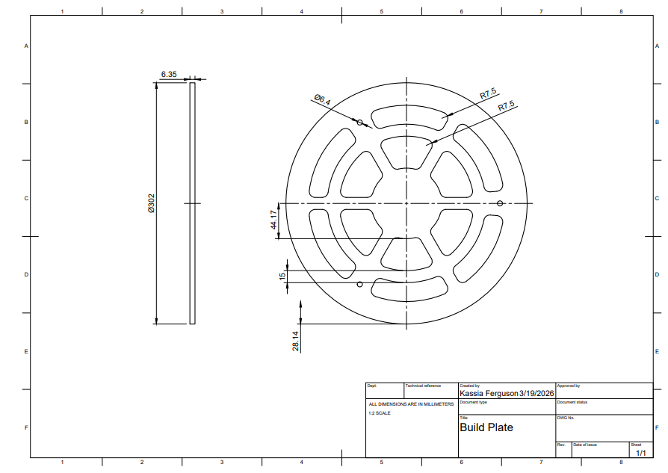
Figure B1 - Printer Bed Technical Drawing
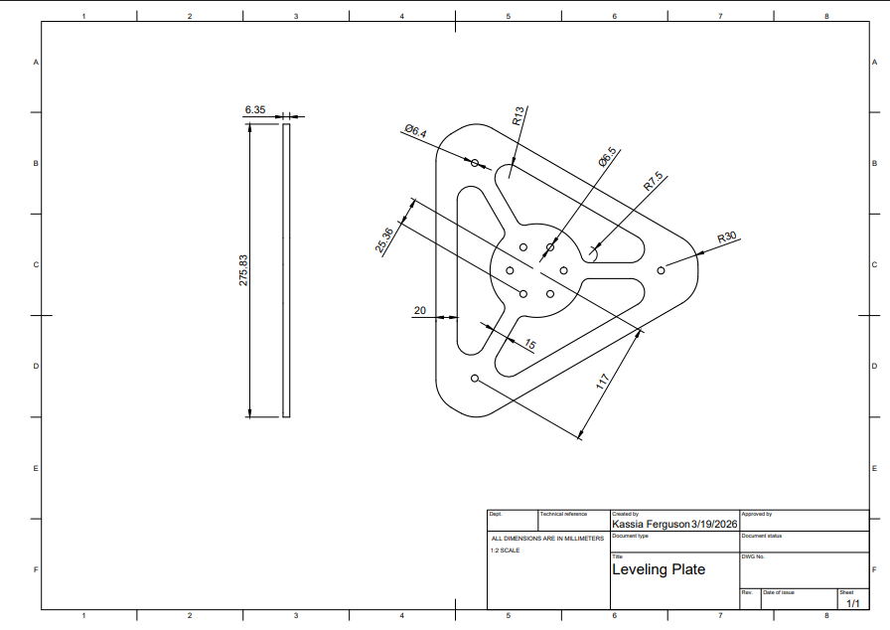
Figure B2 – Leveling Plate Technical Drawing
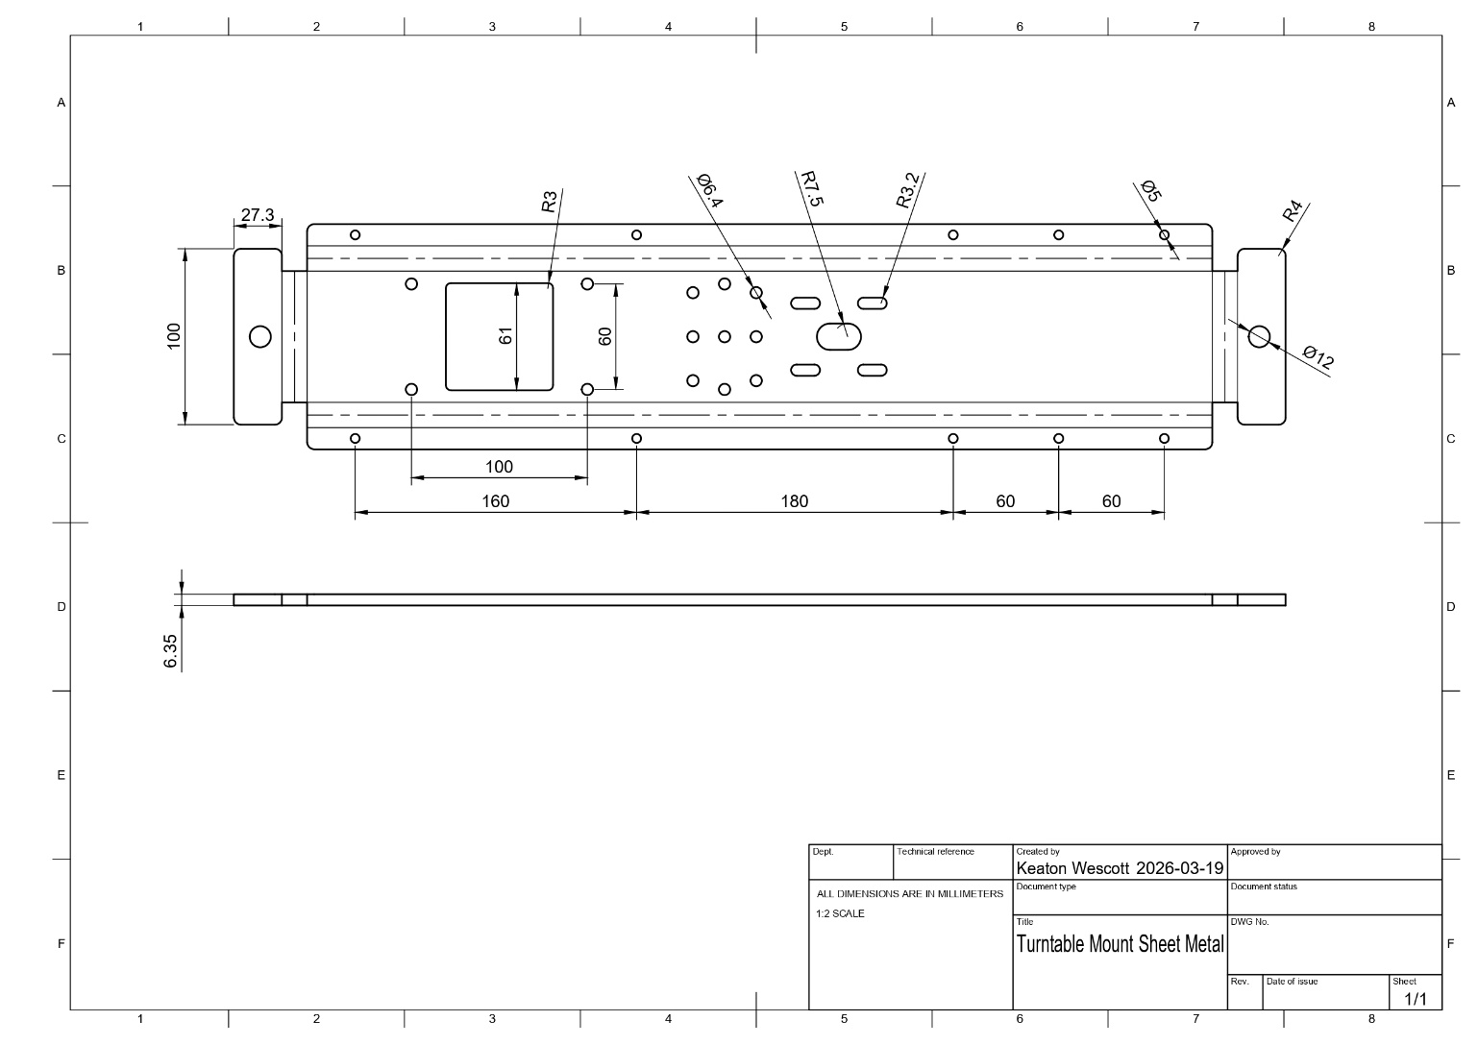
Figure B2 – Cradle Technical Drawing
Appendix C
Painters' tape was applied to the printer bed surface to improve first-layer adhesion. It proved surprisingly effective, with prints adhering exceptionally well throughout testing.
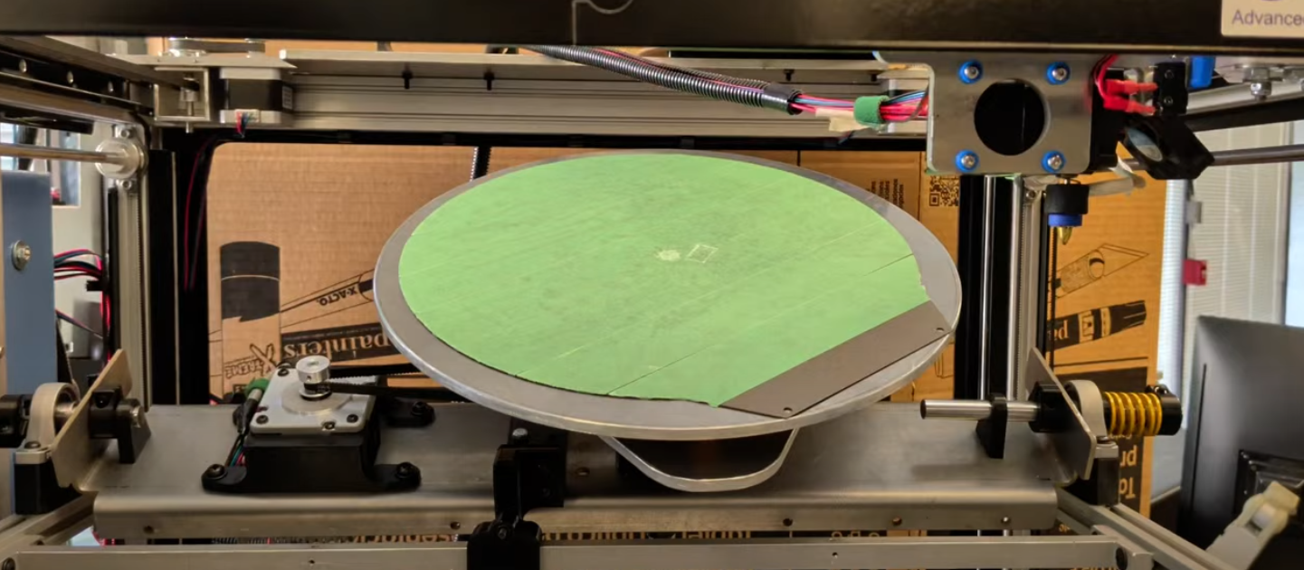
Figure C1 – Painters’ Tape Adhesion
The turntable cradle was fabricated with the help of Maejor Sidhu, who produced the part using waterjet cutting and metal bending to support and constrain the rotating build plate assembly within the frame
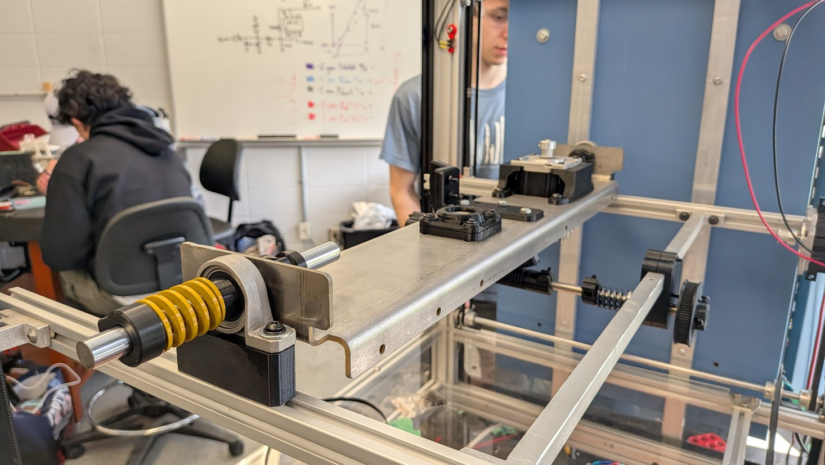
Figure C2 – Turntable Cradle Machined Part

Appendix D
Appendix D outlines the components and associated costs for the turntable assembly. Table D1 shows a total expenditure of $334.52 across 19 parts before shipping and taxes. Table D2 provides the full Bill of Materials, covering mechanical components such as bearings, shafts, springs, and belts, as well as electrical components including the BNO055 IMU, stepper motor cable, and belt nozzle. Materials such as PETG filament and fastener assortments are also included.
Expense Summary
Assembly Name | Turntable
Total Parts | 19
Total | $334.52
Table D1 – Turntable Expense Summary

Turntable Bill of Materials
Item No. | Quantity | Description | Unit Cost | Total Cost
1 | 1 | Round 270mm Gold PEI Build Plate (x1) | $ 33.06 | $ 33.06
2 | 1 | E3D Revo Brass Belt Nozzle (x1) | $ 48.50 | $ 48.50
3 | 1 | 12mm x 32mm x 12mm x Tapered Roller Bearing (x2) | $ 14.00 | $ 14.00
4 | 1 | 2mm x 6mm x 3mmThrust Ball Bearings (x10) | $ 16.58 | $ 16.58
5 | 1 | 8mm x 300mm Shaft (x2) | $ 14.49 | $ 14.49
6 | 1 | 12mm x 300mm Shaft (x2) | $ 16.79 | $ 16.79
7 | 1 | M6 x 40mm Countersunk Head Socket Screws (x10) | $ 10.90 | $ 10.90
8 | 1 | BNO055 IMU (x1) | $ 1.61 | $ 1.61
9 | 2 | 12mm OD 6.5mm ID 25mm Compression Springs (x10) | $ 10.19 | $ 20.38
10 | 2 | 20mm OD 10mm ID 25mm Compression Springs (x5) | $ 15.79 | $ 31.58
11 | 2 | 25mm OD 13.5m+N4m 30mm Length (x2) | $ 13.99 | $ 27.98
12 | 1 | 500 mm Belt (x2) | $ 11.29 | $ 11.29
13 | 2 | 12mm Bore Mounted Flange Ball Bearing | $ 10.49 | $ 20.98
14 | 1 | Pin Conductor Wire with Spool | $ 1.62 | $ 1.62
15 | 1 | M3-M6 Nuts/Bolts Assortment (x516) | $ 17.99 | $ 17.99
16 | 2 | Scotch Lock Wire Connector (x10) | $ 1.62 | $ 3.24
17 | 1 | Crimp Connectors (x280) | $ 1.62 | $ 1.62
18 | 1 | Stepper Motor Cable | $ 19.92 | $ 19.92
19 | 1 | PETG Filament | $ 21.99 | $ 21.99
Table D2 – Turntable BOM

Appendix E
Cable management improved significantly during implementation, though there's still room for refinement. The initial wiring used multiple soldered connections between wire segments with unclear routing, making it hard to troubleshoot and creating potential failure points at solder joints. The final version uses continuous wire runs where possible and has clearer cable pathways, making it much easier to trace connections and identify problems.
While the current setup is functional and a big improvement over the prototype, future work should include custom-length cables, proper connectors, and better cable management hardware.
Figure E shows the before and after comparison.
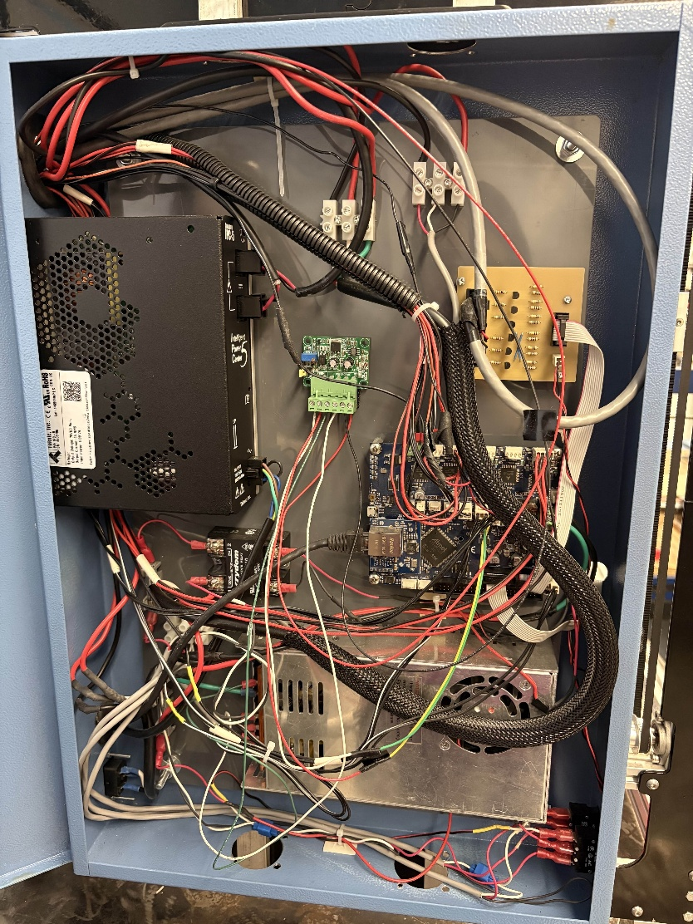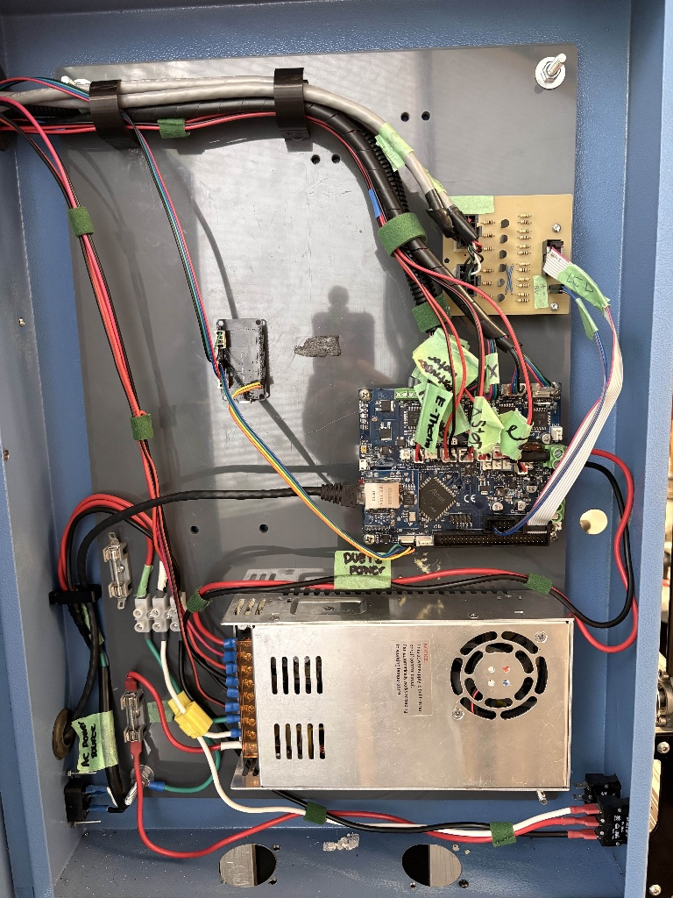
Figure E - Cable Management Evolution: Initial soldered prototype wiring (left) vs. improved continuous wire routing (right)

Appendix F
The electrical system consists of three main schematic groups: The angle monitoring circuit connecting the ESP32 and BNO055 IMU, the motor drive connections for the ClearPath servos and stepper motors, and the Duet 2 controller connections managing all motion axes and system power. These schematics illustrate the power distribution, and connections between all components.
Figures F1, F2, and F3 show the complete electrical architecture of the system.

Figure F1 - Angle Monitoring System Electrical Schematic
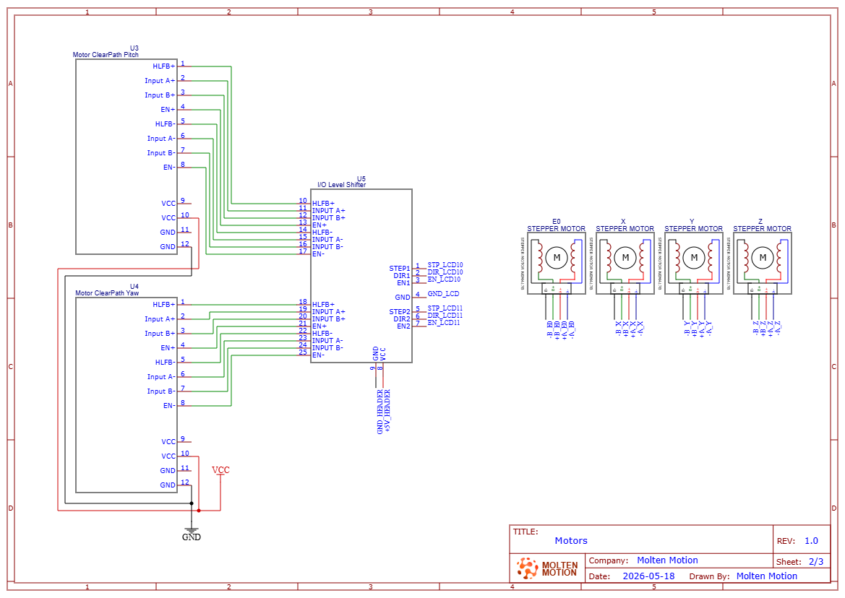
Figure F2 - Motor Connections

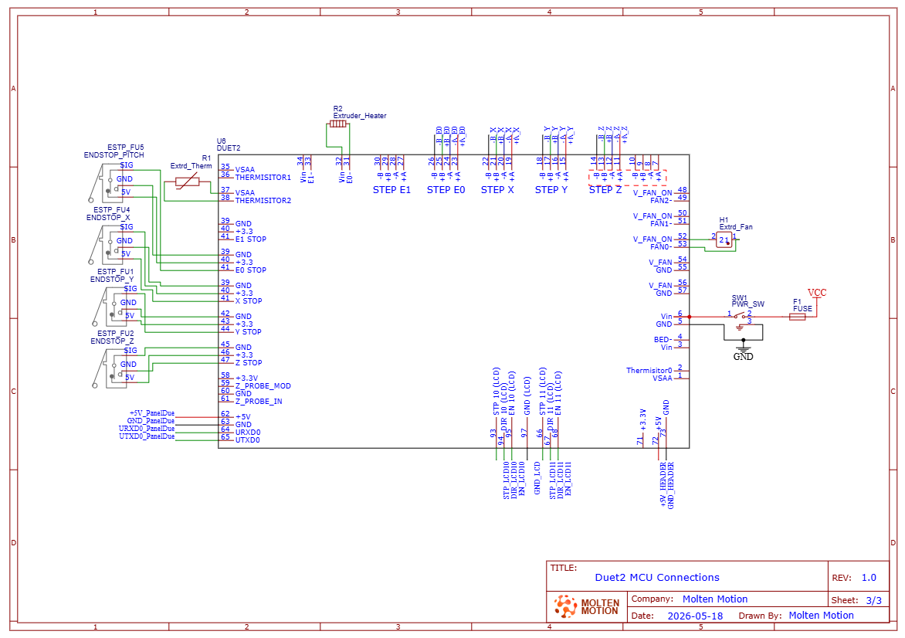
Figure F3 - Duet 2 MCU Connection Schematic

Appendix G
The Non-Planar 3D Printer is capable of printing shapes with geometries with angles greater than 45˚. When tested against a standard cartesian 3D printer, the Non-Planar part takes less time, less material, and provides smooth results.
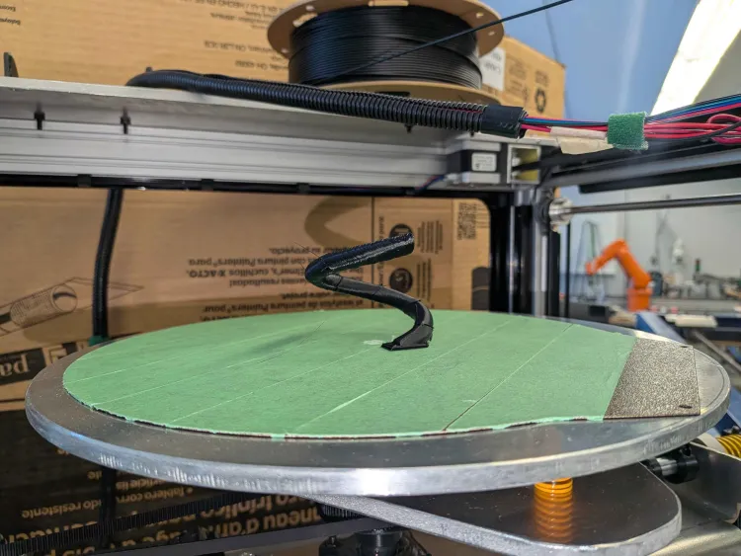
Figure G1 – Non-Planar 3D Printer Completed Sprial
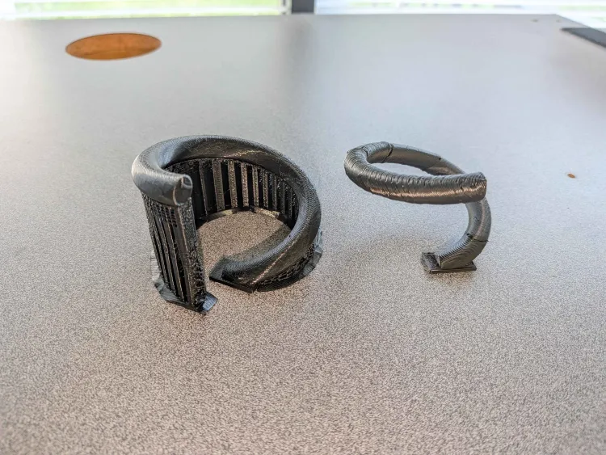
Figure G2 – Prusa Mini+ 3D Printer Spiral (left) vs Non-Planar 3D Printer Spiral (right)

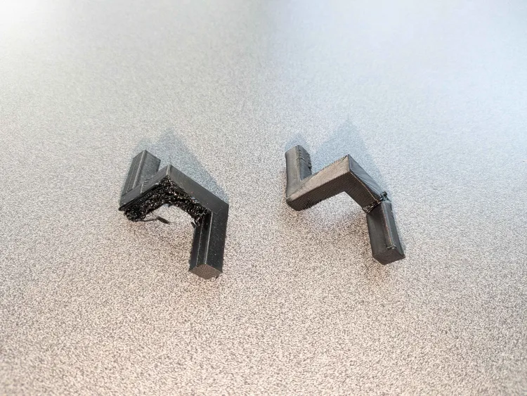
Figure G3 – Prusa Mini+ 3D Printer Unsupported 90˚ Bend (left) vs Non-Planar 3D Printer Unsupported 90˚ Bend (right)
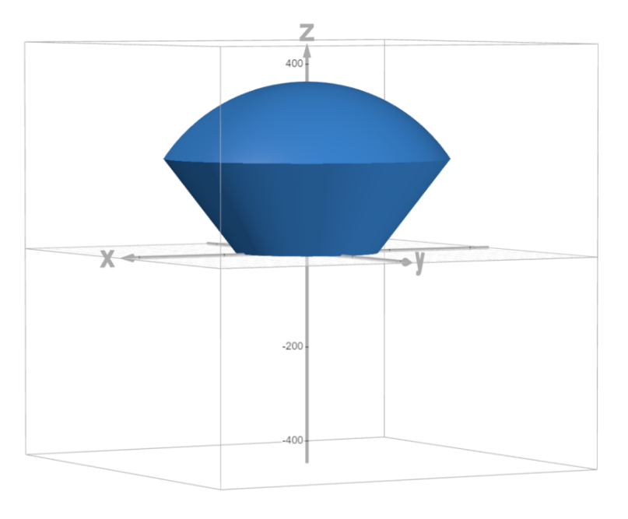
Figure G4 – Non-Planar 3D Printer Work Envelope

