c) Modify the database so that the credit hour of course no 15 is changed to 4.

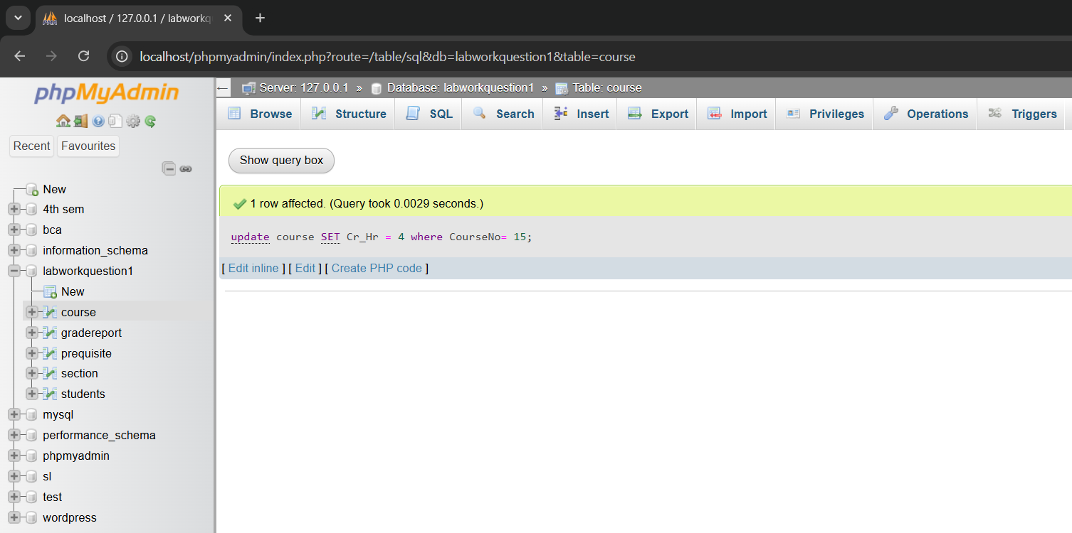

d) Display the name and major of all students whose grades are ‘A’.

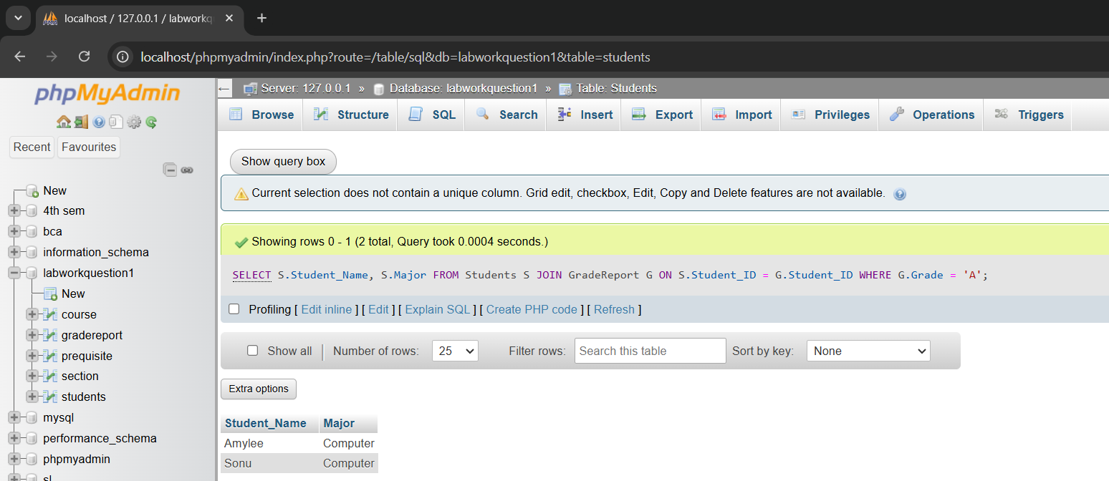

e) Delete all tuples in the section relation whose instructor is Mr.Bean

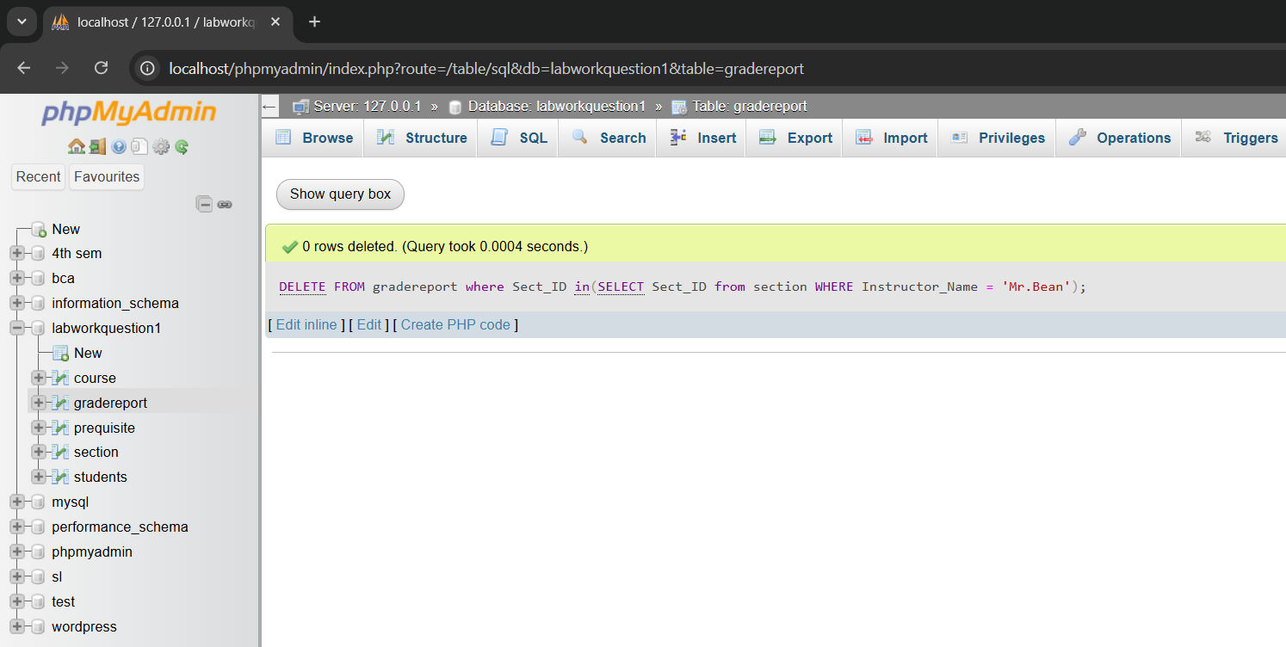

f) Display the number of courses taught by Mr.bill

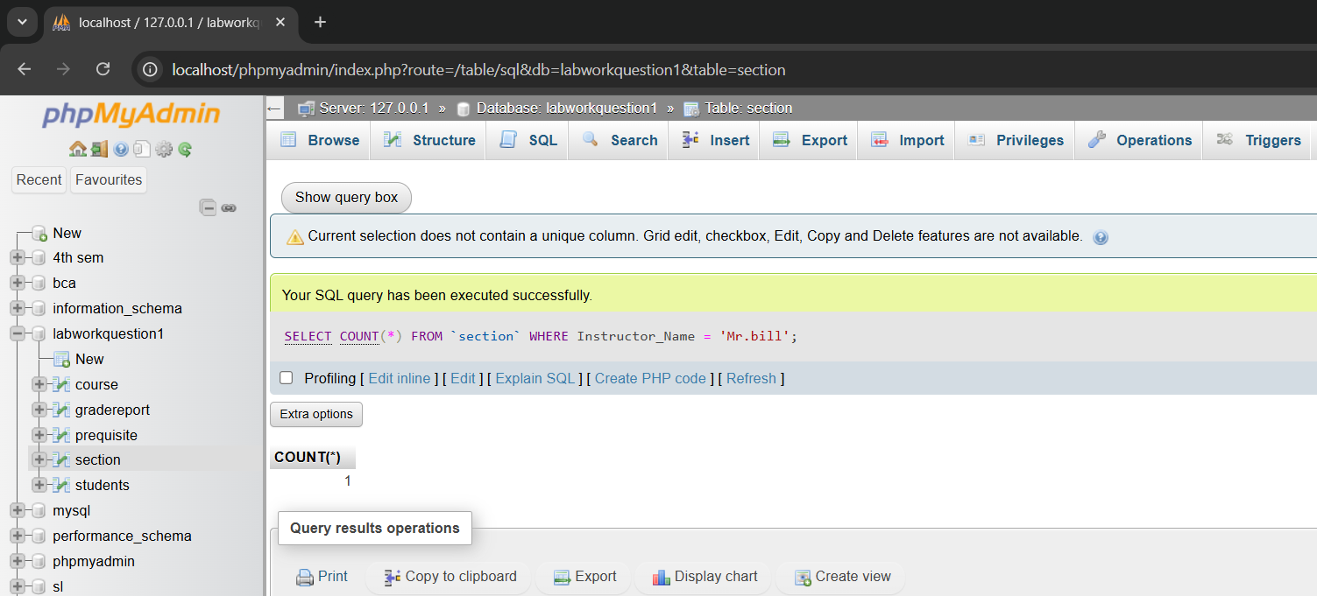

g) Find the number of students in each class

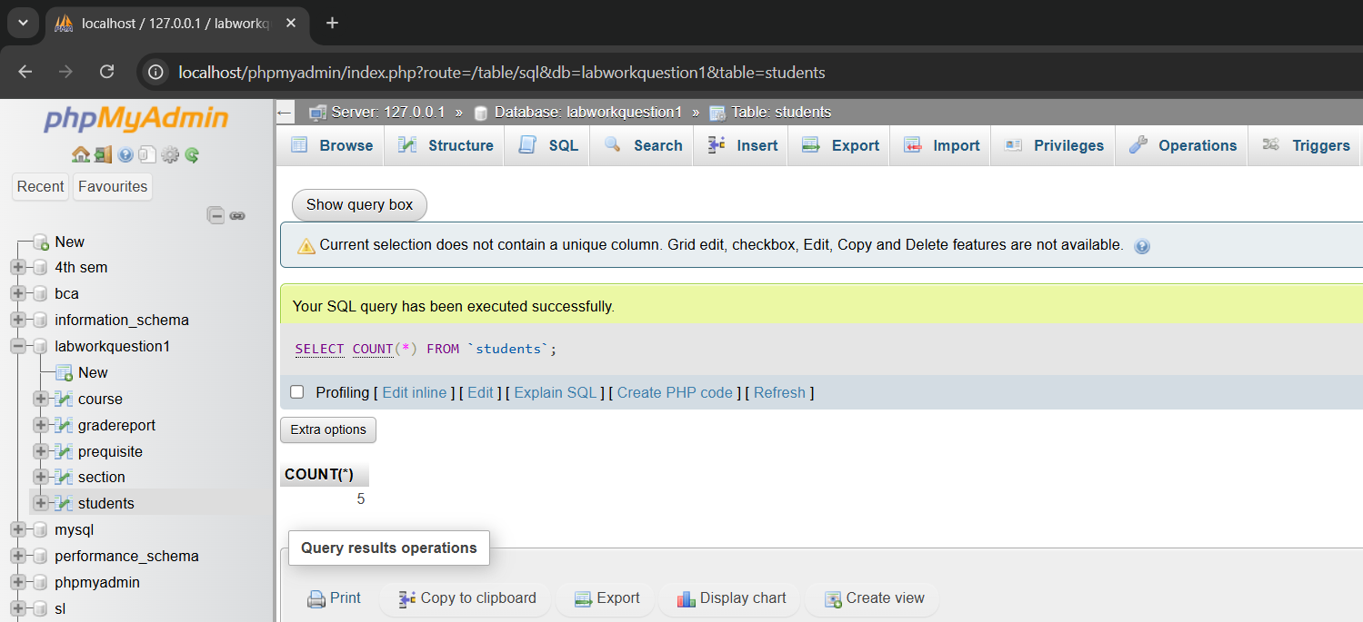

h) Delete the tuples of student table whose course no is 15.

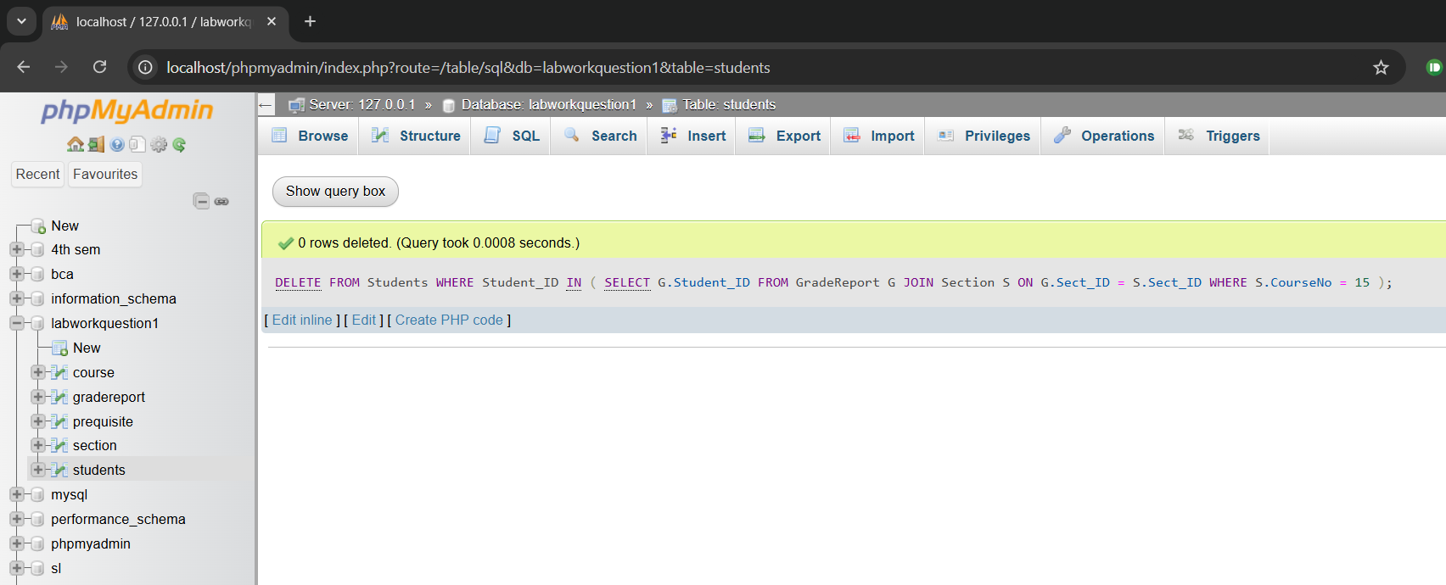

k) Insert 2 new students in student table

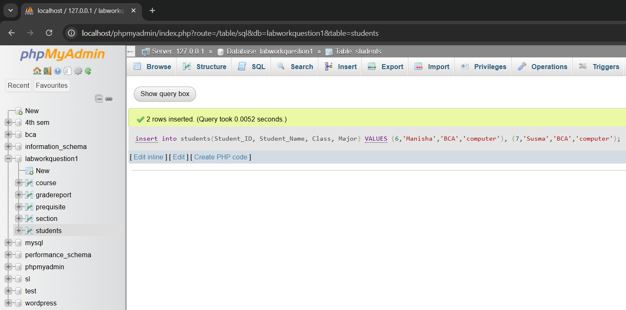

Labworkquestion3

c)Display the name of employees working in BBA department

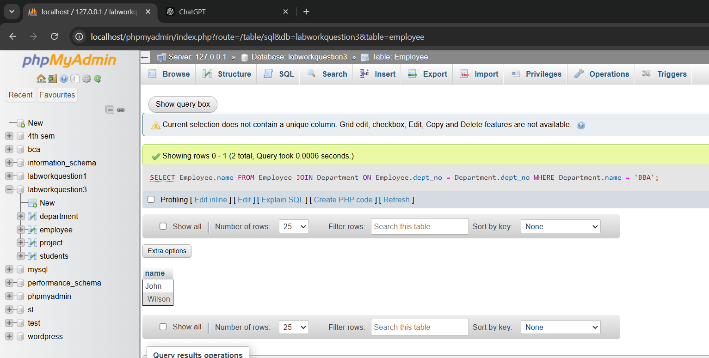

d)list details of the employee earning salary above average salary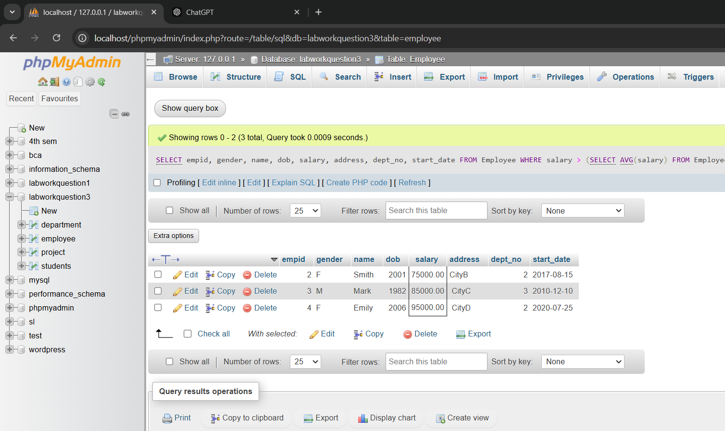

e) List details of all students along with the name of project they are involved in. Also display the name of the department.

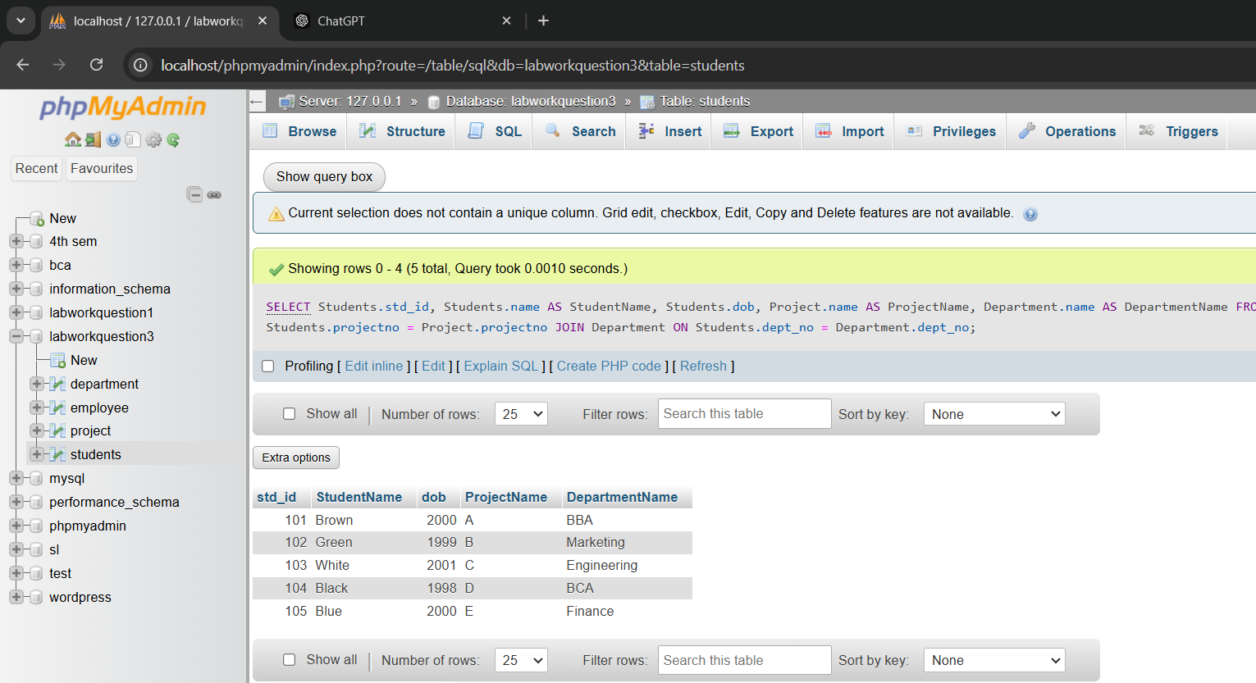

f) Decrease salary by 10% of all employees whose salary is more than 10,000

