#进入docker容器
docker exec -it 50106747d36b /bin/bash

#文件解压到
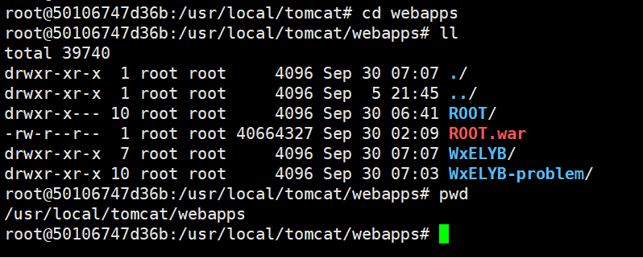

#证书位置
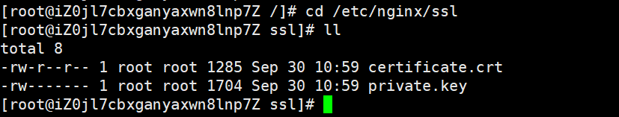
# 创建Nginx SSL目录
mkdir -p /etc/nginx/ssl

# 移动证书文件到正确位置（上传证书到服务器）
cp /www.orientdow/www.orientdow.com.pem /etc/nginx/ssl/certificate.crt
cp /www.orientdow/www.orientdow.com.key /etc/nginx/ssl/private.key

# 设置正确的权限
chmod 600 /etc/nginx/ssl/private.key
chmod 644 /etc/nginx/ssl/certificate.crt
chown nginx:nginx /etc/nginx/ssl/*

# 检查证书文件
openssl x509 -in /etc/nginx/ssl/certificate.crt -text -noout | head -20

# 检查私钥文件
openssl rsa -in /etc/nginx/ssl/private.key -check -noout

# 验证证书和私钥匹配
openssl x509 -noout -modulus -in /etc/nginx/ssl/certificate.crt | openssl md5
openssl rsa -noout -modulus -in /etc/nginx/ssl/private.key | openssl md5

证书
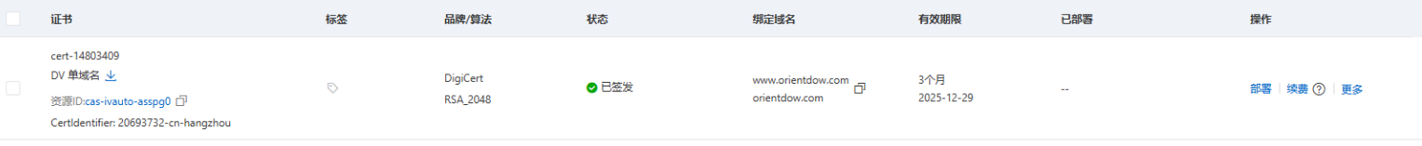

#nginx 配置及位置
[root@iZ0jl7cbxganyaxwn8lnp7Z conf.d]# cat wxelyb.conf
server {
listen 80;
server_name www.orientdow.com orientdow.com;

# 证书验证路径
location /.well-known/pki-validation/ {
root /usr/share/nginx/html;
allow all;
default_type text/plain;
}

location /.well-known/acme-challenge/ {
root /usr/share/nginx/html;
allow all;
default_type text/plain;
}

# 所有HTTP请求重定向到HTTPS
location / {
return 301 https://$server_name$request_uri;
}
}

server {
listen 443 ssl http2;
server_name www.orientdow.com orientdow.com;

# SSL证书配置
ssl_certificate /etc/nginx/ssl/certificate.crt;
ssl_certificate_key /etc/nginx/ssl/private.key;

# SSL性能优化
ssl_session_timeout 1d;
ssl_session_cache shared:SSL:50m;
ssl_session_tickets off;

# 现代SSL配置
ssl_protocols TLSv1.2 TLSv1.3;
ssl_ciphers ECDHE-ECDSA-AES128-GCM-SHA256:ECDHE-RSA-AES128-GCM-SHA256:ECDHE-ECDSA-AES256-GCM-SHA384:ECDHE-RSA-AES256-GCM-SHA384;
ssl_prefer_server_ciphers off;

# 安全头
add_header Strict-Transport-Security "max-age=63072000; includeSubDomains; preload" always;
add_header X-Frame-Options DENY always;
add_header X-Content-Type-Options nosniff always;

# 证书验证路径
location /.well-known/pki-validation/ {
root /usr/share/nginx/html;
allow all;
default_type text/plain;
}

location /.well-known/acme-challenge/ {
root /usr/share/nginx/html;
allow all;
default_type text/plain;
}

# 您的WxELYB应用配置 - 修复路径问题
location / {
proxy_pass http://localhost:8086;
proxy_set_header Host $host;
proxy_set_header X-Real-IP $remote_addr;
proxy_set_header X-Forwarded-For $proxy_add_x_forwarded_for;
proxy_set_header X-Forwarded-Proto $scheme;
proxy_set_header X-Forwarded-Host $host;

# 重定向配置
proxy_redirect http://localhost:8086/ /;

# 超时设置
proxy_connect_timeout 60s;
proxy_send_timeout 60s;
proxy_read_timeout 60s;
}

# 静态资源缓存
location ~* \.(js|css|png|jpg|jpeg|gif|ico|svg|woff|woff2)$ {
proxy_pass http://localhost:8086;
proxy_set_header Host $host;
proxy_set_header X-Real-IP $remote_addr;
proxy_set_header X-Forwarded-For $proxy_add_x_forwarded_for;
proxy_set_header X-Forwarded-Proto $scheme;
expires 1y;
add_header Cache-Control "public, immutable";
}
}
[root@iZ0jl7cbxganyaxwn8lnp7Z conf.d]# pwd
/etc/nginx/conf.d
[root@iZ0jl7cbxganyaxwn8lnp7Z conf.d]#

# 测试配置
nginx -t

# 重载Nginx
systemctl reload nginx

#用的是docker tomcat服务 为了不影响其他程序运行（服务器tomcat正在运行不能中断）
50106747d36b tomcat:9.0 "catalina.sh run" 2 weeks ago Up 48 minutes 0.0.0.0:8086->8080/tcp, :::8086->8080/tcp

# 修改Nginx配置
sed -i 's/8087/8086/g' /etc/nginx/conf.d/wxelyb.conf

# 验证修改
grep "proxy_pass" /etc/nginx/conf.d/wxelyb.conf

# 测试并重载Nginx
nginx -t && systemctl reload nginx

# 复制WAR文件到Docker容器
docker cp /opt/tomcat/webapps/WxELYB.war 50106747d36b:/usr/local/tomcat/webapps/

# 等待自动部署（约10-30秒）
sleep 20

# 检查部署状态
docker exec -it 50106747d36b ls -la /usr/local/tomcat/webapps/WxELYB/

# 查看部署日志
docker logs 50106747d36b --tail 20

# 测试Docker Tomcat中的应用
curl -I http://localhost:8086/WxELYB/

# 测试HTTPS网站访问
curl -k -I https://www.orientdow.com

# 测试网站内容
curl -k https://www.orientdow.com | head -20

# 进入容器手动部署
docker exec -it 50106747d36b /bin/bash

# 在容器内操作：
cd /usr/local/tomcat/webapps/
mkdir WxELYB
cd WxELYB
jar -xvf ../WxELYB.war
exit

# 重启容器使生效
docker restart 50106747d36b

# 1. 检查Docker容器状态
docker ps

# 2. 检查端口监听
netstat -tlnp | grep 8086

# 3. 测试后端应用
curl -I http://localhost:8086/WxELYB/

# 4. 测试HTTPS网站
curl -k -I https://www.orientdow.com

# 5. 在浏览器中访问
# https://www.orientdow.com

# 查看当前数据库配置
cat /usr/local/tomcat/webapps/WxELYB/WEB-INF/classes/jdbc.properties

# 使用sed修改配置（如果没有vi）
# 安装vim（如果需要编辑）
apt update && apt install -y vim

# 或者使用cat创建临时文件修改
cp /usr/local/tomcat/webapps/WxELYB/WEB-INF/classes/jdbc.properties /tmp/jdbc.properties
cat /tmp/jdbc.properties

# 检查WAR文件是否解压
ls -la /usr/local/tomcat/webapps/WxELYB/WEB-INF/classes/

# 如果没有解压，手动解压
cd /usr/local/tomcat/webapps/
rm -rf WxELYB
mkdir WxELYB
cd WxELYB
jar -xvf ../WxELYB.war

# 然后检查配置文件
ls -la WEB-INF/classes/jdbc.properties
cat WEB-INF/classes/jdbc.properties

# 进入容器修改数据库配置
docker exec -it 50106747d36b /bin/bash

# 修改数据库配置文件，使用宿主机IP
cat > /usr/local/tomcat/webapps/WxELYB/WEB-INF/classes/jdbc.properties << 'EOF'
jdbc.driver=com.mysql.cj.jdbc.Driver
#数据库连接地址 - 使用宿主机实际IP
jdbc.url=jdbc:mysql://8.130.85.229:3306/elyb_scsjk?useSSL=false&useUnicode=true&characterEncoding=utf8&serverTimezone=Asia/Shanghai
#客户端名
jdbc.username=root
#密码
jdbc.password=od20200528
#初始化连接数
c3p0.maxPoolSize=30
#最小连接数
c3p0.minPoolSize=10
#关闭连接后不自动commit
c3p0.autoCommitOnClose=false
#获取连接超时时间
c3p0.checkoutTimeout=10000
#当获取连接失败重试次数
c3p0.acquireRetryAttempts=2
EOF

# 验证修改
cat /usr/local/tomcat/webapps/WxELYB/WEB-INF/classes/jdbc.properties

# 退出容器
exit

# 检查宿主机MySQL状态
systemctl status mysqld

# 如果没有运行，启动它
systemctl start mysqld

# 检查3306端口
netstat -tlnp | grep 3306

# 测试数据库连接
mysql -h 127.0.0.1 -u root -p'od20200528' -e "SHOW DATABASES;"

# 检查elyb_scsjk数据库是否存在
mysql -h 127.0.0.1 -u root -p'od20200528' -e "SHOW DATABASES LIKE 'elyb_scsjk';"

# 重启Tomcat容器
docker restart 50106747d36b

# 等待重启
sleep 20

# 检查日志
docker logs 50106747d36b --tail 10

# 测试应用
curl -I http://localhost:8086/WxELYB/

# 检查防火墙是否允许3306端口
firewall-cmd --list-ports | grep 3306

# 如果3306端口没开放，开放它
firewall-cmd --permanent --add-port=3306/tcp
firewall-cmd –reload

# 检查root用户是否允许远程连接
mysql -u root -p'od20200528' -e "SELECT host, user FROM mysql.user WHERE user='root';"

# 如果root只能本地连接，允许远程连接
mysql -u root -p'od20200528' -e "CREATE USER 'root'@'%' IDENTIFIED BY 'od20200528';"
mysql -u root -p'od20200528' -e "GRANT ALL PRIVILEGES ON *.* TO 'root'@'%' WITH GRANT OPTION;"
mysql -u root -p'od20200528' -e "FLUSH PRIVILEGES;"

# 重启Tomcat容器
docker restart 50106747d36b

# 等待重启
sleep 20

# 检查日志
docker logs 50106747d36b --tail 10

# 测试应用
curl -I http://localhost:8086/WxELYB/

# 查看更详细的错误信息
docker logs 50106747d36b | grep -A 20 -B 5 "SEVERE"

# 或者进入容器查看本地日志
docker exec -it 50106747d36b /bin/bash
find /usr/local/tomcat/logs -name "*.log" -exec grep -l "WxELYB" {} \;

# 进入容器测试数据库连接
docker exec -it 50106747d36b /bin/bash

# 安装MySQL客户端测试连接
apt update && apt install -y mysql-client

# 测试数据库连接
mysql -h 8.130.85.229 -P 3306 -u root -p'od20200528' -e "SHOW DATABASES;"

# 如果连接失败，说明网络或权限问题

# 测试配置
nginx -t

# 重载Nginx
systemctl reload nginx

# 测试证书验证文件
curl -I http://www.orientdow.com/.well-known/pki-validation/fileauth.txt

# 测试HTTPS网站
curl -k -L https://www.orientdow.com

# 确保Nginx用户可以访问整个路径
chown -R nginx:nginx /usr/share/nginx/html/
find /usr/share/nginx/html/ -type d -exec chmod 755 {} \;
find /usr/share/nginx/html/ -type f -exec chmod 644 {} \;

# 检查SELinux状态（如果是启用状态）
getenforce

# 如果SELinux是Enforcing，设置正确的上下文
chcon -R -t httpd_sys_content_t /usr/share/nginx/html/

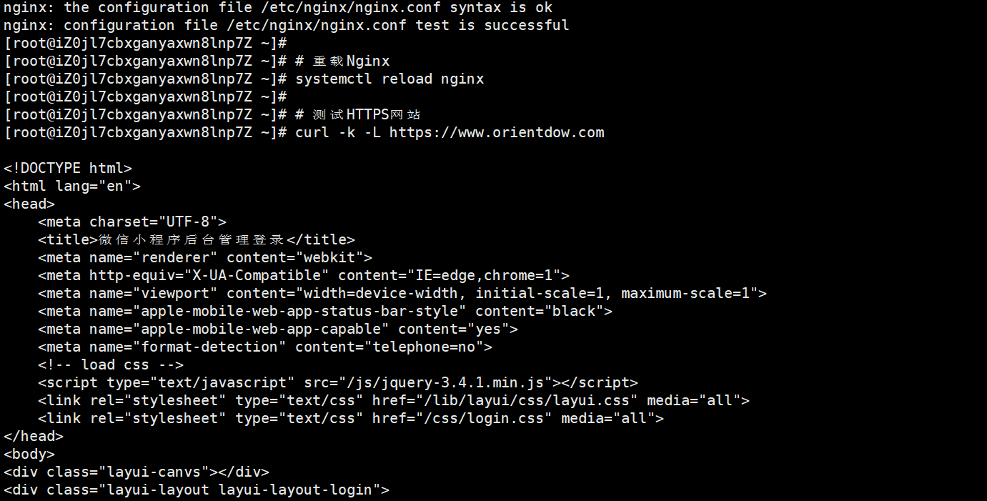

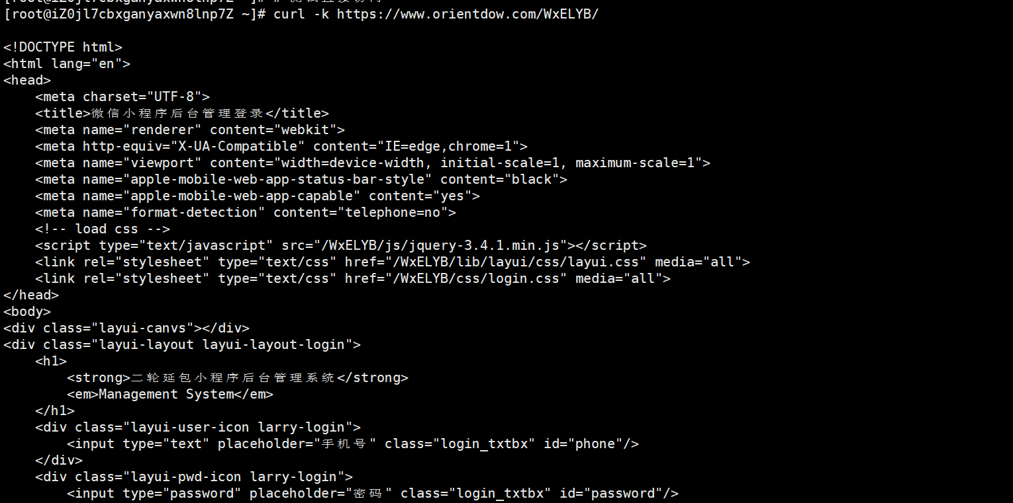

#替换部署（上传文件部署到容器）
rw-r--r-- 1 root root 40664322 Sep 30 16:45 WxELYB.war
[root@iZ0jl7cbxganyaxwn8lnp7Z WxELYB]# pwd
/root/WxELYB

# 将WAR文件复制到Tomcat容器的webapps目录
docker cp WxELYB.war 50106747d36b:/usr/local/tomcat/webapps/

#进入容器
docker exec -it 50106747d36b /bin/bash

#查看是否复制成功
cd /usr/local/tomcat/webapps/
ls -la

#删除原来的部署 并解压
rm -rf WxELYB
mkdir WxELYB
cd WxELYB
jar -xvf ../WxELYB.war
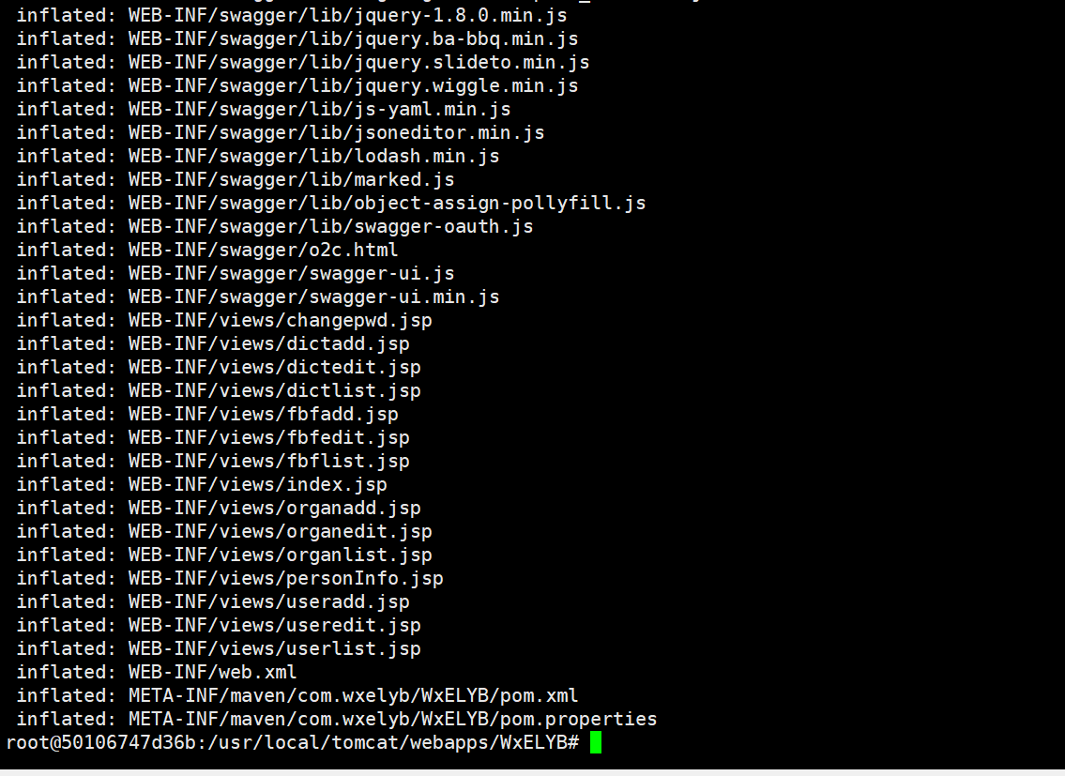
# 在宿主机上重启容器
docker restart 50106747d36b

#数据库连接不上

# 获取宿主机在Docker网络中的IP
host_ip=$(ip route | grep docker0 | awk '{print $9}')
echo "Docker host IP: $host_ip"

# 如果上面的命令没有输出，尝试其他方法
host_ip=$(ip addr show docker0 2>/dev/null | grep -oP 'inet \K[\d.]+' || echo "172.17.0.1")
echo "Using IP: $host_ip"

# 修改配置文件使用实际IP
sed -i "s/host.docker.internal/$host_ip/g" jdbc.properties
docker cp jdbc.properties 50106747d36b:/usr/local/tomcat/webapps/ROOT/WEB-INF/classes/

# 再次重启测试
docker restart 50106747d36b
sleep 20
docker logs 50106747d36b --tail 30

免费证书
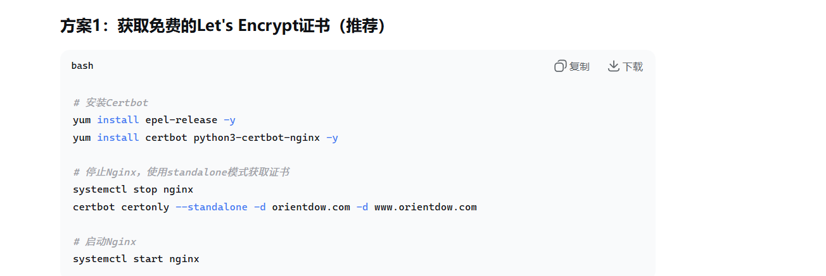

#更新配置文件
[root@iZ0jl7cbxganyaxwn8lnp7Z conf.d]# cat > /etc/nginx/conf.d/wxelyb.conf << 'EOF'
> server {
> listen 80;
> server_name www.orientdow.com orientdow.com;
> return 301 https://$server_name$request_uri;
> }
>
> server {
> listen 443 ssl http2;
> server_name www.orientdow.com orientdow.com;
>
> # 使用Let's Encrypt证书路径
> ssl_certificate /etc/letsencrypt/live/orientdow.com/fullchain.pem;
> ssl_certificate_key /etc/letsencrypt/live/orientdow.com/privkey.pem;
>
> # SSL配置
> ssl_protocols TLSv1.2 TLSv1.3;
> ssl_ciphers ECDHE-ECDSA-AES128-GCM-SHA256:ECDHE-RSA-AES128-GCM-SHA256:ECDHE-ECDSA-AES256-GCM-SHA384:ECDHE-RSA-AES256-GCM-SHA384:ECDHE-ECDSA-CHACHA20-POLY1305:ECDHE-RSA-CHACHA20-POLY1305:DHE-RSA-AES128-GCM-SHA256:DHE-RSA-AES256-GCM-SHA384;
> ssl_prefer_server_ciphers off;
>
> ssl_session_cache shared:SSL:10m;
> ssl_session_timeout 1d;
> ssl_session_tickets off;
>
> # 安全头设置
> add_header Strict-Transport-Security "max-age=63072000; includeSubDomains; preload" always;
> add_header X-Frame-Options DENY always;
> add_header X-Content-Type-Options nosniff always;
> add_header X-XSS-Protection "1; mode=block" always;
>
> # 证书验证路径
> location ^~ /.well-known/ {
> root /usr/share/nginx/html;
> allow all;
> default_type text/plain;
> }
>
> # 代理配置
> location / {
> proxy_pass http://localhost:8086;
> proxy_http_version 1.1;
> proxy_set_header Upgrade $http_upgrade;
> proxy_set_header Connection 'upgrade';
> proxy_set_header Host $host;
> proxy_set_header X-Real-IP $remote_addr;
> proxy_set_header X-Forwarded-For $proxy_add_x_forwarded_for;
> proxy_set_header X-Forwarded-Proto $scheme;
> proxy_cache_bypass $http_upgrade;
>
> # 超时设置
> proxy_connect_timeout 60s;
> proxy_send_timeout 60s;
> proxy_read_timeout 60s;
> }
> }
> EOF
[root@iZ0jl7cbxganyaxwn8lnp7Z conf.d]# nginx -t
nginx: [warn] conflicting server name "www.orientdow.com" on 0.0.0.0:80, ignored
nginx: [warn] conflicting server name "orientdow.com" on 0.0.0.0:80, ignored
nginx: the configuration file /etc/nginx/nginx.conf syntax is ok
nginx: configuration file /etc/nginx/nginx.conf test is successful
[root@iZ0jl7cbxganyaxwn8lnp7Z conf.d]# systemctl start nginx
[root@iZ0jl7cbxganyaxwn8lnp7Z conf.d]# systemctl stop nginx
[root@iZ0jl7cbxganyaxwn8lnp7Z conf.d]# certbot certonly --standalone -d orientdow.com -d www.orientdow.com
Saving debug log to /var/log/letsencrypt/letsencrypt.log
Plugins selected: Authenticator standalone, Installer None
Starting new HTTPS connection (1): acme-v02.api.letsencrypt.org
Cannot extract OCSP URI from /etc/letsencrypt/archive/orientdow.com/cert1.pem
Cert not yet due for renewal

You have an existing certificate that has exactly the same domains or certificate name you requested and isn't close to expiry.
(ref: /etc/letsencrypt/renewal/orientdow.com.conf)

What would you like to do?
- - - - - - - - - - - - - - - - - - - - - - - - - - - - - - - - - - - - - - - -
1: Keep the existing certificate for now
2: Renew & replace the certificate (may be subject to CA rate limits)
- - - - - - - - - - - - - - - - - - - - - - - - - - - - - - - - - - - - - - - -
Select the appropriate number [1-2] then [enter] (press 'c' to cancel):

** Invalid input **
Select the appropriate number [1-2] then [enter] (press 'c' to cancel): 2
Renewing an existing certificate for orientdow.com and www.orientdow.com

IMPORTANT NOTES:
- Congratulations! Your certificate and chain have been saved at:
/etc/letsencrypt/live/orientdow.com/fullchain.pem
Your key file has been saved at:
/etc/letsencrypt/live/orientdow.com/privkey.pem
Your certificate will expire on 2025-12-29. To obtain a new or
tweaked version of this certificate in the future, simply run
certbot again. To non-interactively renew *all* of your
certificates, run "certbot renew"
- If you like Certbot, please consider supporting our work by:

Donating to ISRG / Let's Encrypt: https://letsencrypt.org/donate
Donating to EFF: https://eff.org/donate-le

[root@iZ0jl7cbxganyaxwn8lnp7Z conf.d]# systemctl stop nginx
[root@iZ0jl7cbxganyaxwn8lnp7Z conf.d]# certbot certonly --standalone -d orientdow.com -d www.orientdow.com --force-renewal
Saving debug log to /var/log/letsencrypt/letsencrypt.log
Plugins selected: Authenticator standalone, Installer None
Starting new HTTPS connection (1): acme-v02.api.letsencrypt.org
Renewing an existing certificate for orientdow.com and www.orientdow.com

IMPORTANT NOTES:
- Congratulations! Your certificate and chain have been saved at:
/etc/letsencrypt/live/orientdow.com/fullchain.pem
Your key file has been saved at:
/etc/letsencrypt/live/orientdow.com/privkey.pem
Your certificate will expire on 2025-12-29. To obtain a new or
tweaked version of this certificate in the future, simply run
certbot again. To non-interactively renew *all* of your
certificates, run "certbot renew"
- If you like Certbot, please consider supporting our work by:

Donating to ISRG / Let's Encrypt: https://letsencrypt.org/donate
Donating to EFF: https://eff.org/donate-le

[root@iZ0jl7cbxganyaxwn8lnp7Z conf.d]# # 备份当前配置
[root@iZ0jl7cbxganyaxwn8lnp7Z conf.d]# cp /etc/nginx/conf.d/wxelyb.conf /etc/nginx/conf.d/wxelyb.conf.backup
_name www.orientdow.com orientdow.com;

# 重定向所有HTTP到HTTPS
return 301 https://$server_name$request_uri;
}

server {
listen 443 ssl http2;
server_name www.orientdow.com orientdow.com;

# Let's Encrypt证书路径
ssl_certificate /etc/letsencrypt/live/orientdow.com/fullchain.pem;
ssl_certificate_key /etc/letsencrypt/live/orientdow.com/privkey.pem;

# SSL配置
ssl_protocols TLSv1.2 TLSv1.3;
ssl_ciphers ECDHE-ECDSA-AES128-GCM-SHA256:ECDHE-RSA-AES128-GCM-SHA256:ECDHE-ECDSA-AES256-GCM-SHA384:ECDHE-RSA-AES256-GCM-SHA384:ECDHE-ECDSA-CHACHA20-POLY1305:ECDHE-RSA-CHACHA20-POLY1305:DHE-RSA-AES128-GCM-SHA256:DHE-RSA-AES256-GCM-SHA384;
ssl_prefer_server_ciphers off;

ssl_session_cache shared:SSL:1[root@iZ0jl7cbxganyaxwn8lnp7Z conf.d]#
[root@iZ0jl7cbxganyaxwn8lnp7Z conf.d]# # 删除现有配置
[root@iZ0jl7cbxganyaxwn8lnp7Z conf.d]# rm -f /etc/nginx/conf.d/wxelyb.conf
0m;
ssl_session_timeout 1d;
ssl_session_tickets off;

# 安全头设置
add_header Strict-Transport-Security "max-age=63072000; includeSubDomains; preload" always;
add_header X-Frame-Options SAMEORIGIN always;
add_header X-Conte[root@iZ0jl7cbxganyaxwn8lnp7Z conf.d]#
[root@iZ0jl7cbxganyaxwn8lnp7Z conf.d]# # 创建新的完整配置
[root@iZ0jl7cbxganyaxwn8lnp7Z conf.d]# cat > /etc/nginx/conf.d/wxelyb.conf << 'EOF'
> server {
> listen 80;
> server_name www.orientdow.com orientdow.com;
>
> # 重定向所有HTTP到HTTPS
> return 301 https://$server_name$request_uri;
> }
>
> server {
> listen 443 ssl http2;
> server_name www.orientdow.com orientdow.com;
>
> # Let's Encrypt证书路径
> ssl_certificate /etc/letsencrypt/live/orientdow.com/fullchain.pem;
> ssl_certificate_key /etc/letsencrypt/live/orientdow.com/privkey.pem;
>
> # SSL配置
> ssl_protocols TLSv1.2 TLSv1.3;
> ssl_ciphers ECDHE-ECDSA-AES128-GCM-SHA256:ECDHE-RSA-AES128-GCM-SHA256:ECDHE-ECDSA-AES256-GCM-SHA384:ECDHE-RSA-AES256-GCM-SHA384:ECDHE-ECDSA-CHACHA20-POLY1305:ECDHE-RSA-CHACHA20-POLY1305:DHE-RSA-AES128-GCM-SHA256:DHE-RSA-AES256-GCM-SHA384;
> ssl_prefer_server_ciphers off;
>
> ssl_session_cache shared:SSL:10m;
> ssl_session_timeout 1d;
> ssl_session_tickets off;
>
> # 安全头设置
> add_header Strict-Transport-Security "max-age=63072000; includeSubDomains; preload" always;
> add_header X-Frame-Options SAMEORIGIN always;
> add_header X-Content-Type-Options nosniff always;
> add_header X-XSS-Protection "1; mode=block" always;
>
> # 代理配置
> location / {
> proxy_pass http://localhost:8086;
> proxy_http_version 1.1;
> proxy_set_header Upgrade $http_upgrade;
> proxy_set_header Connection 'upgrade';
> proxy_set_header Host $host;
> proxy_set_header X-Real-IP $remote_addr;
> proxy_set_header X-Forwarded-For $proxy_add_x_forwarded_for;
> proxy_set_header X-Forwarded-Proto $scheme;
> proxy_cache_bypass $http_upgrade;
>
> # 超时设置
> proxy_connect_timeout 60s;
> proxy_send_timeout 60s;
> proxy_read_timeout 60s;
> }
>
> # 静态资源缓存
> location ~* \.(js|css|png|jpg|jpeg|gif|ico|svg|woff|woff2)$ {
> proxy_pass http://localhost:8086;
> proxy_set_header Host $host;
> proxy_set_header X-Real-IP $remote_addr;
> proxy_set_header X-Forwarded-For $proxy_add_x_forwarded_for;
> proxy_set_header X-Forwarded-Proto $scheme;
> expires 1y;
> add_header Cache-Control "public, immutable";
> }
> }
> EOF
[root@iZ0jl7cbxganyaxwn8lnp7Z conf.d]# # 检查证书文件是否存在
[root@iZ0jl7cbxganyaxwn8lnp7Z conf.d]# ls -la /etc/letsencrypt/live/orientdow.com/
total 12
drwxr-xr-x 2 root root 4096 Sep 30 18:44 .
drwx------ 3 root root 4096 Sep 30 18:39 ..
lrwxrwxrwx 1 root root 37 Sep 30 18:44 cert.pem -> ../../archive/orientdow.com/cert3.pem
lrwxrwxrwx 1 root root 38 Sep 30 18:44 chain.pem -> ../../archive/orientdow.com/chain3.pem
lrwxrwxrwx 1 root root 42 Sep 30 18:44 fullchain.pem -> ../../archive/orientdow.com/fullchain3.pem
lrwxrwxrwx 1 root root 40 Sep 30 18:44 privkey.pem -> ../../archive/orientdow.com/privkey3.pem
-rw-r--r-- 1 root root 692 Sep 30 18:39 README
[root@iZ0jl7cbxganyaxwn8lnp7Z conf.d]#
[root@iZ0jl7cbxganyaxwn8lnp7Z conf.d]# # 查看证书详情
[root@iZ0jl7cbxganyaxwn8lnp7Z conf.d]# certbot certificates
Saving debug log to /var/log/letsencrypt/letsencrypt.log
Cannot extract OCSP URI from /etc/letsencrypt/live/orientdow.com/cert.pem

- - - - - - - - - - - - - - - - - - - - - - - - - - - - - - - - - - - - - - - -
Found the following certs:
Certificate Name: orientdow.com
Serial Number: 6e603e089441e170872930832778d64df8d
Key Type: RSA
Domains: orientdow.com www.orientdow.com
Expiry Date: 2025-12-29 09:45:27+00:00 (VALID: 89 days)
Certificate Path: /etc/letsencrypt/live/orientdow.com/fullchain.pem
Private Key Path: /etc/letsencrypt/live/orientdow.com/privkey.pem
- - - - - - - - - - - - - - - - - - - - - - - - - - - - - - - - - - - - - - - -
[root@iZ0jl7cbxganyaxwn8lnp7Z conf.d]# # 测试配置
[root@iZ0jl7cbxganyaxwn8lnp7Z conf.d]# nginx -t
nginx: [warn] conflicting server name "www.orientdow.com" on 0.0.0.0:80, ignored
nginx: [warn] conflicting server name "orientdow.com" on 0.0.0.0:80, ignored
nginx: the configuration file /etc/nginx/nginx.conf syntax is ok
nginx: configuration file /etc/nginx/nginx.conf test is successful
[root@iZ0jl7cbxganyaxwn8lnp7Z conf.d]#
[root@iZ0jl7cbxganyaxwn8lnp7Z conf.d]# # 启动Nginx
[root@iZ0jl7cbxganyaxwn8lnp7Z conf.d]# systemctl start nginx
[root@iZ0jl7cbxganyaxwn8lnp7Z conf.d]#
[root@iZ0jl7cbxganyaxwn8lnp7Z conf.d]# # 检查状态
[root@iZ0jl7cbxganyaxwn8lnp7Z conf.d]# systemctl status nginx
● nginx.service - The nginx HTTP and reverse proxy server
Loaded: loaded (/usr/lib/systemd/system/nginx.service; disabled; vendor preset: disabled)
Active: active (running) since Tue 2025-09-30 18:44:57 CST; 1s ago
Process: 10922 ExecStart=/usr/sbin/nginx (code=exited, status=0/SUCCESS)
Process: 10919 ExecStartPre=/usr/sbin/nginx -t (code=exited, status=0/SUCCESS)
Process: 10917 ExecStartPre=/usr/bin/rm -f /run/nginx.pid (code=exited, status=0/SUCCESS)
Main PID: 10926 (nginx)
Tasks: 9
Memory: 5.9M
CGroup: /system.slice/nginx.service
├─10926 nginx: master process /usr/sbin/nginx
├─10927 nginx: worker process
├─10928 nginx: worker process
├─10929 nginx: worker process
├─10930 nginx: worker process
├─10932 nginx: worker process
├─10933 nginx: worker process
├─10934 nginx: worker process
└─10935 nginx: worker process

Sep 30 18:44:57 iZ0jl7cbxganyaxwn8lnp7Z systemd[1]: Starting The nginx HTTP and reverse proxy server...
Sep 30 18:44:57 iZ0jl7cbxganyaxwn8lnp7Z nginx[10919]: nginx: [warn] conflicting server name "www.orientdow.com" on 0.0.0.0:80, ignored
Sep 30 18:44:57 iZ0jl7cbxganyaxwn8lnp7Z nginx[10919]: nginx: [warn] conflicting server name "orientdow.com" on 0.0.0.0:80, ignored
Sep 30 18:44:57 iZ0jl7cbxganyaxwn8lnp7Z nginx[10919]: nginx: the configuration file /etc/nginx/nginx.conf syntax is ok
Sep 30 18:44:57 iZ0jl7cbxganyaxwn8lnp7Z nginx[10919]: nginx: configuration file /etc/nginx/nginx.conf test is successful
Sep 30 18:44:57 iZ0jl7cbxganyaxwn8lnp7Z nginx[10922]: nginx: [warn] conflicting server name "www.orientdow.com" on 0.0.0.0:80, ignored
Sep 30 18:44:57 iZ0jl7cbxganyaxwn8lnp7Z nginx[10922]: nginx: [warn] conflicting server name "orientdow.com" on 0.0.0.0:80, ignored
Sep 30 18:44:57 iZ0jl7cbxganyaxwn8lnp7Z systemd[1]: Started The nginx HTTP and reverse proxy server.
[root@iZ0jl7cbxganyaxwn8lnp7Z conf.d]#
#特别说明

- Docker内部Tomcat
- 宿主机数据库/nginx
- 官网证书www.orientdow.com /orientdow.com

root@50106747d36b:/usr/local/tomcat/webapps#
cat /usr/local/tomcat/webapps/ROOT/WEB-INF/classes/jdbc.properties
jdbc.driver=com.mysql.cj.jdbc.Driver
jdbc.url=jdbc:mysql://8.130.85.229:3306/elyb_scsjk?useSSL=false&useUnicode=true&characterEncoding=utf8&serverTimezone=Asia/Shanghai
jdbc.username=root
jdbc.password=od20200528
c3p0.maxPoolSize=30
c3p0.minPoolSize=10
c3p0.autoCommitOnClose=false
c3p0.checkoutTimeout=10000
c3p0.acquireRetryAttempts=2
root@50106747d36b:/usr/local/tomcat/webapps#

# 编辑WxELYB的web.xml文件
cd /usr/local/tomcat/webapps/WxELYB/WEB-INF/
sed -i 's/<param-value>book.webapp<\/param-value>/<param-value>wxelyb.webapp<\/param-value>/' web.xml

# 验证修改
cat web.xml | grep -A 2 -B 2 webAppRootKey

# 如果ROOT应用也需要，修改它的web.xml
cd /usr/local/tomcat/webapps/ROOT/WEB-INF/
sed -i 's/<param-value>book.webapp<\/param-value>/<param-value>root.webapp<\/param-value>/' web.xml

# 采用方法1：修改WxELYB的web.xml
cd /usr/local/tomcat/webapps/WxELYB/WEB-INF/
cp web.xml web.xml.backup
sed -i 's/book.webapp/wxelyb.webapp/' web.xml

# 验证修改
cat web.xml | grep -A 2 -B 2 webAppRootKey

rm -rf WxELYB
mkdir WxELYB
cd WxELYB
jar -xvf ../WxELYB.war

docker restart 50106747d36b

docker cp /root/WxELYB/* 50106747d36b:/usr/local/tomcat/webapps/

sed -i 's/loaclhost/8.130.85.229/g' /usr/local/tomcat/webapps/WxELYB/WEB-INF/classes/jdbc.properties

#验证是否成功
cat /usr/local/tomcat/webapps/WxELYB/WEB-INF/classes/jdbc.properties | grep jdbc.url

#最终部署
# /etc/nginx/conf.d/wxelyb.conf
server {
listen 443 ssl http2;
server_name www.orientdow.com orientdow.com;

ssl_certificate /etc/letsencrypt/live/orientdow.com/fullchain.pem;
ssl_certificate_key /etc/letsencrypt/live/orientdow.com/privkey.pem;

# SSL 配置
ssl_protocols TLSv1.2 TLSv1.3;
ssl_ciphers ECDHE-ECDSA-AES128-GCM-SHA256:ECDHE-RSA-AES128-GCM-SHA256:ECDHE-ECDSA-AES256-GCM-SHA384:ECDHE-RSA-AES256-GCM-SHA384:ECDHE-ECDSA-CHACHA20-POLY1305:ECDHE-RSA-CHACHA20-POLY1305:DHE-RSA-AES128-GCM-SHA256:DHE-RSA-AES256-GCM-SHA384;
ssl_prefer_server_ciphers off;

ssl_session_cache shared:SSL:10m;
ssl_session_timeout 1d;
ssl_session_tickets off;

# 安全头设置
add_header Strict-Transport-Security "max-age=63072000; includeSubDomains; preload" always;
add_header X-Frame-Options SAMEORIGIN always;
add_header X-Content-Type-Options nosniff always;
add_header X-XSS-Protection "1; mode=block" always;

# 证书验证路径
location ^~ /.well-known/ {
root /usr/share/nginx/html;
allow all;
default_type text/plain;
}

# 处理重复的 wxelyb/wxelyb/ 路径
location ~* ^/wxelyb/wxelyb/(.*)$ {
return 301 /wxelyb/$1;
}

# 重定向根路径到 /wxelyb/
location = / {
return 302 /wxelyb/;
}

# 处理不带斜杠的 /wxelyb 重定向
location = /wxelyb {
return 302 /wxelyb/;
}

# 静态资源处理 - 修正重复路径
location ~* \.(css|js|png|jpg|jpeg|gif|ico|svg|woff|woff2|ttf|eot)$ {
proxy_pass http://localhost:8087;
proxy_http_version 1.1;
proxy_set_header Host $host;
proxy_set_header X-Real-IP $remote_addr;
proxy_set_header X-Forwarded-For $proxy_add_x_forwarded_for;
proxy_set_header X-Forwarded-Proto $scheme;

# 修正重复路径
sub_filter_once off;
sub_filter_types text/css application/javascript;
sub_filter '/wxelyb/wxelyb/' '/wxelyb/';

proxy_connect_timeout 30s;
proxy_send_timeout 30s;
proxy_read_timeout 30s;

# 缓存设置
expires 1y;
add_header Cache-Control "public, immutable";
}

# JSP 和 HTML 文件处理 - 修正所有重复路径
location ~ \.(jsp|html)$ {
proxy_pass http://localhost:8087;
proxy_http_version 1.1;
proxy_set_header Host $host;
proxy_set_header X-Real-IP $remote_addr;
proxy_set_header X-Forwarded-For $proxy_add_x_forwarded_for;
proxy_set_header X-Forwarded-Proto $scheme;

# 重要：启用响应内容修改
proxy_set_header Accept-Encoding "";
sub_filter_once off;
sub_filter_types text/html;

# 修正重复路径问题
sub_filter 'src="/wxelyb/wxelyb/' 'src="/wxelyb/';
sub_filter 'href="/wxelyb/wxelyb/' 'href="/wxelyb/';
sub_filter 'url("/wxelyb/wxelyb/' 'url("/wxelyb/';
sub_filter "url('/wxelyb/wxelyb/" "url('/wxelyb/";
sub_filter 'action="/wxelyb/wxelyb/' 'action="/wxelyb/';
sub_filter "url: /wxelyb + '/wxelyb/" "url: '/wxelyb/";
sub_filter 'window.location.href="/wxelyb/wxelyb/' 'window.location.href="/wxelyb/';
sub_filter '"/wxelyb/wxelyb/' '"/wxelyb/';
sub_filter "'/wxelyb/wxelyb/" "'/wxelyb/";

proxy_connect_timeout 60s;
proxy_send_timeout 60s;
proxy_read_timeout 60s;
}

# 主要应用代理 - /wxelyb/ 路径
location /wxelyb/ {
proxy_pass http://localhost:8087/wxelyb/;
proxy_http_version 1.1;

# 重要头部设置
proxy_set_header Host $host;
proxy_set_header X-Real-IP $remote_addr;
proxy_set_header X-Forwarded-For $proxy_add_x_forwarded_for;
proxy_set_header X-Forwarded-Proto $scheme;
proxy_set_header X-Forwarded-Host $server_name;
proxy_set_header X-Forwarded-Prefix /wxelyb;

# 禁用压缩以允许内容替换
proxy_set_header Accept-Encoding "";

# 路径修正 - 处理重复路径
sub_filter_once off;
sub_filter_types text/html text/css application/javascript;

# 修正所有重复路径
sub_filter 'src="/wxelyb/wxelyb/' 'src="/wxelyb/';
sub_filter 'href="/wxelyb/wxelyb/' 'href="/wxelyb/';
sub_filter 'url("/wxelyb/wxelyb/' 'url("/wxelyb/';
sub_filter "url('/wxelyb/wxelyb/" "url('/wxelyb/";
sub_filter 'action="/wxelyb/wxelyb/' 'action="/wxelyb/';
sub_filter "url: /wxelyb + '/wxelyb/" "url: '/wxelyb/";
sub_filter 'window.location.href="/wxelyb/wxelyb/' 'window.location.href="/wxelyb/';
sub_filter '"/wxelyb/wxelyb/' '"/wxelyb/';
sub_filter "'/wxelyb/wxelyb/" "'/wxelyb/";

# 超时设置
proxy_connect_timeout 60s;
proxy_send_timeout 60s;
proxy_read_timeout 60s;

# 缓冲区设置
proxy_buffer_size 128k;
proxy_buffers 4 256k;
proxy_busy_buffers_size 256k;
}

# 其他路径重定向到应用
location / {
return 302 /wxelyb/;
}
}

# HTTP 重定向到 HTTPS
server {
listen 80;
server_name www.orientdow.com orientdow.com;

# 证书验证路径
location ^~ /.well-known/ {
root /usr/share/nginx/html;
allow all;
default_type text/plain;
}

# HTTP 重定向到 HTTPS
location / {
return 301 https://$server_name$request_uri;
}
}

# 测试 Nginx 配置
nginx -t

# 重新加载 Nginx
systemctl reload nginx

#!/bin/bash
echo "=== WxELYB 应用快速部署 ==="

# 停止 Tomcat
echo "停止 Tomcat..."
/opt/tomcat/bin/shutdown.sh
sleep 5

# 清理旧文件
echo "清理旧文件..."
cd /opt/tomcat/webapps
rm -rf wxelyb WxELYB ROOT
rm -f wxelyb.war WxELYB.war ROOT.war
rm -rf /opt/tomcat/work/Catalina/localhost/wxelyb
rm -rf /opt/tomcat/work/Catalina/localhost/WxELYB
rm -rf /opt/tomcat/work/Catalina/localhost/ROOT

# 部署应用
echo "部署应用到 /wxelyb/ 路径..."
cp /root/WxELYB/WxELYB.war /opt/tomcat/webapps/wxelyb.war

# 启动 Tomcat
echo "启动 Tomcat..."
/opt/tomcat/bin/startup.sh

# 等待应用部署
echo "等待应用部署..."
sleep 15

# 检查部署状态
echo "检查部署状态:"
ls -la /opt/tomcat/webapps/ | grep wxelyb

# 验证部署
echo "验证应用访问..."
echo "页面访问测试:"
curl -s -o /dev/null -w "HTTP状态码: %{http_code}\n" https://www.orientdow.com/wxelyb/

echo "=== 部署完成 ==="
echo "访问地址: https://www.orientdow.com/wxelyb/"

# 把war文件放在 /root/WxELYB 下面
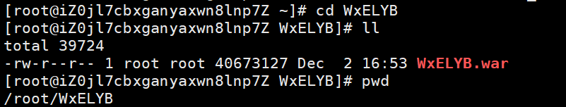
#在服务器任何位置直接执行软连接

sudo /opt/deploy/scripts/deploy-wxelyb.sh

chmod o+rx wxelyb

# 最安全的做法：让所有人都能读取
chmod -R o+r wxelyb
find wxelyb -type d -exec chmod o+x {} \;

# 验证结果
ls -la wxelyb/

监听问题
# 备份当前web.xml
cp /opt/tomcat/webapps/wxelyb/WEB-INF/web.xml /opt/tomcat/webapps/wxelyb/WEB-INF/web.xml.backup4

# 创建一个没有WebAppRootListener的web.xml
cat > /tmp/web-no-listener.xml << 'EOF'
<?xml version="1.0" encoding="UTF-8"?>
<web-app xmlns="http://xmlns.jcp.org/xml/ns/javaee"
xmlns:xsi="http://www.w3.org/2001/XMLSchema-instance"
xsi:schemaLocation="http://xmlns.jcp.org/xml/ns/javaee http://xmlns.jcp.org/xml/ns/javaee/web-app_3_1.xsd"
version="3.1">

<display-name>WxELYB</display-name>
<description>WxELYB</description>

<!-- 编码过滤器 -->
<filter>
<filter-name>encodingFilter</filter-name>
<filter-class>org.springframework.web.filter.CharacterEncodingFilter</filter-class>
<init-param>
<param-name>encoding</param-name>
<param-value>UTF-8</param-value>
</init-param>
</filter>
<filter-mapping>
<filter-name>encodingFilter</filter-name>
<url-pattern>/*</url-pattern>
</filter-mapping>

<!-- 配置DispatcherServlet -->
<servlet>
<servlet-name>SpringMVC</servlet-name>
<servlet-class>org.springframework.web.servlet.DispatcherServlet</servlet-class>
<!-- 配置springMVC需要加载的配置文件-->
<init-param>
<param-name>contextConfigLocation</param-name>
<param-value>classpath:spring-*.xml</param-value>
</init-param>
<load-on-startup>1</load-on-startup>
<async-supported>true</async-supported>
</servlet>
<servlet-mapping>
<servlet-name>SpringMVC</servlet-name>
<!-- 匹配所有请求 -->
<url-pattern>/</url-pattern>
</servlet-mapping>

<welcome-file-list>
<welcome-file>login.jsp</welcome-file>
</welcome-file-list>

</web-app>
EOF

# 应用新的web.xml
sudo cp /tmp/web-no-listener.xml /opt/tomcat/webapps/wxelyb/WEB-INF/web.xml

