**202211341 컴퓨터공학과 이윤희**

**Question1**

#include <iostream>

using namespace std;

int main(void) {

int x, y;

cout << "Enter x location : ";

cin >> x;

cout << "Enter y location : ";

cin >> y;

if (x > 0) {

if (y > 0) {

cout << "The point (" << x << " , " << y << ") is in the first quartile. ";

return 0;

}

else if (y < 0) {

cout << "The point (" << x << " , " << y << ") is in the fourth quartile. ";

return 0;

}

}

else if (x < 0) {

if (y > 0) {

cout << "The point (" << x << " , " << y << ") is in the second quartile. ";

return 0;

}

else if (y < 0) {

cout << "The point (" << x << " , " << y << ") is in the third quartile. ";

return 0;

}

}

cout << "The point (" << x << " , " << y << ") is not in the quartile. ";

return 0;

}

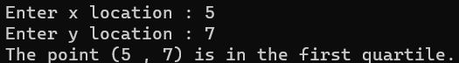

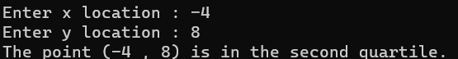

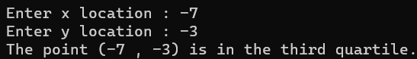

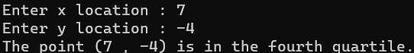

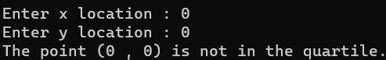

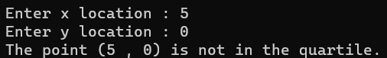

**Question2**

#include <iostream>

using namespace std;

int main(void) {

int N, i;

cout << "Enter a number between 1 & 100 : ";

cin >> N;

cout << endl;

cout << "Factors are : " << endl;

for (i = 1; i < N; i++) {

if (N % i == 0) {

cout << i << " ";

}

}

cout << N << endl;

return 0;

}

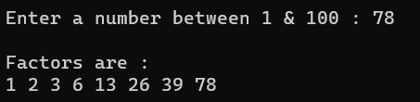

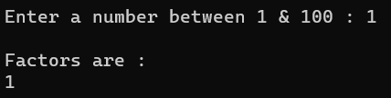

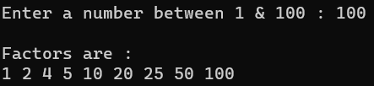

**Question3**

//Triangle.h

#pragma once

class Triangle

{

private:

int firstSide;

int secondSide;

int thirdSide;

public:

Triangle(int firstSide, int secondSide, int thirdSide);

void getSides();

int getPerimeter();

double getArea();

};

// Triangle.cpp

#include "Triangle.h"

#include <iostream>

#include <cassert>

using namespace std;

Triangle::Triangle(int f, int s, int t) :

firstSide(f), secondSide(s), thirdSide(t) {

if ((f + s < t) || (s + t < f) || (t + f < s)) {

cout << "Triangle cannot be made.";

assert(false);

}

}

void Triangle::getSides() {

cout << "(" << firstSide << "," << secondSide << "," << thirdSide << ")" << endl;

}

int Triangle::getPerimeter() {

return (firstSide + secondSide + thirdSide);

}

double Triangle::getArea() {

double p = getPerimeter() / 2;

double area = sqrt(p * (p - firstSide) * (p - secondSide) * (p - thirdSide));

return area;

}

//Main.cpp

#include "Triangle.h"

#include <iostream>

#include <iomanip>

using namespace std;

int main(void) {

Triangle Triangle1(5, 4, 3);

cout << "Triangle1 ";

Triangle1.getSides();

cout << "Perimeter : " << Triangle1.getPerimeter() << endl;

cout << "Area : " << fixed << setprecision(2) << Triangle1.getArea() << endl << endl;

Triangle Triangle2(6, 7, 9);

cout << "Triangle2 ";

Triangle2.getSides();

cout << "Perimeter : " << Triangle2.getPerimeter() << endl;

cout << "Area : " << fixed << setprecision(2) << Triangle2.getArea() << endl << endl;

Triangle Triangle3(10, 11, 19);

cout << "Triangle3 ";

Triangle3.getSides();

cout << "Perimeter : " << Triangle3.getPerimeter() << endl;

cout << "Area : " << fixed << setprecision(2) << Triangle3.getArea() << endl << endl;

Triangle Triangle4(8, 5, 5);

cout << "Triangle4 ";

Triangle4.getSides();

cout << "Perimeter : " << Triangle4.getPerimeter() << endl;

cout << "Area : " << fixed << setprecision(2) << Triangle4.getArea() << endl << endl;

return 0;

}

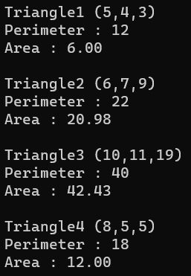

**Question4**

#include<iostream>

#include<string>

using namespace std;

int main(void) {

int i,j;

string s1, s2, s;

cout << "Enter first string : ";

cin >> s1;

cout << "Enter second string : ";

cin >> s2;

for (i = 0; i < s1.size(); i++) {

for (j = s1.size() - 1; j > i; j--) {

if (s1[i] == s1[j]) {

s1.erase(j, 1);

}

}

}

for (i = 0; i < s2.size(); i++) {

for (j = s2.size() - 1; j > i; j--) {

if (s2[i] == s2[j]) {

s2.erase(j, 1);

}

}

}

for (i = 0; i < s1.size(); i++) {

for (j = 0; j < s2.size(); j++) {

if (s1[i] == s2[j]) {

s.push_back(s1[i]);

break;

}

}

}

cout << "String with common characters : " << endl;

cout << s << endl;

return 0;

}

