<Display Recipe Category>

Use-Case-Realization Specification: <Display Recipe Category>

Version <1.0>

[Note: The following template is provided for use with the Rational Unified Process. Text enclosed in square brackets and displayed in blue italics (style=InfoBlue) is included to provide guidance to the author and should be deleted before publishing the document. A paragraph entered following this style will automatically be set to normal (style=Body Text).]

[To customize automatic fields in Microsoft Word (which display a gray background when selected), select File>Properties and replace the Title, Subject and Company fields with the appropriate information for this document. After closing the dialog, automatic fields may be updated throughout the document by selecting Edit>Select All (or Ctrl-A) and pressing F9, or simply click on the field and press F9. This must be done separately for Headers and Footers. Alt-F9 will toggle between displaying the field names and the field contents. See Word help for more information on working with fields.]

Revision History

|  |  |  |  |
| --- | --- | --- | --- |
| **Date** | **Version** | **Description** | **Author** |
| <dd/mmm/yy> | <x.x> | <details> | <name> |
|  |  |  |  |
|  |  |  |  |
|  |  |  |  |

Table of Contents

1. Introduction 2

1.1 Purpose 2

1.2 Scope 2

1.3 Definitions, Acronyms, and Abbreviations 2

1.4 References 2

1.5 Overview 2

2. Flow of Events—Design 2

3. Derived Requirements 2

Use-Case-Realization Specification: <Use-Case Name>

# Introduction

The "View Recipe" use case enables users to easily access and view recipes within the "Recipe Keeper" application. This document outlines how this functionality is realized, detailing the interactions between users and the system components. It includes essential diagrams to illustrate the design and flow of events, ensuring a seamless user experience.

## Purpose

The purpose of this document is to describe how the "View Recipe" use case is realized in the "Recipe Keeper" application.

## Scope

This document pertains to the "View Recipe" use case model and affects other functionalities within the application.

## Definitions, Acronyms, and Abbreviations

* Use Case: A scenario of how a user interacts with the application.
* MVC: Model-View-Controller, a software architectural pattern.

## References

* System design document for "Recipe Keeper."
* MVC design guidelines.

## Overview

This document includes sections describing the flow of events, sequence diagrams, and class diagrams related to the "View Recipe" use case.

# Flow of Events—Design

This section describes how the "View Recipe" use case is realized through collaborating objects.

## sequence diagram

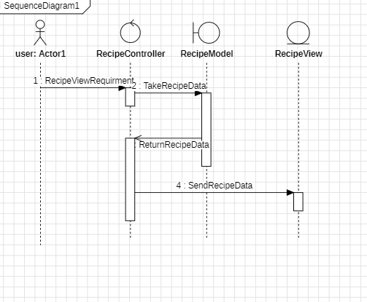

## Class diagram

## 

# Derived Requirements

* The system must allow users to view recipes without errors.
* The response time for loading a recipe must not exceed 2 seconds.